Contents
E-Commerce Websites 2
Evaluation 2
Testing 4
Creating an E-Commerce Website 5
E-Business Applications 7
Bibliography 8
Appendix 10

E-Commerce Websites
E-Commerce is essentially the purchasing or selling of services or products, or the transmitting of funds or data, online (typically over the internet) [1] [2].
There are multiple ways of going about creating an e-commerce output such as a website. You can use hosted e-commerce software which is more user friendly and for beginners or you can use self-hosted open source e-commerce software which is more advanced.
With hosted software, you wouldn't really need to have any knowledge about code or even computers. They have simple drag and drop features to implement the e-commerce shopping cart which are very user friendly. You don't need to hire any expensive developers to code your website; however, you may be limited to the customisable options available on the software. Also, you wouldn't have to worry about hosting it or the security of your website because the host would take care of it.
Open Source software is a lot more difficult to use; you either need to know how to code or you hire someone technical to do the coding for you, however, you do get a bit more flexibility with the customisation of your website [3].

Evaluation
The first section of this report will discuss and evaluate current responsive e-Commerce site design options to see if they have the requirements needed for users to create their own e-Commerce website [4] [5].
Many sources were used for research on this topic [6].
The first requirement that will be discussed is professional layouts and design. When users are comparing multiple e-commerce site design options, they want professional looking layouts that are available and variety will tend to sway their opinion on the matter for people who prefer uniqueness and customisation. Now obviously there are numerous options someone could go for, comparing them will be a helpful way to distinguish the best one for the specific job. Starting with Weebly e-Commerce, this options has a vast variety of professional looking layouts and designs that website owners can use as templates to base the whole site off of. Meanwhile, something like Amazon store front doesn’t have any of these designs or templates, it will always have the same design for each product and this limits customisation which could mean that people may lean towards options that include this requirement if they care about branding [7].
The ability to be responsive to mobile devices is an essential requirement for users when choosing a responsive e-Commerce site design option. This feature offers versatility in your market place; potential customers can view your e-commerce site on the go via their phone if they wish. It allows people to easily access websites when they don’t have access to a computer, and that factor of them immediately being able to access it on demand will increase growth and overall potential customers viewing the site. Now, all main e-commerce site design options will have this feature due to its large benefits for the user. Examples of options are Weebly e-commerce, shopify, spreadshirt and facebook store front all have this feature and they use this requirement to seem more suitable for users.
A product catalogue is a feature that is required for potential customers to browse through the website owner’s number of products in, preferably, a structured and efficient fashion. This is another essential requirement that will really show the difference between e-commerce site design options and will sway opinions on which one to go for. Starting with Weebly e-commerce, it does have a product catalogue option and is easy to implement which is highly desired; now compare that to an Amazon store front where your product is automatically put in the catalogue.
A shopping cart on an e-commerce website allows a customers to select multiple products before purchase so they can buy them all in one payment and not individually. This requirement is more for convenience purposes that benefit the customer using the site. Once again, options such as Weebly e-commerce shopify and Amazon store front all has this feature available. An option without this requirement would seem inferior to its competition.
Payment options such as card and PayPal are another requirement that e-commerce site design options should have. This feature is important because different customers may have different payment method preferences. Some customers may find out they can’t pay via their preferred method and back out of the purchase which means the website owner just lost out on a sale due to a lack of this requirement. The process for these options must be safe a secure for the customers to trust the site in the future. Weebly e-commerce, Amazon store front and shopify all have a number of safe payment method options.
Moving onto an important requirement, allows updates by non-technical personnel via a GUI, which essentially means people who have no previous knowledge of coding can easily edit their site using a simple system on a graphical user interface. This feature is very user friendly and is implemented in a lot of e-commerce site design options. Weebly e-commerce, for example, has a drag and drop system which allows users to drops text boxes, buttons and images right into their pages without touching any code. Amazon store front goes one step further with a step by step process on how to sell through their hosted website [8].
Another requirement that someone might want is no hosting maintenance required. This simply means that the user would not have to pay any costs to the e-commerce site design option company for hosting their website. A service like Weebly e-commerce has no hosting maintenance; however, shopify offers a 14 day trial to their users and then charges after that amount of time to host their website.
The final requirement is for them to be as reasonable as possible; for example, a small business would not be able to afford a high hosting maintenance cost so they may change options based on that. If one of these small businesses decided to choose square space that costs quite a bit to for hosting they might want to consider using something like Weebly e-commerce which has the option of free hosting which will save the company money. Meanwhile, a larger company with more money that is already set up can afford these options with high hosting maintenance costs. The good thing about Weebly e-commerce is that its originally free for a small business but they could eventually upgrade their package for further features.

Testing
The two solutions that will be tested are Weebly e-Commerce and Shopify [9].
Now originally, Weebly didn’t even have an e-commerce option for users to choose and that was added recently to expand their potential customers (See screenshot 4 in the appendix). Shopify has always been an e-commerce site design option so there’s a chance that it’s more catered for non casual businesses and will aim for hosting large businesses that will pay the money for the subscription and maintenance.
Customisation wise, Shopify does have the option to change themes and styles but has no set templates apart from the original starting pages to start from (See screenshot 1 in the appendix). Whereas Weebly has a vast variety of templates to start from and gives the user a lot of options to how they want their e-commerce website to look (See screenshot 2 in the appendix). Shopify also has a layering system set in place to hide certain parts of your page to reduce clutter while designing and work on your site (See Screenshot 5 in the Appendix).
When testing each on responsiveness to mobile devices, it seems that shopify gave you a helpful preview for what your site would look like on a mobile device; Weebly also gave this preview and easily resized itself for the size of a mobiles devices screen.
Adding bespoke images is fairly simple for both options; Weebly has a drag and drop system which allows the user to easily drop in the box and allows them to upload any image they want to that location (See screenshot 6 in the Appendix). As for Shopify, it allows users to add sections to their page and will automatically place it at the bottom of your page on its own but you can then reposition it but not mix it with other sections (See screenshot 7 in the Appendix). The same process is exactly the same for normal text, titles and galleries.
Adding a page for Weebly is incredibly simple, you can just go to “Pages” and click the plus icon and it will create a new page with the style and theme of your preference (See Screenshot 8 in the Appendix). Shopify has a similar feature but you have to know where to look because you can’t add it from the design page, you have to back out to view your online store options, click “Pages” and click “Add Page”; from there you can add multiple pages at once but with little customisation (See screenshot 9 in the Appendix).
From testing both options, Weebly does seem to be the most user friendly for SME’s in comparison to Shopify. Shopify allows the user to cram many products onto one page and encourages it with its default theme (See Screenshot 3 in the appendix) [10].
As Osprey UAV (The business in question) is a smaller company that doesn’t deal with a large number of products (Only services), Weebly seemed to be the preferred options.

Creating an E-Commerce Website
The option, Weebly e-Commerce was chosen for the designing and creation of this website. This part of the essay will document the creation process and showcase the completed site (https://ospreyuav.weebly.com/).
Web design guidelines were taken into account during the creation of the website. The website kept the design simple, it didn’t need extravagant colours or graphics because it might not look as professional and also the focus wouldn’t be on the content of the website [11].
The first thing that was required was to set up all the pages ready the addition of content; all clutter from the theme was deleted and 1 page was deleted because only 4 were required for this site. The navigation bar shows each page, Home, Services, about and contact which will be talked about in more detail.
Bespoke Graphics were needed for the website for branding reasons, it would show potential customers which company the website was run by. The first bespoke graphic created was the logo; this was created using Adobe Photoshop and Adobe Illustrator. Illustrator was used to create the outline of the logo itself and Photoshop was then used the tinker around with it, give it colour, add features and overlay text (See Screenshot 11 in the Appendix). The logo was roughly based off of a concept logo that was found online and was essentially improved upon. The banner for the website was actually an image taken from an actual drone that was implemented as the background to go with the theme of the business as well as using the title tool to add the companies name as an overlay over the image (See screenshot 12 in the Appendix). The banner was only used on the Home page but the logo is displayed on the top left of every page of the site.
Scrolling down the Home page, there is a very brief mention on what the viewer can find on the website. It’s brief due to the majority of the content being on the other pages. A title was added for “HOME” and the sentence below created using the text box on the left hand side GUI (See Screenshot 13 in the Appendix).
Moving onto the Services page, this is where the business shows to the customer what they have to offer. The title “SERVICES” was added to show which page the customer was on. Then an app called Price chart was added which was an easy way to display the services in a structured format. Each service available was added to the price chart as well as their pricing, description, limitations and finally the button to purchase them (See screenshot 14 in the Appendix).
Moving on, we have a slideshow that can be seen in the GUI that has been added to this page to display example of images taken by the company’s drones. This is to show off the quality of the photos that are being taken and the unique perspective from where the camera is (See screenshot 15 in the Appendix).
The final part of the Services page is a YouTube video showing an example of drone footage that was taken by the business. This can be added by looking at the GUI on the left hand side of the page and simply dragging it into the desired location. This is also used to show off the quality and uniqueness of the footage to the customer (See screenshot 16 in the Appendix).
The About page is essentially a brief explanation of what the business is about and what they offer. It has the title “ABOUT” and uses text boxes for the information. There is also a subtitle that has smaller text “WHERE TO FIND US” which is above a map and this shows where the company is based (See Screenshot 17 in the Appendix).
The final page is the Contact page which will be used for customers to contact the company about inquires of feedback and at the top of the page, there is the title “CONTACT”, again showing the customer which page they’re on. The tool that was used for this was the Contact form which was an easy drag and drop job, this form allows the customer to contact the business quick and easily through the website and their comment will be sent straight to their e-mail (See screenshot 18 in the Appendix).
The final part of this page is the title “SOCIAL MEDIA” and a button which is another tool used; when clicked, it links the user to the businesses YouTube channel which is their only social media page but more can be created and added to this page in the future (See screenshot 19 in the Appendix) [12].

E-Business Applications
This part of the essay will be analysing and testing a e-Business applications and software’s to see if they are suitable for SME’s (Small and medium-sized enterprises) [13] [14].
An example of an e-business application for SME’s would be Skype. This application is used for businesses to communicate when staff or stakeholders are unable to be present. Skype allows you to have up to 25 people in a call and also share screens which would help with an e-commerce websites development because each person could see it and give their input. While testing this application, all the features were used. Skype is also a free application which makes it even better for an SME because it means they don’t have to spend any money on software for each staff member [15].

Bibliography

[1] | A. Khurana, “Learn the Basics About E-Commerce,” The Balance, 23 October 2017. [Online]. Available: https://www.thebalance.com/let-s-ask-the-basic-question-what-is-ecommerce-1141599. [Accessed 19 03 2018].
[2] | “E-Commerce Website Design,” fat media, [Online]. Available: https://www.fatmedia.co.uk/services/e-commerce-website-design/. [Accessed 25 March 2018].
[3] | S. Korper and J. Ellis, The E-Commerce Book: Building the E-Empire, Elsevier, 2000.
[4] | A. Harbaugh, “Ecommerce Website Requirements: Does Your Ecommerce Platform Have What Customers Need?,” Hitachi Solutions, [Online]. Available: https://us.hitachi-solutions.com/blog/ecommerce-website-requirements/. [Accessed 22 March 2018].
[5] | D. Travis, E-Commerce Usability: Tools and Techniques to Perfect the On-Line Experience, CRC Press, 2003.
[6] | “E-Commerce Website Builder,” Website Builder Expert, [Online]. Available: https://www.websitebuilderexpert.com/ecommerce-website-builder/. [Accessed 19 03 2018].
[7] | “Starting Selling Online,” Weebly, [Online]. Available: https://www.weebly.com/lp/top-ecommerce-builder?c=mkt_w_chnl:aff_geo:big3_prtnr:ni_subprtnr:[var]-MxOjyFEOhj_camp:ni-uk_ag:ecom_lptype:pdecm. [Accessed 23 March 2018].
[8] | Amazon, “Selling at Amazon.co.uk Marketplace,” Amazon, [Online]. Available: https://www.amazon.co.uk/gp/help/customer/display.html?nodeId=3149141. [Accessed 20 03 2018].
[9] | J. Wong, “Shopify Reviews 2018 | 12 Key Things You Need To Know,” Website Builder Expert, 28 March 2018. [Online]. Available: https://www.websitebuilderexpert.com/shopify-reviews/. [Accessed 29 03 2018].
[10] | “Weebly Review,” top 10 E-commerce builders, [Online]. Available: https://www.top10ecommercesitebuilders.com/reviews/weebly. [Accessed 23 March 2018].
[11] | E. Devaney, “8 Guidelines for Exceptional Web Design, Usability, and User Experience,” HubSpot, 28 April 2016. [Online]. Available: https://blog.hubspot.com/blog/tabid/6307/bid/30557/6-guidelines-for-exceptional-website-design-and-usability.aspx. [Accessed 21 March 2018].
[12] | “Osprey UAV LTD,” YouTube, [Online]. Available: https://www.youtube.com/channel/UCZNkZxir_45LQiefjFa39DQ. [Accessed 24 March 2018].
[13] | S. Nicastro, “25 Best Small-Business Apps in 2018,” nerdwallet, 2 January 2018. [Online]. Available: https://www.nerdwallet.com/blog/small-business/20-apps-small-business-owners/. [Accessed 21 March 2018].
[14] | J. Gasos, E-Business Applications: Technologies for Tomorrow's Solutions, Springer Science & Business Media, 2012.
[15] | “What is Skype for business,” Skype, [Online]. Available: https://support.office.com/en-ie/article/video-what-is-skype-for-business-3a21eca4-434d-41f1-ab06-3d4a268573b7. [Accessed 27 March 2018].

Appendix

Screenshot 1:
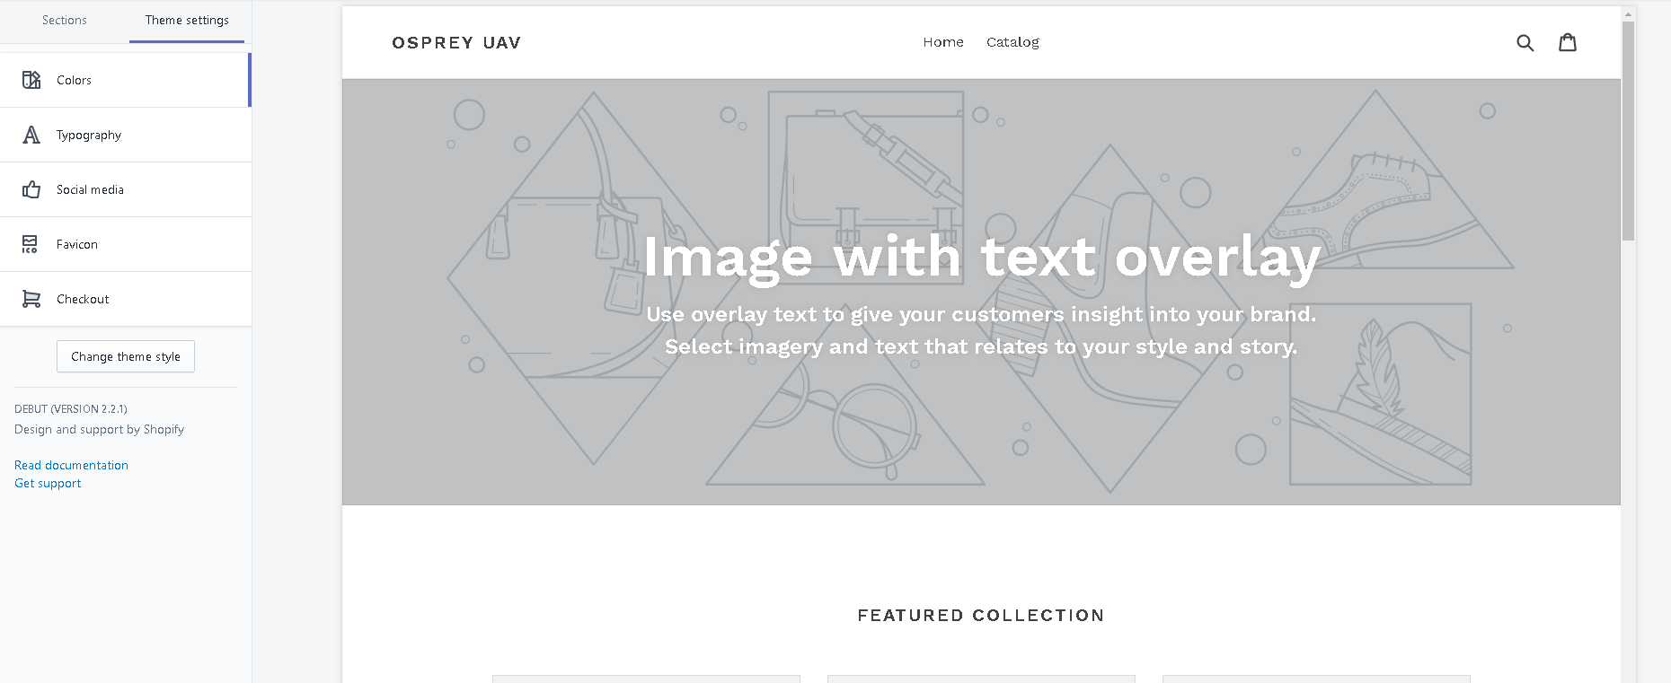
Screenshot 2:
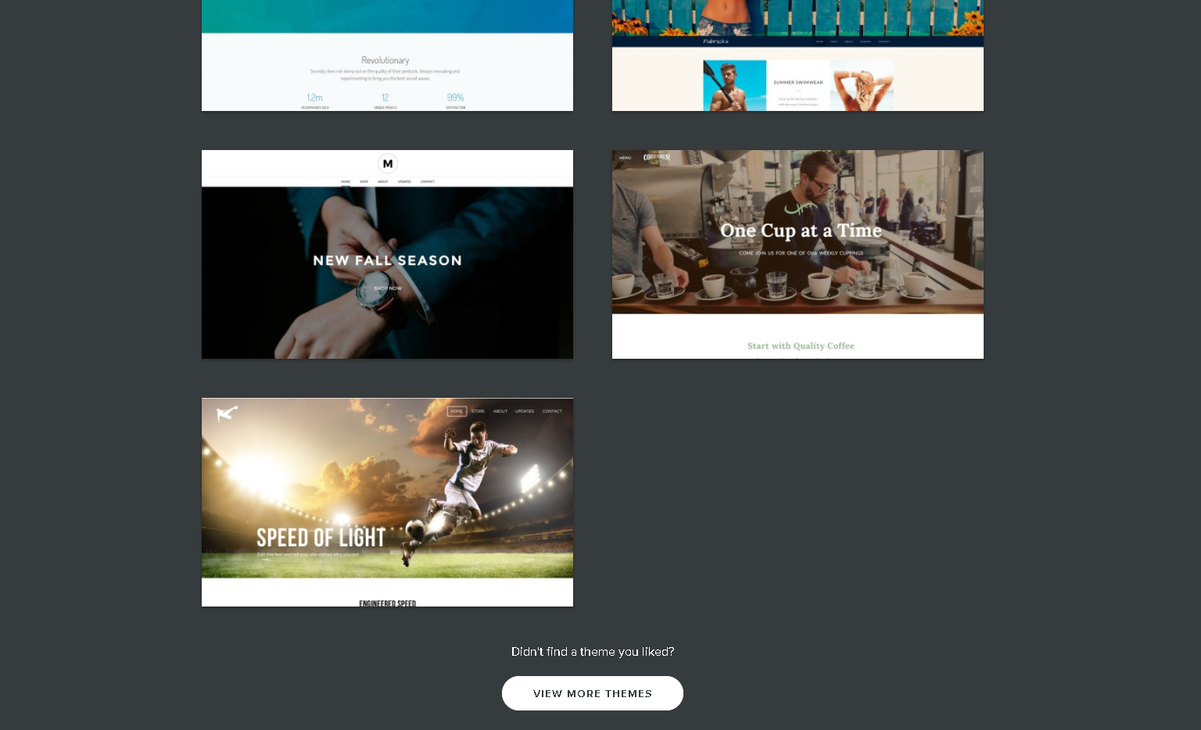

Screenshot 3:
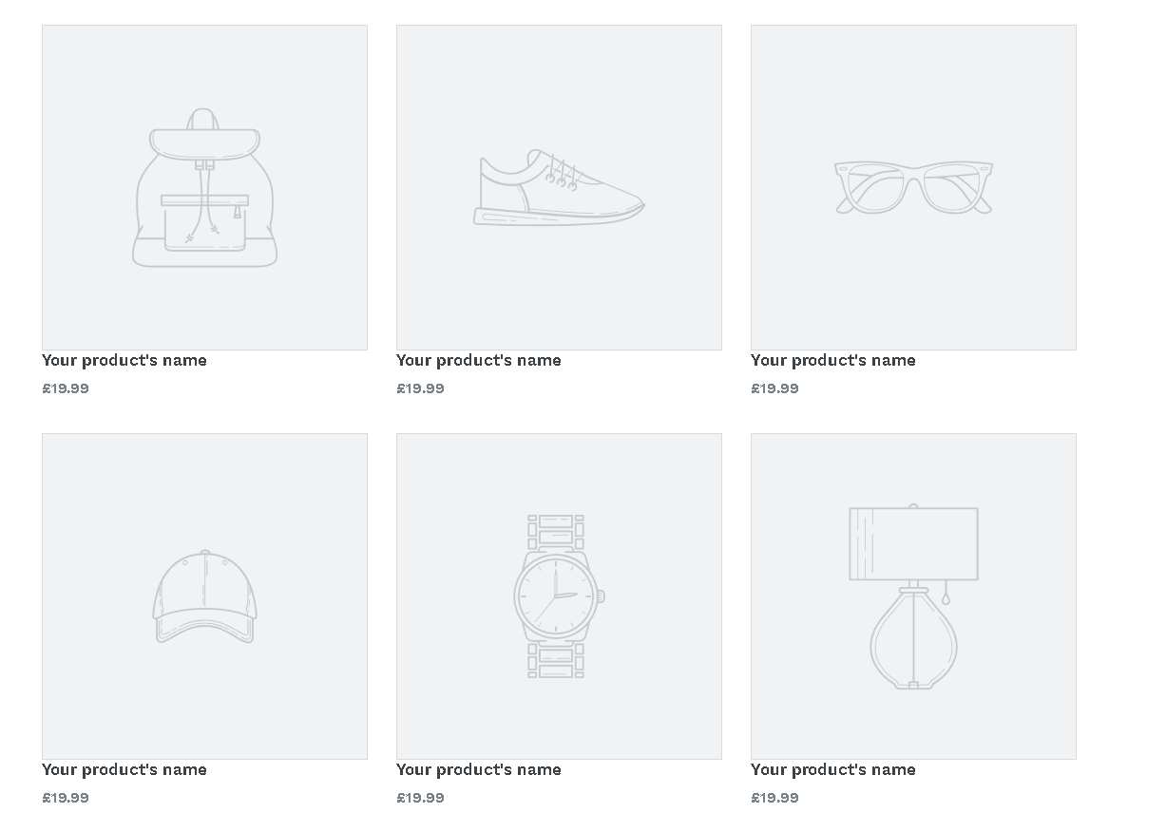
Screenshot 4:
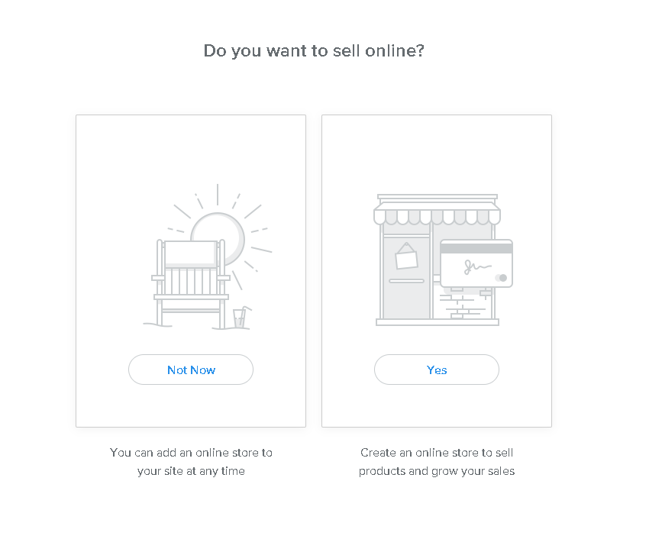
Screenshot 5:
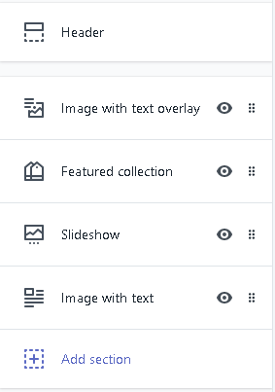
Screenshot 6:
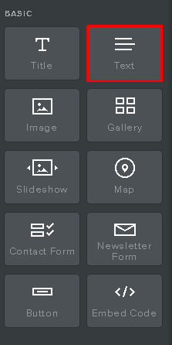

Screenshot 7:
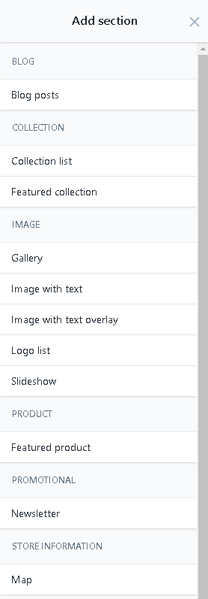
Screenshot 8:
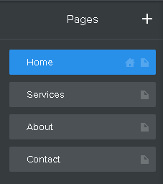

Screenshot 9:
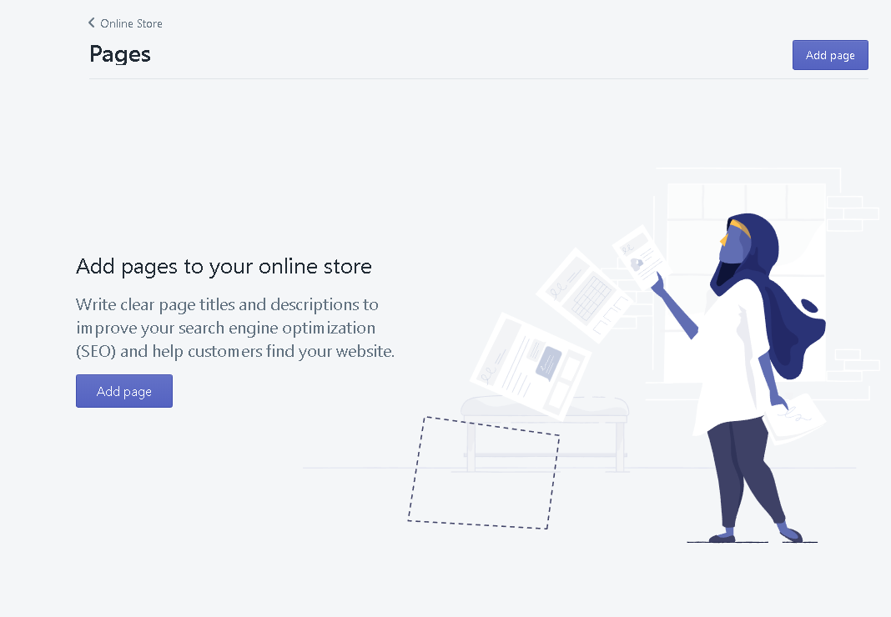
Screenshot 10:

Screenshot 11:


Screenshot 12:

Screenshot 13:
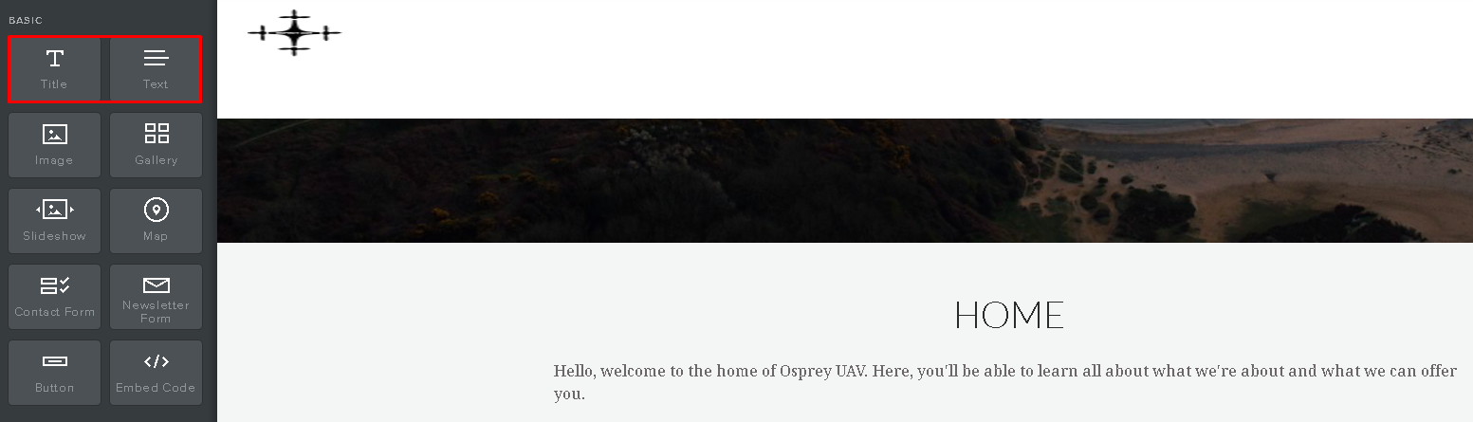
Screenshot 14:
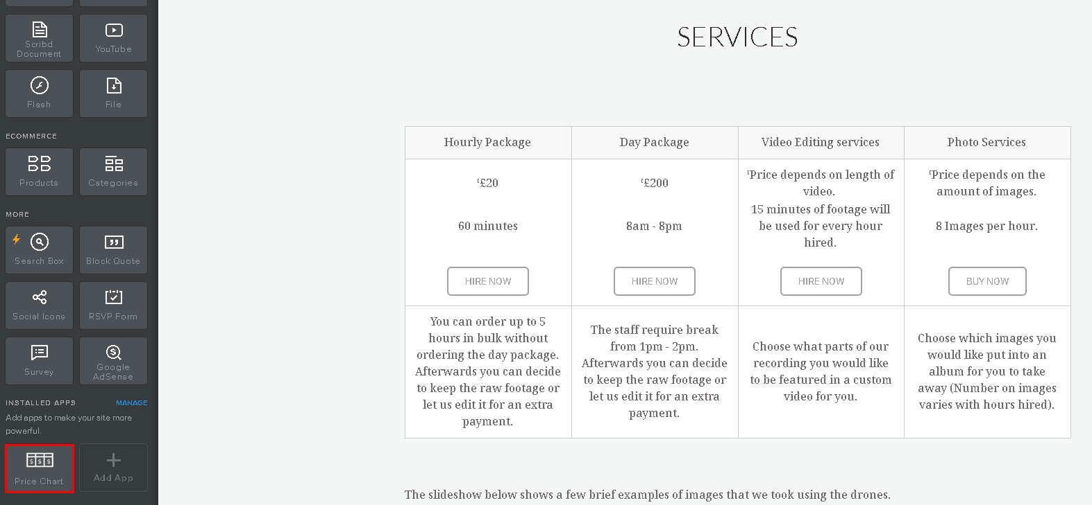

Screenshot 15:
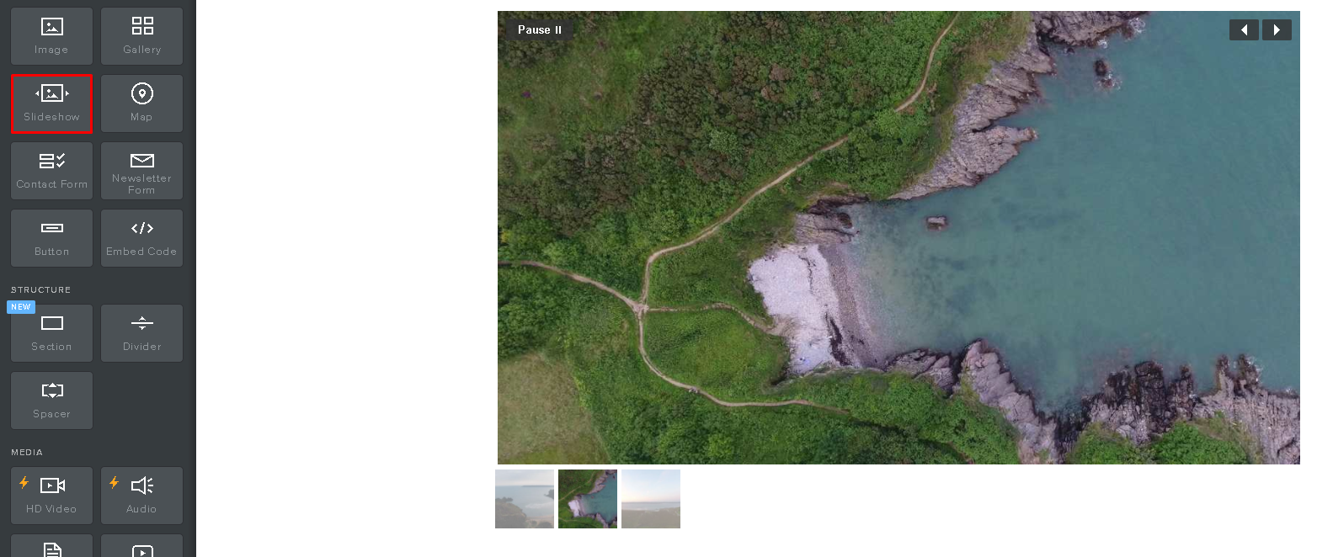
Screenshot 16:
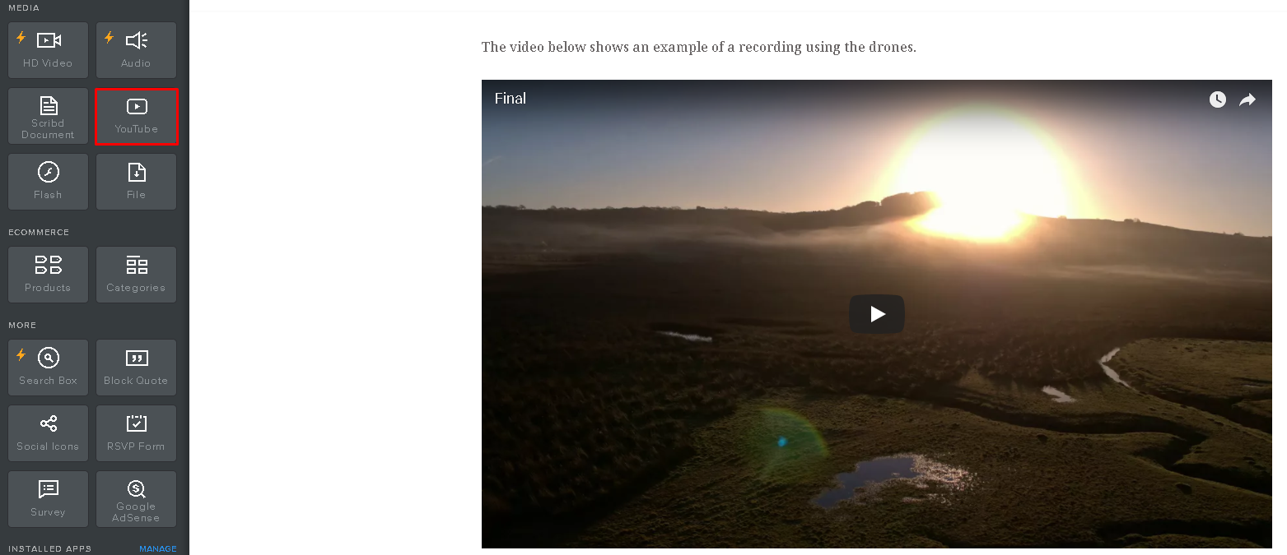
Screenshot 17:
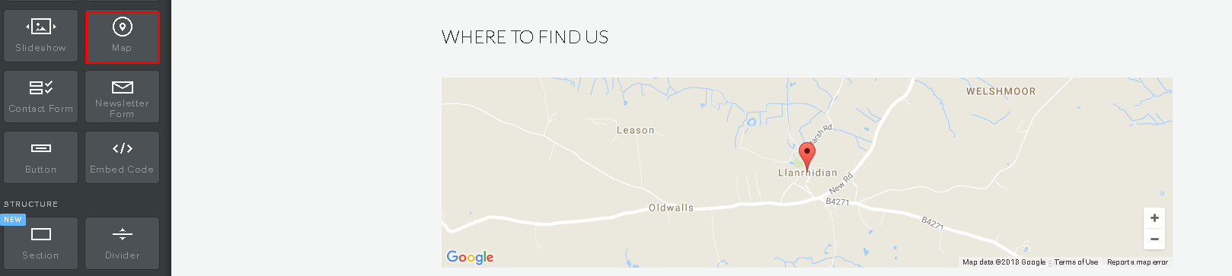

Screenshot 18:
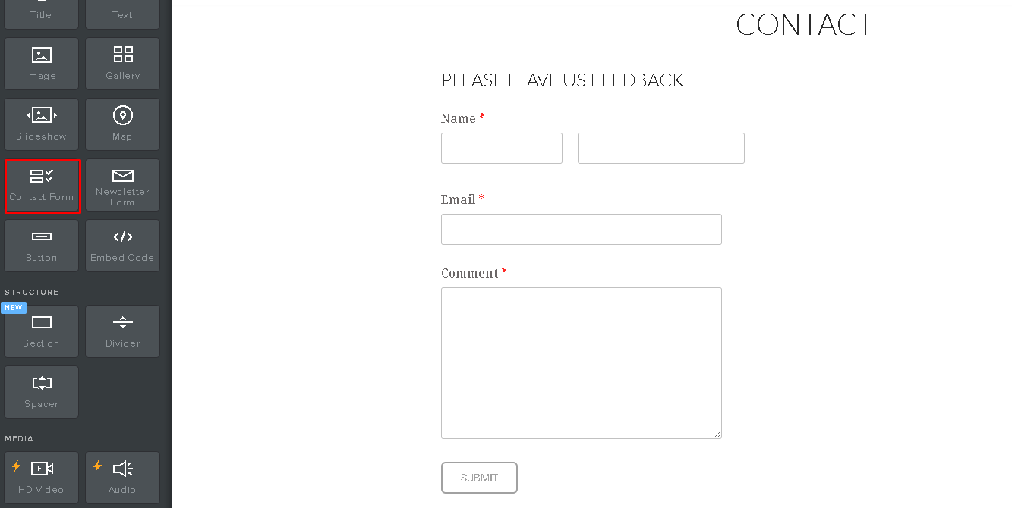
Screenshot 19:


