
Bookstore Database Design.
Information Engineering.
Author - Anne McDonnell Student number 1809128
Lecturer - Mrs. B Holland
Module code – ACCB4013
Programme – BSc computing portfolio

Dylan’s Bookstore has been running successfully in Swansea for many years. Due to their ever increasing customer base the company requires the creation of a user-friendly database system for fast information processing and retrieval.

Contents
1. Introduction. 2
2. Background research. 3
3. Task one. 4
4. Task Two. 8
6. Case study and Brief user guide. 15
7. Conclusion. 18
8. Bibliography. 19
9. Appendix A. 20

1. Introduction.
The purpose of this work is to design and implement a database application for Dylan’s Bookstore. Dylan’s bookstore has been located in Swansea for a number of years. The bookstore has built up a considerably sized customer base who order books from all over the UK. The bookstore has a niche market who are interested in purchasing classic titles and new best sellers. The current standard operating procedures demonstrating the workflow within the bookstore are shown below.

Figure 1 – Current Operating procedures within Dylan’s Bookstore.

In order to maintain a high standard of service and gain new customers, the bookstore know that a fast information processing and retrieval system is required and their priority is to computerise their system. The bookstores has identified their requirements, described below.

Figure 2 – System Requirements for Dylan’s Bookstore.

2. Background research.
The bookstore application should be capable of storing customer information, Book/stock information and order information as well as allow for queries and relevant reports to be printed. In the book, Modern systems analysis and design, it is stated that “as businesses and systems become more sophisticated and complex so too has the emphasis on speed in systems analysis and design” [1].
One must understand the current system state of the organisation, the objectives of the organisation and the processes in order to fully take advantage of the information technology available today. The computer programs and databases designed for businesses must be easy, flexible and meet the needs of the end user. Most software analysts will approach systems design by following the systems development lifecycle which is a common method used for systems development which features the following steps, [2].
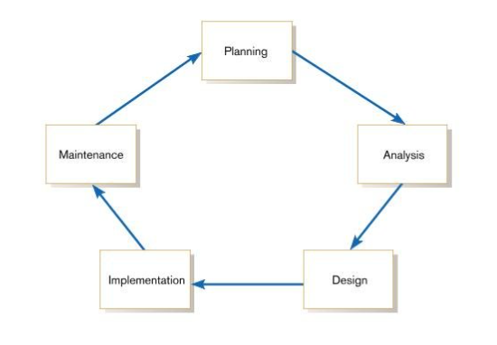
Figure 3 – Systems development life-cycle.
In the book, Modern Systems analysis and design, the following components of an organisation need to be understood:
- How the processes are being done now.
- What information the employees need, and what data they are receiving.
- How they are receiving the data now, and how is it stored.
- Existing business rules.
- Benefits to change in processes and delivering expectation. [1]
This analysis can be done in a number of ways, some examples being interviewing individuals, interviewing groups, and observational analysis. Tools can be used, such as a data flow diagram, to model how data flows through the system. According to the business dictionary, a data flow diagram is a 2D diagram identifies each source of data, and its interaction with other data sources, to reach a common output [3]. Another tool which is most commonly used in modelling is an Entity- relationship diagram.

3. Task one.
In this section, instruction was given to use a design technique to develop a suitable solution for Dylan’s Bookstore. By determining the requirements that have been identified by the end users, the information engineer can begin to understand the needs [4].
The questions asked at this stage to develop the entity relationship diagram are:
- What are the objects within the business – This will identify the data entities.
- What are the distinguishing features of the object/objects – This will identify the primary key.
- What are the characteristics of the objects – This will identify the attributes.
- Are there associations between the objects – This will identify the relationships.
- Can an event occur between certain objects or do all objects need to be involved – This will identify the integrity rules.
The design of the entity relationship diagram for Dylan’s bookstore clearly shows the entities, attributes, and relationships and was designed using Microsoft visio.
A customer has a one to many relationship with orders and one customer can place many orders. The publishers will have a one to many relationship with the book/bookstore as publishers will supply many books to many bookstores, as will collectable bookdealers. The newsletter will have a many to many relationship with customers as customers can sign up for a subscription service.

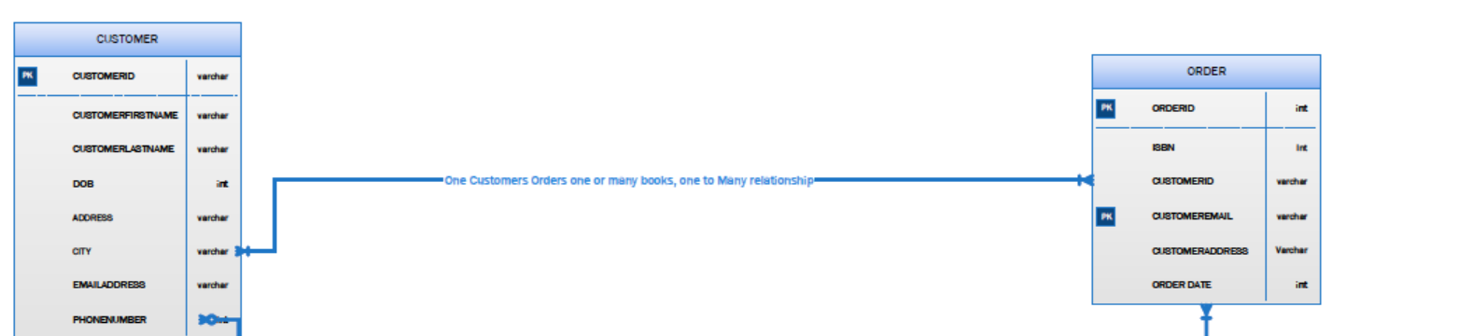
Figure 4 – Customer has a one to many relationship with order.

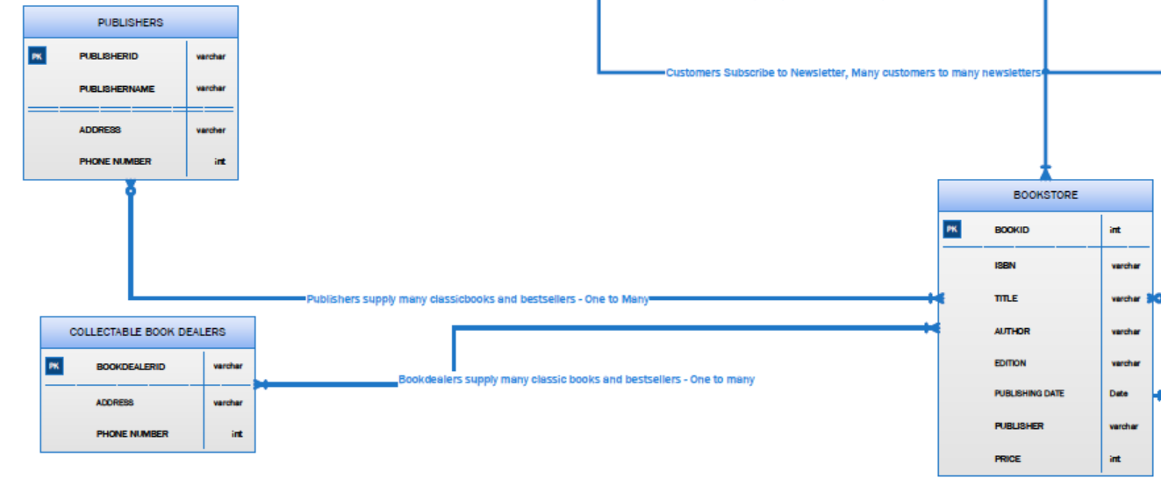
Figure 5 – Publishers and book dealers have a one to many relationship with Bookstores.

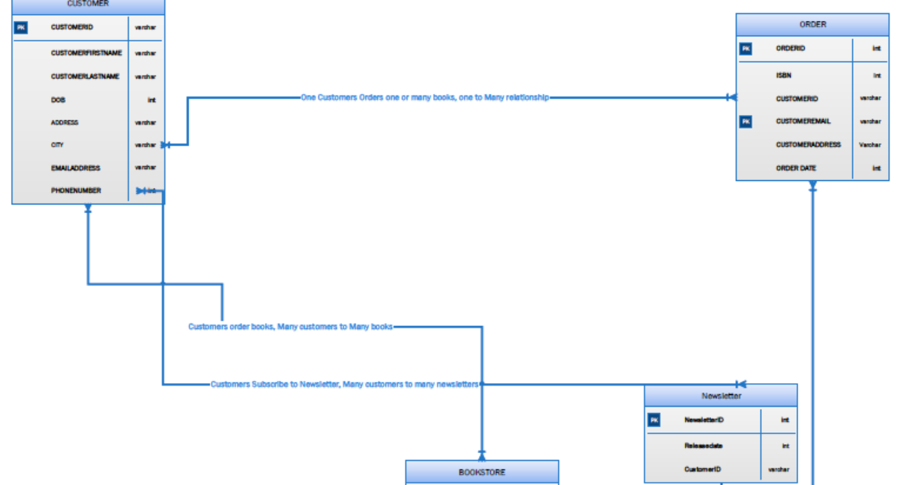
Figure 6 – Many to Many relationship between Newsletter and Customer.

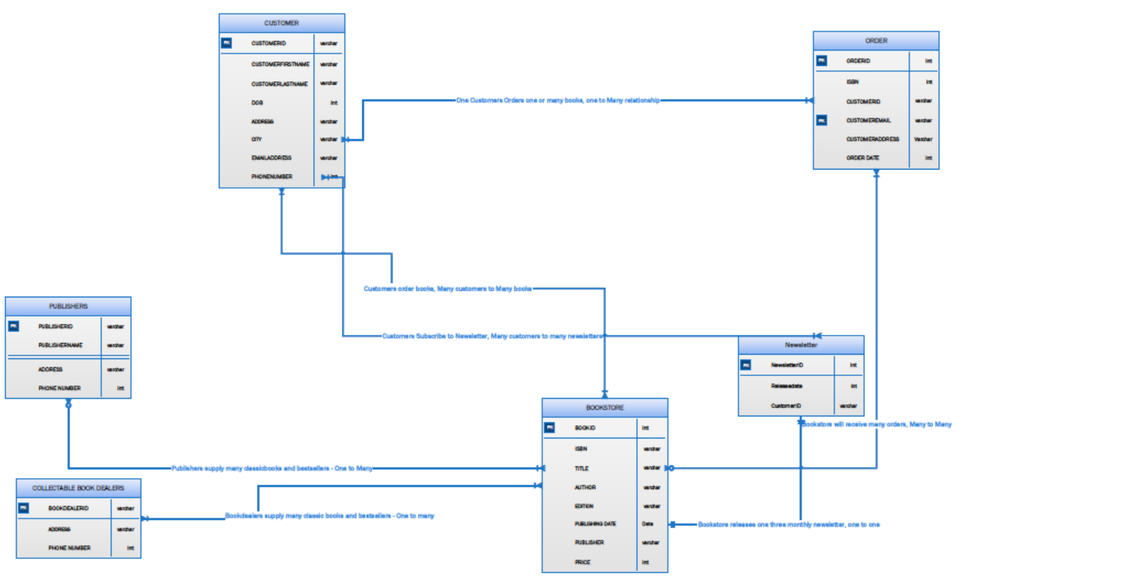
Figure 7 – Complete Entity relationship diagram.

The entity relationship diagram shows the relationships between the different entities in the bookstore model, and shows the primary keys set for each entity. It is important that each entity has a unique identifier to maintain integrity of the data model. Each attribute also has particular dataset which is shown on the right hand side of the attribute, which identifies that this value must be set to characters, or a number. The next stage is to build a logical database to meet the requirements of the bookstore. Normalisation of data is another important factor in database design in order to improve integrity and remove any redundant data – it is the process of organising data in the database into tables and columns, ensuring each table contains relevant data only [5].
As an example of how to do this, the following data will be normalised following normalisation rules.
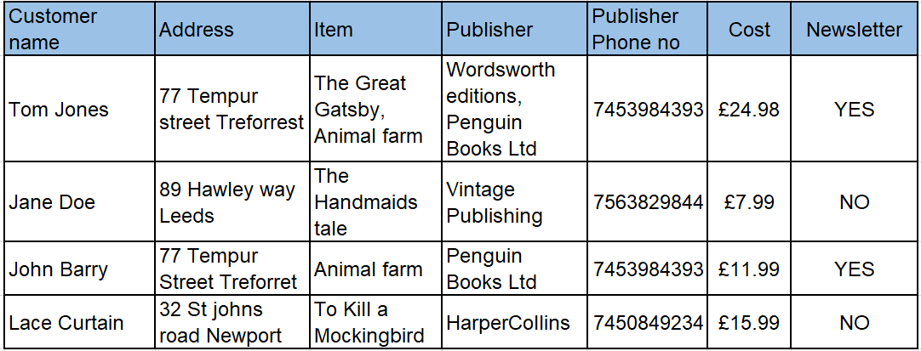

1st Normal form - each cell to be single values, entries in a column are same type and Rows are uniquely identified:

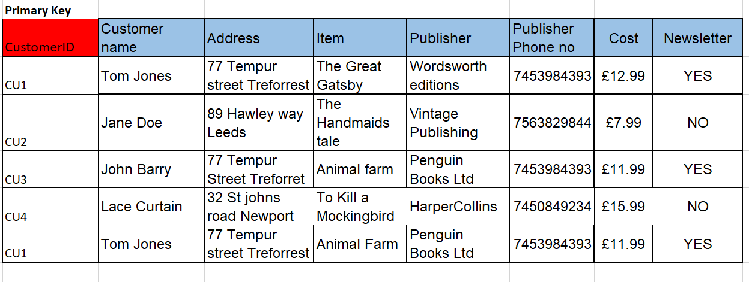

2nd Normal form – All attributes are dependent on the assigned primary key:
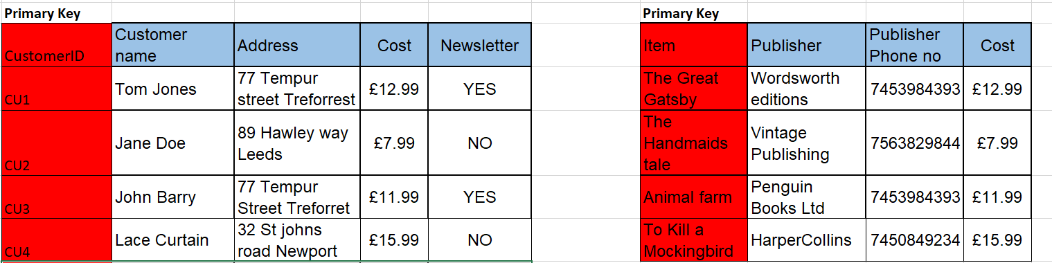

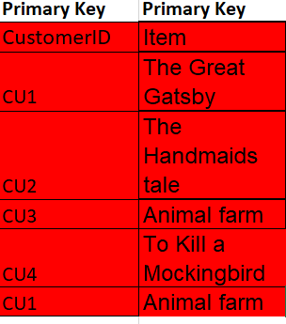

3rd normal form – All columns can be determined by the key in the table and no other column.
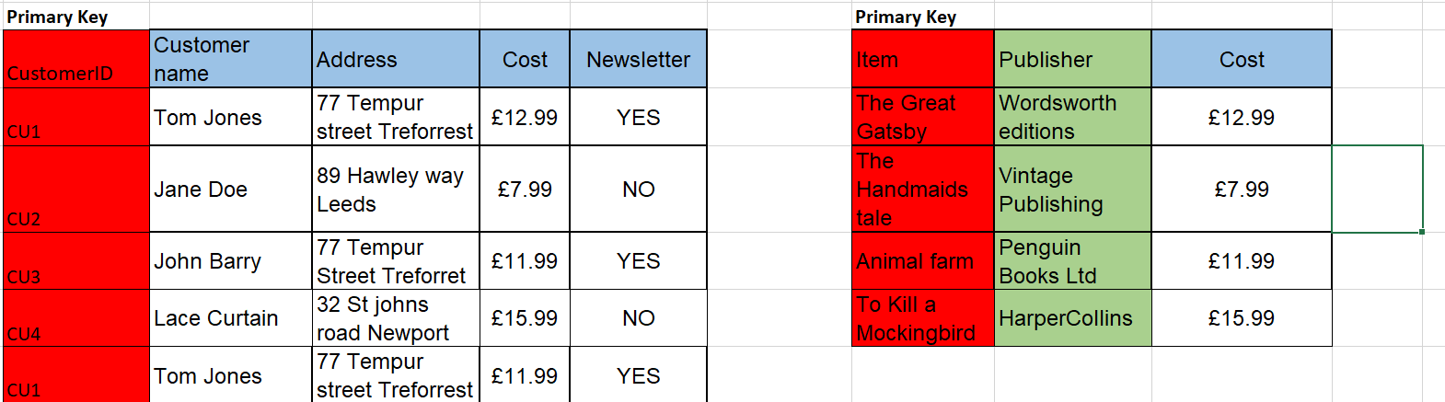

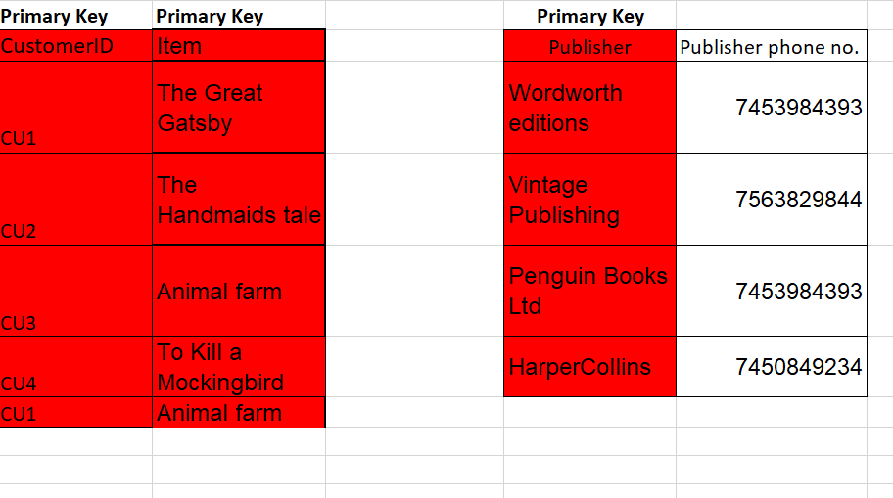

4. Task Two.
In this section, instruction was given to implement a database to meet the requirements of the bookstore, using the Entity relationship model previously developed. Using Microsoft access the tables developed in the entity relationship model were created with sample data.
This is the customer information table created, shown in design view in Microsoft access to show the Field names, Data Types and a unique primary key has been chosen. The additional attribute of “sign up to newsletter” has been added as an additional field to enhance the design. The data type also reflects the data type in the Entity relationship model.

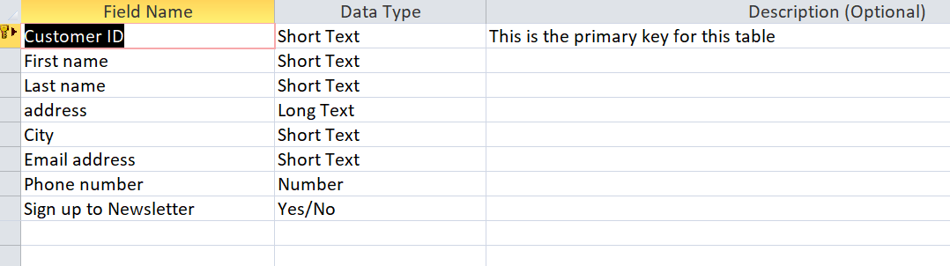

When Datasheet view is selected, all test customers information can be viewed:
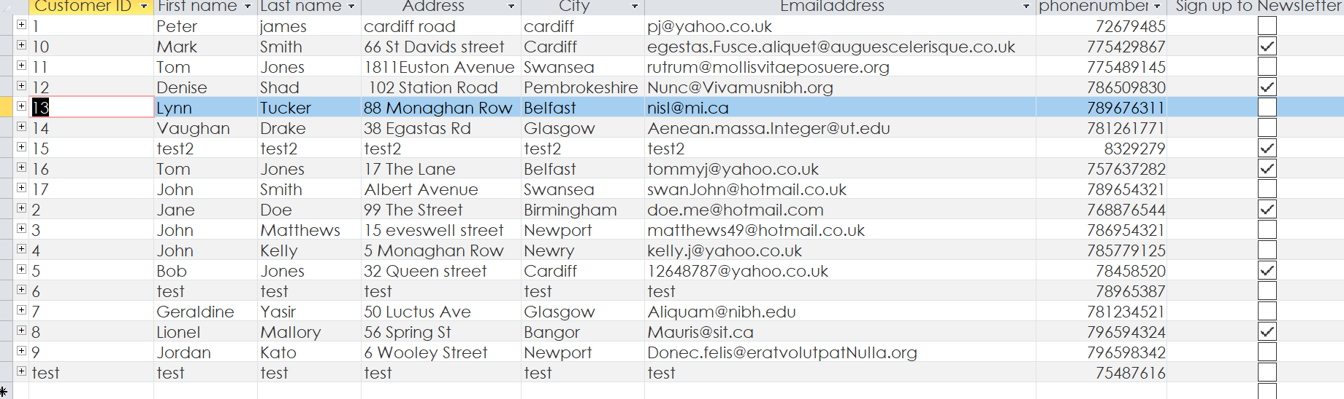

As the user moves through each table, they can see the tables and information held for all the following tables, each with unique primary keys and specific datatypes selected.
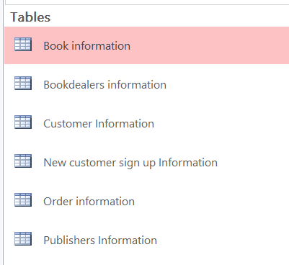

In order to make the database user friendly and easier to navigate through the following menu greets the user when the database is first opened:

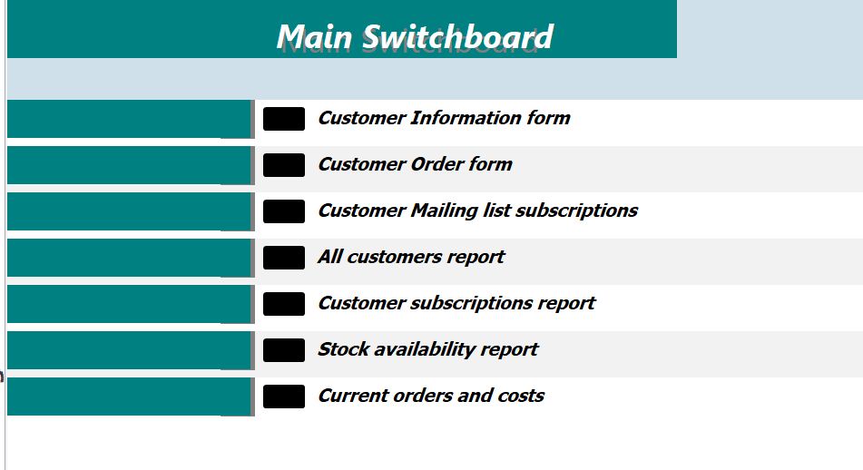

Some examples of functionality within the system are shown below.
The user can select a form to complete, for example customer information form to add a new customer to the database.

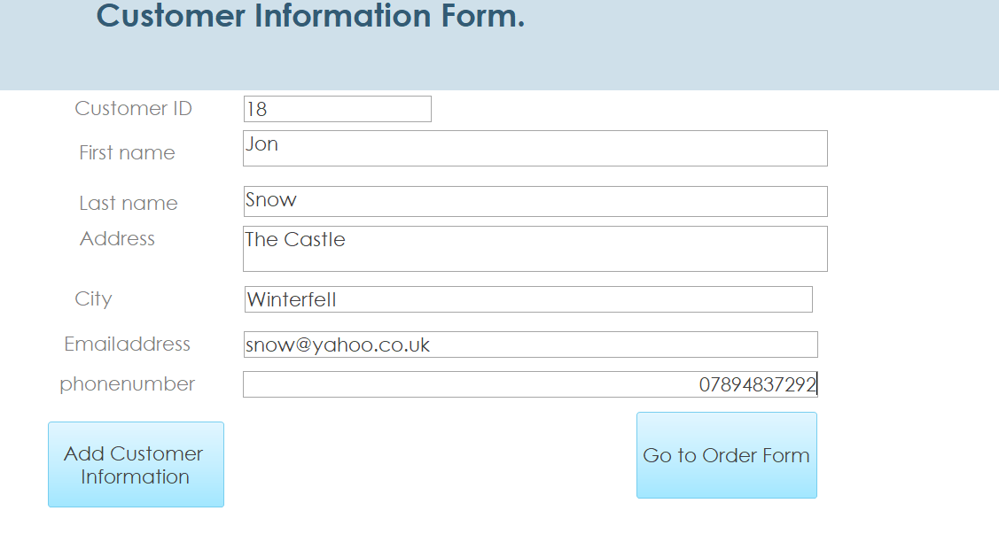

The customer information form is displayed for the customer’s details to be added, and once complete by selecting “Add customer information, the Customers details are automatically added to the database, as highlighted below.

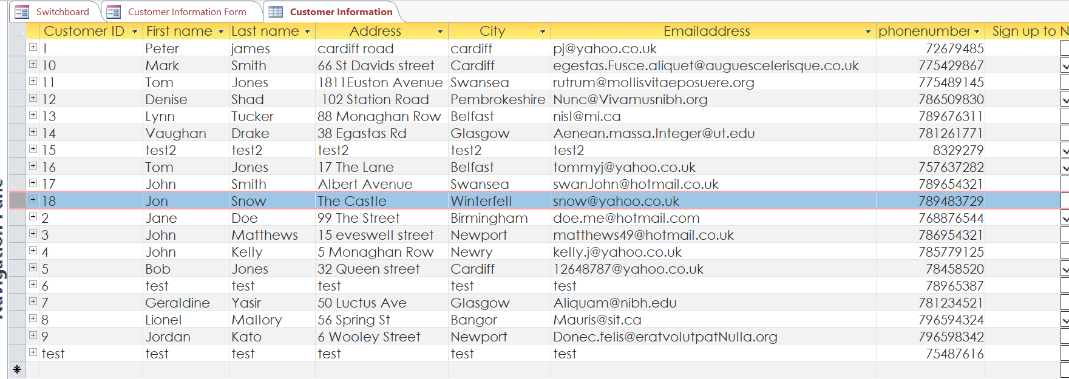

The next form is a customer order form which will add the customer order into the customer orders table once the user has selected add order details:

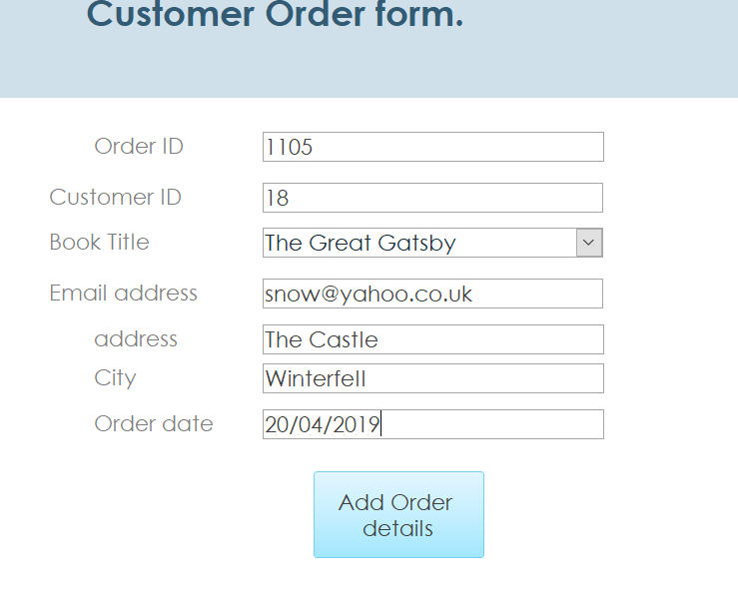

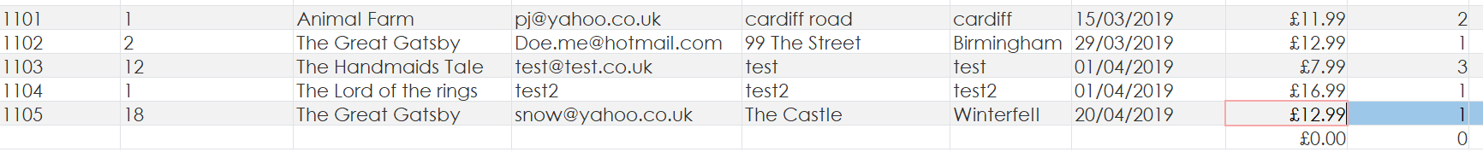

A user friendly report can also be printed out to show, for example the customer base the bookstore has based on location:

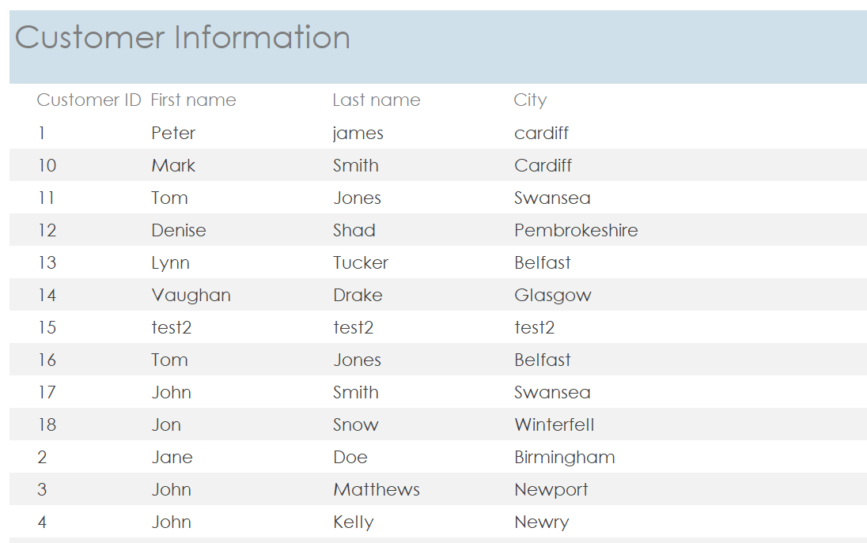

Another relevant report the system has been designed to produce is a stock availability report:
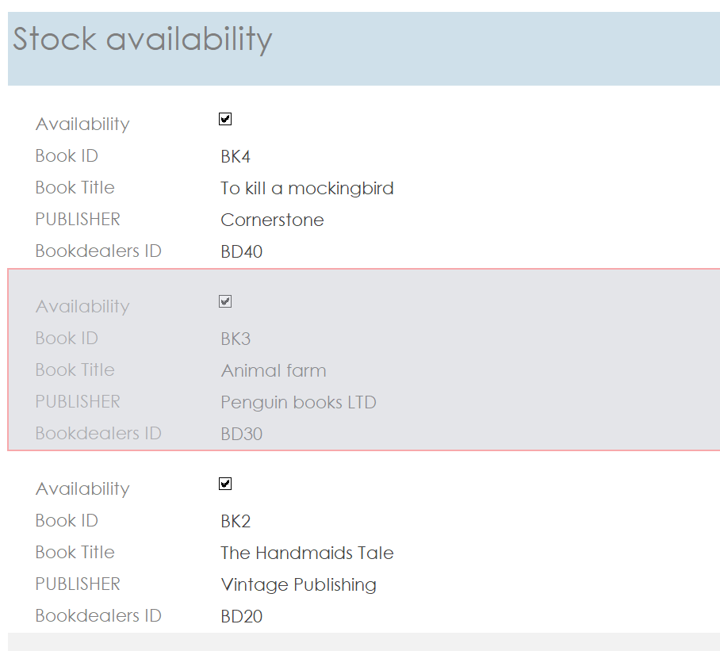
Queries can also be asked of the system to get this information:
SELECT [Customer Information].[First name], [Customer Information].[Last name], [Customer Information].City
FROM [Customer Information];

The system can also be queried and reported on for current orders:
SELECT [Customer Information].[First name], [Customer Information].[Last name], [Order information].[Book Title], [Order information].[Order date], [Order information].address, [Order information].City
FROM [Customer Information] INNER JOIN [Order information] ON [Customer Information].[Customer ID] = [Order information].[Customer ID];
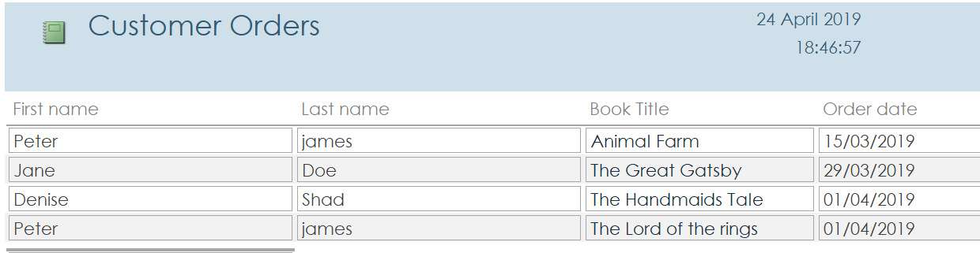

Another query set in the system is to calculate and report the costs for each customer order:
SELECT [Order information].[Order date], [Order information].Price, [Order information].Quantity, [Order information].[Customer ID], [Order information]![Price]*[Quantity] AS Total
FROM [Order information]; 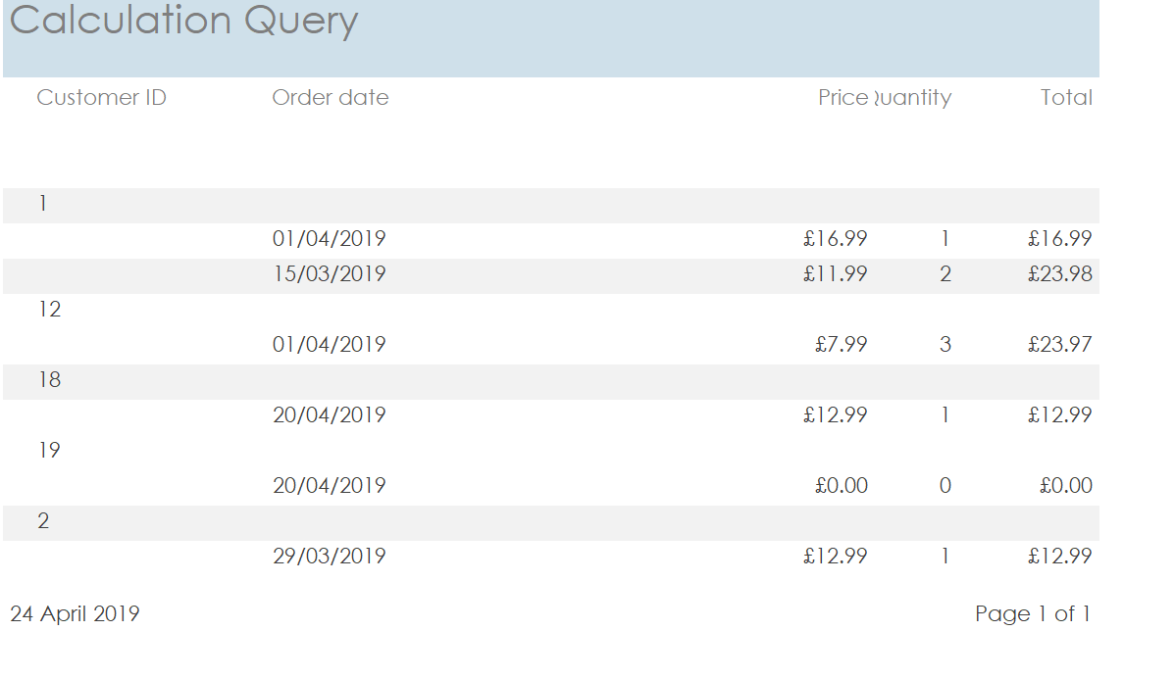

Case study and Brief user guide.
In order to evaluate the results from the database that has been created the below scenario has been developed. The requirements for this database were that it had to be menu-driven with the ability to add customers, orders, query information and produce relevant reports, and so it needed to be easy to use.

Scenario – A first time customer Ed Edwards contacts the bookstore to order the book Animal farm and sign up the newsletter. His address is 64 Christchurch road, Newport and his telephone number is 076853222. His email address is edwards42@yahoo.co.uk.

The bookstore clerk would open up the database and select the relevant form.

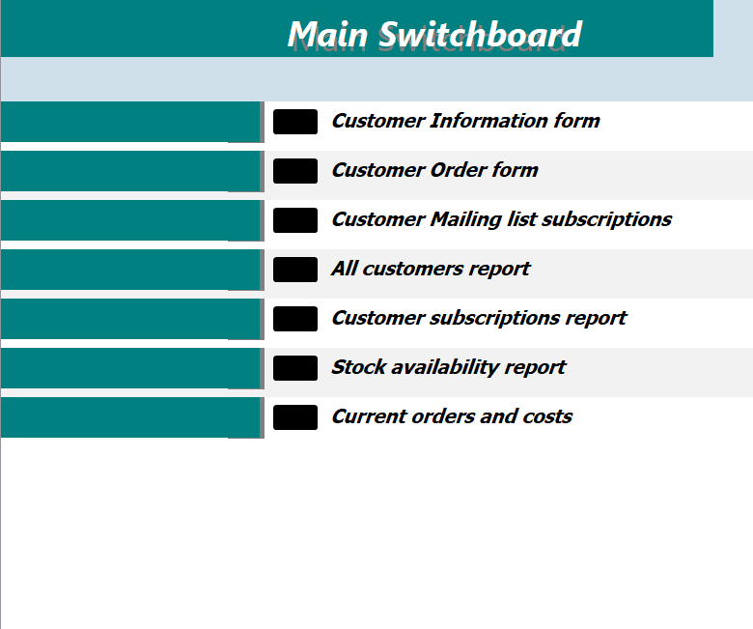
Figure A – Main Menu

The clerk would then input all the information given to him by the customer:

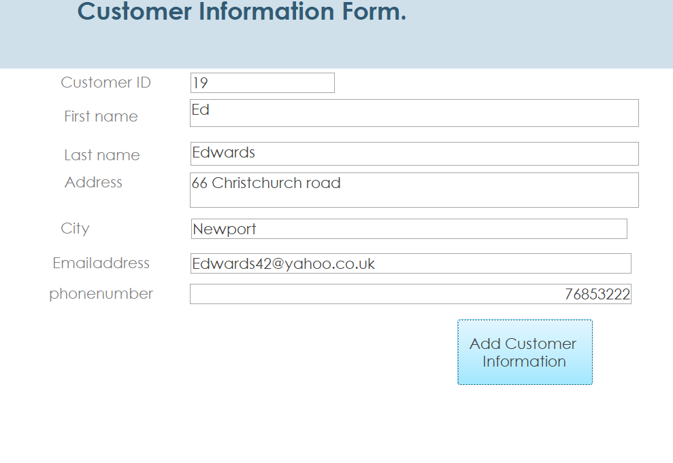
Figure B – Add New Customer to database

As the customer wishes to subscribe to the mailing list, the mailing list form would be completed next:

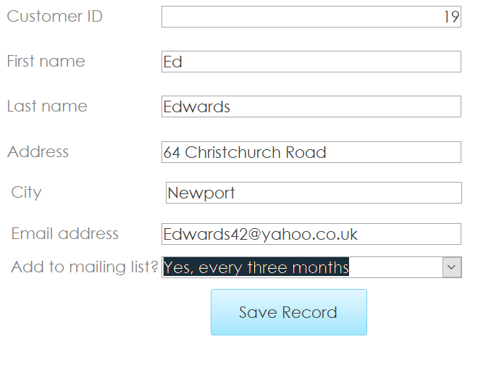
Figure C – Add new customer to Mailing list
After selecting save record, this information will then be automatically added to the relevant table:

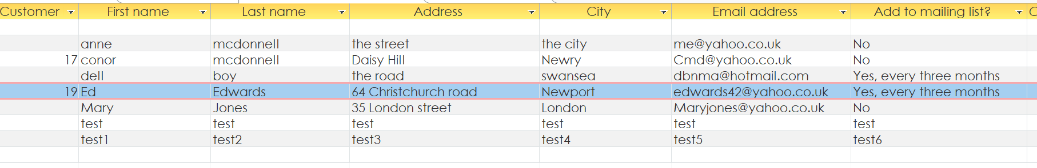

As the customer wishes to order a book, the clerk would then select the order form from the main menu and complete the relevant fields. This would then automatically add the customer’s order to the orders table.

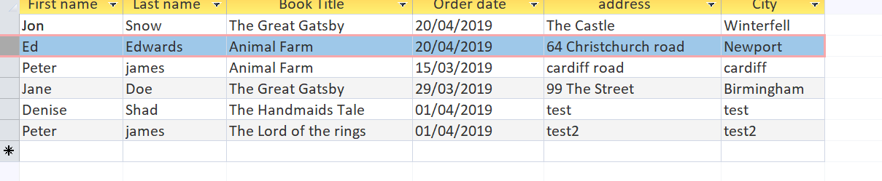

From the main menu screen, there are some basic reports that can be run to show:
- All customer information
- Current subscribers
- Stock information
- Cost of current orders
These reports can be accessed by simply selecting the one the user wishes to print out, as all entered information is automatically added into these reports. SQL queries can also allow the user to choose data and return it.

Conclusion.
The aim of this assignment as stated at the outset was to create a database with the following requirements:

During the course of this assignment a lot of practical information was learnt about how to design a database. Following all the theory behind it putting it into practice by designing a working database did prove to be a difficult task, and while there is some improvement of this design that could be done, the basic tasks of adding customers using forms, navigating through a main menu, running queries and calling reports has been implemented for Dylan’s Bookstore. Tables of data have been created and relationships between these tables can be seen in appendix A. Suitable user documentation has also been shown throughout this assignment which describes the functions of the database.

8. Bibliography.

[1] | J. A. H. e. al, “Modern Systems Analysis and design,” Boston, Pearson, 2014, p. Pg 28.
[2] | J. A. H. e. all, “Modern Systems Analysis and design,” Boston, Pearson, 2014, p. 33.
[3] | “http://www.businessdictionary.com/definition/data-flow-diagram.html,” [Online].
[4] | J. A. H. e. al, “Modern Systems analysis and design,” Boston, Pearson, 2104, p. 176.
[5] | “Database guide - what is normalisation?,” [Online]. Available: https://database.guide/what-is-normalization/.

Appendix A.

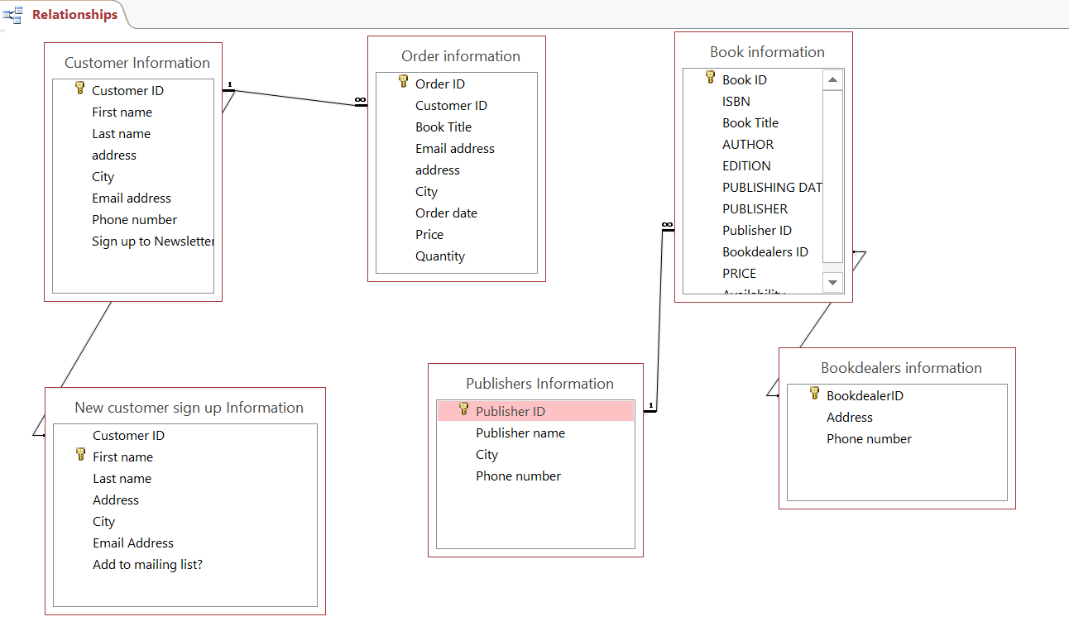
Microsoft access - Relationships in Dylan’s Database Design.

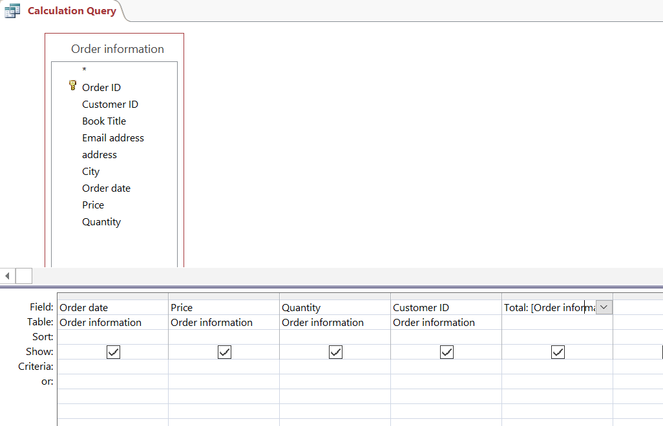
SQL calculation query.

