Examine the arguments for and against removing monuments OR buildings from their sites in the landscape to the safekeeping of the museum.

Heritage provides an important role in today’s society by claiming and securing identity. This is because the landscape has been shaped by generations, enhancing where we came from and showing the public their identity as a nation. The heritage is preserved in various ways through numerous organisations including national or local museums, National Trust, Historic Wales/England, and English Heritage. These organisations collect and display their history in ways that create a new culture of participation, however constructing displays and collecting identities can be questionable to whether or not it is truly traditional. This study is focusing on the advantages and disadvantages of moving historic buildings from their sites within the landscape to the safekeeping of a museum. For the purpose of this research, St Fagan’s National Museum of History, Wales, will be the example drawn upon. Visiting St Fagan’s National Museum of History has illuminated the problems within the organisation on how they require their collections. ‘Over 30 buildings’ (Mason. 2007: 152) have been collected from numerous sites around Wales, depositing them within the open air museum. St Fagan’s aim is to allow visitors ‘to immerse themselves in their collections, developing inspiring stories and creating a catalyst to change their aspirations for the future’ (National Museum Wales. 2017).
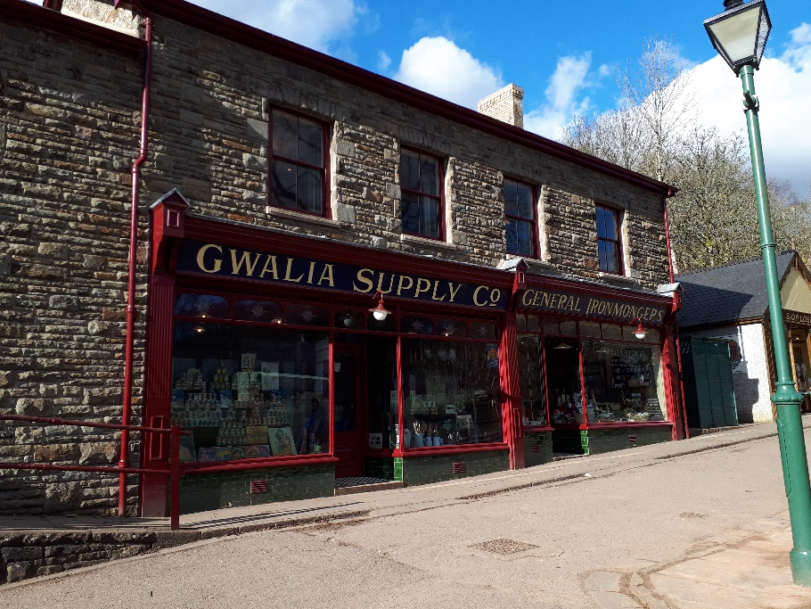
With two more buildings to be added to the collection; the Vulcan hotel from Cardiff and a police station, out of the total number of buildings collected onsite only two are reconstructions. Mason (2003: 23) explains that St Fagan’s museum set out to collect predominantly rural rather than modern industrial material culture. With the development of new generations, the Welsh life and its traditions quickly grew, it was not until the 1980’s that the museum started taking an interest in urban heritage. The problem here is the question of whether this strategy was a true representation of welsh heritage. The purpose of St Fagan’s museum according to Eurwyn (1988:5) was to be used for the re-erecting of scientific chosen examples of traditional buildings from all over wales. However now the open air museum is being used to preserve Welsh heritage connecting with past generations. This movement was considered radical because of its valorisation of ordinary people and their lives. Today St Fagan’s is the leading open air museum in Europe with the representation of Welsh life being presented in a variety of ways appealing to both adults and children alike. From visiting the museum it is clear that St Fagan’s is ‘not representing the Welsh life but what has disappeared from it’ (Mason. 2003: 24). The museum offers a wide range of history that enables the public to get hands on as much as possible. This is done by the re-enactments performed by different craftsmen, the traditional shops where the public are able to buy the products, including a 1930s café where people can have afternoon tea, and how the buildings themselves are layed out allowing the public inside the history of Wales. ‘The museum follows a policy of preservation in situ and would rather see the properties remain in their original place’ (Mason. 2003: 24), however there are many disadvantages to be seen when trying to move a building from one site to another to try and preserve the history.
Photograph 1 showing the Gwalia Supply Co. shop in St Fagan’s, Lockwood: 2018

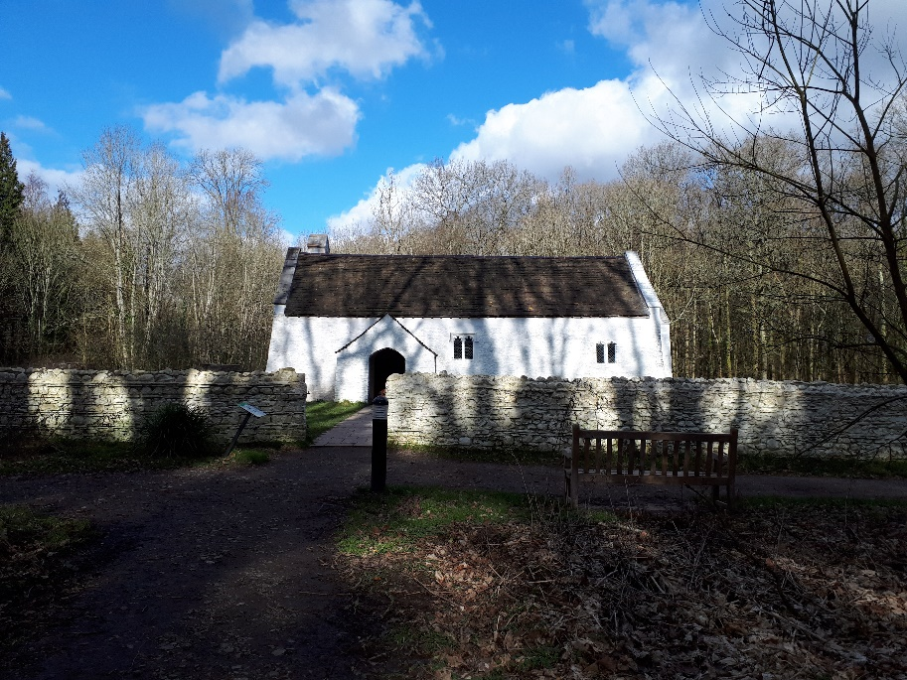
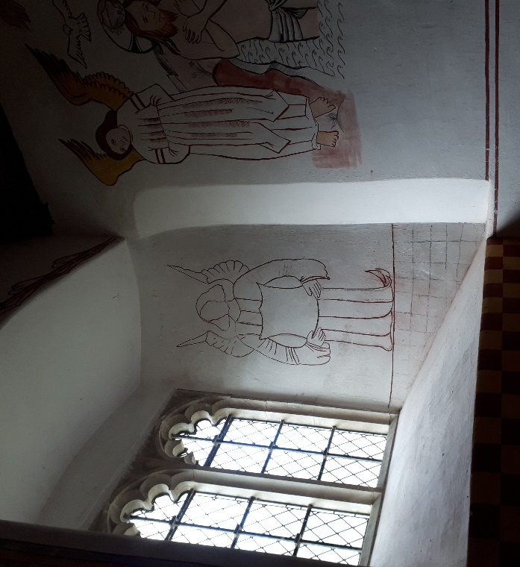
Moving historic buildings such as those that have been moved to St Fagan’s comes with consequences. Kristiansen (1996) discusses that modern society consumes the past by destroying it but preserving that process of destruction both in the museums and within the original landscape. The buildings that are moved can be analysed as not representing welsh heritage due to the authenticity of the building after it has been re-erected, and the fact that the building has been taken out of its original context. This is the point Kristiansen (1996) is trying to put forward. By trying to preserve the buildings in this way the material the buildings are made from become damaged and specialists have to weigh up the damages against the preservation rights. Rebuilding can cause problems for the materials used, ‘the use of the original materials and techniques for repair can sometimes destroy more of the original fabric and decoration that it carries’ (Cadw. 2011: 23). Examining the buildings that have been donated to the museum of welsh life we begin to question the reasoning behind the transfer and the materials used to bring this heritage to life. For example St Teilo’s church which was ‘built in the 12th-13th century and dismantled and moved in 1984-5’ (National Museum Wales. 2018). St Teilo’s church was originally located in Llandeilo, Tal-y-bont, and was threatened with vandalism and subsidence theft. On the one hand moving this building to St Fagan’s meant that the religious side of welsh history could be preserved however during the process of dismantlement, the museum made a big discovery of earlier wall paintings dating to the medieval period. On the other hand, once the building had been moved and restored they built the church in a way that represented what it ‘could’ have looked like in the 1530’s. This was not the state in which the church was left in and the ‘dismantlement’ of such a building then destroys the original art work which is painted on top of the medieval paintings loosing potentially an important piece of history. With this being said they recreated the medieval paintings so they are not the original and the material used do not match that of the original either. The debate here is authenticity and preservation over restoration and preservation, as restoration can clearly compromise authenticity.
Photograph 3 showing the exterior of St Teilo’s Church, Lockwood: 2018
Photograph 2 showing the inside of St Teilo’s Church and the reconstruction, Lockwood: 2018

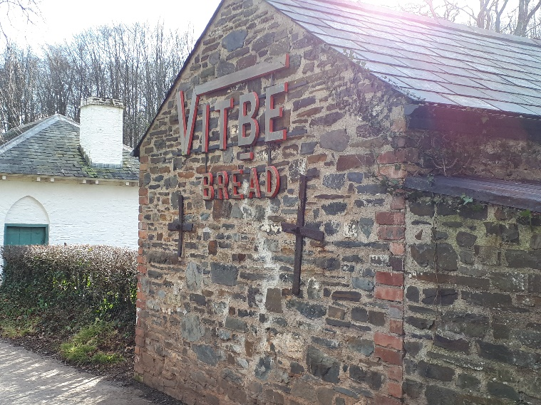
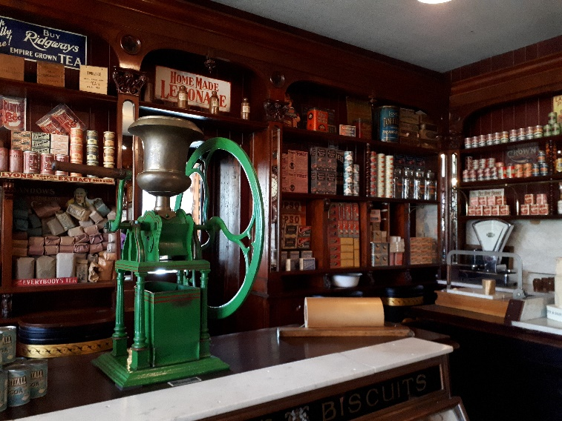
Only half of the buildings at St Fagan’s are actually ‘grade II listed buildings’ (Historic Wales. 2018) therefore the restoration of such buildings can only be acceptable when the heritage is valued more than the heritage that would be lost. Moving these important buildings can prove to be difficult and moving them out of their context does not allow the public to understand the buildings full potential as they only have half a story to learn. Following this, Peltola (2008) discusses in their thesis that part of the significance of a historical building is the location in which it had been built. The materials used within such constructions would be determined on where they were built and the purpose of such a building. With the movement of these buildings the public can therefore not understand the reasoning and the context behind the materials. ‘The physical strain on the building materials, the possible damage the relocation can cause and to the ornamental detailing are the most significant factors’ (Peltola 2008: 1) behind the reasoning to relocate a building. The aim for St Fagan’s is to re-erect buildings and to take visitors out of the present day and place them in the past to acknowledge how people used to live and work. The concept of conservation means ‘the careful management of change’ (Cadw. 2011), however every negative approach will have a positive contour part.
Photograph 5 showing the outside of the bakery, Lockwood: 2018
Photograph 4 showing the interior of the Gwalia Supply Co. shop, Lockwood: 2018

As mentioned above, St Fagan’s museum has a policy whereby they wait until buildings are offered to them as the museum itself would rather see buildings in situ rather then move them out of their contexts. Some of the buildings donated to St Fagan’s have succumb to theft, vandalism and nearly demolition, for these reasons the heritage in wales is threatened and St Fagan’s will step in and help. ‘Changes in the historic environment are inevitable’ (Cadw. 2011: 9) and open air museums like St Fagan’s brings opportunities for the public to save their heritage and learn about their past. Now that the important historic buildings are preserved within the museum, the up keep of the building is still important. Within Cadw’s 2011 Conservation Principles report it discusses how the public have participated in looking after the buildings. This brings the community together in understanding their heritage and taking the interest of the public and the history into their own hands for future generations. Creating an environment like St Fagan’s allows not only the public to help preserve the buildings but the buildings can help the pubic in a way that not necessarily is seen. Williams-Davies (1989) examines the craftsmanship shown within the site of St Fagan’s and explains that the craftsmen who work in the re-erected buildings, such as the woollen mill and corn mill use the tools appropriate for that time period. Furthermore this then allows a number of individuals to train at the site with the equipment they have gained from preservation and develops skills within a certain trade which can then be used in today’s society. This aspect of the open air museum allows the buildings to provide a sustainable investment through the conservation processes as it brings social and economic benefits to the museum. As historic buildings cannot look after themselves, preservationists have to use all the resources they have to save them even if it means moving them to a different location to a similar setting. Peltola (2008) explains that even the smallest possibility of damaging one aspect of one historic building can cause the abandonment of the project and the result could be demolition. This should not be the case, public authorities would be able to make the decision and weigh up the advantages and disadvantages and make an expert judgment on the situation. Therefore by damaging or losing a small aspect of history the museum have gained a bigger insight into their heritage. With ‘over 230,000 years of history’ (St Fagan’s National museum of history. 2018) St Fagan’s has become a community of learning with a reminder that the key role of St Fagan’s is ‘Preserving and championing craft in wales since it opened in 1948’ (St Fagan’s National Museum of history. 2018). Moving the buildings such as the shops and the craftsmen workshops, allowed the public to see first-hand what life was like in rural wales and actually get a taste of it with getting stuck in. Visitors are interested not just in the finished product of the buildings but the process in how they were built and what materials were used. According to Historic England (2018) to be of historic interest a building must illustrate important aspects of the nation’s social, economic, cultural or military past, once a building has been listed it is therefore protected by certain aspects. However this does not protect the building from decay and weather erosion. With the buildings being moved to places of conservation like St Fagan’s, the conservationists and the public are aware of the growing condition of the buildings and are able to look after them and preserve them for longer. The economic benefits that are achieved by the museum allows the money to be spent on the up keep of the buildings and allowing more buildings to be moved into the care of the open air museum.
In conclusion the process of moving historic buildings from out of their context into the safe keeping of museums can have both disadvantages and advantages. From the research above and the study into St Fagan’s national museum of history, it is clear that there is no easy way in moving such buildings when thinking about conservation. Therefore preservationists have to compromise and think what is best for both the buildings and the community. Within this topic there is no right answer and both arguments seem to stand for and against moving such historic buildings. The main argument against moving the building is damaging it to an extent that the historic building no longer represents the welsh community. On the other hand the main argument for moving historic buildings is the preservation against humanity and decay. In my own opinion throughout this research it seems that moving historic buildings into the safe keeping of the museum has more positive outcomes then leaving the endangered building in context. Therefore future generations should examine a way in which it is more ethical to remove such buildings from their landscapes to the safe keeping of a museum in order to preserve the entire history of the building without losing any minor historic value.

Bibliography:
Cadw. 2011. Conservation principle’s: for the sustainable management of the historic environment in wales. Cadw
Available from: https://www.Cadw.gov.wlakes/docs/cadw/publications/conservations-principles_EN.pdf [Accessed 4/3/2018]

Eurwyn, W. 1988. St Fagan’s Castle and its inhabitants: Castell Sain Ffagen a’I drigouon. Cardiff: amgueddfa Gered lae tha Cymru
Historic Wales. 2018. Available from: https://historicwales.gov.uk/#200m=0&lat=300000&lan=258000&layers=BFFFFFFTFFTTT [Accessed 4/3/2018]
Kristiansen, K. 1996. The destruction of the archaeological heritage and the formation of museum’s collections: the case of Denmark. In. W.D. Kingery (ed) Learning from things: methods ad theory of material culture studies. Washington and London: Smithsonian institution press.
Lockwood, E. 2018. Showing Gwalia Supply co shop in St Fagan’s. St Fagan’s. [Photograph]
Lockwood, E. 2018. Showing the inside of St Teilo’s Church and the reconstruction. St Fagan’s. [Photograph]
Lockwood, E. 2018. Showing the exterior of St Teilo’s Church. St Fagan’s. [Photograph]
Lockwood, E. 2018. Showing the interior of the Gwalia Supply Co. shop. St Fagan’s [Photograph]
Lockwood, E. 2018. Showing the outside of the bakery. St Fagan’s. [Photograph]
Mason, R. 2007. Museums, nations, identities: Wales and its national museums. Cardiff: University of Wales press.
Mason, R. 2003. Nation Building at the museum of welsh life. Museum and society. 2(1):18-34. Available at: http://www2.le.ac.uk.departments.museumstudies/museumsociety/documents/volumes/mason.pdf [Accessed 2/3/2018]
National Museum Wales. 2017. Operational Plan. Available from: https://museum.wales/media/36922/Operational-Plan-2017-18-en.pdf [Accessed 2/3/2018]
National Museum Wales. 2018. St Teilo’s Church. Available from: https://museum.wales/stfagans/building/st-teilos_church [Accessed 5/3/2018]
Peltola, X. 2008. Moving historic buildings: A study of what makes good preservation practices when dealing with historically significant building and structures. Unpublished MSc thesis, Clemson University and the college of Charleston
St Fagan’s National Museum of History. 2018. St Fagan’s 70: A year to Celebrate. Available from: https://museum.wales/stfagans/stfagans-70/ [Accessed 12/3/2018]
St Fagan’s National Museum of History. 2018. Making History.
Available from: https://museum.wales/stfagans/makinghistory/ [Accessed 12/3/2018]

William-Davies, J. 1989. The preservation and interpretation of traditional rural crafts at the welsh folk museum. Journal of design history. 2(2/3) pp. 215-218

