Individual Report: The Effect of Globalisation on a Organisations
Marketing Strategy
Student name: Raluca-Maria Manda
Student ID: 2127848
Lecturer name: Efua Adams
Module: Marketing Fundamentals
Module code:LCBB4004

Table of content:
- Introduction
  - History of Ikea
  - Reasons why I choose this company
  - Customer overview
- Swot Analysis
  - Strength
  - Weakness
  - Opportunities
  - Threats
- Porter’s five forces on IKEA
  - Industry rivalry
  - Risk of a new entry
  - The Bargaining Powers of Buyers
  - The Bargaining Powers of Suppliers
- PESTLE Analysis of Ikea
  - Political
  - Economic
  - Social
  - Technological
  - Legal
  - Environmental
- Globalisation of IKEA
- Conclusion
- References

Introduction
To start with an introduction of this assessment, this task will contain 3.500 words and will be answering the task given. This will be an analysis based on customer overview, evolution and globalisation on the company chosen, which is IKEA.
This assessment will contain also charts, graphics and as well personal feedback of the company.

Why is called IKEA?
During research I have found the history of this global company IKEA” reaches millions of hearts and homes all over the world. And it all began in a small Swedish town in the 1940s, with an enterprising boy who hoped to be able to create a better life for people everywhere.”
“Ingvar Kamprad founded IKEA in 1943 at the age of 17, selling goods like pens and wallets. Småland, his home county in Sweden, was heavily forested with stony soil. Hardship bred a tough, resourceful people who were expert at making the most of a little, qualities that have always been at the heart of IKEA.” (ourhistory.com)

Reasons why I have chosen IKEA
One of the reasons why I have chosen this company to discuss is that I am a customer of them. Since I moved into a new flat and I must organise it, I have decided to buy my furniture and my home accessories from them.
I could say that I am impress about how easy they delivered and fast, how quick I did assemble my shelves , my table and my wardrobe from them.
Another reasons why I did called at Ikea, neither I was in Romania or UK, the quality, prices and delivery of the items , suit me very well and the accessibly of price made me decided to buy from them.
Also, another good reason why I decided to be a customer for them is the quality.
Before this company I have tried other competitors like Amazon and Argos, which I can say that I am disappointed about the way they did delivered my parcels( many times I have to refund them because of the damages ) , time, price which we all agreed that is cheap but the quality of the furniture is not for a long term.
I am all the time pleased with my bargain from Ikea , also I could find myself with the style , I preferred the good materials witch they are offering and customer services which they are serving (even in the shop or only they delivered to the customers support, helping and caring).
In another hand , I am happy with the Ikea shops, because of the idea of restaurant in the shop. Even in Romania or UK, I have been to the shops and I could say that they present a good quality of the furniture we all know, but they also wants customers to taste a bit from they’re Swedish dish. Great prices on food , all the time fresh and delicious, and we can see that the customers are happy coming back at Ikea from the longs queue on till/ restaurants.

IKEA founder Ingvar Kamprad was always determined to offer the best possible prices but not at the expense of quality. He was aware that some of his competitors were cheating on quality to keep prices down, something he was not prepared to do. In the 1948–1949 issue of the brochure “ikéa-nytt” he explained how IKEA prices could be kept so low. “Our low prices – by far the lowest in the land – are possible thanks to a high turnover, direct delivery from the factory and very low overheads.” Ingvar’s original idea to offer products with both a low price and good quality is alive and well to this very day and has become a cornerstone of the IKEA culture and identity.(Ikea.com, 2022)

Customer overview
During the research I did found some customer feedback of the shops. IKEA is currently experiencing huge growth and feedback from customers is overwhelmingly positive, saying they feel informed and engaged. As a result, IKEA’s Net Promoter Score has risen to 70 from 25 since the beginning of 2016.(survey.com)

SWOT Analyse of IKEA

SWOT (strengths, weaknesses, opportunities, and threats) analysis is a framework used to evaluate a company's competitive position and to develop strategic planning. SWOT analysis assesses internal and external factors, as well as current and future potential.(Investomedia.com,2022)



Strengths

- Customer knowledge. One of the key competitive advantages IKEA has is its extensive knowledge about the customers. The company understands the purchasing factors that influence customers to buy and implements the best practices to induce that decision. IKEA offers low prices and a huge range of products. Designers constantly introduce new design products that look stylish in the eyes of customers. All the products are designed so it would be easy to transport and assemble. Moreover, the company offers the widest product range and positive shopping experience. All of these factors are aligned with what customers want and need and which results in higher sales. Without such extensive customer knowledge and best practices to benefit from that knowledge, IKEA would be unable to outcompete its current competitors.
- Constantly using innovations to drive costs down. Low prices are the cornerstone of IKEA business idea and the the company always try to do things as efficient and cost-effective as possible. To drive costs down all the time, the company must find new and innovative ways to do that and to incorporate them in its businesses model. The business’ innovations include new materials that contribute more to sustainable environment and are less costly or using newest ways of packaging, handling and transporting materials.
- Supply chain integration. IKEA is committed to long lasting relationships with its suppliers. In this way, the company can order large volumes and benefit from lower prices and greater quality while suppliers are assured of guaranteed orders. IKEA sources its materials close to suppliers to reduce transporting costs. The company also uses IWAY approach to closely integrate suppliers with its supply chain. All the efforts of closely integrating supply chain results in lower costs and a competitive advantage.
- Brand reputation and market presence. According to Interbrand, IKEA is the most valuable furniture retailer brand in the world, valued at nearly $US 12.8 billion in 2012. The business operates 332 stores in 38 countries and is present in the major world markets. More than 600 million customers visit IKEA stores every year. Worldwide market presence and strong brand reputation ensures that customers will often choose IKEA over its competitors.
- Diversified product portfolio. Unlike IKEA’s largest competitors, the company has fairly diversified businesses. In addition to its furniture products, the company operates restaurants, houses and flats. Although, firm’s main business is designing, manufacturing and selling furniture it is not so affected by the changing forces in this market as other furniture retailers

Weaknesses
- Low quality of products and services. IKEA is unable to find compromise between continuous cost reductions while maintaining the same quality of products. According to UK Customer Insights report on IKEA by Verdict, IKEA’s customers are less satisfied with its product and services quality than the average customer in UK buying at other stores. Firm’s cost reductions lead to decreasing product quality, which was followed by higher number of products returned and damaged brand.
- Standard products. IKEA’s main competitive advantage derives from low costs, which in part are achieved due to standardized products. Standardized products attract fewer customer segments. Therefore, the business inability to offer better quality more customized products allows its competitors to fill that niche and fortify their position in it.

Opportunities
- Further expansion into developing economies. Retail markets grew by at least 5% on average in emerging markets in the last year, opening huge opportunities for IKEA’s revenue growth. The company currently operates in most of the developed economies but hasn’t firmly stepped into developing economies, except China. There are great opportunities for IKEA to expand into Brazil, Mexico, Indonesia and Malaysia to increase its presence in these markets to sustain future growth.
- Growing online sales. Online retail sales account for 17% and 4% of total retail sales in UK and US respectively. Online sales grow constantly and with 870 million visitors to its website IKEA could exploit this opportunity and benefit from increased sales and lower costs.
- Expansion to growing grocery market. The current trend of eating healthier food has resulted in higher demand for grocery products in many developed economies. IKEA has an opportunity to expand its grocery business by introducing more grocery stores in its current retail places. The company is already successfully managing its food outlets, so this expansion opportunity would be well aligned with the current operations.

Threats

- Intensifying competition. Many low cost retailers such as Walmart, ASDA or Tesco are entering homeware specialists market where IKEA operates. These large retailers have similar specifics as IKEA, including low costs, well managed supply chain and huge market presence and can easily gain some market share from IKEA.
- Growth of average consumer income. Growth of average consumer income means that people buy less low price and low-quality products, which is exactly what IKEA offers in its stores. With the rising income people will be less attracted to IKEA and will turn to retailers that offer higher quality homeware products.

Porter’s five forces on Ikea
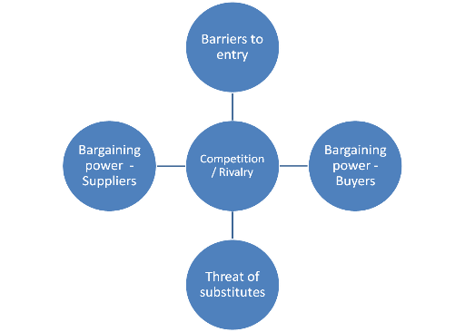(Bing.com, 2022)

As model of Porter’s five forces, we can use to analyse Ikea , base on industry rivalry, bargain power of buyers , bargaining power of suppliers , treat of new entrants).

Bargaining power of suppliers
The bargaining power of IKEA suppliers is low because while their number is large their small size and weak financial position does not offer them enough clout. Ikea can easily switch from one supplier to another whereas if supplier loses business from IKEA, it can be a difficult situation for him.
As a result, IKEA gets to set up the rules of the game and its suppliers are required to follow. IKEA has launched a code of conduct for its suppliers called IWAY.
These suppliers are also responsible for communicating the code of conduct to their sub suppliers. IKEA conducts around 1000 audits each year and checks regularly for any kind of violations. It has formed rules related to child labour, discrimination, minimum wages and safe working environment. The suppliers must comply otherwise they can be removed. In this way, you can see that between IKEA and its suppliers, the brands has the upper hand.

Bargaining power of buyers

While the bargaining power of individual buyers is insignificant in case of IKEA, as a group they hold some significant clout which is why there is so much focus on attracting and retaining the customers. Customers across all the industries are more empowered in the 21st century. Apart from increased competition, technological growth has brought this change about. The balance is now titled in the favor of the customers. IKEA also focuses on heavily on marketing and promotion.

Threat from substitute products

The threat from substitute products for IKEA is low, there are several factors that moderate this threat . One of them is brand image .
Through years IKEA has built a reliable brand image where the level of trust between the customers and the brand is high; it is affordable pricing strategy and customer service also moderate the threat from substitute products.

Threat from New entrants

The threat of new entrants entering the market and stealing market share is low to moderate. New brands can enter on a smaller scale but then they will not have any major effect on the business of Ikea . If a new brand enters into the market , it will take time, efforts as well and investments to grow into a large brand and grab a large market share.

Level of competitive rivalry

The level of competitive rivalry in the home furnishing industry is moderately high. The battle for market share is not as high as in several other industries but still Ikea has got a large number of competitors. Apart from the home furnishing brands that compete directly with IKEA, the super markets and brand stores also sell home furnishing products and pose a competitive threat to IKEA.
IKEA’s popular and reliable image, it’s marketing strategy and other factors like affordable pricing have helped it gain a large customer base. These factors act to moderate the competitive threat from the other brands. Overall, the level of competitive rivalry gets to be moderately high.(Notesmatic.com, 2022)

PESTLE analyses of IKEA

After analysing ,and demonstrating with Porter’s five forces and Swot analyse , now will be demonstrating another frame work witch is PESTLE .
Bellow will be presented and demonstrated in details this frame work.
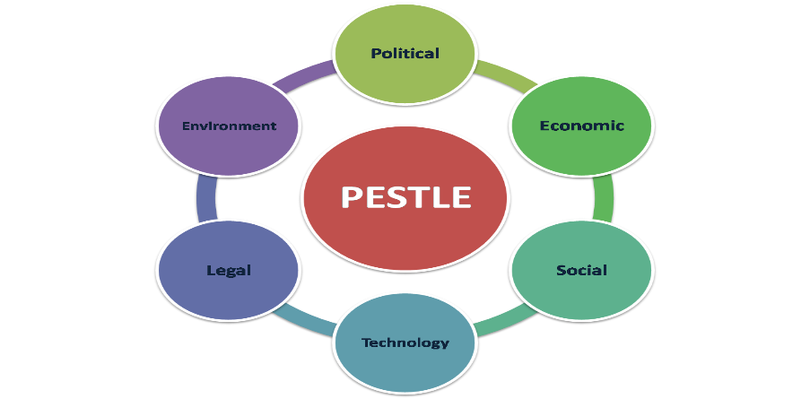(Bing.com, 2022)

A PESTLE analysis is a framework to analyse the key factors (Political, Economic, Sociological, Technological, Legal and Environmental) influencing an organisation from the outside. It offers people professionals insight into the external factors impacting their organisation. The analysis is flexible, so organisations can use it in a range of different scenarios. People professionals and senior managers can use the results to guide strategic decision-making.( Cipd.com,2022)

Political Factors:
Political factors are influential in understanding the expansion of a company. The political ideology of the countries where business transactions take place is an impactful factor. A stable political environment is suitable for global business organizations. The political factors affecting IKEA are:
- IKEA got mired in political controversy when its genesis was traced back to prison labor camps of East Germany. During the 1970s, IKEA suppliers used the prison labor force for manufacturing products. In 2012 a report confirmed this allegation. The company even issued a formal apology to cover up for the same. But more controversies around political issues erupted when allegations against the IKEA founder Ingvar Kamprad came to the forefront for being an active recruiter of the Swedish Nazi group. These events tarnished the image of the brand to a great extent.
- The Lufsig doll incident was another issue that entered the political realm of Hong Kong and caused an eruption in the sale of this artifact in Hong Kong in 2013. The word Lufsig was similar to a swear word in the Cantonese language. In 2013, a protestor threw the Lufsig doll at the chief executive of Honk Kong to show their dissatisfaction. The doll, however, was assumed to be a symbolic status. It was sold out in a day in Hong Kong following that incident.
- The Lobbying activities of IKEA are minimal. One can note this from the company’s expenditure in lobbying activities.

Economic Factors:
Economic conditions of a country reflect the purchasing capacity of consumers. Therefore is directly linked to the business of a company. If a company desires improved sales, it may look for regions with stable market conditions. Here are some economic issues which can impact the sales of the company:
- IKEA maneuvered the economic crisis of 2009 due to its cost leadership plan. Hence, they suffered a one percent drop in the sales volume.
- The IKEA chain doubled the number of manufactured goods locally procured in the UK. It happened due to the weakening of the pound against the euro and dollar.
- The fluctuating cost of raw materials is a vital factor that can affect the business adversely.

Social Factors:
Social conditions have affected IKEA on several accounts. PESTEL analysis IKEA reveals the impact of social conditions on the brand image of a company:
- IKEA needs to follow cultural norms while branding to avoid cultural repercussions from different countries.
- The company needs to address the grievances of customers from different countries to improve its status.

Technological Factors:
Technically IKEA, progressed by setting up an e-commerce website for the sale of products. Printed brochures for IKEA products are still in use. However, the online field is also used for expanding business. PESTEL analysis IKEA lists the challenges that it has to overcome in the technological department:
- Strengthening the e-commerce platform is necessary to provide a smooth experience to customers. Presently many customers have expressed their dissatisfaction over the poor delivery management system.
- Generation of good customer feedback is essential to growing the business. The firm should also avoid technological glitches to ensure satisfaction. They should feature the reviews and ratings through digital platforms to earn credibility.

Environmental Factors:
The world is increasingly becoming environmentally conscious. The sensitive ecological situation requires companies to adapt their production techniques to make it eco-friendly. IKEA is working to improve its technique, and the PESTEL analysis of IKEA enlists the environment-friendly steps they have taken so far:
- IKEA is working towards the renewable energy sector. It wants to use renewable energy for the stores.
- It has invested billion dollars in developing the renewable energy sector in underdeveloped countries.
- It is also working towards using sustainable materials for manufacturing products.

Legal Factors:
Legal issues have a massive impact on the growth of an organization. Pending legal cases and/or multiple lawsuits create a negative image. PESTEL analysis IKEA enlists the legal issues that should be recognized and rectified by the company:
- Labors form the backbone of a manufacturing business. IKEA has faced backlash from the workers regarding unhealthy working conditions. Works have filed lawsuits against the firm. Bad press is inevitable if laborers continue to work in poor conditions.
- IKEA needs to follow the labor laws of those countries where they are setting up manufacturing units. It ensures that laborers don’t face life-endangering situations.
- Customer satisfaction is paramount, and low-quality products can harm it. It can invite lawsuits for the company as clients can move to Court for injuries caused due to faulty products. (edraw.com/pestle analyses .com, 2022)

Globalization of IKEA
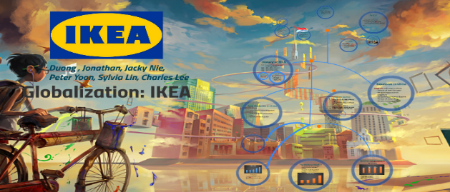
The last part of the assessment, is the globalization of IKEA , which during the research I will present in details how Ikea became a global market and their values.

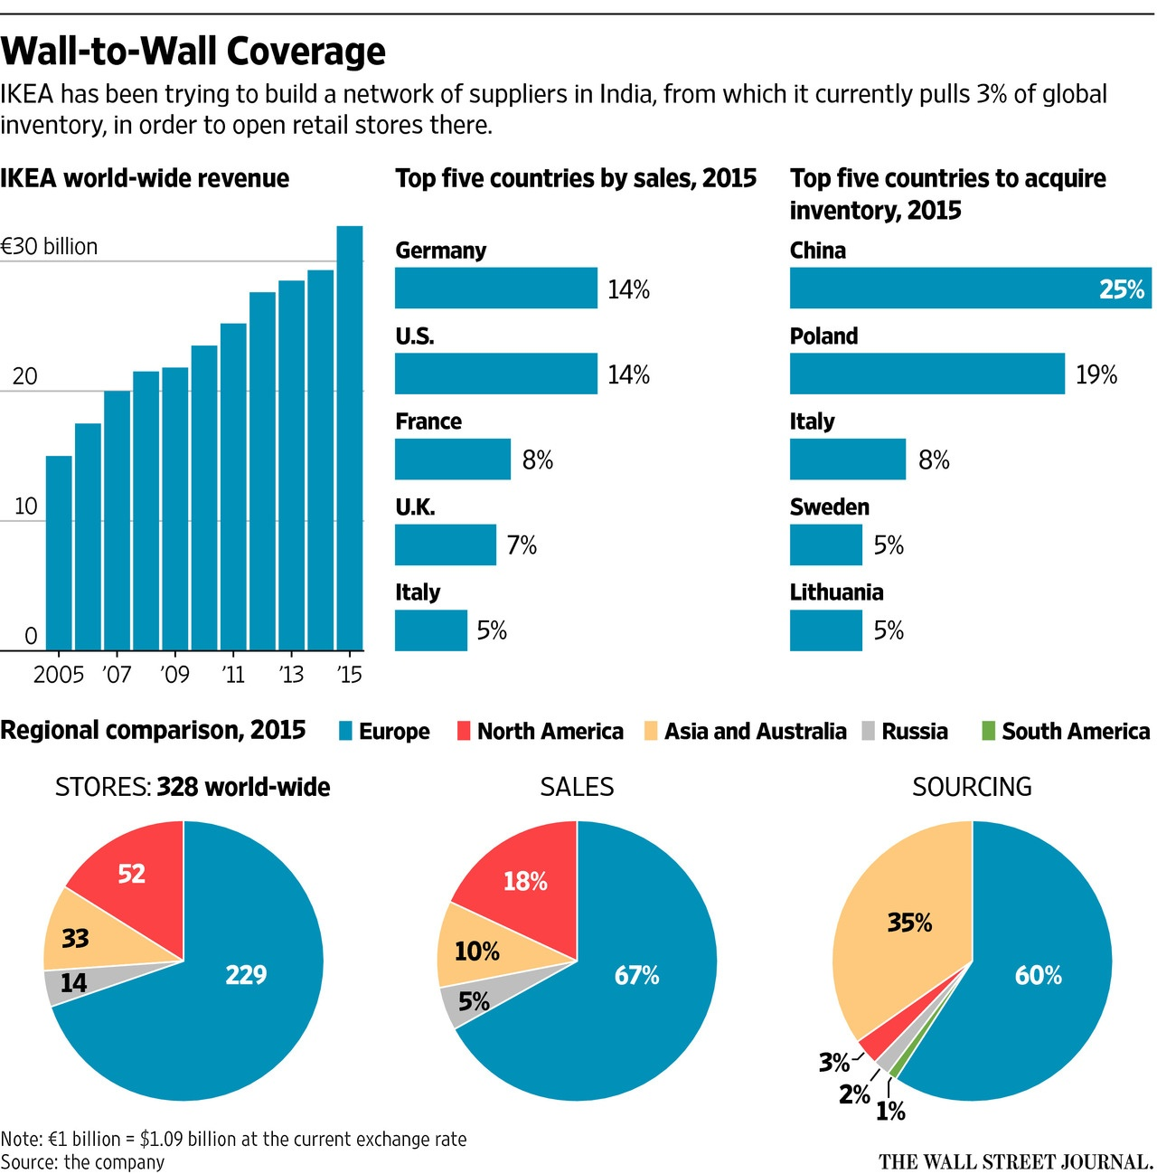

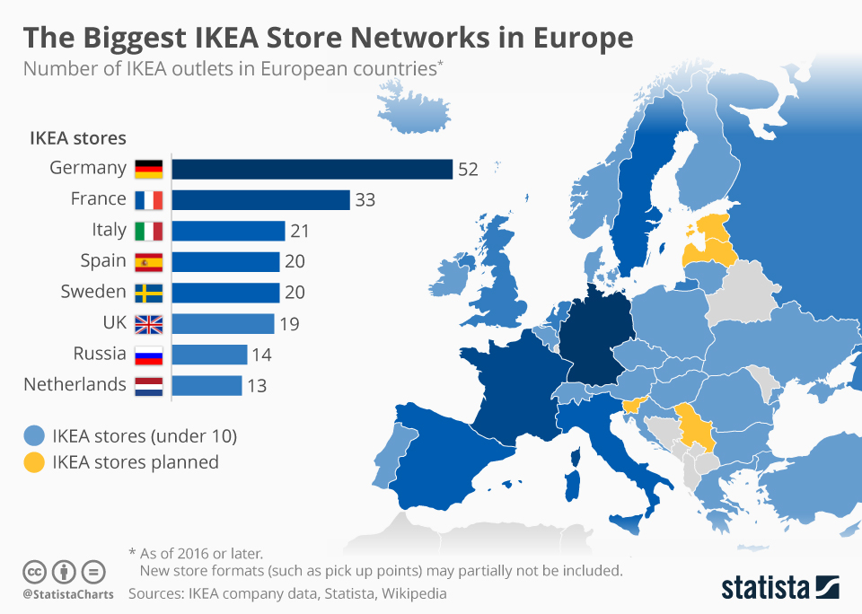

As we understand from those graphs shown , we can see that IKEA is a global market, who open first a shop in Sweden and spread firstly in Europe and slowly opens in Asia and America.
The strategy remains to create and to sell good furniture at better prices , create deals to attract more customers.
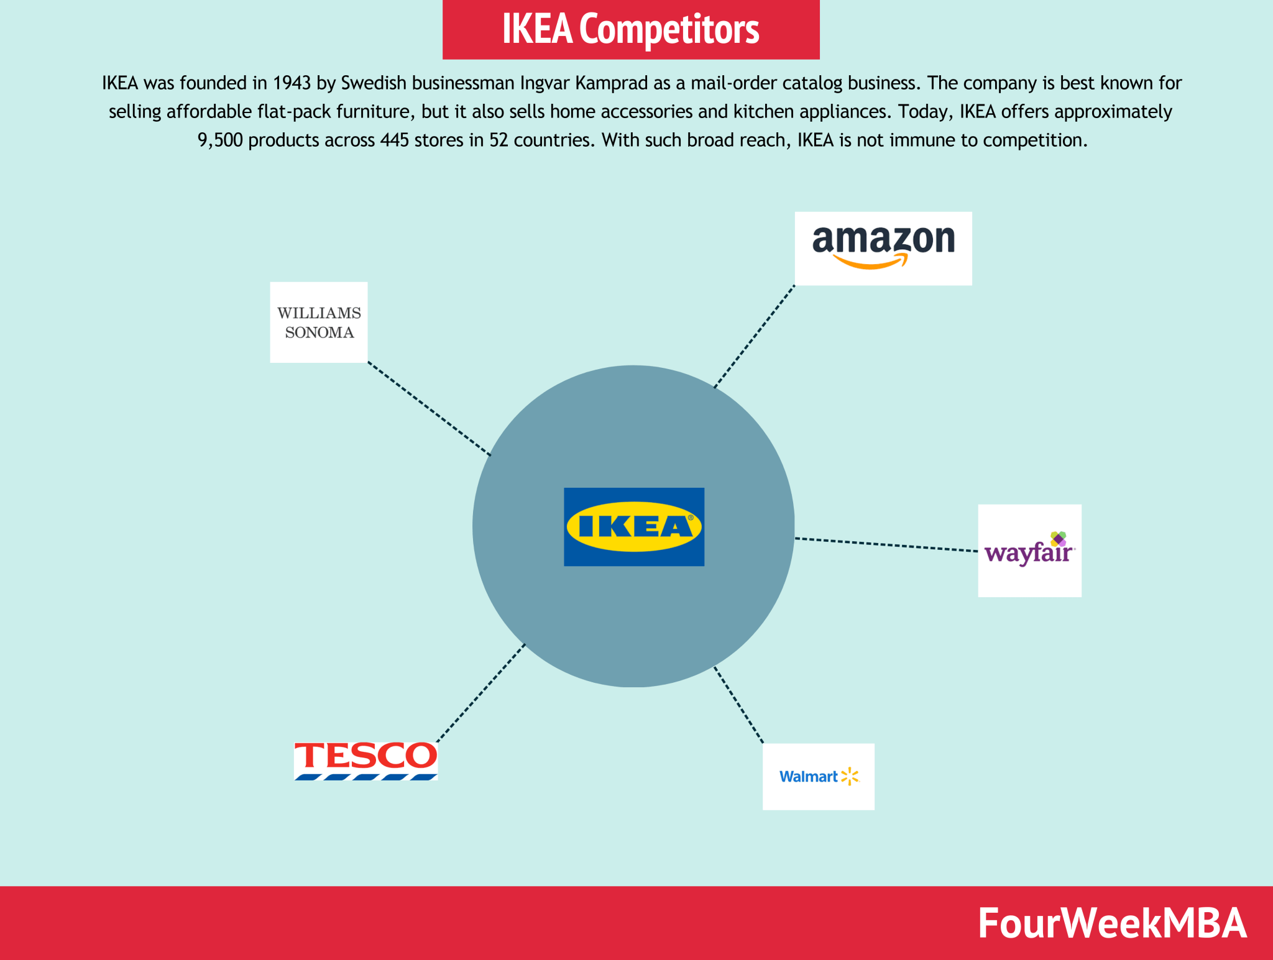

Conclusion

Despite having so many competitors , most of them were mentioned above , IKEA ,remains the world largest and bigger provider furniture company , and it is known for good quality on many home accessories , deals and low prices .
The motto of the company is to create a better life for people .

References.
  - Our history - IKEA
  - https://www.edrawmax.com/article/ikea-pestel-analysis.
  - Bing.com
  - Ikea.com
  - Ikea competitors.com

