
University of Wales Trinity Saint David
International Business Communications
Assignment 1

Student: Georgi Dimitrov 1917423
Lecturer: Ejiro Esohwode (e.esohwode@uwtsd.ac.uk)

Table of Contents
Introduction 4
Brief introduction to Bulgaria 5
Application of theories 6
Hofstede model 6
Intercultural mediation 7
Critical evaluation of cultural sensitivity when doing business in Bulgaria 8
Different communication barriers 10
Appropriate communication strategies 12
Conclusion 13
References 14

Introduction
Cross-border trade is the movement of products and services from one country to another. People from various cultures will almost certainly see one thing in drastically different ways, because of the diverse frames of knowledge provided by their own cultures. Firms that are good at the management of their communications are better able to respond quickly to any change in the market. For the purpose of this assignment we will use the medial technology company Ottobock and their set up of production plant in Bulgaria. The report will discuss about the suitability of the country, cultural differences and barrier the communication. The report also suggested some strategies to deal with the problems.

Brief introduction to Bulgaria
An emerging market is essentially a country that is rising in order to become more involved in international trade. It has certain characteristics of a developed nation, but not all of them. As a result of the lockdown situation of the Covid 19, several industrialised nations saw a huge loss of GDP, but Bulgaria did not experience much loss in its output growth in comparison. The country's geographic position makes it easier for investors to expand their operations into other European Union nations. Because it is highly urbanised with a population of 6,925 million, the labor force is small, but both highly skilled and inexpensive. Among the most important investment criteria, some of the most attractive ones are security, access to skilled personnel, and a reasonable return on investment. According to the Canadian Trade Commissioner Service, the high number of engineering and science graduates makes it an attractive place for MNCs to look for talents, despite the strengths the weaknesses might overshadow them, due to the low fertility rates of 1.2 and the ageing population. Foremost in the minds of international investors contemplating a move to Bulgaria are that the country has a relatively stable political environment, supplies of skilled man force, cheap business materials, and so on. Mainly the manufacturing companies find the country very attractive because of the reasons mentioned as well as because of the efficient supply chain. Also, the country has been making a huge investment in infrastructure that helps in the development of the business quite well. This has made communication in the country quite effective. The country is also investing in digital technology. The IT sector provides for only 100 000 jobs but the trend reveals that Bulgaria has of potential in the sector, especially for companies to outsource. The country has relatively efficient crisis management strategies too. The way Bulgaria has managed the pandemic crisis, it did not face the disastrous impact of the pandemic like the other developed countries in Europe. These are the main reasons why romaine has been chosen by Ottobock to shift their manufacturing to.

Application of theories
There are a number of factors and theories work for the international and intercultural communication in Bulgaria. The company must consider the theories to make effective communication with the people in this country. The host country as well as the guest country will play significant roles in defining the communication in the country.

Hofstede model
Hofstede model identifies regional factors that shape the country culture as well as the behaviour of the people. It has mainly 6 factors. The following graph shows the factors in respective of Bulgaria.
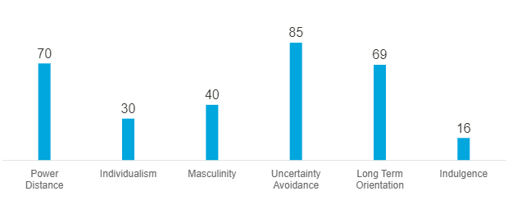
Hofstede insights Bulgaria, 2022

High power distance in Bulgaria proves that people are comfortable with a hierarchical system. The system will allow the people have no additional justifications according to their position. The organisations in the country are mainly centralised and the employees prefer clear directions about what they are supposed to do. Low individualism indicates Bulgaria has a collectivist culture (Hofstede, 2022). The people like to work in a team and maintain good relationship with each other. They expect each other to be loyal to each other too. the office space in this country is spacious enough to work in teams. The score in masculinity shows moderate feminism in the culture of the country. They mainly focus on their personal lives rather than their work-life. The managers try to work on agreement. Cooperation and negotiation are the most effective ways to settle conflicts in the Bulgarian culture. Holidays, times with the family and friends’ etcetera are appreciated by the employees. The country places a high value on avoiding ambiguity in all circumstances. It adheres to strict standards of thought and behavior and feels uneasy with unconventional behavior and ideas, according to the study. Bulgaria has moderate to high long-term orientation where it put emphasis on the past and future of the civilisation. It has a very low score in indulgence. Restrained cultures place little importance on vacation and exert tight controlling over the satisfaction of their needs. These individuals believe that their behaviors are restricted by societal standards.

Intercultural mediation
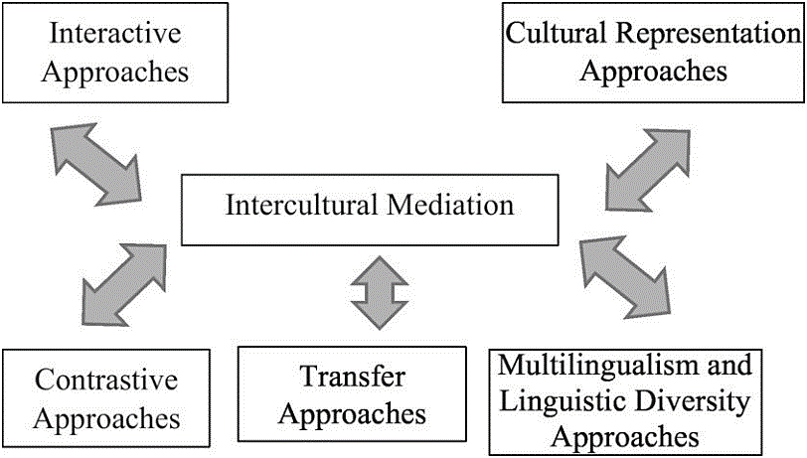
Figure 2: Intercultural mediation
Source: Samovar et al, 2016
It is defined as any type of contact between two parties of various cultures that happens to do something, business in this case (Samovar et al, 2016). The paradigmatic types of such mediation are translation and interpretation, which are both available online. Interpreters serve as intermediaries between distinct cultures and the parties who are trying to make the deals. Using a common language can be also a type of intercultural mediation. Here, the managers of the company will get an advantage. As English is considered common language in many countries, it is expected that the educated people in Bulgaria will know English. Bulgaria scores 23th on the English Proficiency Index from 2021 and a study from 2012 stating that 25% of the population knows the English language. There are more approaches of intercultural mediation. Another approach that can be unused in this case is the transfer approach where the company must show the willingness to adjust new ideas along with the employees of the company in Bulgaria.

Critical evaluation of cultural sensitivity when doing business in Bulgaria
Though Bulgaria has a communist past, it has faced a drastic change in recent years. Also, it joined EU. But still its culture shows touch of its past in several ways. There are a number of similarities and dissimilarities in the Bulgarian and British culture. These are explained below-
Bulgarians, who live in a family-oriented culture, rely significantly on their interpersonal interactions. Once a connection is established, however, the people of the country show extreme loyalty and trust for the foreseeable future (Ghemawat, 2018). It is also maintained in the corporate sphere, where the new people are treated in a formal manner until they have had the opportunity to introduce to each other and create a working relationship. Punctuality is admired in this culture but yet being a little late is acceptable in the meetings. But these meetings are considered highly formal. The parties involved in the meeting must shake hands and share business information in the beginning. Ottobock must keep it in mind to make sure the employees are behaving formally when needed. As mentioned earlier, the culture and people focus on the family more than their work, however other factors may change and affect this.
Bulgarians take employment seriously and put in more hours than is required by the standard working schedule. Work in this country is governed by a particular regulation that is quite similar to that found in other European nations. They welcome foreigners and regard the foreigners as skilled people if they come from nations that have established best practices and extensive knowledge in the field. They appreciate them because of their abilities rather than for their nationality or position. Usually speaking, corporate settings in this country are quite formal (Cavusgil et al, 2014). Examples include the fact that bosses and subordinates are seldom close, and that staff at low levels are given relatively less authority to make decisions. The majority of choices need many levels of clearance. Introducing new ideas or making drastic adjustments to the plan might put employees in an unpleasant situation since they are unable to commit until they have received clearance from the authorities. Personal contacts are very important in Bulgarian business. The ability to make connections helps people solve everyday difficulties, overcome bureaucratic obstacles, and expedite procedures without which, it will require a lot of resources. This is true even when the goal is totally legal and reasonable. When it comes to selecting how information is shared inside a company, favoritism is often a factor. In certain circumstances, personal ties might be the sole source of motivation that allows for development to be made amid a standstill in talks. It is not uncommon in the country to have a more relaxed attitude to deadlines and production. Employees in a business might enjoy extended breaks or fail to meet deadlines (Babcock and & Du-Babcock, 2018). According to reports, absenteeism is very widespread in the corporate culture as well. Ottobock must consider these facts and create a formal culture in the organisation to handle these situations.

Different communication barriers
Due to several reasons, the company will face a number of communication barriers in doing business in Bulgaria. These barriers include-
Language barriers: It will be the first and foremost barrier. As mentioned before, the people in the country mostly speak Bulgarian. But as mentioned before, the use of English may serve as a kind of intercultural communication tool. The company's executives will gain an edge in this situation. Because English is considered a common language in many nations, it is assumed that educated individuals in Bulgaria would be proficient in the English language as well. But if an expat manager tries to work in a foreign country and does not know the language, it could create a number of problems for him or her. Knowledge about the Bulgarian language is a critical, though not absolutely necessary, a component of effective communication. However, while doing business in a foreign country, understanding the original language is regarded a significant advantage and a show of respect by his or her colleagues.
Body language: When delivering a message, it's important for person making the communication to be aware of how they express it, according to Deresky. Since some behaviours which is accepted in one nation may be deemed impolite in another, it can be more critical while traveling. In order to do business effectively, one must be familiar with the local idioms of expression and body language. Bulgarians are known for their warm and welcoming natures.
Culture differences: It is always a big issue in communication. The work culture in the UK and Bulgaria is not that much different. Bulgarians even though might be seen at first as more cold and serious compared to other Europeans., also like These values must not conflict with each other when doing business in Bulgaria.
Geographical distance: Because of digital technology developments, the company will have to create a number of virtual teams. this makes communication more challenging for the company. It is hard to cooperate with each other all the time when the team is virtual. Such groups which connect through different technology may also feel that they are being left out. The team members may feel as though their coworkers aren't contributing as they work in different places and cannot see each other. Time zone differences might sometimes be a problem.

Appropriate communication strategies
As mentioned before, there are a number of barriers to communicate with each other in the company. To shift the manufacturing site in Bulgaria, the company must address the barriers with some good communication strategies.
Being successful in business requires not just the capacity to recognise and seize upon possibilities, it also needs to make a positive first impression and lay the groundwork for long-term relationships. The communist regime in the country left a significant impact, extending poverty and fostering corruption. The country has developed significantly since the fall of the collectivist dictatorship, and the business people have understood that long-standing relations may be concluded provided partners are respectful and kind to one another. The company must consider these issues when communicating with the Bulgarian culture.
Another strategy will be to provide proper training to the expat managers so that the managers are known to the culture properly. If the managers are familiar with the culture, he or she will be able manage the communication better and also know what body language or attitude need to be avoided (Ghemawat, 2018). Bulgarian managers will also help the other managers to connect with the local employees. The workers will need more family time.
The company must employ some supervisors who are good at English language. It will help the companies to communicate more efficiently. The translators must know the language well too as the workers will use mainly the dialect. The local language can be different to a great level compared to the formal Bulgarian language. The teams must not be fully virtual.

Conclusion
Bulgaria has high scores in power distance and uncertainty avoidance which implies people are comfortable with a hierarchical system but not unconventional ideas. Other factors are moderate to low in Bulgaria. It is common for Bulgarians to depend heavily on their social contacts because of their emphasis on family. Bulgarian business relies heavily on personal relationships. Without the capacity to build connections, it would take a considerable lot of resources to solve common problems, overcome bureaucratic roadblocks, and speed processes. There are much differences between the culture in Bulgaria as well as the UK. Bulgarian people like to balance the work and life more casually while the people in the UK work more than the average in Europe. Language barriers, body language, culture differences, geographical distance etcetera are the main barriers in the process. Proper training, business relation can make sure the company is facing the barriers successfully.

References

- Babcock, R. D., & Du-Babcock, B. (2018). Language-based communication zones in international business communication. The Journal of Business Communication (1973), 38(4), 372-412.
- Cavusgil, S. T., Knight, G., Riesenberger, J. R., Rammal, H. G., & Rose, E. L. (2014). International business. Pearson, Australia.
- Deresky, H. (2017) International management : managing across borders and cultures : text and cases . 9th global edition. Pearson, Boston
- Ghemawat, P. (2018). Semiglobalization and international business strategy. Journal of international business studies, 34(2), 138-152.
- Global Affairs Canada (2015). Bulgaria - Market Overview. [online] GAC. Available at: https://www.tradecommissioner.gc.ca/bulgaria-bulgarie/market-facts-faits-sur-le-marche/0000901.aspx?lang=eng [Accessed 6 May 2022].
- Hoecklin, L. (2015). Managing cultural differences. Addison Wesley Longman.
- Hofstede Insights. [online] Available at: https://www.hofstede-insights.com/country-comparison/bulgaria/ [Accessed 6 May 2022].
- Samovar, L. A., Porter, R. E., McDaniel, E. R., & Roy, C. S. (2016). Communication between cultures. Cengage Learning.

