
Skills for the Workplace
Module Assignment Submission
Student Name: | Ancuta Chirita
Student Number: | 1605755
Module No: | BMSK4003_LON
Module Title: | Digital Skills and Research Methods

Statement of Confirmation of Authenticity
By the act of making this submission, the student declares that this is the work of the student named above. The work has not, in whole or in part, been knowingly presented elsewhere for assessment, or where assessment has been built on a previous assessment, this has been identified. Where materials have been used from other sources it has been properly acknowledged. If this statement is untrue, the student acknowledges that an assessment offence has been committed.
Attention is drawn to the plagiarism and unfair practice policies of both the University and of ILM.

Table of Contents
ABSTRACT/EXECUTIVE SUMMARY 3
INTRODUCTION 3
LITERATURE REVIEW 4
FINDINGS/ANALYSIS 6
CONCLUSION/RECOMMANDATION 12
REFERENCES 13
APPENDIX 14

ABSTRACT/EXECUTIVE SUMMARY

Over thirty years of research about consequences of bullying to the workplace, shows that exposure to systematic negative behaviour at work, may have devastating effects on the health and well being of the exposed individuals. The early research consisted mostly of cross-sectional studies, a few case control studies, and clinical interviews with bullied persons. The studies found correlations between exposure to bullying and chronic fatique. Bullying at work not only affects the targets, nonbullied withnesses also present general stress and menthal stress reactions than employees from workplaces without bullying (Vartia, 2001), and some might leave their job as a results of witnessing of bullying. All these early studies suggest that bullying at work is a potent stressor that negatively affects the health and well being of the targets and, to some degree the witnesses as well. The statistics showed that approximatively 30-35 percents from the bullies persons, choose to report the the institutions that being bullied, the rest chose do not report, or to ignore if they see something around to the workplace, some of them motivated that they do not want to risk their job, without to think aboutthat maybe, in the next future they could became also a bullying victims, and maybe to appreciate if somebody else will take attitude against the person which bullying another person.

INTRODUCTION

The purpose of this report is to find the answer for the following question “What qualifies as workplace bullying and what legal protection do you have if you are being bullied at work”? There is not a legal definition about what means exactly to be bullied at the workplace, ACAS name it like “offensive, intimidating, malicious or insulting behaviour, an abuse or misuse of power through means that undermine, humiliate, denigrate or injure the person being bullies”.
In the Equality Act 2010 it is also defined the concept of “harassment” which, unlike bullying, It could be defined as a specifically amount to unwanted conduct relating to a protected characteristic that has the purpose to of violating a person’s dignity or creating an intimidating hostile, degrading, humiliating or offensive environment for that person, The protected relevant characteristics are: disability, gender reassignment, religion or belief, sex and sexual orientation, age, race,

LITERATURE REVIEW

In the module digital skills and research methods, as secondary research methods we learned how to using:
- Journal articles, how to filter the information looking in the specialized journal for the topics that we are looking for, how to check who is the author and hoe credible and reliable are the informations about it, how recent are the informations writted in the articles;
- Web sites, we should filter also the kind of information and keep re-searching until we find credible, relevant information for the topic that we are speaking, writing about;
- Electronical books, how to search, find, filter the books and informations inside of the book an electronical format;
- News article, the same way, to compare the type of the news paper, in the specific area of the news paper, checking who is the author;
- Text books, how to paraphrase a text from a book, how to citate in a propertly way.

As primary research methods, we learned about how to conduct:
- Observation, to make a statistics based on observation when the topic allowed us to do that (Ex: to stay at the door of one shop and observe how many customers came in and out in a specific time and make a statistics, represented in a graph and make a report about a specific topic based on it);
- Survey, how to tailore a survey based on specific topic, with relevant questions which provide relevant answers for the topic, to offer compensations for convince people to answer us to the questions.
- Face to face interviews, how to lead people to provide us the answer for the questions fro having the informations relevant for our topic.
- Survey by telephone as questionaries by dialog, or by messages with questions.

FINDINGS/ANALYSIS

Definetely, about the topic bullying to the workplace, already exist a lot of informations, not being a new topic, there are not too many informations to discover as primary research. This report porpose to find out how many people choose to report when they are bullied at the workplace, or see a person in this situation around, in the same team, in the same company, and how many prefer do not report, based on a lot of intimidations ways from the person that bullying.
Bullying at the workplace can take a lot of forms as constant criticism, blocking promotion, exclusion from (lunches and drinks for example, important emails, relevant meetings), overbearing supervision, making threats or comments about job security without foundation, being overworked and expecting unreasonable response times, taking away responsibility from someone or replacing it with more unpleasant tasks, ignoring someone’s opinion, persistently criticizing someone’s work, spreading gossip or rumors about someone, ignoring or excluding someone at work, hinting to someone that they should quit their job. (Hershcovis,Sandy M.,Reich Tara C,.Niven Karen, n.d.).

 (Anon., n.d.)

Harassment to the workplace can take the follow forms: receiving homophobic comments, being frequently teased and humiliated about a disability, unwelcome sexual advances or touching, standing too close, the display of offensive materials, asking for sexual favours.
Why do people bully at work?
A very simple question with a very complex answer. Personality is definitively one important factor that predicts this kind of behaviour. Also, it occurs in the context of an organizational environment that mitigate or aggravate the incidence of workplace bullying.
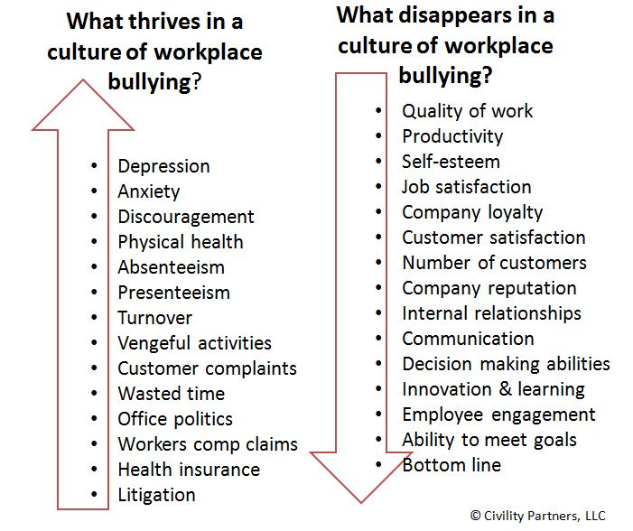
(Anon., 2018)
All the factors of bullying are likely to make up a highly stressful situation characterized by lack of control.People have a strong need to feel that they can predict the future and control the events that happen to them.When they facing uncontrollable and unpredictable events such as bullying, the person will be highly motivated to try to understand what is happening with the purpose to reestablishing perceptions of the world as predictable and controllable.

Questionarry
1. Have you been bullied or harassed at work?
YES/NO
If YES, please give examples (EXAMPLES: e.g. shouting, threats of violence, malicious gossip, etc. )
2. How often have you been bullied/harassed at work? Please Tick
NEVER
RARELY
OCCASIONALLY
FREQUENTLY
CONSTANTLY
3. Have you ever seen another employee bullied at work?
YES/NO
If YES, please give examples (EXAMPLES: e.g. shouting, threats of violence, malicious gossip, etc. )

4. How often have you seen bullying/ harassment at work?
Please Tick
NEVER
RARELY
OCCASIONALLY
FREQUENTLY
ONCE A WEEK
DAILY
5. Which Grades have been guilty of bullying/harassment?
Please Tick
DEPARTMENTAL
HEAD MANAGER
LINE MANAGER
WORK COLLEAGUE
OTHER (PLEASE SPECIFY)

6. Do Management act on bullying/harassment?
YES/NO
EXAMPLES OF TYPE OF ACTION TAKEN OR NOT TAKEN: e.g. ignored, culprit disciplined; complaint ignored
7. Do you think bullying/harassment is taken seriously at your Workplace?
YES/NO
If NO, why not? Please give reasons why you think it is not taken seriously
8. Has your employer got a bullying/harassment policy (please tick as appropriate)
YES NO
9. Does your employer provide advisory facilities to which you can report bullying or harassment? If yes, please specify below what form this takes (e.g. helpline)
YES NO
(GMB, n.d.)

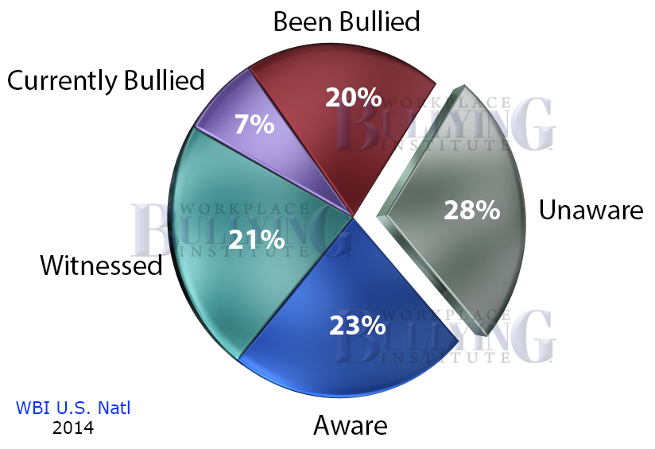 (Anon., n.d.)

CONCLUSION/RECOMMANDATION

Employers have a duty to of cate for all their employees to prevent bullying and harassment to the workplace.They also have responsabilities under the Health and Safety at work Act 1974 for the welfare of employees, by exercise reasonable skill and care in the relashionship with the employer and colleagues. According to the Health and Safety at work Act (1974)(HASAWA) the companies should takes reasonable care for the health and safety of themselves and other people at work.Also to co-operating to enable the employer to fulfil it is a legal duty. The companies must not interfere with or obstruct anything provided in the interests of health and safety at work. (Anon., n.d.)
Another recommendation is to review current policies and procedures to provide respect one to the other in the workplace, implements and follow permanentely. When somebody came as a new member of the team, the company should provide clear expectations regarding interactions among coworkers, also to provide a clear channel for reporting workplace incivility or bullying like toll-free hotlines that employees can call to report instances of incivility or feeling targeted.Also consider implementing employee and customer survey. Implement a standard investigation process to evaluate every reported incident. Establish a unique disciplinary policy for instigators of bulluing, without exceptions. Provide training for all employees in respectful communication protocols and the consequences of not adhering to them.A lot of organizations and companies go a step further and train employees in skills to prevent, recognize and respond to incidents of incivility, aggression, and bullying in their workplace.

REFERENCES
Anon., 2018. [Online]
Available at: https://www.bing.com/images/search?view=detailV2&ccid=ktnTt5Qe&id=36FFF47BBE45A8327C7BF6B17B16ECDA9EBF1F5F&thid=OIP.ktnTt5QefCDEK5P-qUsAFgHaGN&mediaurl=http%3A%2F%2Fnoworkplacebullies.com%2Ffiles%2F2013%2F11%2Fcosts_2.2192439_std.jpg&exph=588&expw=701&q=F
Anon., n.d. [Online]
Available at: https://www.worksmart.org.uk
[Accessed 2nd May 2018].
Anon., n.d. [Online]
Available at: http://www.workplacebullying.org/multi/img/2014prevalence.png
[Accessed 2nd May 2018].
Anon., n.d. Managers Digest. [Online]
Available at: https://www.managersdigest.co.uk/wp-content/uploads/2017/07/bully-at-work.png
[Accessed 2nd May 2018].
GMB, n.d. [Online]
Available at: http://d3n8a8pro7vhmx.cloudfront.net/gmbyorkshireregion/legacy_url/1096/Bullying_and_Harassment_Questionnaire.pdf?1428491178
[Accessed 2nd May 2018].
Hershcovis,Sandy M.,Reich Tara C,.Niven Karen, n.d. Society for Industrial and Organizational Psychology. [Online]
Available at: http://www.siop.org/WhitePapers/WorkplaceBullyingFINAL.pdf
[Accessed 2nd May 2018].
Philip, L., 2017. Guardian Careers. [Online]
Available at: https://www.theguardian.com/careers/2017/mar/29/bullying-at-work-your-legal-rights
[Accessed 2nd May 2018].
Vartia, 2001. [Online]
Available at: http://www.scirp.org/reference/ReferencesPapers.aspx?ReferenceID=1393737
[Accessed 2nd May 2018].

APPENDIX
1. Have you been bullied or harassed at work?
YES/NO
If YES, please give examples (EXAMPLES: e.g. shouting, threats of violence, malicious gossip, etc. )
2. How often have you been bullied/harassed at work? Please Tick
NEVER
RARELY
OCCASIONALLY
FREQUENTLY
CONSTANTLY
3. Have you ever seen another employee bullied at work?
YES/NO
If YES, please give examples (EXAMPLES: e.g. shouting, threats of violence, malicious gossip, etc. )

4. How often have you seen bullying/ harassment at work?
Please Tick
NEVER
RARELY
OCCASIONALLY
FREQUENTLY
ONCE A WEEK
DAILY
5. Which Grades have been guilty of bullying/harassment?
Please Tick
DEPARTMENTAL HEAD MANAGER
LINE MANAGER
WORK COLLEAGUE
OTHER (PLEASE SPECIFY)

6. Do Management act on bullying/harassment?
YES/NO
SEXAMPLES OF TYPE OF ACTION TAKEN OR NOT TAKEN: e.g. ignored, culprit disciplined; complaint ignored
7. Do you think bullying/harassment is taken seriously at your Workplace?
YES/NO
If NO, why not? Please give reasons why you think it is not taken seriously
8. Has your employer got a bullying/harassment policy (please tick as appropriate)
YES NO
9. Does your employer provide advisory facilities to which you can report bullying or harassment? If yes, please specify below what form this takes (e.g. helpline)
YES NO
(GMB, n.d.)

