Module: Employability and Career Development
Code: LCLM4005

Student name: Cristian Chiuariu
Student ID number: 2511685
Module Leads: Vicky Giannaka

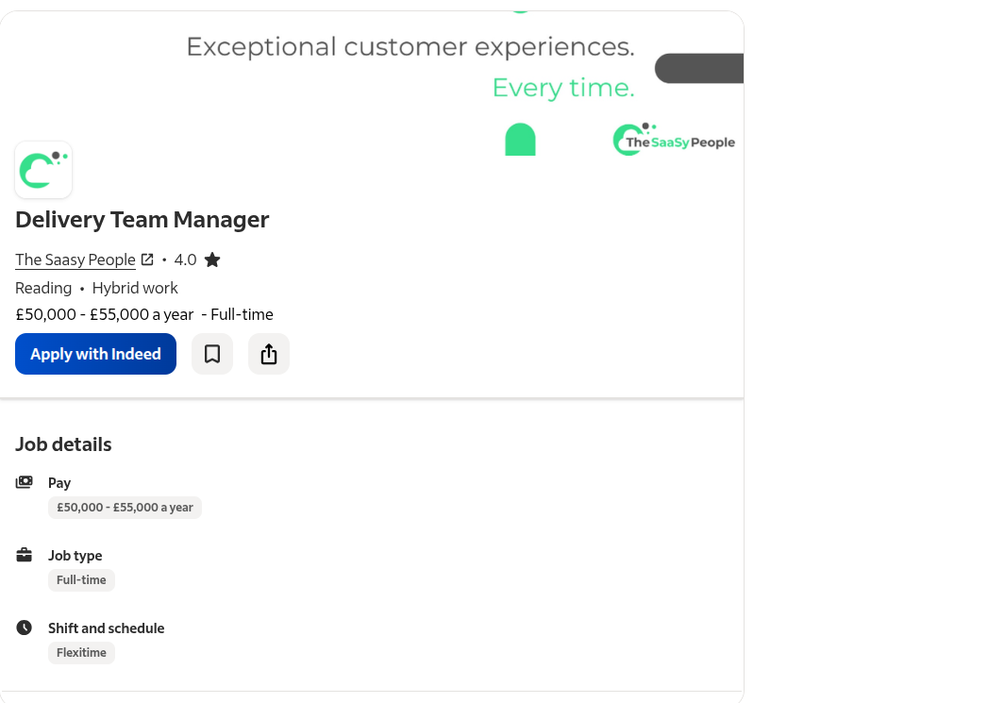

Cristian Chiuariu
Phone: [07111770341]
Email: [chiuariucristian05@gmail.com]
Location: London

Professional Profile
Reliable, hardworking, and responsible professional with over 4 years of delivery experience in Romania and several years of work experience in the UK construction industry. Experienced in working under pressure, managing schedules, and providing excellent customer service. Strong knowledge of driving, route planning, and teamwork. Looking to bring my experience into a Delivery Team Manager role where I can lead a team, improve efficiency, and ensure excellent service.

Key Skills
- Team leadership and coordination
- Delivery operations
- Route planning and time management
- Customer service
- Reliable and punctual
- Health & Safety awareness
- Good communication skills
- Full UK driving licence (8 years driving experience)

Work Experience

Construction Operative
United Kingdom
Several years
- Worked on various construction projects.
- Used a company vehicle to transport materials and complete small deliveries between job sites.
- Maintained company equipment and ensured deliveries were completed on time.
- Worked effectively as part of a team while meeting deadlines.

Delivery Driver
Romania
4 years
- Delivered goods safely and on schedule.
- Maintained excellent customer relationships.
- Handled deliveries accurately and responsibly.
- Managed daily schedules and solved delivery-related issues.

Education
Professional School (Ioan Mincu)
Romania

Licences
- Full Driving Licence (8 years)

Languages
- Romanian – Native

Cover Letter

Cristian Chiuariu
23 Newbury close
Lu49QJ,Luton
chiuariucristian05@gmail.com Hybrid remote in Reading RG1 1AZ
07311770341
Dear Hiring Manager,
I am writing to apply for the Delivery Team Manager position.
I have over four years of delivery experience gained in Romania, where I developed strong organisational skills, learned how to plan efficient delivery routes, and built excellent customer service skills. I understand the importance of meeting deadlines, working under pressure, and ensuring every delivery is completed safely and professionally.
Since moving to the United Kingdom, I have worked in the construction industry, where I was trusted with a company vehicle and regularly completed small deliveries between different job sites. This role strengthened my sense of responsibility, reliability, and ability to work as part of a team.
I am now looking to take the next step in my career by joining your company as a Delivery Team Manager. I believe my practical experience, strong work ethic, and ability to motivate others would allow me to make a positive contribution to your team. I am eager to learn, take responsibility, and help improve daily operations while supporting drivers and ensuring excellent customer service.
Thank you for considering my application. Yours faithfully,
Cristian

