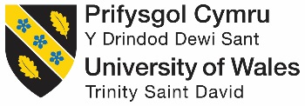

Modern theories of Leadership

Critically evaluating the modern theories of leadership in the context of working within the QINETIQ Test Range Operation & Appraising the effects of the established Culture on implementing change within the work environment.

by

Module: Engineering Management and Law
M6X00943

Lecturer: Professor John Rees

BEng (Hons) Test Range Engineering

February 2018

Abstract
The purpose of the following report is to critically review the modern theories of leadership and how they have required development over time with respect to the continually evolving modern business world. A review and cultural analysis summarises how such an organisational change within a business such as QINETIQ applies these theories to deal with the inevitable changes occurring within the business model reforms and leadership framework demands. Evidence has proven that Situational and Transformational theories need to be seriously and wholly considered for Transform to succeed with respect to the delivery of the business’s vision by everyone involved. The slightest hint of uncertainty against employment rigidity or unclarity of direction can strike fear and upset amongst employees as proven by feedback at QINETIQ Q-Talk seminars. Whilst perfection in employee trust and honour during transformational periods is not possible, it is important to keep everyone in the loop at all times with the full knowledge surrounding the bigger picture. Obtaining limited internal documentation regarding Transform has provided enough evidence of the tools and techniques currently used by QINETIQ to sustain their workforce culture and encourage their vision into reality. Much of the report builds on official summarised versions of research provided in the Appendix (Original documentation was internal QINETIQ proprietary).

TABLE OF CONTENTS
SECTION PAGE
TITLE PAGE 1
ABSTRACT 2
TABLE OF CONTENTS 3
- INTRODUCTION 4
Aim of the report
Scope

- RESEARCH 5-8
Summarising and Critically Evaluating the modern theories of Leadership

- LEADERSHIP IN THE WORKPLACE 8-11
QINETIQ Leadership
Examples of QINETIQ workforce leadership techniques

- ANALYSIS 11-14
The established workplace culture
What is Transform
The impact of the workplace culture on facilitating change within the work environment (Transform)

REFERENCES 15
BIBLIOGRAPHY 16
APPENDIX 17-24

- INTRODUCTION

Aim of the report

The aim of this report is to identify and critically evaluate the modern theories of leadership, this will be supported by an investigation into team dynamics of the test range operations within the QINETIQ workplace. An appraisal will be made on how well the established culture deals with change within the working environment, emphasising how specific leadership styles and techniques used within the business can encourage and support the modern growth of the business.
Scope

The structure of the report will be as follows:
- Research: A brief summary and evaluation of modern leadership theories
- An investigative evaluation of leadership skills and techniques within test range operation teams at QINETIQ
- Analysing the employee work force culture within the operations teams and the support this has given to the recent structural change, namely Transform

- RESEARCH

Summarising and Critically Evaluating the modern theories of Leadership

Leadership is the role earned by an individual to lead others, sometimes referred to as followers, within a specified area or level of the business. Leaders possess certain influential qualities, directive skills and styles that enables them to encourage followers to follow directions and instructions, resulting in successful team work and business. Management is about coping with complexity, whereas leadership is about coping with change.

As described by John P. Kotter, a simple military analogy of leadership is [1];

A peacetime army can usually survive with good administration and management up and down the hierarchy, coupled with good leadership concentrated at the very top. A wartime army, however, needs competent leadership at all levels. No one yet has figured out how to manage people effectively into battle; they must be led [1].

A modern business can be very demanding on its allocated team leaders, with expectations and responsibilities tending to broaden with time. Increasingly, businesses such as QINETIQ continually look to restructure the roles and availability of employees, team leaders and management, to coincide with improving efficiency and attaining new company vision. The umbrella of employees and their required level of structured guidance for which team leaders are expected to lead and provide can vary dramatically, depending on the level in the organisation, the size of the workforce required and the environment of work. An effective leader is someone whom is aware of and appropriately uses a combination of the defined modern leadership frameworks and styles to their advantage. At QINETIQ it is important that a leader is flexible in their role and can adapt to changes of vision by blending certain styles together.

To summarise, leadership is ‘The ability to influence a group toward the achievement of a vision or set of goals’ [2]. ‘Good leaders are made not born. If you have the desire and willpower, you can become an effective leader. Good leaders develop through a never-ending process of self-study, education, training, and experience (Jago, 1982)’ [3]

Throughout modern history, the main varying theories of leadership frameworks that have been proposed by business people and psychologists are; Trait, Behavioural, Contingency, Lead-member Exchange (LMX), Charismatic, Transformational and Authentic [2].

The following summarises the more common theories, often used by QINETIQ to identify and teach good leadership.

- Trait theories:

The earlier theory that predicts leadership and aids consideration for the emergence of leaders within a group, by identifying key qualities and characteristics in people, of which are the recognised building blocks of a good leader. Personality traits such as; integrity, empathy, assertiveness, extraversion, emotional stability and intelligence, conscientiousness, good decision-making skills or likeability etc [2, 3] are the elements which employees commonly seek to differentiate between leaders and non-leaders. This technique helps evaluate candidates at interview stage and can identify suitable leaders but doesn’t guarantee successful selection until evidence proves that they can lead followers to achieve certain goals. Effective leaders can be taught certain traits through development over time but as well as having such qualities it is important that leaders have awareness of other styles of leadership. QINETIQ continually seeks to recruit individuals that already have an inbuilt foundation of positive traits but also provides training courses to further develop necessary leadership skills as described in the Leadership Tool Kit (Appendix A).

- Behavioural theories

Focusses on what the best leaders productively do and how they behave, enabling such positive operative ways of conduct to be taught to others. This approach questions and defines behavioural characteristics of leaders that appear related to constructive performance effectiveness. For example, do they initiate structure to their role and have consideration for others in their team through work-based and interpersonal relationships? Do they involve teams in decision making etc to encourage and support their team? or do they simply dictate instructions and expect full cooperation and tasks to be completed? [3].

Three types of behavioural focused leadership styles include;

Autocratic: When teams input is not required and leaders make quick decisions without consulting their teams. Good for quick turnaround but can negatively impact workers self-value and enthusiasm.

Democratic: Leaders consult the team and allow input before making a final decision, can be useful when full team agreement is of importance and making workers feel valued. QINETIQ uses this style of leadership at operational level, highlighted by weekly team meetings and monthly site meetings that encourage input from everybody. This is evident when confirming the technician and engineer partnerships for each trial, all parties confirm competency requirements and partnership compatibility.

Laissez-faire leaders: Leaders don’t interfere and loosely supervise, allowing team members to make many of the decisions. Can result in or be a result of lazy leadership and production failures but can make workers feel more powerful and valued. At QINETIQ operational level there is an element of this style being in place when leaders allow the engineers on a trial to take lead and control of all stages of a trial from set-up through to completion of testing, including giving full guidance to technicians. Team Leaders don’t usually get involved in the operation of equipment or the physical trial unless issues (failure or staff absence) arise.

- Contingency (Situational) theories

This suggests using specific styles based on the current situation, and to vary the leadership approach accordingly to suit the best chance of a successful outcome. The styles used in normal day to day running of a business maybe different during a crisis etc [4]. A prediction is made on what style will be used for the present scenario, whether more team support / input is required, whether an impulse decision needs to be made on the spot or whether a leader should be more people-orientated or task-orientated. This is a very flexible approach to leadership and commonly used by QINETIQ, where the business model is being restructured with a new company vision being installed. It can be useful when situations change dramatically or rapidly but leaders need to remain cautious regarding the clarity of leadership being provided to workers to avoid confusion and distrust. Situational leadership assures team leaders of safer practice and supports the safety culture we have at QINETIQ due to the high risks involved with making mistakes around explosives. The Path-Goal Theory developed by Psychologist Robert House in 1971 (updated 1996) and the Fiedler Contingency Model created by Fred Fiedler in the mid-1960’s are existing models that can help leaders identify the style or approach to use (behavioural considerations and Least Preferred Co-Worker scale) [4].

- Power and influence theories

Focusses on how the leader uses their power to influence others in the team to achieve successful outcomes and evaluates the styles used to achieve this. The French and Ravens Five Forms of Power is an example of this theory that identifies the types of positional and personal power; legitimate, reward and coercive, expert and referent [4]. It suggests a leader should develop their expertise and that this more legitimate personal power is a stronger form of leadership. This theory of leadership requirement is reflected by the leadership aims of QINETIQ team leaders working on site at the ranges where trials are physically carried out. It can provide motivation directly to the manual work force to drive the workload and ensure trials are ran to schedule in accordance with customer expectations and QINETIQ Code of Conduct. Transactional leadership is another style of power driven leadership. It uses the idea of rewarding team members for their work and focusses on setting tasks with reward structures. Although not a long-term relationship building tool, it can be useful for attaining objectives out of the ordinary. It can be argued that there is an element of this style being used during Personal Development Review meetings, where leaders at QINETIQ often make it clear as to what personal objectives need to be achieved and skills shown for moving up a level on the global pay grading scale. This can be motivational but sometimes the prospect can be demoralising with such far set goal posts.

- Transformational theories

Originally introduced by leadership expert James McGregor Burns in his book Leadership (1978) when he defined the occurrence of transformational leadership as being when “leaders and their followers raise one another to higher levels of morality and motivation” [5]. Further developed by Bernard M. Bass in his book Leadership and Performance Beyond Expectations (1985) he suggested this type of leader: “Is a model of integrity and fairness, sets clear goals, has high expectations, encourages others, provides support and recognition, stirs the emotions of people, gets people to look beyond their self-interest and inspires people to reach for the improbable” [6]. Leaders at QINETIQ are trained to see the bigger picture and use transformational leadership to guide their teams through business transformations to achieve company vision. By showing integrity and motivating people to buy into the vision, leaders can manage the delivery of transforming the business model, hopefully building stronger and more successful teams along the way. This is the most common theory of leadership used to identify good leaders for helping businesses cope with the inevitable changes that modern world business models are continuously executing to meet demand and survivability.

Each approach to leadership has its own advantages and disadvantages as a result of the different styles used, but the theories most called upon nowadays are that of Contingency and Transformational leadership. These describe the mains ways that current leaders at businesses such as QINETIQ are required to lead teams at operational level. QINETIQ uses training courses to teach their leaders on the styles and techniques that they need to practice within the workplace.
By understanding the different styles, a leader can become better at guiding teams through challenging situations. As business needs and targets change, leaders can adapt the style to fit each unique situation.

The requirements of leadership have often been the focus of leadership scholar research. According to a study by Mumford et al (2007) modern leadership skill requirements can be thought of as being ‘layered (strata) and segmented (plex)’ [7], aka strataplex, the tool for analysing leadership skills across an organisation. By applying this type of model to varying levels of management, the study proposes that leadership skill requirements can be segmented into four main categories; Cognitive skills, Interpersonal skills, Business skills, and Strategic skills. More importantly it highlights that the particular categories of leadership required, varies at the different organisational levels. Leading at higher levels in an organisation require higher levels of leadership skills and even though ‘Cognitive skill requirements are important across organizational levels, certain Strategic skill requirements only fully emerge at the highest levels in the organization’ [7].

Table 1 below, taken from Mumford [7], summarises the segmented skills incorporated into modern leadership, and are the supportive findings to this study by associated researchers from past studies;

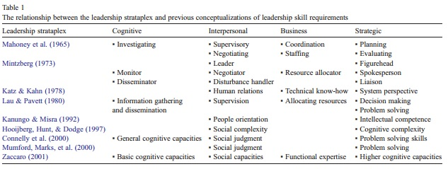

This theory of leadership is a good ideology of how leadership can in fact be broken down into the valuable elements (skills) necessary for a leader to cater for certain control-led responsibilities. It allows businesses to identify enough of the key elements for specific leadership roles to be taught at beginner’s level, depending on the placement position in the company and therefore can be used to grow new team leaders or identify underperforming leaders within a business.

Most companies nowadays use the traits theory of breaking leadership into categories to identify whether current leaders are performing or during interviews to assess suitable candidates. However different businesses desire different combinations of styles of leadership.

- LEADERSHIP IN THE WORKPLACE

QINETIQ Leadership

The current focus of Leadership at QINETIQ is about trying to create good customer based relations and future work load supply through trial output satisfaction. It is about presenting a business that has a strong leading and trusted presence in the market place with a ‘can-do, know-how’ attitude and being ‘the chosen partner around the world for mission-critical solutions, innovating for our customers’ advantage’.

With the business offering increasingly more facilities and technological development by branching out to alternative markets (Space and satellite), leadership is focussing on harnessing the energy of others to develop their performance as team players, enabling them to become multi-skilled and more adaptable across other sites as well as their local site. By offering more training to employees, team members are becoming more experienced and certified competent to perform different tasks, this in turn is creating more efficient staff.

Due to the operational environment employees work (usually with explosives) and increasing workload, leadership is also concentrating on a ‘Safety culture’ that promotes a ‘Stop moment’ policy. If anyone feels the need to stop a task for safety reasons, saying ‘STOP STOP STOP’ ensures everyone downs tools and the task can be further investigated. Leaders are also being tasked to enforce Risk Assessments and ensure that staff have read and understood (and signed) all risk assessments related to any tasks that they are about to perform.
Leaders and managers are to act as role models for the QINETIQ values and standards at all times. They are responsible for; Promoting and upholding standards, providing advice and guidance and ensuring employees have the right knowledge and resources to follow our standards and meet legal requirements. QINETIQ frequently reminds its leaders to refer to and study the Leadership Charter (see Fig.1).

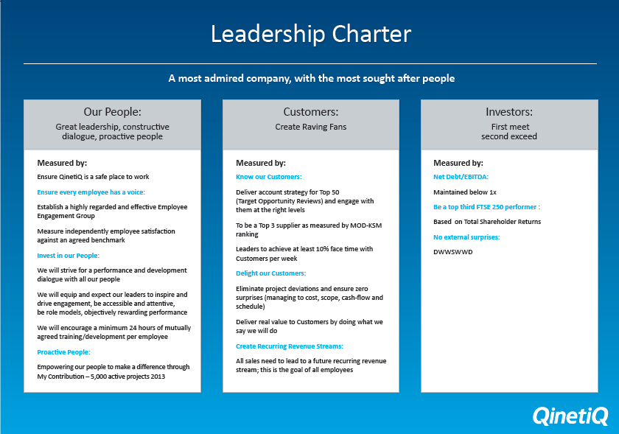 Fig.1
Examples of QINETIQ workforce leadership techniques

For all level of leaders, there are six admirable leadership skills as identified by QINETIQ’s Personal Development Review (PDR) Toolkit [8, Appendix A]; Leading Our Values, Focus and Deliver, Communicate and inspire, People and Team development, Delivering Customer Advantage and Strategic Purpose. This suggests that QINETIQ promotes a mixture of strategic techniques to incorporate varying stylistic and interpersonal leadership skills, where leaders should lead in a transformational and situational approach in combination with personal traits. At its operational level QINETIQ promotes Transformational leadership by recruiting leaders with integrity and high emotional intelligence, good communication and ability to motivate their team with a shared vision of the future. Leaders should have certain traits and be influential, authentic, focussed, empathetic, humble and inspirational and adapt the way that they lead to cater for situational changes. It is important however, that leaders do not get blinded by the vision and give short deadlines and expect others to work long hours. This, however, is often the reality in the defence industry when trials need to be completed for asset life extension plans so that they can be continued to be used out in the combat theatre.

Obvious operational examples of leadership at QINETIQ are that of the two Dynamic and Climate team Leaders at the Environmental Test Centre (ETC) Shoeburyness of whom lead the technicians and engineers within the Dynamics and Climatic teams respectively. The separate roles each include the drive and oversight of the dedicated areas but it is of paramount importance that the sub-division of the placements do not subsequently divided the testing department segmentally into separate operational halves. From studying the specific key responsibilities of an Environmental Trials Team Leader, as specified on Terms of reference for the role (see Appendix B) there is a lot of expectation and many specific objectives that the leaders must fulfil regularly, as found upon questioning the current Team Leaders (see Appendix B2). Importantly, it is noted that leaders are to perform partly managerial roles as well as leading their teams and reporting to the Operations Manager. Rather than only focussing on the personal characteristics of leaders, QINETIQ is exploring and teaching leaders on how to deal with continuous changes to the business. Leaders should not only be adding personally value to the business but helping to turn vision into reality by guiding their team to success through the changes and challenging times ahead.

From studying the Leadership styles chapter, within the 2IC Development Programme issued by QINETIQ to Team leaders for training, it is evident that a Situational style of leadership is preferred. The training suggests ‘You should not wake up in the morning and say to yourself: “I have a certain type of leadership style”.’ It continues; ‘It is appropriate to use different leadership styles every day’ and ‘As a leader you do so ‘openly,’ and ‘Think of your role as adding value to a specific situation’ [9].
Referring to the document [Appendix C: Examples of QINETIQ leadership techniques] it refers to four situational examples of where a leader should adapt the style and approach to followers, depending on their behaviour. In each case leaders set goals but the level of supervision varies depending on the abilities of the follower. This is a good form of leadership that encourages flexible leading but requires high level competencies of judgement with regards to the abilities and trust of other people.

The following Situational leadership behavioural diagrams; Fig.2 and Fig.3 [9] are provided during QINETIQ training to help develop leaders understanding of the way they should be supporting followers during various levels of directive and supportive tasks. It also aids understanding of how leaders can work towards building follower’s development level to enable the use of less time-consuming leadership styles.

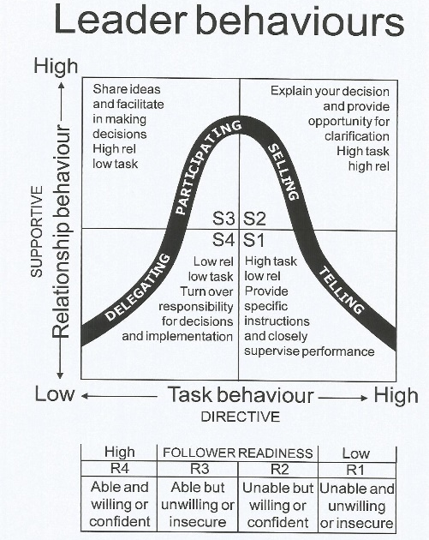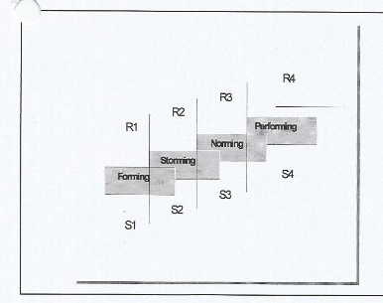
Fig.2 Fig.3
Summarising research from the QINETIQ Competency Framework (see Appendix D), Leadership at QINETIQ should encompass the following competencies: Commercial Vision, Rapid Engagement, Driving Ambition and Leading Others. This suggests QINETIQ operational leadership focus is driven mainly by the company vision and the customer experience it wants to promote. Leadership energy is directed into fast responses to customer requests and into channelling its operational workers to achieve the vision and commercial reputation by using the 3 E’s of leadership: Envision, Energise and Enable [10] (directing, influencing, motivating, target setting and developing workers’ skillsets etc).

- ANALYSIS

The established workplace culture

The workplace culture has recently been highlighted through the recent organisational restructure, Transform. QINETIQ’s plans to facilitate change in the workplace usually conform to a well-prepared process but naturally, Transform has not been without some issues. Commonly Leaders are requested to pull upon the 3E’s of leadership and acts as role models and to help identify and promote common values and beliefs of the company vision. For this to occur however it is important that everyone understands the reasons for change but the clarity of reasons can sometimes be too complex or unclear for others at the lower levels to understand. The established culture at QINETIQ has continued to perform well and feel valued throughout the change but the hint of unclarity and lack of provided predicted time frame for completion did grow fear amongst some. A transform team, TAG (Transform Action Group) was created however, specifically to help deal with the review and understanding of the transform throughout the whole process and provided a regular online update as to the stage of completion. Site presentations are regularly scheduled but often raise temperatures when certain questions surrounding the possibilities of redundancies due to team restructures, cannot be answered on the spot. The level of certainty has not been made clear as to what the outcome will mean with regards to job posts and so the fear of the unknown (Uncertainty) has rightly caused some upset.

What is Transform

QINETIQ is currently having to deal with the evolution of its business and has had to face up to the rate at which its organisation is having to rapidly change to stay functionally efficient, competitive and at the forefront of the defence industry. Evidently, the speedily rate at which the technological industry grows, means QINETIQ is in a highly competitive market for work and the ability to adapt the services and scale of work of which it offers is paramount in this changing world.

Transform is a two-year programme that was introduced in March 2016. It is part of the strategy to deliver a vision to be the chosen partner around the world for mission-critical solutions, innovating for our customers’ advantage. Transformation is an internal change programme impacting all parts of the company through development of teams, changing and improving how we work together, streamlining our process, and modernising our working environment. The first year was focused on creating the right organisation and having the right people in the right places to deliver for our customers and to drive growth. The final year is focused on embedding and maturing our new ways of working, and all the systems and processes that support our people. Team member are more frequently required to be interchangeable and be multidiscipline (cross-trained) across all areas of the testing facilities.

The impact of the workplace culture on facilitating change within the work environment (Transform)
According to the TAG, culture can be described as ‘the self- sustaining pattern of behaviours that determines how things are done’ and QINETIQ’s overall objective is to make its culture one of its biggest assets [11]. To support the vision and strategy, cultural change needs to occur at all levels of the business so that the changes being made are embedded and become part of ‘the way we do things around here’, delivering the benefits promised to employees, our customers and our shareholders.
The state of workplace culture in any organisation has a huge impact on the ability to manage change in any company. Generally, if employees feel empowered to make the changes themselves, the transformation moves ahead in a smooth transition. If employees are forced to make changes to the way they work without being able to have influence or give feedback, they tend to feel uneasy, especially if people are confused having not been made aware early on at the initial stages of exactly how changes are going to happen. If the culture of the workplace is good and people feel part of the change through clarity of the process, an honest period of work and business tend to flow.

Failure to present a restructure of management and team positions within a business such as QINETIQ, can result in some negative responses and feedback from employees, as pointed out by the CEO Steve Wadey, according to his article titled ‘Acting on your feedback to resolve the ‘niggles’’ [Appendix E]. This highlights the key areas of where Transform, needed to improve, including the ‘niggles’ of the new operating model and helping people understand where they fit in and how they can contribute. He stated that ‘you cannot understand how you can contribute if you are not sure how you fit in the new organisation’ [12]. It was at this point that QINETIQ realised that the new operating model was not widely understood or being consistently applied. In response, they produced a Quick Reference Guide to clarify key Operating Principles of how the company is ran and organised, to win and deliver contracts/projects to customers. This aims to provide clarity for everyone to fully embrace, make decisions and adopt the newer way of working based on core values of integrity, performance and collaboration. Work also got underway to support the smooth running of the operating model, including deployment of key tools and integrated resource planning.
Wadey finished the article by saying his ‘expectation is that each and every one of us in QINETIQ rises to the challenge of making our new operational model ‘live’ in our company and takes personal accountability for making it work. This is a critical enabler to our growth.’ He also advises employees to discuss the new business model with their team leaders to help clarify its application and understanding of how the balanced matrix model works. They will hopefully then also understand how they can contribute through ‘customer focussed multi-discipline teams to make it a success.’ This is a statement that lends itself to a hint of self-frustration in not getting the vision put across earlier on and that everyone needs to pull their weight and help him make this change together so that he (rightly-so) doesn’t have the entire Transformation process resting on his shoulders.

During a later blog (see Appendix F) after having received feedback from onsite presentation roadshows, one year on from the start of Transformation, Steve Wadey said QINETIQ had started to
‘make improvements to our communication, accelerated the reorganisation by three months and included local slides to highlight local successes from last year and set out objectives for the coming year.’ [13]
This highlights the fact that improvements had to be made to the methods being used during Transform to keep the clarity and spirits up of the employees and to try and maintain a good working culture.
In conjunction with the current state of the economy and competitiveness of the defence technology market due to availability of smaller private (online) and international services, large company survival is driven by vision and change. The present cyclical life stage of most businesses is currently at Transformation, which has single handily defined the best working methods for leadership style. QINETIQ is a prime example of using a blend of modern day leadership theories to encourage the aspirations of their employees shadowed behind the focus of what is best for the businesses future. During Transformation it is important that employers don’t get carried away with aiming too high and losing sight of what they already possess. When laying out the future to employees, it is important to make it clear what the company’s vision entails and to ensure that employees understand their role in the plan and how they can make a difference by playing their part. It is important to ensure employees still feel valued and secure in their roles and to try and influence them to make changes in the way they work and skills they own in such a manner that it has a positive impact on their outlook on working for the company and their career opportunities. Transform needs to be as streamlined as possible and be presented in the clearest possible way. Consideration needs to be made of the fact that not all employees are knowledgeable on such managerial and leadership areas of company business and assumptions should not be made early on that all employees will understand the move without having the information that needs putting across in non-business mind-like people.
Being part of the current QINETIQ Transformation has highlighted the struggles associated with making such structural changes to hierarchy and teams where the clarity of information was not provided to employees further down the chain at the start of the process, instead complex models and business jargon interrupted peoples understanding and this resulted in notable frustration and ignorance. However, revisiting and presenting the scheduled issue again with the aim projected in a simpler fashion, has rebuilt confidence in people and their understanding of what is changing and by when it will be completed. QINETIQ is trying hard at clarifying its expectations and achieving shared beliefs in capabilities and desire to succeed. As more of the vision is unveiled and promises of a better future are told and recognised, younger people are beginning to see the positive impact this could have on their careers with the promise of more training and the increase in variations of upcoming projects that are opening new doors of opportunity. The general consensus of the older workforce nearing retirement is that change is being received negatively. As commonly seen with such organisational reforms, people don’t like change when they already feel comfortable with bobbing along in their roles that they have sat in for over 20 years. When the future workload doesn’t necessarily matter to people that aren’t going to be present, change is inconvenient. Overall however, the culture is currently changing for the better of the business as planned and will continue to, so long as vision remains clear and transform goals can be achieved as promised. Cultural change is supported by the QinetiQ Visible Active Leadership (QVAL) training programme that brings together process and practices already in use and new ways of working. It is used in many areas of the business, as its flexibility allows business leaders to tailor the programme to meet their specific needs, whether improving productivity, operation efficiently or re-energising safety management systems.

Transform has not been a completely streamlined process as acknowledged and mentioned by the CEO it hasn't been without its "niggles" referring to transparency and clarity in getting information and vision across during roadshows and internal (intranet) nucleus homepage where employees have been (from feedback) frustrated and in fear of the outcome due to the unknown planned vision and uncertainty of their positions. Fears were a result of being informed of positional /skills set restructure and particularly at some sites various redundancy announcements and subsequent rumours of phases of redundancies for particular areas of the operational business. Employee feedback questionnaires proved the initial early stages were not providing enough information to employees as to what the result of the restructure would mean.

REFERENCES
[1] John P. Kotter, The Difference Between Management and Leadership, What Leaders Really Do, Havard Business Review, No. 90309, The Magazine of the Thoughtful Manager, President and Fellows of Havard College, May-June 1990, No. 3, pg. 104. [Magazine]. Available as PDF, pg. 4: http://15f6u431ku111j2j642gabgw.wpengine.netdna-cdn.com/wp-content/uploads/2011/02/What-Leaders-Really-Do-John-Kotter.pdf [Accessed 01/01/18]
[2] Organisational Behavior, Leadership, Stephen P. Robbins, Timothy A. Judge, Edition 15, Chapter 12, pg. 367-401, 2013. [Online Book PDF download] Available: http://bba12.weebly.com/uploads/9/4/2/8/9428277/organizational_behavior_15e_-_stephen_p_robbins__timothy_a_judge_pdf_qwerty.pdf. [Accessed 12/12/17].
[3] Leadership Management: Principles, Models and Theories, Concepts of Leadership, Leadership Management: Principles, Models and Theories, Global Journal of Management and Business Studies, Dr. Manoj Kumar Sharma and Miss. Shilpa Jain, ISSN 2248-9878 Volume 3, Number 3 (2013), pp. 309, [Online] Available: https://www.ripublication.com/gjmbs_spl/gjmbsv3n3spl_14.pdf [Accessed 05/01/18]
[4] Core Leadership Theories, Learning the Foundations of Leadership, Mind Tools Content Team [Online]. Available: https://www.mindtools.com/pages/article/leadership-theories.htm [Accessed 23/12/17]
[5] Burns, J. M. (1978) Leadership. New York: Harper & Row, pg. 20
[6] What is Transformational Leadership, Transformational Leadership, Becoming an Inspirational Leader, Mind Tools Content Team [Online]. Available: https://www.mindtools.com/pages/article/transformational-leadership.htm [Accessed 23/12/17]
[7] The leadership skills strataplex: Leadership skill requirements across organizational levels, Troy V. Mumford, Michael A. Campion, Frederick P. Morgeson, PDF: The Leadership Quarterly 18 (2007) pg. 154-166. [Online]. Available: http://citeseerx.ist.psu.edu/viewdoc/download?doi=10.1.1.605.5725&rep=rep1&type=pdf [Accessed 24/12/17].

[8] QINETIQ PDR TOOL KIT, 6 Leadership skills, [only available to QINETIQ employees via online intranet Nucleus], see appendix below for article.

[9] Leadership, Leadership styles, Chapter 4, 2IC Development Programme, QINETIQ iX Shoeburyness, Autumn 2008, New Leaf International, pg. 27.
[10] QINETIQ Competency Framework 30 June 2002, pg. 5. [Hand out provided inside QINETIQ Learning and Development Management Skills Safari – Part 2, accredited by the Chartered Management Institute, 2006]
[11] Culture Transformation Action group, online blog, [only available to QINETIQ employees via online intranet Nucleus]
[12] Acting on your feedback to resolve the ‘niggles’, Latest blog from Steve Wadey, CEO, 14 July 2017, [only available to QINETIQ employees via online intranet Nucleus], see appendix below for article.

[13] Roadshows: your opportunity to give us feedback, Latest blog from Steve Wadey, CEO, 02 May 2017, [only available to QINETIQ employees via online intranet Nucleus], see appendix below for article.
BIBLIOGRAPHY
1. Leading and Facilitating Change in the workplace, Leadership styles, Chapter 4, 2IC Development Programme, QINETIQ iX Shoeburyness, Autumn 2008, New Leaf International, pg. 26-34. [In house hard copy folder, Available for download from http://www.newleafinternational.co.uk/resources/]
2. Leading and Facilitating Change in the workplace, Change management, Chapter 7, 2IC Development Programme, QINETIQ iX Shoeburyness, Autumn 2008, New Leaf International, pg. 87-100. [In house hard copy folder, Available for download from http://www.newleafinternational.co.uk/resources/]
3. Role of a Manager, Section 1, QINETIQ Learning and Development Management Skills Safari – Part 1, accredited by the Chartered Management Institute, 2006 [Hand out]

4. On Becoming A Leader, Warren Bennis, Section 1, QINETIQ Learning and Development Management Skills Safari – Part 1, accredited by the Chartered Management Institute, 2006 [Hand out]

5. Managing Change, Section 5, QINETIQ Learning and Development Management Skills Safari – Part 1, accredited by the Chartered Management Institute, 2006 [Hand out]

6. QINETIQ Learning and Development Management Skills Safari – Part 2, accredited by the Chartered Management Institute, 2006 [Hand out]
7. QINETIQ Competency Framework June 2002, [Hand out]
8. QINETIQ PDR TOOL KIT, 6 Leadership skills, [QINETIQ Nucleus Intranet, Accessed 20/12/17]
9. What is Leadership and Important Skills that Managers Need for Effective Leadership, Leadership Skills for Managers, Jobs, The Telegraph, 15th March 2017 [Online]. Available: https://jobs.telegraph.co.uk/article/leadership-skills-for-managers/ [Accessed 02/12/17].

10. Personality Traits of a Successful Manager, Traits of Successful Managers, Jobs, The Telegraph, 5th December 2016 [Online]. Available: https://jobs.telegraph.co.uk/article/leadership-skills-for-managers/ [Accessed 02/12/17].

11. Stephen P. Robbins, Timothy A. Judge, Organisational Behavior, Leadership, Edition 15, Chapter 12, pg. 367-401, 2013. [Online Book PDF download] Available: http://bba12.weebly.com/uploads/9/4/2/8/9428277/organizational_behavior_15e_-_stephen_p_robbins__timothy_a_judge_pdf_qwerty.pdf. [Accessed 12/12/17].

12. Brent J. Goertzen, Contemporary Theories of Leadership, Chapter 6, pg. 83-98. [Online]. Available: http://samples.jbpub.com/9780763781507/81507_CH06_Printer.pdf [Accessed 01/12/17].

APPENDIX
Appendix A
A Summary of 6 Leadership Skills
QINETIQ’s PDR Toolkit by Ralph Whittaker

- Leading Our Values:

Performance: Being accountable, acting with courage, taking an innovation-led approach, putting words in to action around innovation and all that you do.

Collaboration: Actively collaborate with customers, companies and colleagues to meet customers’ needs, actively collaborate with colleagues and partners to bring together collective capability.

Integrity: Being Open, honest and do the right thing, have strong ethical principles which guide personal behaviour and decision making, keep promises and maintain integrity in all tasks, admitting you don’t have the answer and when a mistake has been made.

- Focus and Deliver:

-Ensure operational processes are clearly understood and carried out.

-Focussed on continuous business improvement, challenge existing methods (status quo) and help drive innovation.

-Stretch personal and team targets and collaborate to ensure delivery.

-Be a self-starter with a strong, positive competitive edge with a passion to achieve results through the team for the business, QINETIQ and customers.

-Identify opportunities and risks, fundamental to innovation and achieving performance targets.

-Create a safety-first culture where individuals are accountable and responsible for their performance.

- Communicate and inspire:

-Communicate vision and an innovation-led future with clarity and passion.
-Create a culture of listening and responding transparently, using an active feedback loop.
-Provide alignment of people’s activities with common goals (Management by Objectives – MBO).
-Communicate with people face-face whenever appropriate to do so (avoid hiding behind emails).
-Use authentic, inspiring and memorable storying telling when communicating with others.
-Be visible, enthusiastic, energetic and engaging, value diversity of opinion and encourage the sharing of ideas

- People and Team development:

-Create an environment where colleagues feel empowered to manage change and ambiguity.
-Create opportunities for people and teams to grow and value innovation-focussed behaviour. Provide Feedback / coaching to help team reach potential.
-Create high performing teams with individuals committed to not only their own agendas but also to QINETIQ goals.
-Have a strong commitment to personal improvement and continuous learning for myself and others
- Delivering Customer Advantage:

-Listen and respond to customers, aligning capabilities to their advantage.
-Apply commercial awareness to lead and win when working in complex situations, irrespective of role.
-Apply critical thinking, logical analysis and prior to experience, Make effect customer focused decisions.
-Use a reasoning and innovation-focussed mind set to respond pragmatically to any business problem.
-Demonstrate excellent understanding of the business to maximise revenues and minimise costs.
-Apply a business acumen, think widely across internal and external factors, recognising broad issues and concerns which impact beyond the roles business area and across the Group, take responsibility when required.
- Strategic Purpose:

-Use strategic capability to create and deliver meaningful plans which are innovation focussed and resonate with others.
-Consider the implications of actions and plans for people, customers and shareholders.
-Identify patterns and trends, detect opportunities and problems in the market, sponsor long-term innovation focussed solutions.
-Prioritise key actions considering the strategic agenda, allowing delivery of short and long-term goals.
-Be aligned to the vision-based strategy of the business, lead capability, technological and other business-related innovation-led activity.
-Benchmark widely from internal and external sources to stay ahead of competitors and other political, legal or environmental activities on the strategic agenda.

Appendix B
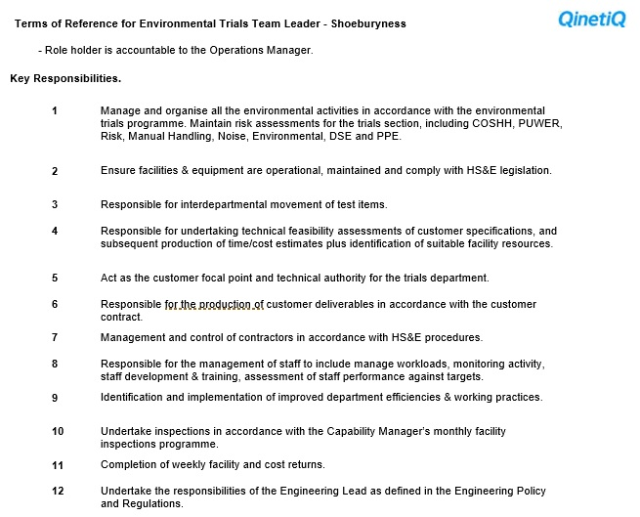

Appendix B2

The following is a list of objectives compiled by Ralph Whittaker, after having questioned the current Team Leaders at ETC Shoeburyness on their requirements of leadership.

The key elements of these specific Team Leader roles include;

- Weekly planning / provision of competent / capable team members to Dynamic and Climatic trial work / delegate trial work to working pairs of Technician and Engineers, communicate important site information / raise awareness of issues, receive feedback from team members regarding plan / scheduling / issues
- Collaborating with other team leaders on site to ensure ideas / plans / schedules collate and are parallel in achieving customer satisfaction and business objectives / vision
- Collaborating ideas with Planning Department regarding scheduling / availability of staff / facilities
- Instil a safe working culture across site
- Providing feedback to group leader / line manager regarding team / own development requirements / achievements and provision of future development plans / vision of potential upcoming issues
- Identifying / organising Training for team members
- Acting as immediate Line Managers to individual team members
- Structuring Personal Development Plans (PDP) with team members
- Monthly one-one meeting with team members to review and ensure they are on target to complete personal objectives and those that conform to the vision and aims of the business. It is also a chance for both parties to praise any achievement and raise any issues with progress or work processes.

Appendix C

Examples of QINETIQ leadership techniques

Below are Situational examples of where a leaders’ role is adapted in situ, hence in their role should perform the following;

Example 1.

Follower is unable and unwillingly/insecure a leader should:
- Set goals and define roles
- Develop an action plan to solve problems
- Control decision-making about how problem should be solved or task completed
- Closely supervise and evaluate the work of followers

Example 2.

Follower has some knowledge, confidence likely to be ahead of ability (unable but willing/confident)
- Set goals
- Develop action plan and consult followers for ideas, opinions and feelings
- Explain decisions to followers and ask for their ideas
- Support and praise followers’ imitative
- Evaluate work of followers

Example 3.
Follower has demonstrated ability but confidence needs to be built (able but unwilling/insecure)
- Involve followers in setting goals
- Ask followers to define how work is to be completed
- Work with follower to evaluate the work of the follower

Example 4.
Follower has demonstrated knowledge and is confident (able and willing/confident)
- Jointly define goals
- Allow follower to develop action plan and control decision-making
- Allow follower to evaluate own work
Allow follower to take responsibility and receive credit

Appendix D

A Summary of the QINETIQ Competency Framework 2002 by Ralph Whittaker

- Commercial Vision - Strategic Thinking: Ability to envisage a future for the business - Broad Scanning: Curiosity for new information, proactively gathering new data

- Rapid Engagement - Concern for the customer: Concerned to understand and meet customer needs, understands that customers are central to QINETIQ’s current and future success
- Influencing Others: A desire to influence colleagues and immediate stakeholders and gain their buy-in and commitment, a full understanding of the range of stakeholders (outside the business)
- Courage: Have confidence in own role and during uncertain or changing circumstances, using personal conviction about what is right for the business and belief in own judgement / capability

- Driving Ambition – Drive and Determination: Possess energy required to increase QINETIQ capability and readiness to deliver and improve business results through system and process enhancements and setting goals for personal / others to achieve
- Bias For Action: Identifying and seize opportunities / address problems and act as soon as possible, to look ahead with anticipation and act to support future developments

- Leading Others - Developing Others: Invest in the development of other individuals based on judgement that they can and are interested in growing / developing in their role
– Transformational Leadership: Channelling the energy of followers to coincide with the aims / future vision of the business. Going one step beyond the immediate requirement of the role, full engagement of leadership of the team by uniting followers and others to embrace the vision for change. – Organisational Insight: Desire to increase knowledge of operating environment including how QINETIQ and other organisations work, the current market climate and culture, the entire range of stakeholder interests and politics between individuals and organisations (partnerships / suppliers / customers), to maintain an understanding of operational behaviour (how and why they operate)

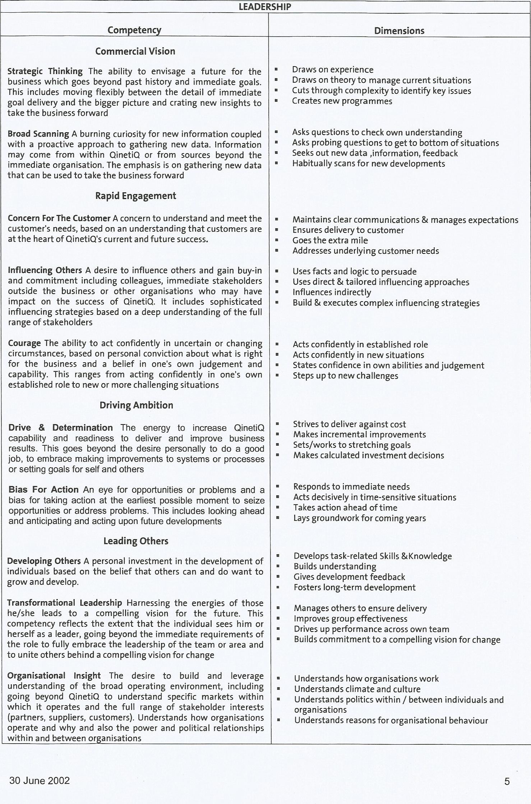

Appendix E

Blog from QINETIQ CEO, Steve Wadey

Acting on your feedback to resolve the ‘niggles’

Latest blog from Steve Wadey, CEO
14 July 2017

Back in April the EC travelled to over 30 sites to deliver the Q-Talk roadshow.
Whilst the majority of feedback we received was positive there were still two
key areas where we need to improve: resolving the ‘niggles’ of our new operating
model; and helping people understand how they can contribute. These are linked:
you cannot understand how you can contribute if you are not sure how you fit in
the new organisation.

To understand the ‘niggles’ in more detail, Ian Beresford, Group Director
Engineering & Operations, and I hosted a series of “collaboration” dinners with
our Integrated Delivery Team Leaders (IDTLs) and Heads of Discipline (HoDs).
These were enlightening. From their feedback and experience it is clear that our
operating model is not widely understood or being consistently applied. In
response we have produced a Quick Reference Guide to clarify the key Operating
Principles of how we run and organise our company to win and deliver
contracts/projects to our customers.

The Guide provides an overview of how a balanced matrix organisation works,
with customer focussed multi-discipline teams at its core, and gives a top-level
summary of how we govern and drive performance. It is the consistent application
of these Operating Principles that will drive the success of our company through
improved customer focus and competitiveness. The Guide provides sufficient
clarity for us all to fully embrace, make decisions and adopt this way of
working, based on our core values of integrity, performance and collaboration.
To support this Guide we also have work streams underway to support the smooth
running of our operating model such as development of key tools and integrated
resource planning etc.

My expectation is that each and every one of us in QINETIQ rises to the
challenge of making our new operating model ‘live’ in our company and takes
personal accountability for making it work. This is a critical enabler to our
growth. Each Business Unit and Function will be engaging their teams over the
coming weeks to help clarify the application of this model. Please take the
opportunity to discuss the Guide with your leadership team and ensure that you
fully understand how the balanced matrix model works and how you contribute,
through the customer focussed multi-discipline teams, to make it a success.

Steve

Appendix F

Blog from QINETIQ CEO, Steve Wadey

Roadshows: your opportunity to give us feedback
Latest blog from Steve Wadey, CEO
02 May 2017

During the roadshows we discussed the progress we made in the first year of our new vision and strategy. Thank you for a great year. We have made great progress and are in a strong place to deliver year two of our plan. As a result of the feedback we received from the roadshows in October we started to make improvements to our communication, accelerated the reorganisation by three months and included local slides to highlight local successes from last year and set out objectives for the coming year. I believe that it is critical that each and every one of us understands how we can contribute to growing QINETIQ and making it an even greater place to work.

