
A profile of chosen organization from the retail sector in the UK
Introducing the Modern Workplace
This coursework is based on a research of one of the UK leading retailer and Sainsbury’s profile and history was used has a case study from one of the UK retail sectors. The research highlights Sainsbury’s overview, strategy and focus area.
Georgiana Loredana Nedelcu
Student ID: 2018584

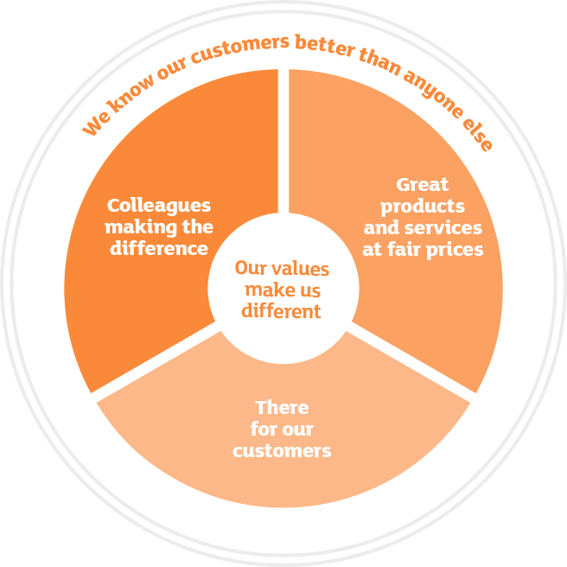
Sainsbury’s is one of the largest UK retails and it has been recognised has the second grocery in the UK with around 16.5% market shares. Sainsbury’s operates around 600 supermarkets and over 800 convenience stores and the supermarkets generate around 90% of business sales (https://www.annualreports.com/Company/sainsbury).
Sainsbury’s was incorporated in 1869, over 152 years ago and the founder was John James and Mary Ann Sainsbury’s, which they both open their dairy shop. The shop was based at 173 Drury Lane, London. England. (https://www.about.sainsburys.co.uk/about-us/our-business-strategy)
The shop became popular due to the fresh quality products they were selling at low cost (https://www.theguardian.com/business).
At around 1882, there were other shops opened by John James and Mary Ann Sainsbury’s in different locations in London. Some of the shops where located at Kentish Town, Stepney and Islington. They were becoming more popular in the capital as people visited the shops and they created the first Sainsbury brand product, which was Bacon in 1882 (https://www.theguardian.com/lifeandstyle)
In 1973, Sainsbury’s went into public and at the time, it was the biggest ever stock market venture capital. Over the years, Sainsbury’s was the largest supermarket in Britain and it was the most money making for many years. In 1995, its competitor, Tesco, overtook the business profit due to complacent of Sainsbury’s management. Sainsbury’s suffered because of lack of commitment to innovations at time, such as the introduction of loyalty cards. The previous chief or boss – David Sainsbury, notably dismissed at the time, mentioned that it is just an electronic green shield stamps. At a different time, another chief executive stated that he will increase the sales of Sainsbury’s by the end of 2007 to 2008, to £2.5bn by the end of the year. The chief executive then was called Justin King, and he was the previous boss of Mark and Spencer. Part of his strategy was to introduce celebrities into the food advertising, such as Jamie Oliver to promote the business (https://www.financialtimes/)
Over the years, Sainsbury’s has shifted away from focusing on just food. The business started selling more of home products, telecom equipment, clothing and other items. The company went further in their strategy to purchase the Home Retail Group in 2016. These purchases were Argos stores (a wide range of merchandise and electronics) and the Habitat online shops for £1.1 billion (https://www.theguardian.com/business)
Sainsbury’s recent business strategy stated that they will put food back at the heart of our business and they continue by mentioning that will build on the changes we have made as we helped our customers throughout the pandemic (covid-19). And their ambitions is to speed up the pace of change across the business, by simplifying the operations and accelerating the cost saving programmes so that we can invest more in food quality, innovation, choice and continue with lower prices for customers. The strategy went one step further by saying we will reduce complexity, transform our cost base by ensuring that our group and selections of brands supports our food focus. By so doing, we will improve financial performance and delivering stronger shareholder returns (https://www.about.sainsburys.co.uk/about-us/our-business-strategy).
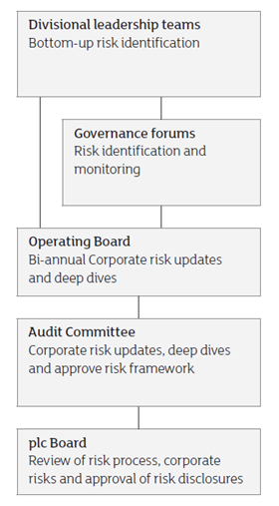
The current Sainsbury’s board is directed by Martin Scicluna. He and his fellow team are accountable for creating and promoting the long term approach and plan for the business. The team take steps in the interests of the shareholders, customers, stakeholders and ensure that they deliver the plans and the promises the business has put forward. Also, the board members focus on daily management of the group and the execution of the approach or the plans the board have set out.
Sainsbury’s upheld its group to the higher standard of corporate governance and applies the code of conduct of the UK corporate governance standard within its group. The code highlights the importance for effective boards, well balanced business, and risk management mitigations, arrangement of payment and compensation policies with interested parties or shareholders relations (http://www.about.sainsbury’s.co.uk).
Sainsbury’s independent audit committee examine the integrity and reliability of their financial details before publication and they review the systems and processes of the internal control of risk management. These risks and review also focuses on information, security and data governance in order to be certified by external audits process. As well as the constancy of significant accounting policies, major issues and how the issues were dealt with and the transparency and comprehensiveness of disclosure in the company’s yearly report and the background in which the report were made (https://www.about.sainsburys.co.uk/~/media).
In July 2021, the introduction of Sainsbury’s first electric refrigerated trailers was announced, which were 5 new electric trailers to its fleet. These 5 electric trailers have electric fridges and they are designed to be carbon friendly, which reduces air pollution in our environment. The trailers are made with new technology that will optimise UK energy efficiency, which is converting the kinetic energy into electricity to expand the battery life. Also, these will reduce noise pollution and the new trailers will add to the sustainable solution for transportation and groceries transferring in the local community. 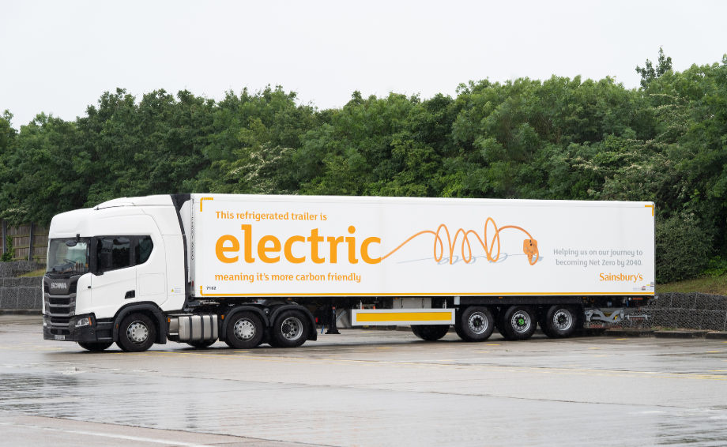
https://www.about.sainsburys.co.uk/news/latest-news
It has been recognised in the retail sectors that Sainsbury’s is the first UK retailer to launch an entirely electric refrigerated trailers to its fleet. These trailers are 100% electric designed and the purposed is to keep our customers food cold. Meaning, the trailers and the fridge in it does not release carbon emissions, such as smoke into the air, dirt or dust. The noise is mute with very low noise emissions and decreases the environmental impact on the planet, reducing energy consumption, as well as protecting local communities. These new electrical refrigerated vehicles by Sainsbury’s are evidence that we are committed to our sustainability policies to a better planet and continue to develop our net zero plan. This plan is a decade in advance of the UK Government’s own target and we will invest over £1 billion into fleet in the next 20 years, to reduce carbon emissions and reduce energy cost significantly (https://www.about.sainsburys.co.uk/news/latest-news).
In addition, here are some interesting things about Sainsbury’s and its stores locations in the UK;
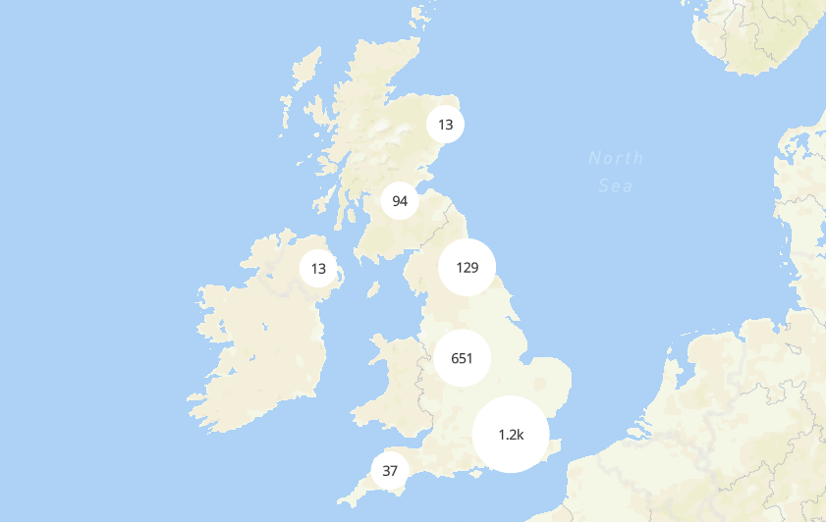
OPERATING INCOME In 2020
986 million
Number of locations:
1,428

152
Years
Revenue
In 2020
28.4 billion GBP
Net income:
£152 million
Employees (est.)  (March 2020) | 111,900
https://sainsburyarchive.org.uk
Conclusion
Overall, Sainsbury is the second UK biggest retail food and it has been trading for over 152 years. It mission is to help everybody to eat better and accessible to everyone. Currently, Sainsbury has over 1200 stores across the UK. In addition, the corporate responsibility and sustainability team evaluates the sustainability policies and strategy. The business development and plans on corporate responsibility are tracked and aligned within the business core values and initiatives from colleague and customer engagement.
Reference
https://www.annualreports.com/Company/sainsbury, accessed on the 20/08/2021
https://www.theguardian.com/business, accessed on the 19/08/2021
https://www.theguardian.com/lifeandstyle/2010/oct/16/sainsburys-great-dynasties-ian-sansom, accessed on the 19/08/2021
https://www.financialtimes/10/April/2007, accessed on the 19/08/2020
https://www.theguardian.com/business/2007/feb/02, accessed on the 20/08/2021
https://www.about.sainsburys.co.uk/about-us/our-business-strategy, accessed on the 20/08/2021
https://www.about.sainsburys.co.uk/~/media/Files/S/Sainsburys/Audit%20Committee%20ToR%202020%20Final.pdf, accessed on the 21/08/2021
https://www.about.sainsburys.co.uk/news/latest-news/2021/08-07-2021-sainsburys-introduces-first-electric-refrigerated-trailers-to-its-fleet, accessed on the 21/08/2021
https://sainsburyarchive.org.uk/


Organisational Behavior

LCBB4003 Introducing the Modern Workplace

Assessment 2-Organisational behavior Reflective report
Relationship between organisational structure and organisational performance

Student name: Valentina Ivanova ID: 2022735

TABLE OF CONTENTS
INTRODUCTION 3
MAIN BODY 3
Analysing the relationship between organizational structure and performance 3
CONCLUSION 5
REFERENCES 6

INTRODUCTION
Organizational behaviour is defined as the study of developing better understanding about how individuals collaborate and coordinate with others in an effective and appropriate way. The principles of this study applied mostly in attempts to make ventures whether small or large, operate more productively and effectively, which is quite beneficial for their progress in particular markets. The current presentation will be based on a specific topic and that is to analyse interrelationship between organization structure and performance of a company. Organizational structure plays a vital role in growth and development of organizations as it contributes to enhance a brand's productivity and enable it to be productive in industry, where it established their venture. An infrastructure of companies contributes to excellent growth of ventures. It is important in the context of varied firms such as Sainsbury that operate under retail industry and effort to give tough competition to main rivals like TESCO, ASDA, Morrison's, etc.

MAIN BODY

Analysing the relationship between organizational structure and performance
An organizational structure is described as an effective system which clearly outlines how certain activities and practices are directed & managed, in order to achieve the objective and aims of a company, such as Sainsbury.
While, organizational performance refers to the sum of actual results that a firm measures against their intended outputs.
Both these terms are related to each other and have a positive impact on performance of organizations. For example, effective and usage of appropriate organizational structure among a list of many, firms may obtain a lot of benefits as it assists to enhance their productivity and specify roles and accountabilities to each candidate.
In the world of business, there are varied forms of structures that organizations use available in bulk. Each company whether it is large or small considered, chose and used specific structure according to their size, scope, and number of operations. When the business format is appropriate, a firm may grow rapidly as it helps to increase their performance and profitability level.
For example, Sainsbury's uses hierarchical organizational structure that may put a positive impact on workers performance and then organization as this format may clarify accountabilities to all candidates in terms of dividing departments and directing employees who work under that about what to do and how. It may provide a lot of benefits to firms in terms of establishing clear lines of authority and comprehending among workers about their accountabilities and duties, which drive their attention to be productive and allow firms to be competitive. With this structure, supermarkets may develop an environment at the workplace that clarifies accountability to employees about strategic directions and actions they effort to take at varied management levels.
A company or business format is an essential and useful part of ventures, because it describes how jobs are formally separated, grouped and coordinated. The relationship between Sainsbury's structure and performance is based on clear understanding among existing and new employees about their duties, according to which they may act and take action. The structure is one of those elements that affect or influence work performance and productivity of candidates as well as their satisfaction level. Furthermore, the relationship between both concepts is analysed by analysing the productivity and profitability of a firm. For example, when the structure is appropriate, the organization may grow effectively and productively. On the other hand, poor and ineffective organizational structure may have a negative impact on business success and its operational efficiency, which is not acceptable and better for the brand. So it is quite essential to select and use those that help to create a positive environment and spread positivity at the workplace.
Hierarchy, functional, divisional, and flat are the types of organization structures that are accessible in the world of business and utilized by several firms on the basis of number of functions and operations. Each structure may affect the staff performance of Sainsbury's that was established in the United Kingdom and attempt to offer its quality services and products to customers. As a key element, the structure of a venture allows a firm to be productive and successful in terms of developing understanding about work, activity and practice that employees may have to conduct in an effective manner.
A structure defines who completes a specific task and how, which is quite important to specify for management to all workers as it may enable them to act accordingly and allow them to contribute to specific extent regarding aim achievements. Effective format may require that roles among employees may be clearly assigned and defined, which enable them to reduce risk of being failure and ineffective.
When the comprehension related to daily work is clear, then candidates may perform in a productive way, which in return increases organizational performance excellently even better than previous years or months. Effectiveness of organization structure may influence the way individuals and management within a firm react and respond to varied circumstances that may occur suddenly. It permits managers and leaders to take fast decisions about organizational growth and development within industry and also strengthen them to improve operating efficiency, which is important and beneficial. The best thing about hierarchical organization structure is that it contributes to reducing potential threat of duplication of work that puts a positive impact on brands as they may offer fresh and unique services without copying from others. It also provides facilities to communicate and coordinate with other employees who may help to develop or improve others effectiveness in terms of skills development, through which individuals may grow and allow firms to do so.

CONCLUSION
On the basis of above discussion, it has been concluded that by choosing and using hierarchical organizational structure, organization has gained competitive advantages, because it has contributed to increased its workers' performance level that directly or indirectly supported firms to perform productively and profitably. Furthermore, the company has enhanced the satisfactory level of customers successfully and increased its profitability more than other brands, as its employees had better understanding about whom they report to and who reported them at the workplace for the purpose of discussion. By using chosen structure, the firm has created a positive and productive working environment that boosted employees productivity.

REFERENCES
Books and journals
Joseph, J. and Gaba, V., 2020. Organizational structure, information processing, and decision-making: a retrospective and road map for research. Academy of Management Annals. 14(1). pp.267-302.
Koçyiğit, Y. and Akkaya, B., 2020. The role of organizational flexibility in organizational agility: A research on SMEs. Business Management and Strategy. 11(1). pp.110-123.
Waruwu, H. and et.al., 2020. The Role of Transformational Leadership, Organizational Learning and Structure on Innovation Capacity: Evidence from Indonesia Private Schools. EduPsyCouns: Journal of Education, Psychology and Counseling. 2(1). pp.378-397.

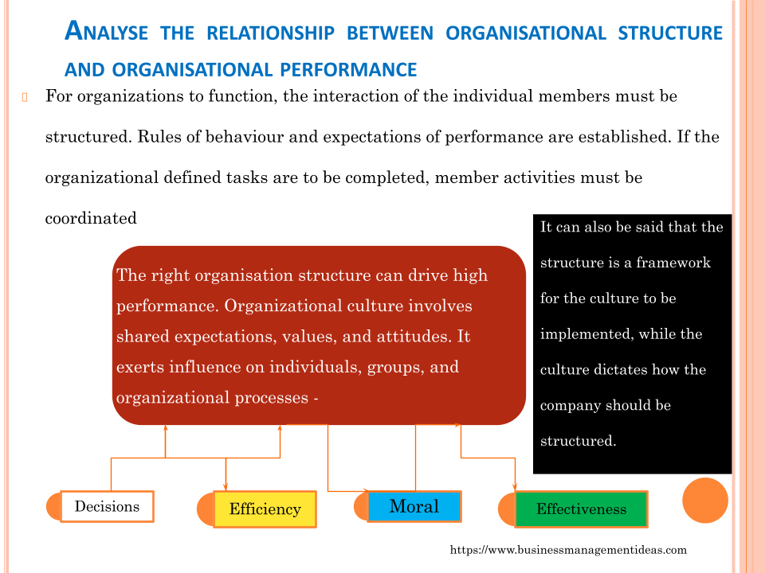

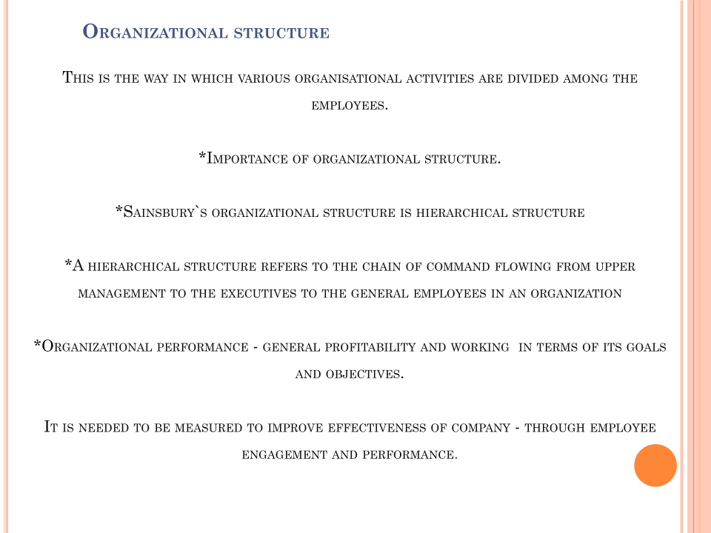

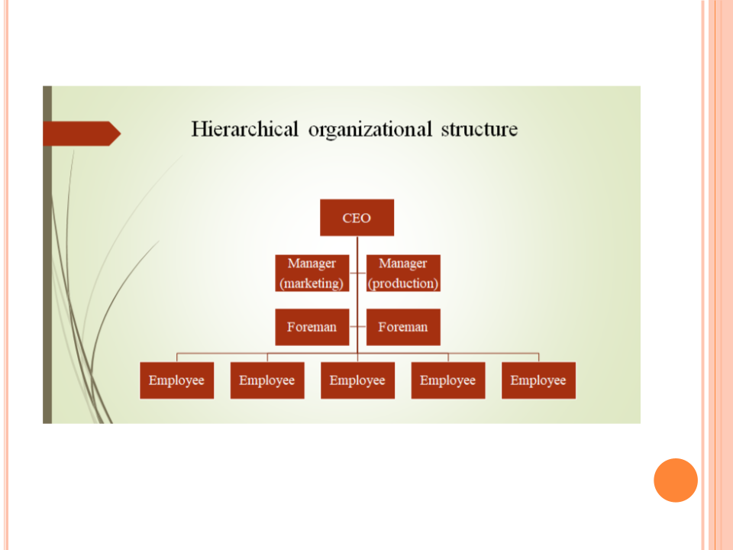

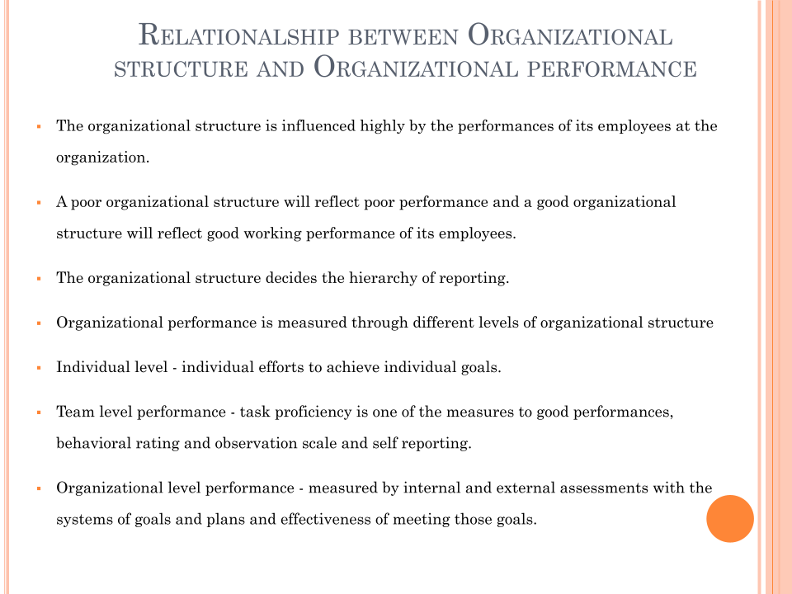

Organizational Behaviour

Student name: Gheorghe Bagatti
Student ID:2020309
Module Name:Introduction the Modern Workplace

Table of Contents

Analyze the different tasks and Skills, a manager can apply to ensure operational effectiveness in the chosen organization 2
References 5

Analyze the different tasks and Skills, a manager can apply to ensure operational effectiveness in the chosen organization
Organizational behavior is the key approach to both individual and group performance in an organization. It is the methodical study of identifying and influencing the working pattern of employees in the organization for drawing from further disciplines and creating an exclusive field (Nuckcheddy 2018). The report shall highlight an in-depth analysis of skills and tasks for management to drive operational effectiveness in the chosen organization, Sainsbury's. For ensuring effectiveness in business operations, the operational head of Sainsbury applies numerous approaches in the business extending from budgeting, decision-making, supply chain, quality management staff development to driving sound outcomes. However, it could apply multiple tasks and skills for driving operational success in the retailing business on a wider scale.
Clear Communication and Collaboration
For Sainsbury working in the wider context, it becomes pivotal to converse both externally and internally as to the status of business value proposition along with its achievement through the business operations and goals (About.sainsburys 2021). For ensuring effective completion of the task, the manager of the company strongly requires technical and communication skills. By developing an accessible and secure network of information amidst departments, Sainsbury’s managers could avoid bottlenecking of the procedures that cause enhanced costs and inefficiency. With the creation of a collaborative and communicative culture through effective problem-solving and communication skills, which rewards teams working together by the development of team having complementary abilities, the entire business of Sainsbury's would run much smoother and potentially have a consumer-focused framework within each department (Akramovich and Muratovna 2019). Attaining it places the effectiveness naturally. For communicating adequately with customers, the manager could use an advanced CRM thereby leverage data for anticipating their requirements. As an instance, if the data system of the company is getting multiple complaints or customer service requests regarding the same issue, the responsible departmental manager must stay aware thereby ready for fixing issues before its growth. Operational issues become an expense; therefore, the sooner they are nicked, the better is for the bottom line.
Understanding Delivery management
For ensuring the greatest quality of retail products, the delivery management tends to take the product management towards the upcoming level. For giving customers, the services that are being promised, the role of the delivery manager at Sainsbury's is synchronizing unanimous steps from processes and people for overseeing the execution (About.sainsburys 2021). For ensuring effective delivery administration, the manager could focus on developing data processing and risk analysis abilities further (Sadun et al. 2017). In integration with inner teams, the board of directors long with 3rd party vendors, delivery management tends to take the service or product via its life cycle for ensuring the optimum consumer experience. Delivery management in Sainsbury’s involves the communication around teams and access to the resources in the business for driving effectiveness.
Focus on Knowledge, Infrastructure Management and Operational Learning
Sainsbury's manager could apply training and development for establishing an efficient process. Operational learning needs employees' and managers' collaboration for being upon a similar page. Definition and documentation of best practices for every department in Sainsbury's thereby simplify it for staffs for information access (About.sainsburys 2021). Flexibility remains a key approach and during making change, the manager must have analytical and data for assessing move towards efficiency (Bag et al. 2020).
Leverage Technology with Resource Management
For attaining effectiveness, technology is significantly about to be a major part of the business equation. Making use of smartphones, laptops, and tablets they help in supporting employees as well as customers in staying connected to the business across the clock and from everywhere around the world. Key inefficiencies are likely to take place when employees at Sainsbury’s used to travel as an instance; however with technology, managers could avoid missing a beat, which could drive further productivity and efficiency(About.sainsburys 2021). For this task, the manager could need technical proficiency, decision-making skills, and strategic planning. The improvement in the technology indulges suitable resource management, which the manager could ensure using the budget management skills. The manager at the company could help teams in prioritizing and train them cross-functionally for eliminating every point of breakdown. Therefore, sickness of an employee or being on leave or vacation, or even resignation, could not drop any point of operational business process (Telukdarie et al. 2018). Additionally, with advanced software sharing methods, employees within the business could be committed to recent business functions thereby interpret the current position of the company's product in the life cycle. The manager must ensure that schedules and plans are not kept locked away.
Improve Employee and Customer Retention
On average, it has been observed that it costs around 5 times more for customer acquisition as compared to it does for retention. It reflects that the manager would focus on prioritizing customer retention for the avoidance of customer churn. The manager at Sainsbury's could undertake it in multiple ways such as offering incentives, being communicative, asking for feedback, rewarding the repeat and loyal customers as well as onboarding and nurturing potential customers (About.sainsburys 2021). To ensure such effectiveness in business operations, Sainsbury's operational head is likely to stress boosting strategic planning and staffs management skills. Considering employee retention in the business, the manager could hire accurately for culture and talent from the get-go as every time it trains a staff, it becomes costlier across unanimous resources indulging time, effort, and money (Rodriguez and Walters 2017). Offering attractive opportunities for continuous learning along with personal and professional development for enhancing employee satisfaction and thereby leads to a decline in workforce turnover. Furthermore, human resources become a key benefit to the operational effectiveness as they could design as well as facilitate innovative business practices.
Operational effectiveness tends to come down to all the work, which gets accomplished for providing customers with business propositions. The establishment of best practices and administration of knowledge, infrastructure, resources, and communication could help the company in optimizing it for effectively positioning processes, which reduces costs, also maximizes output thereby outperforming

References
About.sainsburys, 2021, [online] Available at: <https://www.about.sainsburys.co.uk/~/media/Files/S/Sainsburys/documents/reports-and-presentations/annual-reports/sainsburys-ar2021.pdf> [Accessed 14 August 2021].
Akramovich, I.M. and Muratovna, N.N., 2019. Importance of Peculiarities of Services in Management of Enterprises. Asian Journal of Technology & Management Research [ISSN: 2249–0892], 9(1).
Bag, S., Wood, L.C., Xu, L., Dhamija, P. and Kayikci, Y., 2020. Big data analytics as an operational excellence approach to enhance sustainable supply chain performance. Resources, Conservation and Recycling, 153, p.104559.
Nuckcheddy, A., 2018. The effect of personality on motivation and organisational behaviour. Psychology and Behavioral Science International Journal, 9(2), pp.1-5.
Rodriguez, J. and Walters, K., 2017. The importance of training and development in employee performance and evaluation. World Wide Journal of Multidisciplinary Research and Development, 3(10), pp.206-212.
Sadun, R., Bloom, N. and Van Reenen, J., 2017. Why do we undervalue competent management. Harvard Business Review, 95(5), pp.120-127.
Telukdarie, A., Buhulaiga, E., Bag, S., Gupta, S. and Luo, Z., 2018. Industry 4.0 implementation for multinationals. Process Safety and Environmental Protection, 118, pp.316-329.

ORGANISATIONAL BEHAVIOUR

Introducing the Modern Workplace LCBB4003
Simeon Taranov
Student ID:2022103

TABLE OF CONTENTS

INTRODUCTION 3
How leadership can inspire and motivate staff members to improve performances 3
CONCLUSION 5
REFERENCES 7

INTRODUCTION
The report is on an aspect of organisational behaviour, namely how leadership can inspire employees for bringing improvement in performance. The organisation chosen is Sainsburys which is a UK organisation under facilities of service providing.

How leadership can inspire and motivate staff members to improve performances
The transformational leadership approach is one in which a leader inspires and provides motivation for team members for creating changes which are positive in organisation. The style of leadership may increase morale of group which leads for innovation rapidly, improving resolution of conflicts, bringing decline in turnover and bringing an ownership sense in the team. The process of leadership is where followers and leaders raise one another to high levels of morality and motivation. At Salisbury, it has been seen that transformational leadership has brought influence on the employees and motivated staff to see the vision of their leader and align their objectives with that of the organisation (Veliu and et.al.,2017).
Transformational leadership is the process where following steps are taken:
- Encouragement is provided to team members.
- Clear goals are set with clear vision for employees.
- Support and recognition has been provided.
- Integrity and fairness has been modelled.
- Positive emotions are provoked.
- People are inspired for goal achievement.
In transformational leadership, leader provides motivation to employees for bringing change in them by self-motivating them for achieving the objectives. This leadership seen in Salisbury sees both team and leader develop qualities and skills as individual. This helps in better work management to take up tasks which are complex and help increase performance.
Effective transformational leadership for being effective, there has to be an inspirational and clear vision of future of team. Vision has to be outlining the organisation’s purpose being relevant for the business and mission like being done at Salisbury (Bakari, Hunjra and Niazi, 2017).

Motivation for the team
Transformational leader knows that with the purpose being very inspirational, there is requirement for believing in motivation that is common for employees to get influenced.
There are four components of transformational leadership:
- Stimulation which is intellectual: The leaders applying transformational theory at Salisbury not only challenge the status quo, but also influence to bring creativity among the followers. The leader gives encouragement to followers for exploring new ways of performing things and having new opportunities for learning (Veliu and et.al., 2017).
- Consideration which is individualised: The leadership involves support and encouragement to followers individually. For fostering relations that are supportive, leaders at Salisbury keep communication lines open for followers feeling free for sharing ideas and leaders can provide recognition of follower’s contributions.
- Inspirational motivation: Transformational leaders have vision that is clear and are able to infuse enthusiasm in employees for increasing their performance to fulfil goals.
- Influence which is idealized: Transformational leader serves as role model for followers. As followers respect the leader, individual is emulated and the ideals are internalised. This leads employees to do their best and achieve good results at Salisbury.

Behavioural theory of leadership
It lays focus on the behaviour of leaders. For example, the behaviour of leader in situations demanding the type of action. There are three types of leaders:
- Autocratic leaders: They have to make decisions and they do this on their own. This leadership style is considered suitable where there requires decisions to be made quickly and when there is no requirement for input and team agreement is not required for an outcome to be successful (Bakari, Hunjra and Niazi, 2017).
- Democratic leaders: They allow team for providing input before making decision, degree of input may vary from leader to leader. The style is prominent where agreement of team matters however it may be difficult for management where there are present many perspectives and ideas. At Salisbury there are leaders following this approach and employee giving inputs in making decision feels to be a part of the company’s decision-making and this further elates performance of individual.
- Laissez faire leaders: These are the leaders who do not interfere and allow people in team for making decisions. It works well when team is found to be capable, remains motivated and does not require high supervision. The behaviour may arise due to the leader being distracted and this is where leadership style may fail.

It thus, can be interpreted that the behaviour of leaders affecting the performance. Researchers have got realisation, that there are different situations where different leadership theories are suitable. The leaders who are best are those who utilise different styles of behaviour and choosing the right style of leadership for every situation (Islam, Furuoka and Idris, 2021).

Transformational and democratic leadership theories being followed at organisation help increase the performance of employees by making them feel part of the organisation by aligning their objectives with that of organisation. Thus, they feel to be part of organisation’s goals. Employees at Salisbury being motivated to bring change in themselves feel less of pressure and try to improve upon their shortcomings. There being free flow of communication with leader, employees can share their thoughts and bring change in themselves. Energy and enthusiasm of the leader is bound to reflect on the employees also thus bringing their performance up. Democratic style being followed allows employees sharing their ideas in bringing improvements in their departments and ultimately assist in organisation’s decision-making thus joining them in the significant decision-making process with the management and it not only infuses enthusiasm in them but also leads them of thinking of new ways for supporting changes in organisation and also being acceptable to changes.

CONCLUSION
It can be concluded that leadership styles influence employees’ performance and help in boosting creativity. The report discussed the theories of leadership, their effects on employee performance in the organisation and the relevance of motivation for increasing performance.

REFERENCES
Books and Journals
Veliu, L., Manxhari, M., Demiri, V. and Jahaj, L., 2017. THE INFLUENCE OF LEADERSHIP STYLES ON EMPLOYEE'S PERFORMANCE. Management (16487974), 31(2).
Bakari, H., Hunjra, A.I. and Niazi, G.S.K., 2017. How does authentic leadership influence planned organizational change? The role of employees’ perceptions: Integration of theory of planned behavior and Lewin's three step model. Journal of Change Management, 17(2), pp.155-187.
Islam, M.N., Furuoka, F. and Idris, A., 2021. Mapping the relationship between transformational leadership, trust in leadership and employee championing behavior during organizational change. Asia Pacific Management Review, 26(2), pp.95-102.
Ma, X. and Jiang, W., 2018. Transformational leadership, transactional leadership, and employee creativity in entrepreneurial firms. The Journal of Applied Behavioral Science, 54(3), pp.302-324.

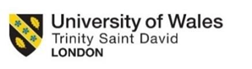

Mihaela Dodoc

Student ID: 2022006

An analysis of factors influencing group and team behavior

This study attempts to analyze the factors that influence the behavior of the group and work teams in Sainsbury's stores. In this presentation, I will talk about teamwork about its importance and about the important factors that motivate the team or not. The purpose of this presentation is an analysis of factors influencing group and team behavior at Sainsbury.
The behavior of the team or work group in an organization has become a very important topic because it depends on the success of the company they belong to. The behavior of the team is influenced by the environment in which it operates but also by the management of the organization.
Teamwork is most effective in any large organization. It is basically a method of improvising the activity, productivity, maintaining the motivation, skills and commitment of employees (Mullins, 2002, p.466).
Teamwork brings people together and motivates them to rely on one another to get things done. Also makes progress easier and allows the group to overcome obstacles that would have stymied an individual. Without teamwork, none of that would be possible. The benefits of teamwork include increased efficiency, the ability to focus different minds on the same problem and mutual support. When a team is able to work well together they accomplish more than individuals can do alone. This helps a company save money while being more competitive in their market.
Instead, there are several factors that can influence the behavior of the working group and the performance. Among the factors that influence the behavior and performance of teamwork we list: communication, empowerment, leadership, the style and methodology of group leadership. Each of these factors plays an important role in influencing team performance and results.
Communication is essential in any organization in order to solve any problem and continue the activity. Communication is how labor is divided, ideas and problems are discussed, problems are solved. Regarding the communication of the team, it can be done either face to face, or in a meeting at a table, or by video conference or by email. The environment must provide the team an open communication space, must be relaxing so that each member of the team can express their ideas without any restraint. It is important that each team member can feel comfortable so that they can express themselves freely. In an organization, communication is the most important, because it is the source through which employees can cooperate and collaborate together to achieve common goals.
Leadership is another factor as important as communication, as it helps the group achieve organizational goals. Therefore, leaders can strongly influence team connection, goal setting, and achievement (Trent, 2003). Organizations thrive on effective leadership and suffer in many ways from bad leadership. Leaders are responsible for designing the vision and ultimate goals of an organization, so leaders have a duty to make decisions that are as beneficial as possible in order to reach the target.
Most critical decisions are coming from director board. According to the article “Exploring the impact of higher management's leadership styles on Lean management” there are several types of leadership among which: Transformational leadership, Servant leadership, Empowering leadership.
Sainsbury combines leadership with management so that work teams from different shifts have good communication, especially when it is necessary to supply the store with products.
A good leader will encourage employees and motivate them to achieve the best results. If managers are to be professional and efficient in their role, it is important for them to be aware of how they act - what kind of management style suits them best and will work in their team and organization. Adopting the right style helps managers build relationships, trust and respect, hire team members and build and maintain good working relationships. Store managers are the key to success because the good functioning of the store employees depends on them, the relationships built with them creating a welcoming atmosphere for customers.
Empowerment is a method by which a manager expresses his authority and thus entrusts another person with various tasks to perform. This method of empowerment gives the other self-confidence and motivates him to perform the task for which he was empowered. It is a common method found in many organizations and often brings exceptional results.
In order to empower someone, we must first know if those people understand what tasks have been used for them and especially that they are able to complete them. When the manager empowered the teams with various tasks, then the team needs to know all the details in order to perform the tasks as correctly as possible.
Empowerment can also positively influence team behavior if used properly so that team members feel motivated to perform tasks as well as possible. A motivated team brings the best results in a short time. And that is strictly up to the leader of the organization.
If a good leader knows how to motivate the team then the whole organization will achieve success.

Conclusion
This essay examines the factors that influence the behavior of Sainsbury's work teams. It can be clearly seen that people are the key factor and individual behavior proves belonging to the group and further to the performance of the entire team whose role is to achieve common goals. The power and success of an organization is represented by the teams that are either well led and motivated and get the best performance or do not communicate effectively and there are internal conflicts and then the results will be commensurate. A good leader who will lead a team effectively will make every member of the group feel motivated and his role is very important. Each team member has a different personality and only a good experienced leader will be able to adapt to each of these so that there is a strong connection between all team members.

References
Environmental and social factors influencing wolf (Canis lupus) howling behavior. David E. Ausband1 | Sarah B. Bassing2 | Michael S. Mitchell3
Strategic leadership : theory and research on executives, top management teams, and boards Oxford University Press.; Donald C Hambrick; Albert A Cannella; Sydney Finkelstein c2009; New York ; Oxford : Oxford University Press
Mullins, LJ (2007), The Nature of Leadership, Management and OB (8e)

