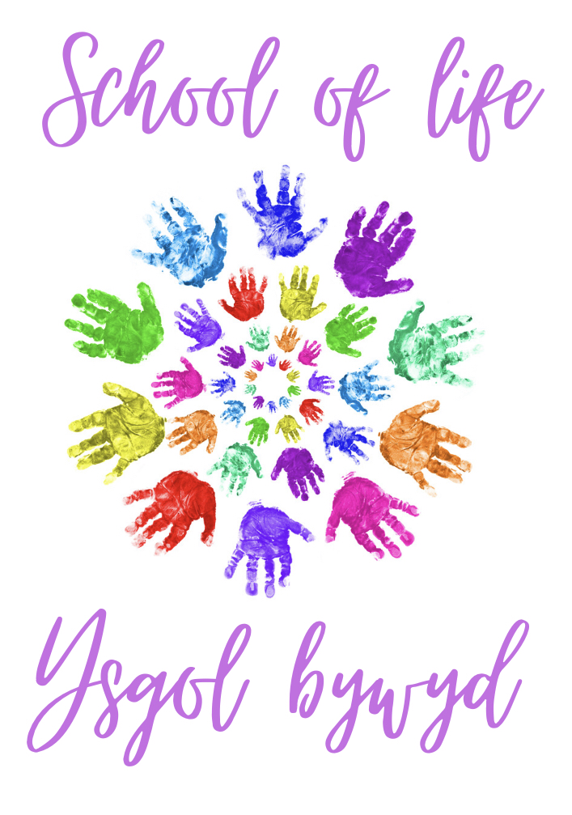
School Prospectus 2020-2021
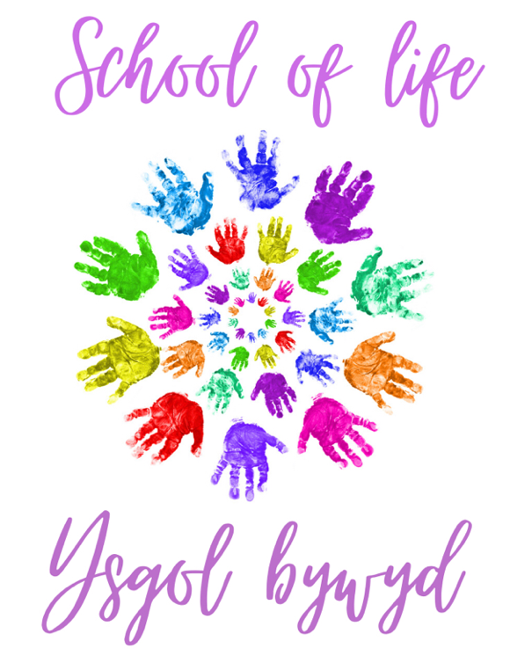
Dear Parent or carer,

We welcome you and your child/ children to the School of life, ysgol bywyd. During the time your child is in our care we will ensure he/she feels happy, safe and secure and that they receive the best Education.

As a school we will be working closely with you as parents to ensure your child has the best education. Your part is extremely important to ensure your child gets the best out of their time in our school. We cannot reassure you how important your support is.

When your child starts in our Nursery class here at school of life, we ask that you support your child whilst they adapt to the new environment and the new challenges which may be faced by your child, this can be very challenging for you as the parent/carer and the child and your child’s early years experience is essential to build a foundation for their future at our school.

Please do not hesitate to contact me if you have any questions.

Mrs L Jones, Headteacher.
School of life
Ysgol bywyd
Clordir Road
Pontlliw
Swansea
SA4 9EY

Tel: 01792 677844
Email: admin.school-of-life@swansea.gov.uk
Website: www.school-of-life.co.uk

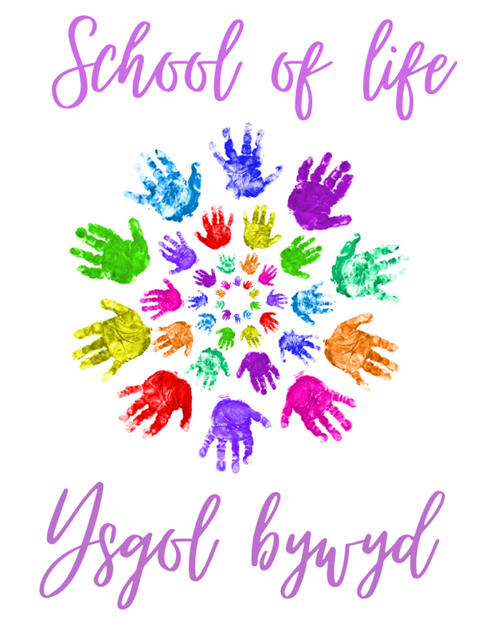
Contact us
School of life
Ysgol bywyd
Clordir Road
Pontlliw
Swansea
SA4 9EY

Tel: 01792 677844
Email: admin.school-of-life@swansea.gov.uk
Website: www.school-of-life.co.uk
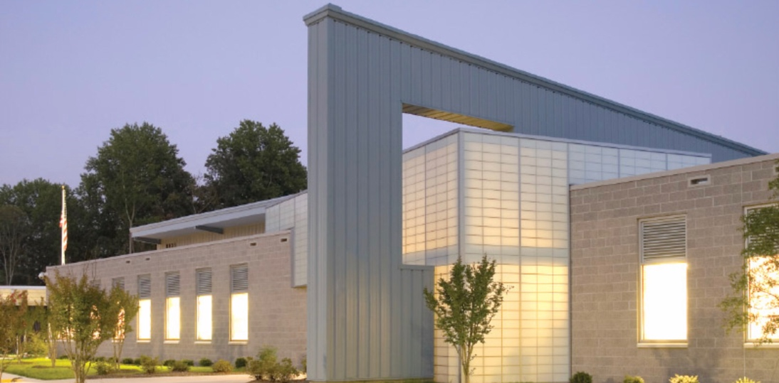
Headteacher: Mrs L Jones
Deputy Head: Mrs C Thomas
Assistant Head: Mr E Davies

Chair of Governors: Mrs Dickinson
Vice chair: Mrs Cusack

The Governing Body can be contacted through the school.
David Hartcorn (2010) ‘Purposeful Architecture’.
Contents
Welcome to the School of life, Ysgol Bywyd .………………… 5
Definitions and quotations ……………………………………………..6
Our School Values …………………………………………………………..8
Aims and objectives …………………………..……………………………9
Curriculum statement ……....……………………………………………11
How do we teach our pupils? .………………………………………..13
School hours and attendance …………………………………………14
Term dates and bank holidays ………………………………………..15
Health and well-being ….…………………………………………………17
School curriculum …………………………………………………………..19
Primary department ……………………………………………………….21
Secondary department ……………………………………………………23
Post 16 ..………………………………………………………………………….25
Welsh, RE & Sex Education ……………………………………………..27
Family engagement …………………………………………………………30
To Conclude ……………………………………………………………………33
Reference list ………………………………………………………………….34

Welcome to the School of life,
It gives me great pleasure to welcome you to the School of life, which caters for children and young people aged between 3 and 16 with a range of severe, profound and complex needs. The school also caters for those who have a range of learning difficulties including those with Autistic Spectrum conditions. Selecting a School that will meet the needs of your child and to provide the best Education is one of the most important decisions that we as parents have to make for our children, The intention of this prospectus is to assist you in making that choice. On the other hand, this prospectus cannot provide all the answers to questions you may have, and if parents are interested in their children attending the School of life, are encouraged to visit the school prior to making a decision.

The school of life is located in the Swansea area in Ponlliw, the school has been adapted for those with complex needs and our school has first class facilities to accommodate those pupils who need. The school was discovered back in 2001, and has been adapted over the recent years, the school catered for mainstream school children and over the last five years the school has been renovated to cater for all.

It is one of the largest schools in the Swansea area, and provides an excellent education for over 300 pupils, from Swansea and other neighbouring authorities who have statements of Additional Learning Needs.

The School of life has always been at the heart of Additional Learning Need Education. Our school has a outstanding reputation, and I look forward to meeting you and taking you around the school. With. Best wishes, Mrs. Llinos Jones (Headteacher).

Ysgol bywyd

Definitions and quotations
“The government, in their Green Paper published in September 2003, introduced and outlined their ambitious plans for transforming services for all children and young people, and in particular the vulnerable or those at risk of poor outcomes, in order to protect, nurture and improve their life chances and well-being outcomes in relation to them being healthy, staying safe, enjoying and achieving, making a positive contribution, and achieving economic well-being”. Cheminais (2010).

“The Education and Inspections Act 2006, Section 38(1), effective from September 2007, placed a new duty on the governing body of primary, secondary and special maintained schools, pupil referral units (PRUs) (now short stay schools) and academies, to promote the well-being of pupils in terms of the five ECM outcomes that go to make a good life:
- Their physical and mental health and emotional well-being
- Protection from harm and neglect
- Education, training and recreation
- The contribution made by them to society
- Their social and economic well-being”

Cheminais (2010).

Every Child Matters (ECM)
“ECM was originally introduced for the purpose of bringing agencies together to safeguard children. It was not designed specifically to raise standards. ECM is about the whole child, whereas standards are about the school. ECM has become a universal entitlement for every child, as it is about doing things for all children, and not just for a few”. Cheminais (2010).

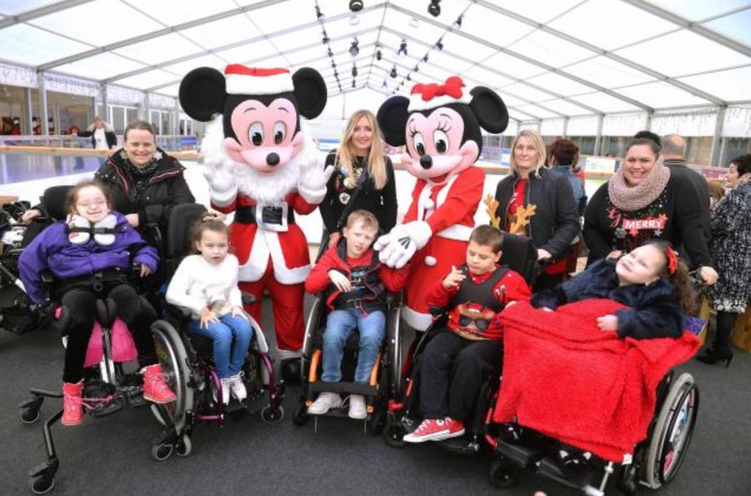
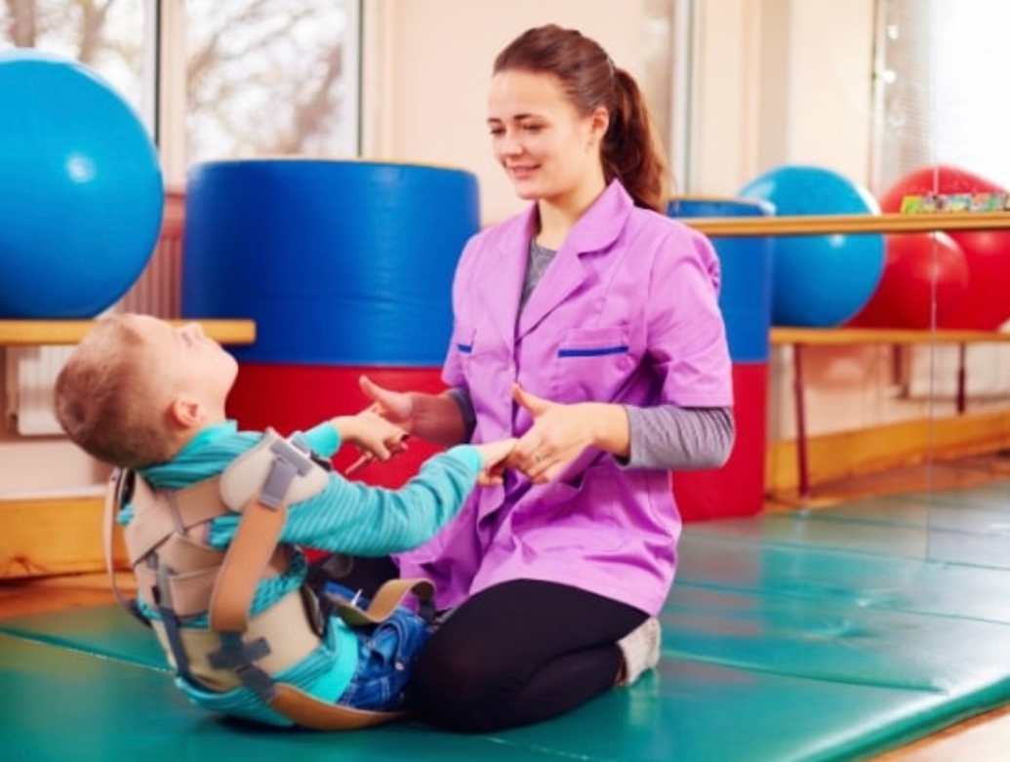
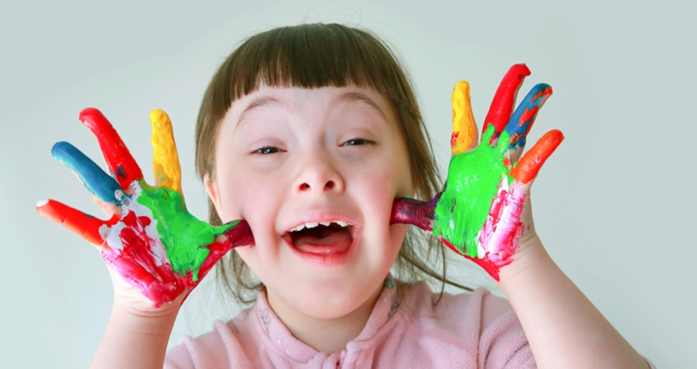
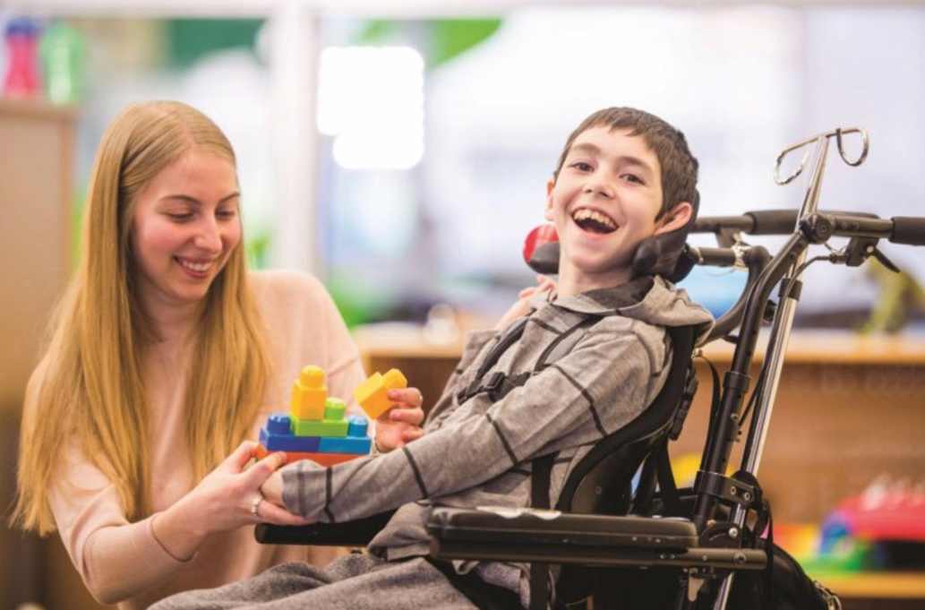
Ferguson, S. (2018) ‘Wheelchair ice-skating a hit at the Celtic Manor’. [picture]
Maher, C. (2018) ‘How to explain special needs to a child’. [picture].
FTF (2018) ‘If your child has a special need’. [picture].
United way of palm beach county (2020) ‘special needs recourses’. [picture].

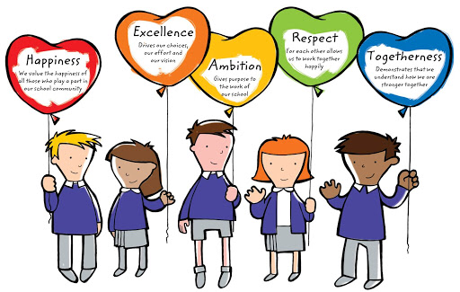
Our school values
Pensford Primary school (2020) ‘our mission statement, vision and values’.
School of life Values:
- Happiness
- Excellence
- Ambition
- Respect
- Togetherness
Our non-negotiable aspiration is that:
School of life is a place where children and young people feel happy and secure and where everyone is valued and respected for who they are.
School of life aspires to be:
- A school for children and young people with additional learning needs, with high expectations for all children in the school.
- Providing a welcoming and motivating learning experience for all children within out school.
- A school in which is engaging, providing relevant curriculum where each child is supported, challenged to their needs, inspired and to e sure that they are happy and safe.
Aims and objectives
- Create amazing opportunities for our children to learn through direct experiences within a happy, caring environment which motivates learning. According to Inhelder et al (1976) they stated that promoting purposeful learning allows children to develop lively and enquiring minds, and this is done all through hands on experiences.

- Develop children’s understanding, regardless of background and ability by providing different ability tasks that allow children to succeed. We as a school will encourage the development of the imagination and reasoning.

- Prepare each child to become a responsible member of their society by placing an importance on values such as honesty, perseverance, respect and tolerance for others and courtesy and also the willingness to make 100% effort and produce their best at all times regardless of any disability.

- Develop ambitious, ethical and healthy learners. Each child has an important contribution to make to our society and also the ability to be good in some areas. We will provide the opportunity to experience enjoyment and pleasure whilst completing tasks and ensuring all our children and young people are aware of their contribution to the school, the community and the environment by providing experiences that will nurture this knowledge.

- Creating strong and close links between staff and parents/ or carers in order to make the process of learning smooth. Providing a variety of social activities that will enable children to be aware of their language and their culture and their place in the world and develop their social and communication skills.

- The ability to be who they are, and to ensure that their needs are met and that each individual is treated equally.



ICMEI (ND)
Kairzhanova (2016)
Our aims for our learners are that they:
- Develop knowledge and understanding of who they are and that they are proud of their identity.
- To show and understand a concern for the environment and to acknowledge their responsibilities as global citizens.
- To show independence with their thinking skills and creativity, and to explore their world that they live in and to try new things out.
- To have an expanding ability to respond to a range of changes and are equipped for developments within literacy, numeracy and technology.
Our school ethos is that:
- Promotes respect, empathy, teamwork and tolerance.
- Teaching, learning and behaviour are set to high standards to ensure the pupils meet this criteria.
- Values each individual, nurturing growth and development.
- Creates a safe, secure and caring environment where each individual is included.
Curriculum statement
The school has clear targets to maintain standards at all times. We carefully monitor test results, teacher assessment and reading test and then we analyse them. The information is used to set performance targets for each class.

Our school teaching styles are chosen to meet the learning needs of all the children. Direct and indirect techniques are used to encourage children’s learning so that they have opportunities to learn through investigation and exploration, and according to Masquita et al (2015) stated that indirect learning can promote engagement and Eratay (2020) stated that direct learning has an important part on children’s lives in the society, to be able to develop social relationships. Through receiving instructions, this can be difficult in some cases due to additional learning needs, therefore any communication from the child is accepted as these individuals may find it difficult to communicate in certain ways, on the other hand according to Eratay (2020) stated that activities which are direct can be beneficial for children and young people with additional learning needs as it has a important part on their lives as it improved their motor and social interaction. Therefore, play can be seen as a vital tool in our school, according to Hoyles (2019) stated that play is vital for children and young peoples mental health and also it is the foundation of learning. On the other hand, if there is no opportunity to learn through play, Hoyles (2019) stated that it can result in lack of confidence and of course we as a school encourage confidence in our children, and according to singer et al (2006) stated it can lead to depression. Vygotsky (1967) noted that play was a vital tool for development of the child, Mooney (2000) also noted that John Dewey had the same thought that play is a vital tool to education, learning and development.

Continued…
In our school we have around maximum of 7-8 pupils in each class to ensure that we meet the needs of all children, and there are around 6-7 members of staff depending on the needs of the children and of course the staffing ratio. As a school we believe that Maslow Hierarchy of needs is important to us in our school and to ensure we do the foundation tier first and then move up, and according to Koltko-Rivera (2006) he stated that we need to build a foundation and then look to move the children up, by jumping up stages will not benefit the child. Gawel (1996) stated that Maslow believed people follow in sequence, and believed this was the best way. As a school we ensure when moving children up the Hierarchy of needs pyramid we ensure that the children are ready to move up. Children in each class range in their needs and abilities, and teachers plan activities and then use techniques which then give all the children an opportunity to succeed. This is the process of differentiation.

The school provides extra curriculum activities after school such as signing, swimming, acting, dancing, therapy, after school club and more, there are a range of activities throughout the week and provide extra support for not only the children but also the parents/ or carers. According to Perry (1998) she stated that after school club is beneficial for children’s experiences and also puts fresh experiences with the child, the child is also able to learn new skills and also to develop their social skills. By developing different skills, it allows the child to gain confidence in themselves and according to Educational Journal (2019), they stated children can develop their confidence with nature, and with after school clubs that we offer in the school children will gain confidence within themselves in our very own nature reserve, and our gardening clubs. Whilst doing gardening activities it encourages children to grow their own fruit and vegetables and according to Almers et al (2018) they stated that gardening and and outdoor education will encourage children to eat healthy, have better academic results, better social skills and higher self-esteem why not give your child the extra education with our after school clubs.
How do we teach our pupils?
Disability Mary Land (2020)
All our pupils have individual learning programs, and these are to address that each child is different and learn in different ways. In the learning programmes there are targets for improvements and these then are reviewed annually, the targets are too allow the practitioner to work on those targets when planning tasks.

Each child will have an individual planner, and these will identify their termly targets, these are sent home so that parents are aware fo what targets they have, and they will be implemented in school.

Within the school we have a multi-sensory room, therefore we have a multi sensory learning approach to learning, and this will enable all children to access the curriculum appropriately based on their needs. We b elite as a school positive behaviour management and we celebrate each child’s success, and this shows the child no matter how small the step is, your still closer to your goal. It is important within our school to ensure the children are praised to ensure positivity within our school.

Allowing the child to have a voice is one of our main key points, listening to the child’s voice is important feedback for our staff and our children. Person centred approach reviews will provide us as staff, parents, carers, professionals to engage as a whole to forward a plan for the future of the child.
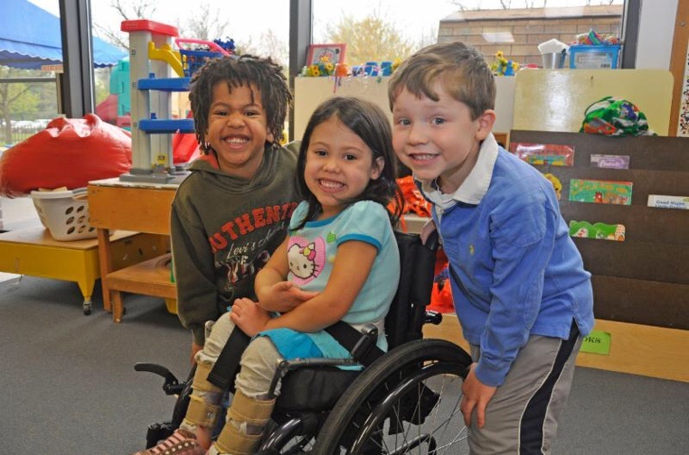

School hours
School hours:
The children will arrive at the school around 8.40 a.m. and will be collected by their class staff and taken to their classroom. In the afternoon the children are taken out by their class staff to their allocated transport at 3.00 p.m.

Start: 9.00 a.m.
Finish: 3.00 p.m.

Lunch: 12.00 p.m. (Primary)
Lunch: 12:30 p.m. (secondary and post 16)

Attendance
As a school we believe that attendance is vital to children and young peoples opportunity to reach their full potential. Through coming to school every day the children and young people will meet their targets set at the beginning of each year and will make progress, if however, your child is absent for any reason, it is important to let the school office know as soon as possible via our telephone number 01792 677844.

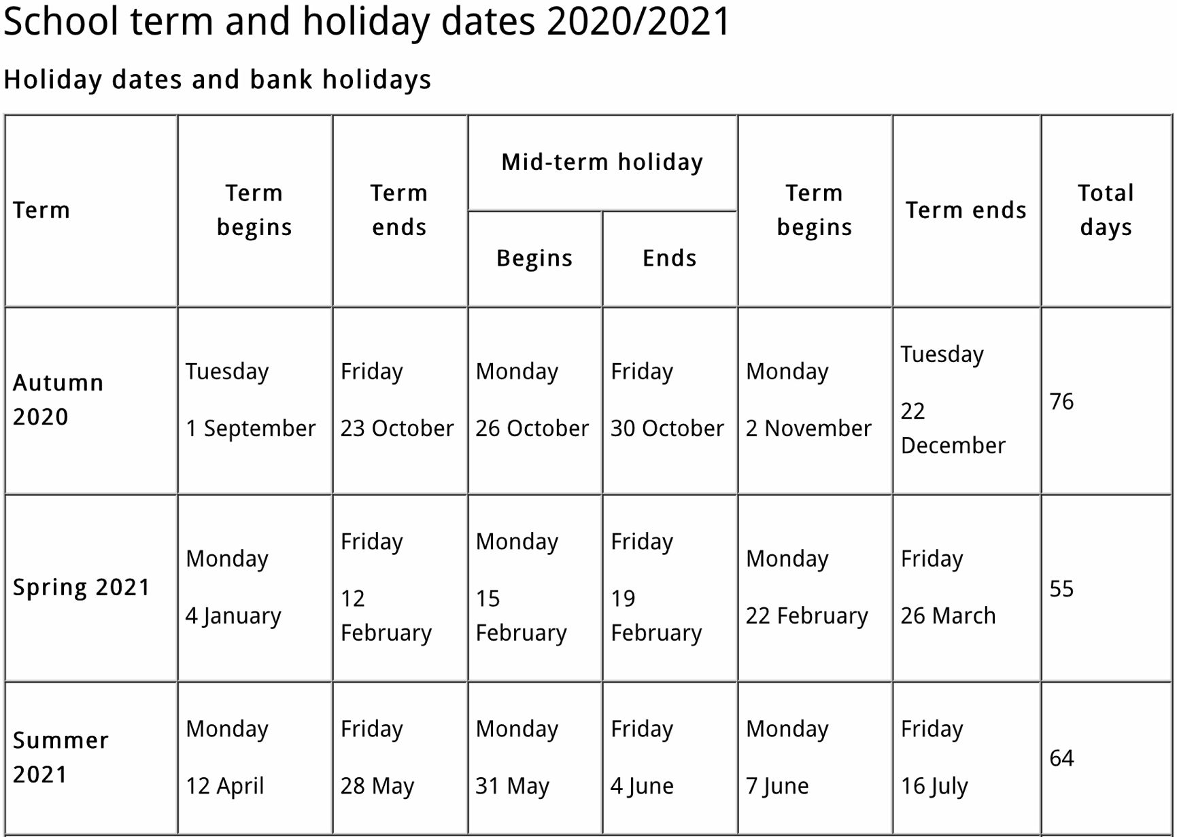
Term dates

Swansea Council (2019) ‘school term and holiday dates 2020/2021’.

Bank Holidays
2 April 2021 - Good Friday

5 April 2021 - Easter Monday

3 May 2021 - May Day

31 May 2021 - Spring Bank Holiday

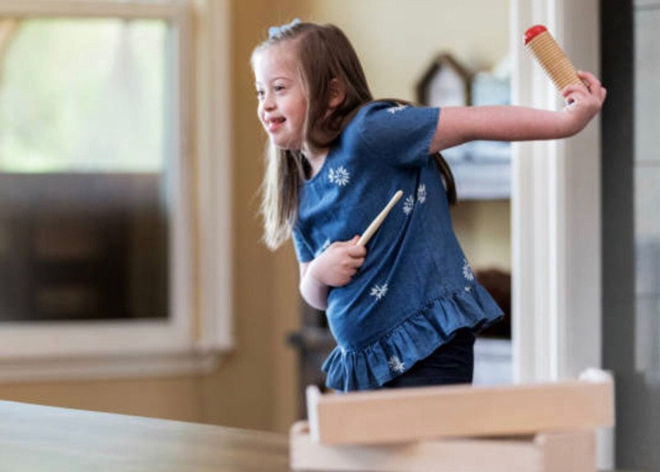
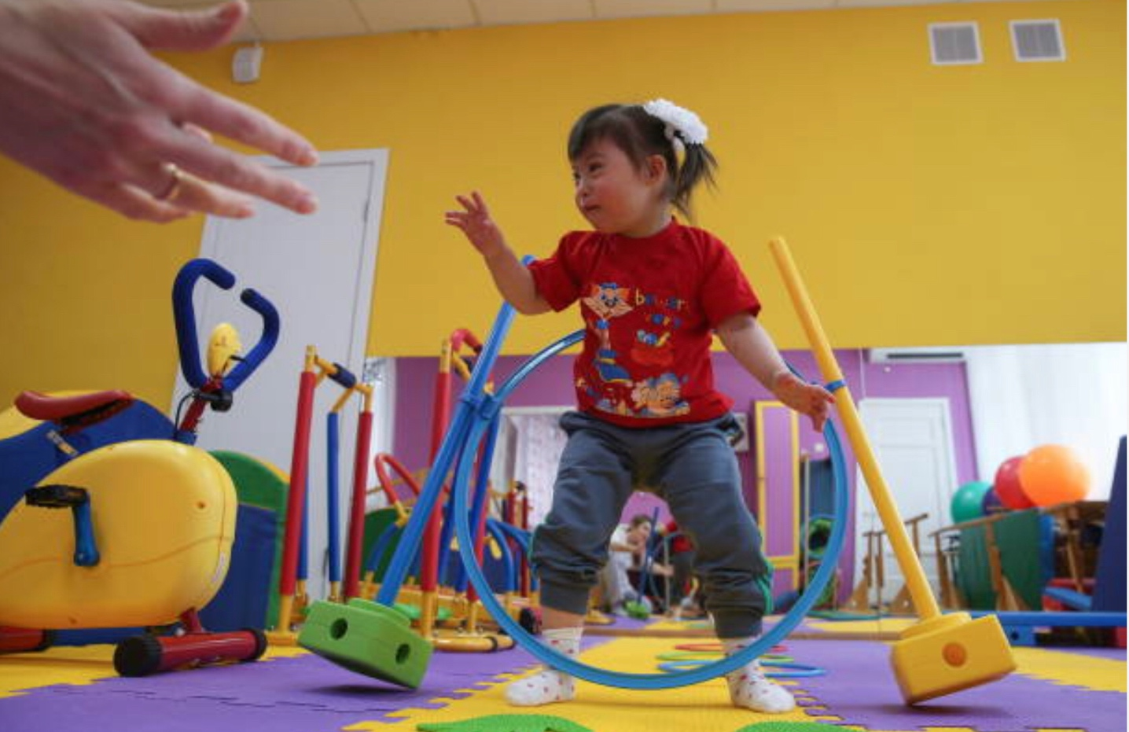
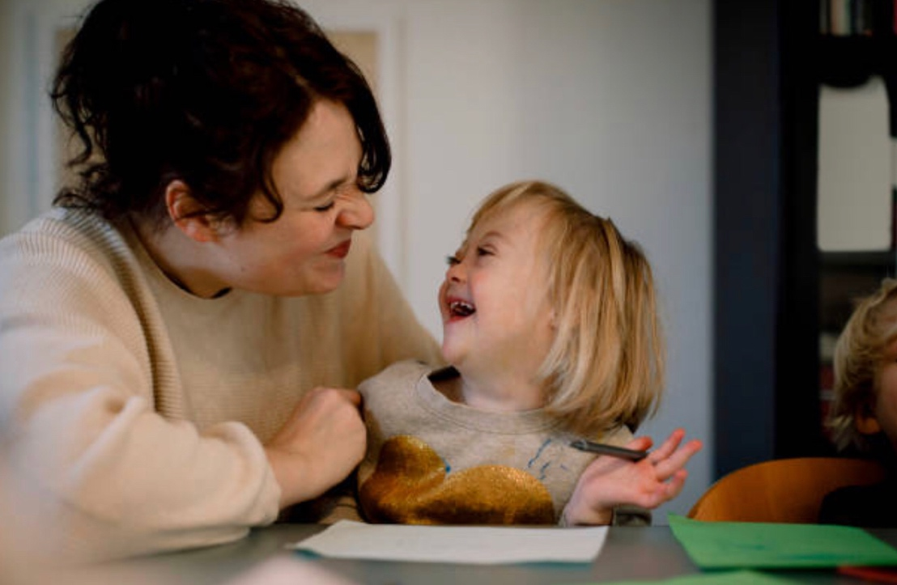

Gettyimages (2020) ‘special needs images’. [picture].

Health and wellbeing
We have placed Health and Wellbeing at the heart of our curriculum. We firmly believe that a child who is happy at school is a child who is ready to learn. According to Fabri and Fortuna (2020) they stated that a Maria Montessori’s method of teaching is still used throughout school today, and a child who is happy and healthy will learn best. This is seen as beneficial for children’s learning and development.

Healthy eating within the school will be promoted at all times, and according to Mikkelsen et al (2005) , they stated that healthy eating in schools is important as the rise in obesity and children overweight is increasing. Children are getting into eating habits which may result in these health risks.

Risk Assessments will be taken regularly to ensure that the buildings are safe for the children, the staff and visitors.

There is a school nurse at our school permanently for the children, due to health conditions it is required for our school to have a nurse here full time. The children will have routine health checks with the schools nurse and therefore will be checked regularly, and parents or carers will be informed of any further treatment that is necessary. If a child is feeling unwell or has had an accident parents or carers will be contacted, unless there is a minor injury which is able to be treated at school with our first aiders.

If a child requires medicine at school, our nurse or our reception team will administer it and will need to be signed in prior to the child arriving at school and signed home at the end of the day. The medication must be prescribed to your child and have their name labelled on the medication.

our multi-professionals within our school
We have a range of professionals within the school such as:
- Speech and language therapist
- Paediatrician
- School nurse
- Physiotherapists
- Occupational therapists
- School councillor
- ELSA
- Psychology assistants
- Teacher of the visually impaired
- Hearing impaired assistant


Mayo, A. Woolley, A. (2018)
School curriculum
As a school we provide a happy learning environment which is both secure and challenging and where each child is able to develop their ability, talent, maturity, social interaction and of course increase their self-confidence.

School of life offers a range of different learning experiences to all of our pupils. The Foundation Phase Curriculum and National Curriculum are taught at our school at ranges of different levels to meet the needs of our pupils.

Our main key aim is to equip and prepare our pupils for life after school of life, and providing them with the necessary skills that they will need for later on in life. We enable all our pupils within the school of life to develop communication skills and to effectively interact with the world around them, we take each day as it comes, and we understand that not two days are the same.

We use the foundation Phase as our Curriculum for children aged between 3-7 years old and the Welsh Government (2015) stated that it was introduced in 2010 and there are seven areas of learning which your child will engage in and that it encourages children to be creative and imaginative and makes learning more enjoyable for children. The seven areas of learning are:

- Personal and Social Development and Wellbeing
- Language, Literacy and Communication Skills
- Mathematical Development
- Physical Development
- Multicultural Understanding
- Knowledge and Understanding of the World
- Creative Development

We try and encourage our learning through play to meet the needs of our children, and according to Hoyles (2019) stated that learning through play develops social interaction and we feel children benefit from this Much better and it is a life skill that they are able to use for life.



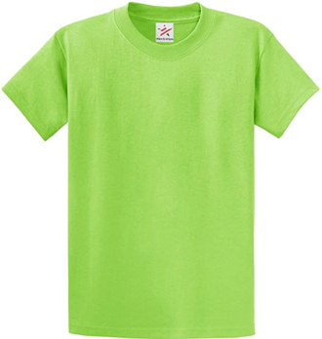



Staff uniform
MONDAY TUESDAY WEDNESDAY THURSDAY FRIDAY
Here is our staff uniform, we have different colours for the days of the week. We have done it this way so that children learn the colours of the rainbow, and that the members of staff stand out on the school yard.

school Transport bus
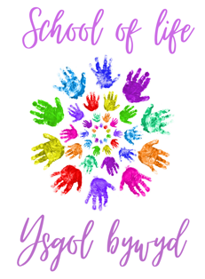
Primary Department
Our primary department are given a range of experiences for the seven areas of learning within the Foundation Phase. Our primary department is divided into six classes, this includes the Foundation Phase and key stage 2 learners. The curriculum within our primary department is delivered in a stimulating, structured and exciting environment where all children are encouraged to reach their full potential, we aim to ensure that the children are aware of each task throughout the day to provide structure for them. Within our primary department we have touch therapy, aromatherapy, massage therapy, rebound and music therapy, these allow the children to relax, feel comfortable and to stimulate their needs.

How our groups are divided?
Our groups are divided according to age and key stage, our classes are small to ensure that we meet the needs of all our children within the class as stated above out class consists of 7-8 pupils maximum and around 6-7 members of staff per class. We have very simple class names and these are class 1, class 2, class, 3, class 4, class 5 and class 6, these are very basic to ensure that our children do not get attached to specific class names and that it can be easily remembered what class they are in, and that it can be signed easily for those who require sign language.

We use appropriate learning aids such as PECS, sign along, pictures, objects and switches this allows every child to communicate in their own way and allow them to have a voice in what’s they would like to do.

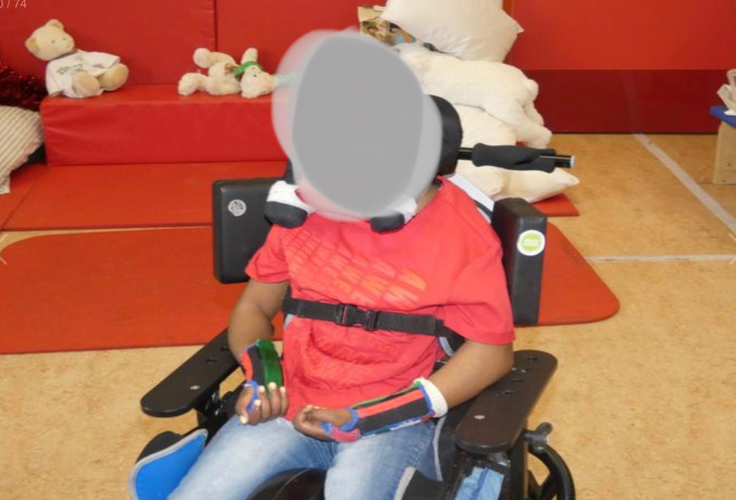
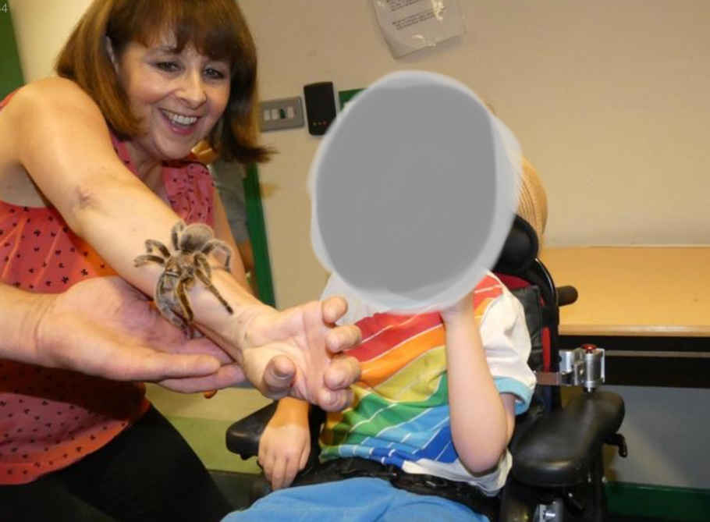
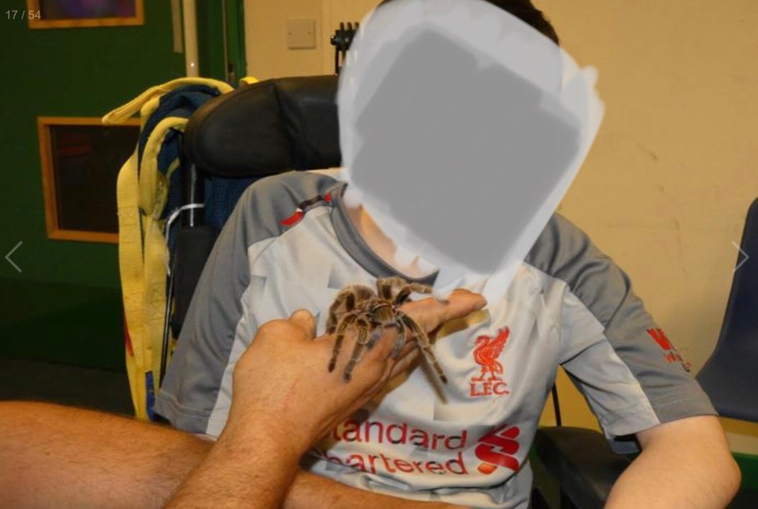
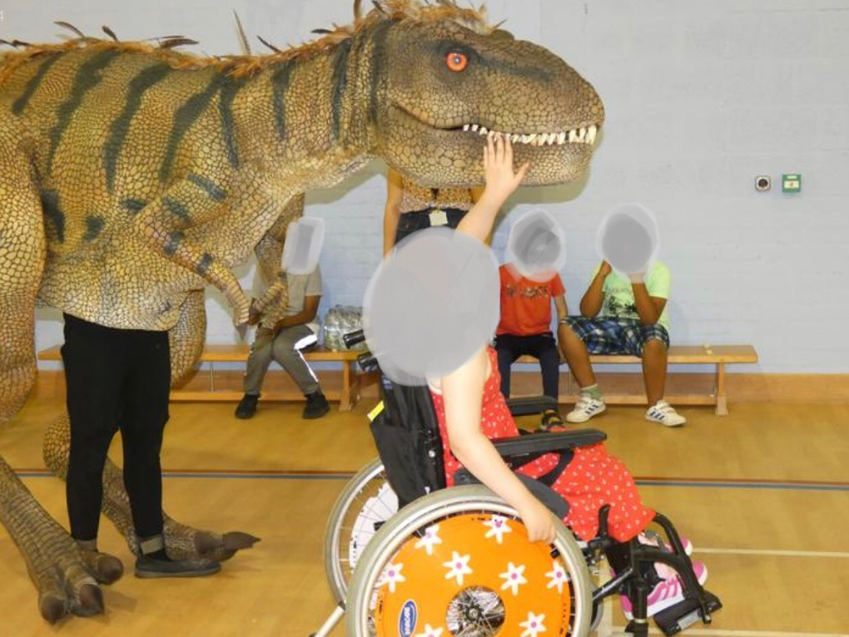
Ty Gwyn special school (2020)
Secondary Department
In our secondary department this is where out key stage 3 children are and this is grouped in year groups. Very similar to mainstream schools each child will be grouped for English and Mathematics according to their ability. All other subjects such as Art, Welsh, Geography, Science, Religious Education and more the children will be in their year groups.

At key stage 3 our children will experience a range of experiences such as going on trips, staying in residential, this is where your child can experience different areas of life. According to Carlson (2017) he stated that life experiences that children have can have a lasting impact on their adult hood, and it is important to allow children to have those experiences.

Key stage 4 children follow the national Curriculum guidelines here at the school of life. Also, children work towards different tasks such as WJEC, to gain skills and qualifications. Pupils will also have different opportunities to gain different awards such as different level 2 qualifications and this is where they will be able to choose what subject they would like to do. This allows the pupils to gain confidence in themselves and to provide them with life skills that they will need once they leave the life of school to go onto adult hood.

Our pupils have a range of opportunities to go on school trips such as residential stays, going to theme parks, performing in different act, going to see live shows and lots more.

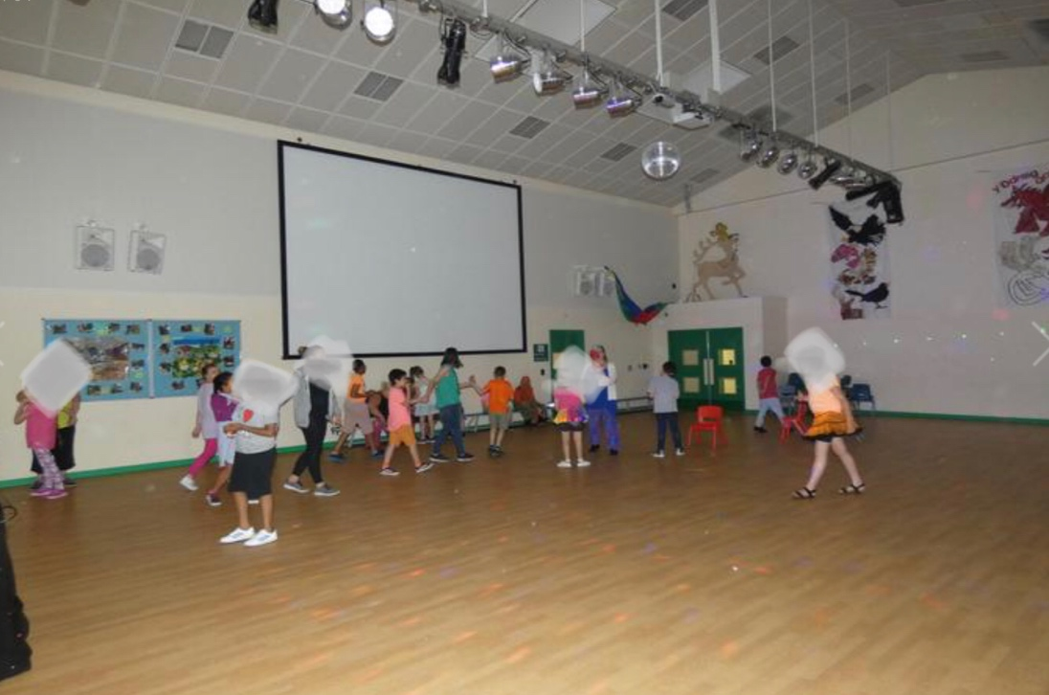
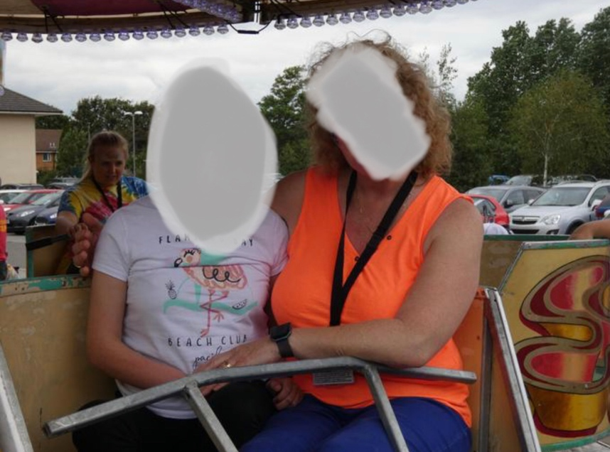
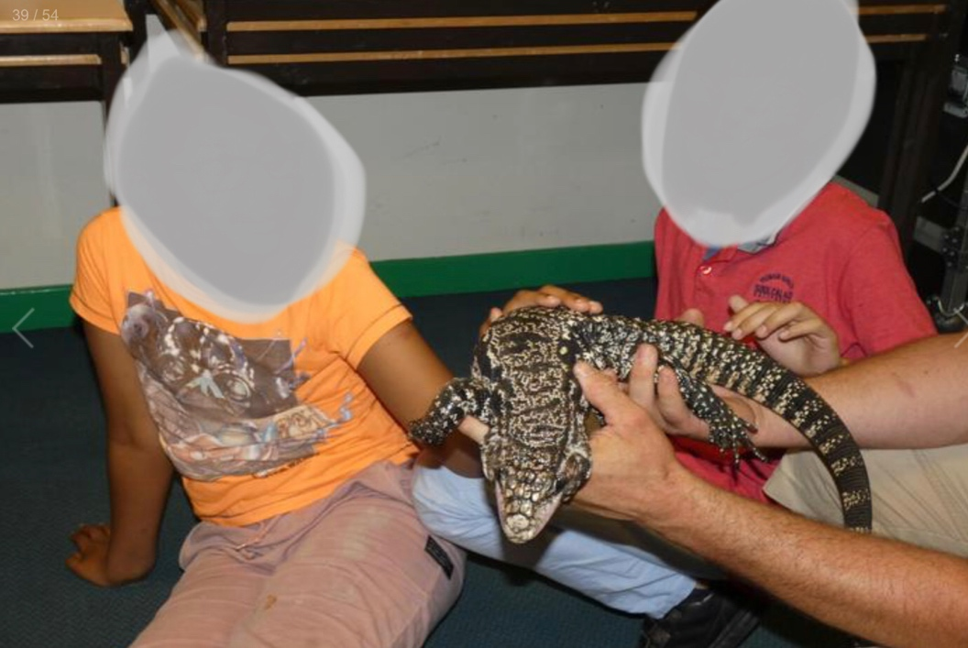
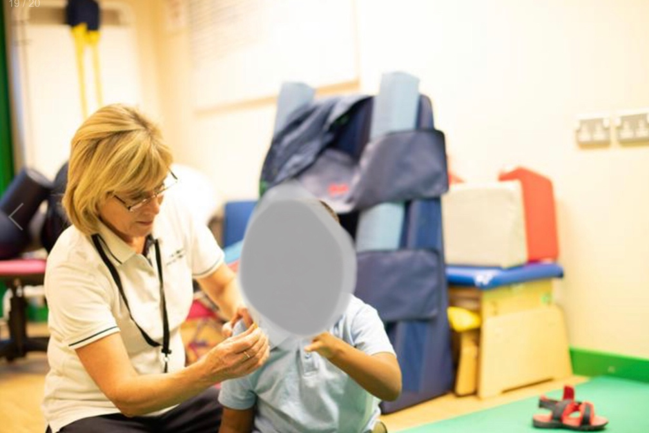
Ty Gwyn special school (2020)

Post 16 Department
This is our final stage before our pupils go onto adult hood and use their skills and experiences they have gained with us here at the school of life. This can be an emotional time for us as staff, the children and fo course you as parents/ or carers, seeing your child go from being 5 years old to being 16-18 and leaving school, here has the time gone.

Our post 16 department focuses on life skills to prepare them for independence for an example they will have opportunity to cook meals, to serve customers in our pupil centred café, to work alone and lots more skills that they would have learnt from secondary and just enhancing them now. This is a chance for our pupils to gain access to college which is located around 20 Minutes from our school here at the school for life, this will give them a chance to select which subject they would like to do for an example childcare, engineering, science, we have many pupils doing our childcare course here with us at our school where they will learn first hand experiences and will get their diploma in childcare level 2 at the end of the one year course. Many of our student do not choose to go to college but choose to go and work, this is very rewarding for them as individuals gaining confidence and social skills to be able to communicate with other in. The world and their environment.

Our pupils also have an opportunity to go on trips to different countries such as Paris, Spain and different countries to explore the world, we also have different courses for those who may not feel comfortable in going to far from home but to go to different residential homes around their area to gaining the confidence in staying away from home.
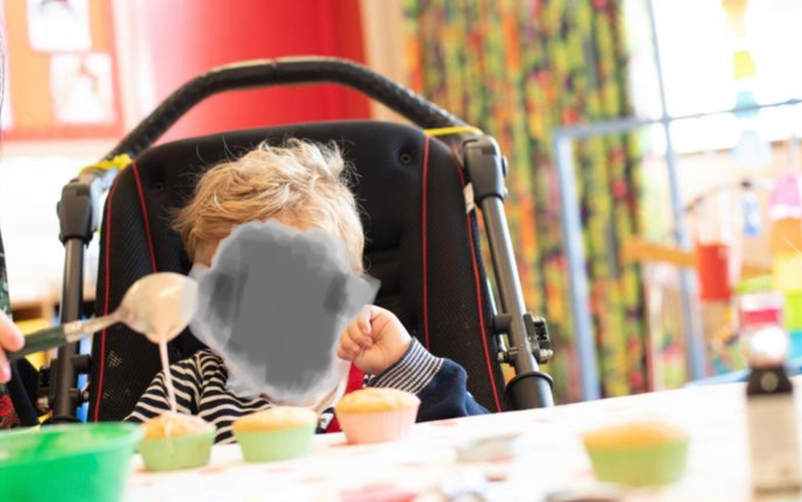
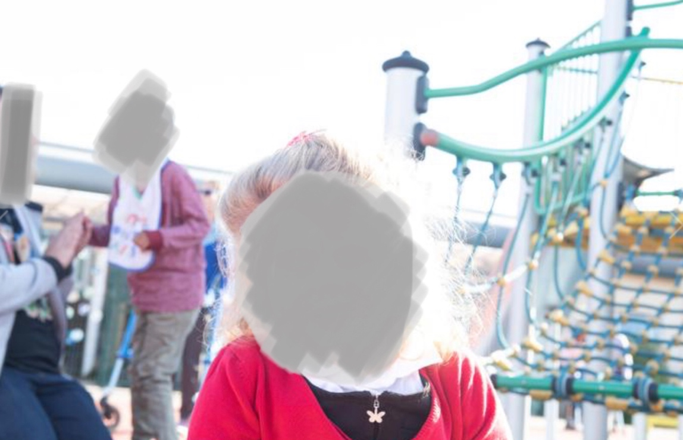
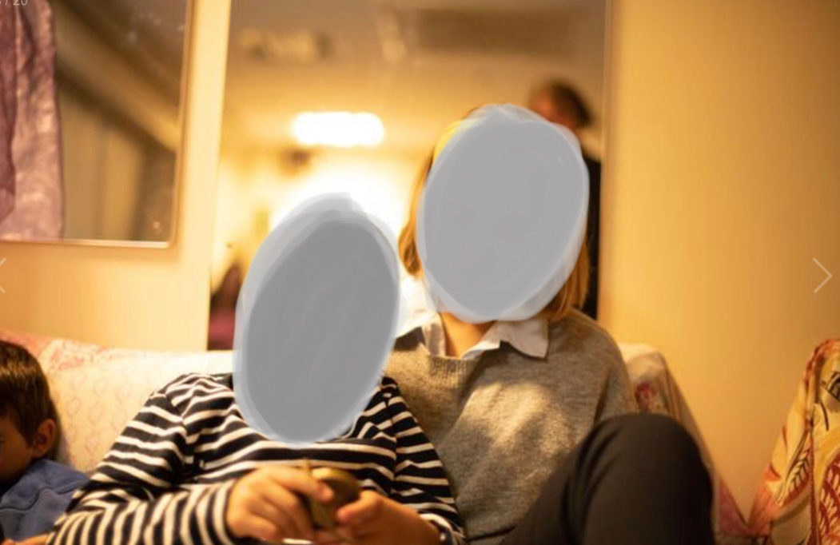
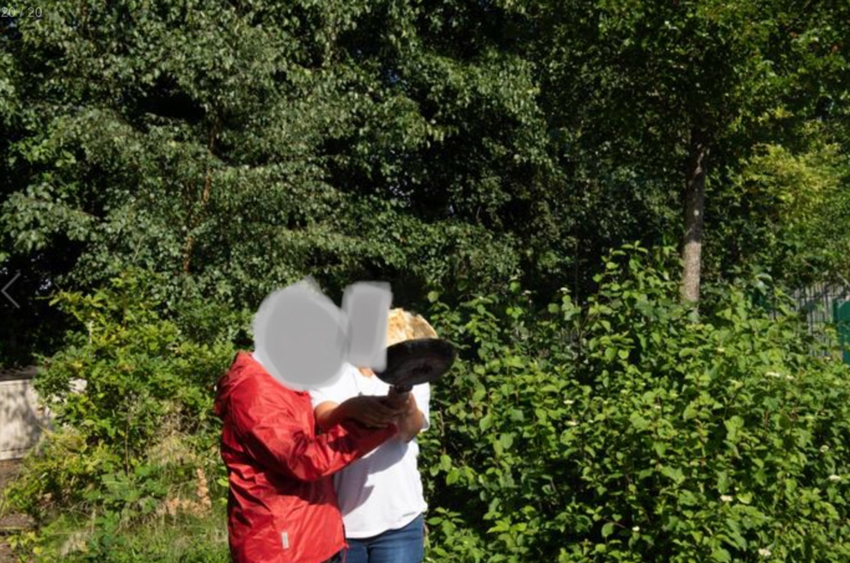
Ty Gwyn special school (2020)
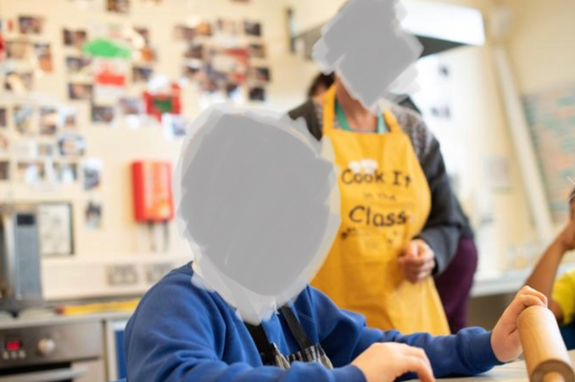
CYMRAEG - WELSH
Ty Gwyn special school (2020)
The School of life teaches Welsh as a second language within our school. The Welsh culture is celebrated across our school to praise the children on what they have achieved wether it is through poems, singing or stories this is seen as a big achievement for our children here at the School of life. According to the Welsh Government (2015) they stated that “The Foundation Phase contributes to the Curriculum Cymreig by developing children’s understanding of the cultural identity unique to Wales across all Areas of Learning through an integrated approach”.

In our school we encourage our children to appreciate all languages taught to them especially Welsh and to ensure they are fully aware of the different images, sounds, objects and tastes that the Welsh Culture brings us and why it is important to us.

Our school supports our children to learn the Welsh language and to progress their skills further, we understand that learning a new language can be difficult, but as a school we will progressively develop your children’s Welsh language skills throughout their time here at the School of life. The Welsh Government (2015) stated that children are required to be taught the Welsh language from age three – seven years of age, if in a English mainstream school.
Religious Education
We will develop your children’s understanding of religious education as a school, and by Law it is compulsory for children to be taught this subject. Within our school we do things slightly different so all children are able to understand what religious education is, by doing it through a multi-sensory approach. According to the Welsh Government (2015) they stated that “The framework confirms that religious education must be provided for all registered children in maintained schools, including those in Reception classes but excluding children in nursery schools and nursery classes as set out in Circular 10/94 and subsequent legislation”. This will be done by doing different sessions related to religion wether it is through music or setting the sensory room with different objects from that religion. As a school we celebrate many different religious festivals such as Diwali, Eid al-Fitr, Mawlid ab-Nabi, Hanukkah, Chinese new year and of course Christmas.
Other Festivals we Celebrate as a School
We celebrate different festivals through out the year such as safer internet day, Valentine’s Day, Fair-trade, Pancake Day, St David’s Day, World book Day, Sport Relief, St Patrick’s Day, VE Day, Mental Health week, Mother’s Day, Outdoor classroom Day, Father’s Day, Roald Dahl Day, Easter, Recycle Week, harvest Day, ADHD awareness month, Black history month, World animal Day, World Space week, World Teacher Day, Halloween, Bonfire Night, Remembrance Sunday, Anti Bullying week, World science week and New year. If you do not want your child participating in one or more of these festivals, please contact me directly on 01792 677844, thank you.

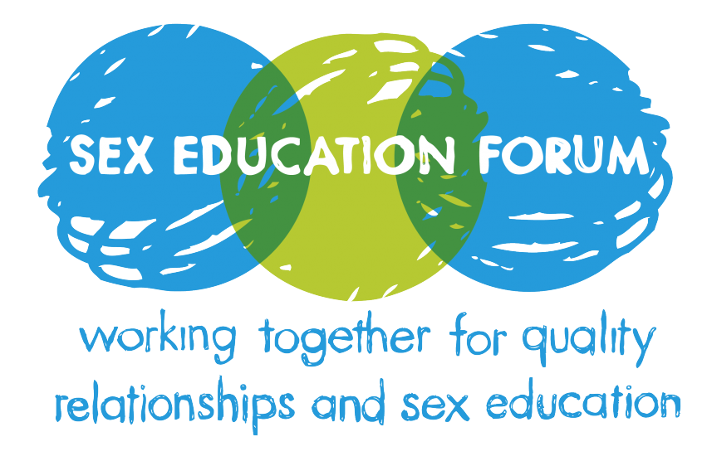
Sex and relationship Education
National children’s bureau (2020)
Schools are legally obliged to provide and teach pupils about sex and relationship education, and it is also a very important subject to be taught to pupils. This subject is not taught as a single subject but within Personal and social Education. We try and educate our pupils so that they are fully aware of their body and how different experiences may effect them. This subject is taught in a sensitive manner and is taught only when it is considered appropriate to meet the needs of the pupils.

According to the Welsh Government (2015) they stated that sex and relationship education is important for children so that they develop an understanding of themselves and other people. Also, whilst studying this subject children’s ill be encouraged to understand and acknowledge that other children have different views, needs, abilities and also beliefs. According to the Welsh Government (2015) they stated that within the Foundation Phase it notes that “Personal and Social Development, Well-being and Cultural Diversity is at the heart of the Foundation Phase”. As a school we encourage children to be mindful and respectful of others, and that they understand that each child has a different need and that everyone thinks in a different way.

Family Engagement
We highly recommend you taking a tour of our school, if you are interested then please contact the school on the above Information.
At the School of life we believe that sharing education with parents is our main responsibility, and the reason for this is that we appreciate any assistance from you as the parents as you know your child best. We understand some times can be difficult and finding a solution to something can be very stressful, b it as a team we will work together to find that solution that works best for that child. We also encourage you as parents to be actively involved with your child within the school or at home, we understand each person has different needs, and we encourage all parents to be engaged with us.

We also have an open door policy to encourage the parents to contact the school if they have any concerns regarding their child or anything else. You as parents can simply telephone us on 01792 677844 or email us at admin.school-of-life@swansea.gov.uk . Also, your more than welcome to arrange a meeting either with the Headteacher or the class staff that your child is allocated to, this is where we will answer any of your queries or concerns regarding your child or anything else.

On our website we have a section for parents/ or carers so that you are able to access useful information about the school. On a regular basis we put new and useful online courses such as BSL Sign language, Medication training, Epilepsy awareness and much more, so keep your eyes peeled on our parents/ or carers section on our website to ensure you are up to date with our training for you. We try and encourage all parents to take part and to communicate with us to ensure we are meeting the needs of your child and that you are aware of what support is available to your child. We also do training for parents/ or carers to access within the school so that they are able to meet the needs of their children, such as First aid, therapeutic play, BUCCAL training and much more, for an example if your child requires BUCCAL then us as a school will provide you with relevant training to support you with your child.

Our current opening days and times for 2021 are as follows below:

January
Monday 11th 4pm
Wednesday 13th 4pm
Saturday 30th All day

February
Tuesday 2nd 4pm
Thursday 18th 4pm
Saturday 27th All day

March
Monday 8th 4pm
Wednesday 17th 4pm
Saturday 27th All day
April
Tuesday 13th 4pm
Thursday 22nd 4pm
Saturday All day

Any queries or questions please do not hesitate to contact us on the above information.

Thank you from all of
us here at the School of life.
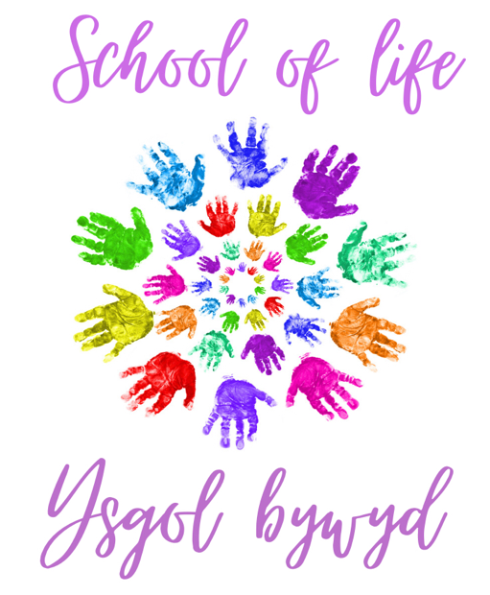

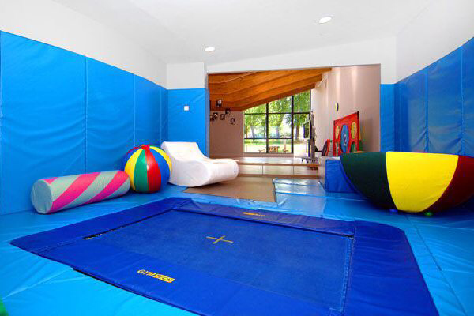
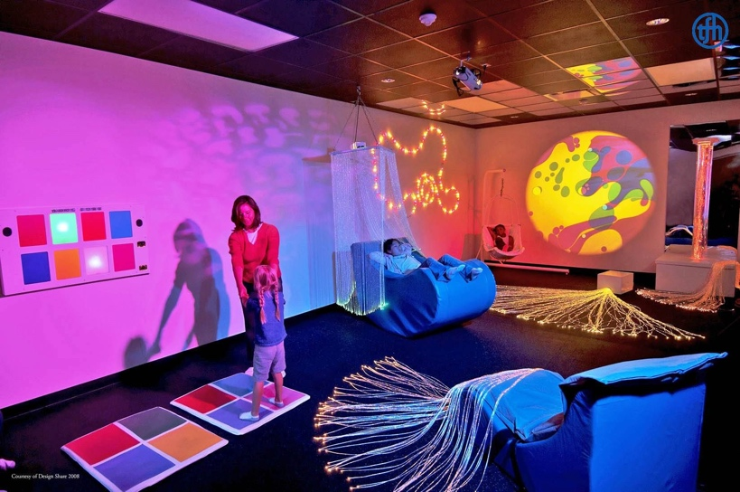
To conclude
Pinterest (2020)
Geraldi, R. (2019)
To conclude, by looking at the above information it is clear to see that this school has a range of opportunities for your children to explore. Whilst looking at the evidence it is clear to see we are going above and beyond for our school and for our children. I would like to note that the School of life has many positive points for you to consider when choosing the right school for your child, and I can ensure you that their needs will be met throughout their time at the School of life. Students benefit from our style of learning and we ensure that all our students learning styles are met. I understand it can be a hard decision making a school choice for your child/ children, and we want you to feel supported through the process, if you need any advice or any information about our school then please do not hesitate to contact us via email, phone or pop into our school to have a chat.
Reference list
Almers, E. et al. (2018) ‘Why forest gardening for children? Swedish forest garden educators’ ideas, purposes, and experiences’, vol. 49(3), p. 242-259. DOI: https://doi.org/10.1080/00958964.2017.1373619.

Cheminais, R. (2010). ‘Implementing the Every Child Matters Strategy : The Essential Guide for School Leaders and Managers’. London: Routledge.

Carlso. B.A. (2017) ‘Early life experiences have complex and long-lasting effects on behavior’, vol:114(44), p. 11571-11573. DOI: https://doi.org/10.1073/pnas.1716037114.

David Hartcorn (2010) ‘Purposeful Architecture’. [picture]. Available at: https://purposefularchitecture.com/purposefularchitecture/. (Accessed: 13th October 2020).

Disability Rights Maryland (2020) ‘Education’. [picture]. Available at: https://disabilityrightsmd.org/education/. (Accessed: 24th October 2020).

Educational Journal (2019) "Spending More Time with Nature Can Improve Young People’s Confidence.", Vol: 391, p. 18. Available at: https://web.a.ebscohost.com/ehost/pdfviewer/pdfviewer?vid=1&sid=d4a4ba03-bc8c-4e81-ba4b-c0f39746046d%40sdc-v-sessmgr03.

Eratay, E. (2020) ‘Effectiveness of the Direct Instruction Method in Teaching Leisure Skills to Young Individuals with Intellectual Disabilities’, vol. 12(5), p. 239-431. DOI: 10.26822/iejee.2020562134.

FTF (2018) ‘If your child has a special need’. [picture]. Available at: https://www.firstthingsfirst.org/parent-kit/child-special-need/. (Accessed: 20th October 2020).

Fabri, M. and Fortuna, S. (2020) ‘Maria Montessori and Neuroscience: The Trailblazing
Insights of an Exceptional Mind’, vol. 26(5-6), p.394-401. DOI: 1073858420902677.

Ferguson, S. (2018) ‘Wheelchair ice-skating a hit at the Celtic Manor’. [picture]. Available at: https://www.southwalesargus.co.uk/news/17312497.wheelchair-ice-skating-hit-celtic-manor/. (Accessed: 20th October 2020).

Geraldi, R. (2019) ‘ How to Build a Trampoline Room in House (and Low Cost)’. [picture]. Available at: https://www.gettrampoline.com/trampoline-articles/trampoline-room-in-house/. (Accessed: 24th October 2020).

Gawel, J.E. (1996) ‘Herzberg's Theory of Motivation and Maslow's Hierarchy of Needs’, Vol: 5(11), p: 1-4. DOI: https://doi.org/10.7275/31qy-ea53.

Gettyimages (2020) ‘special needs images’. [picture]. Available at: https://www.gettyimages.co.uk/photos/special-needs-children?mediatype=photography&page=2&phrase=special%20needs%20children&sort=best. (Accessed: 20th October 2020).

Hoyle, Th. (2019) ‘Why is play so important for everyone?’, vol: 43, p. 62-64. Available at: https://web.a.ebscohost.com/ehost/pdfviewer/pdfviewer?vid=1&sid=c4c29c66-e454-478b-a1bb-4f19de39ed7f%40sessionmgr4007.

Inhelder, B. Et al (1976) ‘Piaget and His School. Springer Study Edition’. Available at: https://link.springer.com/chapter/10.1007/978-3-642-46323-5_2#citeas. (Accessed: 24th October 2020).

ICMEI (ND) “Aims and Objectives’. [picture]. Available at: http://www.icmei.in/aims-objectives/. (Accessed: 24th October 2020).

Koltko-Rivera, M.E. (2006) ‘ Rediscovering the Later Version of Maslow's Hierarchy of Needs: Self-Transcendence and Opportunities for Theory, Research, and Unification’, Vol: 10(4), p: 302-317. DOI: 10.1037/1089-2680.10.4.302.

Kairzhanova (2016) ‘Aims and objectives of my research work’.[picture]. Available at: https://kairzhanova.wordpress.com/2016/10/09/aims-and-objectives-of-my-research-work/. (Accessed: 24th October 2020).

Mayo, A. Woolley, A. (2018) ‘Teamwork in Health Care: Maximizing Collective Intelligence via Inclusive Collaboration and Open Communication’.[picture]. Available at: https://journalofethics.ama-assn.org/article/teamwork-health-care-maximizing-collective-intelligence-inclusive-collaboration-and-open/2016-09. (Accessed: 24th October 2020).

Maher, C. (2018) ‘How to explain special needs to a child’. [picture]. Available at: https://babyyumyum.co.za/how-to-explain-special-needs-to-a-child/. (Accessed: 20th October 2020).

Mikkelsen, B. Et al. (2005) ‘The role of school food service in promoting healthy eating at school – a perspective from an ad hoc group on nutrition in schools, Council of Europe’, vol. 5(1), p.7-16. DOI: 10.1111/j.1471-5740.2005.00110.x.

Masquita, I. Et al. (2015) ‘The Value of Indirect Teaching Strategies in Enhancing Student-Coaches' Learning Engagement’, vol.14(3), p. 657-669. Available at: https://web.a.ebscohost.com/ehost/pdfviewer/pdfviewer?vid=2&sid=dd3ef30b-b3fd-4fbf-a489-20751bcbbfc3%40sdc-v-sessmgr03.

Mooney, C.G. (2000) ‘Theories of childhood : an introduction to Dewey, Montessori, Erikson, Piaget, and Vygotsky’. St. Paul, Minn. : Redleaf Press.

National children’s bureau (2020) ‘sex education forum’. [picture]. Available at: https://www.ncb.org.uk/about-us/our-specialist-networks/sex-education-forum. (Accessed: 24th October 2020).

Pensford Primary school (2020) ‘our mission statement, vision and values’. Available at: http://pensford.bathnes.sch.uk/Our-Vision-Aims-and-Values/. (Accessed: 20th October 2020).

Perry, B. (1998) ‘Ceirw Bach : an evaluation of the effectiveness of an after school club in promoting children's learning’. Swansea: Swansea institute of higher education.

Pinterest (2020) ‘sensory room’. [picture]. Available at: https://www.pinterest.co.uk/pin/758856605941620942/. (Accessed: 24th October 2020).

Singer, D. Et al. (2006) ‘Play = Learning : How Play Motivates and Enhances Children's Cognitive and Social-Emotional Growth’.

Swansea Council (2019) ‘school term and holiday dates 2020/2021’. Available at: https://www.swansea.gov.uk/article/50941/School-term-and-holiday-dates-20202021. (Accessed: 20th October 2020).

Ty Gwyn special school (2020) ‘gallery’. [picture]. Available at: https://www.tygwynschool.com/gallery/. (Accessed: 24th October 2020).

United way of palm beach county (2020) ‘special needs recourses’. [picture]. Available at: https://unitedwaypbc.org/special-needs-equipment-fund/. (Accessed: 20th October 2020).

Vygotsky, L.S. (1967) ‘Play and Its Role in the Mental Development of the Child, Soviet Psychology’, Vol: 5(3), p: 6-18. DOI: 10.2753/RPO1061-040505036.

Welsh Government (2015) ‘Foundation Phase Framework’. Available at: https://gov.wales/sites/default/files/publications/2018-02/foundation-phase-framework-revised-2015.pdf. (Accessed: 21st October 2020).

