

Skills for the Workplace
Module Assignment Submission

Student Name: | Arfana Akhtar
Student Number: | 1715085
Module No: | BMSW5003
Module Title: | Understanding & Engaging in the Customer Experience

Statement of Confirmation of Authenticity
By the act of making this submission, the student declares that this is the work of the student named above. The work has not, in whole or in part, been knowingly presented elsewhere for assessment, or where assessment has been built on a previous assessment, this has been identified. Where materials have been used from other sources it has been properly acknowledged. If this statement is untrue, the student acknowledges that an assessment offence has been committed.
Attention is drawn to the plagiarism and unfair practice policies of both the University and of ILM.

Contents
Introduction: 3
Critically analysing the factors that influence your organisations ability to maximise customer value. 3
Customer Services: 5
CSR 6
CRM – value and purpose of customer relationship management 7
Explaining Buyer seller relationships 8
Identifying the systems that supports Superdrug’s quality to process and evaluating the process in meeting customer requirements. 8
Customer expectation; 8
Focus on customer experience; 9
Effective Communication: 9
Realistic Promises: 9
Appreciation of the importance of quality control; 10
Models. 10
Recommendations for the business: 13
Conclusions: 13
References: 14

Introduction:

In this report I will talking about a specific organisational context which I will show or apply all the critical thinking and where I will also be evaluating in organisational context of Beliefs, Attitudes, Values Systems and also the management theories of the business.
I will be also be including relevant management theories as well as using models to show an understanding of the organisation in the report.
One of the vital factors according to most businesses helps maintain the quality of their product and could also be to increase and to secure all the customers satisfaction, which is the quality control.
The customer satisfaction is affected by many factors which is harder to maintain the ability of the businesses.
There are certain procedures which can be followed to provide and can also be used to produce new services to customers, which is also quite important for all highly competitive business organisations in the sector, but if the business cannot maintain the strategy for good levels of business then any sort of flaws or down fall risen within the business would then turn into quite a big considerable loss for the organisational.

Critically analysing the factors that influence your organisations ability to maximise customer value.

The chosen organisation that I have chosen and will be talking about will be the named company, Superdrug Ltd.
I will also be talking in depth about the quality, demands and the brands of the business.
Superdrug Ltd is quite a well-known organisation nationwide which is a business that sells beauty products, Pharmaceutical and health products, Superdrug Ltd also promote their business via on line where some customer prefer to shop online then come out in person and have shopping delivered to home address.
The first impression is it gives a welcoming feel with a sense of openness allowing you to see the whole store prior to entering the store. It has been recently renovated and is well designed, which gives the feeling of being spacious and yet packed full of items.
Superdrug also has a impression on customer when they shop on line as many offers are only online. A lot of customers prefer shopping online from the comfort of their home and take their time in shopping by adding to basket and in the end taking out items or adding more items.
As you can see I have provided a screenshot of a page of Superdrug and as you can see straightaway they have the customers eyes glued on as the offer comes up straight away and makes the customer more eager to carry on shopping due to the offer.
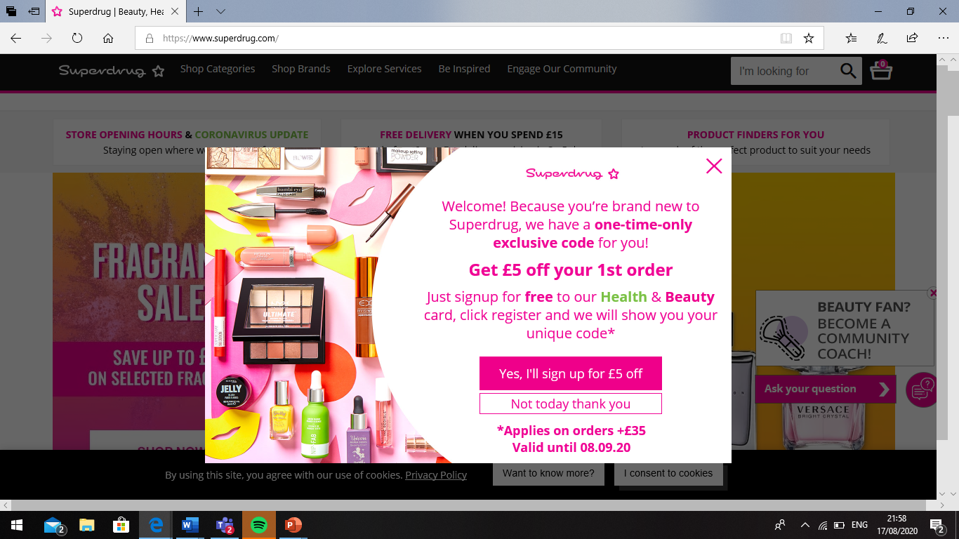
(Superdrug | Beauty, Health, Skincare & Perfume, 2020)

Superdrug is a very known company. It is also the second largest company straight after the well know company named Boots.
The company has been a subsidiary of A.S Watson Group since October 2002. It trades from nearly 900 shops across the United Kingdom and Ireland and serves Sweden, Superdrug los supply via online to Finland and Norway.
Superdrug has employers over, 4,000 people, which is ranging from minimum wage jobs to some of the highest paid within the industry.
Form 2016 Superdrug Ltd was the UK fastest growing health and beauty retailer, which was more than doubling its profit in 2015.
Besides health and beauty, the company has pharmacies with consultation rooms in over approx. 220 shops, and a further 19 containing nursing clinics, making it the fourth largest chemist chain in the United Kingdom.
Superdrug also maintains the links with the additional sister companies owned by A.S. Watson Group: Savers and the Perfume Shop.
Superdrug has E-Commerce which is used to refer to a system which allows buyers and sellers to connect on an online platform for buying and selling products.
E-Commerce has been introduced to almost all countries due to the increase in the internet users.
E-Commerce has many perks that appeal to the general consumer. These are discussed as follows:
- Reduced geographical barriers: Superdrug Ltd products are not available in all states of every country, but they try to operate in such cases where the customers are not deprived of the utility of all beauty or pharmacy products as they can have an informed purchasing decision through e-commerce sites. The customers also receive the product at their comfort of their own environment even if their region is empty of Superdrug outlets.
- Lower Costs: E-Commerce does not require any physical space to showcase products, but it does require some digital space which is significantly cheaper than the former result. Purchases made form E-Commerce sites can be sold at lower prices as the cost of maintaining and showcasing inventory is minimal, by maintain this the company adds value to the customers purchase.
- Comparison Shopping: Superdrug can be compared through e-commerce sites where the consumer can objectively compare among features of multiple alternatives. This provides the customer to make informed choices and spend their money where there is most value. But also have the choice of adding and taking out items from the baskets without feeling discomfort of other customers watching them.
- 24/7 Services: Superdrug sites remain active 24/7 and there is always an advisor available for addressing customer inquiries, or if a customer had a question or help with beauty products.
This channel of communication allows customers to acquire information about their products and even acquire remote solutions for their devices.
The diagram below is an example of how E-Commerce is used, and it shows exactly what the process is like what happens at each point before finally reaching the customers hand.
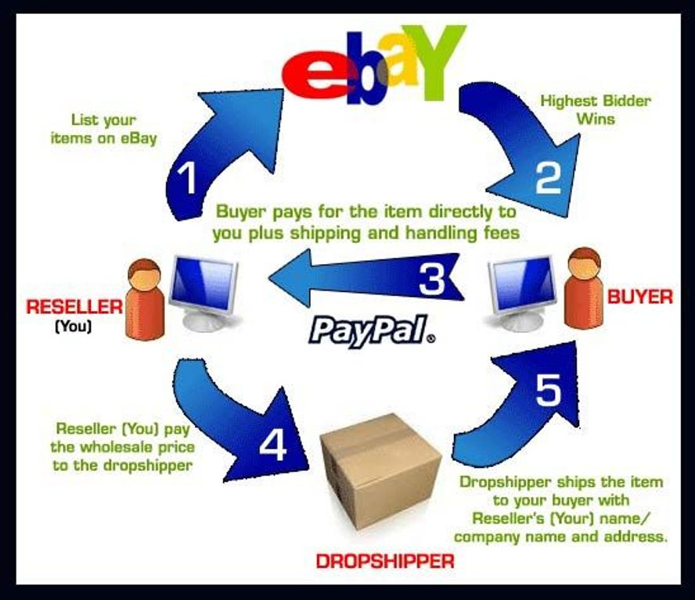
(Newyorkecommerceforum.com, 2019)
The diagram above is a breakdown of how E-Commerce works, as you can see the diagram above is a E-Commerce of selling and buying using the worldwide network business eBay, there are five steps.
The first step is where the customer uploads pictures and a brief description of the item about the product they are listing for other to purchases but this site is using the bidding strategy.
Step 2 is where the item is listed for another buying customer to bid and wait until the time is over, then the highest bidder wins the item.
Step 3 is when the buyer pays the owner directly for the item which at times includes shipping and handing fees.
Step 4 is when the seller must pay the wholesaler their price for the shipping.
Step 5 which is the last step is the drop shipper ships the item to the buyer with the allocated name and address.

Customer Services:

In the organisation Customer Service can also be referred as the provision of amenities provided by the organisation or company while selling and after sale services.
An organisation is seen as a very important factor which any relationships between the customers and the organisations is promoted or builds a good rapport with each other.
Superdrug Ltd strives to maintains a high quality standard of level of work in dealing with customers, so every customer’s demand are met, and all needs can be fulfilled to a great extent without the disappointment of the customer.
To maximising customer value, the company will follow a strict conduct of no compromise when it comes to customer service.
All the services of the store are designed for maximising the customer value. The organisation makes sure that this is by three means;
- Empathy is the first one that the businesses is then required to understand the requirements of the customers.
- Second is to focus on the important aspects that matter to the customers.
- Third one is imputing by which the business is to provide the best possible products with all the best kind of conveniences in the most creative possible way.
There are several ways the customers can communicate with the businesses about customer service. I will talk about three ways Superdrug like to use, one of them is when customers can contact via on line with any customer service or they can even be able to send email’s to the business organisations regarding customer care, even liaise with the customer care executives whom which call upon to the customers request.
Superdrug have many employees who can deal with customers and are always available to solve customers problems but most times its sorted and dealt with a collegue, but at times the managers need to step in and deal with the situation.
The kind of services for the customers and the service provisions are designed according to the needs and the convenience of the customers.
Superdrug has a policy in place which is called the customer policy, and it mentioned in the policy that they want to make each one of their customers experience a wonderful feeling and always swilling to return.
Customer service is such a huge integral part of the business and is also one of the main aims at Superdrug, which is to give a great outstanding service, and to also maintain and be an enjoyable pleasant shopping experience for everyone workers and customers, whilst offering the latest in beauty and health.
Superdrug value feedback weather its good or bad, because receiving feedback the company can make sure they are moving in the right direction and always listening to their customers, and to also meet their customers’ needs and never stopping to strive to improve their service for colleagues as well as for the customers in person or online.

CSR

The CSR is a process with the aim to embrace responsibility for the company’s actions and encourage a positive impact through its activities on the environment, consumers, employees, communities and stakeholders.
The meaning of CSR is Corporate Social Responsibility which is an approach that contributes to sustainable development by delivering economic, social and environment benefits for all stakeholder, it is also a concept with many definitions and practices.
Superdrug has CSR in place with four pillars which are Environment, Workplace, Marketplace and Community.
The environment in the business is to aim to provide the best in the everyday beauty that’s not only great value for the customers but also an outstanding achievement for the environment too.
The workplace is based on the staff of the company at being at the heart of everything that the business does. Superdrug promises to nurture, develop, support and to invest in the future of the best talent across our teams.
The marketplace in the business is always striving to provide the best customer service, so they are always left with the welcoming feeling to return again and again, as good customer service is very important to maintain a good business with good feelings or vibes for the customers to always return back.
The Community at Superdrug is that they pride themselves on using our trusted place in the community to make a difference to people’s health, wellbeing, and future. (Superdrug.com, 2019)

CRM – value and purpose of customer relationship management

CRM is a type of approach which means managers and all relationships and interactions of the company with all sorts customers, which all greatly emphasized on CSM is to give the maximum priority on customers which ultimately create value to the customers experience in the organisation.
I have included below a diagram of CRM which shows a breakdown:
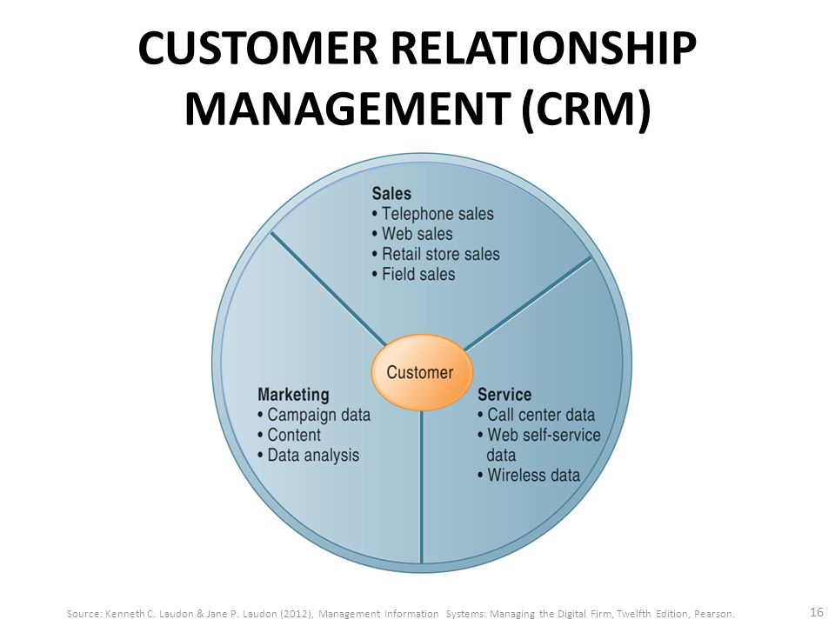
(Slideplayer.com, 2019)
The main purpose of maintaining customer relationship in Superdrug Ltd is to ensure a long period of relationship between the store and the customers via in store or via online using e-commerce.
CSM is mainly implementing through retailing which they can get or even approach all the loyal customers through the system.
Through CSM Superdrug wants to give the customers a unique experience or memory of buying goods or medication rather then just dealing with a service.
The company uses CRM for meeting their customers and keeping a data on them as well as it is helping the business to being loyal to their customers by the data, they have received via the CRM system.
They use CRM for making calls or even receiving calls. They also use it to send out E-Mails which helps keep a track of important information, so the customers are easily reachable for future preferences.
They use CRM for marketing results in order to promote a product or medication, which by doing so they will gain more customers via shopping in the stores or via shopping online via the website which alot of customers find very convenient and easy to maintain.
CRM helps the business keep a track of all the customers profile.
CRM helps keep a track of the sales they make via in store or via online from the website.
CRM also helps keeping a track of reports regarding customers or the business
Most CRM is often associated with equipment’s e.g. computers, electronic, telephones, etc or manual processes involving telephone calls or visits in the branch.

Explaining Buyer seller relationships

The main foundation of the buyer to seller relationship is the trust amongst both which is very important.
Superdrug is the second largest company behind well known Boots which means for Superdrug to always maintain the relationships between the buyer and seller they have to work hard and be very constant in keeping the reputation and high level of work recognised in the company or business.
Superdrug has been able to always strive to maintain the reputation by having hard working employees who always work as a team and always push themselves harder to maintain the progression at a very high level.
The business has also been able to hold the ability of having an outstanding reputation by quality management, sustainable product development.
They also have a proper market segmentation or identification of the best route for suppliers, production accordingly to demands, or even the high brand value.
They have a good advertising strategy which is by using the CRM.
Superdrug have a quick response on their call centre.

Identifying the systems that supports Superdrug’s quality to process and evaluating the process in meeting customer requirements.

Customer expectation;

The retail business which is Superdrug’s holds or strives to always hold a high level of expectations are quite high just like another business or organisation, so it is one of the top businesses straight after the success of Boots.
In order to maintain a good level of customer service of good expectations, it is very important to be able to fully understand all the customers properly without any misunderstandings at all so all customers receive the required attention and dealt with accordingly, which not only leaves the customer happy but boosting the reputation of the business at a higher level, and most importantly leaving the customer wanting to come again or even talking about the good experience to another person which will always boast the company to receive more customers.

Focus on customer experience;

Customers feedback is seen as a important source of information which is used to redesign the service delivery process weather in store or via the official website.
If customers inform or make an enquires about the troubles that are being faced by them, then Superdrug has a tendency of taking immediate action to make sure that the troubles of the customers are taken care of by a team of expects and or someone who can deal with the matter promptly.
The company will act upon the issue straight away until the situation is dealt with and everyone is happy which includes workers and customers.

Effective Communication:

Emails are sent out to all their users and making enquiries about the services or experiences of buying or even asking about how it was by using the website to order products or items.
By getting feedbacks it is very helpful for the business to gain more information which could help the business or prioritize services or the products to the customer. It can also help make changes and always striving to make the company better and always maintain a high level at all times.
Apart from all the above the business also maintains a strong communication system around the world which helps them to try and go higher in the world, which also helps the company be more known worldwide.

Realistic Promises:

It is very crucial to encourage the customers about the future upgraded items or products in order to make them be more interested and by staying loyal too all customers.
Superdrug has always tried their hardest to always comply with all the customer needs and giving them realistic promises to all their customers, whom will be all the future of the upgraded products.
They also provide actual specification of the products weather it’s the shop beauty products or the pharmacy products regarding any of the medications.
Buying decisions making process: ethical considerations such as fair-trade, sustainable resources, and decision-making process of buyers can be influenced by different policies of any organisation issues like ethical considerations which will have significant impacts on the over all sales of any organisations.

Appreciation of the importance of quality control;

Quality control is all about the monitoring, calibrating and the reporting. The importance of quality control is very significant when it comes to maintaining high quality standards.
All the products of Superdrug go through the quality check before going into the market. Variation is also important in any business or organisation in the world.
Superdrug tries there best to always try to maintain the quality of their product. But there are different ways by which the business maintains quality of its products.
One of them is Competence which is that the business ensures the products procedure, quality and the momentum is always highly well maintained with the requested demands of the required market.
The high competence of products is appreciated in the market, but the organisation does lack in certain variation, without bringing the variation in the products may lose the capability of the market.
Quality driven strategy is like the significant importance of maintaining the quality of its products and in the order of ensuring that the organisation is undertaking the required strategies that are driven by the quality of standards.
Customer orientation is what provides the organisation with the insight and willingness to understand the required requirements of all the users of customers.
For Superdrug the business takes a different initiative to fulfil the demands of the customers.
The marketing survey is the conduct survey to address and to identify the demands of the customers. At times changing the brands or trends sometimes of the customers must be followed in order to fulfil the demands requested because if the organisation fails to address the demands of the customers then it will in the end just fail to deliver the kind of products all the customers desire or need.

Models.
I will be showing a couple of models and talking about SERVQUAL here too with definitions and how it related to the organisation I have chosen to discuss about.
SERVQUAL is model that indicates the name of the name SERVQUAL which is a measure of service quality. Essentially it is a form of a structured market research that splits by the overall service into five areas or some other components.
The SERVQUAL is a model that features in many services marketing textbooks, which is usually when it is a discussion on customer satisfaction.
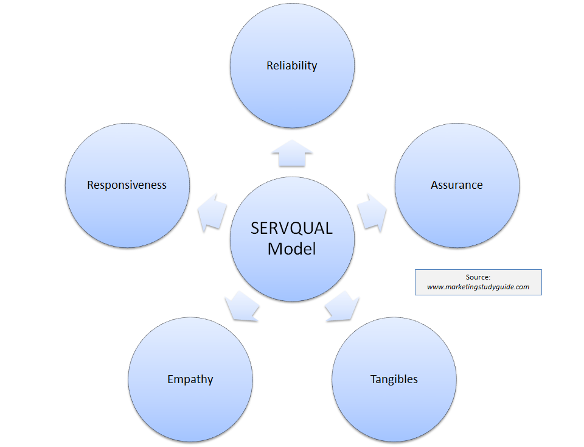
(Marketingstudyguide.com, 2019)

The SERVQUAL model is a breakdown of reliability, assurance, tangibles, empathy and responsiveness.
Tangibles is the appearance of the physical facilities, equipment, personnel and the communication material.
Reliability is the ability to perform the promised service dependably and accurately
Responsiveness having the willing to help the customers always and to provide the accurate prompt service always
Assurance is the knowledge and the courtesy of employee and their ability to convey trust and confidence
Empathy is the provision of caring on an individualized attention to the customers.

The SERVQUAL model can be used against Superdrug and I will talk about how the model can be related too:

Tangibles: with Superdrug the tangibles can be benefits like rewards to their customers for loyalty. The loyalty can be things like loyalty cards, store membership cards, reliance retail or even points to gain rewards or even a surprise gift or something.
Also, tangibles can be also treating the unsolicited customer feedback with respect and responding to it.

Reliability: with Superdrug reliability is when the organisation or business provides a value to the customer and it also can distinguish products. Reliability also can be that the product, service or even the system will perform as expected now as well as in the future.
Satisfactions provide the language to discuss the product reliability.
Reliability also refers to a situation where a service provider or company is providing the business or organisation with desirable services. A customer may pay in advance for the service where it is expecting the services provider to provide the required service at a later stage.
If the required or expecting service provider or company settles the debt agreeably the right and expected way, then the customers will make the business or organisation a reliable one. (Bayt.com, 2019)

Responsiveness: in Superdrug being responsive in customer service is quite an important communication which has a very specific but very obvious meaning once you know what it is and the responsiveness is absolutely critical for creating better relationships, trust and building a good rapport with people at home and at work.
Responsiveness is an approach one can intentionally cultivate by paying good attention to what the other person is saying, as well as focusing on the customer to respond directly to them before shifting the focus of the conversation to one’s self. (Work911.com, 2019)

Assurance: customer service assurance (CSA) is the meaning of all the collections of communications service provider (CSP) customer usage information from all practical sources including network traffic, network devices, content severs, management database and the user devices to ensure that the customer service quality is always consistent with CSP expectations.
CSA also has whenever it is required the real time monitoring of a customer’s purchased services and it is also the analysing this data to note all the trends, preferences, usage problems and eventually proactive assurance of customer level or the service level issue.
There is a numerous quality which is regulating methods which are often interconnected with customer service assurance. It is also typical to find Quality Assurance and Quality Control, as it is also in some cases Service Level Management (SLM) is also included within this group. (En.wikipedia.org, 2019)
The CSA information can also be addressed as several business issues including the following:
- All individual’s user data collection and correlation for the troubleshooting and for the VIP reporting
- All individuals service level agreement reporting
- Noting all customers preferences of certain network/content combinations.
- Real time which concerns alarming usage and problem to analyse for specific services/ group of users.
- Also, for the troubleshooting and reporting for all device configurations.

Empathy: In Superdrug it is vital that the organisation or business has empathy in their customer service as having empathy is a very important skill which is required to develop, as it requires and is very helpful for the employees truly listen to their customers.
It is vital as well as being very important to hear all the customers frustration, listen intently which helps develop many solutions to solving a lot of the problems which were initially raised.

Recommendations for the business:

I would like to recommend a few solutions for Superdrug for more outstanding customer services in the business.
Superdrug should hold more staff meeting in order to hear or update staff of bettering the customer service.
They should also more staff training for customer services.
Even though I have recommended the above solutions Superdrug already has been using these solutions I have suggested but sometimes more training and more staff training is vital for a much better outstanding result in the workplace.

Conclusions:

The report demonstrated an understanding of customer service in an organisation of my own choice which was Superdrug. The report covered the basic difference customer service models and I also critically wrote about CRM and CSR.

It is also based on the discussion of the customers value maximization depending on several factors. All the factors include quality models and standard CRM and, I wrote about the buyer and seller relationship.
This report also is focused on the organisational system that foster n the organisational ability to maximize the customers value. Customers are the base of the organisation and it is the duty to ensure the customer are treated in a way so that they can have trust on the organisational services.
Maintaining the relationship with the customers can be vital technique for the organisation to increase its customers base.

References:

Newyorkecommerceforum.com. (2019). [online] Available at: https://www.newyorkecommerceforum.com/wp-content/uploads/2018/05/Peer-to-Peer-business-model-in-e-commerce.jpg [Accessed 6 Sep. 2019].

Lh-ag.com. (2019). [online] Available at: https://www.lh-ag.com/wp-content/uploads/2018/12/6-CSR-and-the-Sustainability-Reporting-Landscape-of-Malaysia.pdf [Accessed 6 Sep. 2019].
Superdrug.com. (2019). Corporate Social Responsibility | Superdrug. [online] Available at: https://www.superdrug.com/csr [Accessed 6 Sep. 2019].
Marketingstudyguide.com. (2019). [online] Available at: http://www.marketingstudyguide.com/wp-content/uploads/2013/08/servqual-model1.png [Accessed 6 Sep. 2019].
Slideplayer.com. (2019). [online] Available at: http://slideplayer.com/slide/4457890/14/images/16/CUSTOMER%20RELATIONSHIP%20MANAGEMENT%20(CRM).jpg [Accessed 6 Sep. 2019].
Bayt.com. (2019). What does it mean RELIABILITY in Customer Service with suitable story? - Bayt.com Specialties. [online] Available at: https://specialties.bayt.com/en/specialties/q/297267/what-does-it-mean-reliability-in-customer-service-with-suitable-story/ [Accessed 8 Sep. 2019].
Work911.com. (2019). What is "responsiveness" and why is it so important in communication? [online] Available at: http://work911.com/communication/skillsresponsive.htm [Accessed 8 Sep. 2019].
En.wikipedia.org. (2019). Customer Service Assurance. [online] Available at: https://en.wikipedia.org/wiki/Customer_Service_Assurance [Accessed 8 Sep. 2019].
Superdrug.com. 2020. Superdrug | Beauty, Health, Skincare & Perfume. [online] Available at: <https://www.superdrug.com/> [Accessed 17 August 2020].

