INTRODUCTION TO PUBLIC HEALTH
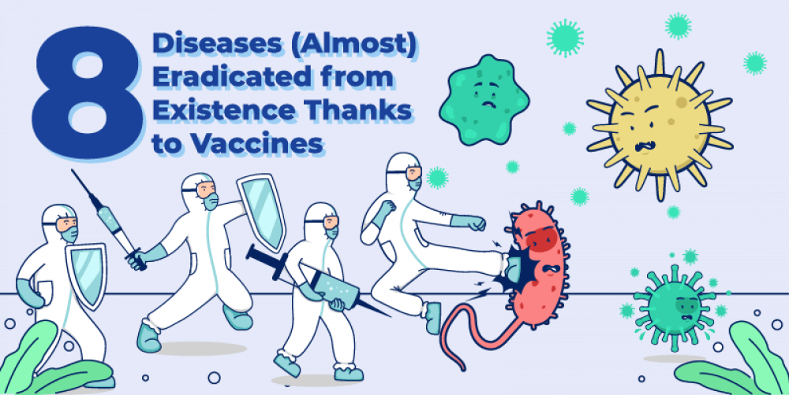

CASE STUDY - CHICHEN POX

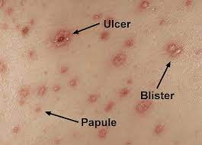

Student Name: Sharon Barnett
Student Number: 2217515
TUTOR: Bianca Sanfilippo

TABLE OF CONTENTS

Table of Contents PAGE 2

Question 1 PAGE 3

Question 1 PAGE 3

Question 3 PAGE 4

Question 4 PAGE 5

Reference PAGE 7

Questions For Discussion and Management of Chicken Pox Infection

Questions 1

Scientists and Health Professionals use a variety of methods to track, study and predict the outcomes of infectious disease outbreaks. This is known as the study of Epidemiology.

Epidemiologists both measure and monitor these outbreaks by using two statistics to describe the disease; Prevalence and Incidence (CDC.gov no date)

Before this, they must first identify each appearance of the disease in a selected region, which is usually the area where the disease was first encountered. These appearances are referred to as cases. A new ‘case’ is reported to have occurred whenever someone ill meets the case definition for chicken pox. the infectious disease

The case definition is an outline of what signs, symptoms and clinical test results are consistent with most, if not all of the individuals infected with chicken pox.

Once a significant amount of data on those carrying the disease has been collected and a case definition has been formed, the aforementioned statistics of prevalence and incidence can be used to gain insight into how much of an impact the disease will have on the wider population of the region.

Questions 2

Prevalence is defined as the proportion of the population infected with chicken pox at one static and unchanging moment in time. The formula for calculating prevalence would be the number of cases, divided by the total population, and then multiplying by one hundred for a percentage answer (CDC.gov). The prevalence statistic includes all individuals infected with the disease, regardless if the case is new or not. It can be a useful indication of whether or not a particular area is more at risk, or more resistant to the infection spreading.

Incidence is defined as the rate at which new cases of infection are appearing amongst the population over a measured period of time. The formula for calculating incidence would be: New Cases /(The size of the population * The amount of time they were studied for in weeks, months or years) (CDC.gov). The Incidence statistic excludes all pre-existing and/or ongoing cases. It can be a useful indication of how fast an infection is spreading in a particular area in comparison to others, and can be used to measure whether preventive measures or better practices put into place in the area are working.

When determining both the prevalence and incidence of an infectious disease, epidemiologists are careful to only include the population at risk when considering the total population. The population at risk refers to individuals who are physically capable of contracting a disease. For example, the population risk for a group of one thousand equally divided men and women would have a population risk of five hundred regarding a disease that only affected one gender.

The gathering of this data to measure and monitor diseases is known as descriptive epidemiology.

Another example of descriptive epidemiology is contact tracing, a process in which members of an infected area self-report individuals they have been in contact with, and as such could have possibly been infected. Lab testing, data analysis and effective communication to raise awareness are essential tools that can be used to monitor chicken pox disease outbreaks (CDC 2021) (WHO 2022)

Question 3
After analysis of figures obtained by the methods above, health professionals and governments can determine what can be done to begin control of a chicken pox disease outbreak.

There are three components that cause the spread of infection known as the epidemiological triad.

These components consist of hosts, agents, and environment. A host refers to those who can potentially carry and spread a disease, including both humans and animals. An agent refers to an organism that causes the disease to be contracted. Common examples of agents include viruses, bacteria, parasites and fungi. Environment refers to the conditions and surrounding physical circumstances that allow the disease to gain prevalence.

Containment and control methods often target one or more of these components. Some of these methods include:

Behavioural Changes - Targets both Host(s) and Environment
Behavioural changes can be encouraged amongst the population of an outbreak via public service announcements, posters/other forms of print, and online media. Through these mediums governments and other authorities concerning healthcare can advise the public on both what the disease is, and what the average individual can do to prevent its spread. Advice such as frequent handwashing, avoiding risk factors such as dense crowds, routinely sanitising well-occupied areas and coughing and or sneezing into elbows helps to reduce the likelihood of infected individuals getting others sick.

Medication - Targets both Host(s) and Agents. Medication can be developed and supplied to those who contract the disease, both to relieve symptoms and also to treat the infection. Treating the infection among affected areas reduces the time frame in which patients are ill and therefore contagious, slowing the pace of its spread. Medications known antimicrobials kill or stop agents from dividing, and as such eradicate the pathogens within hosts. In the case of some diseases this can prevent more serious complications and even death.

Strict Treatment Facility Protocol - Targets Environment

In the areas where the ill are being treated, it is imperative that those who are treating them do not become infected themselves. As a result, safety protocol needs to be implemented. This can include the sterilisation of medical equipment, frequent hand washing/cleaning of the facility, and for especially contagious diseases, isolation of the patients. Professionals caring for patients would be provided with PPE, (shortened from Personal Protective Equipment) are articles of clothing and other items designed to protect the wearer from pathogens. They can include scrubs, masks, respirators, aprons, gloves and goggles.

Question 4

Outside of outbreaks, governments and medical authorities also take steps to upkeep a more general health standard among the public, utilizing both strategy and policy.
This is true for the UK, which has implemented laws such as RIDDOR (Reporting of Injuries, Diseases and Dangerous Occurrences Regulations 2013), which has made practices such as contact tracing easier by having organizations and workplaces report not only physical accidents, but also diseases that have been particularly prevalent amongst their workforces. By surveillance which involves monitoring the occurrence of an infectious disease outbreak in a given population over a specific period. Surveillance is a strategy that is also used to systematically gather data on the number of cases by demographic characteristic, geographic location, time of onset, the severity of illness, and other relevant information. This information can be used to identify the source of the outbreak to evaluate control measures and monitor disease trends according to the (CDC no date)

A non-legislative measure, vaccines are an incredibly effective, but non-mandatory way the UK protects children from suffering from dangerous diseases such as measles, polio, and rotavirus. Some diseases have been very nearly eradicated due to vaccines (RIDDOR no date).

References

The BJM (no date)
https://www.bmj.com/about-bmj/resources-readers/publications/epidemiology-uninitiated/1-what-epidemiology
Accessed 10 April 2023

Hopkins, R. et al. (2003) Summary of notifiable diseases — United States, 2003. MMWR 2003;52(No 54):1–85.
https://www.cdc.gov/csels/dsepd/ss1978/lesson3/section2.html
Accessed 10 April 2023

RIDDOR - Reporting of Injuries, Diseases and Dangerous Occurrences Regulations 2013 (no date)
https://www.hse.gov.uk/riddor/

Accessed 10 April 2023
Makati Medical Centre
https://www.makatimed.net.ph/blogs/8-diseases-almost-eradicated-from-existence-thanks-to-vaccines/

CDC (no date)Principles of Epidemiology in Public Health Practice, Third Edition: An Introduction to Applied Epidemiology and Biostatistics. (2021).
https://www.cdc.gov/EpiCore/Principles/index.html
Accessed 10 April 2023

World Health Organization (WHO). Outbreak surveillance and investigations. (2022).
https://www.who.int/csr/resources/publications/surveillance/WHO_CDS_CSR_ISR_99_2_EN/en/
Accessed 10 April 2023

https://www.google.com/search?q=chicken+pox&rlz=1C1CHZN_en-gbGB998GB998&sxsrf=APwXEdfWcQ0ZJDVqjlZZu4CKoMEJyGhppQ:1681171434489&source=lnms&tbm=isch&sa=X&ved=2ahUKEwjo4qLRw6D-AhWaSMAKHU9-C-AQ_AUoAXoECAEQAw&biw=1536&bih=760&dpr=1.25

Accessed 10 April 2023

https://www.makatimed.net.ph/blogs/8-diseases-almost-eradicated-from-existence-thanks-to-vaccines/
Accessed 10 April 2023

