

Wales Institute of Science and Art:
Applied Computing

Undergraduate Induction Programme
Year 1/Foundation

Monday, 20th September 2021 (online)
and Wed 22nd/Thursday 23rd (on campus)

 | Monday, 20th September
FOUNDATION AND LEVEL 4 NEW STUDENTS
10:00am | Welcome Address: Kapilan Radhakrishnan  Teams link for 10AM Click here to join via Teams  Or http://bit.ly/Year1Found
 | Covid-19: Social distancing and expectations

UG Programme stream talks with question & answer sessions
- Applied Computing Structure
- Online Library information and Student Services resources
- Timetables
- Questions
---------------------------------------------------------------------------------------------------
- 11am ish Breakout: Programme Specific Information with Q&A led by Programme Managers/relevant lecturers
(see below for breakout links)

Group 1 breakout: Click here to join via Teams or https://bit.ly/3nfWuUw
BSc/HNC/HND Applied Computing
BSc/HNC/HND Computing (Data and Information Systems)
BSc/HNC/HND Computing (Web Development)
Beverley Holland, Mike Dacey

Group 2 breakout: Click here to join via Teams
or https://bit.ly/38V1t4C
All Foundation year entry students
Gareth Jones

Group 3 breakout: Click here to join via Teams
or https://bit.ly/3BWYJ31
BSc/HNC/HND Computing (Games Development)
BSc/HNC/HND Computing (Software Engineering)
Gordon Dickers, Tim Bashford

Group 4 breakout: Click here to join via Teams
or https://bit.ly/3njMAkQ
BSc/HNC/HND Computing (Computer Networks and Cybersecurity)
BSc/HND/HNC Cloud Computing
Carlene Campbell, Nitheesh Kaliyamurthy

Group 5 breakout: Click here to join via Teams
or https://bit.ly/3E0fiNs
BA Computer Games Design
BA Computer Animation
Richard Morgan, Adam Head, Nabeel Masih, Phil Organ

Group 6 breakout: Click here to join via Teams
or https://bit.ly/3jWiNwd
BEng/HNC/HND Electrical and Electronics Engineering
Gaynor Thomas (for Steve/Gary)

 | Break
12:00pm | University Regulations, Unfair Practice, ECP, PASS, Bursary, Personal Tutors, Student Union, Computer Society
1:00pm | Lunch
2pm | Teams link for 2PM Click here  Or http://bit.ly/Year1Found  SOAC computer lab/network orientation  - Network accounts,  - SOAC accounts,  - Logging on and remote access,  - Accessing Moodle and Mail - Gaynor’s Moodle video  - Questions
3:30pm | Finish

University online induction resources, students please read in own time:
https://hwb.uwtsd.ac.uk/pages/student/resources_welcomeandinduction/inductionresources

Wed 22nd Sept /Thurs 23rd Sept In person, on campus – talk and library tour
See below for your group

Wed 22nd Sept  Meet at IQ002 – Ground floor, IQ building | Please wear masks unless exempt
Group 1 - 9.45pm | 9.45am | IQ002
Foundation Year, all streams Year 1 (9 students)  Gareth Jones, Gaynor Thomas | 10am-10.30am | Fforwm Library Tour
 | 10.45am-11:45pm | IQ002: Intro and IQ Tour
Group 2 - 1pm | 1pm-2pm | IQ002: Intro and IQ Tour
BSc/HND Computer Networks and Cybersecurity A  BSc/HND Cloud Computing  (10 students)  Carlene Campbell, Nitheesh Kaliyamurthy  (Surnames starting A-L) | 2pm -2.30pm | Fforwm Library Tour
Group 3 - 2pm | 2pm-3pm | IQ002: Intro and IQ Tour
BSc/HND Computer Networks and Cybersecurity B  (10 students)  Carlene Campbell, Nitheesh Kaliyamurthy  (Surnames starting M-Z) | 3pm -3.30pm | Fforwm Library Tour

Thurs 23rd Sept  Meet at IQ208 in IQ building | Please wear masks unless exempt
Group 4 - 9am | 9.00am | IQ208: Intro and IQ Tour
BA Games Design and BA Animation Year 1 (17 students)  Richard Morgan/Phil Organ | 10am-10.30am | Fforwm Library Tour
Group 5 - 10am | 10am-11am | IQ208: Intro and IQ Tour
BSc/HND Games Development  BSc/HND Software Engineering  BSc/HND Web Development  (10 students)  Gordon Dickers/Tim Bashford | 11am -11.30am | Fforwm Library Tour
Group 6 - 2pm  Meet at IQ205 in IQ building | 2pm-3pm | IQ205: Intro and IQ Tour
BSc/HND Applied Computing  BSc/HND Data and Information Systems  (5 students)  Gordon Dickers/Nik Whitehead | 3pm -3.30pm | Fforwm Library Tour

Staff List – 2021/2

 | Name |  | Room | Email
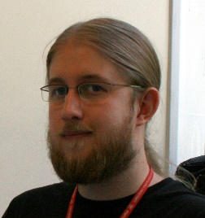 | Dr Tim Bashford |  |  | tim.bashford@uwtsd.ac.uk
 | Dr Carlene Campbell |  |  | carlene.campbell@uwtsd.ac.uk
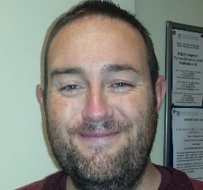 | Lee Cobley |  |  | lee.cobley@uwtsd.ac.uk
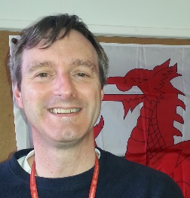 | Dr Michael Dacey |  |  | michael.dacey@uwtsd.ac.uk
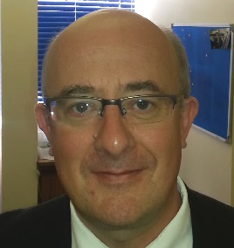 | Gordon Dickers |  |  | gordon.dickers@uwtsd.ac.uk
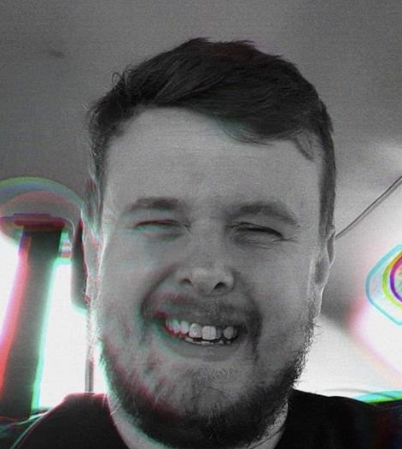 | Adam Head |  |  | a.head@uwtsd.ac.uk
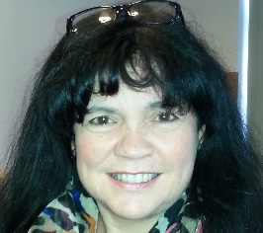 | Beverley Holland |  |  | beverley.holland@uwtsd.ac.uk
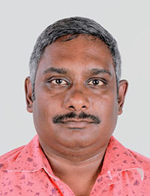 | Nitheesh Kaliyamurthy |  |  | n.kaliyamurthy@uwtsd.ac.uk
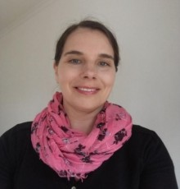 | Ewa Kazimierska |  |  | e.kazimierska@uwtsd.ac.uk
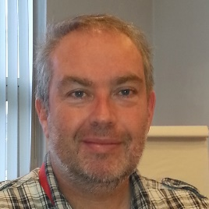 | Gareth Jones |  |  | gareth.jones@uwtsd.ac.uk
 | Dr Gary Jones |  |  | gary.jones@uwtsd.ac.uk
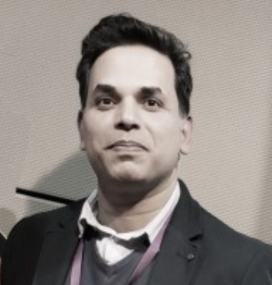 | Nabeel Masih |  |  | n.masih@uwtsd.ac.uk
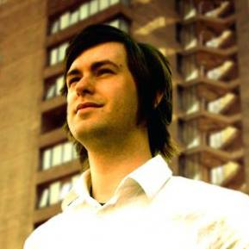 | Richard Morgan |  |  | richard.morgan1@uwtsd.ac.uk
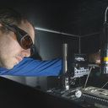 | Dr Steve Mosey |  |  | stephen.mosey@uwtsd.ac.uk
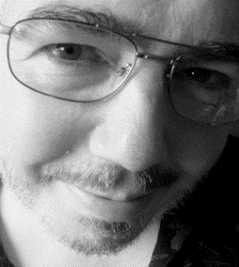 | Phil Organ |  |  | philip.organ@uwtsd.ac.uk
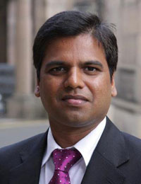 | Dr Kapilan Radhakrishnan |  |  | kapilan.radhakrishnan@uwtsd.ac.uk
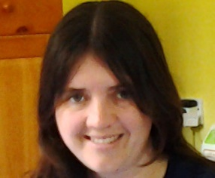 | Gaynor Thomas |  |  | gaynor.thomas@uwtsd.ac.uk
 | Associate Professor Nik Whitehead |  |  | nicola.whitehead@uwtsd.ac.uk
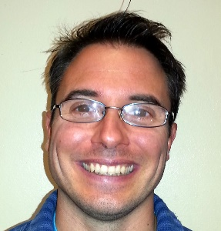 | James Williams |  |  | james.williams@uwtsd.ac.uk
 | Mohammed Bennasar

