UNIVERSITY OF WALES TRINITY SAINT DAVID

MODULE NAME AND CODE

Digital Skills for Personal and Professional Growth

BMSW4008
ASSESSMENT TITLE
Evidence of Learning E-portfolio
Student name:Andreea Elena Tudorie
Student ID:2321488

Table of Contents
Task 1: Questionnaire Analysis for Andreea Nails Artist 3
Introduction 3
Selected Questions and Analysis 3
Conclusion 7
Task 2: Website and Marketing Materials Design for Andreea Nails Artist 9
Introduction 9
Analysis of Questionnaire Data 9
Website Design 10
Marketing Materials Design 13
Conclusion 16
Task 3: The Importance of Microsoft Excel in the Digital Era 17
Introduction 18
Main Body 18
Conclusion 20
Task 4: Video Pitch 22
References 24
Appendices 27
Task 1 Raw Data 27

Task 1: Questionnaire Analysis for Andreea Nails Artist

Introduction
The questionnaire responses of Andreea Nails Artist, a nail salon from Newport, have offered important insights about the customers. These are insights that can be used to inform the overall business plan, the marketing and communication as well as other service delivery methods. The results highlighted in this analysis are determined by addressing 4 key questions derived from the collected data. With an evaluation of customer satisfaction, chance of repeat business, marketing affinities, and durability of the service the salon is capable of improving its services and guarantee the customers’ patronage and expansion (Cespedes et al., 2024)

Selected Questions and Analysis
1. How satisfied were you with your gel manicure service today?
Analysis:
The above results show that out of nine customers five of them mentioned to have had very satisfactory gel manicure service hence revealing a high degree of customer satisfaction. This positive trend is an indication that the salon services especially the gel manicure expresses the expectation of the majority of clients. Three of the respondents were satisfied or somewhat satisfied, therefore there must be options that, if implemented, would increase satisfaction among all customers even more.
Application for Business Strategy:
- Quality Assurance: Among the somewhat satisfied respondents, getting the job done in perfecting its gel application can ensure that more of these consumers are converted into very satisfied clients (Gompers and Levindo, 2024)
- Customer Feedback: The salon should offer a second survey to elaborate the reasons of the ‘’somewhat satisfied’’ opinion.
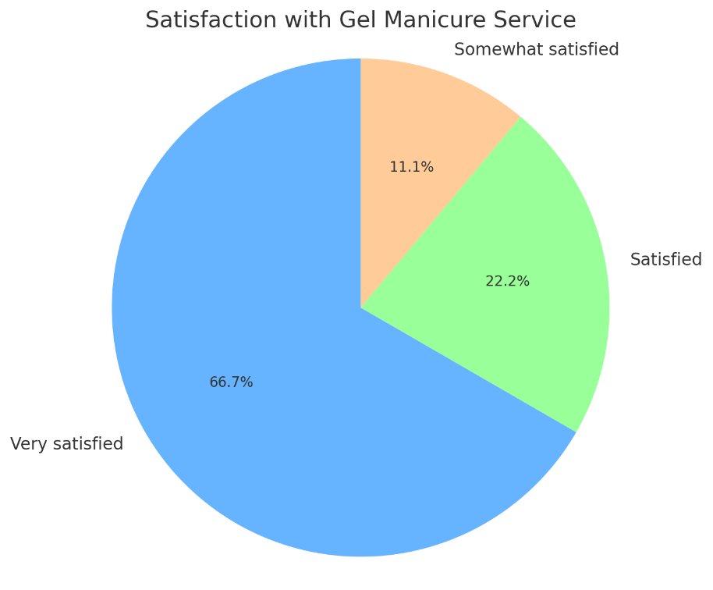
Figure 1 Graph 1
2. How likely are you to return for another appointment?
Analysis:
All the respondents (7 out of 9) were very likely to come back for another appointment. This means customer retention and satisfaction, and this indicates to us that the salon is getting the job done in satisfying customers. Responses categorised either as somewhat likely or both neither likely nor unlikely may suggest aspects that require focus, for example, service quality, pricing or customer experience.
Application for Business Strategy:
- Retention Programs: Being that clients will be coming back most of the time, the salon can include offer bonuses for the next service in the services offered and referrals.
- Customer Engagement: This is a clear indication that both the neutral and less enthusiastic responses should be followed up with some effort just to know what it is that customers are holding back from doing (Buell et al., 2024). Further before or after care could encourage the follow-up appointments; Simple individualized messages or promotions could also have higher chances of appointment among the patients.
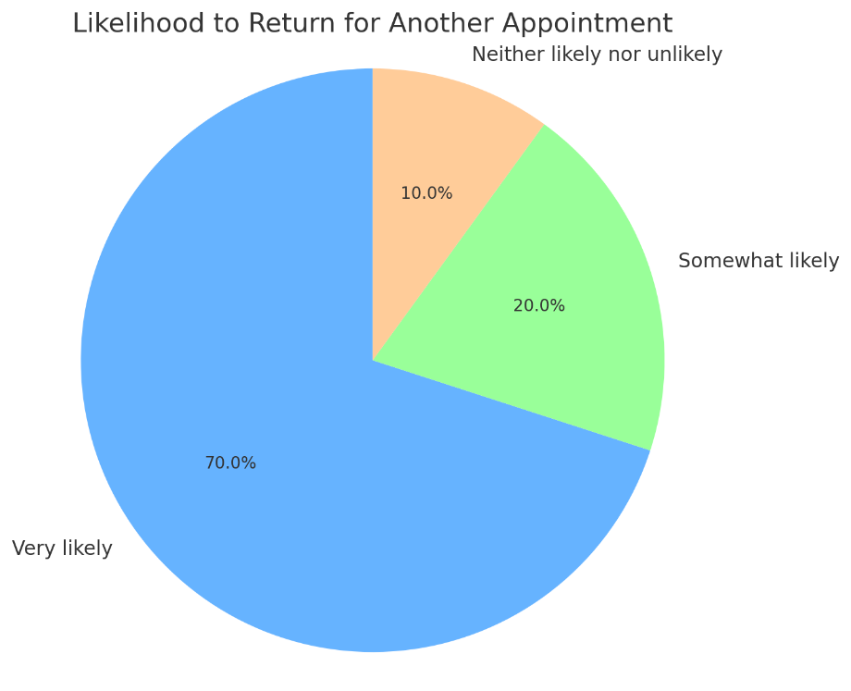
Figure 2 Graph 2
3. How long do your gel manicures typically last?
Analysis:
Three of the five surveyed customers claim that they get their gel manicures to last 3-4 weeks or even longer, which is what clients expect from the manicure. However, 3 of the respondents complained that their gel manicures only lasted 1-2 weeks, thus, some of the costumers might have had problems with durability of the gel. The fact that the long length of the service is perceived as a positive characteristic implies that any variations in the application of service delivery could be enhanced to increase customer satisfaction (Manning and Bodine, 2020).
Application for Business Strategy:
- Service Refinement: Strengths can therefore be regarded as the concentration on enhancing the gel manicure’s lasting of durability by perhaps again on the technique of application or caliber of the gel polish.
- Customer Education: Inform a client the best ways to take care of their manicure and also give recommendations on how to do it to make them last longer. This should be conveyed either through the next email or during the appointment (Rosário and Casaca, 2023)
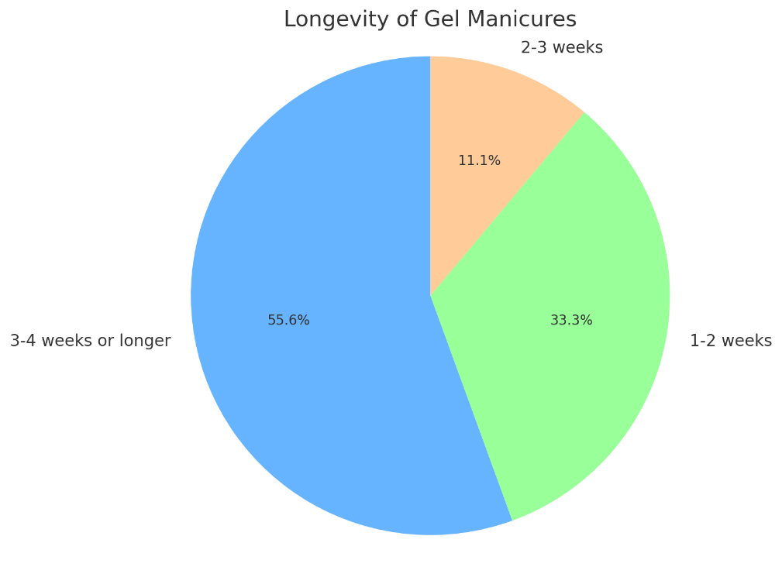
Figure 3 Graph 3
4. How do you like to receive marketing from us?
Analysis:
According to the survey updates customer’s marketing notification using email were more popular with 50% of the respondents as compared to social media tool with 22% . One of the customer prefers both the options of SMS/Text and Phone, all these facts justified that the email is the best communication mode for this customer. The combination of low percentage in SMS/Text communications and phone communications suggest that the polular clients of ‘advertising -driven’ carmakers are less inclined to accept direct and intrusive forms of marketing.
Application for Business Strategy:
- Email Marketing Focus: The salon must focus on using e-mail newsletters to send out promotions, and occasional messages, and information about new services and special deals. Something like that would improve the engagement even more such as sending personalized mails depending on the client’s likes and past purchases (Mittal et al., 2023)
- Social Media Engagement: Though, email is the most popular, it needs to be combined with active accounts on social networks to reach the clients who are actively using it. He added that the establishment’s images of the nail art works, customers’ comments and special offers on Instagram and Facebook may attract new clients.
- Minimize Intrusive Marketing: Based on the fact that many customers show less interest in and `never’ use the SMS/Text and the phone calls the salon should avoid the regular marketing through those channels and use the channels that the customers are most receptive to (Dixon, Toman, and DeLisi, 2020).
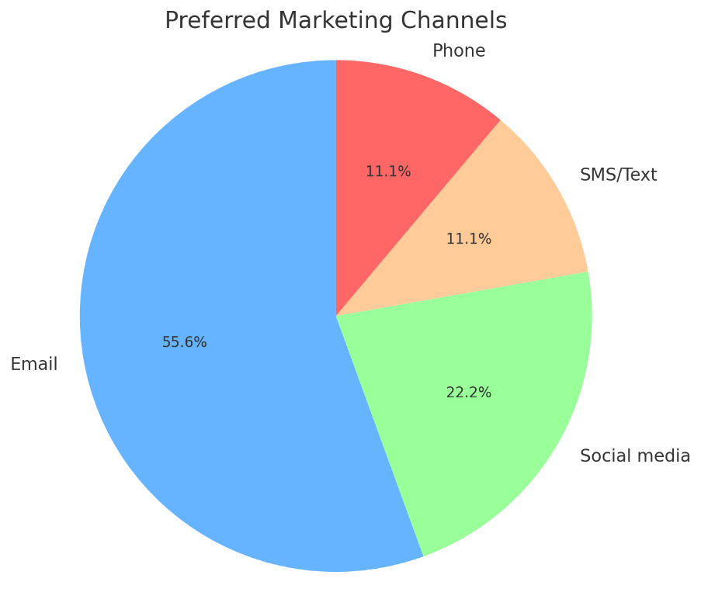
Figure 4 Graph 4

Conclusion
Consequently, the point and the answers obtained through the completed questionnaires for the case of Andreea Nails Artist are very useful and offer indications of customer satisfaction and their preferences. The potential return signifies that the gel manicures satisfied the client sufficiently and the salon can provide services which would meet the needs of the clients. But there are ideas for further development, including the problem of gel manicures’ endurance for some customers and the issue of the correct promotion for clients’ needs. Thus, concentrating on service homogeneity, encouraging client retention, and using e-mail and social network advertising, the company can improve its operational model, improve customer satisfaction in Newport, and advance in the market.

Task 2: Website and Marketing Materials Design for Andreea Nails Artist

Introduction
Andreea Nails Artist is a superior fashion nail bar based in Newport, Wales, promoting creative brand values and professionally customised nail treatments. The goal of this task is to design a two-page website and promotional materials that would represent the salon and make possible clients attracted to it. The web design and the appearance of marketing campaigns adapted from a customer satisfaction questionnaire which give insight regarding the customer behavior and preferences. By applying these insights, the purpose is to raise the interest of the customers and boost the impact of the business on the Internet. This document also describes the procedure of designing the website and promotional materials with regard to the value of customer feedback in digital marketing.

Analysis of Questionnaire Data
The results from the questionnaire were instrumental in influencing the features of the designed website and overall look of the marketing collateral. Among the most important results we have to highlight that 80% of our customers were very satisfied with the gel manicure service and 100% noted high professionalism of the staff members. This underscored the need to sustain high service standard and increased customer satisfaction which was reflected on the web site and promotional materials (Kalalo et al., 2020). Further, the cross-tab analysis showed that 51.5% of the respondents wanted to receive marketing updates through email, although a smaller percent via social media or short message service (SMS) to guide marketing communication for email-based marketing campaigns (Godin, 2020).
As for the improvement, the data also showed that a majority of the clients anticipated that their gel manicures would last 3-4 weeks and therefore stressing on the quality and longevity of services while designing the website (So et al., 2020). Moreover, in the customer segmentation with reference to preferred price, numerous clients were seen to fall into both the economy and luxury bracket with price of a gel manicure ranging between £20 and £40 . This segmentation was adopted in presenting the website with different and separate price portfolios and service offerings to accord to the different customers’ needs.

Website Design
Based on the information gathered from the questionnaire, the site for Andreea Nails Artist was developed in order to create a good user experience and quality customer-interaction. The homepage has a marquee area which contains a photo of one of the clients’ nails that communicate the creativity of the salon. This creates a perfect and eye-attracting introduction that is needs to be attended while serving to remind visitors that the business cherishes quality, as identified in the questionnaire part of this research by Kalalo et al., (2020).
Homepage Design: The call to action is also evident and well pronounced on the homepage and any visitor is freely encouraged to shop by clicking on see our shop button. This is in line with the high degree of loyalty that was revealed in the customer satisfaction/better value and repeat booking intention set out in the questionnaire where the respondents had a ‘very likely’ consensus of coming back for another appointment, which came to more than 70% (Berger, 2020). The structure of the website is simplistic with simplicity in its appearance, mirroring the salon, but with clear menus containing links to services, prices, and testimonials.
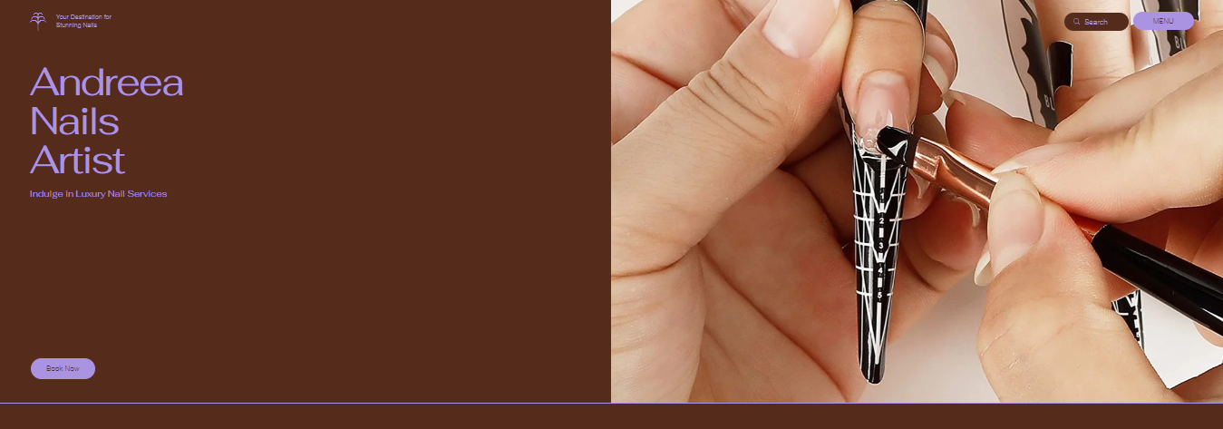
Figure 5 Homepage
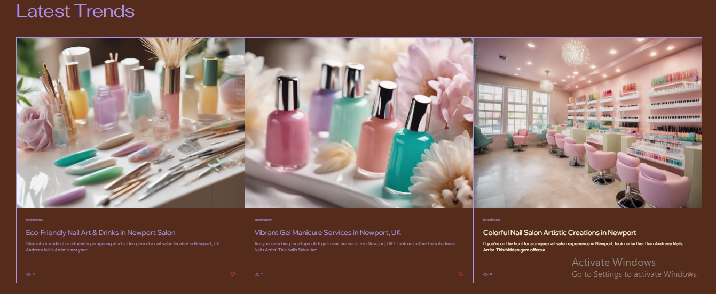
Figure 6 Homepage
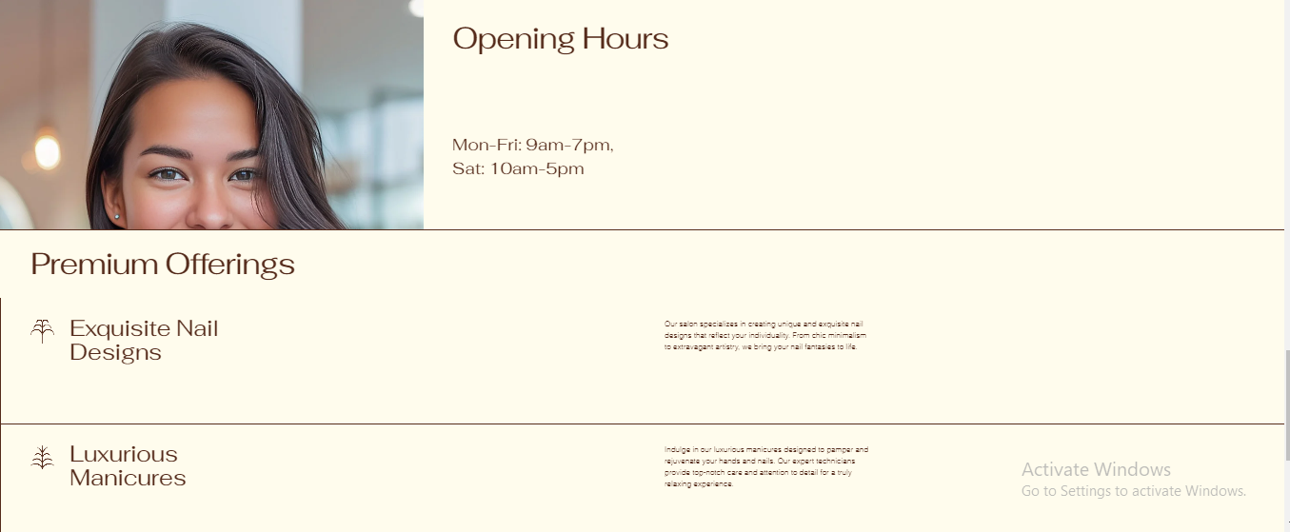
Figure 7 Homepage
Services Page: recommendations for the services page includes the following, From the results of the questionnaire, participants’ most preferred services were those for which the price was stated clearly, From the analysis carried out above, the following services were recommended on the services page; Also, a strategy of SEO optimization was used to increase website visibility on search engines. Phrases like ‘gel manicure Newport’ and ‘nail salon Newport’ were used to make it possible to capture a name on a search because, with the growth of technological advancement, clients prefer online searches (Kotler et al., 2020).
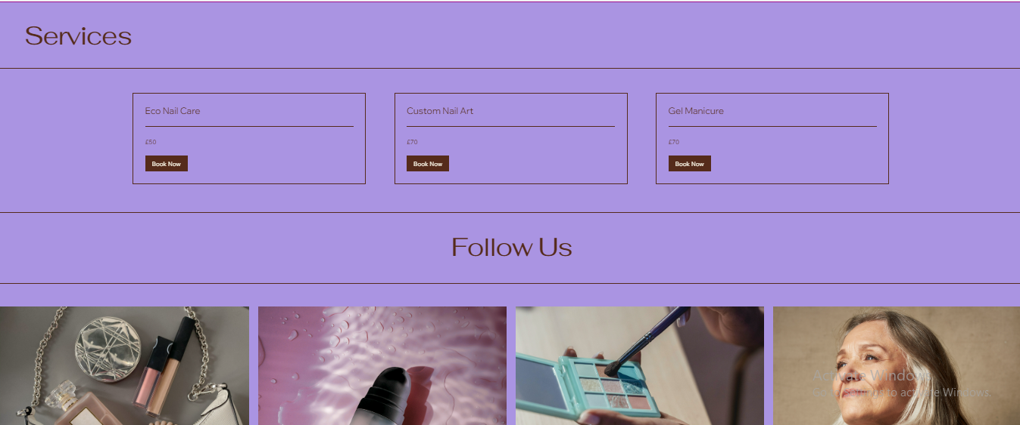
Figure 8 Services
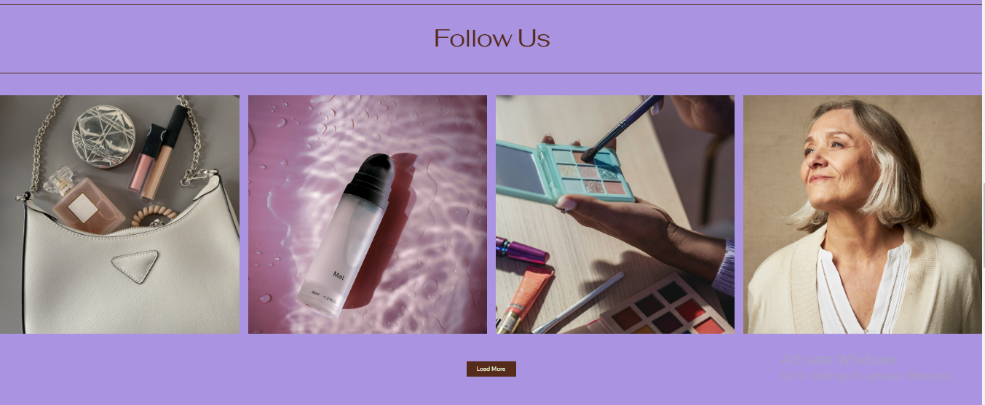
Figure 9 Services
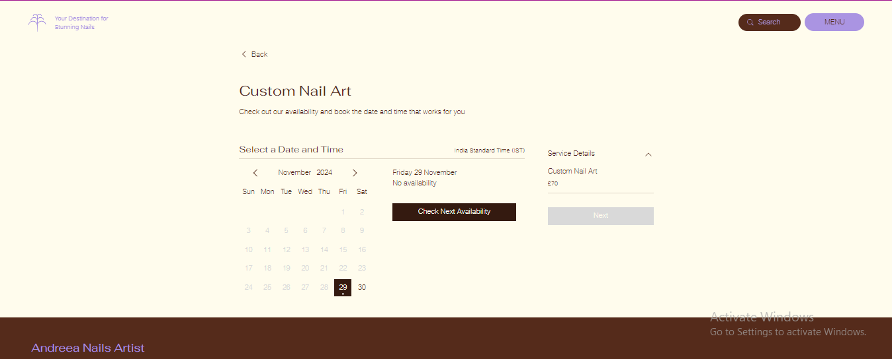
Figure 10 Booking Page

Marketing Materials Design
Promotional flyers for Andreea Nails Artist were created through the Canva to harmonise with the brand image and the information about the main clients that was received through the questionnaire. In the flyer and poster, there are exposure areas that include attractive images of nail premises or detailed nail art images that appeal to the identified customer responses for creativity and complex designs. The use of fusion colours and typographically big headlines help grab the viewers’ attention with the overall presentation looking very neat and clean.
Flyer: The flyer might include the business name, followed by an even stronger call to action and booking details. Since the means through which respondents preferred to receive marketing material was through their email, the flyer adopts an online booking link that directs users to its website to book their service. Warm and cool colors are used on the flyer since they make the audience feel warm and stylish, which is a relief for the salon’s target group of people.
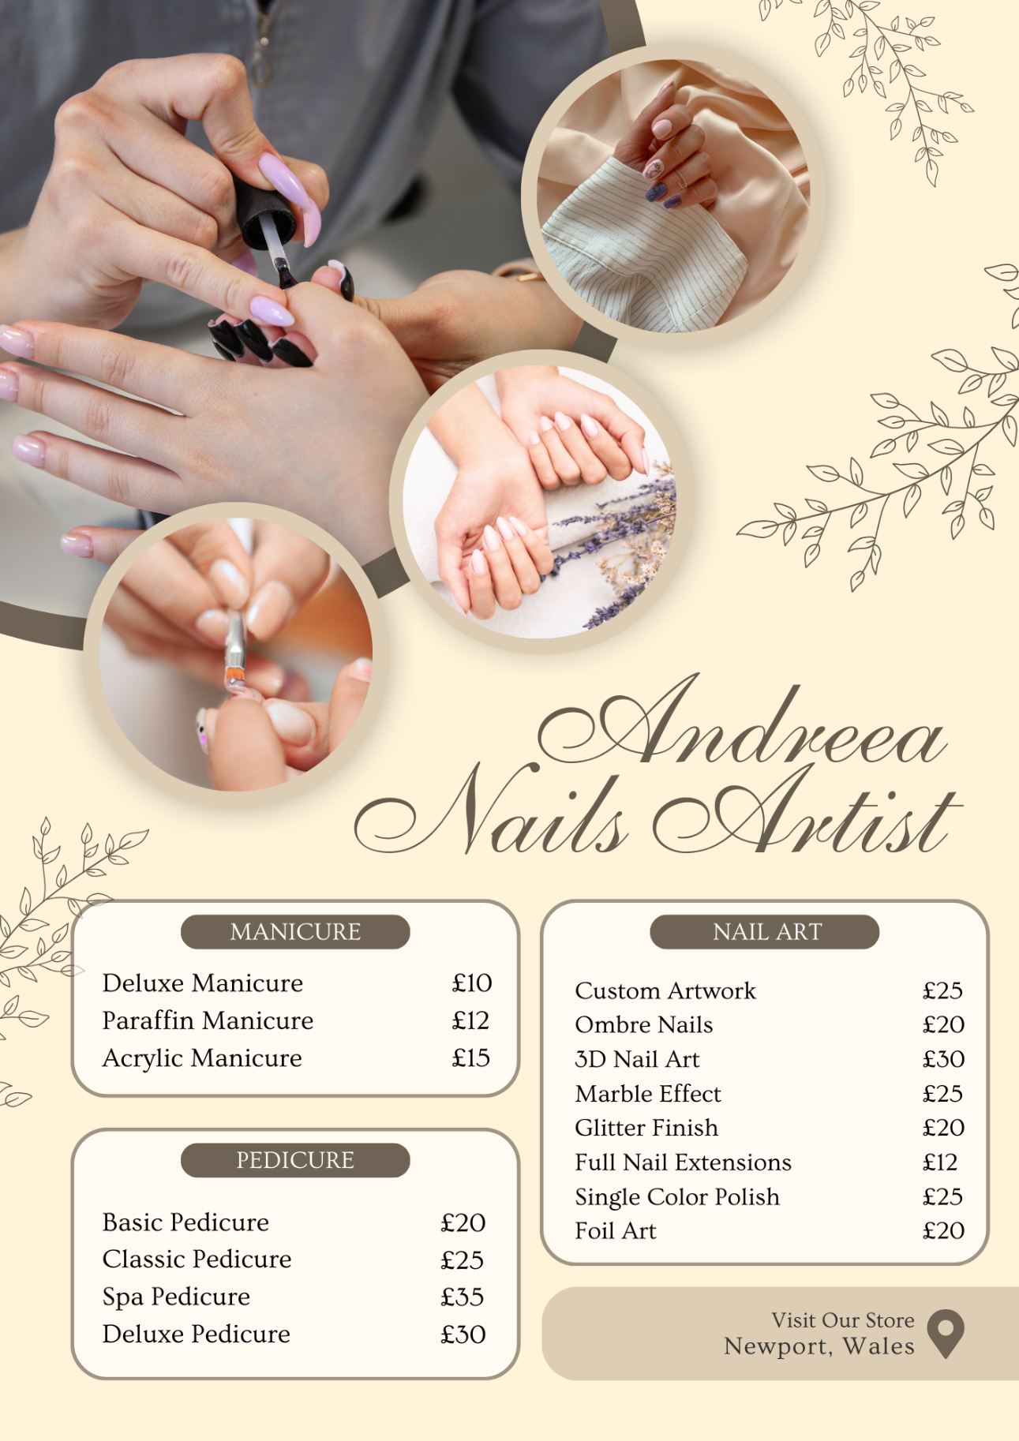
Figure 11 Flyer
Poster: Likewise, we aimed at creating engaging poster that presents services offered in Burch University. Popular services include gel manicures and nail art, and the prices are easily seen. The poster focuses on price and ease of access, thus integrating what the clients suggested with respect to the prices, which range from low to high (Kotler et al., 2020). Elaborate website marketing information include the company’s contact information, location, and social media contacts, all of which are present in both pieces of marketing material.
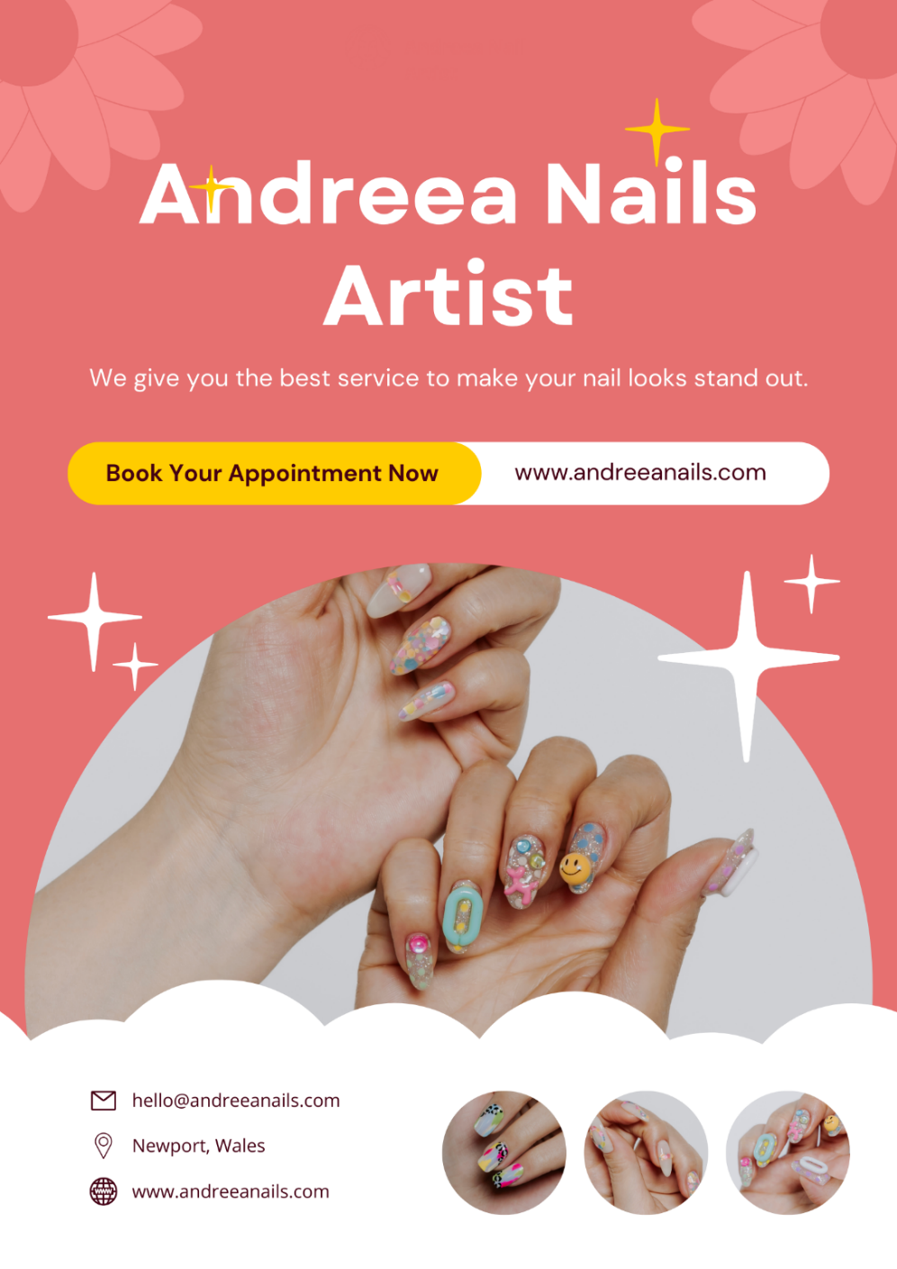
Figure 12 Poster

Conclusion
This research paper shows how information that was gleaned from the customer satisfaction questionnaire has been useful in the development of the website and the marketing material of Andreea Nails Artist. Due to the intensive analysis of customers’ preferences regarding the services, prices, and means of communication with the company, it occurred possible to design a customized, attractive, and easy-navigated website and all the necessary advertising materials for the salon’s clients. The SEO strategies help make the website reachable as the marketing material adequately informs the target clientele on what is being offered and where to book. Such cooperation, based on customers, will certainly help to enhance the brand and develop a long-term cooperation between the business and the customer (So et al., 2020).

Task 3: The Importance of Microsoft Excel in the Digital Era
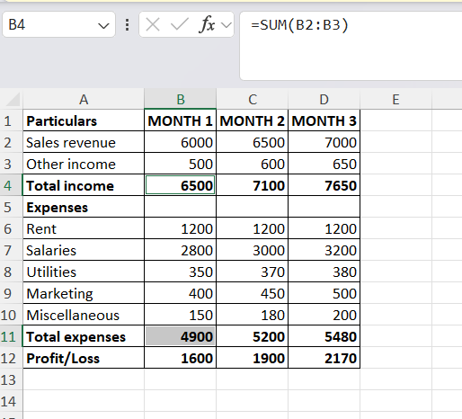

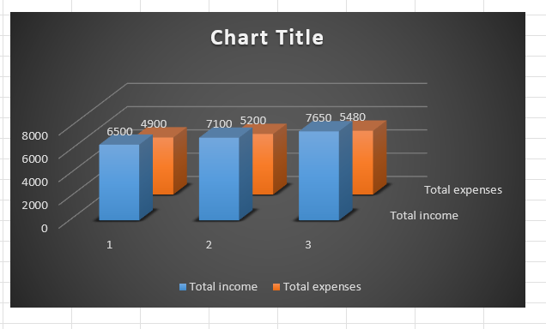

Introduction
A lot of change since the initial release of Microsoft Excel which began life as a simple spreadsheet environment and has grown into a comprehensive data analysis, automation and collaboration tool. In particular, using Excel as a tool for data management and analysis becomes more significant as businesses and organizations experience a boost in the number of data dependent processes. As cloud technology, artificial intelligence and machine learning advance, Excel becomes even more useful, supplying its users with better solutions in handling large amounts of data and helping businesses enhance their efficiency (TechRadar, 2022). Added to this, this essay will dwell on the main advantages of Excel; how it has adopted to the new technological world and why it remains important for business today.

Main Body
An area in which Excel is most powerful is in operations that involve organizing and analyzing big data. Since organizations gather large volumes of data every day, Excel enables the categorization and amendment of the data collected. Some of the features include the VLOOKUP, SUMIF, and INDEX, or even custom functions that help the user to be able to calculate heavy functions, massing for functions and prevent the user from having to repeat long sequences and calculations that would have taken a lot of time (Evidhya, 2023). Moreover, Excel is capable of pulling pivot tables and using enhanced charting tools allowing businesses to summarize and gain insights from data rapidly (Wilson, 2021).
And, especially, it is worth mentioning that Excel has an essential function in the financial analysis. Companies employ Excel to record sales revenues as well as expenses and COGS and to work out anticipated earnings and losses. With help of financial models and budgeting templates as well as accounting capabilities, using Excel in companies will help to provide control and effectiveness in the distribution of resources. However, the integration of Excel with other business applications like accounting or CRM system ensures that the application of data across those platforms is made easy (McKay, 2020).
The role of Excel in decision making in the digital age is all pervasive. Today, businesses use facts and figures in real-time and possible outcomes for decision-making processes. Excel offers options that let one carry out analysis in a short amount of time, which will add up the benefit of managers and executives who will be able to weigh numerous factors and make decisions in the needed amount of time that would otherwise be taken learning the methods (Smith, 2022).
Conditional formatting, data validation and other features in Excel make it easier than for the user to quickly find something odd or suspicious that can be a problem to solve or an opportunity to seize. Further, the spreadsheet application has the capacity to perform complex calculations besides allowing companies to conduct business models and execute other scenarios, which helps organizational decision-makers determine how specific decisions would affect operations (DigitalDefynd, 2024). Here is where ability to analyze data and model data in moments important for businesses that have to adapt and be flexible in rapidly changing environment.
The key to the digital workplace is working together. It’s therefore for these demands that Excel has incorporated cloud functionality. This means that with Microsoft 365, several persons engaged in the use of Excel can edit one document simultaneously as well as fund in real time. This has greatly transformed how working parties lead projects, solve numerical problems, and prompt collaboration. Being cloud-based, Excel also provides an opportunity to input a range of updated data cleanly, so that the ultimate decision-makers have clean and updated data at their disposal (TechRadar, 2022).
Also, the combination of AI and machine learning into Excel improves its analysis of data processing capabilities. It has features like “Ideas” in excel that can actually present certain insights given the data we feed to the program. This makes it easy for any person with little technical background to harness advanced analytics, which gives a more efficient user interface and enables the business to make accurate and fast decisions as necessary (Brown, 2023).
It must also be mentioned that using Excel is possible within various businesses since the tool is quite scalable. Inability to adapt keeps Excel from not only small companies, but large corporations they need a more complex system. Small business users will find Excel easy to navigate and not complex to use while larger organisations can utilise the more complex function of Excel and data control and integration with other software (Wilson, 2021). Also, continuity and compatibility are achieved since Excel can handle large data volumes and is easily fitted into changing organizational needs of the business.
Especially for merchants, hospitals, and other economic organizations, using Excel can save costs in many specified areas of inventory control, customer interaction or financial statements. Excel can be used even as organisations grow while improving on other complex technologies by ensuring that their data management system is an improvement on their current business growth (McKay, 2020).

Conclusion
In conclusion, it can be true that Microsoft Excel is still useful in the era of computers being a prominent tool in every organization. The reason why it is still popular can be attributed to its outward features, user-friendly interface and ability to Integrate with latest technologies including cloud and artificial intelligence. In this aspect, it supports data analysis and decision making and provides organizations with affordable ways to challenge the giants and remain as agile as possible in today’s big data world. As companies adapt to change and develop, this tool will continue to play an important function of digitalisation, enabling organisations to base their decisions on fact and figures.

Task 4: Video Pitch
https://www.youtube.com/watch?v=zphNL8UE7_0
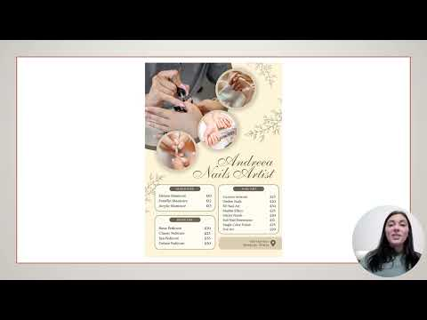
When shooting the video for Andreea Nails Artist, elements of narrative were used to present the brand’s information to the targeted audience appealingly. The video has been well crafted, designed and has a view of narrative structure and the use of visuals thus making the target audience emotionally engaged from end to end. Fang and Tsvetkova (2023) pointed out that storytelling not only enables students to obtain knowledge but also build social competencies since the focus is on content that can be told in an entertaining way. This is perhaps seen when the video incorporates acknowledge the use of customers in the video since it endows the message with credibility. In addition, according to the source Kelly (2020), the choice of performing cinematic shots, the cuts and the transitions in relation to each other play an essential role in enhancing the audience’s interest and ensuring smooth narration. At the end of every scene in the video, there is some sort of signal that assists the viewers in knowing how to proceed from introduction to call to action. According to Gordon and Benjaminsen (2021), telling a coherent and reaching for the audience’s emotions story through the use of new technologies is one of the biggest focuses of digital storytelling and that was done by presenting the personal story of the Salon and its professional experience in it. Both these forms of storytelling help to guarantee that while the content is being delivered as informative it is also persuasive and compelling the audience into action.

References
Berger, J., 2020. Contagious: why things catch on. Simon and Schuster.
Brown, L., 2023. The Role of Microsoft Excel in Modern Data-Driven Decision Making. International Journal of Data Science, 15(2), pp.123-135.
Buell, R. W., Ramdas, K., Sönmez, N., Srinivasan, K. and Venkatesh, R. 2024. Shared service delivery can increase client engagement: A study of shared medical appointments. Manufacturing and Service Operations Management, 26(1), pp. 154-166.
Cespedes, F. V., Peterson, S. and Weinfurter, D. 2024. 4 steps that can optimize your sales process. Harvard Business School Case, 824-144.
DigitalDefynd, 2024. 15 Reasons You Must Learn Excel [2024]. Available at: https://digitaldefynd.com/IQ/reasons-you-must-learn-excel/
Dixon, M., Toman, N. and DeLisi, R. 2020. The effortless experience: Conquering the new battleground for customer loyalty. Harvard Business Review Press.
Evidhya, 2023. MS Excel - Importance of Excel in Data Management and Analysis. Available at: https://evidhya.com/subjects/ms-excel/importance-of-excel-in-data-management-and-analysis
Fang, M. and Tsvetkova, M., 2023. Storytelling, Creativity and Writing as a Tool for Building Sophisticated Social Skills. Journal of Psycholinguistic Research, 52(4), pp. 1397-1408. doi:10.1007/s10936-023-09949-01.
Godin, S., 2020. This is marketing: you can’t be seen until you learn to see. Portfolio.
Gompers, P. A. and Levindo, P. 2024. Nomad: A license to bank. Harvard Business School Case, 824-144.
Gordon, N. and Benjaminsen, G., 2021. Telling Tales: Digital Storytelling as a Tool for Qualitative Data Interpretation and Communication. International Journal of Qualitative Methods, 20(1), pp. 1-10. doi:10.1177/160940692110225293.
Kalalo, R.R., Scipio, J.E., Kalangi, J.S. and Lumentah, L., 2020. The effect of customer satisfaction on the service at Lady Salon during the Covid-19 pandemic. BIRCI Journal, 1(1), pp.1-10. Available at: https://doi.org/10.1088/1757-899X/1/1/010012
Kelly, B., 2020. The Art of Cinematic Storytelling: A Visual Guide to Planning Shots, Cuts, and Transitions. Oxford Academic. doi:10.1093/oso/9780190054328.003.00012.
Kotler, P., Kartajaya, H. and Setiawan, I., 2020. Marketing 4.0: moving from traditional to digital. Wiley.
Manning, H. and Bodine, K. 2020. Outside in: The power of putting customers at the center of your business. Harvard Business Review Press.
McKay, S., 2020. Why is Excel Important? 9 Top Functions Explained. Available at: https://blog.enterprisedna.co/why-is-excel-important/
Mittal, V., Han, K., Frennea, C., Blut, M., Shaik, M., Bosukonda, N. and Sridhar, S. 2023. Customer satisfaction, loyalty behaviors, and firm financial performance: What 40 years of research tells us. Marketing Letters, 34, pp. 171-187.
Nam, H. and Jin, Y., 2021. The effect of hairdresser’s job crafting on customer orientation and work performance. Journal of the Korean Society of Cosmetology, 27(6), pp.1427-1436. Available at: https://doi.org/10.52660/jksc.2021.27.6.1427
Rosário, A. and Casaca, J. A. 2023. Relationship marketing and customer retention: A systematic literature review. Studies in Business and Economics, 18(3), pp. 44-66.
Smith, J., 2022. Excel in the Digital Age: Enhancing Data Analysis and Management. Journal of Business Technology, 12(3), pp.45-58.
So, Y.-J., Lee, J.-Y., Choi, Y.-J., Lee, W.-S., Cho, A.-J., Youn, M.-K., Lee, L.-S. and Choi, E.-M., 2020. Customer satisfaction management and service quality according to the DISC behavior type. Journal of Distribution Science, 18(12), pp.79-89. Available at: https://doi.org/10.15722/jds.18.12.202012.79
TechRadar, 2022. Excel’s evolution: how cloud and AI are transforming the digital workplace. Available at: https://www.techradar.com/pro/excels-evolution-how-cloud-and-ai-are-transforming-the-digital-workplace
Wilson, J., 2021. Why Excel Is Important? (Key Benefits Revealed). Tooling Ant. Available at: https://toolingant.com/why-excel-is-important/

Appendices

Task 1 Raw Data

ID | Start time | Completion time | Email | Name | Last modified time | How satisfied were you with your gel manicure service today? | How would you rate the cleanliness and ambiance of our salon? | How would you rate the professionalism and friendliness of your nail technician? | Did the service meet your expectations in terms of quality and durability of the gel manicure? | How long do your gel manicures typically last? | What do you think of the range of gel colors available? | Would you recommend Andreea Nails Artist to a friend or family member? | What is your preferred price range for a gel manicure? | How likely are you to return for another appointment? | How do you like to receive marketing from us?
1 | 10-24-24 13:46:58 | 10-24-24 13:48:14 | 2321857@student.uwtsd.ac.uk | Florina Dinitica |  | Very satisfied | Excellent | Excellent | Yes | 3-4 weeks or longer | Very satisfied | Yes | £30-£40 | Very likely | Email
2 | 10-24-24 14:54:48 | 10-24-24 14:55:55 | 2239816@student.uwtsd.ac.uk | George Marin |  | Very satisfied | Excellent | Excellent | Yes | 1-2 weeks | Very satisfied | Yes | £30-£40 | Very likely | Email
3 | 10-25-24 5:33:22 | 10-25-24 5:35:45 | 2310530@student.uwtsd.ac.uk | Ileana Ionita |  | Very satisfied | Good | Excellent | Yes | 2-3 weeks | Satisfied | Yes | £40 and above | Very likely | Social media
4 | 10-25-24 7:14:23 | 10-25-24 7:17:38 | 2323940@student.uwtsd.ac.uk | Cristian Dinicuta |  | Very satisfied | Excellent | Excellent | Yes | 3-4 weeks or longer | Very satisfied | Yes | £20-£30 | Very likely | Email
5 | 10-25-24 8:15:51 | 10-25-24 8:16:23 | 2323940@student.uwtsd.ac.uk | Cristian Dinicuta |  | Very satisfied | Excellent | Excellent | Yes | 3-4 weeks or longer | Very satisfied | Yes | £20-£30 | Very likely | Email
6 | 10-26-24 15:18:05 | 10-26-24 15:21:16 | 2320920@student.uwtsd.ac.uk | Viktoriia Sashchenko |  | Satisfied | Good | Good | Yes | 1-2 weeks | Satisfied | Yes | £20-£30 | Somewhat likely | Social media
7 | 10-28-24 13:13:41 | 10-28-24 13:16:08 | 2321394@student.uwtsd.ac.uk | Sorina Bortos |  | Very satisfied | Excellent | Excellent | Yes | 3-4 weeks or longer | Very satisfied | Yes | £30-£40 | Very likely | Email
8 | 10-29-24 4:32:19 | 10-29-24 4:33:10 | 2318489@student.uwtsd.ac.uk | Mariela Hidalgo Jorge Hidalgo |  | Somewhat satisfied | Good | Good | Yes | 1-2 weeks | Satisfied | Yes | £20-£30 | Somewhat likely | SMS/Text
9 | 11-5-24 13:43:10 | 11-5-24 13:43:29 | 2311765@student.uwtsd.ac.uk | Fernando Bagi |  | Satisfied | Poor | Good | No | 3-4 weeks or longer | Satisfied | No | £40 and above | Neither likely nor unlikely | Phone

