Marketing Plan

Issue: Lack of experienced food and beverage staff as complained by the customers of Hilton Hotel

1. Introduction
The issue related to well recognised Hilton Hotel located at Thames River is there is the absence of qualified food and beverage employees which is resulting in a loss of their revenue by 54% as per the report 2021. Therefore, the purpose of the marketing plan would be to appoint well-experienced food and beverage employees to serve exotic traditional as well as modern dishes and bring refinement in their revenue. The proposed marketing plan being prepared for appointing experienced food and beverage workers would be to increase its revenue by attracting middle and senior-aged professionals with high levels of income belonging to the upper social class who have complained regarding the concerned issue. In order to fulfil their plan of recruiting and selecting qualified food and beverage artisans, Ansoff Matrix, SOASTAC framework, and Marketing Mix would be utilised in the assignment.
2 Situation Analysis (5C’s)
2.1. Company
SWOT Analysis
Strengths  - High Brand Recognition which would assist the HR Department of Hilton Hotel to invest in progressive recruitment techniques such as employee referrals and virtual reality, therefore appointing higher qualified food and beverage staff.  - Praiseworthy employee retention through various benefits like health care, life insurance and the discount would gain the attention of the skilled food and beverage staff having knowledge in preparing exotic items like shepherd’s pie and cornish pasty. | Weaknesses  - Little market share with only 42% in the United Kingdom would cause a limitation in incurring the cost of the high authority to appoint experienced workers.  - Large number of debts with a loss of 54% would lower the interest of the newly appointed food and beverage artisans to work diligently, as they would not get an appropriate salary.
Opportunities  - Emphasising on the research and development would give the respective hotel opportunity to increase their learning about the innovative recruiting techniques like Artificial Intelligence and Virtual Reality leading to excellent appointments.  - Building of strategic alliances would assist to attract the investors such as Nine Group to invest financial resources hence would give them a chance to improve their selection procedure. | Threats  - The large number of competitors such as Marriott, Ritz Carlton and Four Seasons with higher market share would prove to be a threat in attracting skilled artisans because of their benefits.  - The lack of investment in training techniques would prove to be a threat for Hilton Hotel because the newly appointed food and manager artisans would not be trained properly about planetary mixers and aqua cookers, restraining from providing fast service.

2.2 Customers
Segmentation and Targeting
Segmentation Types | Explanation
Psychographic | Hilton Hotel would achieve the concerned plan of recruiting skilled food and beverage workers for the high-class general and professional customers.
Demographic | The concerned hotel would fulfil the plan for middle and senior-aged customers of age 28-60 years.

Target Audience
Income Group | Higher Income Groups
Age Group | 28-60 years, Middle and Senior aged professionals
Location | U.K

2.3 Competitors
Perceptual Positioning Map
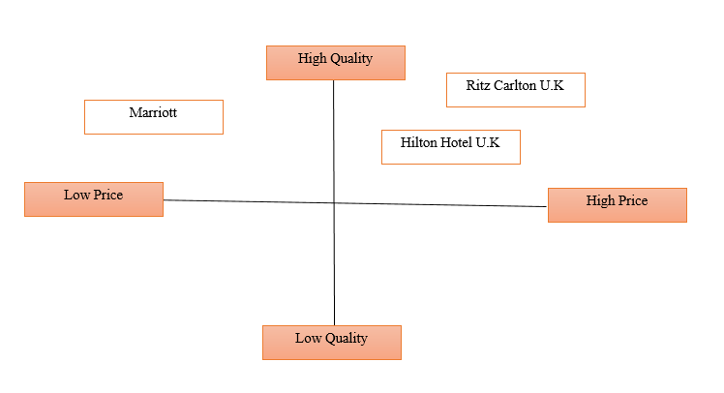
Figure 1: Positioning Map
Source: Developed by learner
Bowman's Strategy Clock
From the combinations of Bowman Strategy Clock, Hilton Hotel in order to execute the marketing plan of appointing excellent food and beverage employees, would follow a Focused Differentiation clock position which is illustrated as the offering of high quality food at high prices. This would result in higher levels of profits and they would use the gains in innovative recruitment strategies, appointing skilled employees.
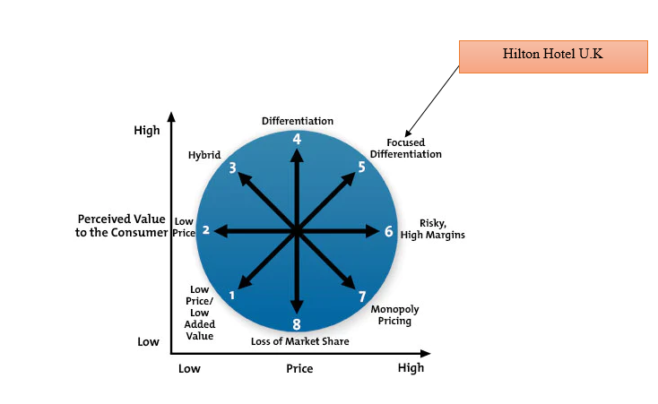
Figure 2: Bowman's Strategy Clock for Hilton Hotel U.K
Source: Configured by learner
2.4 Collaborators
- Relationships
Hilton Hotel would only be able to attract highly qualified food and beverage managers through maintaining a good connection with them which can be developed through provision of facilities like paternity leave, bereavement leaves, adoption assistance and paid time. The on-the-job training and e-learning of various kitchen innovations such as blast chiller, combi oven and vacuum training for engaging the newly appointed staff rate.
- Partnerships
The partners and stakeholders of the Hilton Hotel would be kept happy by inviting ion conferences as well as providing them discounts for staying henceforth, Waldorf Astoria Hotels, LXR Hotels and Homewood Suites would help with expenses of fulfilling the recruiting strategy plan.
- Franchises
The 60% franchise of Hilton Hotel U.K would encourage them with managerial and technical assistance to upgrade their selection strategy inducing AI and Virtual Reality to appoint highly skilled staff.
2.5 Climate
PESTLE Analysis (Macro analysis)
Factors | Analysis | Impact
Political | Political Instability due to Brexit | The political tension arising because of Brexit would restrain the high authority of Hilton to appoint experienced food and beverage employees outside the European Union, lowering their chance to improve customer service and revive their profits in U.K.
Economic | Economic Degradation because of pandemic | The unemployment rate that arose due to the pandemic is recorded to be 21.4% for the hotel industry leading to a fall of GDP. Therefore, it would prove beneficial to appoint knowledgeable food and beverage artisans reducing the rate of unemployment and similarly fulfilling the aim of earning impressive profit in the domestic market.
Social | Less Demographic rate because of deaths in pandemic | The shifting of digital lifestyle would give a chance to recruit excellent workers in food department through social media advertising. It would become easy for them to fulfil their marketing plan and provide excellent service to customers in U.K market.
Technological | Digital Media to communicate with employees | The e-learning would be adapted as a procedure for training the newly appointed employees about various kitchen innovations for providing faster food to middle-aged and high-level professionals, improving their productivity and achieving sales in U.K market.
Legal | Equality Act 2010 | This legal provision would protect the rights of the artisans attracting the well-experienced staff to join the hotel.
Environmental | Green Recruitment Procedure | It would assist them to reduce their recruitment costs by automating the process and protecting the environment from hazards.
4Ps Marketing Mix
Product/ Service | Restaurant, Bars, Swimming Pools, Food and Beverage Services.
Price | Premium Pricing Strategy
Promotion | Premium Magazines and Customer Review Sites
Place | U.K, 168 hotels

3. Objectives
Objective | Specific | Measurable | Attainable | Relevance | Time Bound
To improve the recruitment strategy in order to appoint excellent food and beverage manager | Financial Investment by stakeholder Nine Group. | Assessing the net customer worth and lifetime value. | Programmatic Advertising and Employee Review Sites. | Provide Quicker Service to the customers and revive their 54% loss. | 4 months

4. Strategy(350)
Value Proposition
The value proposition would be to provide exotic food services to the customers by training and recruiting qualified employees in the food and beverage department.
Ansoff Matrix
It would follow Market Penetration Strategy because it would revive its revenue in the United Kingdom by providing excellent traditional food by recruiting qualified employees in the food and beverage department.
Changes in the marketing mix
4P’s | Analysis
Product | Traditional English food services
Price | Competitive Pricing Strategy
Promotion | Social Media Marketing and Digital Advertising
Place | Ireland and England, U.K

5. Tactics (350)
RACE/ Communications Mix
Race Elements
Reach | Social Media Advertising
Act | Select from a large number of applications.
Convert | AI and Virtual Reality in Recruitment
Engage | E learning and on the job training
6. Action (100)

7. Control(100)
Key KPI Indicators
Revenue Growth | By appointing excellent food and beverage employees through inclusion of AI in recruitment.
Revenue per client | Through preparing the exotic food by the qualified chefs as per their taste.
Profit Margin | By preparing traditional English dishes like yorkshire and pancakes by the excellent chefs appointed.
Client Retention Rate | By the provision of fast food service using innovative kitchen appliances.
CustomerSatisfaction | Through provision of quality level food with delicious taste and on time.

8. Conclusion
Therefore it can be concluded that Hilton Hotel would improve the issue of poor quality of food and beverage staff by bringing a change in their recruitment strategy through inclusion of AI and Virtual Reality. Moreover it can be evaluated that competitive pricing strategy and promotion through social media would assist in fulfilling the plan. Apart from it, the Market Penetration Strategy would assist in fulfilling the market plan. The key recommendation is that the marketing plan would have been better by mentioning the types of financial sources the hotel would adapt like Venture Capital or Loan to achieve the improvement of the recruitment strategy.

Component B: Presentation
Introduction
The marketing plan for Hilton Hotel is prepared for improving the recruitment strategy of the food and beverage staff in order to provide excellent service to customers and reviving the loss of 54%.

Situation analysis
The stronger brand value would assist Hilton Hotel to invest in the recruitment techniques and attract a wide range of skilled employees. Apparently, it would follow Psychographic and Demographic Segmentation targeting the middle aged and elderly aged high class professionals of U.K. Apparently, it would maintain good relationships with employees by providing benefits like paternity leaves and bereavement, in order to attract them. The macro factors like green recruiting would reduce their costs in appointing experienced employees in the food and beverage deprtment. The price strategy followed is premium and is located in U.K, around 164 locations.

Objective
The primary objective is to improve the recruitment strategy by posting through programmatic advertising and employee review sites.

Strategy
The e-learning and on the job training would be utilised to train the newly appointed food and beverage employees to provide excellent food survival to the customers. It would follow Market Penetration Strategy which would help to improve the quality of food and the changes in food product would be bringing traditional English dishes and following the competitive pricing strategy.

Tactics
The reach would be through social

Action

Control

Conclusion

