
Moodle Blogs Basics
Formatting Text: Inserting Images: Inserting Links
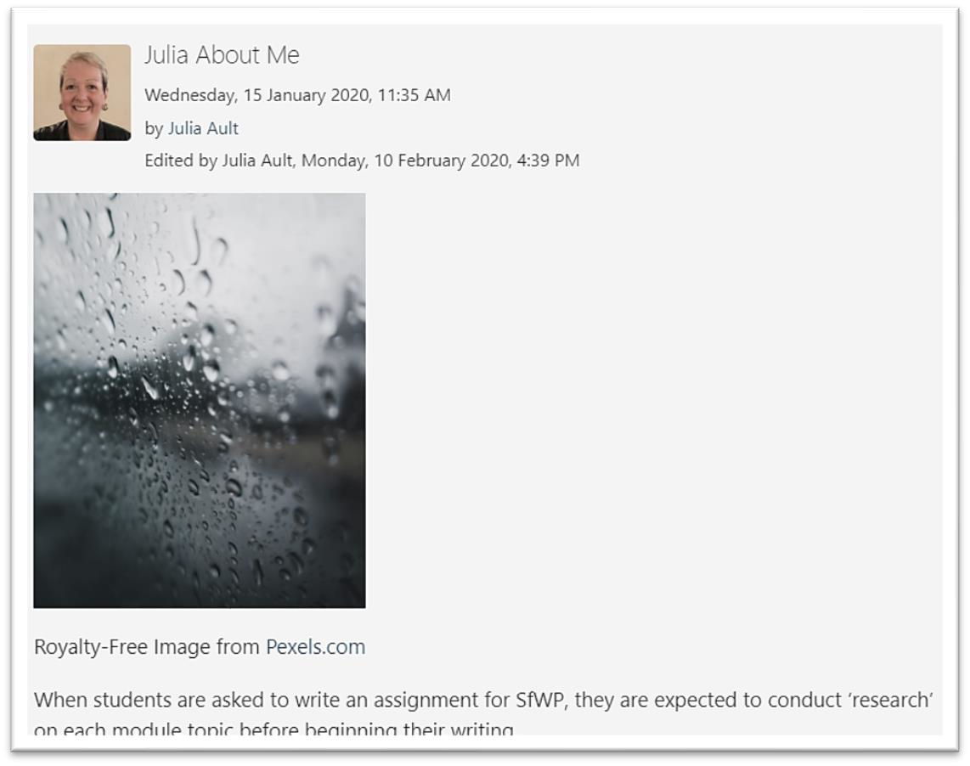

Table of Contents
Formatting Text and Inserting Images on Moodle Blogs ........................................................ 1
Open a blog entry to edit ....................................................................................................... 2
Highlight Text ........................................................................................................................ 2
Remove Formatting Method 1 ............................................................................................... 4
Remove Formatting Method 2 ............................................................................................... 5
Remove Formatting Method 3 ............................................................................................... 6
Inserting an Image into your blog .......................................................................................... 8
Find a suitable image ............................................................................................................ 8
Insert an image into your blog ............................................................................................... 9
Modify Image Size .............................................................................................................. 12
Inserting Links ..................................................................................................................... 13

Open a blog entry to edit

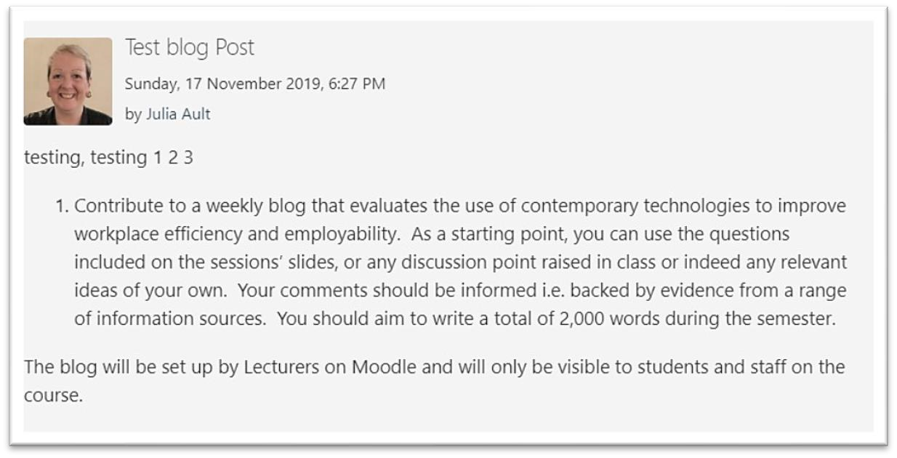

Scroll down to the bottom of the post and click on Edit
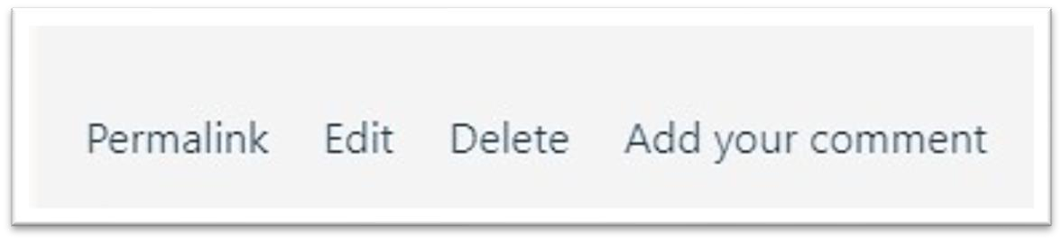

Click on the button on the far left to show more editing options
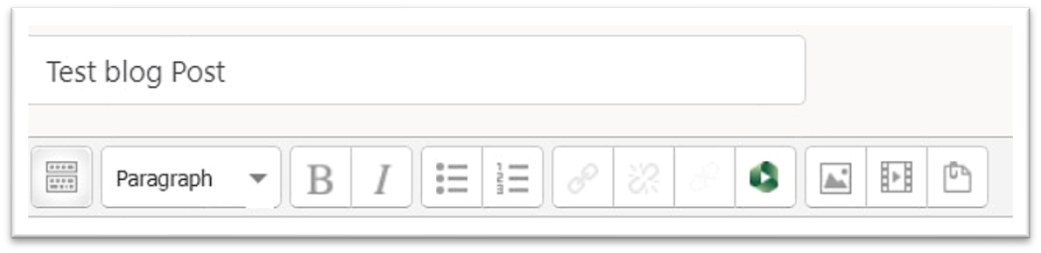

Highlight Text
You will need to highlight/select your text before you can edit it.
There are 2 easy ways of doing this.
1.Click your left mouse button and whilst holding it down, drag it across your blog text to select it
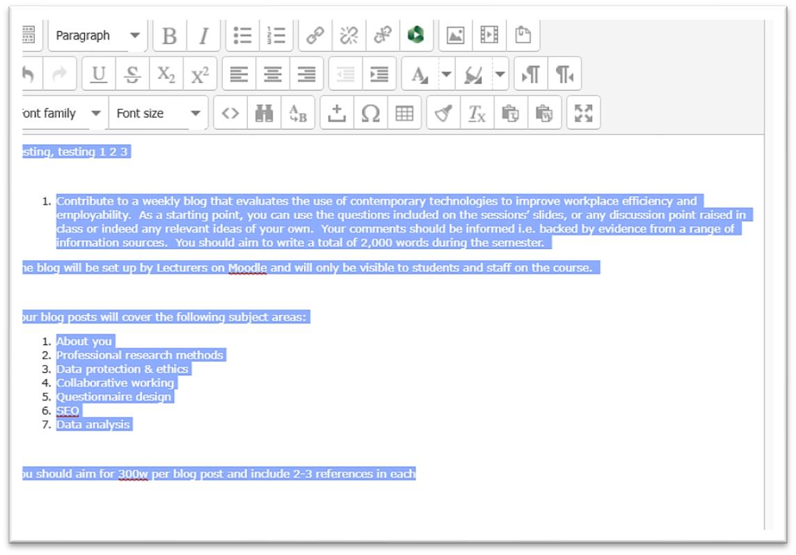
OR

2.Put your mouse cursor into your blog post and then hold down the CTRL and A keys on your keyboard TOGETHER
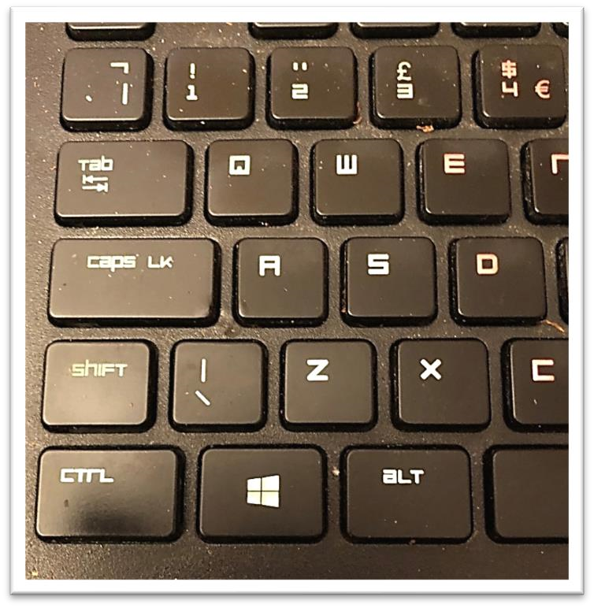

Remove Formatting Method 1

With your text highlighted, click on Tx on the right of the third row
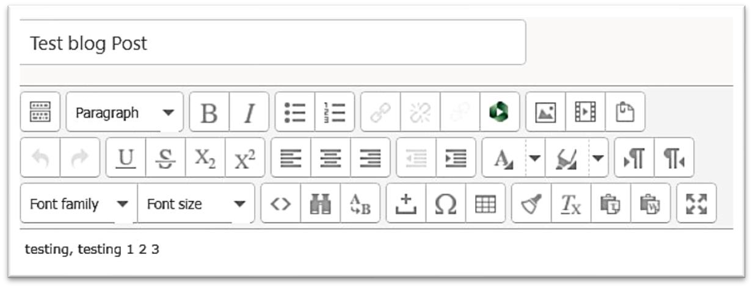

This button should remove all formatting from your text.
You may want to do this because text you have written or copied in from Word may be very big or very small and doesn’t look professional.
Example of very large text
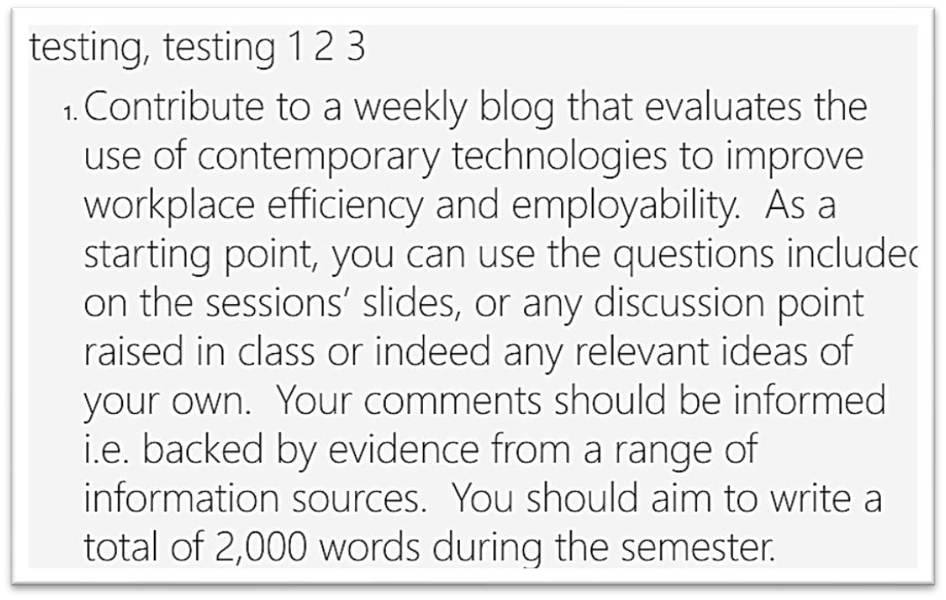

Scroll down the page and click on Save changes so you can check that the formatting has been removed.
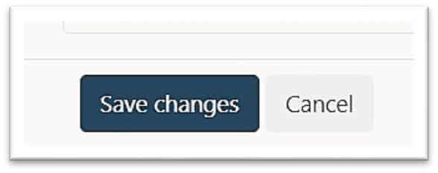

Remove Formatting Method 2

If this doesn’t work (it doesn’t always!) go back in to Edit, highlight your text as shown above and then click on the Dropdown box with Paragraph showing.
Click on the word Paragraph
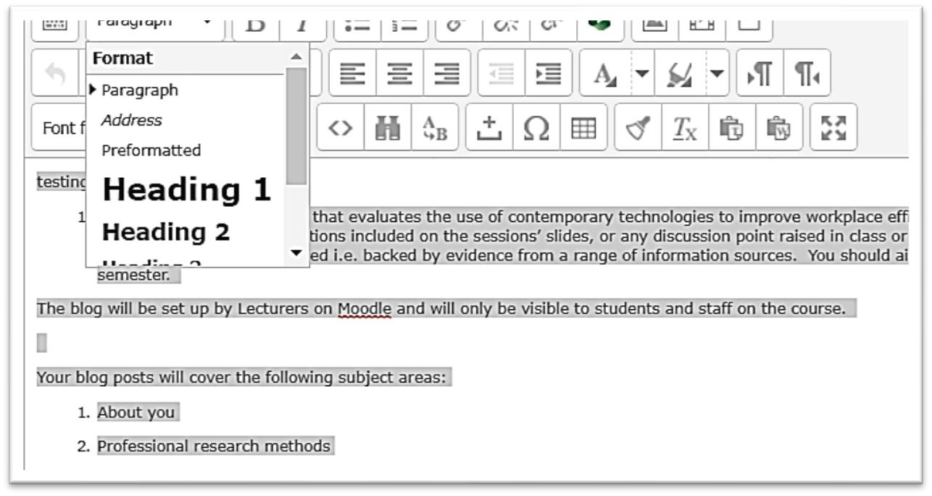

Hopefully this will reduce the size of your text and you can Save changes again.
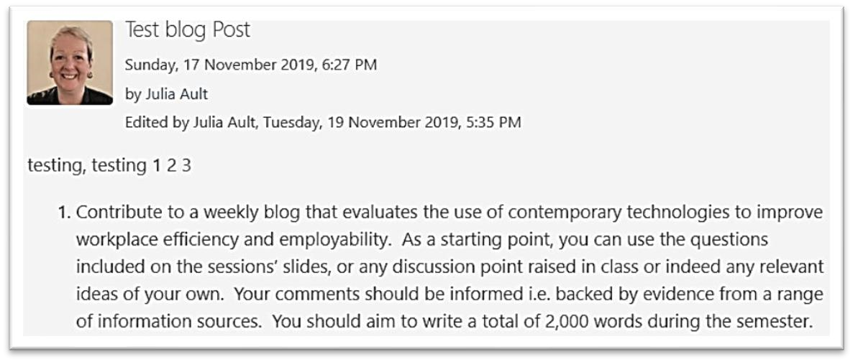

Remove Formatting Method 3

If all else fails(!) highlight, (CTRL + A) your text - then copy (CTRL + C) and paste your text into a new Word document (CTRL + V)
With the pasted text still highlighted, click on the Clear all Formatting button in Word in the Font box.
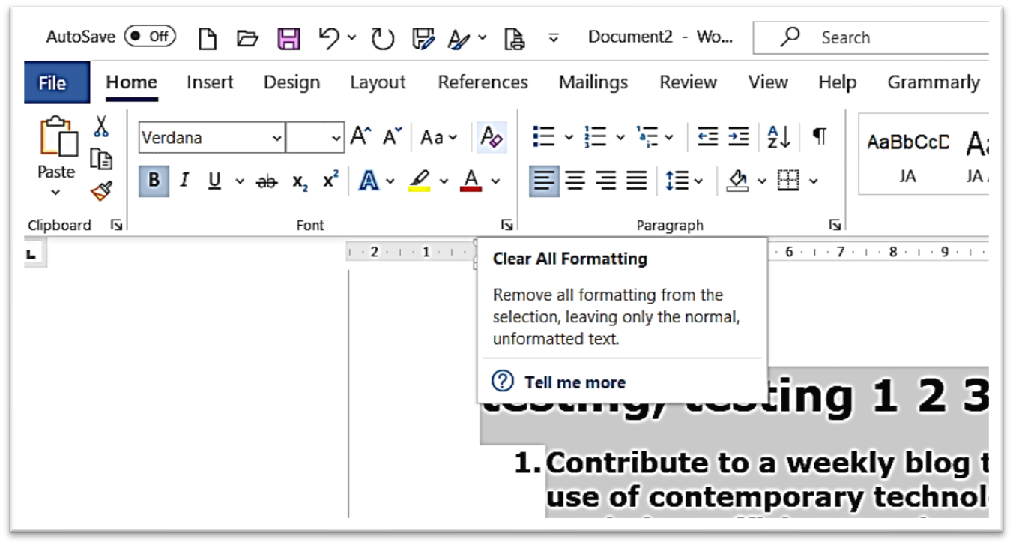

Your text should then be reduced to normal size and whilst still highlighted, you can copy it again (CTRL + C).
Go back to your blog post, click and drag to highlight the large text and then click the DELETE (might just say del) key on your keyboard to get rid of it.
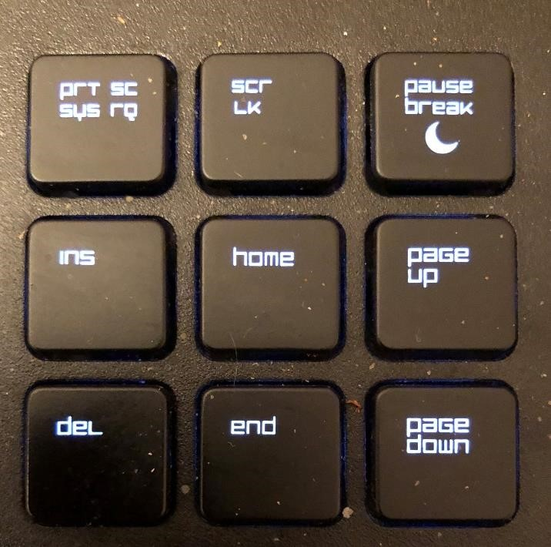

Then paste the new text in from Word using CTRL + V
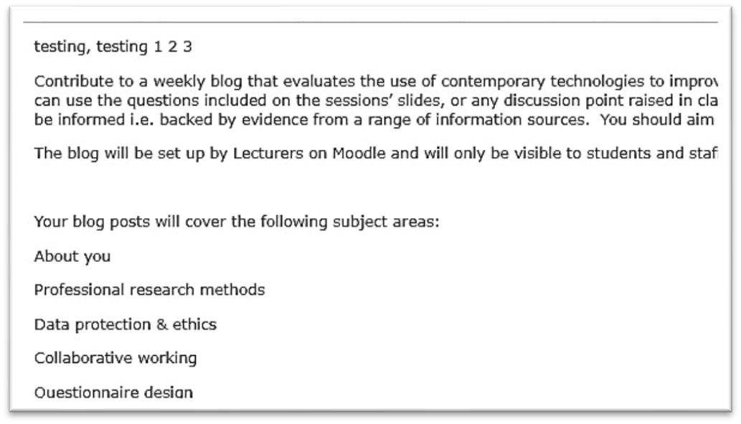
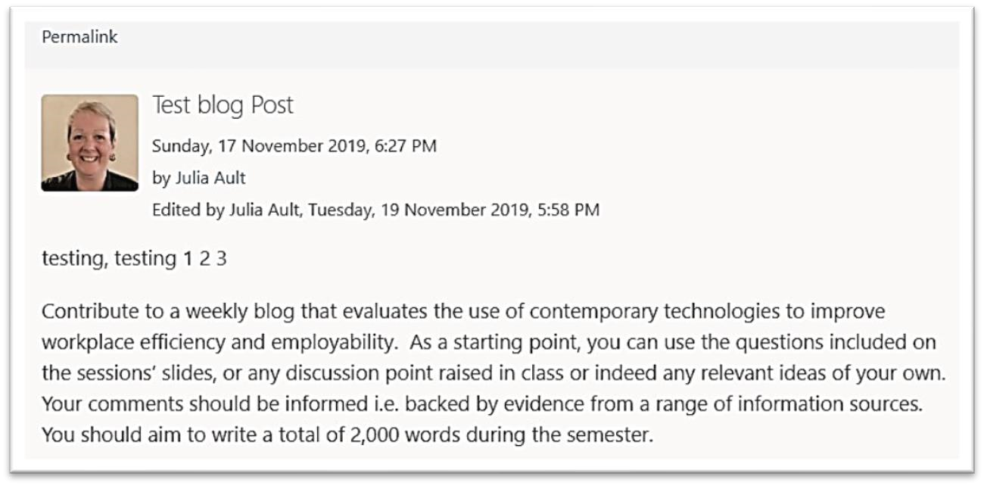

Inserting an Image into your blog

Find a suitable image
Go to www.pexels.com
Find a picture you like to test the process and click on it.
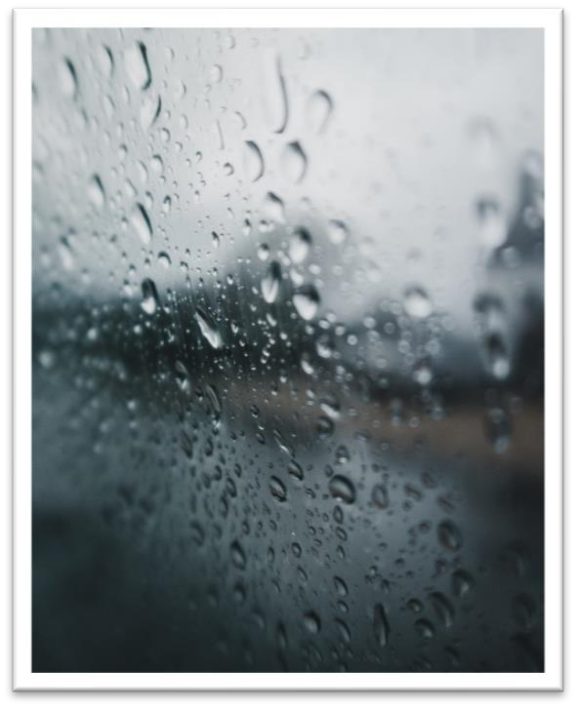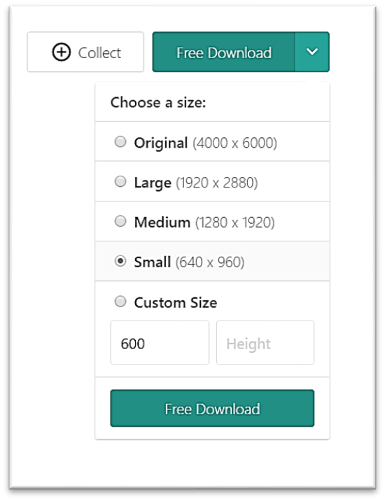

Click on the
arrow next to the
Free Download button on the
right hand side

of the page
:

Choose a size for your picture. You can pick any size you like if you want to keep the image for other purposes – but it will need to be reduced in size for your blog.
Click on the Free Download button under the sizes and the image will be downloaded to your pc. It should appear at the bottom of the screen
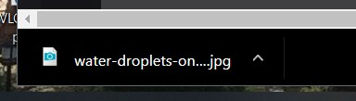
Click on the up arrow to open the image or show in folder. You can then move it to another folder of your choice (on your OneDrive would be sensible) so you will know where to find it again.
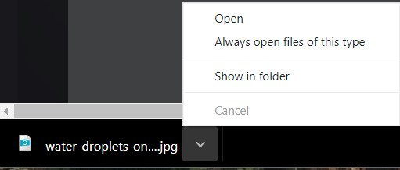

You might wish to follow the image author on Instagram or join Pexels if you think you may be downloading several images (perhaps for your business website, for example).


Insert an image into your blog

Create a new blog post (or edit an existing one).
Put your mouse cursor into the blog post where you want the image to appear and click on the image button on the toolbar.
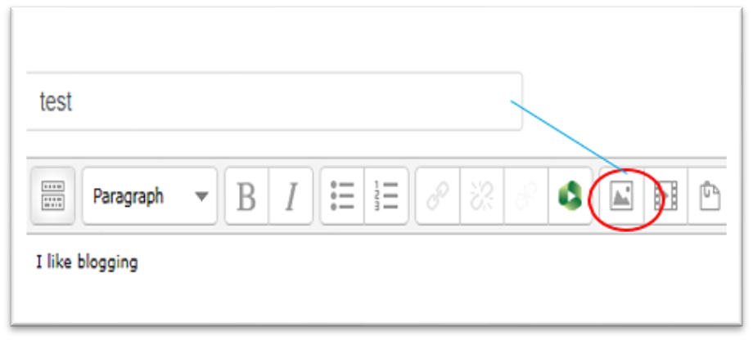

The insert/edit image dialogue box will appear.
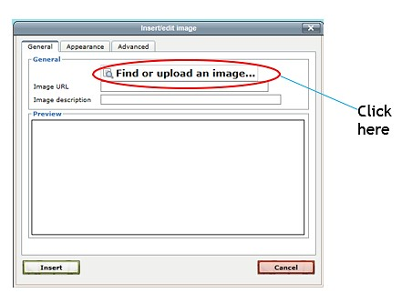

Browse for the image you want to insert.
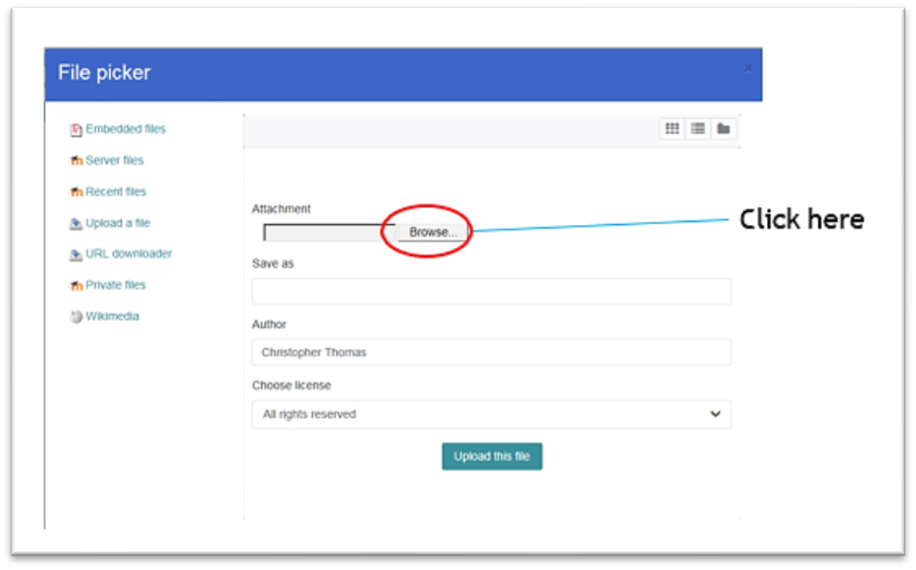
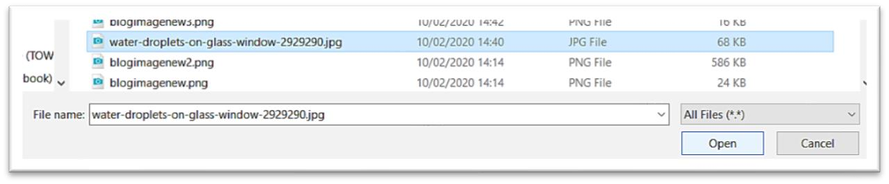
Select the
image

and
click
O
pen

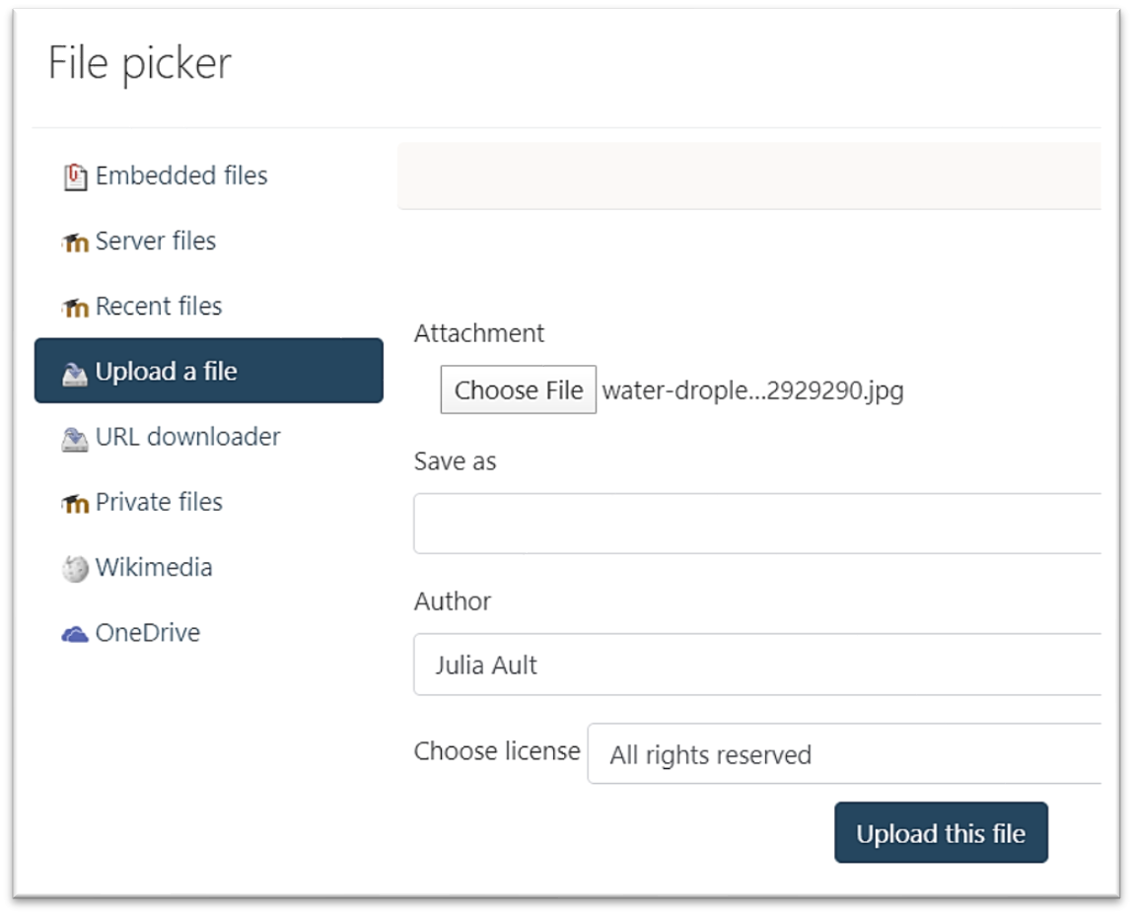
Click on Upload this file. Your image should appear in the Preview box.
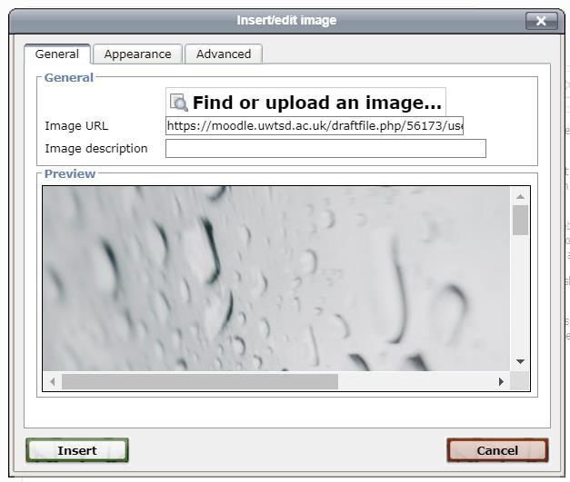

Modify Image Size
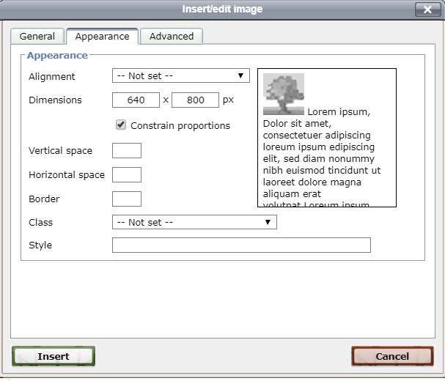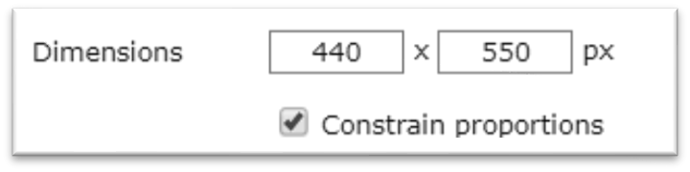
C
lick
on the
Appearance

Tab

If
the
image

is too big
–

you
can reduce the size here.

Chang
e

the

numbe
r

in the left
box, click out of the bo
x and
t
he number in the right box will
change
automatically
.

W
ith
dimensions reduced

You can play around with these numbers if needed and when you are happy with your image size, click on Insert.
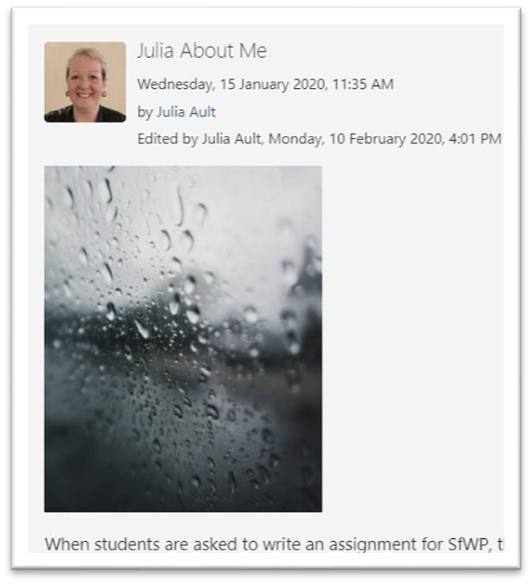

Inserting Links
To practice inserting links, type the sentence:
Royalty-Free Images from Pexels.com.
in your blog post and then highlight the words Pexels.com (left mouse button click and drag over the words)
Royalty-Free Images from Pexels.com.
Click on the link button on the toolbar (looks line a chain link)
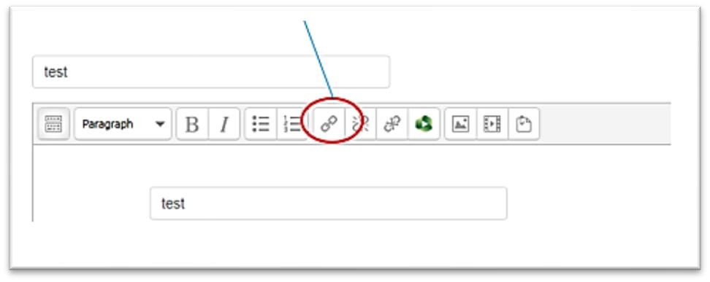

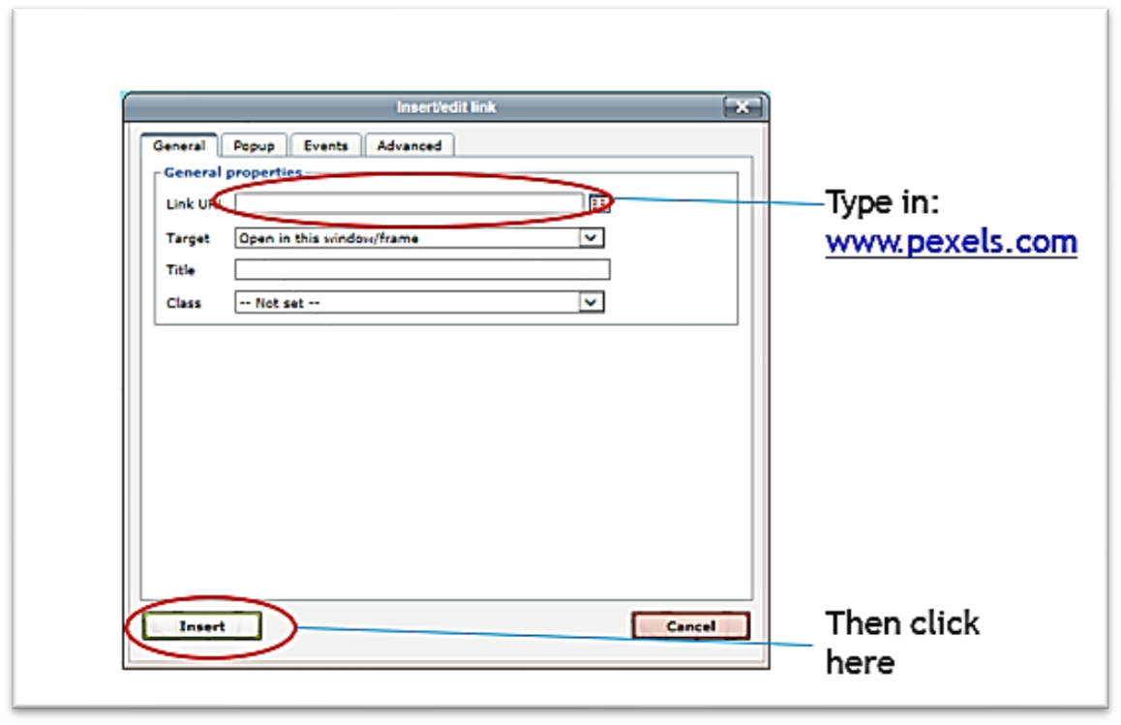
Scroll to the bottom of your screen and click ‘Add post’ to save.
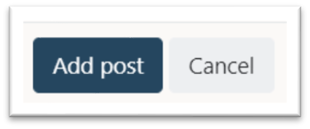
View your post and click on your link to see if it worked.

