Design of an industrial automatic control system



Module: Control & Automation
Module Code: ACMA5001
Lecturer: Rob Goodson
Student: Thomas Hughes
Student Number: 1909575
Contents
Introduction 3
Brewing Process overview 4
Design Specifications 5
DC Power Supply 6
PID Controllers 6
Heat exchanger 7
Pumps. 7
General equipment. 7
Vessels. 8
Valves. 8
Heating Elements 8
Sensors. 8
Analog gauges. 8
Hopper 8
Dead legs 8
Clean-in-process (CIP) 9
Safety Considerations 10
Hot water safety. 10
Breakers 10
Operating specifications. 11
Industry Standards & Regulation 12
Recommendations 12
Renewable energy 12
Works Cited 13

Introduction

The beer brewing process has developed throughout time, with the global growth of craft brews creating a need to own and make beer. The automation of these processes has proven critical to the consistency and quality of beer. The brewing process may be controlled and automated using technology to ensure that the same taste and quality beer is produced every time.
As an engineer at a small microbrewery, I am responsible for planning and executing a continuous process control strategy for a new product line. This report's criteria include detailing how the system will self-regulate, as well as any process alarms and data collection for process improvement.

Brewing Process overview

Water, malted grains, hops, and yeast are the main ingredients in any beer.
The mineral concentration of your water can have a significant impact on the type of beer you brew. Hardness of water affects how yeast develops and metabolises the sugars in your brew, therefore it's important to have good water quality when brewing. Consideration of water filtration and softening should be taken when designing the system. Once the water has been heated it can then move to mash lauter tun for the mashing process to begin.
The process of mashing involves combining crushed malt with extremely hot water. Malted grain has undergone a controlled germination process, which breaks down the endosperm and produces enzymes. Those enzymes become active when exposed to hot water at a specified temperature. They transform the easily available starches in the malt into sugars and dextrin’s when they are active (brewing, 2021). At this point, temperature and timing are crucial, so we must examine how to control both during the design. After that, the liquid is removed from the now-used grain can move on the boil kettle, how the liquid is transported automatically between each vessel will need to be included within the design.
The boiling process has many purposes, the boiling removes all bacteria by sterilising the sugary wort, it’s also where the hops and other flavourings are added dependant on the taste of the brewer.
After the wort has finished boiling, transfer it to a fermenter and pitch brewer's yeast into it! The wort must first be cooled. The wort is transported via a heat exchanger before being sent to a fermenter. This method enables for precise cooling to a set temperature. Yeast is pitched into the fermenter once the transfer is complete. The yeast will consume all the sugars formed in the mash over the next 4-6 days and convert them to alcohol and carbon dioxide. (brewing, 2021)
The yeast ferments the glucose to produce ethanol (alcohol) and CO2 (carbonation). The following is the chemical equation:
C₆H₁₂O₆ → 2 C₂H₅OH + 2 CO₂
This is the overall equation for fermentation, but the type of yeast employed in brewing can have an impact on individual products. (science, 2021)
After the fermentation process is finished, the beer will be chilled again, allowing the beer to settle to the bottom of the tank. The beer will be filtered and moved to the 'Brite tank,' where it will be carbonated and ready to be distributed in kegs, bottles, or cans.

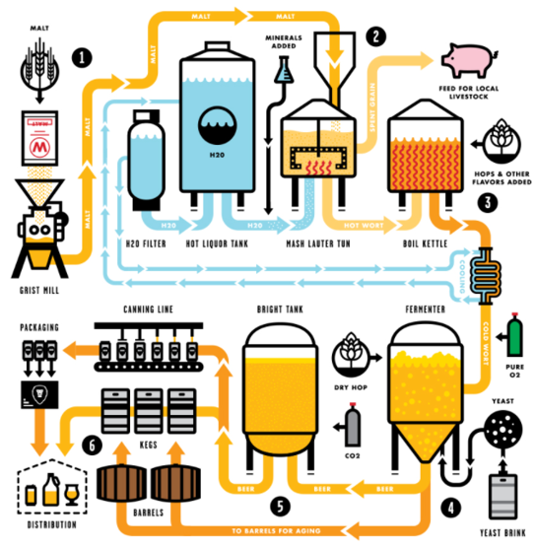
(brewing, 2021)

Design Specifications

Now that we know the key ingredients used to make beer and the method behind the brewing process, we can start to design and automate the brewing system. All materials selected conform with the food and drink standards.

DC Power Supply
Direct current, rather than alternating current, is required for the control panel signals. It may possibly run on a battery, but the easier approach is to convert alternating power from a normal outlet to direct current. The equipment is compact and simple to install, use, and maintain. It also works well with variable voltage outputs.

PID Controllers
PID employs three distinct constant parameters: proportional, integral, and derivative values. Consider the algorithm to be measuring current mistakes, accumulating previous errors, and forecasting future errors based on the current rate of change. The weighted total of these three data is utilised to modify the process as needed to achieve and maintain a specified value (SV), which is generally in temperature. (Panasonic, 2021)
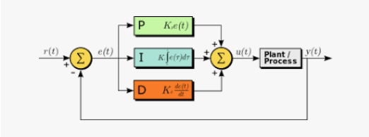
(Wikipedia, 2021)
The PID controller will be programed to regulate the heating, pressure and flow of the system, the PID can be set to the requirements of the user with relative ease. Maintaining a specific temperature for a given time is crucial when brewing beer, the PID ensures this is completed.
If any upper or lower set points are reached, the PID can be programmed to send an alarm to the user notifying them of the out of spec reading. This data can be stored and used for quality control or process improvement activities.
All parameters, warning alarms and e-stops will be positioned and controlled via a control panel, similar to the picture below. (Brewing, 2021)
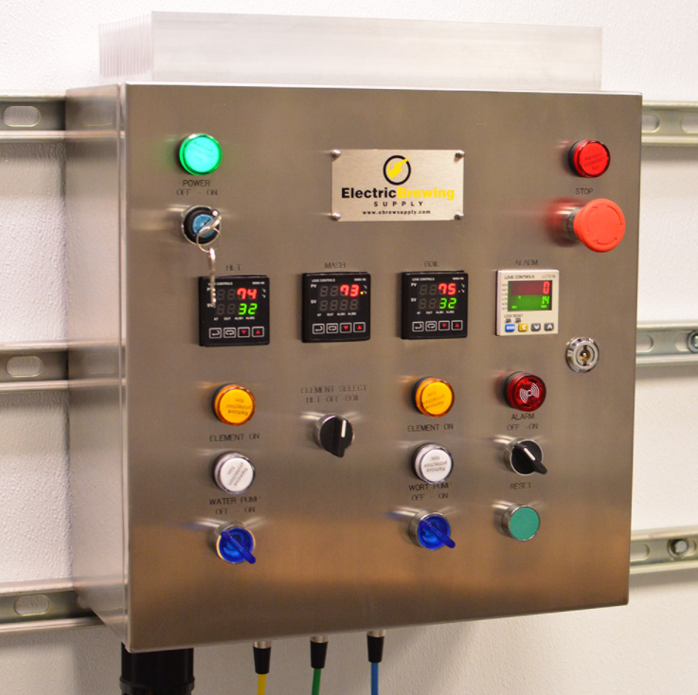

Heat exchanger
During the brewing process it’s essential that the liquid is cooled before entering the next tank, especially at the fermentation stage. The hot wort will pass through a heat exchanger to aid with cooling requirement. The heat removed during this process will be used at the start of the process to heat the filtered water. Heat exchangers are one of the most efficient methods of cooling (Hundy, 2016) because the hot water is circulated throughout the system, allowing the boiling process to begin sooner.

Pumps.
There are several types of pumps available. First and foremost, the pump must be food safe. A seal-less pump is thus advised to minimise leaks and liquid collection in the bearing and adjacent regions, which might lead to contamination. A magnetically driven centrifugal pump is an example of this. For identical reasons, the tubing and fittings should be thread less.
Progressive cavity (PC) will be chosen for dosing the yeast in to the Fermenting tank, because of its valve less construction this type of pump is particularly well suited to the brewery design. The PC pump which is both a pump and control valve, may draw yeast flow in both directions. Seepex 3-A PC pump meters’ yeast into fermentation tanks; its flow can be reversed easily for CIP/SIP cleaning. (Anon., 2013)

General equipment.
For each tank and each step of the process there will be many similarities to ensure the requirements of the brewing process are met whilst running automated.
The food and drink industry are heavily regulated, material selection and design methods must be introduced to ensure the highest order of cleanliness is kept.

Vessels.
Vessels may vary in size depending on the system owner's needs, and they will be manufactured of stainless steel to meet food and beverage industry standards (food.gov.uk, 2020). For safety considerations, the containers must be double the size of the batch capacity.

Valves.
All valves will be non-return pneumatic control valves, controlling flow rate in industrial facilities is a critical operation that is often accomplished using pneumatic control valves. (Goyal, et al., 2019) The valves will be controlled via a signal that will be programmed within the PLC. The time on which the valves will open/close will be dependent on the requirements of each step of the process. All valves will be made from stainless steel.

Heating Elements
The ability to heat the wort quickly and maintain temperature is vital to the quality of the beer, stainless steel heating elements will be attached to all tanks within the system and controlled via the PID system.

Sensors.
To control and automate the system efficiently many sensors are required.
- Temperature sensors – Critical to the brewing process as most process steps depend on the temperature of the wort being accurate to its needs.
- Level sensors – To ensure the correct level or liquid is available in each tank.
- Pressure sensor – monitor the pressure during boiling and when carbonating the beer.
- pH electrode sensor – To ensure the correct pH levels are maintained for beer quality purposes.

Analog gauges.
Analog pressure gauges will be attached to each tank measure the temperature and pressure, this will allow the user to view both in the event of the HMI failing.

Hopper
A hopper will be installed to the Mashing tank to enable the brewer to add the malt to the hot water.

Dead legs
If the dead leg is used, it can produce significant contamination inside the system, reducing the efficiency of the beer and putting the end user at risk. Not only would this be deemed as breaking the law, it could have massive cost implications to the business.
Duties under the Health and Safety at work Act 1974 (HSWA) include legionella bacteria hazards that may emerge from work activities. More precisely, the control of Substances Hazardous to Health Regulations 2002 (COSHH) establish a framework of activities aimed to assess, prevent, or control the danger posed by bacteria such as Legionella and to take appropriate safeguards. (HSE, 2021)
The following schematic diagrams show two systems, the first with dead legs within the design, and secondly with the dead legs removed.
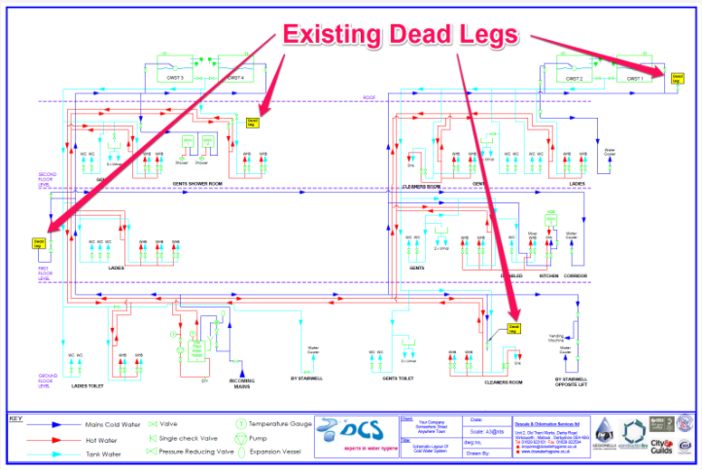
(DCS, 2021)
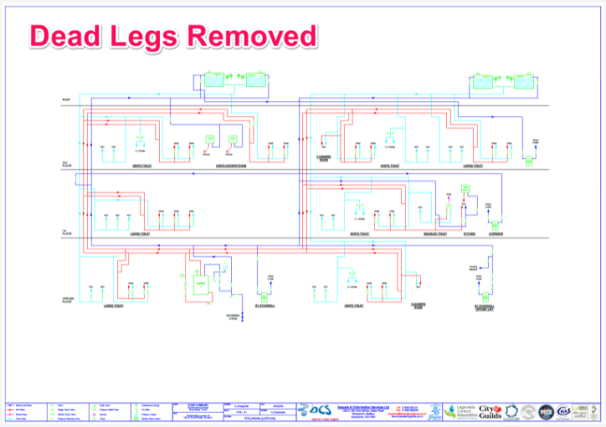
(DCS, 2021)

Clean-in-process (CIP)
In breweries, hygienic design, and Cleaning-In-Place (CIP) systems are required to decrease equipment and pipework fouling, yeast, wort, and beer cross-contamination, and the presence of potentially contaminating microorganisms. Fouling of equipment and piping inhibits heat transfer and gives microbial growth sites (Davies, et al., 2015)
Brewery layout, pipework, and valve design and size are all examined because of their importance in achieving a hygienic process in practise. Cleaning via the CIP method reduces the danger of contamination and cross-contamination, ensuring that food is always safe.
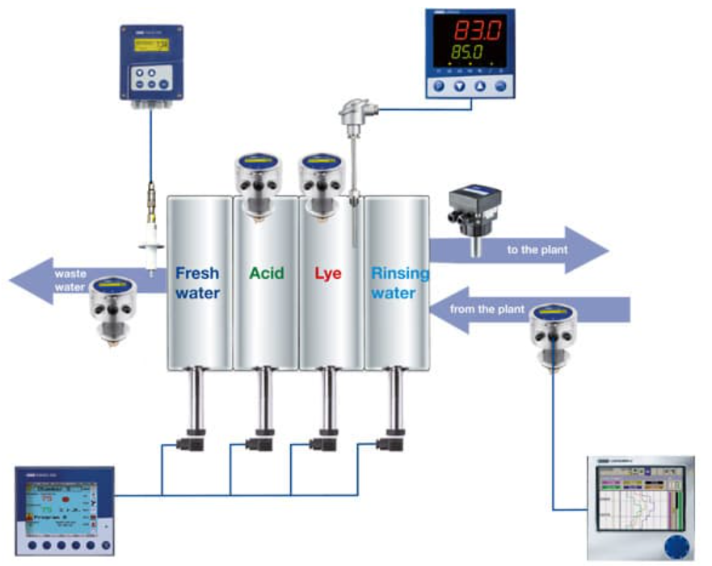
(Jumo, 2021)

Safety Considerations

Hot water safety.
When wort reaches boiling temperatures, it is known for producing a significant volume of froth. As a result, vessels should be 1.5 to 2 times bigger than the batch capacity. The surfaces of the vessel can become hot enough to burn anyone who comes into contact with them. In these cases, a layer of insulation is required. A vessel with two jackets is fairly popular and successfully addresses this problem. Guard rails and other strategically placed apertures should be provided to protect users from falling or otherwise inadvertently exposing themselves to hot liquids.

Breakers
This prevents short circuits and power surges. Breakers function like a switch, cutting electricity when a fault condition is satisfied. In this design, it is critical to ensure that all circuits lead to a breaker and are not fed directly from the building's primary power supply

Operating specifications.

Water that has been filtered will be pumped into the hot water tank. The heating elements, which are controlled by the PID, will heat the water; once it reaches the appropriate temperature, a signal will be sent to open the pneumatic valve and pump the hot water to the next stage of the process.
The Malt will be added through a hopper at the top of the tank once the hot water has been poured into the mash lauter tun. When a sensor detects the correct level, the mixing blades within the tank begin mixing the mash automatically. The wort must retain the required temperature, which is controlled by the PID. A timer should be included so that the temperature is not only reached but also maintained for the appropriate period of time. To optimise the process, dynamic optimization studies with a comprehensive mashing model show that profiles of "temperature averages" of roughly 51 °C are favoured above conventional industrial mashing’s of 64 °C. (Corazza, et al., 2009).Upon completion of this cycle a signal will be sent for the valve to open and pump the hot wort separated from the malt, in to the boil kettle. The spent grain is usually recycled and given to local farmers to feed their animals, no alcohol is present at this point.
Boiling necessitates a somewhat different set of conditions. Because of the high foam content, wort is prone to fast boil overs, which can be dangerous if left unattended. Instead, the user can set the PID to a lower but near-boiling temperature, such as 98 degrees Celsius. The user may design the PID controller to operate the heating elements at a lower power level while keeping an eye out for the initial boil over, which is detected by the temperature and pressure sensors. The PID may then be readjusted to keep the boil going with a more or less vigorous roll. A timer and alarm, similar to the mashing, may be added to regulate the duration of the boil and inform the user when it is finished.
After the boiling stage is complete, the liquid shall be pumped through the heat exchanger to cool before entering the fermentation stage. A PID controller linked to a solenoid valve may regulate the cooling fluid flowing in the opposite direction. To double or half the flow rate, the solenoid valve would open or close a second stream of cooling fluid. In many situations, two conventional water outputs can be utilised for small breweries, with one completely open and the other at a reduced rate. Because the temperature of the wort cools and heats slowly in response to varied flow rates, a wider hysteresis band setting would be necessary. Second, the solenoid would wear out prematurely. (Zhou, et al., 2013)
The yeast brink will be dosed into the now-cooled wort through an external pumping station, with the PID controlling the temperature and time. Fermentation of the beer can take up to 4-6 days, thus excellent quality components capable of maintaining the temperature for lengthy periods of time will be necessary.
After the fermentation process is complete, the beer will be cooled and transported into the brite tank, where a filtering system will be used to eliminate any remaining impurities. A Co2 injection will be used to carbonate the beer. When the time comes, the carbonated beer can be kegged, bottled or canned ready for sale.

Industry Standards & Regulation
There are a number of legal considerations for running a brewery, including taxes, duties, and laws governing the promotion and labelling of alcoholic beverages. Beer production requires a considerable quantity of water and electricity, therefore the environment and measures to decrease energy usage must constantly be taken into account.
Dust, manual handling, slips and falls, and chemical irritants are all dangers associated with the production of beer. Businesses have a duty to safeguard themselves, their employees, and the general public.
Other regulations and legislation to follow are:
- The Health and Safety at Work Act 1974 controls this.
- The Beer Regulations 1993.
- the Control of Substances Hazardous to Health Regulations 2002. (COSHH)
- Environmental Protection Act 1990
- Weights and Measures Act 1985
- Weights and Measures (packaged goods) Regulations 2006
- The Food and Drink (Amendment) (EU Exit) Regulations 2020

Recommendations
The grinding of the malt grain and the canning line are two processes that have been left out of this report. It would be both cost effective and sustainable for the firm to incorporate both of these into the system.
A hydraulic system would be advantageous both directly and indirectly; such a system might be utilised on the canning line. At the end of the process, whether kegs, cans, or bottles are utilised, the weight of the product will exceed manual handling restrictions, necessitating the employment of fork trucks or hydraulic lifting equipment.

Renewable energy
The brewing industry is becoming more aware of its water and energy use as a result of tighter legislation and environmental and economic incentives. Maintaining high temperatures consumes a lot of energy, and the CIP process, in particular, consumes a lot of water.
Renewable energy is becoming more popular among businesses. Take, for example, one of the major corporations, Heineken, the world's second largest beer brewer. It established a new goal to cut carbon emissions today. By 2030, the brewer hopes to increase its use of renewable thermal energy and electricity in production from 14 percent to 70 percent. (Heineken, 2018)
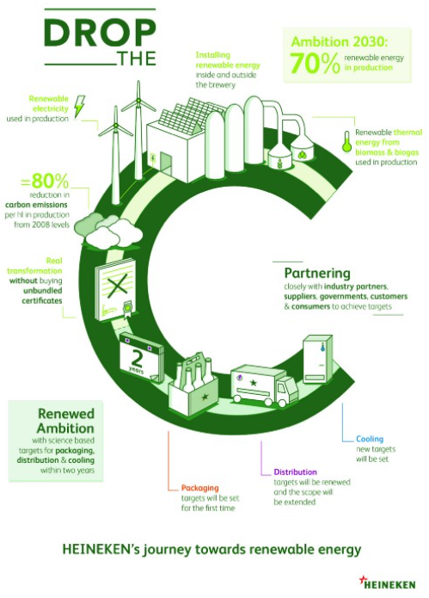
(Heineken, 2018)

Works Cited
Anon., 2013. Food Engineering. Food Engineering, 85(10), p. 121.
brewing, A., 2021. Aslanbrewing.com. [Online]
Available at: https://aslanbrewing.com/thebrewingprocess
[Accessed 01 October 2021].
Brewing, H., 2021. Home Brewing.com. [Online]
Available at: http://www.homebrewing.com
[Accessed 16 October 2021].
Corazza, F. C., Durand, G. A., Blanco, A. M. & Corazza, M. L., 2009. Food Control. The International Journal of HACCP and Food Safety, 20(12), pp. 1127-1140.
Davies, S., Sykes, T., Phillips , M. & Hancock, J., 2015. Managing Microbes, Ensuring Quality and Valorising Waste. Brewery Microbiology, pp. 221-239.
DCS, 2021. DCS Water Hygiene. [Online]
Available at: https://www.dcswaterhygiene.co.uk/services/dead-leg-removal/
[Accessed 17 Ocotber 2021].
food.gov.uk, 2020. www.food.gov.uk. [Online]
Available at: https://www.food.gov.uk/about-us/key-regulations
[Accessed 12 October 2021].
Goyal, V., Mishra, P. & Deolia, K. V., 2019. The Arabian Journal for Science and Engineering.. The Arabian Journal for Science and Engineering., 44(3), pp. 2597-2611.
Heineken, 2018. Heineken.com. [Online]
Available at: https://www.theheinekencompany.com/newsroom/heineken-announces-drop-the-c-campaign
[Accessed 17 October 2021].
HSE, 2021. Health and Safety Exectutive. [Online]
Available at: https://www.hse.gov.uk/legionnaires/what-you-must-do.htm
[Accessed 17 October 2021].
Hundy, G. H., 2016. Refrigeration, Air conditioning and Heat Pumps. 5th ed. Oxford: Butterworth-Heinemann.
Jumo, 2021. Jumo.com. [Online]
Available at: http://www.jumo.co.uk/en_GB/Industry/food/applications/brewery/cip-cleaning.html
[Accessed 14 October 2021].
Panasonic, 2021. Panasonic. [Online]
Available at: https://na.industrial.panasonic.com/blog/temperature-controllers-using-hysteresis
[Accessed 14 October 2021].
science, I., 2021. Interesting Science. [Online]
Available at: https://interestingengineering.com/science-brewing-beer
[Accessed 16 October 2021].
systems, C., 2021. crystalclear-systems.com. [Online]
Available at: https://crystalclear-systems.com/services/reverse-osmosis-systems/
[Accessed 02 October 2021].
Wikipedia, 2021. Wikipedia. [Online]
Available at: https://en.wikipedia.org/wiki/PID_controller
[Accessed 10 October 2021].
Zhou, L., He, J. & Yan, Q., 2013. Applied Mechanics and materials. Fuzzy PID Contro Application in Temperature Automation Control Systems, Volume 442, pp. 466-471.

