

LEVEL 4

SEMESTER 2

MODULE CODE: SHSS4078
Adventure: A Risk worth Taking

aSSESSMENT TYPE: aSSIGNMENT
Assessment/Component: 1 (Part A)
COMPONENT WEIGHTING: 55 %
WORD COUNT: 2000 WORDS
MODULE TUTOR: Denise leonard

Assignment:

With reference to a critical incident case study that we have examined, identify one key contributing hazard. In relation to this hazard, evaluate your own personal logged experiences from the module.

As appendices to this submission you should include a logbook recording every activity session you complete during this module and a synopsis of the critical incident case study you have referred to in your essay.

SUBMISSION DETAILS:

Deadline:
Date: 1st May 2020
Time: 3.00pm
Portal: Turnitin

School of Sport, Health & Outdoor Education

Assessment Feedback Sheet

Student No./Name: 1902236/ Jennarong Trongklang
Module: SHSS4078
Module Code: Adventure: A Risk Worth Taking

Personal Evaluation – to support your academic progress please complete the section below BEFORE submitting your work.
What do you consider to be the best aspects of this work? |  |  | I have used relevant references to support my essay
Which aspects do you consider could have been improved in this piece of work? |  |  | I think the content of this essay could have been better
What have you found most satisfying whilst undertaking this submission? |  |  | I have found researching the incident interesting
ASSESSMENT CRITERIA | Learning  Outcomes |  | GRADE
ASSESSMENT CRITERIA |  |  | Poor  0 – 25% | Unsatisfactory  26-39% |  | Satisfactory  40 – 49% | Good  50 – 59% | Very Good  60 – 69% | Excellent  70 – 85% |  | Exceptional  86– 100% | %
Complete logbook for each session | All |  |  |  |  |  |  |  |  |  |  | 15%
Provide a synopsis of a critical incident case study | All |  |  |  |  |  |  |  |  |  |  | 15%
Identify a specific significant hazard and the risk it poses to undertaking adventurous outdoor activities | 1,2,3,5 |  |  |  |  |  |  |  |  |  |  | 30%
Discuss a range of appropriate measures that might effectively control the identified hazard and consequent risks. | 1,2,3,5 |  |  |  |  |  |  |  |  |  |  | 30%
Appropriate references used and correctly formatted | All |  |  |  |  |  |  |  |  |  |  | 10%
It is expected that students will present work that is proof read, correctly referenced and adheres to the Assessment Checklist. Therefore a range of 0 – 10 marks will be deducted for non-completion of any of the points on the checklist below.
TUTOR COMMENTS:

Submission date:  via Turnitin |  | Return date:  (at least within 4 weeks) |  |  | Tutor: Denise Leonard |  |  |  |  | Mark:

Assignment Checklist

- Please complete the Personal Evaluation section of the Assessment Feedback sheet, add your name and details, and paste the whole of this assignment document into the front of your assignment

- Submission is a single word file, clearly labelled with your name and module code
- Font style - Times New Roman, size -12 for text and 14 for headings
- Ink colour – black only
- Line spacing – 1.5 line spacing and 2cm- 2.5cm page margins
- Quotations more than three lines to be indented 1 line spacing
- One line space between paragraphs, paragraphs must be left aligned
- Pagination (your assignment should have page numbers)
- All tables and figures are internally referenced and have a title
- Word count checked and written at end of text (before references and any appendix)
- Assignment is within 10% of the word limit (excluding references and any appendices)
- All references in the text are included in the reference list
- Correct referencing following the Harvard style, as described in the Palgrave study skills book ‘Cite them Right’.
- Correct spelling using UK English
- Correct use of punctuation
- Grammar and syntax correct- double check anything that has a green line under it
- I have read my assignment out loud to myself and it makes sense and is easy to read
- Somebody else has read my work and it makes sense to him or her!
- I have checked and I have not plagiarised
Failure to follow these guidelines will cost you marks!

The Lyme Bay incident is well known for being one of the most devastating events that changed the way adventurous activities are being delivered today. As Woolven et al (2007) states that “The Lyme Bay kayaking incident of 1993, in which four children died…” was the reason the act of Parliament and the introduction of the Adventure Activities Licensing Authority (AALA) was introduced by the British Governmnet. AALA is, “a body established to regulate adventurous recreational and educational outdoor activities” (Woollven et al. 2007, p. 1). It should in turn also “allow young people to experience exciting and stimulating activities outdoors without being exposed to avoidable risks of death or disabling injury” (Health and Safety Executive 1996). AALA was created in April 1996 and is currently sponsored by the DWP (Department for Work and Pensions). Their aim is to ensure good safety management is practiced throughout all the activiy providers (Health and Safety Executive 1996). So in this essay I will be identifying one key contributing hazard and discussing its role in this incident that happened in Lyme Bay.

22 March, 1993 a group of eleven canoeists were attempting to paddle from Lyme Regis to Charmouthat 10:30 am. The head instructor and the teacher were left behind and separated from the rest of the group which were drifting away from shore. This incidented cost the lives of 4 pupils (Jenkin, 1994). I believe that the key hazard present in this incident was the lack of experience which led to bad decisions being made. The two instructors, Anthony Man and Karen Gardner who both held the British Canoeing Union (BCU) 1 star qualification, were being trained and invigilated by Steven Gynes (BCU qualified to level senior instructor for inland, and a trainee istructor for the sea) a few weeks before the incident with intent to complete more instructing sessions in the next few weeks (Jenkin, 1994). Geary (1996) wrote:

In the Lyme Bay case the jury heard evidence that there was no specific recruitment criteria to become an instructor at the centre and that the two ‘instructors’ were not qualified to lead a sea trip. Indeed, the only canoeing that they held was the British Canoe Union One Star certificate, the lowest level of competence that can be awarded and which is generally regarded as a mere encouragement test.
(p. 6)
This shows that the instructors did not have the required experience to lead such a large group. For the level of their competence, the ratio between their canoeing competence to students was not met (Jenkin, 1994). For this to be managed safely, the group should have had an escort boat but due to the lack of experience and qualifications the instructors did not plan to have an escort boat. The lead instructor, Anthony Man, was reported to be the only person who carried a tow line and a first aid kit (Jenkin, 1994) however this was not enough because it was a large group. A competent instructor with suitable equipment to hand might meet this requirement if instructor/participant ratios are sufficient to ensure the safety of the rest of the group meantime (Health and Safety Executive, 2007, p. 13). Reports also show that a VHF or flares were not carried with them so this poor judgement meant that they could not effectively signal for help. Where activities take place on the sea or some large inland waters, a VHF radio is the most appropriate means of communication in an emergency (Health and Safety Executive, 2007, p. 13).

The BCU 1 star qualification that they held did not show the required level of experience as Geary (1996) stated. Furthermore their low level of experience lead them to more bad decisions including handing out innappropriate kit and safety gear to the group. The pupils were given wetsuits but only because one of the students requested to have them; the instructors should have been more aware that even if the incident was not to happen, if pupils got wet in normal clothing then they would have gotten cold and possibly suffer from hypothermia. Whereas wetsuits would keep them warmer. Helmets were also not given to the pupils which would also prevent heat from escaping from their heads. Manual inflating life jackets were given instead of bouyancy aids meaning that inflation errors would have been made and they should have used bouyancy aids instead. AALA states that:

To determine the most appropriate device providers may need to consider factors such as whether it restricts movement, including the ability to swim or otherwise self-rescue or be rescued, the potential for long exposure, and the user group. In general, buoyancy aids, as distinct from life jackets, will be suitable for many water activities even for non-swimmers, provided there is adequate supervision. Providers must consider the needs, abilities and water confidence of users as well as the activity to be undertaken.
(Adventure Activities Licensing Authority, 2013)

Report from the incident shows that all except one life jacket were not inflated meaning they did not have any means of flotation devices to help them float. If bouyancy aids were used instead, then the pupils who fell in would have been able to float without any problem. They would also be able to self rescue and possibly got back into their canoes if they had been trained to. However the instructors only trained the pupils in capsizing drills but not any self rescue was taught (Jenkin, 1994). If the instructors had more experience then they would know that it would be safer for the casualty to first try and self rescue rather than risk involving more people and endangering them aswell. Consequently, appropriate vessels should have been provided to the pupils and the teacher because they did not have as much experience as the intructors. The canoes that were used by the pupils were Mirage scout canoes which did not have adequate safety features for open water such as deck lines, spray decks and supplimentary bouyancy in the canoes. As AALA states:

Additional flotation should generally be added to canoes and kayaks. This makes their rescue and recovery easier and provides greater support should the paddler capsize and end up in the water. Attention should be paid if this is in the form of airbags that may become damaged or deflated.

(Adventure Activities Licensing Authority, 2013)

The teacher was provided the same Lazer II three fifty canoes which the instructors used; it was not suitable for the teacher because compared to their canoeing ability, the vessel was too small and less stable. This led to multiple capsizes from the teacher which was the reason they were separated from the group. Anthony Man was the one who was helping the teacher but failed to give instructions to the rest of the group on how to safely wait for them.

As the group got separated, the instructor that was with them, Karen Gardner, instructed them to raft up which was difficult because they did not have deck lines. So they had to come side by side and hold onto eachothers vessels. Although they achieved to stay together, Karen should have realised that this was creating a bigger area for the wind to push them further away from land. With no means of calling for help and the canoes gradually filling up with water; rafting up might not have been the safest idea.

So if they had been prepared from the start, this incident could have been avoided. If they were more experienced then they would know that they should assess potential risks and manage them from the beggining. With good preparation comes experience and knowledge of efficient safety management The HSE (2007) mentions that:

Providers should ensure that instructors have the training, experience, personal qualities and communication skills appropriate for ensuring the safety of the participants according to their age and taking account of any special educational needs. Providers may demonstrate the competence of their instructors by externally awarded qualification, local validations, in-house training, experience or any combination of these. There may be other ways. The licensing authority will accept whichever means a provider chooses, so long as it is satisfied that instructor competence has been demonstrated.
(Health and Safety Executive, 2007, p. 9)

The Health and safety Executive also states that:

Where a provider wants to use instructors/leaders whose competence comes through experience, the provider would need to provide evidence acceptable to the licensing authority that their competence is adequate for the task. Evidence that someone with the qualifications to fulfil this role for the equivalent national qualification has assessed their competence would generally be suitable.

(Health and Safety Executive, 2007, p. 10-11)

Since the Adventure Activities Licensing Authority (AALA) was introduced, adventurous activity providers now expect the instructors and leaders to not only be competent but to show relevant qualifications. For the leader this means holding either:

• a relevant NGB award (or an acceptable equivalent);
• an explicit statement of competence from a technical advisor following a
formal process of in-house training and assessment;
• an explicit statement of competence from a technical advisor verifying
adequate relevant experience, both personal and instructional;
• an explicit statement of competence from a technical advisor verifying observation of one or more sessions run satisfactorily, together with an understanding of the appropriate response to a range of foreseeable emergency situations;
• any combination of these.
(AALA, 2002, p. 21) [original emphasis]

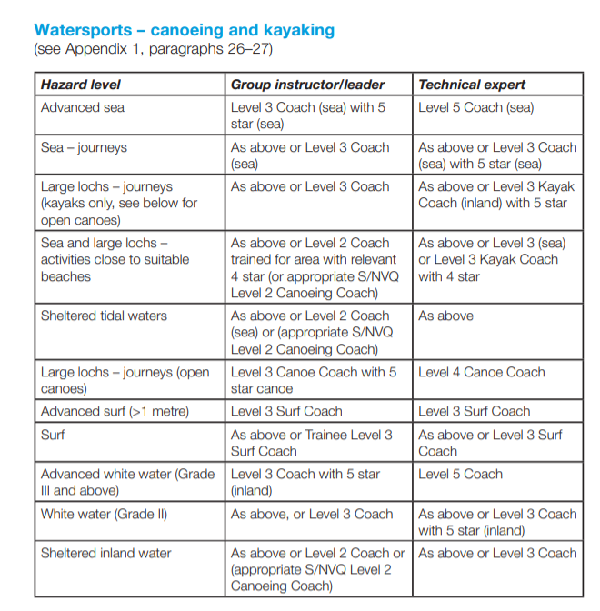
So now the requirements for leaders to take groups out canoeing have changed. The table, that is provided by the Health and Safety Executive (2007), below represents the requirements.

This image shows
The qualifications required to lead an activity (HSE, 2007).

As you can see for sea- journeys in Canoes or kayaking, they would have needed more experience and qualifications such as the level 3 coach (sea) and/or a 5 star (sea). Although this was not a requirement back then, this table shows what is now the expected level of competence and the instructor in the Lyme Bay incident only held a 1 star British Canoeing Union Qualification. If leaders wish to take groups out for small journeys at sea, they must undergo training such as: the British Canoeing Coastal Navigation and Tidal Planning course or similar RYA course.

This course delivers the personal skill level and leadership ability required to lead a group of paddlers, on short, single or multi-day journeys in a moderate tidal water environment with winds not exceeding Beaufort Force 4.

(British Canoeing)

In our course, we have participated in 4 activities that were led by qualified and experienced instructors. The aim of the sessions were to experience the process of risk assessments and find out what was required to manage a group. Before the activities we were told to search the relevant qualifications that were required to run the activities that we were participating in (white water kayaking, stand up paddling and outdoor rock climbing). We were also told to keep log books of what we have done so that we can keep track of our experiences. Keeping track of experiences will help employers see your level of competence so they can determine whether you are experienced enough to take out a group. From my personal experience in white water kayaking and stand up paddleboarding, I understood the reasons for the risk assessments and the knowledge of the equipment, weather conditions and abilities of the group. I was new to white water kayaking and so was very unstable in the smaller sit in kayaks which were very unstable. I persevered for a while but the instructors could see that I was struggling so they told me to change to a more stable, bigger, sit on top kayak. From their experience, they could see that a small and unstable kayak was unsafe for me and the group because I would have been capsizing in the river and with only 2 instructors, it would have been difficult to manage the group whilst tending to me. The instructors also made sure that we were given appropriate kit such as: throwlines each, bouyancy aids, wetsuits and helmets so the risks were managed. Whereas the pupils in Lyme Bay were far from prepared.

To conclude, the experience of both of the instructors was mearely enough to manage the size of their group. The lack of experience led to multiple bad decisions which in turn cost the lives of 4 pupils. This would have been prevented if the instructors knew how to properly prepare themselves as well as the students, with the appropriate kit and planning. However this incident has resulted in the AALA being formed and ensured that this does not happen again.

Word count: 2116

Log book

Llandysul Paddling session 1

Weather collected from XCweather
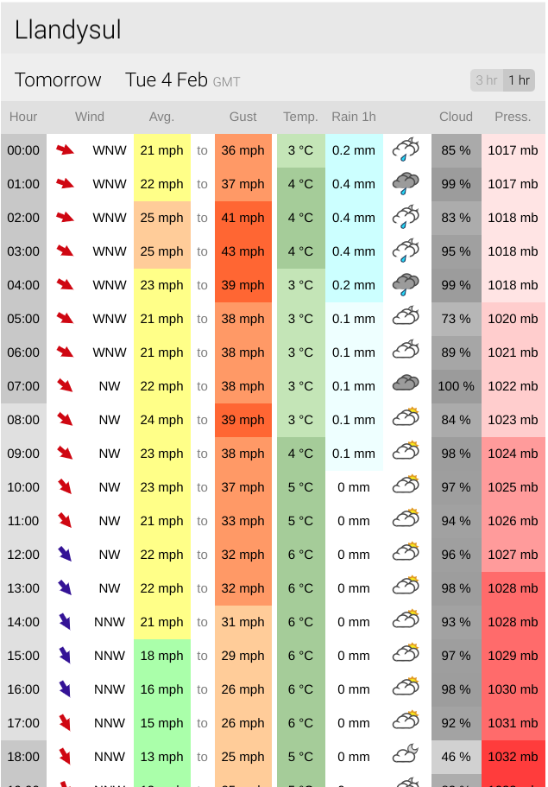
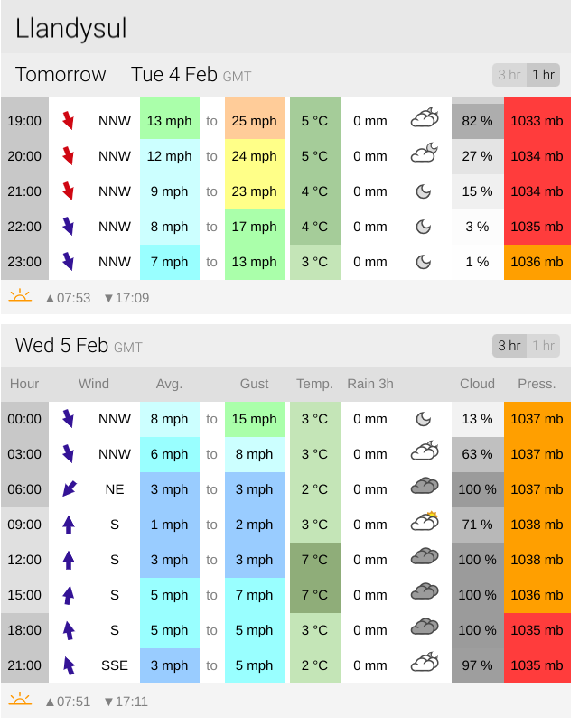

The activity
- We had a small group of 7 members between 2 instructors.
- We began by thinking about the safety of others and ourselves within the task of pumping up the paddle boards.
- Some of us were familiar with the activity site so we could already begin to spot any hazards.
- It was quite windy but we did our exercises in the lake next to the river so these conditions were suitable for the drills that we were participating in.
Your performance
Do you have any improvements to note regarding your
- personal performance;
I think that I was quite nervous at the start of the day because I have never been in a white water kayak before and it appeared very unsterdy and a tight fit for my body. The thought of sitting in something that was easily capsizable was making me worried and so I was being cautious at the start. However as the day went on and I capsized and experienced exiting the white water kayak, I started to feel more comfortable and relaxed. This made it easier to focus on my techniques and skills.
- preparation for the activity
I was quite warm whilst taking part in the activity, however as I fell in, my feet got really cold and I panicked a little bit. I think I should have got wetsuit socks so that I can stay calm and therefore think better to make better decisions. Especially when I fell out of the white water kayak.
- clothing, food and water selection
I had some warm food and a cold coffee roughly 20 minutes before the activity.

Feedback
Did you gather any group feedback? If so make comment on it.
We talked a lot about site specific risk assessments and clarified a few things that make it “site specific” for example there were electric cables that run over one side of the bank and that was a site specific risk.

Notes:
We started by pushing a vessel to one side of the lake with our white water kayaks. We did a few tows with some rope and painters on canoes. I found that I was very unstable in the small sit in kayaks because I capsized a few times. I also found it very difficult to self rescue myself because I have never done it before so I was just panicking and tring to push myself out of the kayak all the time. I think I would cope better with a bigger and more stable kayak for the time being.

LLandysul- site specific risk assessment

Hazard | Who might be harmed, and how? | Before Management  L S R |  |  | Action to avoid | After Management  L S R |  |  | Risk Acceptable  Y/N
Water | Users who are in the water, either paddling or swimming, can drown | 2 | 4 | 6 | Wear bouyancy aids at all times to help them stay affloat, and wetsuits to keep them warm. Get participants to practice capsize drills in the pond next to the river or on dry land. | 1 | 3 | 4 | yes
Wet grassy banks | Participants could slip and accidently fall. | 3 | 3 | 6 | Wear appropriate footwear and avoid the banks. Enter the river at designated points. | 1 | 3 | 4 | yes
Rocks in the river | Participants could get forced into a rock whilst they’re using the river or they could unintentionally hit a rock and capsize their vessel. | 4 | 4 | 8 | Wear helmets to prevent injuring their head and wear buoyancy aids to help them float if they capsize. | 4 | 3 | 7 | yes
Trees and branches on the side side of the river or in the river | Participants could get hit by overhanging branches and capsize. | 2 | 3 | 5 | Keep helmets on at all times aswell as buoyancy aids. Inform them about these before they enter the water. Get them to identify them before using the river. | 2 | 2 | 4 | yes
Undercuts on the banks | Participants could get forced into an undercut on the river left side of the bank, which is a building overhanging, and could hit their head. | 2 | 3 | 5 | Keep helmets on at all times and inform the participants before they enter the water. Also show them where it is so that they know when to be aware of it. | 1 | 2 | 3 | yes
Bridge | Participants could get forced towards the bridge and capsize because there is a ledge on the edges that is occasionally covered by water. | 1 | 2 | 3 | Keep away from the edges. | 1 | 2 | 3 | yes
Wet rocks on river banks | Participants could slip and fall if they stand on them. | 2 | 3 | 5 | Avoid them if possible and use designated areas for entering or exiting the river. | 1 | 3 | 4 | yes
Slalom poles | Participants could get hit by them because they are overhanging in different places on the river. | 4 | 3 | 7 | Wear helmets and be aware of them. Inform the participants and tell/show them where to expect them. | 3 | 2 | 5 | yes
Collision with other users of the river | Participants could bump into the other river users and injure themselves or the other users. | 2 | 3 | 5 | Acknowledge them when you can and possibly ask them where they plan on using the river and when so that you know what you can do in the river and where you can go. | 1 | 2 | 3 | yes
Floods | Participants could get caught in a flood and get washed downstream or forced into rocks or the river bank. | 1 | 4 | 5 | Research the weather conditions and see if there are any flood warnings. Ask locals or Llandysul centre instructors before you decide to enter the water. | 1 | 4 | 5 | yes
Electric cables overhead | People could tangle throwing lines and get shocked | 2 | 4 | 6 | Never conduct throwing line activities on that side of the bank and try to avoid using throwing lines there. | 0 | 4 | 4 | yes
Slalom ropes | Throw lines could get stuck or tangled and this could prevent proper use of a throwline | 3 | 4 | 7 | Assure proper throwline techniques are demonstrated so that users can avoid the slalom ropes | 2 | 4 | 6 | yes
Road | People could get hit by moving cars | 2 | 4 | 6 | Make sure everyone is aware ofany incoming traffic | 1 | 2 | 3 | yes

Key: L - Likelihood, S - Severity, R – Risk

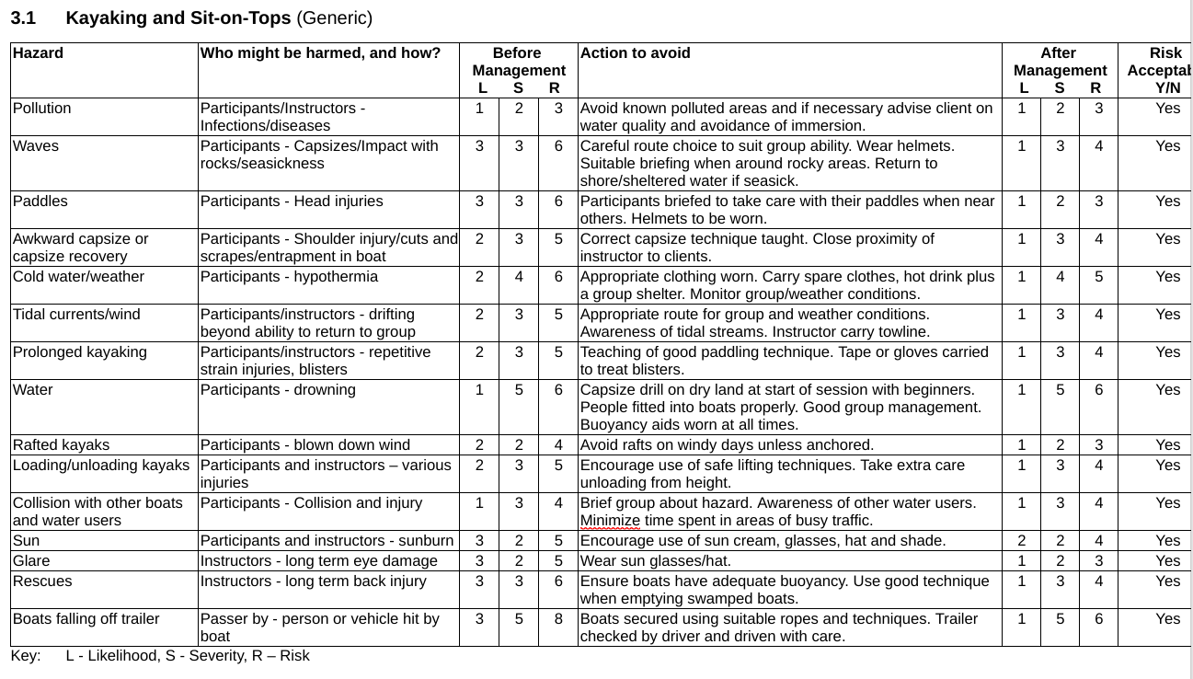

Llandysul paddle boarding session 2

Weather collected from XCweather
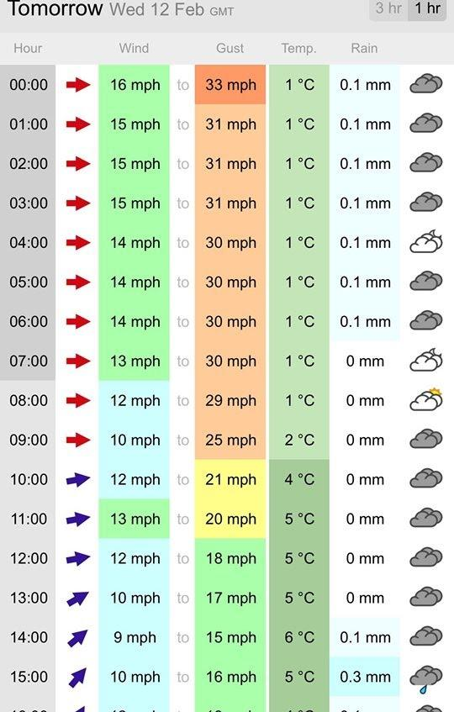
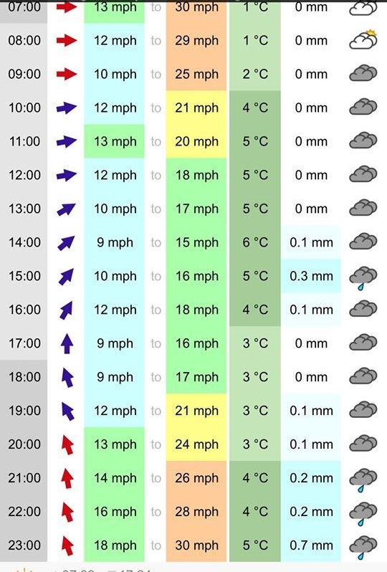

The activity
- This session was a progression from the first session. We also tried rescue techniques on stand up paddles boards and I was told to use a sit on top kayak instead of a white water kayak. Which I used in the first session and found it hard to control and stay upwright. The sit on top was more stable for me. Also it was my first time on a stand up paddle board so I was very unstable on that too. However we got some time to get used to them and I soon became conmfident on them.
- I chose to take the sit on top kayak to use on the lake because I was guaranteed to capsize due to my experience so it was better to have a sit on top and fall out rather than a closed cockpit kayak where I could get tracpper below the surface or the water.
Your performance
Do you have any improvements to note regarding your
- personal performance;
For this session I chose to carry on experimenting on the white water kayak in the lake. This time I chose a more suitable vessel which was more stable and less likely to roll. So I was able to focus on practicing more skills such as perfecting my paddling, rather than trying not to capsize all the time. I was able to be more comfident because the vessel was more stable, even though I did capsize, I felt a little more control of what I was doing.
- preparation for the activity
We used the same kit as we did in session 1.

- clothing, food and water selection
I turned up in trainers which limited me when we were assessing the river from the river bank because the grass was wet and slippery. I should have worn better footwear to allow me to fully participate in the activity.

Feedback
Did you gather any group feedback? If so make comment on it.
The instructors decided to finish a bit early because they could see that some of use were just about coping with the river conditions and some people were capsizing so it was getting hard to manage the group.

Notes
We can help someone back onto their paddle board but we had to use a specific technique where we supportted their arm gently and flipped them onto the baod using our weight. However we were told to be careful because we could potentially injure their arm in the process.

Port Eyon Climbing session 1

Weather collected from XCweather

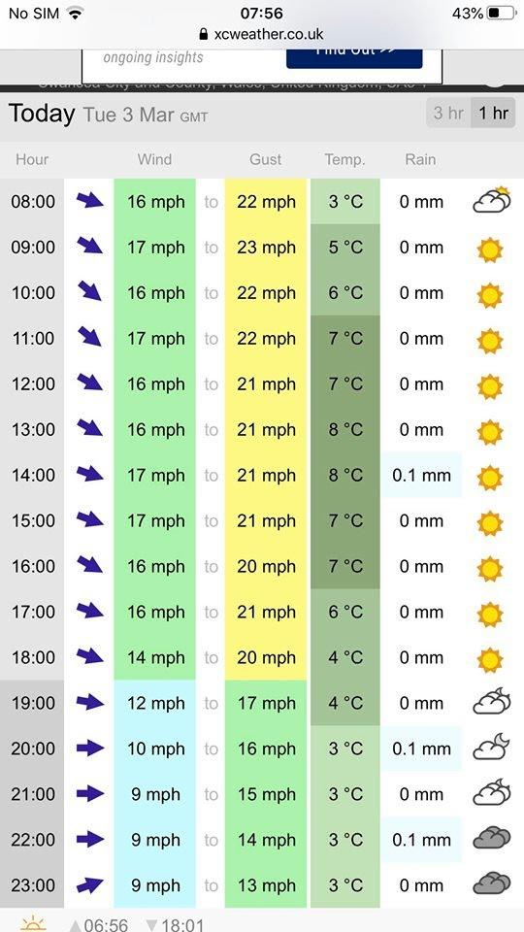
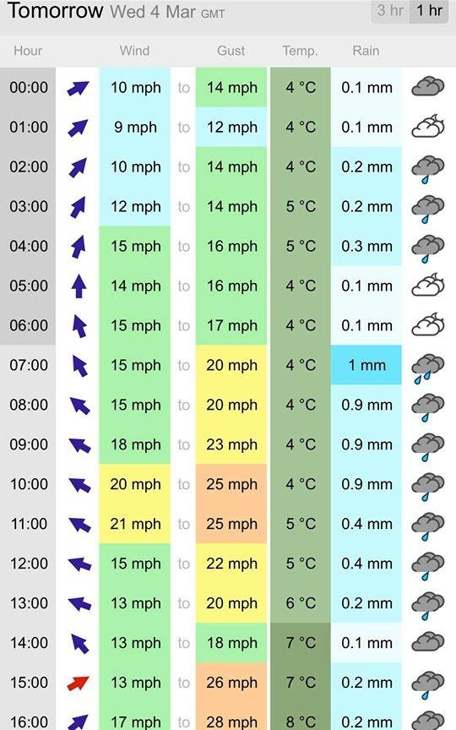

The activity
For this activity we went rock climbing/ ab-seiling down Boiler slab, Port-eynon Swansea. We started with a briefing and then was left to do a site specific risk assessment around the site. In the brief we talked about the safety procedures such as line of sight and communication because it was quite windy and it was almost impossible to communicate from the top or the bottom of the slab. It was a very clear day which made visibility quite good but we still had to keep in line of site of eachother.

Your performance
Do you have any improvements to note regarding your
I am not quite good with heights so I was already beggining to worry about taking part in the session. Especially on a cliff on the caost with loose rocks and a scary drop. However I wanted to volunteer for the first activity which was to abseil down before climbing back up. To make things more scary, I had a bucket full of heavy rope strapped between my legs. I was hoping to do this to overcome my fear and it kind of worked because I felt like I was special forces. This comfidence soon disappeared when it was time to climb back up. The cliff looked much higher than it did on the way down. I was struggling half way because I couln’t find andything hold onto so I wanted to descend. However one of the instructors wanted me to carry on so I was forced to climb on, not knowing that I was nearly at the top. After completing the session I felt more comfident with climbing.
- clothing, food and water selection
For this activity I wore warm clothes that were ligt material because I knew it was gonna be cold standing around but when I climb it would get a bit hot. So I thought light warm clothing was suitable and it was for me.

Feedback
Did you gather any group feedback? If so make comment on it.
We evaluated our site specific risk assessment and talked about control measures that we could use such as using radios to communicate with eachother from the bottom to the top of the slap.

Notes
There were a few hazards that were site specific such as adders and the loose rocks. We decided that it was best to stay on paths.

Climbing session 1 - site specific risk assessment

Hazard | Who might be harmed, and how? | Before Management  L S R |  |  | Action to avoid | After Management  L S R |  |  | Risk Acceptable  Y/N
Loose rock | Particpants and instructors could slip and injure themselves. | 3 | 3 | 6 | Stick to paths and watch your step. Also wearing helmets would protect your head from falling rocks | 1 | 3 | 5 | yes
Steep cliffs | The particpants and instructors using the site because it is situated on a caost consisting of high cliffs so they could fall off | 3 | 3 | 6 | Stick to paths and be careful where you walk. | 1 | 3 | 4 | yes
Wildlife | People could step on or disturb wildlife and there are adders there that are lethel if people get bitten by them | 1 | 4 | 5 | Avoid bushes where most adders like to hide in and do not disturb any wildlife habitats such as birds nests | 1 | 4 | 5 | yes
Other climbers | The climber, particpants and instructors could interfere with eachothers climbing equipment | 1 | 4 | 5 | If there are clibers alreday there then ask them how long they will be there if possible or use another site. Avoid touching their eqipment. | 1 | 4 | 5 | yes
 |  | 2 | 2 | 4 |  | 1 | 2 | 3 | yes/no

Key: L - Likelihood, S - Severity, R – Risk

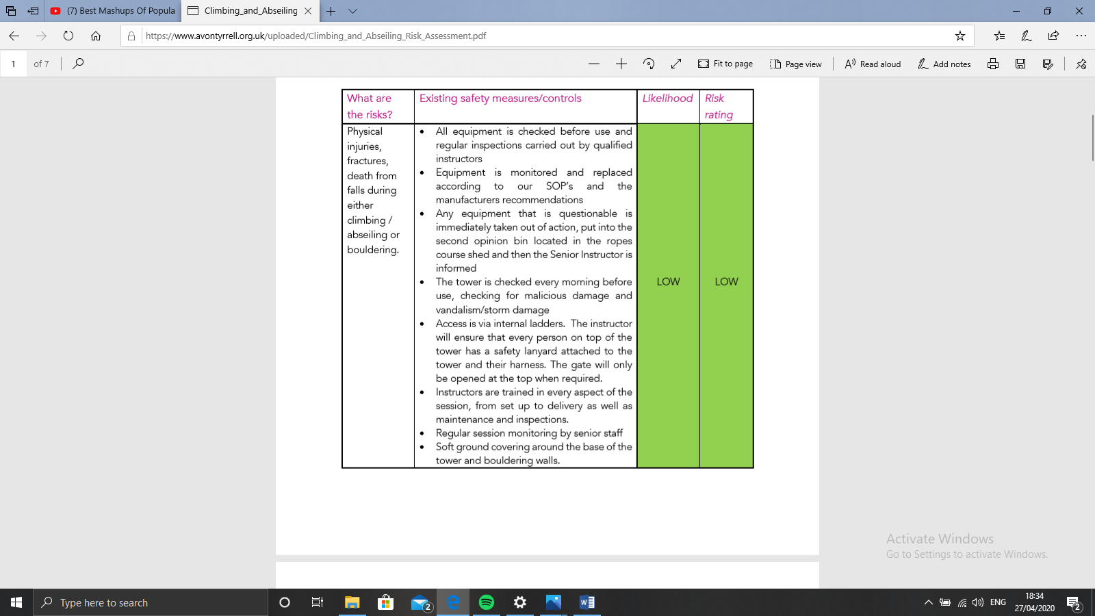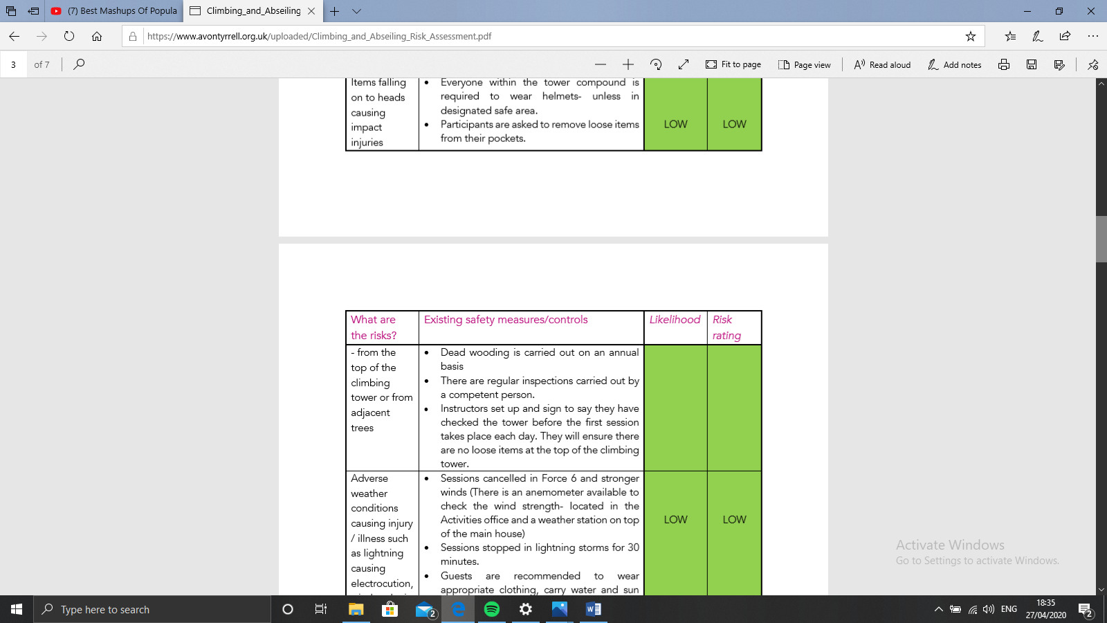

Climbing session 2 Three Cliffs

Weather collected from XCweather

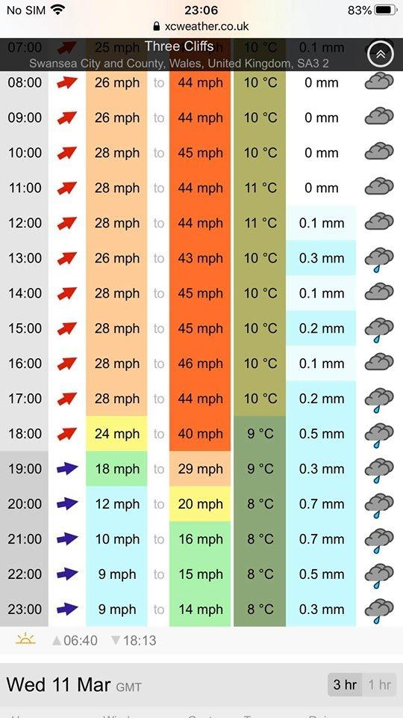
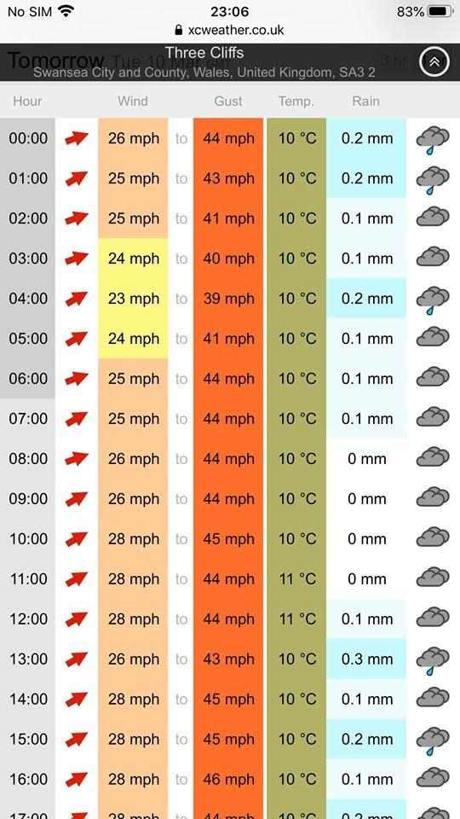

Tide times for 3 cliffs bay
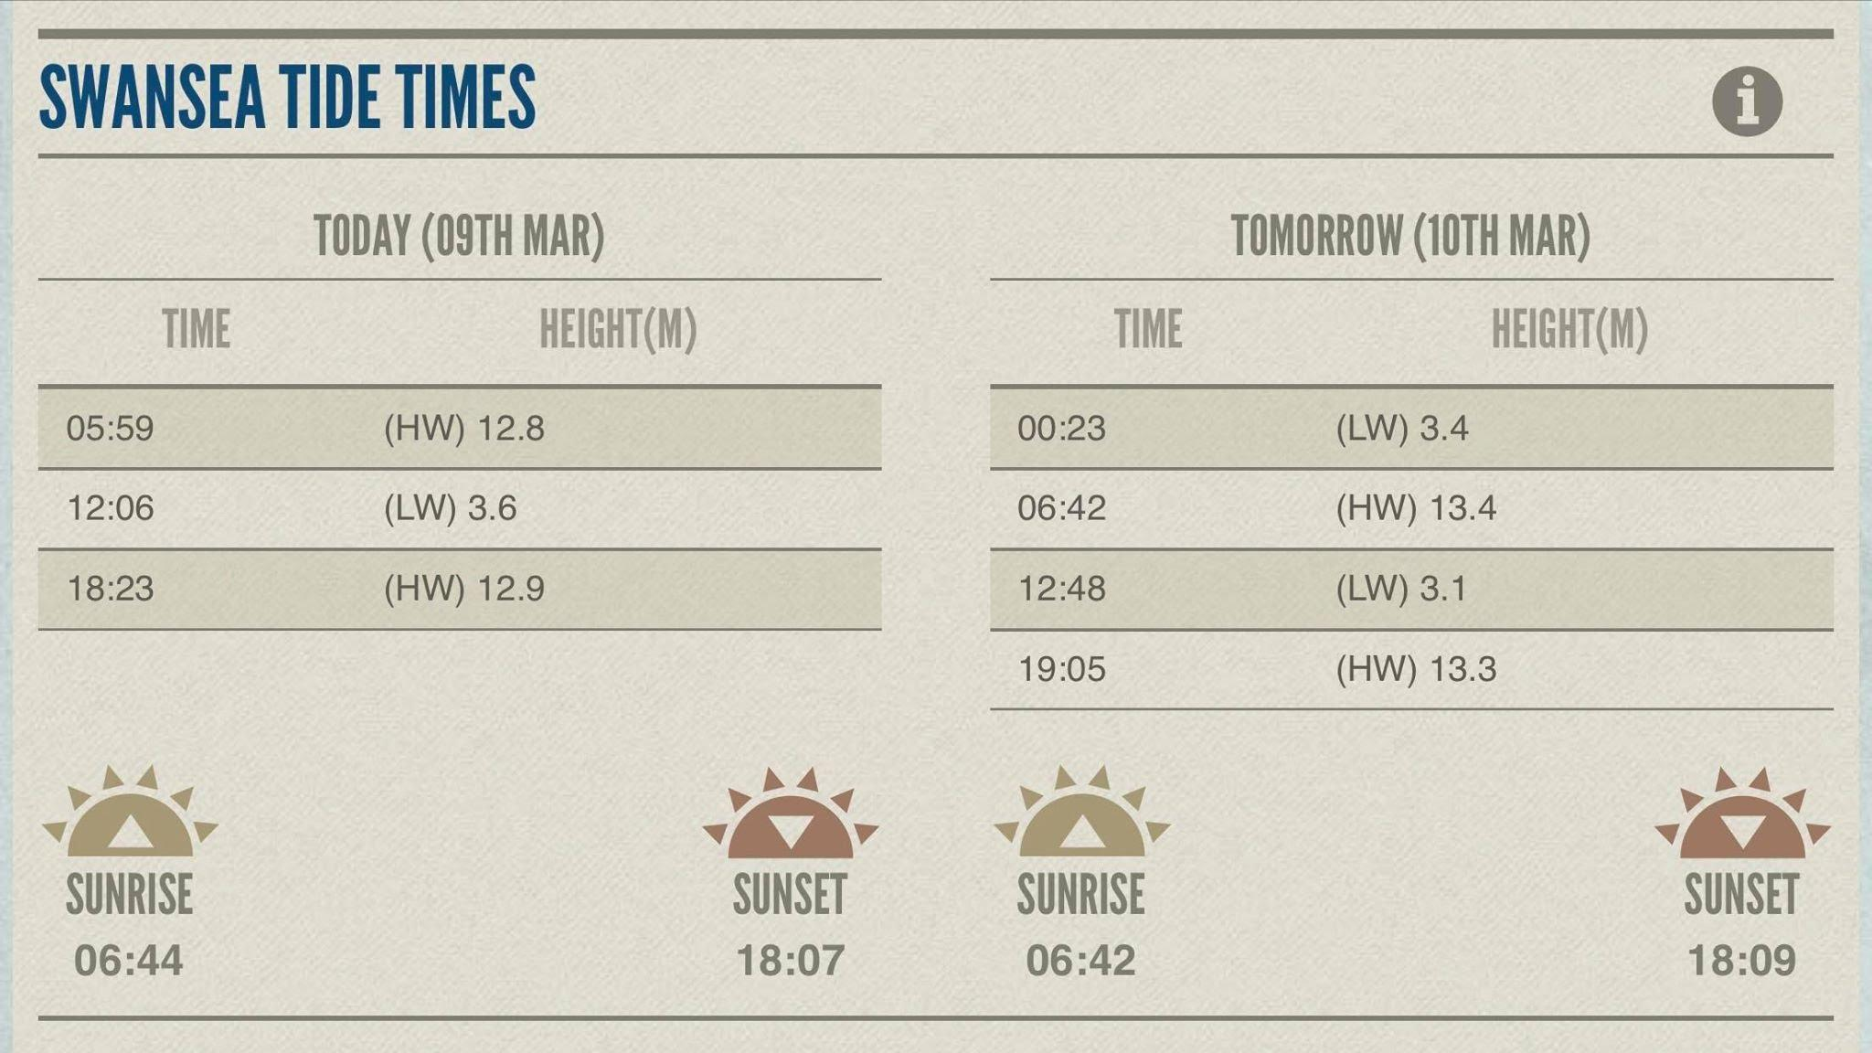

The activity
For this session we were rock climbing/ ab-seiling down 3 Cliffs. It was quite cloudy but visibility was still good and there was also some light rain which made the rocks very slippey. We began by looking around for potential hazards and escape routes. The rocks were pointed out by one of the instructors and they mentioned that the different colours on them represented the different types of algae and they caused the rocks to be slippery. We looked at possible escape routes, a cave under the cliff and around the cliff. We came to an agreement that thos two options were not suitable if we had a group of kids so we chose to go over the top of the cliff.

Your performance
Do you have any improvements to note regarding your
- personal performance;
I was looking forward to this session because it was my first time down Three Cliffs. Also because I built up my comfidence from the previous session I thought that this would be an easy climb but the same happened here as the session before. I got stuck by the top because there was nothing that I could see to hold on.

- clothing, food and water selection
I wore some waterproofs because I saw that there was going to be some rain from the weather forecast. I also brought extra warm clothing, snacks and food

Feedback
Did you gather any group feedback? If so make comment on it.
I struggled to finish the climb when I was at the top because there was a ledge and I couldn’t find any to hold on. So like the session before, I panicked and just frose. I wanted to go back down but it was unsafe because the tide was coming in. After a few minutes being stuck in one place, my muscles began to fatigue so I had to get to the top. After getting to the top I was told that if i used my body more efficiently then that climb would have been easier for me.

Notes
We came to a conclusion that it was safe to plan ahead and avoid being caught out by the tide. The instructors mentioned that we should leave a few hours between a low tide and high tide so that we had time to evacuate.

Climbing activity 2 - site specific risk assessment

Hazard | Who might be harmed, and how? | Before Management  L S R |  |  | Action to avoid | After Management  L S R |  |  | Risk Acceptable  Y/N
Rip tides | Anyone swimming in the water could get swept out to sea and drown | 2 | 3 | 5 | Avoid getting into the water and make sure there’s plenty of time to allow for packing up and leaving the area before the tide comes in | 1 | 3 | 4 | yes
Difficult and long access to the beach | It could be difficult to evacuate a casualty from the beach because it is quite far from the car park. | 3 | 3 | 6 | Be prepared to be stuck there for a while. So take spare warm clthing and spare food. Take group shelters. | 3 | 2 | 5 | yes
The river when the tide is in | There is a river which runs next to the last cliff making it harder to leave that way. | 2 | 3 | 5 | Allow time to leave the area and plan other routes to leave as backup plans | 1 | 3 | 4 | yes
Seaweed | People could slip on them and break their ankls, especially ones that are on the rocks and rock pools | 3 | 3 | 6 | Advise people to wear appropriate footwear that has ankle supports if possible. Suggest staying off the seaweed and explain why. | 1 | 3 | 4 | yes
W/SW winds | The Western side of Three Cliffs is quite exposed to the wind because there's just flat sand. This could pick up moisture from the sea and the river and spray the rocks making them slepppery. People could get wet and uncomfortable. | 2 | 2 | 4 | Take waterproofs to wear and check which direction the wind will be blowing and how strong it will be. If the conditions are too rough then consider other options such as indoor climbing walls or do another activity. | 1 | 2 | 3 | yes/no

Key: L - Likelihood, S - Severity, R – Risk

Synopsis

At roughly 10:30 am on the 22nd of March 1993, 10 canoeist; consisting of 8 pupils, a teacher from Southway School in Plymouth and 2 instructors who worked for St Alban’s Centre in Lyme Regis were involved in a tragic but an avoidalbe accident. The instructors planned to take the group and paddle from Lyme Regis to Charmouth, which was estimated to take roughly 45 minutes and then it would have taken roughly 1 hour to get back. However, something that was going to be a simple trip, panned out to be a long and horrific sequence of events that eventually took the lives of 4 teenagers. The 2 ‘unqualified’ instructors should have realised the potentual dangers of not having the appropriate personal protective equipment (PPE) for that activity and also the necessary competence that is required to take charge of such a big group of novice canoers. The ratio of ‘competent canoeists’ to students was not met. So the consequence of giving the students canoes without suplimentary buoyancy or spray decks lead to 9 canoes being capsized. The lead instructor Anthony Man was left behind to assisst Norman Pointer whowas the teacher incharge of the pupils in the group. This meant that there was only one junior instructor left to deal with 8 pupils. Due to the lack of qualifications and competence, an escort boat should have been in the company of the group. The pupils and the instructor were in desperate need of assisstance but rescue was nowhere to be seen because a fisherman notified the coastguard at around 1443 hours of a wandering canoe and they did not raise serious concern because a lost canoe or small boat being lost was not unusual for them. After the Coastguard being informed by the Lyme Regis Harbourmaster that a report of a missing group of canoeists was due back some time, they then began their search and 4 hours later the last person was rescued from the water. This devastating event was a national outcry that resulted in a court case and the Centre’s Manager Director was convicted of manslaughter. Consequently, because of this event, “the introduction of a system of inspections, controls, and licensing for centres and businesses providing adventure activities for young people” (Woollven et al. 2007, p. 2).

References

Adventure Activities Licensing Authority. (2002). Good practice in adventure activities within the education sector. Retrieved February 3, 2004, from: www.aala.org.uk

Adventure Activities Licensing Authority. (2013). Equipment Selection, Checks and Maintenance. Available at: file:///home/chronos/u-67ce8bbd6017ea35b8e064bceee6bdcf8235197a/MyFiles/Downloads/7.01_ver_3___Equipment_selection_and_checks.pdf (accessed: 30/04/20).

British Canoeing. Sea Kayak Leader. Available at: https://www.britishcanoeing.org.uk/courses/sea-kayak-leader (Accessed: 30/04/20).

Geary, R. (1996). The Lyme Bay canoeing tragedy and the criminal law. Journal of Adventure Education and Outdoor Leadership, 12(4), 4–7.

Health and Safety Executive. (2007). ‘The Activity Centres (Young Persons’ Safety) Act 1995’, Guidance from the Licensing Authority on the Adventure Activities Licensing Regulations 2004. Available at: https://www.hse.gov.uk/pUbns/priced/l77.pdf (accessed: 30/04/20).

Jenkin, S, W, G. (1994). The Lyme Bay canoeing tragedy. Devon county council. Available at: file:///home/chronos/u-67ce8bbd6017ea35b8e064bceee6bdcf8235197a/MyFiles/Downloads/LB%20Pages%201%20-%206%20(1).pdf (accessed: 03/03/20).

Rowland Woollven, R. and Allison, P. and Higgins, P. (2007). ‘Perception and Reception: The Introduction of Licensing of Adventure Activities in Great Britain’, Journal of Experiential Education, Volume 30, No. 1 pp. 1–20. Available at: http://www.docs.hss.ed.ac.uk/education/outdoored/woollven_allison_higgins_jee.pdf (accessed: 30/04/20).

