CERT HE Business Skills for the Workplace Level 4
LCLM4005 - Employability and Career Development
Component 2
Compare Four Job Adverts

Lecturer DINGNING LIU

Task 1. Please find below the FOUR JOBS & chart highlighting the common skills and knowledge areas mentioned across the advertisements of the role of HOUSING OFFICER in Birmingham (Extracted from Indeed.com)

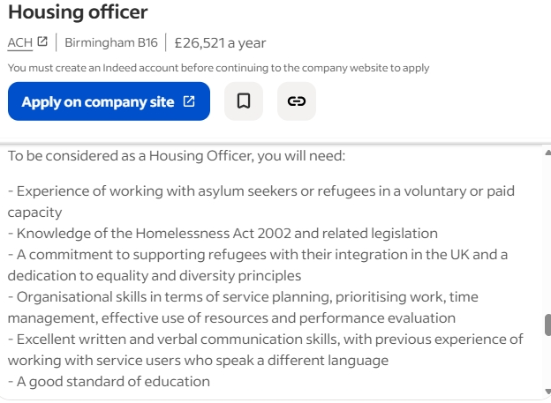
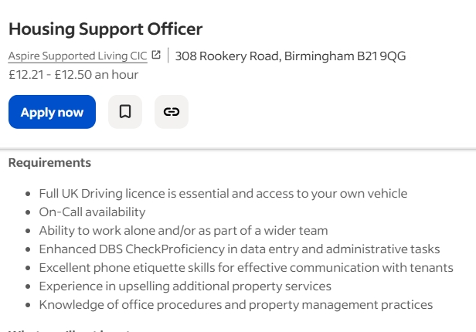
JOB 1 – ACH HOUSING LTD

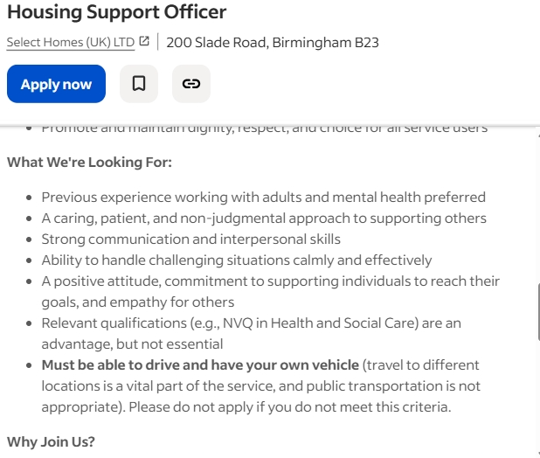
JOB 2 - SELECT HOMES UK LTD

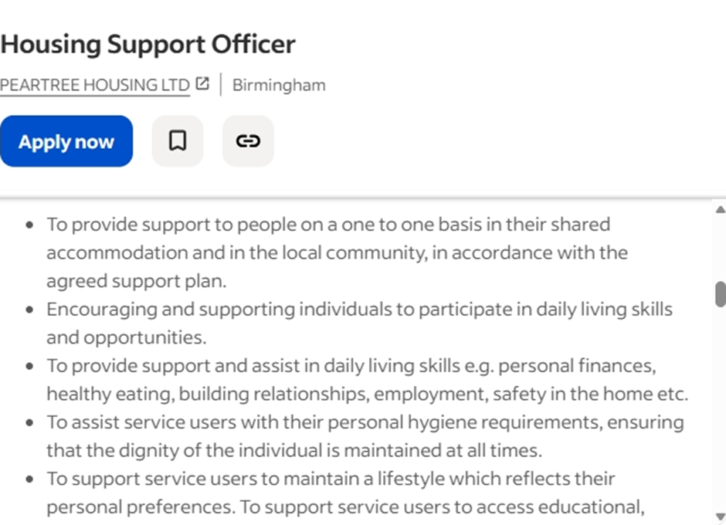
JOB 3 – PEARTREE HOUSING LTD

JOB 4 – ASPIRE SUPPORTED LIVING CIC
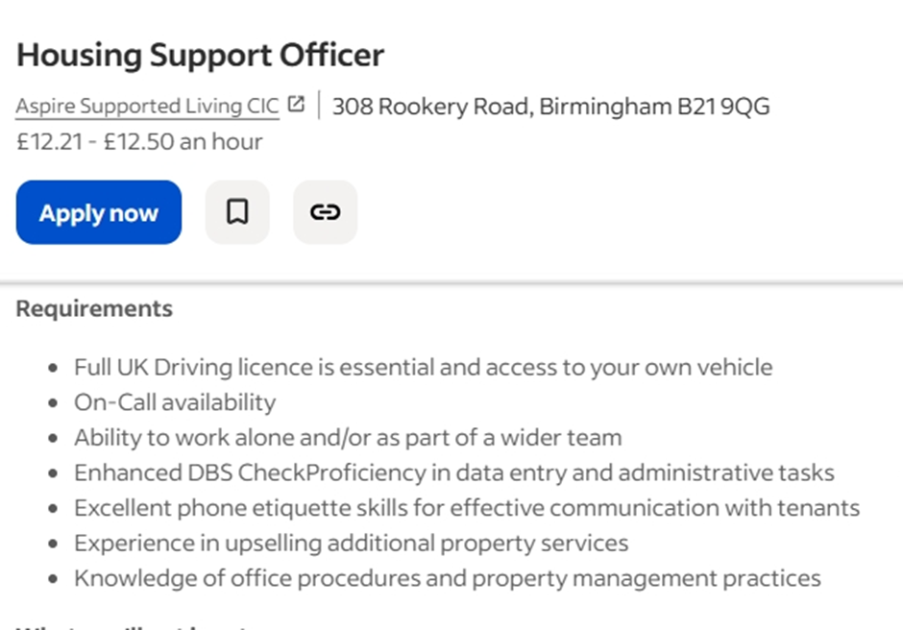

Skills / Knowledge Areas | ACH Housing | Select Homes UK Ltd | Peartree Housing Ltd | Aspire Supported Living CIC
Experience with vulnerable groups | Refugees / asylum seekers | Adults with mental health needs | People requiring care / support | Tenants in supported living
Communication skills (verbal & written) | Excellent (especially cross-cultural) | Strong interpersonal skills | Clear and sensitive communication | Excellent phone & written skills
Empathy, patience, and non-judgmental approach | Cultural sensitivity | Essential for support work | Respect for dignity and privacy | Customer service and tenant support
Organisational & time management skills | Planning and prioritising workload | Managing visits and schedules | Planning and initiative | Administrative efficiency
Legislation / policy knowledge | Homelessness Act 2002, Equality & Diversity | Awareness of Health & Social Care standards | Safeguarding, data protection | Property management procedures, safeguarding
Commitment to equality & diversity | Core requirement | Inclusive approach | Respect and dignity focus | Ethical and fair practice
Ability to work independently | Service delivery planning | Lone working with clients | Using own initiative | Working alone or on-call
Teamwork and collaboration | Within refugee support teams | Part of wider care team | Cooperative with colleagues | Team and admin coordination
Education / qualifications | Good education standard | NVQ Level 2/3 (advantageous) | Experience in care | Admin or property management experience preferred
Driving licence & own vehicle | Not specified | Essential | Essential | Essential
Ability to work independently | Service delivery planning | Lone working with clients | Using own initiative | Working alone or on-call
Teamwork and collaboration | Within refugee support teams | Part of wider care team | Cooperative with colleagues | Team and admin coordination
Administrative / record-keeping skills | Case recording and evaluation | Basic reporting | Accurate recording | Data entry and reporting
Driving licence & own vehicle | Not specified | Essential | Essential | Essential
Education / qualifications | Good education standard | NVQ Level 2/3 (advantageous) | Experience in care | Admin or property management experience preferred

Task 2. a) Self-assessment report to identify my personal strenghs and areas of development. Tools utilised: - SWOT Analysis
STRENGHTS  - Strong Leadership & Initiative: Proven ability to lead programmes, manage teams, and drive community projects through Harmony Nexus Hub CIC.  - Empathy & Emotional Intelligence: Naturally compassionate, able to connect with diverse learners, especially those facing hardship. | WEAKNESSES  - Expanding Professional Qualifications: Further management training could open new career pathways.  - Funding & Project Growth: Proven success in funding bids positions you to scale programmes or lead larger educational initiatives.
OPPORTUNITIES  - Expanding Professional Qualifications: Further management training could open new career pathways.  - Growing Network & Influence: Existing relationships with local authorities and community organisations can lead to leadership or advisory roles. | THREAT  - Burnout Risk: High emotional involvement and workload could impact long-term wellbeing.  - Funding & Community Sector Instability: Reliance on grants or partnerships can affect project continuity.  - Role Overlap: Taking on multiple community, leadership, and operational tasks may reduce focus on your own professional goals.

I discovered that I have ENFP personality type using the Myers-Briggs Types Indicator. My ENFP personality means my learning style is people-focused, creative, and intuitive. I learn best through discussion, collaboration, and real-life examples, as hearing different perspectives helps me understand ideas more deeply. I prefer to see the bigger picture before focusing on details and enjoy visual, flexible, and creative learning activities. I also need time to reflect and connect new information to what I already know. Traditional lecture-style learning does not fully engage me, but interactive, practical approaches keep me motivated. I recognise the need to strengthen my attention to detail, but overall, my learning style is a strength that brings curiosity, creativity, and meaning to my studies.
I have consistently demonstrated strong readiness for employment and personal advancement through my leadership roles, community engagement, and commitment to continuous learning. As Director of Harmony Nexus Hub CIC, I have managed and delivered programmes supporting children, young people, and SEND learners. This role has strengthened my organisational, communication, and problem-solving skills, while teaching me to work effectively under pressure, meet deadlines, and support individuals with diverse needs. I have also gained experience in monitoring progress, creating tailored support plans, and leading teams to achieve positive outcomes.
My wider work as a Community Leader has further prepared me for professional environments. I have participated in focus groups with Birmingham City Council, West Midlands Police, and other key stakeholders, contributing to discussions about local challenges and community-based solutions. These experiences helped me understand the importance of collaboration, strategic thinking, safeguarding, and clear communication. They also made me aware that I am part of a wider collective working toward sustainable change, which has strengthened my confidence and motivation.
Across my roles, I have received positive feedback from partners, peers, and mentors for my professionalism, reliability, compassion, and ability to engage diverse groups. Together, these experiences demonstrate that I am adaptable, responsible, and ready for the next stage of my professional journey.
b) Evidence of Readiness with examples:
I am well-prepared to transition into a Housing Officer role due to my extensive experience supporting vulnerable individuals, managing community programmes, and working collaboratively across agencies. As Director of Harmony Nexus Hub CIC, I regularly support families facing overcrowding, homelessness risk, SEND challenges, and social vulnerability. This has strengthened my ability to assess needs, complete reports, manage sensitive information, and communicate with empathy, all core skills for a Housing Officer.
I have worked closely with Birmingham City Council, West Midlands Police, Shelter, and other partners, giving me practical insight into housing issues, safeguarding, tenancy challenges, and community engagement. My responsibilities were coordinating support plans, resolving problems, advocating for clients, and maintaining detailed records which directly mirror the duties required in housing roles.
Colleagues highlight my reliability, strong interpersonal skills, and ability to remain calm under pressure. Combined with my academic development and passion for community wellbeing, these experiences demonstrate my readiness to build a successful career in housing.

Task 3 a) Based on the weaknesses demonstrated on the SWOT analysis, these are my short-term and long-term goals.
- Short-Term Goals (Next 12–18 Months)
My first short-term goal is to strengthen my professional qualifications by completing additional management and sector-specific training. This includes courses in housing practice, safeguarding, tenancy management, and leadership. Improving these areas will help me address gaps in technical knowledge and enhance my confidence when taking on more structured, compliance-focused responsibilities.
Another short-term goal is to refine my skills in project planning and monitoring so I can deliver programmes more efficiently. This is important for building credibility when transitioning into new roles and ensuring that I can demonstrate measurable impact.
- Long-Term Goals (2–5 Years)
In the long term, I aim to take on senior roles where I can lead larger programmes, influence service delivery, and develop strong housing support systems. Expanding my expertise in funding, contract management, and strategic development will allow me to scale projects and design long-lasting initiatives for disadvantaged groups.
These goals align with my career aspirations of becoming a well-rounded professional who can manage services, support vulnerable communities, and contribute to sustainable social change.

b) My Personal Development plan outlining specific actions that will take to address my weaknesses, including timeline, resources needed and how I will measure my success.

Weakness Identified | Action Steps | Timeline | Resources Needed | How Progress Will Be Measured
Limited Formal Management Qualifications | a) Enrol in Level 3 or Level 5 Management/Leadership course  b) Complete CPD in Housing Practice, Safeguarding & Tenancy Management.  c) Attend workshops on conflict resolution, case management & compliance. | Start within 3 months. Complete qualifications within 12–18 months. | a) Course funding (self/employer)  b) Online learning platforms  c) Mentor in housing/community sector. | a) Certificates and CPD hours completed  b) Increased confidence with structured/compliance tasks  c) Positive feedback from mentors/supervisors.
Need to Strengthen Funding, Project Growth & Scaling Skills | a) Attend training on monitoring, evaluation & impact measurement  b) Practise writing larger-scale funding bids.  c) Shadow project managers for advanced delivery skills  d) Develop 1–2 year plan for expanding community | a) Start training/shadowing within 6 months.  b) Implement new project planning skills within 12 months.  c)Aim to secure or contribute to a medium-scale (£20k–£50k) grant within 18–24 months. | a) Bid-writing workshop  b) Project management training (PM Lite/Prince2 basics)  c) Templates & guidance from funders.  d) Support from experienced colleagues/mentors. | a) Improved quality of project plans.  b) Increased funding success rate.  c) Evidence of programme growth & impact. d) Feedback from peers/partners on planning improvements.

In conclusion, exploring these job adverts genuinely excited me. As a neurodivergent person with ADHD, my curiosity is wide-ranging, and I thrive when pursuing multiple career paths. I can see myself working as a Housing Officer, using my empathy and community experience to support people in need. Journalism appeals to my love of storytelling and raising important issues, while Lecturing aligns with my creative, people-focused learning style. I also remain committed to my current community work. My ADHD means my career journey is not linear, but it is meaningful. Each path reflects my strengths and passion for making a positive impact.



~~~~~~~~~~~~~~~~~~~~~~~~THE END~~~~~~~~~~~~~~~~~~~~~~~~

