Design Testing and Evaluation Report.

This report is a continuation of my “UX Research and Design” portfolio. Its objective is to clearly portray my testing and evaluation of my 3 prototypes, based off information gathered by a “focus group”

Prototype 1’s concept is based off releasing the vacuum left in jars after manufacture. The jars are put under vacuum as it helps to increase shelf life by removing scenarios where bacteria can grow on the product. One commercial product for sealing jars boasts “…to create an effective vacuum seal that locks out air, sealing freshness in.”
It should be noted that this vacuum sealing doubles as an indicator to the consumer of the jars relative freshness. We are taught not to buy jars of food if the top of the lid isn’t depressed.
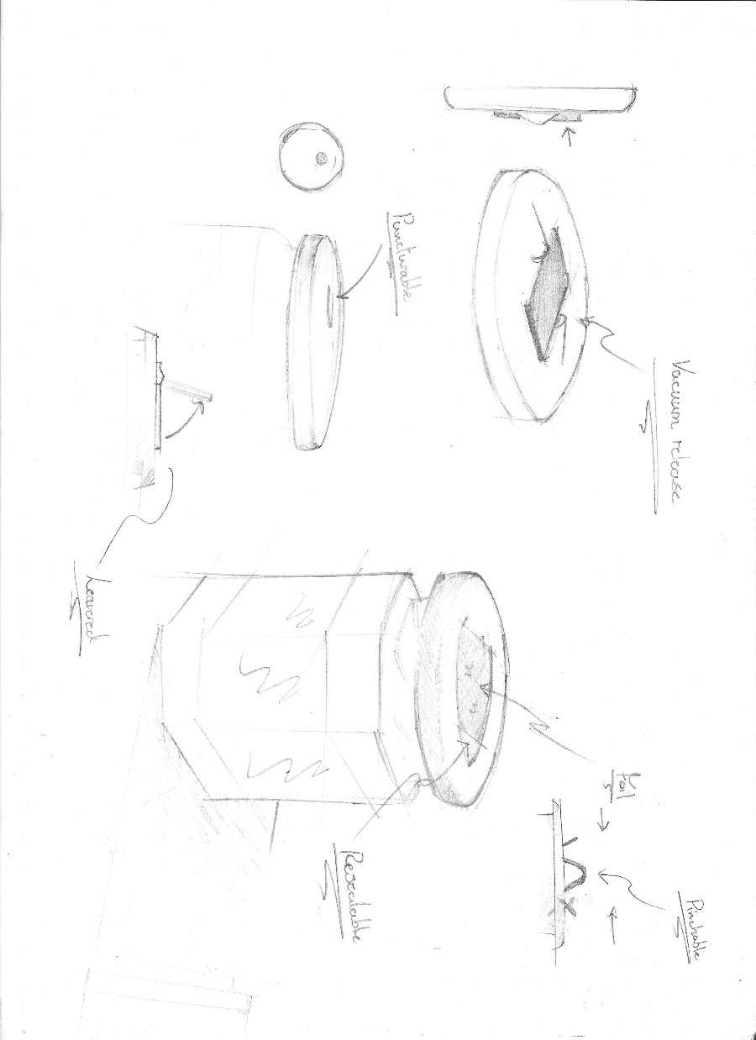

This lid has been open for some time. Thus, the lid is no longer vacuum sealed.
When a jar is vacuum sealed the lid has a slight depression in the centre. Once it has been opened this depression pops out of the lid to become a distinct protrusion.

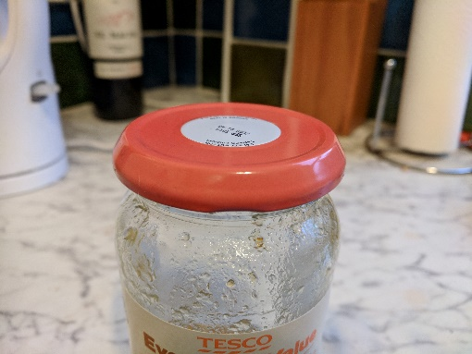
Prototype 2’s concept is based off the idea of gaining a greater grip on the lid through the use of a tool. There are many tools currently on the market that claim to help people open jars. These come in a wide variety of shape, size, weights and complexities.

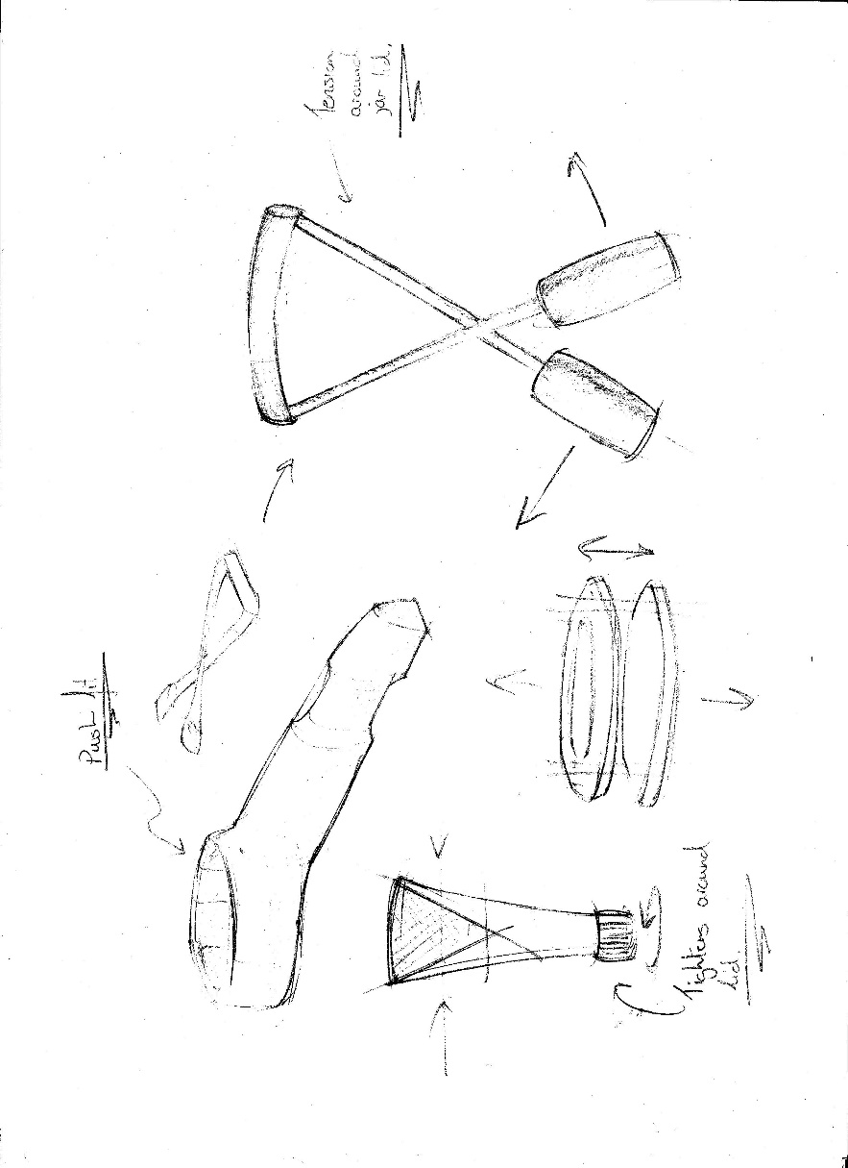

As my design is intended for people who struggle normally with the weight or size of jars I wanted to make mine smaller, lighter and easier to use than others currently on the market. The images below show some of the different types of tools currently available on the market.

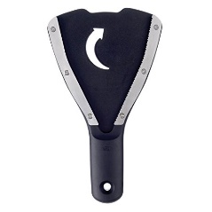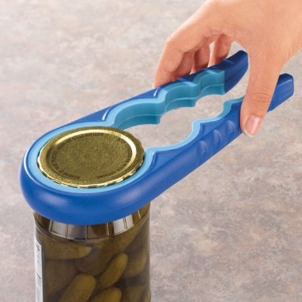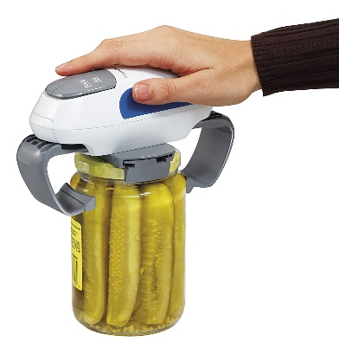

Prototype 3’s concept is to increase the amount of leverage and contact surface area the user can manipulate when attempting to open a jar. The mason jar was invented in 1856 with a lid design very similar to what we currently use. That means that users are being forced to wrangle with over 150 year old technology just to open their jars. This concept redesigns the integrated lid, removing the need for any tools or drastic measures to be implemented by the user.
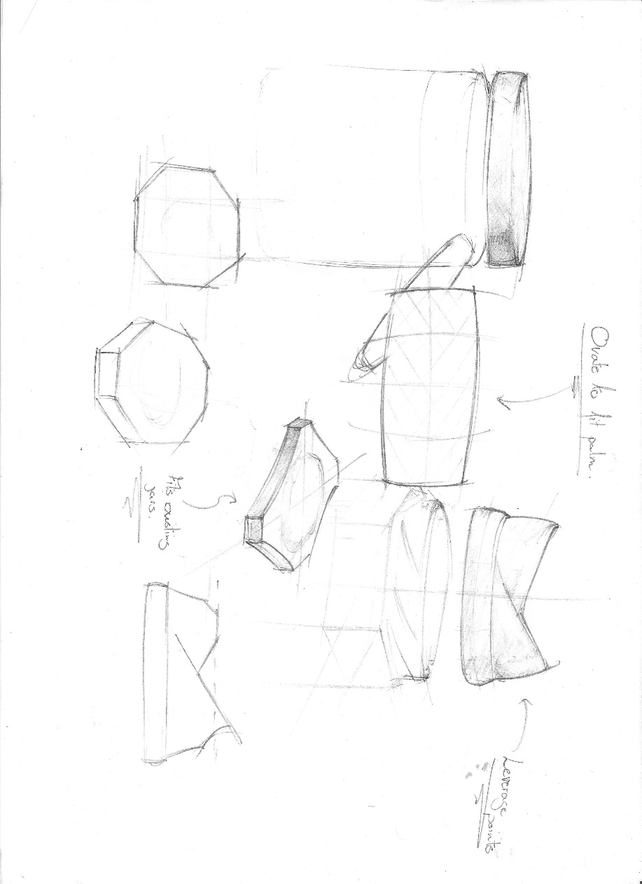

Testing;

To test these concepts, I collected a focus group of 10 people of a range of ages and genders. I gave each 4 jars. 2 jars with prototypes 1 and 3 concept variant lids, 1 jar with the prototype 2 tool and 1 jar as a reference. Each jar was emptied and cleaned before testing and were all the same make and shape.

Each jar (except prototype 1) had a small amount of boiling water poured into it before testing and was then sealed. After a few minutes the water vapour in the jars condensed causing a negative pressure difference. (equivalent to that of a vacuum) (I chose to not create negative pressure in prototype 1’s jar as the concept is to release the pressure before opening)

Each member of the focus group chose a jar, and attempted to open it. After each asked them all to fill in a questionnaire each, listing:
- Were they able to open the jar?
- On a scale of 1 – 10 How easy would they say it was to open?
- On a scale of 1 – 10 How likely would they be to buy a product like this?
- On a scale of 1 – 10 How little strain, do you think opening the lid put on your hands?
- Any comments about the opening the lid?

Once the questionnaire was completed, I took both the jar they were reviewing and their responses and asked them to choose another jar and repeat the process. (I didn’t tell any of the focus group the number of the prototypes or how to use them as I wanted the designs to be judged at face value. As my research suggested. By taking the jars away after they had tested them, I tried to remove any bias caused by the previous concept they tested)

When all the jars had been reviewed I asked each member of the test group to order the 4 jars in order of which they liked the most. Taking into account aesthetics, anthropometrics and usability.

Compiling the data;

After sorting through the data, I converted the responses to each question into a score for the jar.
- Were they able to open the jar? (If yes + 10)
- On a scale of 1 – 10 How easy would they say it was to open? (Score equal to where on the scale the user indicated. i.e. 6 on the scale would translate to +6)
- On a scale of 1 – 10 How likely would they be to buy a product like this? (Score equal to where on the scale the user indicated. i.e. 6 on the scale would translate to +6)
- On a scale of 1 – 10 How little strain, do you think opening the lid put on your hands? (Score equal to where on the scale the user indicated. i.e. 6 on the scale would translate to +6)
(I didn’t convert the groups comments into a score as I felt they were easier to display as text rather than numbers) Then I added up each person’s score, for each jar, and formatted them in a sunburst graph against each other.
- Prototype 1
  - Question 1 90
  - Question 2 61
  - Question 3 73
  - Question 4 71
  - Total 295
- Prototype 2
  - Question 1 70
  - Question 2 46
  - Question 3 53
  - Question 4 75
  - Total 244
- Prototype 3
  - Question 1 100
  - Question 2 63
  - Question 3 81
  - Question 4 60
  - Total 304
- Standard Jar
  - Question 1 70
  - Question 2 50
  - Question 3 62
  - Question 4 39
  - Total 221

Comments;

Below are some of the comments left by the focus group about each concept. I’m only showing some of the comments as most of them were generic and repeated. (And some people didn’t leave a comment)

Prototype 1
- The jar lid is hard to grip my hand keeps slipping.
- Wouldn’t this reduce the lifespan of the food in the jam? As it is difficult to completely reseal the lid.
- Looks very similar to the current lids so wouldn’t be difficult to get used to.
Prototype 2
- I couldn’t work out how to use the tool.
- It was difficult to tie the wire around the jar and keep it tight.
- …once it was on it took the lid off well.
- It was nice to have something to hold onto.
Prototype 3
- It felt comfortable in my hand but squished my hand a bit when I went to open the jar.
- The only one so far, I could open.
- Would cost more than a normal jar.

Evaluation;

Throughout this project I have looked, in-depth, at many different aspects of “Meal Preparation” I categorized these aspects into: “shopping”, “preparing”, “cooking”, “serving” and “cleaning”. Through my research I realised that the majority of problems, during “Meal Preparation” occur as part of the “preparing” and “cooking” sections. I believe this to be because, even though problems do occur during the other sections people are better at adapting to those environments. For example, “Gary” took a rucksack when he went shopping, during my “A Day In The Life” research, as he knew he would struggle to carry the groceries with a plastic bag.
Due to this realisation, I focused my area of inquiry on those 2 areas when I was deciding on a problem to propose a solution for. I also used those 2 areas in most of my explanations of my research, trying to convey the most pressing problems.
Research drawn not only from “preparing” and “cooking”, but all of the different aspects of “Meal Preparation” helped guide my concepts by showing what I should and shouldn’t include. I found that some people have trouble cleaning intricate tools and packaging and others heavily consider the aesthetics of even a purely functional product.

Of the 3 design concepts I proposed Prototype 3 was best received by the focus group, not only scoring 304 but it also had the most people chose it as the one the liked most. This concept meets my specification in every aspect:
- It reduced the level of grip strength required to open a bottle or jar lid
- It has been designed to be used by people with limiting factors like arthritis or hypermobility.

Despite the concept meeting the specification, there are other factors that also need to be considered in the design. If I was to have the chance to redesign the concept I would account for:
- Logistics. The protrusions the user is intended to grab also prevent the jars from stacking as efficiently as the current design. This has a wider reaching impact than just for shipping the product. The product would be unable to be stacked on shelves both in stores and at home. This could cause problems with some groups of people, primarily people with mental health problems. I believe someone like “Liese” from my research may struggle with this product.
- The design has replaced useful features in the original design. I would consider adding a concave section to mirror the existing design’s button.
- At the moment the current variant of jar lid is made in the millions and is thus cheap to produce. I would like to look into adapting the current manufacturing process to keep the costs low.

It should be noted that this projects data is based off of a the daily routines or a small sample group. (And then tested by a small focus group) Because of this I cannot say with certainty that my concepts are a solution to a problem that everyone faces. But I do believe they are leading in the right direction.

