

BSc (Hons) Ordnance, Munitions & Explosives – Material Science

Analysis for the minimisation/prevention of material failures
Thomas Beswick – 1910566
25/11/2022

Contents
1 Introduction 3
2 Product 4
2.1 Design 4
2.2 Processing 4
3 Improvements 4
3.1 Design 4
3.2 Processing 4
4 Conclusion 4
5 Recommendations 4
6 Bibliography 5

Introduction

A small arms ammunition round is commonly made up of four main components. These are cartridge case (the terms cartridge, case and cartridge case are used interchangeably), primer cap, propellant and the projectile. Each of these components are designed to perform certain functions and must interact with each other in order to ensure safety and quality of the product. An example of this is the interaction between the cartridge case and the projectile. The interface between these two components must be an interference fit to secure the projectile and produce and airtight seal while also allowing the projectile to be expelled from the case under pressure. If faults within the components occur, these can have a direct effect the performance and therefore impact the safety of the overall product. This report will detail the base design features of a cartridge case and the processing that goes into recreating the features at a mass scale of up to 250 parts per minute, it will then research the common faults that can occur during this processing such as fracture, friction, wear, surface finish, and cracks. Once the root cause of these processing faults is determined, improvements to the design and processing will be recommended.

Product

The area of the product that this report will focus on is the cartridge case. There are a few key features on this component that perform various functions to allow the case to function correctly, these are labelled in Figure 1 and discussed below.
- Mouth (1) – This will secure the projectile in the final product and create an airtight seal to ensure the propellant contained within is protected from the elements the product must endure. This feature is incredibly important in ensuring the round produces the correct pressures, velocities and obturation.
- Extractor Groove/Head (2) – This feature allows the case to be extracted during the function of the weapon where typically the gas from the fired round recoils the bolt of the weapon backwards, allowing the extractor to catch on the groove to eject the fired case.
- Shoulder (3) – This feature ensures the round will sit correctly within the weapon chamber. This must also provide the necessary strength to the mouth during the processing of inserting the projectile into the mouth of the case, as any folding or crushing will affect the geometry of the final product.
- Case Wall (4) – This feature must endure the full pressure of the firing. These often reach up to 4000bar, with some stress testing reaching 5000bar [1]. Any faults within the area of the component could be critical to safety as the escaping gasses would have a path the user of the weapon.
4
3
2
1

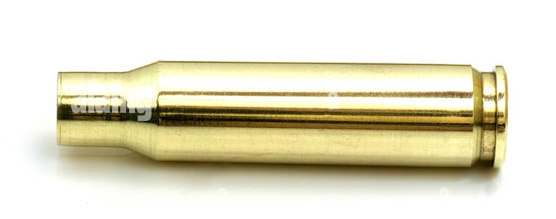
Figure 1 - 7.62mm Cartridge Case [2]

Design

The design of the cartridge case is controlled primarily by NATO, as all design of ammunition for military use must conform to STANAG (AOP) 4147 [3] which contains geometry for the casing and the chamber it will be required to conform to. A full case cartridge drawing from STANAG 4172 is found in Appendix 1. This limits the freedom industry has over modifications to the design of the cartridge case.

Regardless of this restriction of design, there features present on the design for the purpose of the reduction of stress within the material. The shoulder of the cartridge contains a radius prior to the parallel mouth, as shown in Figure 2. During the firing sequence the overall length of the cartridge will increase as the pressure pushes the material on the mouth of the case up the barrel of the weapon.

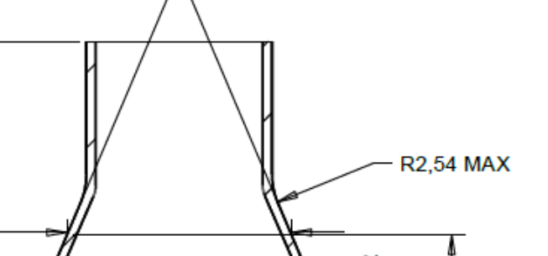
Figure 2 - 5.56mm Cartridge Case Mouth

This radius has the critical role of ensuring during that application of this stress that a strong stress concentration factor does not occur in this location. A large stress concentration factor would cause the material to experience a localised stress more than the load applied, calculated using Equation 1 below for K_{t} [4]. If this localised stress exceeds the material properties of tensile and compressive strength then this opens the design to failure, which includes the mouth of the case fracturing from the body and introduces an additional projectile moving down the barrel of the weapon. This causes a significant safety and performance concern depending how this fracture piece interacts with the intended projectile.
$$K_{t}=\frac{σ_{max}}{σ_{0}}$$
Equation 1 - Stress Concentration Factor

Stress concentrations occur at any change in geometry, however these can be reduced and controlled by the introduction of radii. The use of a small radius on the mouth of the case ensures that the stress lines within the material are less severely bent around the geometry and will reduce the localised stress applied to the mouth of the case.

The amount of geometry changes on the design causes a large amount of these stress concentration sites which must be accounted for within the material and where geometry can be altered.

Processing and Material
A cartridge case is commonly made from a type a brass categorised as an alpha brass [5] which means that it will contain less than 40% zinc. As defined by DEF-STAN 95-9, the alloy used in cartridge cases is a 70/30 copper zinc alloy [6]. In the case of 70/30 brass, the atomic structure is always in the form of Face Centred Cubic (FCC) which has a combination of high strength and high ductility [7]. This combination allows the material to meet two of the requirements within the manufacture of cartridge cases, the ability to endure high pressure while being formable within the process.
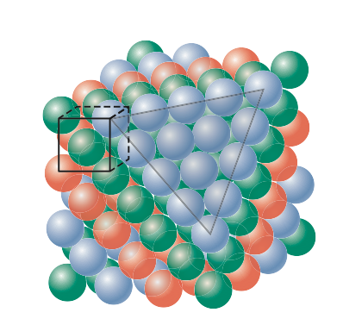
Figure 3 - FCC Crystal Structure [8]

The FCC forms a crystal structure with diagonal intersections as seen in Figure 3. As the material is deformed, this crystal structure is encouraged to slip against itself along the diagonal slip planes. As the material deforms and slips, the atoms move an atom at a time along the plane until the additional atom becomes at step on the surface of the structure. This is shown diagrammatically in Figure 4. As these slips occur, the planes are used up and causes a strengthening of the material and therefore requiring a higher stress to incur further slip. These slips happen until the atoms meet a blocker, most commonly the grain boundary, however, this can also be caused by substitutional atoms such as iron or lead or interstitial atoms such as carbon [8]. This is the basic principle behind work hardening on the brass alloy.

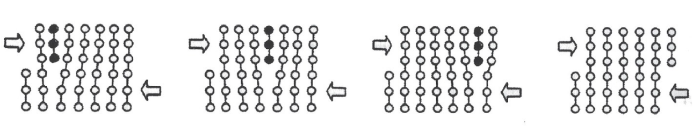
Figure 4 – Atom movement in crystal structure [9]

The work hardening effect reduces the formability of the material during the process. The industry standard process for forming cartridge cases involves a three stage drawing process followed by a pinch trim to length before moving on to a six stage forming process for the shoulder, head, cap chamber and mouth sizing. The shoulder is often formed in multiple stages along with the head of the case being indented, flattened, and pierced for the fire hole. All of this causes immense amount of work hardening within the material. The work hardening caused increases the likelihood of cracks occurring the further into the process the product goes, this must be overcome within the process.

There are a variety of trace elements that can be present within the copper zinc alloy, some of which can be added to enhance and optimise the mechanical properties of the alloy, whilst also influencing the features such as corrosion resistance, thermal conductivity and formability [10]. The following trace elements may be encountered with the alloy and their effects discussed.
- Aluminium – This element will influence the corrosion resistance of the brass if present at over 1%, however at this percentage will influence the ductility and formability of the alloy. [11]
- Antimony – This element will significantly reduce the ductility of the alloy, which will increase the occurrence of splits and cracks during machining. [11]
- Bismuth – This element is insoluble in brass and therefore gathers at grain boundaries cause weaknesses for splits and cracks. Bismuth will also reduce the ductility of the alloy which will not allow conventional forming methods to be used. [11]
- Lead – The effect of lead on the alloy is dependent on the distribution within the crystal structure. Commonly, iron will reduce the ductility of the alloy when iron is gathered at the grain boundaries. For products that require drawing and machine, concentrations of less that 2% lead should be used. [10]
- Iron – This element will have the effect of reducing ductility and increasing the hardness of the material and will therefore reduce the ability to be machined. [11]
- Manganese – When combined with Iron, this will provide resistance to cracking and will also promote dezincification. [12]
- Nickel – This is generally included in high percentages to improve the corrosion resistance of the alloy. [11]
- Tin – This element will reduce the ductility of the allow whilst also increasing the likelihood of cracking during an annealing process. Tin is generally considered to be less harmful on the ductility of the material and therefore can be included in small quantities to provide corrosion resistance. [11]
- Sulphur – Increases the machinability of the alloy, however, causes reactivity in the alloy. [10]
- Zinc – This is the main element added to the copper to produce the final alloy which has a large effect on the corrosion resistance. Significantly affected is the resistance to stress corrosion cracking, which increases with the quantity of zinc used. [10]

Improvements

Design

As discussed previously the design of the case is controlled by the NATO standard however, there are a few features which can modified, these are listed below:
- Wall Thickness – While the external geometry of the wall of the case is controlled, the internal dimensions are not, therefore the wall thickness of the case can be modified. This allows for this thickness to be increased to allow the case to endure the pressure of the firing sequence. While this increase will allow for more pressure, this will also decrease the fracture toughness of the case. The increased thickness will create a smaller plastic zone within any cracks that occur which will allow that crack to propagate easier than the thin wall [13].
- Bridge Thickness – The bridge thickness is defined as the thickness between the internal cavity of the cartridge and the base of the cap chamber. This feature functions in a similar fashion to the wall thickness, with the difference being that this ensures none of the produced gases can go rearward towards the user of the weapon. For this reason, the same strengths and weaknesses are present. The thicker this feature is the more resistant to the pressure it is, however, this comes at the trade-off reduced fracture toughness. Another critical property of the bridge thickness is the hardness of the material in the head, the ability to endure the impact of the gases is important to ensure the head of the case does not fail and cause a breach explosion.
- Internal Cavity – The internal cavity of the cartridge determines the volume of propellant that can be contained within the round. The overall geometry is not controlled by the NATO standard and therefore, radii can be added at between the wall, shoulder, and head of the case. This allows for a reduction in the stress concentration on the internals of the cartridge. By reducing these concentrations, it ensures that failures don’t occur, originating from the internals of the cartridge, at the change of geometry between the wall, shoulder, and head.

Processing and Material

As discussed in Section 2.2, impurities within the material can cause problems with the formability, corrosion resistance and conductivity of the brass alloy used for the cases. With this consideration, the ideal material composition is required. This is stated as a general requirement within the NATO DEF-STAN. Table 1 shows these requirements. These requirements limit the presence of the negative elements while also ensuring the elements that provide enhancing effects are contained within the alloy.
Table 1 - DEF STAN 95-9 Brass Specification
Element | Symbol | Max %
Copper | Cu | 68.5 - 72
Lead | Pb | 0.02
Iron | Fe | 0.05
Bismuth | Bi | 0.002
Nickel | Ni | 0.10
Tin | Sn | 0.03
Aluminium | Al | 0.005
Arsenic | As | 0.01
Antimony | Sb | 0.005
Manganese | Mn | 0.005
Silicon | Si | 0.005
Phosporus | P | 0.001
Cadmium | Cd | 0.005
Zinc | Zn | remainder

While these are the requirements set by the DEF-STAN 95-9, an improvement that is often implemented is a tighter tolerance on many of the impurities and negative elements. The specific limits and changes employed by BAE Systems cannot be discussed however, in general the presence of Lead, Iron, Nickel, Tin, Aluminium and Arsenic have an increased level of control in the brass used for cartridge cases. This ensures the material used has all the positive effects of the alloying elements while reducing the negative of the impurities.

An example of these differences is the inclusion of an increased quantity of aluminium. As discussed in section 2.2, aluminium starts to become an issue at percentages of 1% while the DEF-STAN limits the inclusion at 0.005%. By increasing the percentage of aluminium, the corrosion resistance of the material will be improved without significantly impacting the formability.

Sulphur is not listed in the DEF-STAN requirements. However, considering that the addition of this element will increase the reactivity of the material, sulphur is limited in the BAE Systems specification to ensure compatibility with the explosive compositions that will be in contact with the cartridge case. As military applications are often required to have a service life of over 10 years, ensuring compatibility between components used is a critical part of the qualification process.

In addition to these requirements, a ‘virgin’ brass is commonly used in military applications due to the ability to control the impurities and alloying elements present in the material. This also ensure the material has not previously endured the high temperatures and pressure of the firing sequence. In the commercial market, reloading of brass cartridge cases is common practice in order to reduce the cost burden of the hobby. Repeated loading and heating of the cartridge case increases the likelihood of critical failure of the material due to fatigue [14].

Even after selecting the correct material, the effect of work hardening on the brass is still present. Due to the large amount of forming and machining required on the brass to achieve the final form, the effect of work hardening is extremely significant, as demonstrated in Figure 5. This Figure also provides the answer to the problem in annealing.

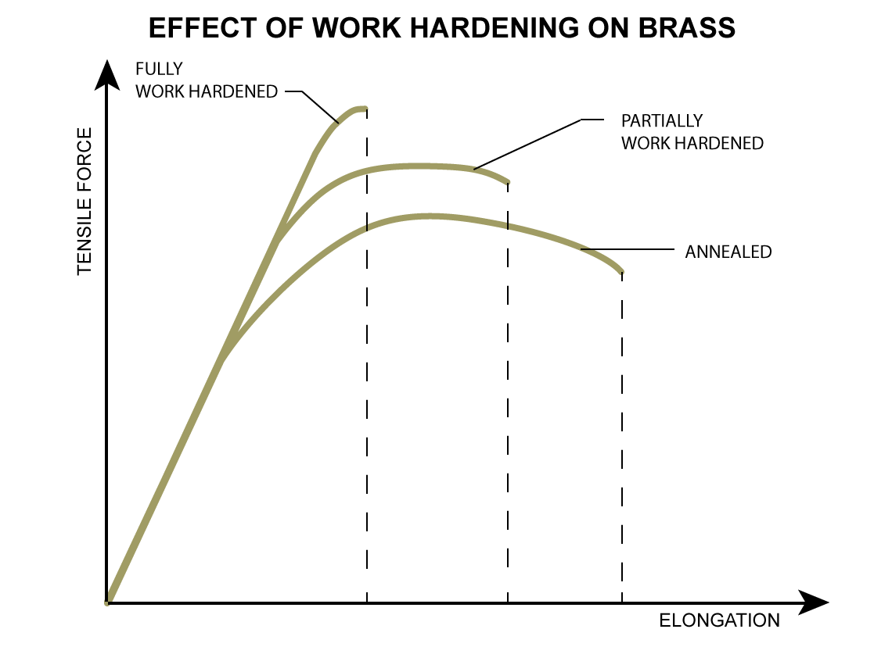
Figure 5 - Effect of Word Hardening on Brass [15]

The effects of work hardening are, fortunately, reversible with the process of annealing. Annealing allow the crystal structure of the brass, which has grown due to the effect of slip planes to essentially reset back to a ‘softer’ state [15]. The temperature at which this occurs is difference between various materials and will also be dependant on time at which the material endures these temperatures. Brass will often start the annealing process at approximately above 350°C [16], which is high enough for the atoms in the crystal structure to begin migration and reduce the number of dislocations in the structure. This can be visually seen by reversing the image seen in Figure 4 where the atoms at the edge of the grain boundary moves back towards the centre of the structure.

Figure 6 shows the effect of increasing the temperature of the annealing process and the final effect on the brass if the timing (one hour in the example shown) is kept the same. Due to the high-speed nature of cartridge case manufacture, the ovens required to anneal the cartridge cases will need to be large to allow a high quantity of product to pass through the oven at the required speed. Ensuring the brass endures the correct temperature for the desired time is critical to ensure the recrystallization of the structure.

There is no reason to control the colling times of the annealed brass, once the crystal structure has been altered to the required state, not further work is required and the brass can now be worked again. It is generally recommended that this annealing process is included between the initial drawing process (resulting in a tube) and the shoulder, head and mouth forming sections. As this final forming induces the most stress on the material, having the material reset for this forming is desirable. An additional annealing process could also be included at the end of the process focuses on just the mouth section of the cartridge case, this will ensure that upon insertion of the projectile, the brass mouth does not split or crack under this interference fit. The added sealing and crimping of the case mouth will ensure a seal.

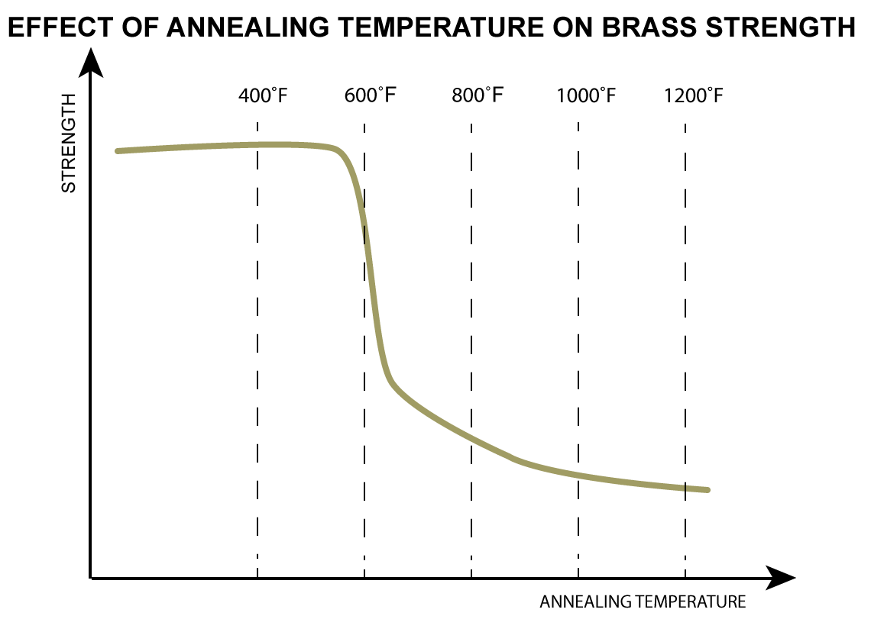
Figure 6 - Effect of Annealing Temperature on Brass Strength [15]

Conclusion
- Work hardening is a significant contribution to the difficulty in manufacturing and processing of the brass cartridge case. However, this is overcome by gaps in the process for the annealing treatment. By recrystallising the structure of the material, the risk of cracks and fractures in the brass is reduced.
- The addition of the annealing process should be included at the desirable position of between the tube and final forming processes. It would also be recommended to include a final annealing process at the end of cartridge manufacture to reduce the likelihood of mouth splits.
- Adding an increase in thickness and hardness of the material will aid in the strength of the material in theory, however it also causes a reduction in the fracture toughness. This increases the importance of reducing the stress concentration sites by including radii and minimizing the effect of geometry changes throughout the design.
- Ensuring tight controls are implemented into the material being purchased and used in the cartridge case manufacture is critical to ensuring formability, corrosion resistance and resistance to cracking.

Bibliography

[1] | Commission Internationale Permanente, “CIP - Introduction (Document must be requested),” [Online]. Available: https://www.cip-bobp.org/en/cip. [Accessed 07 December 2022].
[2] | alamy, “7.62 x 51 NATO cartridge,” [Online]. Available: https://c8.alamy.com/comp/BXXWP0/762-x-51-nato-308-winchester-cartridge-showing-bullet-and-brass-case-BXXWP0.jpg. [Accessed 25 November 2022].
[3] | NATO, Technical PErformance Specification Providing for the Interchangeability of 5.56mm x 45 Ammunition, NATO Standarisation Office (NSO), 2022.
[4] | J. K. N. Richard G. Budynas, Shingley's Mechanical Engineering Design, New York: McGraw-Hill, 2014.
[5] | Britannica, “Brass Alloy,” 09 September 2022. [Online]. Available: https://www.britannica.com/technology/brass-alloy#ref167379. [Accessed 02 December 2022].
[6] | NATO, DEF-STAN 95-9, NATO Publications Office.
[7] | K. K. L. L. A. M. M. S. H. &. U. G. Haruyuki Inui, “Uniaxial mechanical properties of face-centered cubic single- and multiphase high-entropy alloys,” MRS Bulletin, vol. 47, pp. 168-174, 2022.
[8] | R. D. Callister Jr W., Fundamentals of Materials Science and Engineering, Singapore: Jogn Wiley and Sons , 2013.
[9] | J. E. C. T W Clyne, Testing of the Plastic Deformations of Metals, Cambridge: Cambridge University Press, 2021.
[10] | J. Davies, Alloying - Understanding the Basics, ASM International , 2005.
[11] | J. Jevons, The Metallurgy of Deep Drawing and Pressing, John Wiley and Sons, 1940.
[12] | D. Davies, A Note on the dezincification of brass and the inhibiting effect of elemental additions, New York: Copper Design Association Inc., 1993.
[13] | C. M. Stewart, “Fracture Mechanics - Crack Tip Plasticity,” in MECH 5390-6390, 2020.
[14] | R. H. A. Lowe, “Cartridge case deformation test,” Journal of Energetic Materials, vol. 16, no. 4, pp. 289-307, 1998.
[15] | Bison Ballistics, “The Science behind Anealling Brass Cartridges,” 24 May 2013. [Online]. Available: https://bisonballistics.com/articles/the-science-of-cartridge-brass-annealing#:~:text=If%20heat%20is%20applied%20to,It's%20a%20fully%20reversible%20process.. [Accessed 07 December 2022].
[16] | Bodycote, “Soft Annealing,” [Online]. Available: https://www.bodycote.com/services/heat-treatment/annealingnormalising/soft-annealing/#:~:text=For%20copper%20and%20brass%20alloy,%C2%B0C%20for%20brass%20alloys.. [Accessed 07 December 2022].

