Web Development and Database Concepts
Assignment 2
Lewis Tucker

Table of Contents
Contents
Table of Contents 2
Introduction 3
Design 4
Tables/Fields 4
Normalisation 5
Data Dictionary 6
Entity Relationship Diagram 7
Forms 8
Report 9
SQL Implementation 10
Creating Tables 10
Customer 10
Damage 10
Order 10
Tool 11
Entering Data into Tables (SQL) 12
Customer 12
Damage 12
Order 12
Tool 12
Microsoft Access Implementation 13
Forms 13
Reports 15
Menu 16
User Documentation 16
Bibliography 19
References 19

Introduction
For this report, I have been tasked with both designing, and creating a suitable database for a tool hire company. Given a description as to what the company desires, I must suitably design and implement a functional database. The design process includes creating suitable fields, normalising the data, creating forms and creating a data dictionary. The implementation process includes creating the database using Microsoft SQL and creating a front end using Microsoft Access.

Design

Tables/Fields
The first protocol when designing this database was to identify all of the suitable fields that I will need to compile the database. After identifying the 4 tables that I would require, I then broke them further down into fields. Given that this is a tool hire company, the first table that I identified is Tool. The next tables I identified were Customer, Order and Damage. The Customer field is used to store details on the customers. The Order field is used to track all of the order details. Finally, the Damage table is used to track any details on any damage the hired tool may endure.
Here are the tables that I have created –
Tool
Tool ID
Tool Name
Cost
Condition
Reserved
Reserved Date
Customer
Customer ID
First Name
Surname
DOB
Address
Email
Phone No
Order
Order ID
Payment Method
Hire Date
Return Date
Actual Return Date
Late Charge
Damage
Damage ID
Part
Damage Charge

Normalisation
After identifying all of my fields for the database, I then had to ensure that they are normalised to 3rd normal form (3NF). Normalisation is a process in which you logically sort your data into suitable groups. This helps the user read the data as well as ensuring that data is not duplicated before creating a database. All the tables within the normalisation link together through the use of primary keys.
Here is the normalisation from 1NF to 3NF –
Bold = Table Name Underline = Primary Key
1NF
Customer (Customer ID, First Name, Surname, DOB, Address, Email, PhoneNo)
Tool (Tool ID, Tool Name, Cost, Condition, Reserved, Reserved Date, Order ID, Payment Method, Hire Date, Return Date, Actual Return Date, Late Charge, Damage ID, Part, Damage Charge, Customer ID)

2NF
Customer (Customer ID, First Name, Surname, DOB, Address, Email, PhoneNo)
Tool (Tool ID, Tool Name, Cost, Condition, Reserved, Reserved Date)
Order (Tool ID, Customer ID, Order ID, Payment Method, Hire Date, Return Date, Actual Return Date, Late Charge, Damage ID, Part, Damage Charge)

3NF
Customer (Customer ID, First Name, Surname, DOB, Address, Email, PhoneNo)
Tool (Tool ID, Tool Name, Cost, Condition, Reserved, Reserved Date)
Order (Order ID, $\overline{Tool ID}$, Customer ID, Payment Method, Hire Date, Return Date, Actual Return Date, Late Charge)
Damage (Damage ID, Tool ID, Order ID, Part, Damage Charge)

Data Dictionary
The next objective for me was to create a data dictionary. This is a place where I can store and declare all of my variables whilst designing the database. This allows me to then just refer back to the data dictionary when I need to use one of the variables. This declares characteristics such as its data type, references and it is null or not.
Here is my data dictionary for the database –
Table | Column | Data Type | References | Default | Not Null
Tool | Tool_ID | varChar(5) |  |  | Y
Tool | ToolName | varChar(50) |  |  | Y
Tool | ToolCost | varChar(10) |  |  | Y
Tool | Condition | varChar(50) |  |  | Y
Tool | Reserved | varChar(3) |  |  | Y
Tool | ReserveDate | Date |  |  | Y
Customer | Customer_ID | varChar(5) |  |  | Y
Customer | FirstName | varChar(50) |  |  | Y
Customer | Surname | varChar(50) |  |  | Y
Customer | DOB | Date |  |  | Y
Customer | custAddress | varChar(50) |  |  | Y
Customer | Email | varChar(50) |  |  | Y
Customer | PhoneNo | varChar(11) |  |  | Y
Order | Order ID | varChar(5) |  |  | Y
Order | Payment Method | varChar(10) |  |  | Y
Order | Hire Date | Date |  |  | Y
Order | Return Date | Date |  |  | Y
Order | Actual Return Date | Date |  |  | Y
Order | Late Charge | varChar(3) |  |  | Y
Damage | Damage ID | varChar(5) |  |  | Y
Damage | Part | varChar(50) |  |  | Y
Damage | Damage Charge | varChar(10) |  |  | Y

Entity Relationship Diagram
The next process of design was to create an entity relation whip diagram. An entity relationship diagram is a flowchart that demonstrates how different components of the database will link together [1]. This chart shows what tables have a standard relationship, and what tables have a one to many relationship.
Here is the entity relationship table for my database –
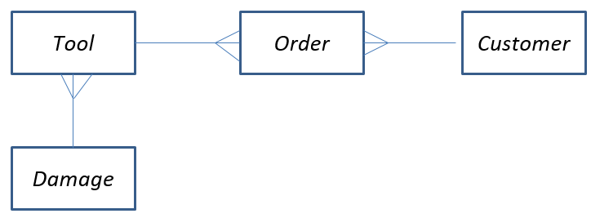
This table demonstrates that damage has a one to many relationship with tool, tool has a one to many relationship with order and customer likewise has a one to many relationship with order.

Forms
To ensure that the user can enter data to the database with ease, I will be creating forms. Forms will ask the user for certain prompts to enter data into the database. All forms will share the same design, the only difference being that they will ask for different information depending on the data its asking for.
Here is the design for the forms –
FORM TITLE
Field #1 | *User Input*
Field #2 | *User Input*
Field #3 | *User Input*
Field #4 | *User Input*
Save Button | Print Button | Next Button

It is important to note that the amount of fields are not fixed to 4, certain forms will require more fields than others.

Report
Reports are used in order to display any information that has been entered into the database. It is more of a user friendly way of reading database entries and it used as a front end for the database. Here is my design for the report.
REPORT TITLE
Field #1 | Field #2 | Field #3 | Field #4
*Data* | *Data* | *Data* | *Data*
Late Charge

SQL Implementation

Creating Tables
Here are the code listings that I used when creating the tables whilst using SQL. Before creating these tables, I used a suitable amount of research [2] to ensure that I was creating them correctly.

Customer
use Assignment2;
Create Table Customer(
customerID varChar(5),
FirstName varChar(50),
SurName varChar(50),
DOB date,
custAddress varChar(50),
email varChar(50),
PhoneNo varChar(11),

primary key (customerID)
);

Damage
use Assignment2;
create table damage(
DamageID varChar(5),
Part varChar(50),
DamageCharge varChar(10),

primary key (DamageID)

);

Order
use Assignment2;
create table Order_(
OrderID varChar(5),
PaymentMethod varChar(10),
HireDate date,
ReturnDate Date,
ActualReturnDate Date,
LateCharge varChar(3),

Primary key (OrderID),
);

Tool
use Assignment2;
Create Table Tool(
ToolID varChar(5),
ToolName varChar(50),
ToolCost varChar (10),
Condition varChar (50),
Reserved varChar (3),
ReservedDate Date,

primary key (ToolID),
);

Entering Data into Tables (SQL)
Once I had created the tables, I then had to enter the data into it. Here is a listing of the code that I used to enter the data in correctly –

Customer
use Assignment2;
insert into Customer values ('C1','Lewis','Tucker','2002-07-14', '48 Heol Hafdy', 'lewis@gmail.com','47650375663');

Damage
use Assignment2;
insert into Damage values ('D01','Handle', '£10');

Order
Use Assignment2;
insert into Order_ values ('O01','Card','09-05-2021','10-05-2021','10-05-2021','No')

Tool
use Assignment2;
insert into Tool
values('T01', 'Drill' , '£50' , 'Good' , 'No' , '10-05-2021' )

Whilst entering the data for this database, I had to ensure that the data that I was entering was suitable for the data type that was declared. For example, if I had defined a data type to only store 3 characters, I could not enter any more than 3 which is the defined amount. To ensure I was doing this correct I referred back to my data dictionary.

Microsoft Access Implementation
Once I had completed the design and implementation aspect I was then required to link my SQL database to Microsoft Access. Once the database was connected, I then had a series of features to implement to the database in order to create a functional front end.

Forms
The first feature that I created was a form for every table. The forms are used for the front end of the database to enter data into the database with ease. Using the “Form Wizard” function within access it allowed me to easily create the form and use the correct fields, here is the screenshot evidence of me creating the form.
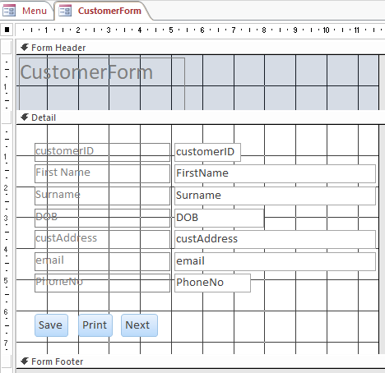
This is the form within design view on access. It allows me to suitably layout the form and make it easy for the user to enter data. This design view also allowed me to place buttons into the form. These buttons make the form easy to save, print or go to the next form.
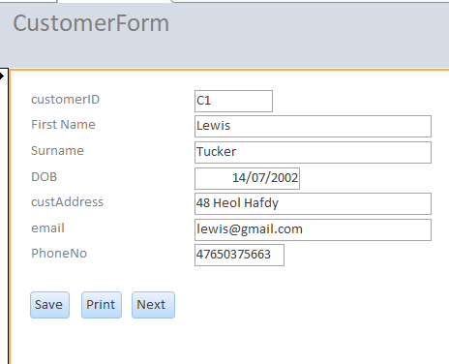
Here is the form once it has been saved in design view –

Once I had finalised the design and button layout for the forms, I then had to test that the data I was entering into the form was correctly being saved into the table.
Here is evidence that the data is being saved correctly into the table –
Here is the data that I am entering into the form –

Here is the data saved into the table –
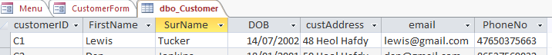

Reports
My next task for the Microsoft access implementation was to create a report to display the data entered into the tables. The purpose of this is to create a user friendly display for the data that was entered into the tables. Here is the design view for the report that I created.
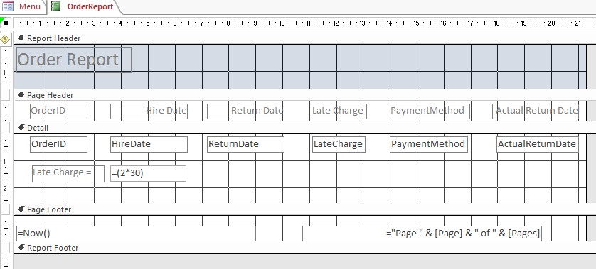
I created this report using the “Report Wizard” function in Access. Similar to the design for the forms, this allows me to present the data in an organised manner, making it easy on the user to read. This report also contains a calculation. The calculation displays the late charge of £30, for the 2 days that it was late.
Here is the finalised report that is visible by the user.
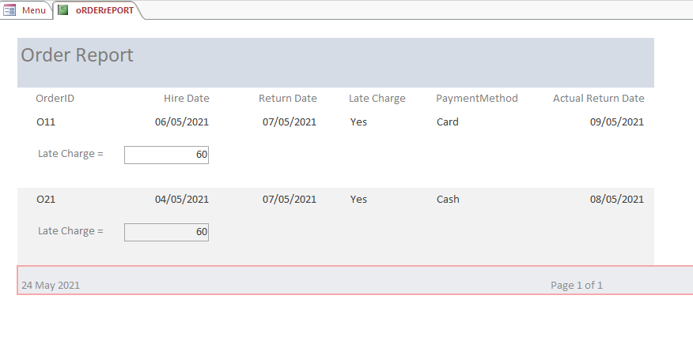

Menu
The final feature that I was required to implement within Access is a functional menu that displays itself as soon as the database is loaded up. I created this menu so that it allows easy navigation of the database to the user.
To create this menu, I created a form with buttons that lead to other forms on the database. To ensure that it was shown upon opening of the database I ensured that it was called “AutoExec”. Creating a macro and calling it AutoExec will ensure that that form takes priority over other forms and will be displayed before anything else within the front end of the database.
Here is the Menu that the user is greeted with –
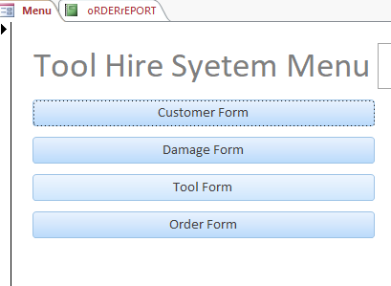

User Documentation
Here is a step by step guide as to how to navigate, and successfully use the database from a user’s perspective.
The user will be greeted with the menu –

The user is then able to select which of the four forms that they would like to enter data into.
Once they have selected, they will be taken to their chosen form, in this instance as an example I will be using the customer form however this applies for all forms –

Once the user has entered in the required data, they are then met with three buttons. The three buttons are as follows –

Once the user has entered all the required fields of data, they can use the Save button in order to ensure that their data is saved successfully into the database.
The Print button will allow the user to print the form that they have just filled in. once clicked, the user will be met with this screen.
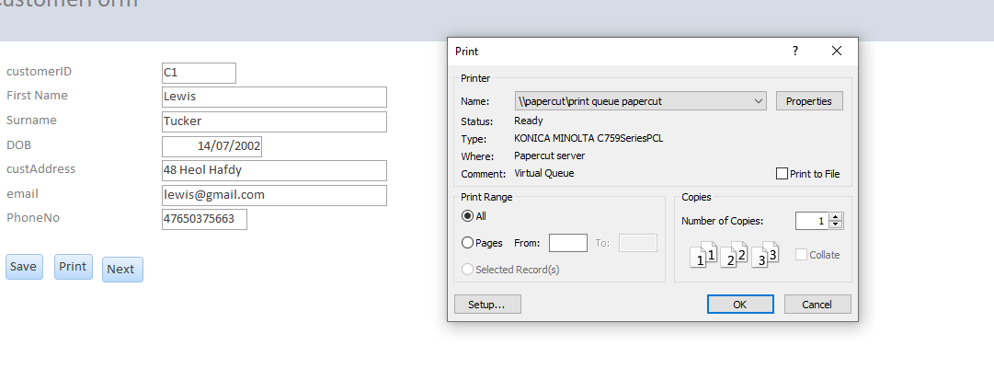
This allows the user to select their preferences when it comes to printing off the form. This includes features such as selecting the correct printer and the layout of the print.
Finally, the Next button allows the user to progress to the next form on record, they will progress through the forms until they come to the end form, where they will be greeted with a new blank form to fill in if they wish.
This guide applies for all forms.

Bibliography

References
1 – Entity Relationship Diagrams
Link - https://www.lucidchart.com/pages/er-diagrams

2 – Creating tables in SQL
Link - https://www.w3schools.com/sql/sql_create_table.asp

