Design and Evaluation of Wireless Sensor Networks

Shay Friel
Wireless Networks and Simulation
Module Code: ACCB5004
Swansea, Wales
Sfriel.151758@student.uwtsd.ac.uk

Table Of Contents
Introduction………………………………………..1
Related Work……………………………………...1

Implementation..…………………………………..5
Results/Findings and Discussion…….…….……...9
Conclusion………………………………………...7
References………………………………………..8

Abstract— Communication from the 60’s to the 2000’s has evolved massively and the reason for that is technology. Digital communication methods are adapting fast and soon most of the communication that takes place around the world will be digital. This report will discuss the concepts, the principles and analyse the BPSK modulation technique. An implementation of Binary Phase Shift Keying (BPSK) using the Matlab software, along with the advantages and disadvantages of the modulation technique. The report will also include an implementation of a wireless sensor network design & evaluation for intensive and mixed farming. At the end of this report, an evaluation of the performance of the wireless sensor network will be compared to the BPSK modulation scheme.

Introduction
Communication through entertainment media like internet, radio broadcasting, newspaper and television is so important these days because it gives people awareness of what goes on around them. These communications work by transmitting signals from one location to another.
Modulation is the key process for these communications because they strengthen the signals which are transmitted from one location to another over a long distance. There are many digital modulation schemes, but only one will be discussed during this report.

This report reviews and justifies the Binary Phase Shift Keying (BPSK) modulation technique, giving examples of the advantages and disadvantages, examples of implementations, how the concepts of computer network simulations relate to communication systems and the pros and cons of using simulations instead of methods like test-bed and mathematical.

Related Work
What is the function of modulation in a communication system? Within the modulation process, there are two signals. First is the modulating signal which is the information signal and the second signal is the carrier, which is a high frequency sinusoidal signal. Inside the modulation process, a parameter of the carrier wave like frequency for example is mixed in correspondence with the modulating signal. The signal is then transmitted by the transmitter. The receiver demodulates the modulated signal and retrieves the original information signal. [1]

How does the concepts and principles of computer network simulations relate to communication systems? Both computer network simulation and communication systems relate to each other because in network simulation, computer network is formed with applications, devices, and links for example. The most popular networks and technologies these days such as WLAN’s, wireless sensor networks, cognitive radio networks, Internet of Things for example, all support the use of network simulators. This is where communication systems apply to the network simulations. The communication systems allow these technologies and networks to communicate with each other by transmitting signals from one source to another. An example of a communication system is ‘Radio Communication System’ and this works with the benefit of a transmitter and a receiver both supplied with an antenna. [8]

The fundamentals of BPSK
BPSK stands for Binary Phase Shift Keying and it is a digital modulation technique. It is a two phase modulation scheme where the sine wave carrier takes two phase reversals such as 0° and 180°. [2] The 0’s and 1’s in binary are expressed by two different phase states in the carrier signal, binary 1, θ = 0° and binary 0, θ = 180°. [3] These two are represented as:

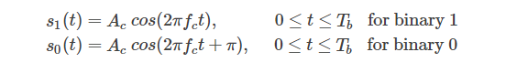
Figure 1 [3]

To breakdown these two functions, Ac represents the amplitude of sinusoidal signal, Fc is the carrier frequency, t is the instant time in seconds, and Tb is bit period in seconds. [3] s0(t) is the carrier signal when information bit ak = 0 was transmitted and signal s1(t) indicates the carrier signal when information bit ak = 1 is transmitted. [3]

BPSK modulator, which consists of the carrier wave generator as one input and the binary sequence (data) as the other input. See figure 2.

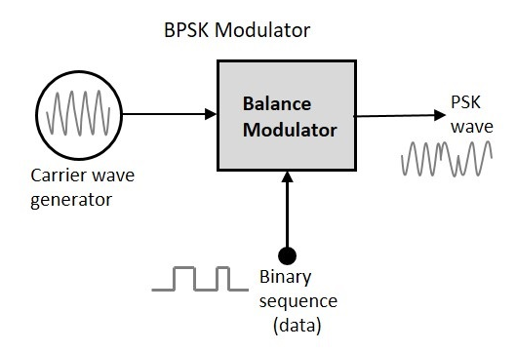
Figure 2 [2]
In figure 2, two signals are multiplied at the input by a balance modulator. If there is a zero binary input, the phase will be 0° and if there is a high input the phase reversal is 180°. [2]

Figure 3 represents a BPSK modulated output wave along with its given output. The output sine wave of the modulator is the inverted (180° phase shift) input carrier, which is the data signal function. [2]

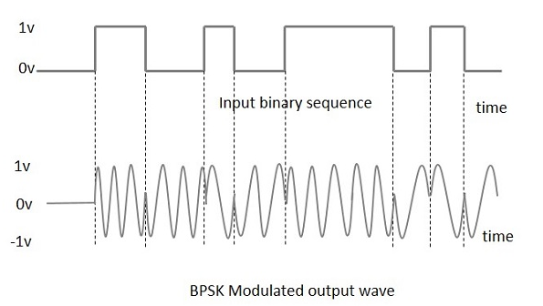
Figure 3 [2]

The first stage of BPSK demodulator begins by recovering the band-limited signal, whilst acquiring the help of the mixer circuit. Then the base band signal (band limited) is collected and this signal is used to reestablish the binary message bit stream. [2] The second stage of the demodulation begins when the bit clock rate is required at the detector circuit to produce the initial binary message signal. Assuming that the bit rate is a sub-multiple of the carrier frequency, then the bit clock transformation is simplified. As seen in figure 4, in the 2nd stage of the detection a decision-making circuit has been added to make the circuit easily understandable. [2]

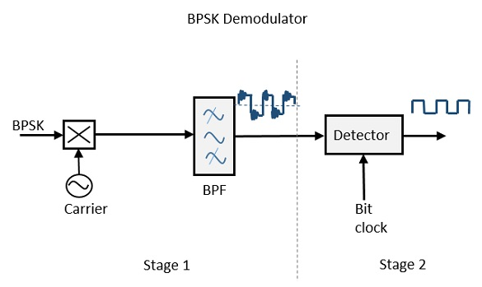
Figure 4 – Diagram of a BPSK Demodulator

BPSK advantages and disadvantages
BPSK has many advantages and disadvantages over the other modulation techniques. Some of BPSK’s advantages are: [6]

- Binary 1 and 0 are detached by 180° phase shift of the carrier, therefore data can travel longer distances when transmitted from places such as base station
- Most cellular towers operate off BPSK for long distance communication or transmission of the data
- BPSK receiver is more simplified compared to other modulation techniques because the demodulator only needs to make two selections in order to regain the initial binary information
- BPSK is power competent because less power is required to transmit the carrier with fewer number of bits

BPSK’s disadvantages are: [6]

- Only one bit is carried by one single analog carrier in BPSK modulation technique. This is the reason why data rate in bits per second (bps) is equal to the symbol rate. Compared to other modulation techniques like QPSK, its half in comparison and much less in comparison to greater modulations such as 16QAM for example
- BPSK is not bandwidth competent like other modulation techniques

Matlab/Simulink Experiment
In this part of the report, we will be using Matlabs Simulink to create a simulation model of BPSK and calculate its performance whilst progressively increasing the level of noise affecting the channel.

First off, we created BPSK simulator model using blocks on Simulink. The blocks used were Bernoulli Binary Generator, which generates random binary sequence of 0s and 1s for transmission. A BPSK modulator and demodulator. An AWGN channel which is used to mimic random processes that can occur during transmission. An error rate calculation which calculates the error rate by comparing the transmitted signal (Tx) and the received signal (Rx). We also used a scope block which generates a graph that displays the noise affecting the channel and finally a display bloke which displays the bit error rate, number of errors and total number of transmitted bits. See figure 5 for overview of the modulation.

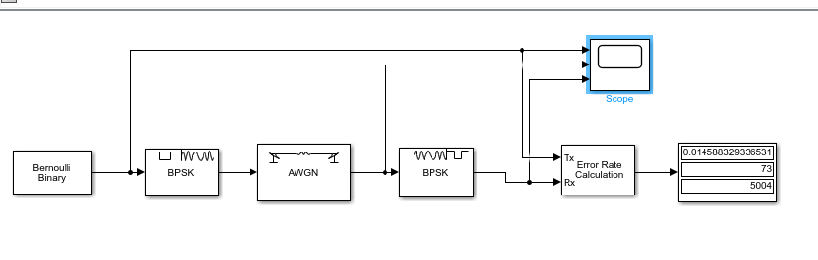
Figure 5

Here are the results (3 results) for performance whilst gradually increasing the level of noise affecting the channel.

Display Block as follows:
- Bit Error Rate (BER)
- Number of Errors
- Total number of transmitted bits

- Signal to noise ratio = 5

In figure 6, the result of inputting a signal to noise ratio of 5 has a bit error rate of 0.0071942446043165, 36 errors, and 5004 in total of transmitted bits.
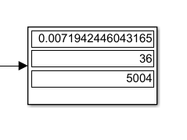
Figure 6

In figure 7, this is where we change the signal to noise ratio on the block AWGN to affect the channel of noise. In this case, the signal to noise ratio is set to 5.

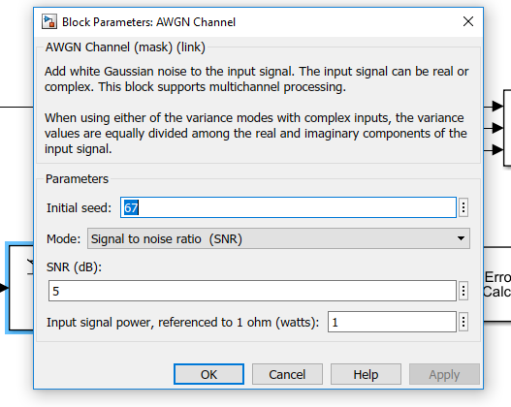
Figure 7
In figure 8, the input and output data are very similar which indicates hardly any packets were lost during the process. The middle graph shows the level of noise affecting the channel.

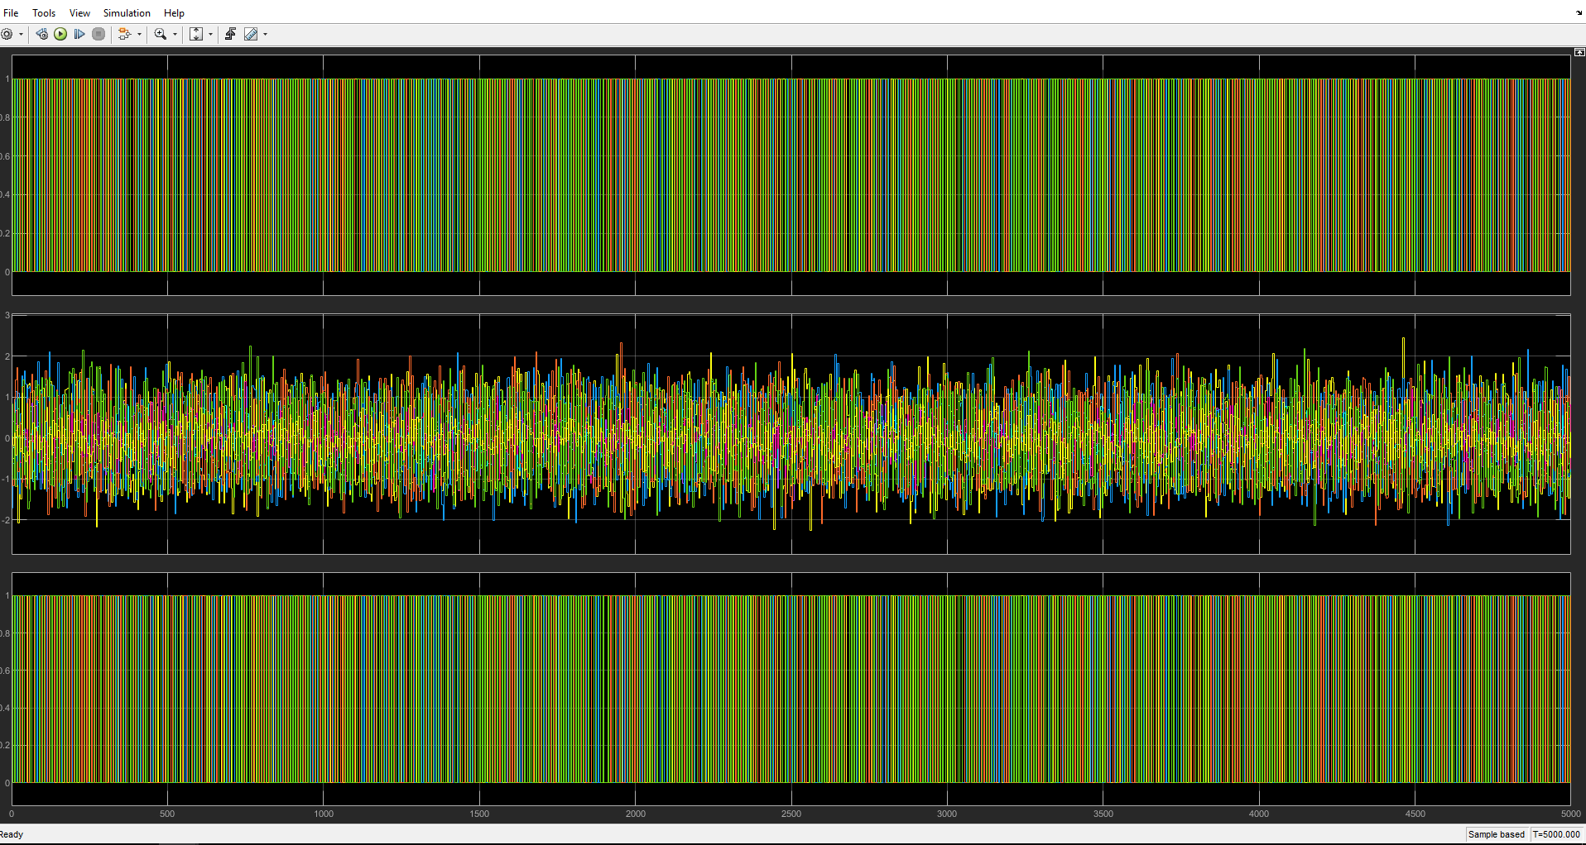
Figure 8

- Signal to noise ratio = -9.4

In figure 9, the result of inputting a signal to noise ratio of -9.4 has a bit error rate of 0.30864197530864, 100 errors, and 324 in total of transmitted bits.
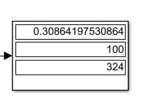
Figure 9

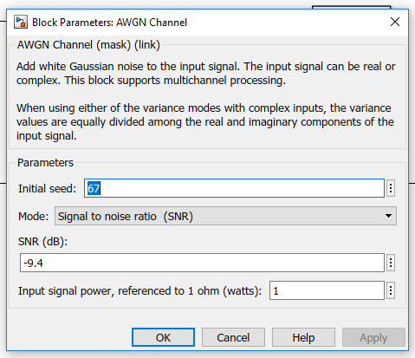

Figure 10
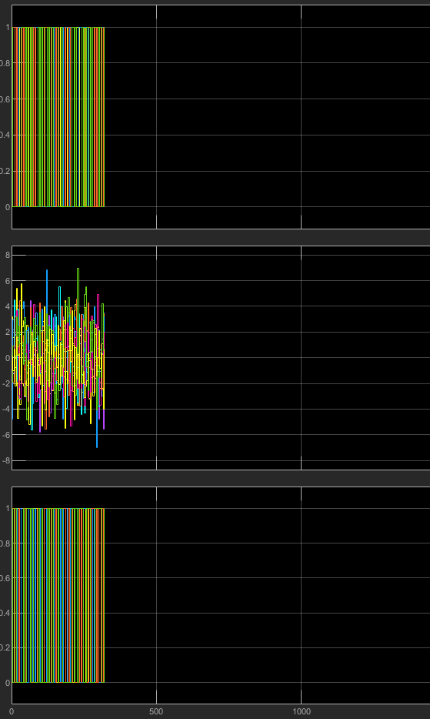
Figure 11

- Signal to noise ratio = 1

In figure 12, the result of inputting a signal to noise ratio of 1 has a bit error rate of 0.050100200400802, 100 errors, and 1996 in total of transmitted bits.

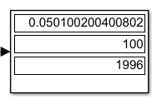
Figure 12

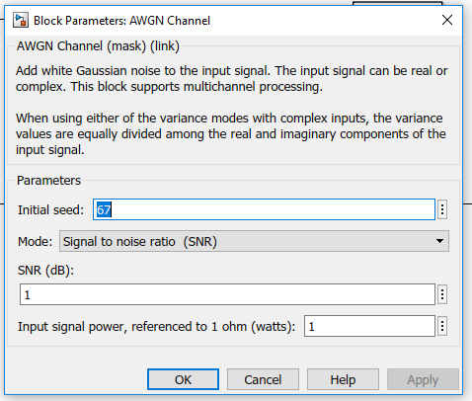
Figure 13

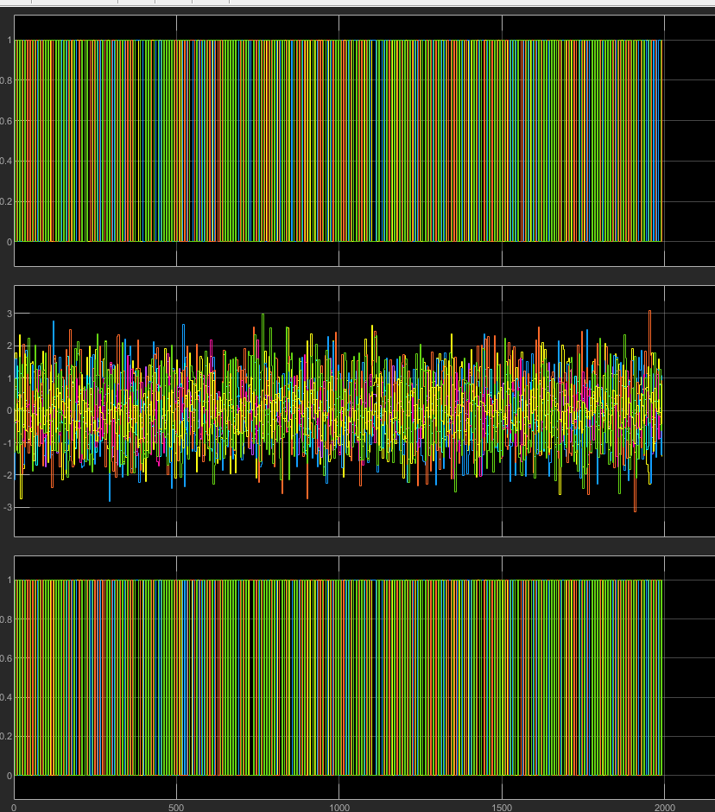

Figure 14

To conclude on Simulink, the creating of BPSK modulation was nice and simple, cost effective and learned more about how BPSK works whilst creating the modulation rather than research about BPSK.
Some pitfalls whilst creating the modulation was failure to collect good system data when inputting a large signal to noise ratio. Also the verification of the correctness of the simulations implementation was hard to achieve.

Pros and Cons Using Simulations
Some of the pros of using simulations is that you can test the behavior of a simulation before creating. For example, you can create a product in simulation before building it to see if the product would succeed in the real world. This is an advantage for engineers that use simulation. The use of simulation allows you to analsye the system if the mathematical results are incorrect. Simulation produces accurate results and it can also be used by teachers in class/lecture to teach students. Places such as industries and businesses also use simulations as a first stage in testing new products and services. Simulation is easy to build and affordable to create.
Simulation has its disadvantages, such as it takes a long time to create a simulation, especially if the simulation doesn’t work and ends up as a waste of time. Simulation can be expensive. Simulation can be problematic when trying to read the data back. Even though data gets displayed in graphs, when large amounts of data get put into a simulation, some information may be misplaced. When a simulation is extremely large, it causes computational complexity.

Comparing simulation to other methods such as test-bed for example, test-bed has an ease of making adjustments to the production system and has space limitations. On the other hand, test-bed needs dependable data and doesn’t have any no hands on understanding and experience to expedite learning. [9]

Comparing simulations to a mathematical method, mathematical offers a simplified situation and help develop a better understanding of the real world because some variables can be altered. On the down side the model does not include all aspects of the problem and the model may only function in some situations. [10]

Implementation
The final task of the assignment was to design and simulate a sensor network for intensive and mixed farming. NetSim was the software used in order to create this design.

Here is an overall view of the wireless sensor design network. See figure 15.

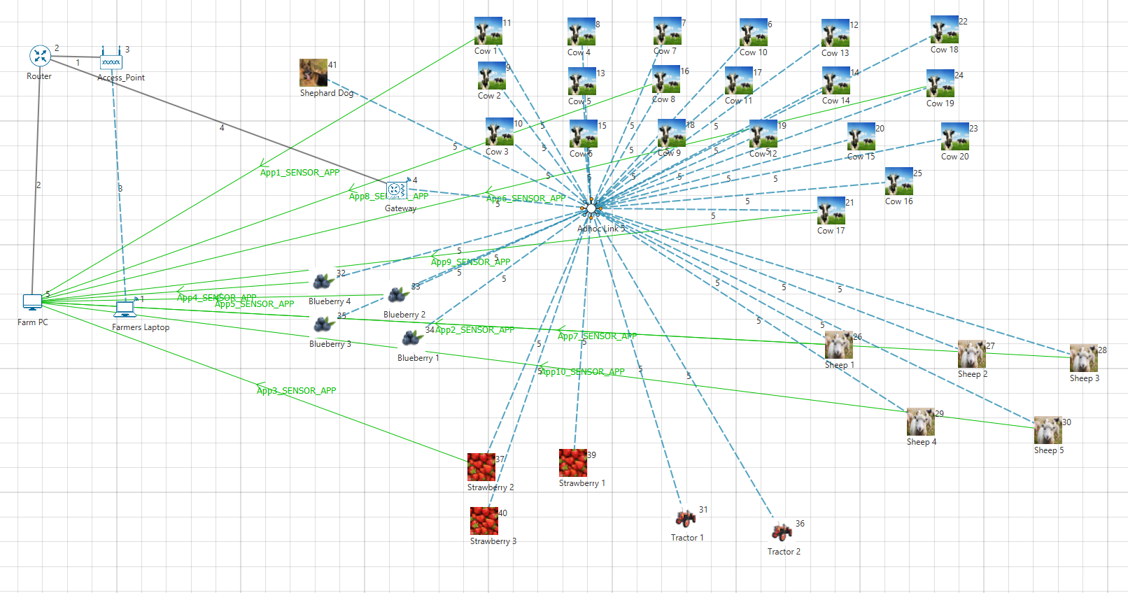
Figure 15

Within Netsim, the first task was to create a wireless lan so that the farmer could connect his PC to the internet to monitor his farm. The network includes 1 router, 1 access point, 1 wired PC, 1 wireless laptop and a gateway. After connecting these devices up using wired/wireless connections, the next step was to deploy an Adhoc Link, which is used to connect wireless nodes and sensors. Using the wireless sensor tab, 35 wireless sensors were plotted into separate groups all over the design. 1 group consisted of 20 cows, another group consisted of 5 sheep, another group for 3 strawberries, another group for 4 blueberries, another group for 2 tractors and 1 more wireless sensors for the farmer’s shepherd dog. Each of these sensors were connected to the Adhoc Link, icons and sensor names were changed to the appropriate names and pictures.

After the initial design is setup, the next step was to use the application traffic generator to allow users to model traffic flow between two nodes of the network. For example, cow 1(wireless sensor number 11) is connected to the Farm PC. See figure 16.

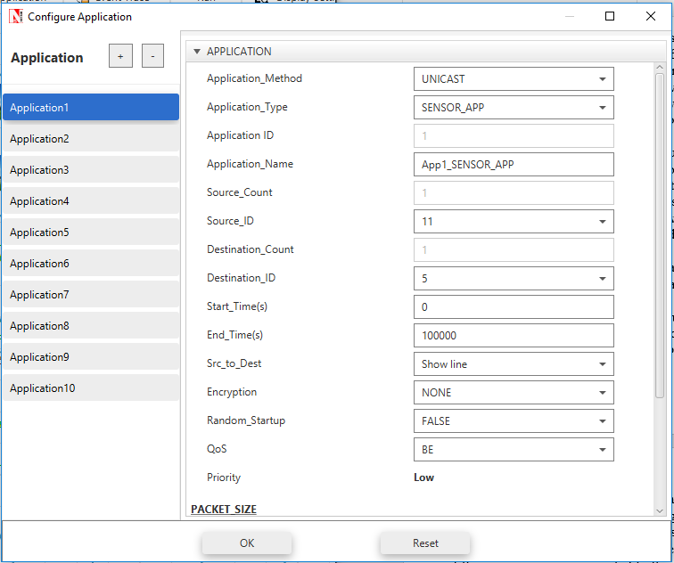
Figure 16

This process was done for at least 2 of every group to determine whether the Farmer can monitor each group. So once all the farm was set up and connected to each other for monitoring, the design was put through run configuration in order to redeem the simulation results.

In figure 17 below, we can see the application metrics results after running the configuration. As seen in the results, every application sensor has been successfully generated, with 100 packets being generated each application sensor. We can also see the packets received by every sensor, which depend on the sensor and the level of noise coming through the channel. The megabits per second(mbps) throughput, and they delay in microseconds for every sensor.

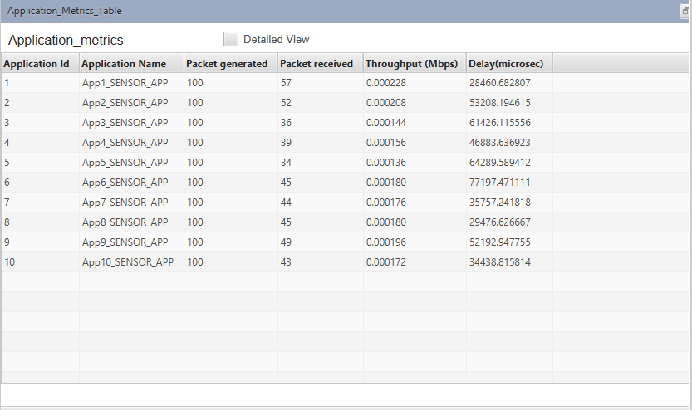
Figure 17

Figure 18 shows the full simulation results tables.
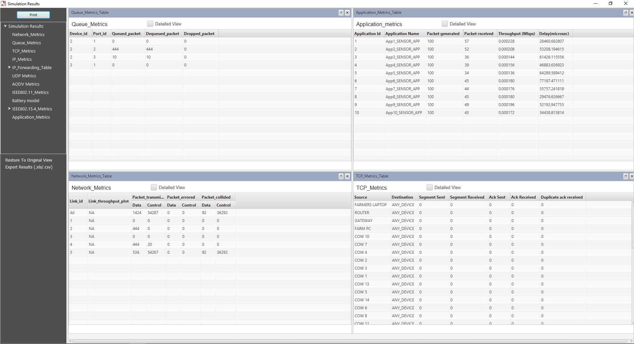
Figure 18

Results/Findings and Discussion
After evaluating the performance of the wireless sensor network across the BPSK modulation scheme tested in task 1, its fair to say that BPSK is a reliable digital modulation technique for a real life situation, for example a smart farm as established in task 2 because it is simplified and power competent.

On the other hand, BPSK only contains two constellations and can only transmit one bit per burst, and also has low bandwidth reach which might not be suitable for a bigger smart farm.

Conclusion
In this assignment, we have researched Binary Phase Shift Keying (BPSK) and its fundamentals, created a BPSK modulation in Matlab Simulink and created a wireless sensor network diagram for a smart farm.

BPSK is the simplest and most power efficient, but for future reference, different modulation techniques such as QPSK, 16QAM will be implemented instead because BPSK is the most standard and basic modulation technique which doesn’t offer much when it comes to implementing the modulation. Also BPSK is not bandwidth competent like other modulation techniques such as QPSK, which carries two bits of data for every carrier and therefore offers a lot more bandwidth.

To conclude, a future recommendation about the wireless sensor network and communication system needs to be in more depth, in terms of more sensor devices connected to the Farmers PC and Farmers Laptop, this would’ve give the network a much bigger outlook. When receiving the results from running the network, more data should’ve been displayed such as graphs to visually illustrate the data.

References

[1] Explain the need for modulation in a communication system, by SASMITA, January 2016
Available: https://electronicspost.com/explain-the-need-for-modulation-in-a-communication-system/

[2] Digital Communication – Phase Shift Keying, Tutorials Point, 2019
Available: https://www.tutorialspoint.com/digital_communication/digital_communication_phase_shift_keying.htm

[3] Binary Phase Shift Keying (BPSK) – modulation and demodulation, by Mathuranathan, April 2010
Available: https://www.gaussianwaves.com/2010/04/bpsk-modulation-and-demodulation-2/

[4] Digital Modulations using Matlab: Build Simulation Models from Scratch, by Mathuranathan Viswanathan, June 2017 (Book)

[5] Digital Modulation Techniques – Artech House Telecommunications Library, Fuqin Xiong, January 2000 (Book)

[6] Advantages of BPSK | Disadvantages of BPSK, RF Wireless World, Available:
http://www.rfwireless-world.com/Terminology/Advantages-and-Disadvantages-of-BPSK.html

[7] Wireless Communication Systems in Matlab, Mathuranathan Viswanathan, September 2018 (Book)

[8] Different types of communication systems, Management Study Guide, by Prachi Juneja
Available: https://www.managementstudyguide.com/different-types-of-communication-system.htm

[9] Test Bed Architectures, Research Gate, by Christian Eliasson Lijia
Available: https://www.researchgate.net/figure/Advantages-and-Disadvantages-of-test-bed-structures_tbl1_328433222

[10] Advantages and Disadvantages of Mathematical Models, by nuttyk, January 2017
Available: https://getrevising.co.uk/grids/advantages-and-disadvantages-of-mathematical

