[Date]
Suneth Fernando
WUTSD- 2025
IWD : Database Design and Development
Assignment 01
Student- Olha Kozmenko
Student ID – 2335644
Gr 2

Contents
Introduction to the case study 2
Task 1 — Practical Implementation 2
1.1 SCENARIO ANALYSIS 2
1.2 ENTITY RELATIONSHIP DIAGRAM (ERD) 3
Type of Relationship between Entities 4
One-to-One Relationship 4
One-to-Many Relationship 4
Many-to-Many Relationship 4
Relationships between tables 5
Entities interact within the database 5
1.3. DATA STRUCTURE DEVELOPMENT 5
1.4 — NORMALISATION PROCESS 6
First Normal Form (1NF) 6
Second Normal Form (2NF) 6
Third Normal Form (3NF) 7
1.5 — SAMPLE DATA POPULATION 7
1.6 — QUERY DEVELOPMENT 9
1.7 — VALIDATION AND TESTING 12
Forms Creation 14
Dashboard Creation 16
Calculations 17
Task 2 - Written Elements 18
Introduction 18
Design Decisions 18
Reflection 19
References 19

Introduction to the case study
EcoRide is a new electric bike rental service that works in public places such as parks, stations and university areas. The main idea of this project is to help people travel in a more green and healthy way. At the moment, the company is keeping all records on paper and in simple spreadsheets. Because of this, the team often has problems. For example, they cannot always see which bikes are available, which bikes need repair, or which bikes were not returned on time. It is also difficult for them to prepare reports and understand how the service works.
To solve these problems, the company needs a clear and organised database. A relational database can store all important information in one place, such as riders, bikes, locations, rentals, payments and maintenance. This makes the system easier to use and reduces mistakes. It also helps staff quickly find the information they need.
In this report, I describe how I designed and built a relational database for EcoRide using Microsoft Access. The report includes scenario analysis, ERD diagram, table structure, normalisation, sample data, queries and testing. Finally, I also reflect on what I learned and what can be improved in the future.
The full Microsoft Access database file (EcoRide.accdb) is submitted separately as part of this assignment, as required in the brief.

Task 1 — Practical Implementation

1.1 SCENARIO ANALYSIS
The EcoRide system needs to store information about many different parts of the electric bike service. After studying the scenario, I identified several main entities that are important for the daily work of the company. Each entity holds a specific type of information, and together they help organise the whole system.
The Rider entity stores details of people who use the service, such as their full name, phone number, email and ID document. This information is needed to register a rider and link them to their rentals.
The Bike entity contains information about each electric bike. It includes the bike type, model, condition status, availability and notes. This helps staff understand where the bike is and if it needs repairs.
The Location entity shows where EcoRide stations are placed. It stores the location point, address and postcode. Each rental starts and ends at a location.
The Rent entity records every rental activity. It stores the rider, the bike, start and end locations, the date and time of the rental, and the number of hours. This gives a full history of how bikes are used.
The Payment entity keeps information about the rental cost, hours and payment status. This helps the system track completed and unpaid rentals.
The Maintenance entity records all repair and service work done on the bikes. It stores the staff member, service dates, service type and cost.
The Staff entity contains information about employees who work with bikes and service them. Together, these entities form a clear structure of the EcoRide system.

1.2 ENTITY RELATIONSHIP DIAGRAM (ERD)
The Entity Relationship Diagram (ERD) shows how all the main parts of the EcoRide system are connected to each other. It helps to understand the structure of the database before creating the tables in Microsoft Access. The ERD is based on the scenario and the real needs of the bike rental service.
In the ERD, each entity represents an important group of data. The Rider entity stores information about people who rent bikes. The Bike entity stores details about each electric bike. The Location entity shows where rental points are placed. The Rent entity records each rental activity. The Payment entity keeps information about rental costs, and the Maintenance entity stores details about repair work. The Staff entity includes information about people who work in the service and repair bikes.
The connections between entities are shown as relationships. One rider can have many rentals. One bike can be rented many times. A bike can also have many maintenance records. Staff members can complete many maintenance tasks. Each rental has a starting and ending location, so the Rent entity connects to the Location entity twice. Payments are linked to rentals because each rental has one related payment record.
Overall, the ERD provides a clear picture of the whole system. It helps to build the tables correctly and to make sure the database works in a logical and organised way.
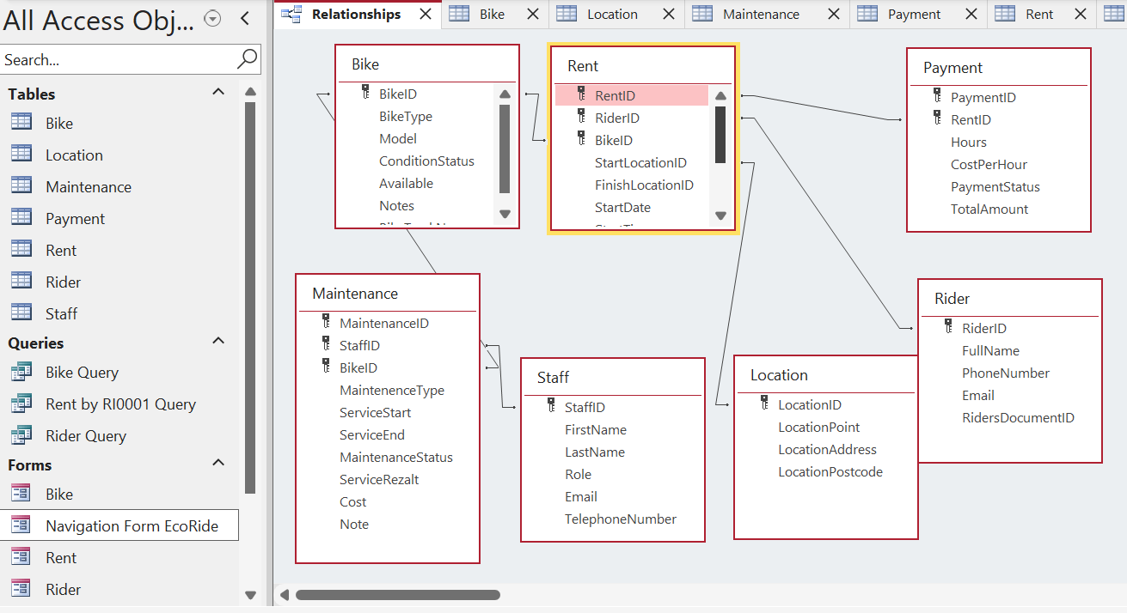
Figure 1.2 – ERD Diagram (Relationships View)

Type of Relationship between Entities
In the EcoRide system, different types of relationships exist between the entities. These relationships show how the tables connect and how the data depends on each other.

One-to-One Relationship
A one-to-one relationship happens when one record in a table is linked to only one record in another table. In this project, the Payment table uses a one-to-one relationship with the Rent table. Each rental has only one related payment, and each payment belongs to only one rental.

One-to-Many Relationship
This is the most common type of relationship in the EcoRide database. For example, one Rider can have many different rentals over time. Another example is the Bike entity. One bike can be rented many times, so Bike has a one-to-many relationship with Rent. A single bike can also have many maintenance records, so Bike and Maintenance also use a one-to-many relationship.

Many-to-Many Relationship
A direct many-to-many relationship does not exist in the final database, because it is not used in Microsoft Access. Instead, it is solved through connecting tables. For example, if riders could join many locations and locations could have many riders, it would be many-to-many. In this case, it is resolved through the Rent table, which sits in the middle.

Relationships between tables
Each table in the EcoRide database uses a Primary Key to identify every record and Foreign Keys to create relationships between tables. RiderID is the Primary Key in the Rider table and is used as a Foreign Key in the Rent table. BikeID is the Primary Key in the Bike table and is used as a Foreign Key in both the Rent and Maintenance tables. LocationID is the Primary Key in the Location table and appears twice in the Rent table as StartLocationID and FinishLocationID.
RentID is the Primary Key in the Rent table and is used as a Foreign Key in the Payment table. StaffID is the Primary Key in the Staff table and is used as a Foreign Key in the Maintenance table. These key attributes connect the tables and make it possible to track riders, rentals, bikes, payments and maintenance activities across the whole system.

Entities interact within the database
The entities in the EcoRide database interact with each other to support the full bike rental process. Each entity stores a different type of information, but they are connected through Primary Keys and Foreign Keys. These connections allow the system to work as one complete structure.
The Rider entity interacts with the Rent entity because every rental must be linked to a specific rider. This helps the system keep a full history of who used which bike and when. The Bike entity also interacts with the Rent entity, because a rental cannot happen without a bike. Through this interaction, the system can track the usage of each bike.
The Rent entity interacts with the Payment entity because each rental has one payment record. This allows the company to check if the rental was paid and how much it cost. The Bike entity also interacts with the Maintenance entity. When a bike needs service or repair, a maintenance record is created and linked to that bike.
Finally, the Staff entity interacts with Maintenance, because each maintenance activity is completed by a staff member. These interactions show how data flows through the system and how the entities depend on each other.

1.3. DATA STRUCTURE DEVELOPMENT
The data structure of the EcoRide system was created using the ERD as the main guide. Each entity from the diagram was turned into a separate table in Microsoft Access. Every table has a Primary Key, which helps to identify each record. Foreign Keys were added to create the correct links between tables. This structure helps the database work in a clear and organised way.
The Rider table stores information about people who use the service. It includes fields such as RiderID, first name, last name, phone, email and ID number. RiderID is the Primary Key.
The Bike table contains information about every electric bike. It includes BikeID, type, model, condition, availability and notes. BikeID is the Primary Key.
The Location table stores the rental point information. It includes LocationID, location name, address and postcode.
The Rent table records each rental operation. It includes RentID, RiderID, BikeID, start and end locations, rental date and time, and hours. RiderID, BikeID and LocationID work as Foreign Keys to connect this table with Rider, Bike and Location.
The Payment table holds information about the rental fee. It includes PaymentID, RentID, number of hours, total price and payment status. RentID is the Foreign Key connecting payments to rentals.
The Maintenance table stores information about service and repair work. It includes MaintenanceID, BikeID, StaffID, service date, service type and cost.
The Staff table includes details about workers who check and repair the bikes. It stores StaffID, first name, last name and position.
This structure helps keep the database clear, reduces mistakes and supports correct relationships between all parts of the system.

1.4 — NORMALISATION PROCESS
Normalisation is used to organise the data in the database and remove any problems with repetition or dependency. It helps make the tables more clear and easier to maintain. For the EcoRide system, the tables were normalised up to Third Normal Form (3NF). Below is a short explanation of each step.

First Normal Form (1NF)
To meet 1NF rules, every table must store only single values in each field. There should be no repeating groups. In my database design, all fields contain one value only. For example, in the Rider table, the phone number and email address are stored in separate fields. There are no lists or multiple values inside one cell.

Second Normal Form (2NF)
To meet 2NF, the table must already follow 1NF and all non-key fields must depend on the whole Primary Key. In the EcoRide database, most tables use a single-field Primary Key (such as RiderID, BikeID, StaffID). Because of this, all the fields in each table depend directly on the Primary Key. For example, in the Bike table, the bike type, model, condition and availability all depend on BikeID.

Third Normal Form (3NF)
To meet 3NF, the table must already follow 2NF and all fields must depend only on the Primary Key, not on other fields. This removes any indirect dependencies. In my database, fields like total price in the Payment table are calculated from hours, but they do not create dependency problems. Every field describes only the main key of the table. No field depends on another non-key field.
After normalisation, the tables are clean, organised and do not repeat data. This makes the EcoRide system more efficient and easier to update in the future.
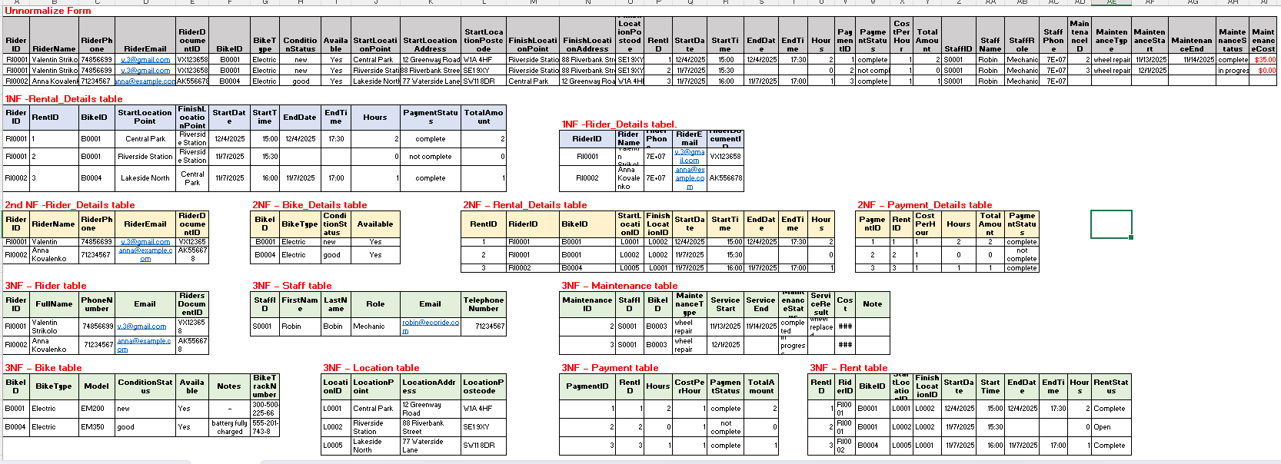
Figure 1.4 – Normalisation Process from Unnormalised Form (UNF) to Third Normal Form (3NF) for EcoRide database.

1.5 — SAMPLE DATA POPULATION
After creating the tables and setting all Primary and Foreign Keys, I added sample data to the database. The sample data is based on the EcoRide scenario and shows how the system works in real life. Each table contains at least five records. This helps to test the relationships, queries and reports in Microsoft Access.
The Rider table includes different users with names, phone numbers and ID documents.
The Bike table shows several electric bikes with different types and conditions.
The Location table includes the rental points used in the system.
The Rent table records examples of bike rentals made by riders.
The Payment table shows how much each rental costs and if the payment is completed.
The Maintenance table contains sample service records for the bikes.
The Staff table includes workers who repair and check the bikes.
The sample data helps to check that the database works correctly and that all links between tables operate without errors.
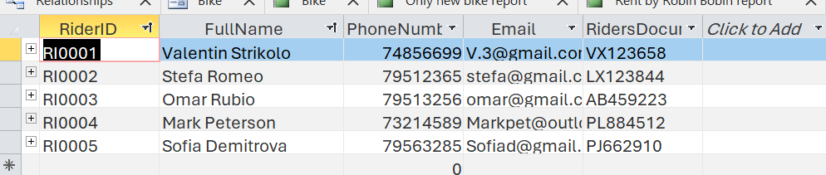
Figure 1.5.1 – Rider Table (Sample Data)
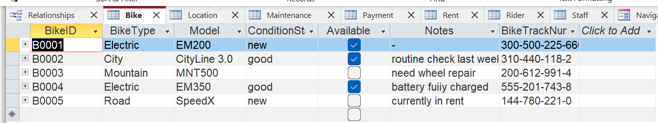
Figure 1.5.2 – Bike Table (Sample Data)
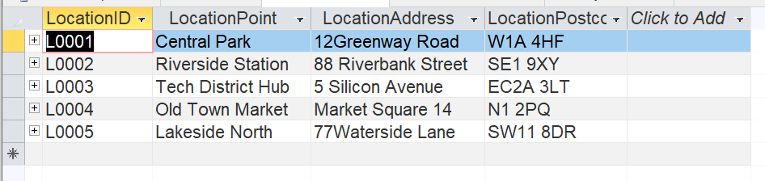
Figure 1.5.3 – Location Table
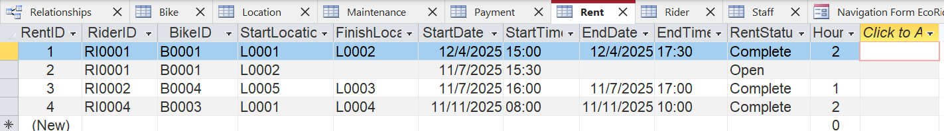
Figure 1.5.4 – Rent Table
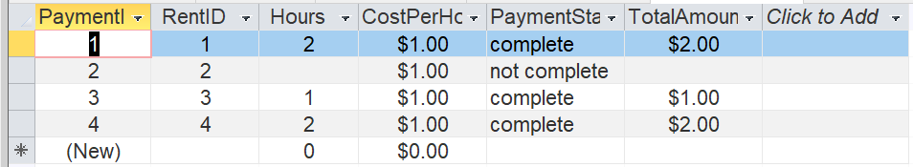
Figure 1.5.5 – Payment Table

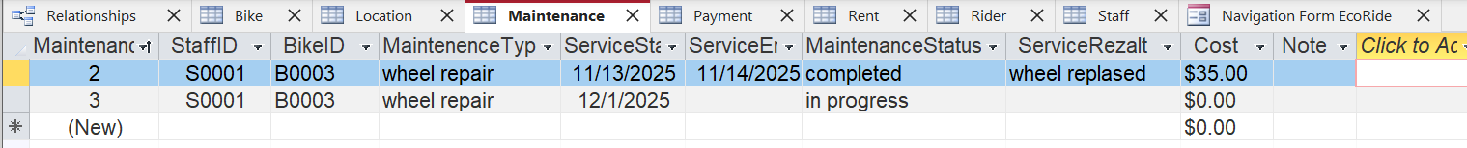
Figure 1.5.6 – Maintenance Table
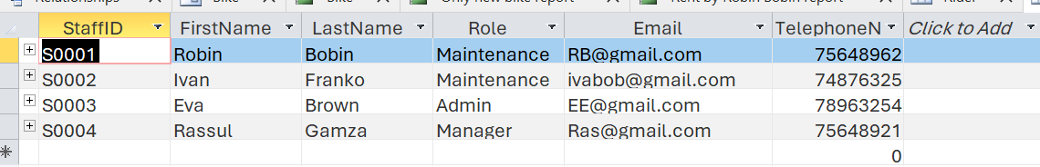
Figure 1.5.7 – Staff Table

1.6 — QUERY DEVELOPMENT
Queries are used in Microsoft Access to find and organise data in the database. They help the user quickly check important information, such as active rentals, payments or bike usage. For the EcoRide system, I created several queries to show how the database can support daily work.
The first query shows a list of riders. This query helps staff quickly see all registered riders with their contact details. It is useful when checking customer information or starting a new rental.
Another query shows rentals completed by a specific rider. In this query, I filtered the Rent table by RiderID (for example, RI0001). This helps the company see how often a rider uses the service and check any past rental history.
I also created a query that shows rental payments. This query makes it easy to check which rentals are paid and which are still pending. It helps the team manage income and avoid missing payments.
These queries demonstrate how the system can support real tasks, such as tracking riders, checking rental records and controlling payments. Queries make the database more practical and easier to use for the EcoRide staff.

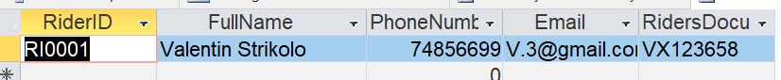
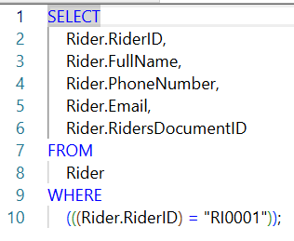
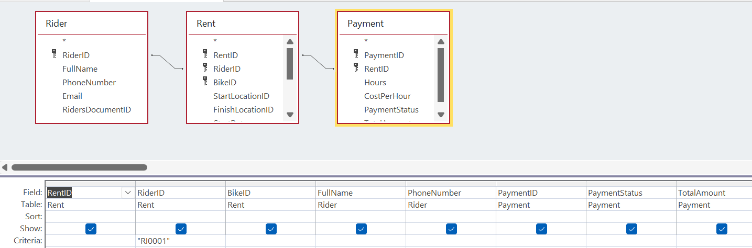
Figure 1.6.1 Rider Query

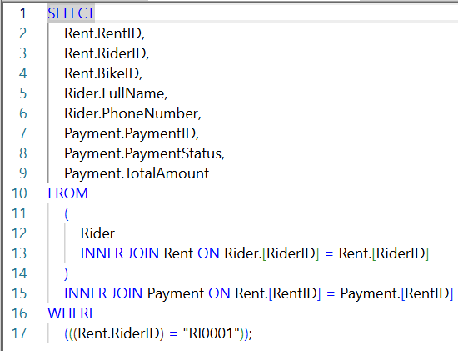
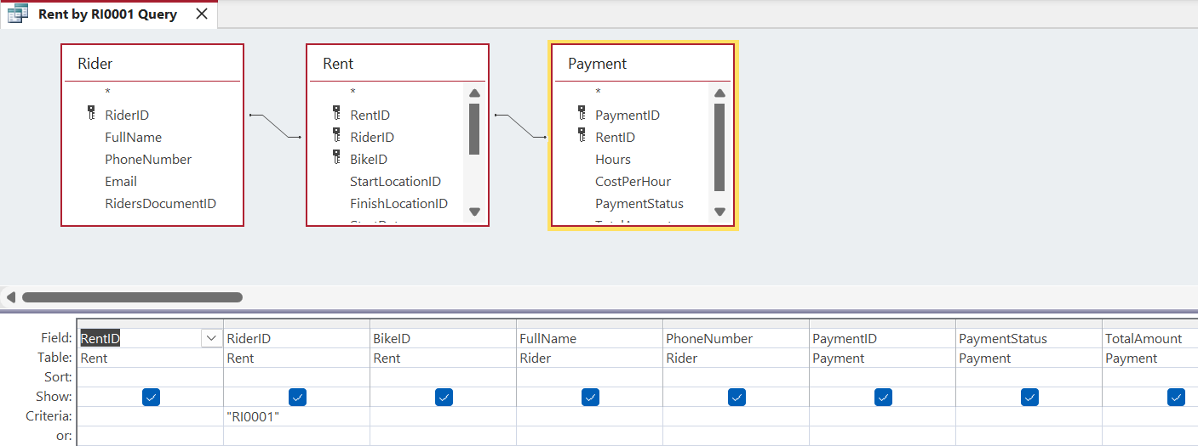
Figure 1.6.2 – Rent by Rider Query

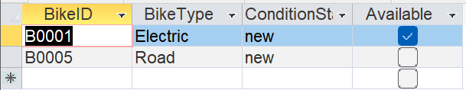
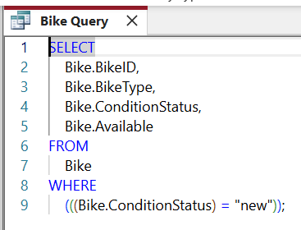
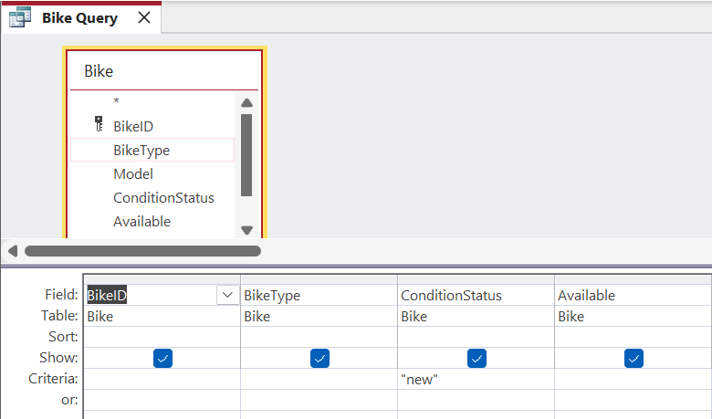
Figure 1.6.3 – Bike Query (Only Bikes with Condition Status = ‘new’)

1.7 — VALIDATION AND TESTING

Test Cases | Expected Results | Actual Results | Any Discrepancies
1. Manage bike inventory | The system should store all bikes with type, condition and availability. | The Bike table was created and populated. All bikes show correct type, condition and availability. | no
2. Record rentals for riders | Each rental should save RiderID, BikeID, start location, finish location, date and hours. | The Rent table correctly stores all rental details linked to Riders, Bikes and Locations. | no
3. Track payments for rentals | Each rental should have one payment with hours, total cost and payment status. | The Payment table stores hours, total cost and status for each RentID. Reports show correct payment information. | no
4. Show only new bikes | A query and report should display only bikes with condition “new”. | The Bike Query and “Only new bike” report show exactly the bikes with ConditionStatus = "new". | no
5. View rentals by a specific rider | A query should filter rentals by RiderID and show only that rider’s history. | The “Rent by RI0001” query and report correctly show only rentals for RiderID RI0001. | No
6. Forms should open and show correct data | Forms should display correct fields from tables and allow data viewing/editing. | Rider, Bike and Rent forms open correctly and show the right fields. | No
7. Navigation Form should work as a dashboard | Dashboard should open forms and reports through buttons. | “Navigation Form EcoRide” opens forms and reports without errors. | No

After creating the database tables, queries and relationships, I tested the EcoRide system to make sure everything works correctly. Testing helps to check if the database gives the right results and if the links between tables are working without errors.
First, I tested Rider Query and Rent by Rider Query. The query for RiderID RI0001 showed the correct rider’s name and the correct rental history. This confirmed that the Foreign Key between Rider and Rent is working as expected. It also showed that the query filters the data correctly.
Next, I created reports based on my queries. The Rent by Rider report showed all rentals made by one rider and included payment status and total amount. This helped me check if the payment information is linked correctly to each rental.
I also tested the Only New Bike report, which showed only bikes with the condition “new”. This confirmed that the filters and conditions in the Bike Query work correctly.
Finally, the Bike report displayed all bikes in the system. It helped to check that all bikes appear in the correct order and that all fields are displayed.
Overall, the testing showed that the database works correctly. The queries return the right results, and the reports are generated without problems. This means the system is ready for use.
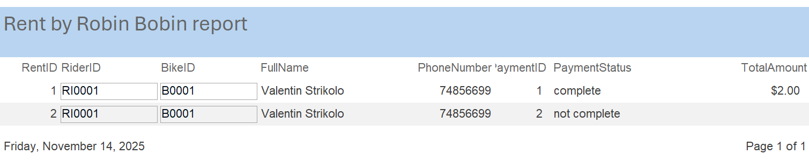
Figure 1.7.1 – Rent by Rider Report
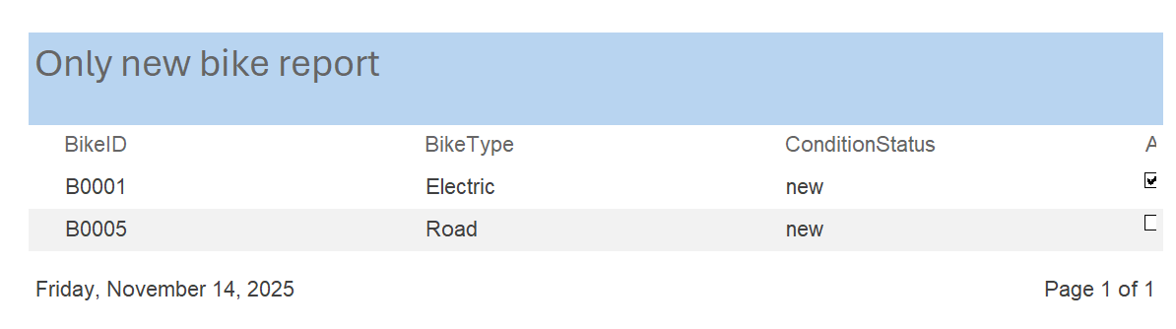
Figure 1.7.2 – Only New Bike Report

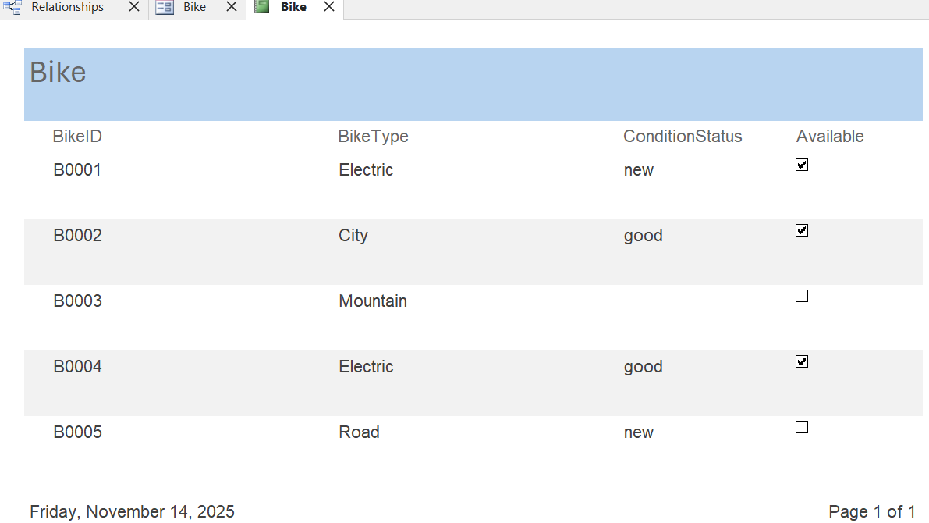
Figure 1.7.3 – Bike Report (All Bikes)

Forms Creation
In Microsoft Access I created separate forms for the main tables, such as Rider, Bike and Rent. These forms help staff enter and edit data more easily, without working directly in the datasheet view. Forms are also safer because they prevent users from changing the wrong fields by mistake.
The Rider Form is used to enter basic rider information such as full name, phone number and email.
The Bike Form helps staff update bike details, including type, condition and availability.
The Rent Form allows the user to record new rentals by choosing a rider, a bike and the start and finish locations.
Each form is based on its related table and shows only the fields needed for daily work. This makes the system easier to use and more organised.

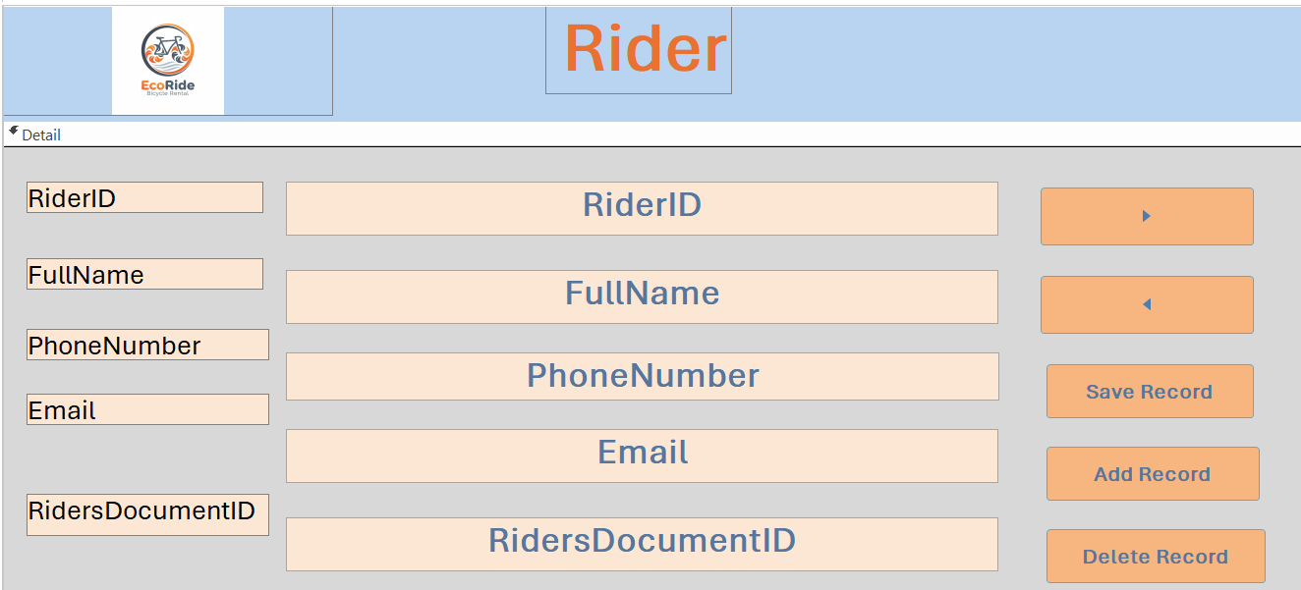
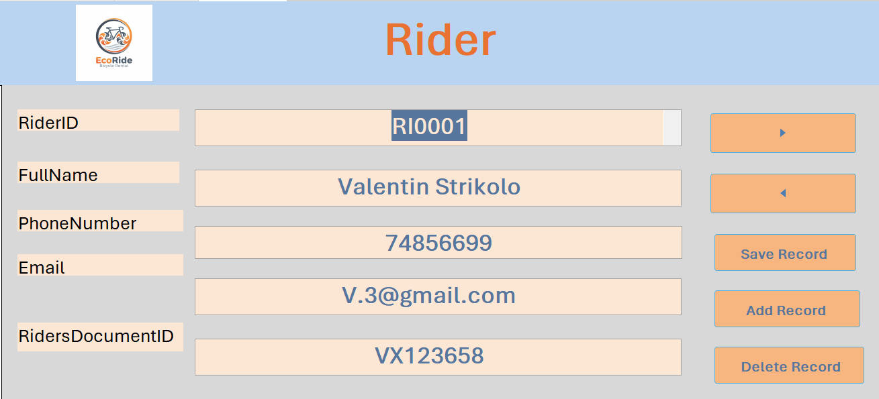

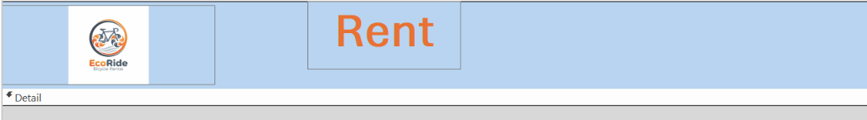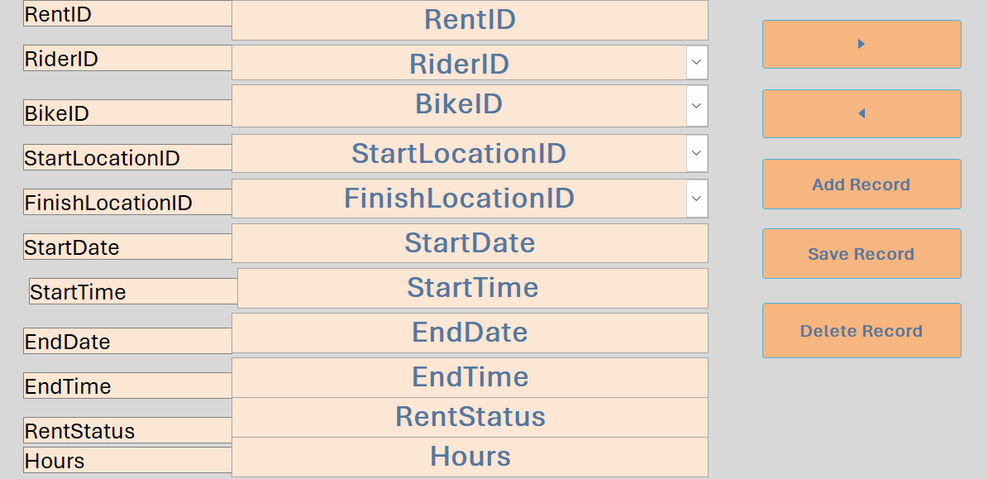
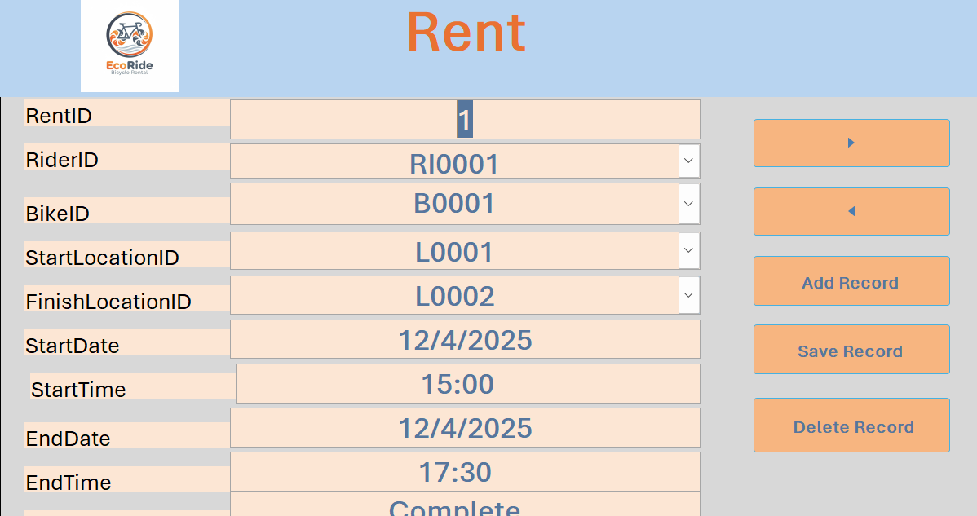

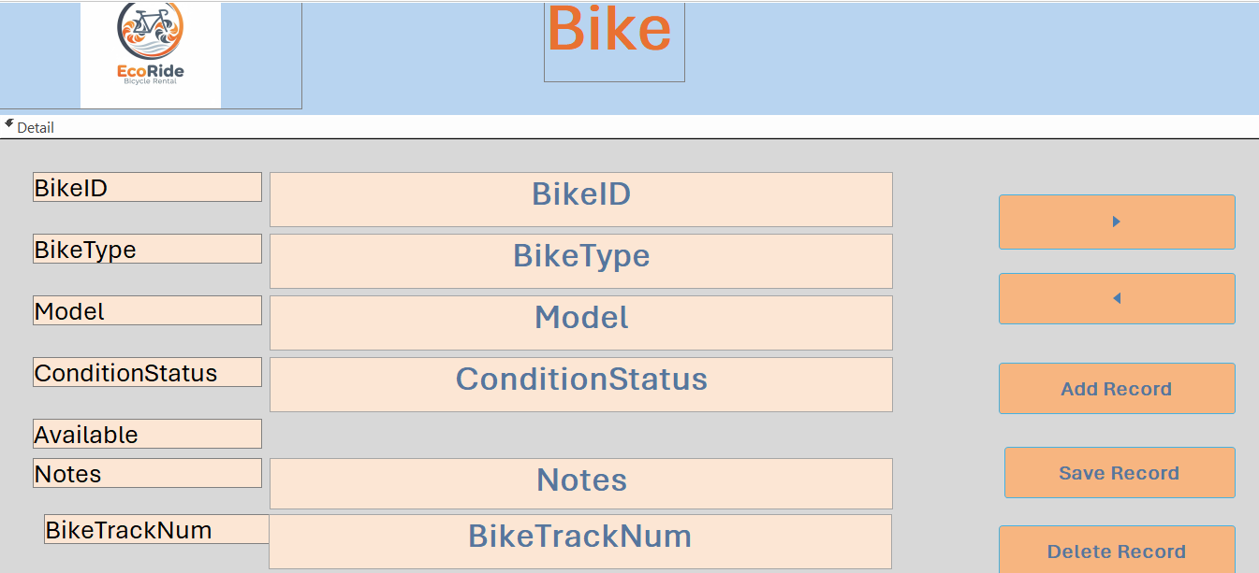
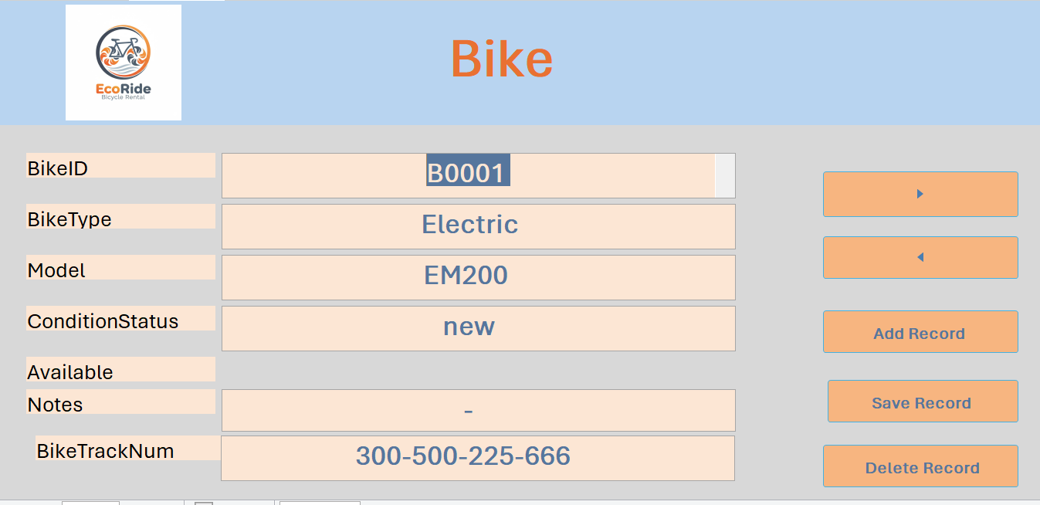

Dashboard Creation
To make the EcoRide system easier to navigate, I created a dashboard using the Navigation Form in Microsoft Access. The dashboard works as the main menu of the database. From this form, the user can open the important forms and reports, such as Rider, Bike, Rent and the rental reports.
This makes the system more user-friendly because staff do not need to search through the Access object list. Instead, they can use clear buttons on one screen to move between different parts of the database. The dashboard makes the system feel more like a real application and helps improve workflow.

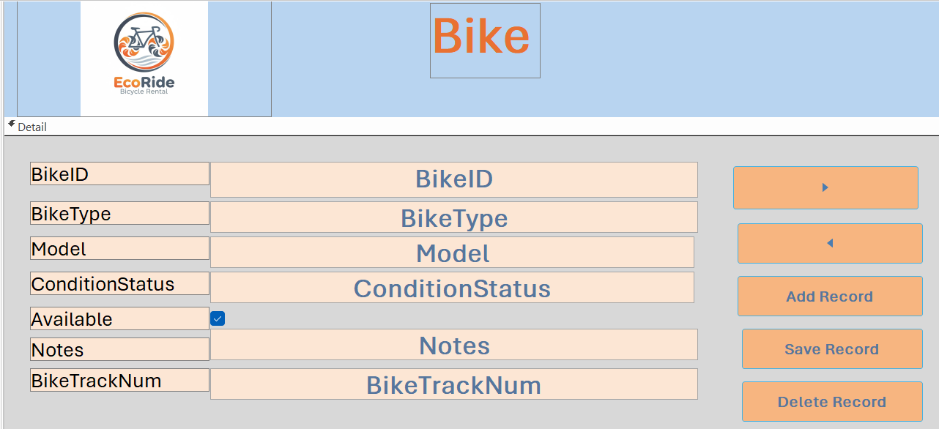
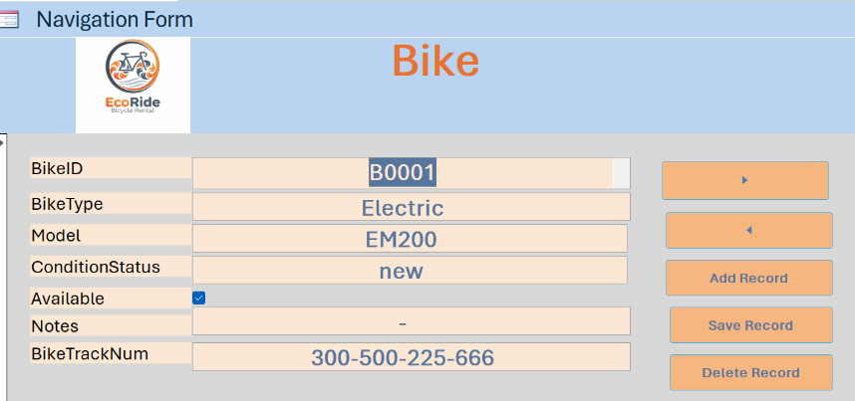

Calculations
The EcoRide database includes a simple calculation inside the Payment table. The field TotalAmount is calculated using the number of rental hours and the cost per hour. This helps the system automatically show how much the rider needs to pay without manual calculation. The formula used in the database is:
TotalAmount = Hours × CostPerHour
This calculation was tested with sample data to make sure the results were correct. Using a calculated field makes the system more accurate and reduces possible mistakes.
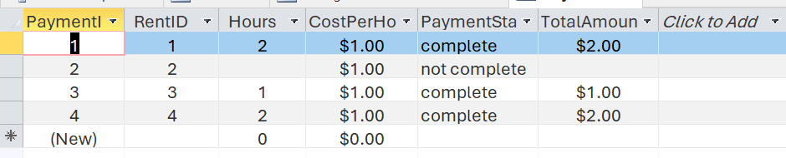
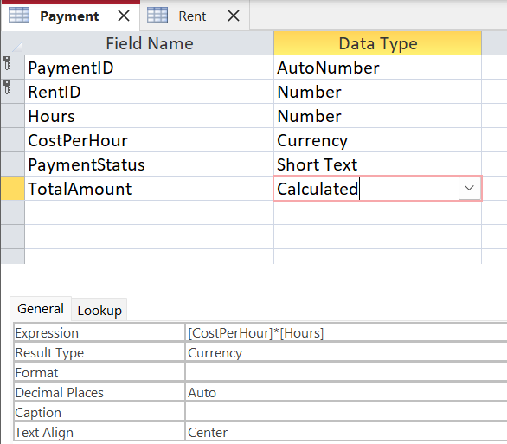

Task 2 - Written Elements

Introduction
EcoRide is a small electric bike rental service that operates in public areas such as parks, train stations and university campuses. The company wants to improve the way it stores information because paper notes and simple spreadsheets often cause mistakes. For example, staff cannot always check bike availability, track maintenance, or see rental history quickly. A relational database can help organise information in a clear, structured and safe way. Relational databases are widely used in businesses because they improve data accuracy and reduce duplication [1].
For EcoRide, a relational model is the best choice because it divides information into separate tables and connects them with keys. This makes the data easier to manage and reduces errors [5]. The EcoRide database includes tables for riders, bikes, rentals, locations, payments and maintenance. These tables together support the entire rental workflow.
This section explains how the database was designed and built in Microsoft Access. It includes scenario analysis, ERD, table design, normalisation, sample data, queries and testing. The final part reflects what was learned during the project.

Design Decisions
The design of the EcoRide database was based on the scenario requirements and the needs of a bike rental company. A relational database structure was chosen because it separates information into tables but still keeps the data connected using Primary Keys and Foreign Keys. This approach supports a clear structure and avoids repeating the same information many times [3].
I decided to create small and focused tables. For example:
- Rider table stores rider details only,
- Bike table stores bike details only,
- Maintenance table stores service information only,
- Rent table connects riders, bikes and locations together.
This follows good design practice and makes the database easier to understand and manage [1].
Field names were kept short and clear to help with queries and reports. I also selected appropriate data types, such as text, number or date/time, to ensure accuracy and consistency.
These design decisions helped create a database that is simple, easy to use and suitable for the daily work of EcoRide. The structure can also be expanded in the future if the company grows.

Reflection
Working on the EcoRide project helped me understand how a real database is designed and how data is connected across different tables. I did not have much experience with Microsoft Access before, but through practice I learned how to create tables, set keys, build queries and design reports. Learning with a real scenario made the process easier to understand [2].
The most difficult part for me was understanding relationships between tables. At first, it was not easy to see how Primary Keys and Foreign Keys work together. After building the ERD and creating relationships in Access, I understood much better how the data flows between Rider, Rent, Bike, Location, Payment and Maintenance tables.
Creating queries helped me see how companies use databases to find specific information. For example, I created a query to show all rentals for one rider, a query to show only new bikes, and a query to show rider details. Reports helped to present the information in a clear and professional way, which is useful for real business situations [6].
Overall, the project improved my understanding of relational databases and gave me useful technical skills. I now feel more confident with tables, relationships, queries and reports.

References
[1] A. Silberschatz, H. Korth, and S. Sudarshan, Database System Concepts, 7th ed. New York: McGraw-Hill, 2019.
[2] Microsoft, “Introduction to Microsoft Access,” Microsoft Learn, 2023. Available: https://learn.microsoft.com
[3] R. Elmasri and S. Navathe, Fundamentals of Database Systems, 7th ed. Boston: Pearson, 2016.
[4] Tutorialspoint, “DBMS – ER Model,” 2023. Available: https://www.tutorialspoint.com/dbms
[5] W3Schools, “SQL Tutorial,” 2024. Available: https://www.w3schools.com/sql
[6] Lucidchart, “What is an ER Diagram?” 2023. Available: https://www.lucidchart.com

