Portfolio
Foreign Languages and Cultural Awareness
BMIH5003
Nicusor Florin Mistode (2246469)
Lecture’s name: Giulia Chifari
Word count: 1610
Table of Content
Introduction 3
Component 1 3
Component 2 4
Component 3 6
Component 4 7
Conclusion 10
References 11

Introduction
Foreign language and cultural awareness are important in the hospitality sector because they help in providing proper services and care to the people (Ho, 2020). An individual with good knowledge of language and culture helps in understanding requirements of people and developing an effective strategy accordingly. The following report is divided into four different components and has provided the required information regarding foreign language and cultural awareness.

Component 1
I was a waiter in a hotel restaurant and during dinner service. A guest from Japan enters a restaurant and sits at one of our tables. As I was approaching the table to take the order, I noticed that a guest seemed to be nervous and reluctant to engage in the conversation. Though I tried every possible method to be attentive and friendly, the guests remained reserved and also did not respond to them enthusiastically. In such a situation cultural differences occur because of differences in the communication style and also social norms between Japanese and Western culture. In Japanese culture, there needs to be a strong emphasis on politeness, and indirect and formal communication (Nazarian et al., 2022).
On the other hand, in Western culture, there is more assertive and direct communication, especially in the customer service setting where the development of rapport and engaging with the guest is the major priority. My friendly nature might be over-familiar and also intrusive to Japanese guests which causes them to feel uncomfortable and withdrawn. For the situation like cultural misunderstanding like this in the future, I recognise the requirement to develop certain behaviours and skills. I need to improve my cultural sensitivity because it will help me in my social interaction and communications or the workshop to learn about the different cultures' norms, values and communication styles. Cultural diversity helps motivate the employees and guests in the restaurant, it helps in understanding and respecting cultural differences and can greatly enhance customer experience. Guest feel much more appreciated and comfortable when their cultural norms and preferences are respected and also acknowledged. Active listening is also one of the important skills which I need to develop because it will help me with my outgoing personality. It will help me pay attention to the nonverbal clues that might indicate discomfort or hesitation, it involves being patient, responsive and emphatic to the requirements and reference of each individual guest (Stoyanova-Bozhkova et al., 2022).
Adaptability skills are important in the approach to customer services, recognising that different guests might have a different expectation and preferences based on their cultural backgrounds. These skills will help in adjusting the communication skills, behaviour and tone to be aligned with the cultural norm and also the preferences of individual guests. Such kind of skills help in dealing with changing circumstances properly because they help in understanding the situation and developing an effective solution. Emotional intelligence is also important because it helps the staff to understand and also emphasises the emotional and cultural background of a customer. It helps in providing personalised and culturally sensitive services and also enhances the dining experience (Kai Liao et al., 2022). Overall, cultural differences create some major problems while dealing with customers in the restaurant business. There are certain skills that which is required to be developed by an individual in order to perform in a much more effective manner.

Component 2
Training plan for cultural competency and emotional intelligence in the hospitality sector.
Training objectives
- To increase the understanding and awareness of cultural diversity and its impact on customer interaction.
- To develop empathy, conflict resolution skills and effective communication skills among the staff members.
- To foster a culture of inclusiveness, teamwork and respect within the workplace.
Components for the training
Cultural awareness and sensitivity training
This training will provide information regarding cultural diversity in the hospitality sector. Understanding the cultural norms and preferences in customs is important in the hospitality sector because it helps in providing better customer service to the guests (Yurur et al., 2021). Further, it will also recognise and challenge cultural biases and stereotypes, which will help in increasing knowledge and skills.
Emotional intelligence training
It is one of the important skills and to develop this skill, I will be getting an introduction to the concept of emotional intelligence and its importance in the hospitality sector. Further, it will also help in developing self-awareness and understanding personal emotions, reactions and triggers. This training will also help in improving communication skills, active listening and nonverbal communication and also expressing empathy. These are some of the important skills which help an individual to perform their communication and understand the requirements of people in the organisation. Further, it will also provide information regarding techniques for managing emotions for handling professional manner and frustration in the workplace.

Conflict resolution and customer service excellence
This training will help in developing knowledge regarding de-escalating conflicts and also resolving issues with customers from diverse cultural backgrounds. In the hospitality business, people from different cultural backgrounds work and visit. In such a situation, it will help in resolving the issues and reducing the chances of a conflict (Sayed et al., 2021). I will also go for assertiveness training which will help in advocating the customer requirements and maintaining professionalism.
The above-mentioned training will be delivered with the help of combined seminars, workshops, online modules and a practical exercise. Workshops will be facilitated by external trainers and specialised in cultural competency and emotional intelligence, supplemented by in-house experts. Training sessions will be conducted in small groups because it will help in reaching and getting proper education and also resolve the queries. The training plan will also include resources and ongoing support, such as reading material, online forums and videos will help reinforce learning and encourage continuous improvements.
Evaluation and feedback
There will be pre-training assessments and post-training assessments which will help to measure the improvements in the attitudes, skills and knowledge (Ghani et al., 2022). There will also be frequent feedback surveys which will help to gather insights regarding the effectiveness of a training program and the areas for future improvement. Further, there will also be regular performance evaluations will be done in order to assess the application of learned skills in real-world situations. Overall, this training plan will help empower the employees in hospitality to embrace cultural diversity, demonstrate emotional intelligence and also deliver exceptional customer service.

Component 3
The Gibbs reflection model is one of the most effective models for reflection because there are 6 different stages (Adeani et al., 2020).
Description: At the initial stage I did not have good information regarding cultural awareness in the hospitality sector. I have found the importance in the sector such as being respected and polite to guests from different backgrounds. I lack a proper understanding regarding the cultural awareness of the guest experience and also the success of a business.
Feeling: I am getting more information regarding critical culture to my practical experience, it has increased my curiosity level and motivated me to gather more information regarding cultural awareness. I realised that cultural awareness is not only about avoiding any kind of offence, it is about creating an inclusive environment and embracing diversity where every individual person is respected and valued.
Evaluation: While understanding the importance of cultural awareness I understand its impact on the overall performance. I came to understand the multifaceted nature of cultural awareness and its implication for the aspect of hospitality from customer services to marketing strategies. I also gather information regarding cultural awareness, which is a fundamental mindset which influences how an individual interacts with each other and conduct business. In some cases during my experience, I was frustrated because I lacked the basic knowledge of cultural awareness which is important for working in the restaurant business because people from different backgrounds visit the organisation.
Analysis: One of the crucial experiences which I got during the understanding regarding cultural awareness was while working in a restaurant with a diverse range of guests. I have encountered different guests from different cultural backgrounds and unique expectations and preferences. With the help of thorough interaction with the guest, i found that active listening and empathy is crucial in understanding the needs and also exceeding their respective expectation.
Conclusion: My journey of self-reflection and exploration has provided me with an understanding of cultural awareness. It is one of the important skills in the hospitality sector, it is not just about the skill, it is a continuous process of adaptation and learning. It requires different attributes, such as humility, openness and willingness to step outside the comfort zone. In the current landscape of the global hospitality industry, cultural awareness is crucial for the success of organisations. Overall, it has provided me with a deeper understanding of the cultural awareness importance in the hospitality sector.
Action Plan: After the whole analysis I found that I need to develop someone my knowledge regarding cultural awareness and ongoing training and education. I will always seek an opportunity to engage with an individual from diverse cultural backgrounds and also learn from different perspectives. Further, I will also receive constructive feedback from my colleagues, which will help me in developing or improving my cultural awareness within the organisation and promoting initiatives which foster diversity and inclusivity.

Component 4

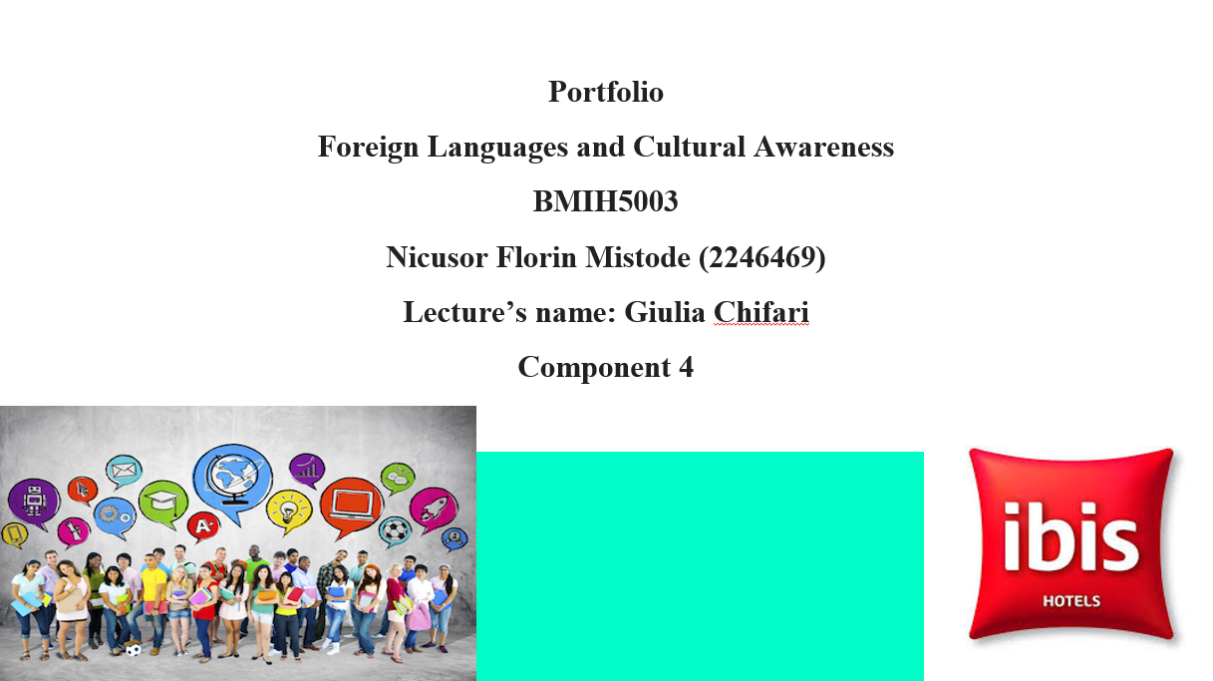
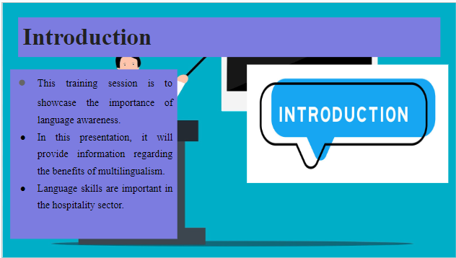
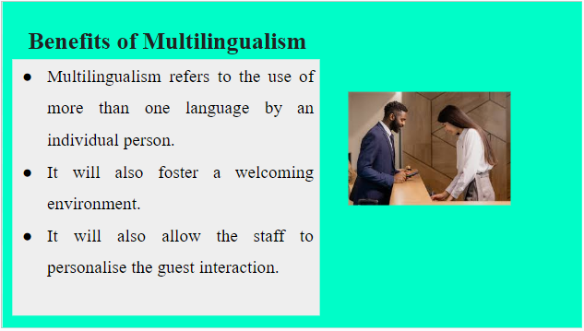
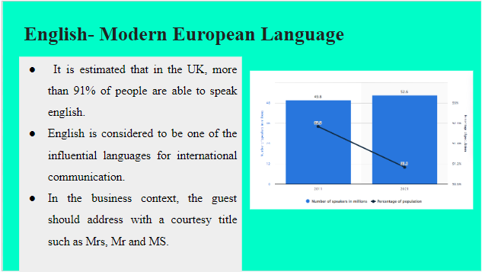
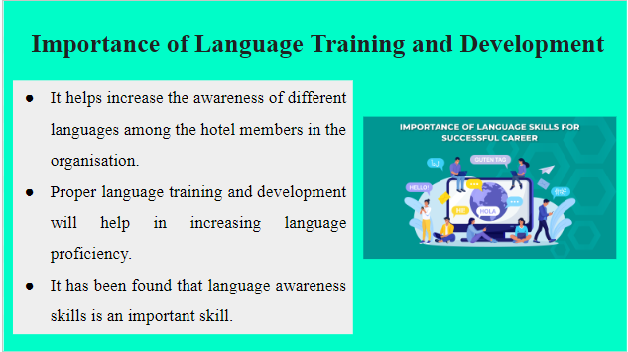
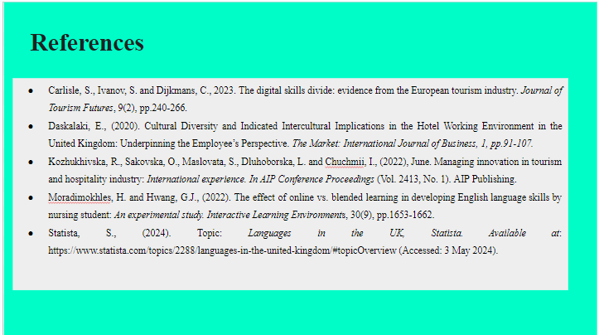

Conclusion
The above report has provided important information regarding foreign language and cultural awareness. In the hospitality sector, people from different places gather or visit the hotel or restaurant. In such a situation having a good knowledge of language and culture helps in improving cultural awareness. Staff can communicate in their native language with the customer which helps in developing brand name and also maintain customer loyalty.

Component 1 References

Kai Liao, Y., Wu, W.Y., Dao, T.C. and Ngoc Luu, T.M., 2021. The influence of emotional intelligence and cultural adaptability on cross-cultural adjustment and performance with the mediating effect of cross-cultural competence: A study of expatriates in Taiwan. Sustainability, 13(6), p.3374.

Nazarian, A., Zaeri, E., Foroudi, P., Afrouzi, A.R. and Atkinson, P., 2022. Cultural perceptions of ethical leadership and its effect on intention to leave in the independent hotel industry. International Journal of Contemporary Hospitality Management, 34(1), pp.430-455.

Stoyanova-Bozhkova, S., Paskova, T. and Buhalis, D., (2022). Emotional intelligence: a competitive advantage for tourism and hospitality managers. Tourism Recreation Research, 47(4), pp.359-371.

Component 2 References

Ghani, B., Zada, M., Memon, K.R., Ullah, R., Khattak, A., Han, H., Ariza-Montes, A. and Araya-Castillo, L., (2022). Challenges and strategies for employee retention in the hospitality industry: A review. Sustainability, 14(5), p.2885.

Sayed, Z., Proches, C.N.G. and Sayed, Z., (2021). Exploring the Role of Emotional Intelligence in the Customer Service Industry. Gender and Behaviour, 19(1), pp.17676-17695.

Yurur, S., Koc, E., Taskin, C. and Boz, H., (2021). Factors influencing intercultural sensitivity of hospitality employees. International journal of hospitality & tourism administration, 22(1), pp.26-44.

Component 3 References

Adeani, I.S., Febriani, R.B. and Syafryadin, S., (2020). Using GIBBS’reflective cycle in making reflections of literary analysis. Indonesian EFL Journal, 6(2), pp.139-148.

Ho, Y.Y.C., (2020). Communicative language teaching and English as a foreign language undergraduates’ communicative competence in Tourism English. Journal of Hospitality, Leisure, Sport & Tourism Education, 27, p.100271.

Kozhukhіvska, R., Sakovska, О., Maslovata, S., Dluhoborskа, L. and Chuchmii, I., (2022), June. Managing innovation in tourism and hospitality industry: International experience. In AIP Conference Proceedings (Vol. 2413, No. 1). AIP Publishing.

