Name: Lewis Duggan
Module- Critical Review
Module Code- ADFM6001
Assignment Title: Your Exit Strategy: Personal Promotion Material

Starting my business card wasn’t easy. The unlimted designs, options, colour styles, fonts and patterns got me at a loss. So instantly I began some research into looking what types would be great for an eye catching and appealing yet professionl look for my business card.
Once under going my research I managed to find 7 important tips for creating a business card. These will help me gain a reference into what I am hoping to achieve. The 7 tips given are listed below:
- Finding a template which reflects my brand/ my personality.
The aim is to find a design and colour code which symbolsies me and what I represent. So I chose 3 base colours to work with which were Red, black and white. Quickly after choosing the colours I began to look into different designs. I found that straight lines and sharper deisgns tend ot look cleaner on business cards and catches the attentiion of employeers more often. It looks more profressional whilst curves and circles tend to look more fun or flambouant.

- Finding the right type face.
This represents the type of font and size of font I am going to use. Ensuring the type of font andsize used is in sync and compliments the design face of the business card. Otherwise, in conclusion it will look messy and unorganised. Eris Bold ITC was the font I decided to use with a font size of 8pt.
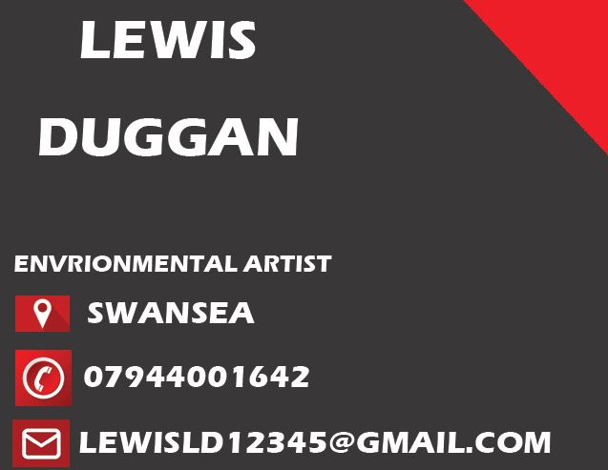
- Settle on a size and shape
The size being used was mentioned In the brief of this assigment. Therefore I qill be using 91mm x 61mm.
- Organise my information
I needed to make sure that I had every contact detial necessary for employeers to contact me. Whether this is via email or phone number along with a link to my showreel to present the work I have doen and can do.
- Do double duty
Double duty means to make my business card twice. Busniess cards will work hard for myself and my business therefore having a back side to show a piece of work I have done perhaps or use loyalty stamps. My logo or even leave it blank. Having a double sided buiness card makes the visuals clean and fluent. The back has exactly the same design as the front of the card.
- Leave some white space
Leaving white space on the business card makes sure that to viewer sees the important bits first. Fore xample my logo and contact details. If the business card is too crowded or dense it will be hard for the viewer to track their way around the card.
- Proof read
I need to proof read and look over my final product for the business card o make sure its upto indsurty market standard.

Final Business card Design- Front and Back


Link to Showreel
https://youtu.be/MhanDBhIUmY
Ctrl + Left Click
Bibliography
Vistaprint Ideas and Advice US. 2022. What makes a good business card? 10 golden rules. [online] Available at: <https://www.vistaprint.com/hub/business-card-design-rules> [Accessed 16 May 2022].
https://www.digitalartsonline.co.uk/features/creative-software/how-create-perfect-3d-vfx-or-games-art-showreel/. 2022. How to create the perfect 3D, VFX or games art showreel. [online] Available at: <https://www.digitalartsonline.co.uk/features/creative-software/how-create-perfect-3d-vfx-or-games-art-showreel/> [Accessed 16 May 2022].
May, T., 2022. Eight things everyone should do when creating a motion design showreel. [online] Creative Boom. Available at: <https://www.creativeboom.com/tips/8-hot-tips-for-creating-a-motion-design-showreel/> [Accessed 16 May 2022].
Sagar, J., 2022. 15 pro tips for crafting the perfect showreel. [online] Creative Bloq. Available at: <https://www.creativebloq.com/advice/15-pro-tips-for-crafting-the-perfect-showreel> [Accessed 16 May 2022].
Ellis, M., 2022. How to Design a Business Card: The Ultimate Guide. [online] 99designs. Available at: <https://99designs.co.uk/blog/logo-branding/how-to-design-business-card/> [Accessed 16 May 2022].
Hampton-Smith, S., 2022. How to design a business card: 7 top tips. [online] Creative Bloq. Available at: <https://www.creativebloq.com/graphic-design/how-design-business-card-10-top-tips-9134291> [Accessed 16 May 2022].

