Final organisational Consultancy report for Clyne Farm Centre

By Elise Lewis P150274

University of Wales Trinity Saint David
International Travel and Tourism Management


Lecturer: Michael Davies and Suzanne Wells

Client details:

Geoff Hayden Owner/Manager

Email: hello@clynefarm.com

01792 40333

Table of Content:

Page 3
Page 4
Page 5
Page 5
Page 6
Page 6
Page 6-8
Page 9
Page 9
Page 10-13
Page 10
Page 12
Page 12
Page 13
Page 13
Page 14-23
Page 23-24
Page 24-25
Page 24
Page 25
Page 25-26
Page 26-27
Page 27
Page 27-28
Page 28-29
Page 29
Page 30-32
Page 33

- Acknowledgements
- Executive summary
- Introduction
- Rationale
- Terms of Reference
- Objectives
- Research methodology
- Piloting
- Issue log
- Research findings
  - Secondary research findings
  - Green Farm Riding School
  - Goldenberg Stud Riding Centre
  - Dinefwr Riding School
  - Pembrey Riding Centre
- Primary Research Findings
  - Primary Research Questionnaire
- Interview questions
- Discussion and analysis using key themes
  - Weather dependant
  - Distance
  - Work
  - Social media
  - Price
- Evaluation
- Conclusion
- Recommendations
- Appendices
- Reference list

List of tables and figures

Figure 1 Page 15
Figure 2 Page 16
Figure 3 Page 17
Figure 4 Page 18
Figure 5 Page 19
Figure 6 Page 20
Figure 7 Page 21
Figure 8 Page 22

- Acknowledgements:
The consultant would like to give a great thank you to Clyne Farm Centre who helped with this consultancy project, giving up time and continuous efforts to give advice throughout. The consultant is also very appreciative to the customers at Clyne Farm who responded to the questionnaire and Geoff Hayden who took the time to help with completing the questionnaire and getting a number of quality responses needed. Without the help from these individuals this project wouldn’t be able to be completed. Also, a big thank you to the lecturers Mike Davies and Suzanne Wells for giving guidance throughout the project to enable the best possible outcome.

- Executive summary:
To summarise, Clyne Farm is a successful riding and activity centre with excellent facilities and great staff. Having celebrated its 30th anniversary this year, provides great opportunity to attract new customers to this established centre. This will be achieved through successful or affective changes to online marketing tools currently utilized by Clyne Farm (Instagram, Facebook, Twitter) As well as creating a social media presence on other new social media platforms (YouTube). The consultant believes these changes will be effective in attracting young families to the business during both the mid-week and weekends.

Another target for a new customer base could be directed towards local universities who currently use a competitor riding school who is much further away. This could provide a new revenue stream from the Universities riding schools. While looking at the option of an indoor riding facility, it is believed it would be affective in attracting new customers as participation is weather dependant. However, other cost-effective tactics could be employed more cost effectively.

The report finds and recommends that social media platforms like YouTube should be added to increase online following, resulting in increased customer numbers and improved brand value.

- Introduction:
This is a final report for an organisational consultancy on Clyne Farm Riding School. The consultant and client agreed that the report should focus on boosting visitor numbers during mid-week and targeting mainly families. As discussed between the consultant and client, Clyne Farm has been recently adapted for families over the years by adding new accommodation to draw families in, which is why families were also agreed as a target market. This report will present clear aims and objectives which were present from the commencement of the project and primary research methods which were carried out to gather data. The consultancy is to overcome the problem of less visitor numbers during midweek at Clyne Farm and to try and get similar numbers both midweek and on the weekends. The information was collected using both secondary and primary research.

- Rationale:
The client believed this project was relevant because improving the visitor numbers midweek, as well as weekends will increase revenue and add new members to the riding school. The consultant and client discussed that marketing towards families would be the best option, because this market segment has the greatest potential for growth.
The consultant has now acknowledged why Clyne Farm are not getting the customer numbers during mid-week in comparison to weekends and will use the marketing strategy to bring in similar numbers as weekends during mid-week. The client wants to attract 8 or 9 people a day during mid-week at the moment they are only attracting 4. The consultant believes a successful marketing strategy could double this number. Clyne Farm has been adapted over the years to accommodate more families, this is a main reason why Geoff (Owner) wants the consultant to target the market strategy towards families. The accommodation at Clyne Farm has been updated to facilitate and market towards families. The consultant has now carried out significant research primary and secondary agreed by the client.

- Terms of reference:
This final consultancy report is written for Clyne Farm Centre and University of Wales Trinity Saint David completed by International Travel and Tourism student Elise Lewis, who herself has a passion for horse riding since a young age and as well as riding school tutor in Texas, USA in 2017.
The overall aim of this project is to critically review and identify a potential marketing strategy to improve the visitor numbers during mid-week, focusing on the riding school at Clyne Farm centre. The consultant and client (Geoff Hayden) agreed on a marketing strategy to boost visitor numbers at the riding school instead of other areas of the centre (activities, accommodation) because the riding school is where the business makes the least profit and the client generally wants to boost riding school visitor numbers.

- Objectives:
These are the SMART objectives that were set to achieve the overall aim of the project:
- Evaluate the effectiveness of Clyne Farms current marketing platforms, looking at the strengths and weaknesses. (Facebook, Instagram and Website)
- To identify marketing strategies other riding schools are using in the area.
- To increase its visitor numbers to 8/9 a week from just 4 and revenue
- Provide recommendations on how to improve Clyne Farms marketing techniques, business dimension and make them more effective in attracting families.

- Research methodology:
(Saunders, 2009) defines research as something that people undertake in order to find out something in a systematic way, thereby increasing the knowledge of an individual. According to theorist (O’gorman, 2015) research is essentially about the production of new knowledge.
The consultant’s philosophical approach is interpretivism because of interpreting the questionnaires and interviews to gather data. An inductive approach of research methods has now been carried out by the consultant collecting data that is relevant to the marketing strategy. The consultant has used a mixed method approach of primary research methods throughout this project including interviews and questionnaires. The consultant decided on using a mixed method approach to look for different patterns in data, the consultant will be using a questionnaire to reach a larger sample of people to see if families will attend the riding school during mid-week and to see what times they will attend. The consultant decided on a mixed methods approach to develop a better understanding into the issue Clyne Farm is having to attract the same amount of visitor’s mid-week as weekends.

This project will look at a range of secondary and primary research, with qualitative and quantitative data to receive a large amount of data to analyse. Qualitative research usually uses words than numbers when collecting and analysing the data (Bell et al., n.d.) There are many steps of qualitative research, the first step includes the general research questions, As stated in the project initiation document the consultant was going to interview 2 members of staff, but this has now changed due to (Sarah Hayden) unable to attend the interview. The consultant carried out the questionnaire before the interview with the client (Geoff Hayden) to ensure suitable questions were asked referring to the questionnaire responses. The consultant also made sure the questions were relevant to the topic, which is attracting families to Clyne Farm during midweek. Also, the questions needed to relate back to the riding school at all times and no other activities which are on site, to ensure there were relevant answers to analyse.

Theorist (Miles 1979) describes quantitative data as an attractive nuisance. Because of the attractiveness of its richness but the difficulty of finding analytic paths through that richness (Bell et al., n.d.). The consultant is using both qualitative and quantitative research to be able to analyse enough data for the project. An advantage of using a multi-methods approach is that it enables triangulation to take place (Saunders, 2003). The consultant felt using the multi-method approach in the same project because the consultant would be able to get responses from Clyne Farms customers and the owner to compare responses. Giving more confidence when analysing results and by interviewing a manager important issues could be addressed.

Primary research is original data collected first hand for a specific research goal. However, secondary research is found in books, journals and the internet. For this project a use of both primary and secondary research has been used to analyse enough data for the project. The project initiation document states that the questionnaires will be sent via email and social media sites to gather as many responses for the project. But the consultant changed this to get more results from current customers attending the centre. The consultant has used a range of secondary research for example, looking at other riding schools in the area and comparing marketing techniques and pricing. The customers that took part in the questionnaire were visitors to Clyne Farm who were there on the days the consultant was at the farm and customers who had been there in the past who now work at Turtle Bay.

The consultant decided to get a mixture of responses to see if there would be a variety of responses which were able to be compared.
The secondary research was carried out using a range of secondary research such as newspaper articles and the internet. The secondary research will be looking at if Clyne Farm’s current marketing platforms are successful giving recommendations on how to improve where needs and comparing Clyne Farm’s marketing technique to other riding schools in the area.

The primary research was carried out by the consultant after receiving project initiation document on the 8th April 2019 until 7th May 2019. There were two types of primary research approaches conducted including a questionnaire created (survey monkey) and interview. The questionnaire was taken to Clyne Farm and customers were asked to answer the questionnaire on a tablet, through the survey monkey application to get accurate results from people who have attended the business. For the second part, an interview was carried out with the owner Geoff Hayden at Clyne Farm.

- Piloting:
(Saunders 2009) describes the purpose of pilot testing Is to refine the questionnaire so that respondents will have no problem answering the questions which will result in data easy enough to record. Before, taking the questionnaire to the business, the consultant gave four samples out to people to answer to check if the questionnaire was ideal to use with the customers, the questionnaire lasted the five-minute time frame and if they could give any advice on how to improve it. The consultant received advice from all four people who sampled the questionnaire, the first person added that there should be a question “Overall, how would you rate Clyne Farm” they believed that this question should be added to see if customers are generally enjoying Clyne Farm and a comment box included to see if there were any issues with their experience which could be reported back to the client (Geoff Hayden). This type of question is where customers will give their honest opinion which the consultant is why was told to add this to the questionnaire.
The consultant decided on carrying out the primary research at Clyne Farm to get reliable results from current customers that were there, rather than people in Swansea City centre who had never head of Clyne Farm before. Having these respondents take part in the questionnaire will show the client if current customers are enjoying their experience, outlining any improvements that need to be made.

- Issue log:
The consultant was hoping to get more responses for the questionnaire but due to a limited number of customers at Clyne Farm was only able to get 18 responses at Clyne Farm, resulting in asking members of staff Turtle Bay Swansea if they had visited Clyne Farm before, this resulted in 2 response from the questionnaire coming from past customers. As previously outlined in the project initiation document, it states that the consultant organised interviews with two members of Clyne Farm Geoff Hayden (Owner/manager) and Sarah Hayden (Manager) but due to circumstances the consultant was only able to interview Geoff.

- Research Findings:
  - Secondary research findings:
- Evaluating the effectiveness of Clyne Farms current marketing platforms, looking at the strengths and weaknesses. (Facebook, Instagram and Website)

Theorists (O'Gorman and MacIntosh, 2015) define secondary data as data that is already out there for a researcher to collect and analyse.
As mentioned in the objectives the consultant decided on carrying out secondary research as part of this project to evaluate the effectiveness of Clyne Farm’s current marketing platforms, focusing on the strengths and weakness. This is to enable the consultant to give recommendations, on how the client can improve the marking of the business and if the marketing is consistent enough.

With social media on the increase worldwide every year it is an important marketing technique for many businesses, which is why it is important to get right. According to (Virtanen, Björk and Sjöström, 2017) social media is becoming an integral part of people’s everyday lives, sharing information and communicating, it has completely transformed consumer behaviour, which is why it is an important development companies need to respond to.

Clyne Farm has its own website, Facebook page and twitter. As researched the consultant believes the most effective marketing campaign Clyne Farm use is Instagram with a number of images, videos and competitions used to encourage people to visit. However, there could be more images of the horse-riding taking place and unicorn days to intrigue people. It is important to keep up to date and active with marketing on Instagram because many businesses have found incorporating Instagram into a marketing strategy is a must. Clyne Farm uses a variety of images on Instagram of accommodation, horse riding and activity photos although this may encourage some people to visit it could overwhelm others. Which is why the consultant thinks an Instagram page solely dedicated to the riding school, would be a good option to promote, it also may help Clyne Farm to be found on searches on Instagram if it is named Clyne Farm Riding School, because tourists visiting the Swansea area may be looking for riding schools in the area, and if they search riding schools into Instagram it is more likely to come up. Whereas, the current account is called Clyne Farm Centre which is the business name, may make it more difficult to promote to customers that it is a riding school in a quick search. The consultant found from the secondary research that, the Instagram account is active but not active enough. There are images posted every two weeks with the use of hashtags, but there could be more use of stories to attract their followers, showing any activities going on that day, as Instagram followers are usually more likely to look at stories, as its quicker than looking at their Instagram feed where there may be thousands of posts from different businesses in the area.

Clyne Farm is advertised on the Visit Swansea Bay website which is a good promotion technique and strength as it’s the official provider for tourist information for Swansea, which is a use of marketing campaign tourists will look at before heading to Swansea for a holiday. Although, from secondary research the consultant has found that this marketing campaign doesn’t include any information about Clyne Farm being a riding school, even though it does include specific information about the accommodation and activities (Challenge Valley).

Secondary research has found that Clyne Farm is most active on Facebook and has the most following on this platform was 2,617 likes compared to the Instagram page only having 1,020 followers. Although both the Facebook page and Instagram post the same information. A strength shown from the Facebook page is that any events taking place at the farm are advertised for example, on May 27th, 2019 there is an introduction to indoor climbing and archery, which could boost visitor numbers. Also, through Facebook Clyne Farm have many positive reviews from past customers, when tourists are looking at visiting an attraction, the reviews of the business will be looked at first, which is why it is important for any business to keep up with positive reviews.

With YouTube on the rise and being the second most popular search engine on google “Almost 5 billion videos are watched on YouTube every single day” (Merch,2019) this source of marketing is all about videos and video marketing is the current rage. Clyne Farm currently don’t use YouTube to market any of the business, the consultant spoke with the client about introducing YouTube to show videos of the riding school and the activities that take place (Unicorn days) to attract viewers.

A YouTube channel is free, promotions can also be added to YouTube videos to drive further traffic and boost sales.

- To identify marketing strategies other riding schools are using in the area.
  - Green Farm:
Green Farm riding stables are also located in Swansea, but the difference with this riding school compared to Clyne Farm is that it’s only a riding school whereas Clyne Farm is a centre which includes accommodation and other activities to take part in. With similarities to Clyne Farm, Green Farm has a pony club which is especially for children, but only takes place at Green Farm on a Saturday afternoon. If Clyne Farm were to schedule their pony club on weekdays too this could encourage customers to attend after school. Green Farm also have horse riding lessons, pony trekking and birthday parties available to customers. However, Green Farm has an advantage because they have horse riding available for the disabled.
After searching numerous times Green Farm don’t have an official Instagram account or Facebook page marketing their business, which means they only target people who look online at websites. Comparing to Clyne Farm who use Facebook, Instagram, website and twitter to promote.

  - Goldenberg Stud:
Goldenberg Stud and Livery/Riding yard which is located in the Gower, Swansea. This is the nearest riding school to Clyne Farm currently, this riding school also offer lessons. The difference with this is that the centre solely focuses on horse riding and doesn’t have accommodation facilities, which is an advantage for Clyne Farm because customers are also able to stay on site if they were visiting for the weekend. An advantage of Goldenberg centre is that it has an indoor riding school which allows customers to visit regardless of the weather. Despite Goldenberg having superior riding infrastructure the business fails to attract as many customers, as it does not optimise the efficiency of marketing on social media as successfully as Clyne Farm.

  - Dinefwr Riding Centre:
Swansea University have its very own Equestrian Club open to students, they choose to ride at Dinefwr Riding Centre in Ammanford Carmarthenshire, when Clyne Farm is a 5-minute drive from Singleton campus. This centre is also a family run business, Clyne Farm could look at attracting students as well as families during the midweek, and how to market towards this type of audience instead of the universities using a riding centre which is located a far distance compared to Clyne Farm. The consultant believes this riding centre would be a competitor if it is attracting students from the university which is close by. Dinefwr riding centre also use a website and Facebook to advertise but are not as active as Clyne Farm. This would also cut costs for students travelling to Carmarthenshire for Equestrian lessons when they can take place at Clyne Farm on the Universities door step and could increase demand getting more students to join the Equestrian Club.

  - Pembrey Park Riding Centre:
This riding centre is also family run, located in Carmarthenshire near Llanelli. Looking at the pricing for this riding centre and comparing it to Clyne Farm riding school, this riding centre is cheaper in comparison for a 1-hour riding lesson being £30 compared to Clyne Farm which Is £32. This riding school is the most similar to Clyne Farm because it is an outdoor riding school and it also offers hacks, 1-1 private riding lessons. This riding centre also advertises using a website and social media (Instagram and Facebook). Pembrey Park has more likes on Facebook 4,974 compared to Clyne Farm only having 2,617. This consultant believes Pembrey Park has more likes on Facebook because of being more active and interacting more with customers on posts. For example, a post on 5th May showed a young boy winning a rosette after passing a test at the riding school. Clyne Farm could do this to interact with customers more. The two riding schools are also similar because riders are able to ride along the beach at both riding schools which can be a strong selling point for people in the area or tourists coming into Swansea. With these similarities, Clyne Farm’s marketing could be improved to compete with Pembrey Riding Centre.

When speaking to Geoff he pointed out that 3 of his main competitors have recently closed down. This is due to falling demand amongst younger riders due to the growing influence of technology such as gaming consoles. The amount of time eaten up by gaming leaves less time for children and young people practising sport and outdoor activities. This is why Clyne Farm needs to embrace social media platforms as this is where their target audience is.

- Primary Research Findings:
According to (Saunders, 2009) a questionnaire is one of the most widely used survey data collection, this is because each respondent is asked to respondent to the same set of questions, it is an efficient way of collecting responses from a large sample. For the primary research findings at Clyne Farm the consultant managed to gather 20 respondents who were happy to answer the questionnaire, the consultant spend 2 full days at Clyne Farm during the Easter period, 1 day being a bank holiday Monday because this is when the centre is busy during holidays, the consultant had a 5 minute questionnaire on a tablet with the use of an app (Survey Monkey), on the app there is an option to switch to kiosk mode which enables the customers to answer the questionnaire on the tablet the same way as they would if there was a link attached online, the customers made sure to build a rapport with the customers, thanking them for their time and patience. The consultant felt this was the most effective way to get accurate results from people who have attended Clyne Farm centre rather than people who have never been to the site. The client wanted to receive a truthful response from the questionnaire.

  - Primary research Questionnaire:
- How often do you visit Clyne Farm riding school?
Please tick the appropriate response on how often you have visited this
riding school/centre?
Figure 1.
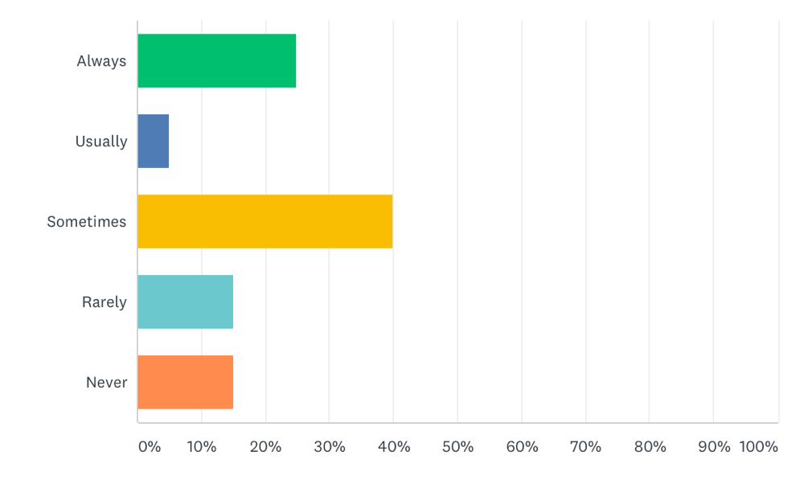
- Always (Only riding school they attend)
- Usually (Once every month)
- Sometimes (Once every 1-2 months)
- Rarely (Once a year)
- Never (Not attended the riding school before)
Question 1 aims to find out how often or if it’s the customers are first time attending the riding school, this question will show if customers tend to come back to the business. The highest percentage of answers for this questionnaire was sometimes with 40%, next being always with 25%, rarely and never at the same percentage of 15% and usually at 5%. From the results it shows that customers will visit Clyne Farm when they are free. The results show that customers generally do attend Clyne Farm and tend to attract more existing customers rather than new. Which is the reason the consultant and client agreed on creating a marketing strategy, to promote the business to a different type of customer or tourists visiting the Swansea area. The consultant felt this was a good opening question to see if guests regularly visit Clyne Farm or if it was their first time.

- What attracted you to Clyne Farm?
Please circle the appropriate response on how you found out about Clyne Farm for example for social media if you heard through Facebook

Figure 2.
or Instagram.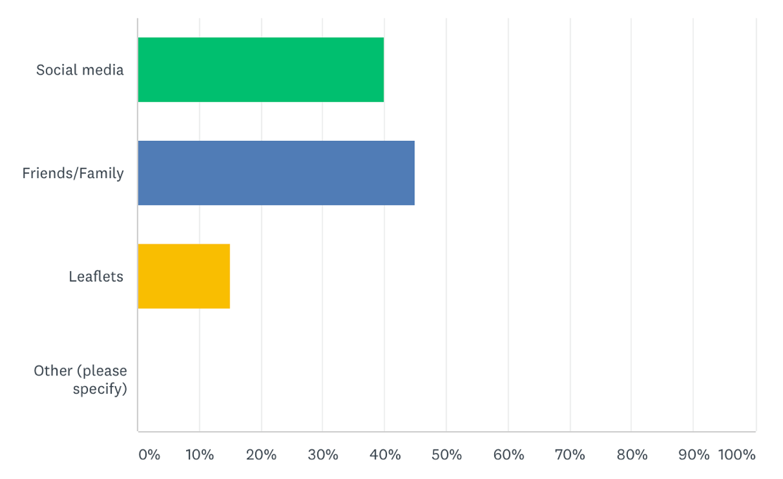
- Social media (Facebook, Instagram, Twitter)
- Friends/Family
- Leaflets
- Other (Please specify) For example, Clyne Farm official website
The aim for question 2 was to find out how the customer heard about Clyne Farm and if the marketing platforms already put in place (Facebook, Instagram and website) were working. This question was also set to help with the marketing strategy for this consultancy project, to see if customers use more of social media or original marketing campaigns the Clyne Farm leaflets. Which will help focus on what marketing techniques can improve on and use more of in the business. The answers for question two clearly show that people have found out about Clyne Farm through word of mouth (friends/family) 45%, social media 40% and leaflets 15%. From these results it still shows that the farms social media campaigns are working to an extent (Facebook, Instagram, Twitter) but more may have to be used, and different types to grab more people’s attention especially when attracting new visitors. Most of the customers answers found out about this business through family/friends. Some of the customers that were spoken to at the farm explained that they don’t really use social media.
- What would attract you most during mid-week at Clyne Farm?
Please tick the most appropriate response on what would interest you to the farm during mid-week.

Figure 3.
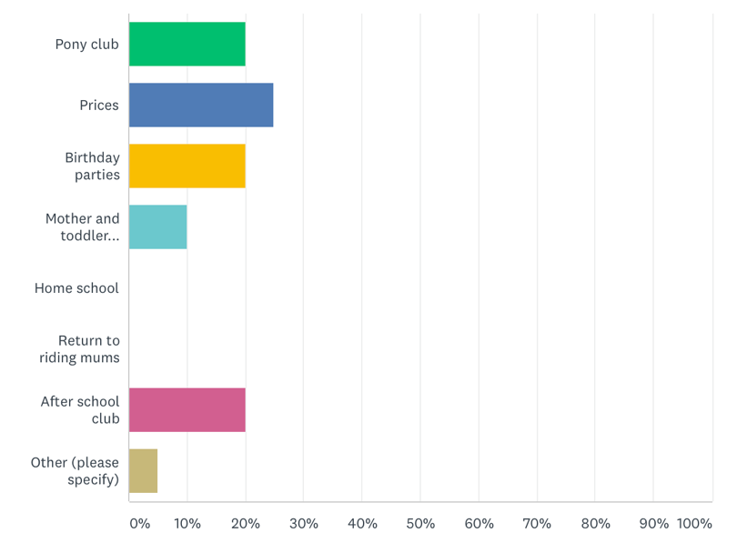
- Pony club
- Prices
- Birthday parties
- Mother and toddler sessions
- Home school
- Return to riding mums
- After school club
- Other (Please specify)
Question 3 gives customers the different options, Geoff Hayden told the consultant to include as these activities had been introduced to attract more customers during mid-week and on weekends. The results for the question will help to see what different customers are interested in. 25% of respondents said they were interested in the prices, because they offer value for money, 20% of respondents answered Pony club, birthday parties and after school club would be at their interest. 10% of respondents said Mother and toddler activities would be an interest of theirs. Whereas 5% of respondents said Other reasons and (Respondent, 14) specified that they “Live in Cardiff, today is just a day trip to Swansea for Easter holidays”.

4. Overall, how would you rate Clyne Farm?
Please tick the most appropriate response rating your experience at Clyne farm from Excellent to Poor.

Figure 4.
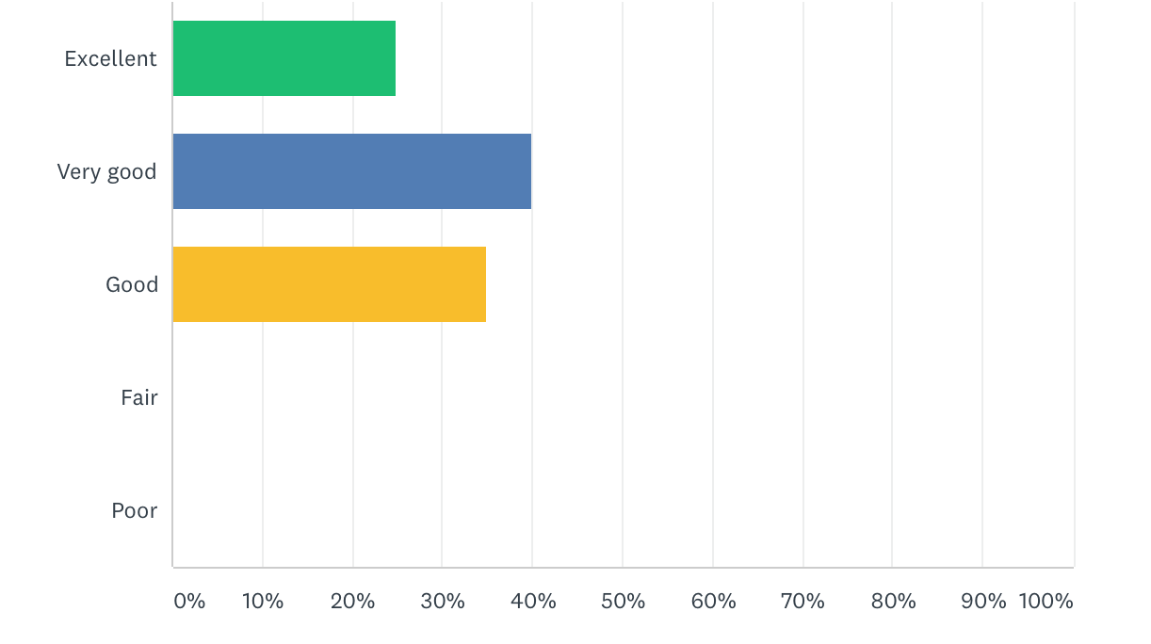
- Excellent
- Very Good
- Good
- Fair
- Poor
Question 4 will show how the customers felt their visit to Clyne farm went with options from excellent to poor. This question was set to see if customers are enjoying their overall experience at Clyne Farm. 40% of the respondents answered that their experience was very good, 35% said good and lastly, 25% of the respondents answered excellent.

5. What made you want to visit?
Please tick the most appropriate response on why the reason is you attended/attend Clyne Farm?

Figure 5.
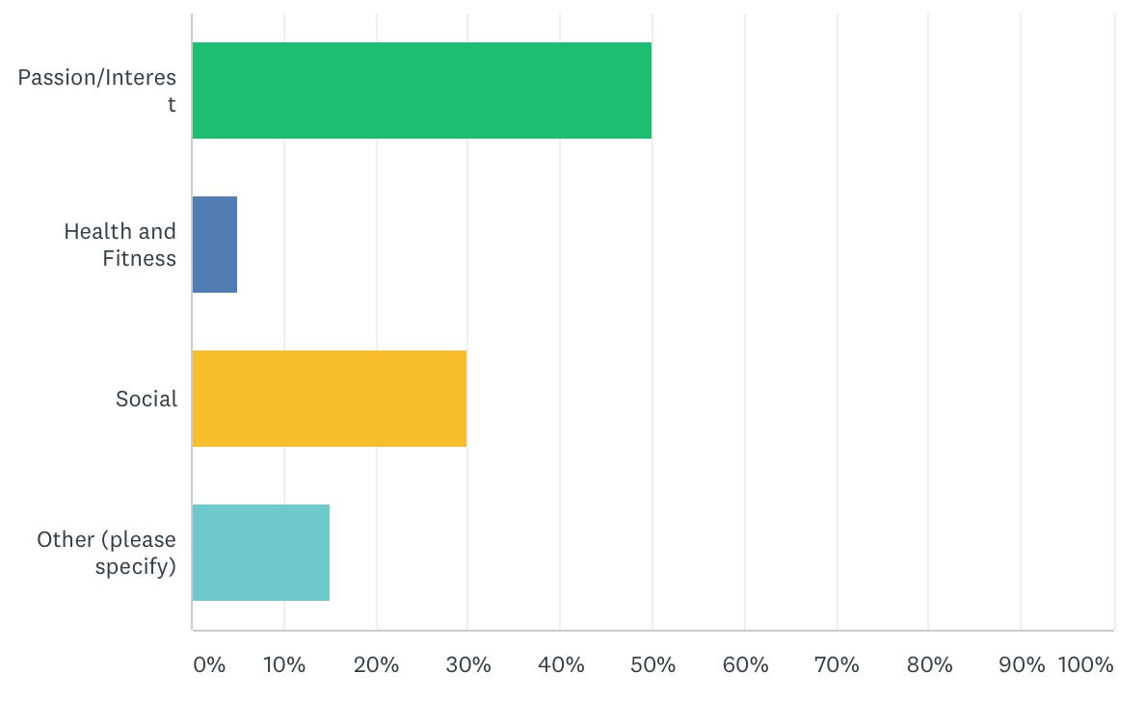
- Passion/Interest
- Health and Fitness
- Social
- Other (please specify)
Question 5 is set to see what the customers reason is for visiting and if they are visiting for the first time or a holiday. The overall answer to this question shows that the customers that took part in the questionnaire have a passion/interest in horse riding this shows because 50% of respondents answered passion/interest was the reason they attend/attended Clyne Farm and have an enjoyment for horse riding. The second popular answer was social reasons with 30% of the respondents answering the reason they visit is to be social. 4% of respondents answered that they visit the riding school for health and fitness reasons. Whereas, 15% of respondents specified other reasons. Including (Respondent, 20) “Day trip to Swansea”, (Respondent, 14) “Family day out”, (Respondent, 9) “Family time.

6. In your opinion does the price of your visit represent value for money?

Figure 6.
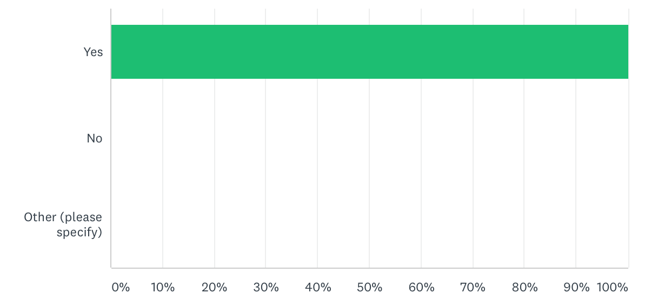
- Yes
- No
This question 6 was set because Geoff wanted to see if the customers felt the price of the riding school was good and if any customers were unsatisfied which it is why is just a yes or no answer box. The results from this question shows that 100% of the respondents answered yes, their visit to Clyne Farm represented value for money.

7. What would prevent you from visiting the riding school midweek?
(Please tick the most appropriate response)

Figure 7.
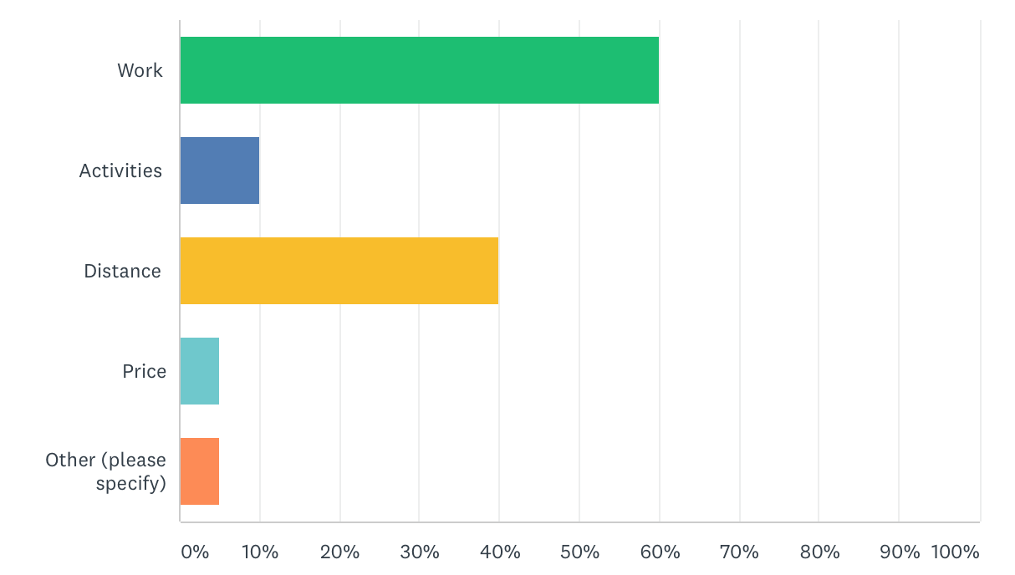
- Work
- Activities
- Distance
- Price
- Other (Please specify)
Question 7 of the questionnaire included “What would prevent you from visiting the riding school midweek?” 60% of the respondents said work, 40% said distance, 10% answered other activities, and 5% of the respondents answered prices and other reasons. (Respondent,11) stated “Take my children to football, swimming and dance”

- How likely Is it that you would recommend Clyne Farm to a friend or colleague? (Rating from 0 Not at all likely to 10 extremely likely)
Figure 8.
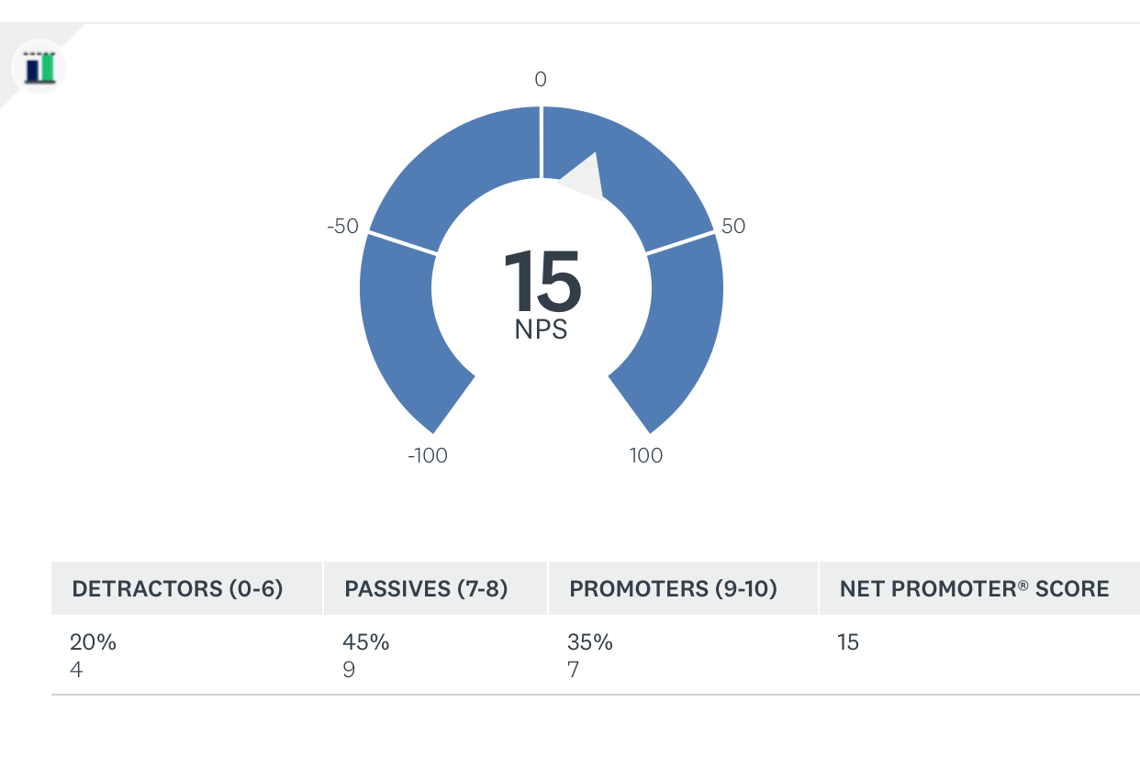

0= Negative response, wouldn’t recommend Clyne Farm to anyone.
5= Adequate response, may recommend Clyne Farm to 1 person.
10= Most positive impression of experience, would recommend to anyone.

Question 8 of the questionnaire asked, “How likely is it that you would recommend Clyne Farm to a friend or colleague?”

- Do you have any other recommendations, comments, questions or concerns?

Question 9 was the closing question for the questionnaire “Do you have any other recommendations, comments, questions or concerns?” giving customers the chance to add any other comments about their experience. 17 of the respondents either skipped this question or answered n/a because they felt they had answered everything needed and didn’t have any concerns responding no. However, 3 of the respondents answered giving comments about the organisation, “wish we could attend more often” (Respondent,20), the next answering “No, Clyne Farm is a great place, been riding here for 5 years” (Respondent,13). And another said, “Usually attend an indoor riding school in Cardiff” (Respondent,12).

- Interview questions:
I Interviewed the family who run Clyne Farm Geoff and Sarah, I wanted to interview the key people to enable good answers. I asked a number of questions concerning the riding school:
- What do you think people want from the riding school during mid-week?
Answer: Geoff believes customers attending the riding school midweek will be the ones that have a passion for horse riding and who consider it as a hobby. He thinks that the main customers during mid-week are the ones who don’t have work commitments and tend to be parents with young children. He also thinks the after-school riding club will be a success for local children in the Swansea area and will encourage more children to join the club.

- What do you currently do at Clyne farm to attract visitors?
Answer: Geoff explained that Clyne Farm use several marketing techniques to try and attract customers. He feels that they need to use more photos to market the business showing the grounds and the spectacular view of the Mumbles coastline. The main website and social media campaigns are what they do most (Facebook, Instagram and Twitter) describing that he needs to start using YouTube to share videos of the riding school to attract new riders, sharing videos of the scenic hacks through the Mumbles country side and the unicorn days which were a success when it first started because of the young children having an interest. Geoff explained when the company first started and for the first ten years they used press releases in Swansea local newspapers and the evening post, Geoff is disappointed that this doesn’t really happen anymore due to the lack of local newspapers because they have all gone national and don’t solely focus on just the Swansea area anymore which can be a downfall for business to market.

- Do you feel targeting families to the riding school during mid-week will be a success?
Answer: Geoff said yes, they want to increase visitor numbers and attract a new market different times of the week.

- Do you feel the riding school is weather dependant? If yes, how can we overcome this?
Answer: Geoff said yes, the riding school is weather dependant to a large extent because people don’t want to take part in activities outside when it’s raining, obviously Clyne Farm attracts more visitors in the summer months and half term breaks because it’s when more families will go out together because of the children not being in school.

- What does Clyne Farm succeed at, what’s its strongest selling point?
The main profit of the business comes from the accommodation, activities and riding would come last which Is why Geoff agreed for help with increasing visitor numbers to the riding school generally. Geoff is hoping by adding more activity days particularly focused on riding for example pony club and after school will increase visitor numbers, and with the use of the consultants marketing strategy new marketing campaigns focused on these ideas will be introduced to attract a different type of visitor.

- Discussion and analysis of results by key themes:
  - Weather dependant:
For the client’s (Geoff Hayden) 4th interview question, the consultant asked “Do you feel the riding school is weather dependant? If yes, how can we overcome this?” the client responded with “Yes, the riding school is weather dependant to a large extent because people don’t want to take part in activities outside when it’s raining, obviously Clyne Farm attracts more visitors in the summer months and half term breaks because it’s when more families would go out together because of the children not being in school”. From the secondary research the consultant found that Clyne Farm has 3 main competitors. One of the competitors Pembrey Riding Centre is also an outdoor riding facility which means they could attract the same number of visitors as Clyne Farm due to weather conditions. However, Goldenberg riding school has an indoor riding centre, this gives an advantage over Clyne Farm because customers often prefer an indoor riding school because they can attend in any weather conditions. A previously mentioned this currently damages Clyne Farm’s riding school visitor numbers due to bad weather conditions (Rain). However, comparing these two riding schools, Clyne Farm has a better online profile on Facebook, Website and Instagram. This strong social media and website presence will ultimately build upon Clyne Farm’s brand image, which will strengthen the company and perhaps even sway potential customers towards Clyne Farm as a result of a strong established/familiar/trusted brand image and company awareness.

  - Distance:
Looking at the primary research findings, distance is a key theme that comes up in the questionnaire, for instance question 3 asked “What would attract you most during mid-week at Clyne Farm?” (Respondent, 14) answered “Live in Cardiff, today is just a trip to Swansea for Easter holidays” this was this customer’s 1st trip to the riding school because (Respondent, 14) also answered question 1 “How often do you visit Clyne Farm riding school with the response “Never”. For this customer, distance is an issue, also answering question 7 “What would prevent you from visiting the riding school during midweek?” (Respondent 14, distance). Distance is another issue for (Respondent, 20) answering question 5 as “Day trip to Swansea”. Although, (Respondent, 20) did enjoy their visit to the farm because the last question 9 of the questionnaire “Do you have any other recommendations, comments, questions or concerns?” the comments added were “Wish we could attend more often” (Respondent, 20).
  - Work:
Another key theme throughout the primary research found that customers were usually unable to attend during midweek due to other commitments for instance, question 7 asked “What would prevent you from visiting the riding school during midweek?” with 60% of the respondents answering work which would be the same as many other customers that didn’t answer the questionnaire. According to the client Clyne Farm always doubles its visitor numbers during midweek and weekends on schools’ holidays and the summer months, this is mainly because of adults being off work and children off school. Trying to get these numbers during normal weekdays can be a difficult task because of work commitments, but with a successful marketing strategy Clyne Farm will aim to achieve the numbers they want referring back to the objectives (8/9 people a day instead of just 4).

From Question 1 “How often do you visit Clyne Farm riding school?” the responses show that Clyne Farm have a large number of customers that return often with 25% of the answering this question with “always”. This shows that these customers enjoy the riding school. If new visitors were attracted through a successful marketing strategy this could boost visitor numbers significantly and get them to always return the same as the 25% respondents who answered the questionnaire.
Question 3 in the questionnaire “what would attract you most during mid-week at Clyne Farm?” refers to Geoff’s 1st interview question which was “What do you think people want from the riding school during mid-week?” Geoff believes that the after-school riding club will be a success and will encourage more children to join the club. 20% of the respondents answered question 3 of the questionnaire that the after-school club would be the activity, that would attract them most the Clyne Farm during mid-week. Which is really good for the client because that’s what they believe would be a success.

  - Social media:
A key theme that kept reoccurring throughout the mixed research method approach, was the importance of social media to a business. Question 2 asked the respondents “What attracted you to Clyne Farm?” Where 40% of the respondents answered “social media” for how they found out about Clyne Farm. This shows that social media is an extremely successful marketing platform because without (Facebook, Instagram, Twitter) 40% of the respondents wouldn’t be at Clyne Farm. Which is why the business should make sure they are up to date on all marketing platforms especially Facebook and Instagram. Due to the rise of technology this is how people are finding businesses and the social media platform will be the face of the business. Referring back to the secondary research the main competitor for Clyne Farm is Pembrey Riding Centre who are located in Llanelli, also use the same social media sites, except have the advantage from Clyne Farm by using YouTube to show riding lessons taking place at the centre and across the beach. The consultant has given Clyne Farm a recommendation to use YouTube as it is a strong marketing source, with the number of viewers watching YouTube daily. If Clyne Farm were to show the activity days which take part there (Unicorn days, Pony Club) this could attract younger viewers.

  - Price:
The consultant felt it was important to add a question in the questionnaire about price. Question 6 asked the respondents “In your opinion does price represent value for money?” 100% of the respondents answered “yes” that they thought Clyne Farm was value for money. However, referring to the secondary research a competitor, Pembrey Riding Centre is cheaper for a 1-hour riding lesson. There is only a 2 pounds difference, but this could change potential customers minds if they are comparing prices on riding schools in the area.

- Evaluation:
From the data collected, it is hard to attract the same visitors during midweek as weekends, because customers will have work commitments during midweek. Clyne Farm could use a new marketing technique YouTube, to video the riding lessons, unicorn days, pony club or treks. This type of visual marketing will give new upcoming customers more of an insight to the riding school and what they have to offer instead of images. As mentioned above, from the secondary research the consultant feels that there should be an Instagram account for Clyne Farm designated to the riding school only, to enable customers to find the page easier especially if riding schools in Swansea are being searched on Instagram. Having one Instagram account with images designated to all activities on site could overwhelm some people and won’t necessarily inform them it’s a riding school straight away, especially if the page is called Clyne Farm Centre. From the secondary research carried out using online sources, the consultant found that on Visit Swansea Bay website the promotional campaign about Clyne Farm didn’t state enough information about being a riding school, if there was more information about the riding school and what they offer (including unicorn days, pony club) this could boost visitor numbers during midweek at the riding school due to Visit Swansea Bay website being a popular marketing source for tourists coming into Swansea. Some tourists won’t always use social media platforms such as (Facebook and Instagram) to see what a destination has to offer they will use solely internet sources such as this website, the consultant believes it is important for this website to be updated to attract more visitors during midweek. Another recommendation is to create link deals for accommodation and the riding school, as Clyne Farm was adapted specifically for families by improving accommodation facilities, this could increase the number of visitors during mid-week marketing the accommodation and the riding school together. It’s important to take into consideration that the riding school is weather dependant and more deals/competitions to attract customers on social media. For example, a competition where people following Clyne Farm can win an overnight stay, riding lesson and beach hack. One of the conditions for the viewers to win the prize, could be telling them they have to advertise the competition on their story and have to tag Clyne Farm Centre Instagram account to their story too. Many businesses do this on Instagram to increase brand awareness and attract a new type of audience and to gain new followers. Because if the followers of the Instagram account post on their Instagram account, and have thousands of followers this could boost visitor numbers dramatically. The consultant believes more use of websites such as Groupon and Wowcher to attract customers looking for days out also.

- Conclusion:
To conclude of all aspects of this consultancy report, the consultant has evaluated the effectiveness of Clyne Farm’s current marketing platforms, using a range of primary and secondary research. From this data it is clear that the existing marketing online successfully brings in new customers. However, new approaches and more regular hosting’s are recommended to increase following which will lead to increased customers and improve brand awareness. The improvement of the brand will improve brand loyalty.
Although, the prices of Clyne Farm riding activities are higher than some competitors such as Pembrey Riding School, existing customers are clearly satisfied with the price, as can be seen from the questionnaire which shows the price for riding schools is relatively price inelastic for Clyne Farm. Three local competitors have closed down reducing competition opening up the potential of attracting their previous customers.
Clyne Farm can invest in an indoor riding infrastructure to attract more customers on poor weather days, as it being a highlight of the interview with the client. However, this would be a predictably high cost to the company. So other improvements such as marketing as suggested, could be employed before this expensive option is explored.
The consultant and client have set the target of increasing visitor numbers from 4 a day in the week to 8/9 a day, 44% to 50% increase. It is believed this will be achieved through the effective online marketing improvements suggested. Combined with potentially attracting new customers including potentially the local university.

- Recommendations:
Provide recommendations on how to improve Clyne Farms marketing techniques, business dimension and make them more effective in attracting families.

- Use YouTube as a new marketing platform for the riding school, by uploading videos of riding taking place and activities carried out such as Pony club.
- Communicated with Visit Swansea Bay.com to see if more information can be added to the marketing campaign about the riding school and not just the other activities on site. And ask about adding more images rather than just text to make it more appealing to new customers.
- Accommodation and riding school could be linked as a deal to attract families.
- Interact with customers more through social media, for example on Facebook showing images of customers or members of the riding school horse riding.
- More deals/competitions to attract customers on social media.
- Increased use of companies like Groupon and Wowcher, the company is popular with families. To attract new customers looking for a day out. Similar to those who answered the survey saying they were there for a family day out.

- Appendices:
First Section
A.1. Communication log
Minutes of meetings-
Date: Thursday 14th February 2019
Time: 2:00pm-3:00pm
Location: Clyne Farm
1st meeting with client (Geoff Hayden) to discuss consultancy project ideas.
Date: Monday 8th April
Time: 12:00pm-1:00pm
Location: Clyne Farm
Meeting with Geoff to show him questionnaire I had produced and interview with him.
Date: Tuesday 7th May
Time: 10:00am-10:30am
Location: Clyne Farm
Final meeting between the consultant and Geoff to show him questionnaire responses and ask a few questions about the responses. Thanking Geoff for assisting me through this project.

A.2. Emails between consultant and client

Wednesday 6th February- Consultant emailed Geoff Hayden to explain that the BID for the project had been completed, from the bid feedback the consultant realised the target audience was too big, so in this email the client was asked if there was a specific target audience they wanted to focus on? (Schools/Families)
Later that day, Geoff replied to say that he would be looking to increase families during midweek and that schools are a difficult market to get into, so there is more scope with families. This lead on to the consultant agreeing for overall aim of the project to be, boosting visitor numbers during midweek targeting towards mainly families.

Wednesday 3rd April
The consultant emailed Geoff to explain that the first two parts of the project had been completed (BID and PID) asking if the consultant could show Geoff the questionnaire before and permission to carry out questionnaires with customers at Clyne Farm and interviews with himself and Sarah Hayden. Geoff replied to the email later that day today that ’t's absolutely fine.

Friday 5th April
Email between consultant and client arranging meeting time for Monday 8th April.

Monday 15th April
Email between consultant and client about asking when it would be a suitable time for Geoff for the interview to be conducted.

A3.
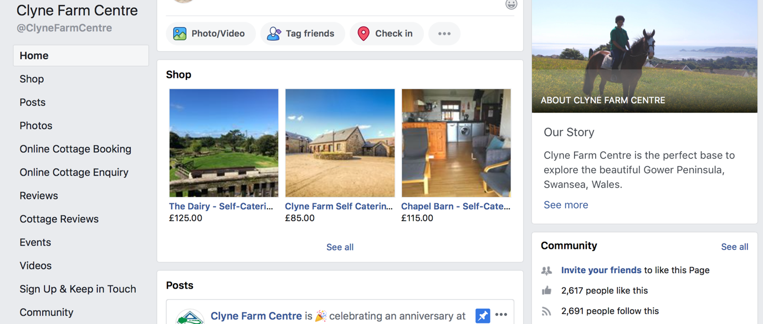
Clyne Farm Centre Facebook page. (Facebook, 2019)

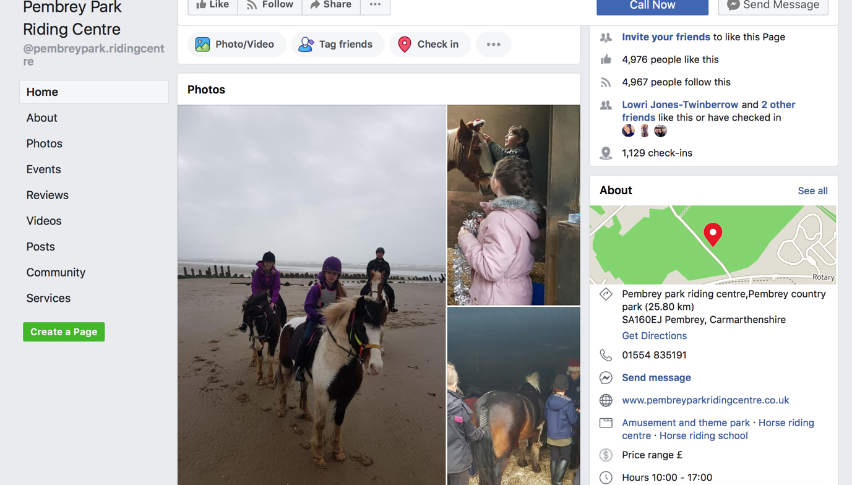
Pembrey Park riding Centre Facebook page. (Facebook, 2019)

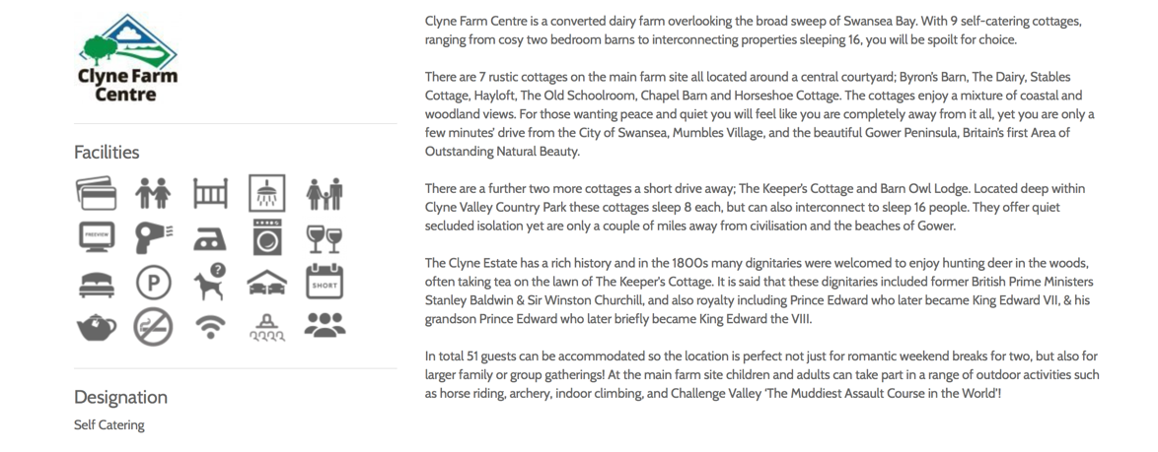
Visit Swansea Bay promotional campaign for Clyne Farm (Visit Swansea Bay,2019).

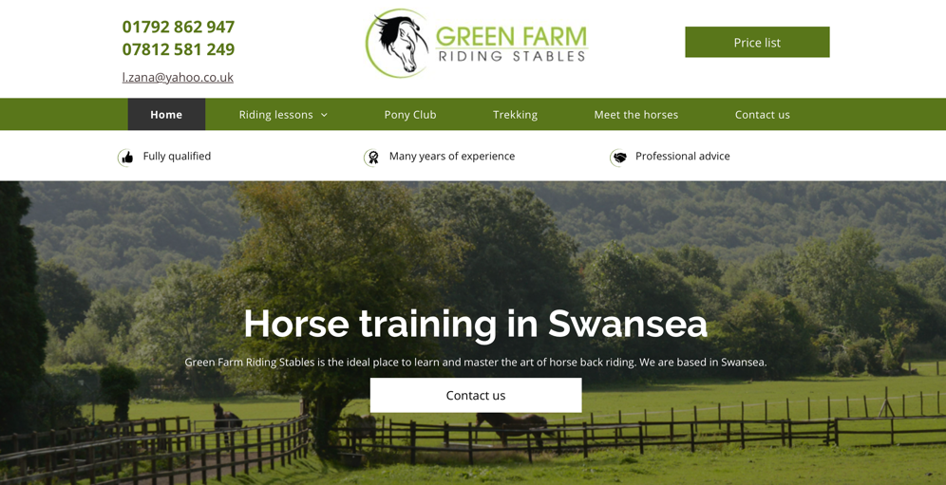
Green Farm Riding Stables Website. (Green Farm, 2019)

A.4. Client consent for primary research carried out at Clyne Farm-

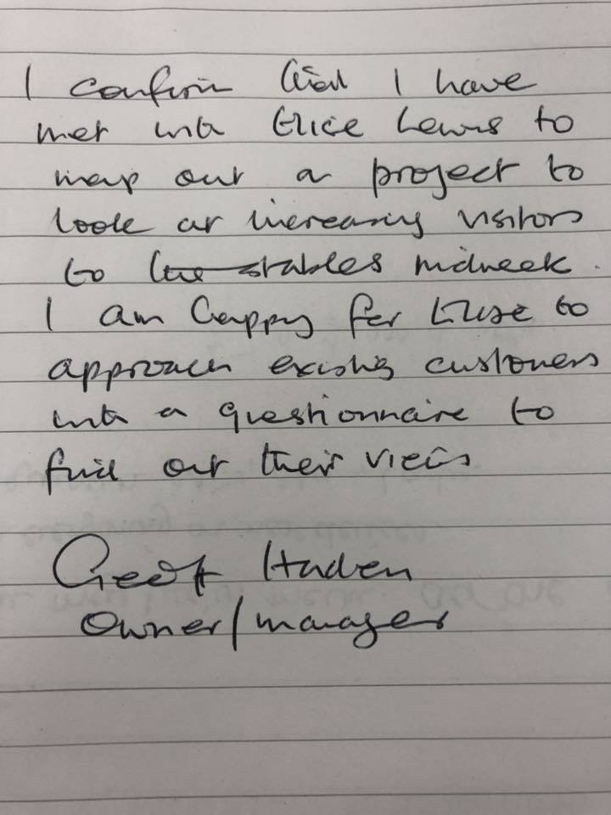

- Reference list:

- Facebook.com. (2019). Clyne Farm Centre. [online] Available at: https://www.facebook.com/ClyneFarmCentre/ [Accessed 10 May 2019].
- Facebook.com. (2019). Pembrey Park Riding Centre. [online] Available at: https://www.facebook.com/pembreypark.ridingcentre/ [Accessed 9 May 2019].
- Greenfarmtrebanos.net. (2019). Horse training | Green Farm Riding Stables. [online] Available at: https://www.greenfarmtrebanos.net [Accessed 8 May 2019].
- Greenfarmtrebanos.net. (2019). Horse training | Green Farm Riding Stables. [online] Available at: https://www.greenfarmtrebanos.net/ [Accessed 12 May 2019].
- MerchDope. (2019). YouTube Facts, Figures and Statistics – 2019 - MerchDope. [online] Available at: https://merchdope.com/youtube-stats/ [Accessed 13 May 2019].
- O'Gorman, K. and MacIntosh, R. (2015). Research methods for business and management. 2nd ed. GoodFellow.
- Saunders, M. (2003). Research Methods for Business Students. 3rd ed. Pearson, p.99.
- Saunders, M., Lewis, P. and Thornhill, A. (2009). Research methods for business students. 5th ed.
- Virtanen, H., Björk, P. and Sjöström, E. (2017). Follow for follow: marketing of a start-up company on Instagram. Journal of Small Business and Enterprise Development, 24(3), pp.468-484. (Accessed: 8th May 2019)
- Visit Swansea Bay. (2019). Clyne Farm Centre. [online] Available at: https://www.visitswanseabay.com/listings/clyne-farm-riding-activity-centre/ [Accessed 6 May 2019].

