Operating Systems
Module Name: Computer Architecture & OS
Module Code: ACCA 4022
Student Name: Bernard Unuigboje Ileogben
Student ID: 2512918
Lecturer Name: Md Shantanu Islam

Submission date: 13 March 2026

Contents
Introduction 3
Key Functions of General Operating Systems 3
Task Management: 3
Application/Program Management: 4
File/Directory Management: 4
Device Management: 5
Security Management: 5
Use of Windows OS CLI commands 6
Example 1: 6
Example 2: 7
Example 3: 7
Example 4: 8
Example 5: 8
Example 6: 9
Example 7: 9
Example 8: 10
Example 9: 10
Example 10: 11
Use of Linux OS CLI commands 11
Example 1: 11
Example 2: 12
Example 3: 13
Example 4: 13
Example 5: 14
Example 6: 14
Example 7: 14
Example 8: 15
Example 9: 15
Example 10: 16
Use of Windows OS scripts 16
Example 1: 17
Example 2: 17
Use of Linux OS scripts 18
Example 1: 18
Example 2: 19
Conclusion 20
References 21
Appendices 22

Introduction
An operating system is the main program that manages all the hardware and basic software on a computer so other programs can run safely and efficiently. It controls the processor, memory, files, and input/output devices and gives users and applications a clear, easy way to use the machine instead of dealing directly with the hardware. Many textbooks also explain that the operating system acts as a “resource manager” and “control program". Sharing resources between program and protecting them from each other. It also protects them from each other [1] [2].

Key Functions of General Operating Systems
Windows is an operating system from Microsoft, first released in 1985 [3], that lets users control a PC with windows, icons, and menus instead of only typed commands. It is important because it runs programs, manages files and devices, and helps people work, communicate, and play easily.

Task Management:
Task Manager in Windows is a built-in tool (opened by Ctrl+Shift+Esc) that lets you monitor and control running programs and system resources. It shows processes with CPU, memory, disc, and network use in real time so that you can spot slow apps or high usage. Key tabs include ‘Processes’ (end tasks), ‘Performance’ (live graphs), ‘Details’ (set priorities), and ‘Startup’ (manage boot apps). Use it to close frozen programs, check bottlenecks, or tweak efficiency [4].
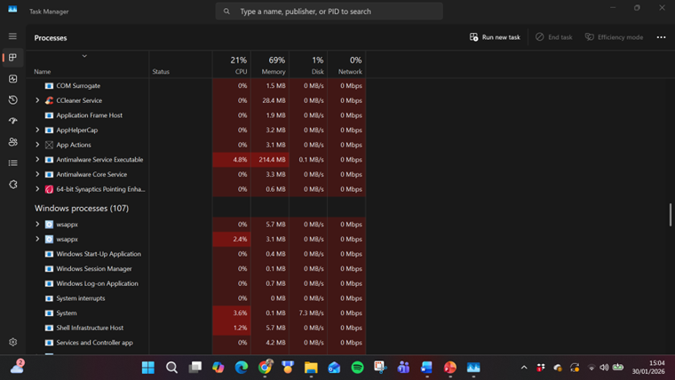
Figure 1: Task Manager

Application/Program Management:
Application or program management in Windows means how the operating system installs, runs, updates, and removes apps to keep your computer safe and working well. Windows uses tools like the Microsoft Store for easy app downloads and updates. You can also install traditional .exe programs from the web, but Windows checks them with SmartScreen to block bad ones. In Settings > Apps, you manage what runs at startup, uninstall programs, or set default apps (like which browser opens links). For businesses, Intune lets IT admins push apps to many PCs silently [5]. To access this location on your computer. Go to Settings > Apps > Installed apps Like the example below.

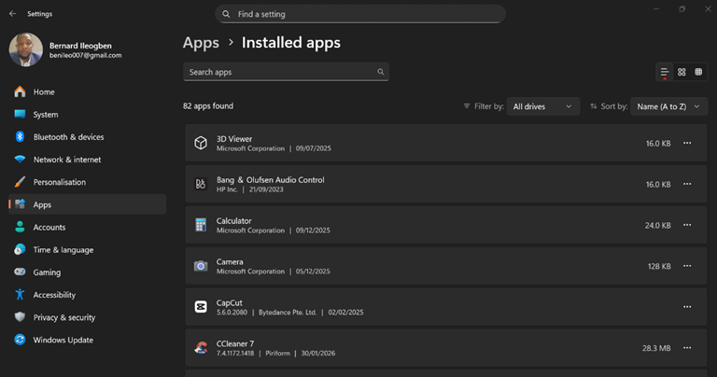
Figure 2: Application/Program Management

File/Directory Management:
File and directory management in Windows is handled mainly by File Explorer (press the Windows key + E to open it). It lets you create, move, copy, delete, and rename files and folders on your hard drive or external storage. Windows uses the NTFS file system, which supports long file names, permissions (who can read or change files), and compression. You can organise files into folders, search by name or type, and view hidden items via View > Show > Hidden items. Right-click for quick options like "New Folder" or "Properties" to check size and access rights. For safety, Windows blocks changes to protected system folders like Windows\System32 [6].

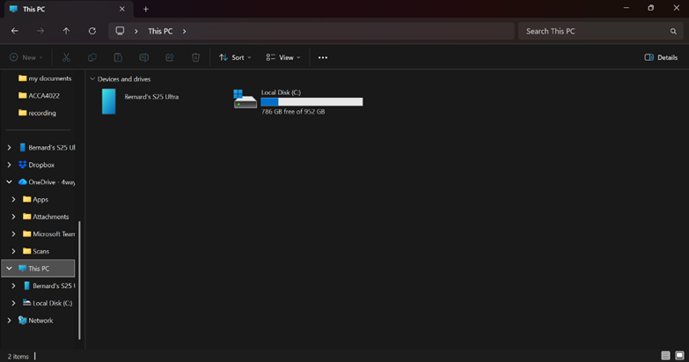
Figure 3: File Manager

Device Management:
Device management in Windows is handled by Device Manager, a built-in tool you open by right-clicking Start and selecting it (or typing devmgmt.msc in Run). It shows all hardware, like printers, USB drives, graphics cards, and sound devices, in a list. You can update drivers (right-click > Update driver), enable/disable items, roll back changes, or scan for new hardware. Yellow triangles mark problems, like missing drivers. Windows uses Plug and Play to auto-detect and install most devices, but Device Manager lets you fix issues or uninstall faulty ones. For networks or updates, it links to Windows Update [6].
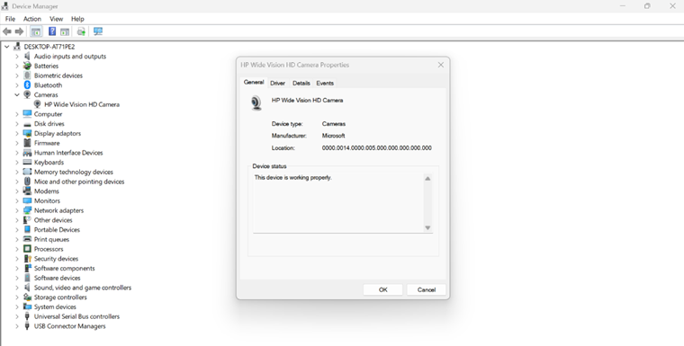
Figure 4: Device Management

Security Management:
Security management in Windows keeps your computer safe from threats like viruses, hackers, and bad changes. Key parts include Windows Security (the main app for scans and firewall), BitLocker (encrypts your hard drive so data stays private), User Account Control (UAC) (asks before big changes to stop malware), Windows Defender (built-in antivirus that blocks viruses in real time), and Secure Boot (checks that only trusted software starts your PC) [7]. You also get Windows Firewall to control network traffic and App & Browser Control to stop dodgy downloads. Go to Settings > Privacy & Security > Windows Security to manage it all.

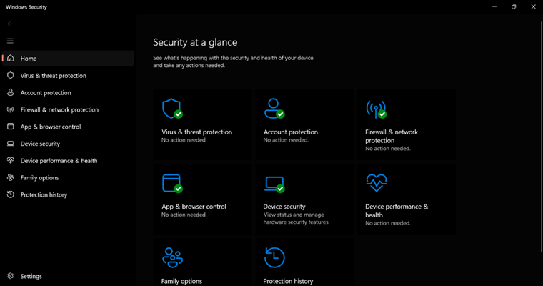
Figure 5: Windows Security Management

Use of Windows OS CLI commands
Windows CLI (Command Prompt/PowerShell) supports functions like file operations (dir, mkdir), process management (tasklist), networking (ipconfig, netstat), and diagnostics (systeminfo). Applications: automation, remote admin, troubleshooting [3].

Example 1:
From my Command Prompt user directory, I typed 'dir', which lists files and subdirectories in the current directory. The screenshot below shows a total of 23 folders.
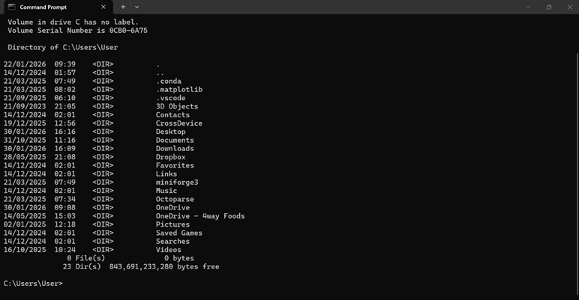
Figure 6: Command dir

Example 2:
From my Command Prompt user directory, I moved up one directory level using the 'cd..' command. I then used the 'cd' command with the appropriate path to change the current directory back to my user directory. In the screenshot, I moved from the Documents folder up to my user folder.
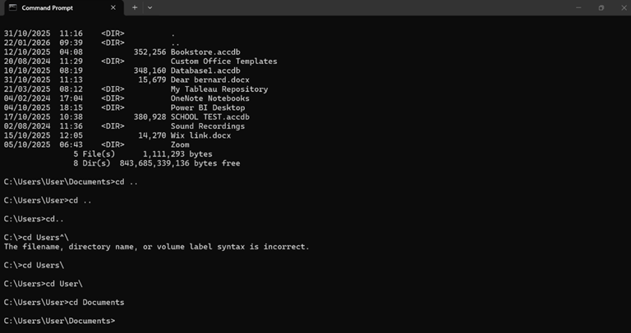
Figure 7: Command cd

Example 3:
From my Command Prompt user directory, I entered the mkdir "new folder" command, which created a new folder called "new folder". From the screenshot, the new folder was created on 30/01/2026 at 16:53, and the directory now shows 5 files and 15 folders.
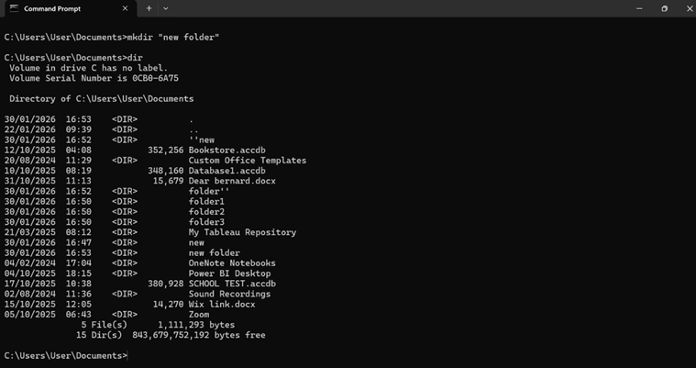
Figure 8: Command mkdir

Example 4:
From my command prompt user directory, I entered "rmdir new", which deletes an empty directory named "new". In the screenshot below, this successfully removed the "new" folder, reducing the total folders to 14.
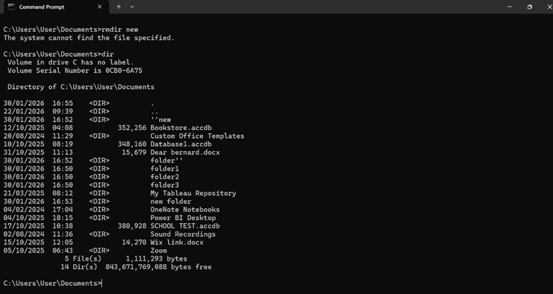
Figure 9: Command rmdir

Example 5:
From my Command Prompt user directory, I used the 'echo' command to display the text message 'This is an example.' The screenshot below confirms that the Echo command successfully outputs this message.
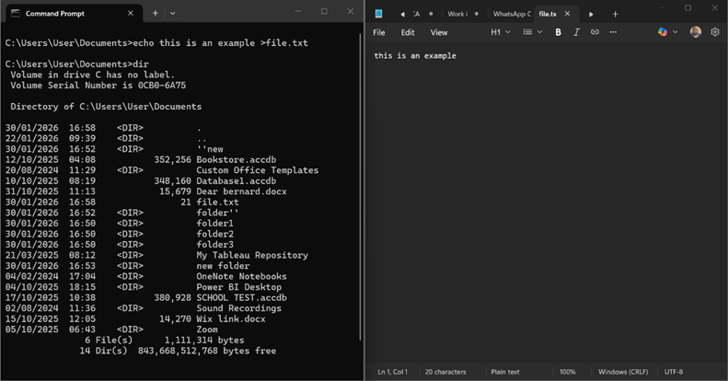
Figure 10: Command echo

Example 6:
From my Command Prompt user directory, I used 'cd Documents' to enter the 'documents' folder. I then typed 'tasklist' to display a list of all currently running processes (tasks).
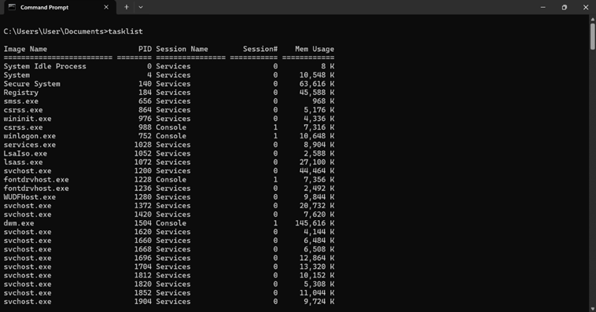
Figure 11: Command tasklist

Example 7:
From my command prompt, I used the systeminfo command to display detailed configuration information about my Windows computer and OS, including hardware (RAM, CPU), OS version, system model, time zone, and network details.
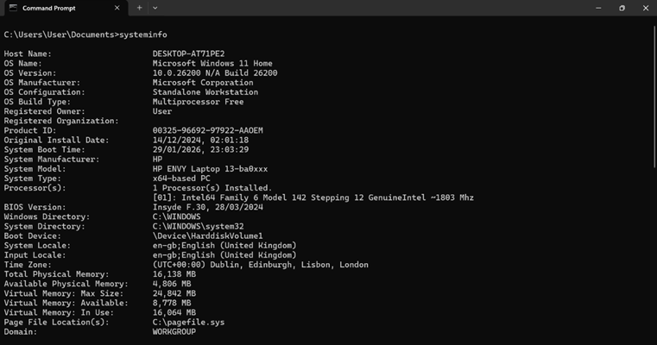
Figure 12: Command systeminfo

Example 8:
From my command prompt, I used the ipconfig command to display TCP/IP network configuration, including IP addresses, hostname, wireless LAN/Wi-Fi adapter details, and DNS suffix.
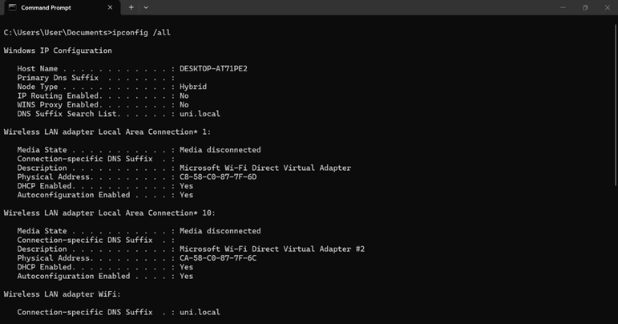
Figure 13:” Command ipconfig”

Example 9:
From my command prompt, I used the ping command to test network connectivity to a host, displaying response times along with the number of packets sent, received, and lost.
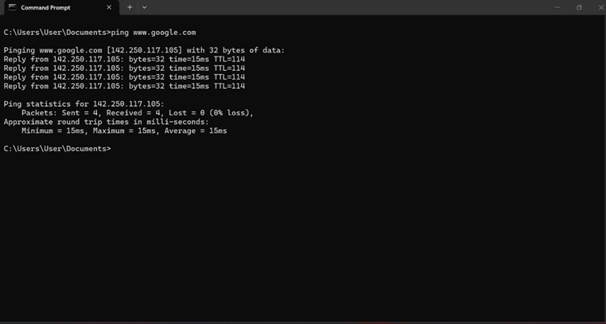
Figure 14: Command ping

Example 10:
From the Command Prompt, I used the netstat command to display active TCP connections (including local and foreign addresses and listening ports), Ethernet statistics, and the IP routing table.
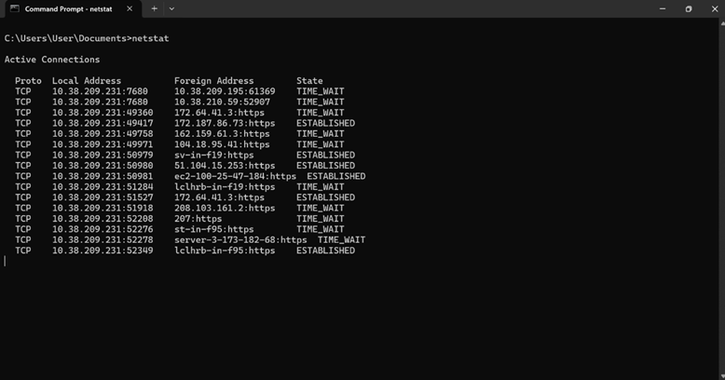
Figure 15: Command netstat

Use of Linux OS CLI commands
The Linux CLI enables command-based system control via shells like Bash. Commands manage files, processes, networking, and permissions. It supports automation, scripting, server administration, and development tasks, offering efficiency, precision, and remote management capabilities [8].

Example 1:
In Linux, su switches to another user account (usually root) to run commands with elevated privileges. For example, 'su sysadmin' prompts for the sysadmin user's password before switching your current shell to that account. As shown below, 'su root' asks for the root password before completing the switch.
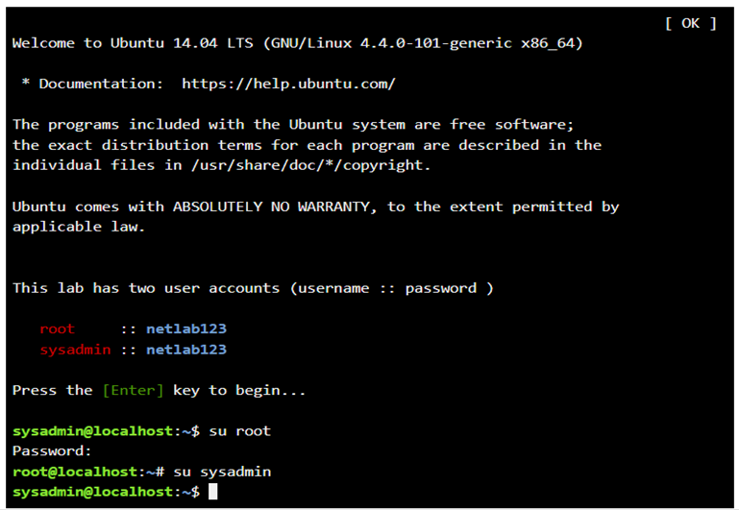
Figure 16: Command su

Example 2:
In Linux, the pwd (Print Working Directory) command shows the full path of the directory you are currently in, printing the absolute path from the filesystem root to your current location, as shown in the screenshot below.
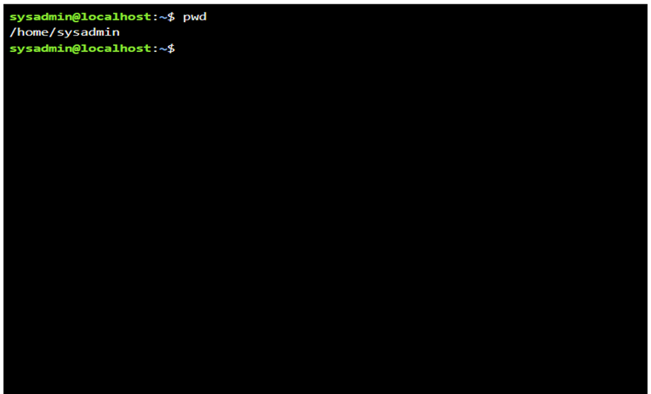
Figure 17: Command pwd

Example 3:
The Linux ls command lists the contents of a directory. Without options, it shows files and directories in the current directory; with -al, it lists all files (including hidden ones) in long format. As shown below, ls -al displays all hidden files.
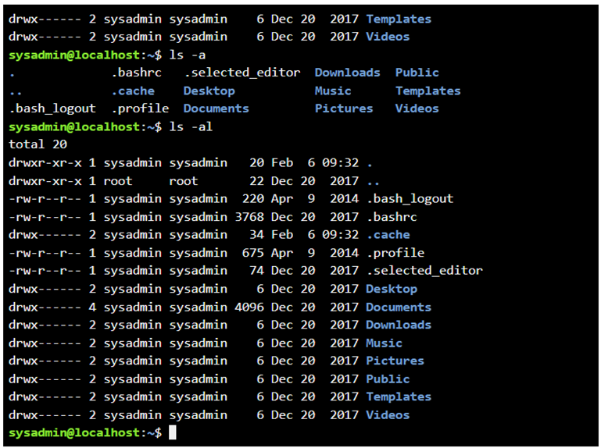
Figure 18: “Command Is”

Example 4:
The Linux `cd` (change directory) command moves you to a different folder in the filesystem. Use 'cd' to go to your home directory or 'cd Desktop' to enter a desktop subfolder (if it exists), which will then change to a blue colour.
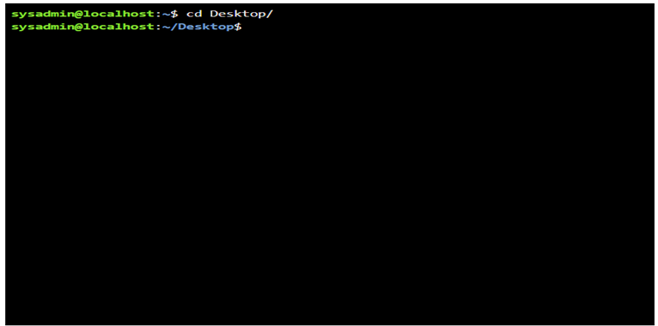
Figure 19: Command cd

Example 5:
The Linux mkdir (make directory) command creates new directories in your current location unless you specify a path. In the example below, I created a "new" directory from my home directory using mkdir new.
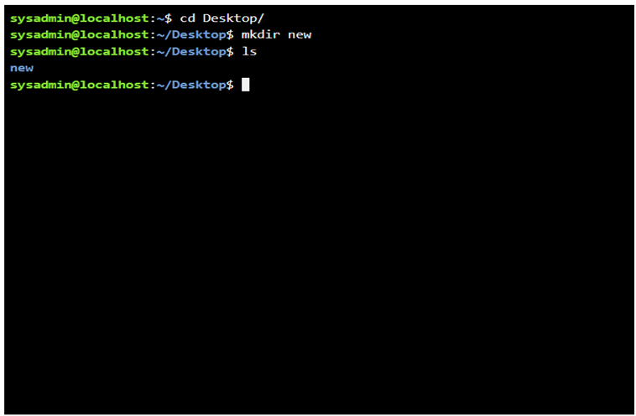
Figure 20: Command mkdir

Example 6:
The "remove directory" rmdir is the Linux command to remove empty directories (folders). The command helps to delete only empty directories completely. In the example below, I deleted the “new” directory that was made using mkdir above.
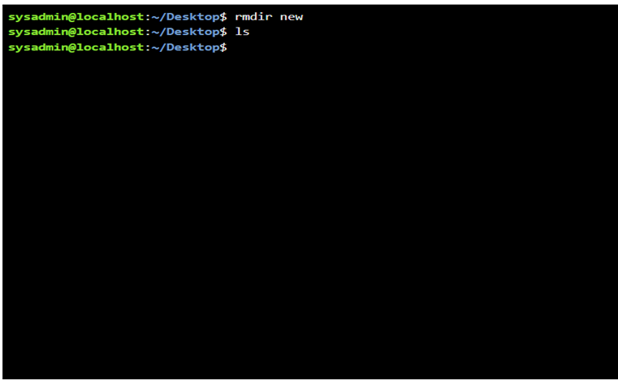
Figure 21: Command rmdir

Example 7:
The Linux touch command creates empty files. In the example below, `touch new.txt` successfully creates a new empty file called "new.txt".
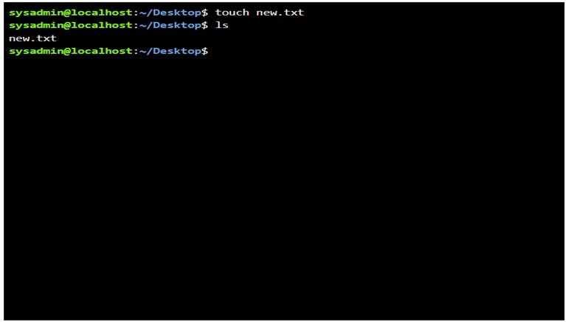
Figure 22: Command touch

Example 8:
The 'echo' and 'cat' commands are essential Linux commands for handling text output and file content. The `echo` command displays text, variables, or command output to the terminal, and the `cat` command shows the file contents, like the example below showing “this is test” as output.
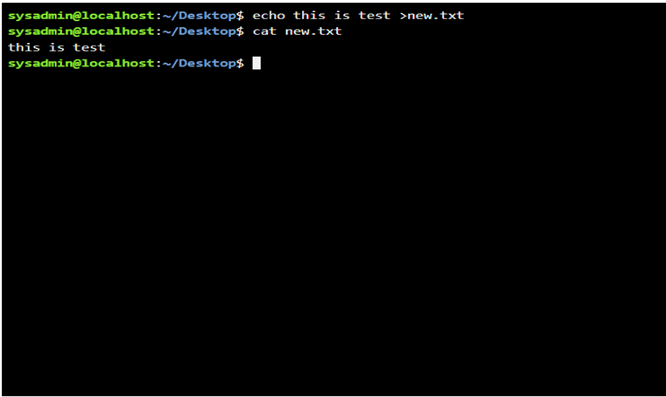
Figure 23: Command echo and cat

Example 9:
In Linux, the ifconfig command shows all network interfaces with their IP addresses, status, and configuration details (though ip addr is now preferred). Use 'ip route' to view the routing table/default gateway and 'cat /etc/resolv.conf' to view the DNS servers.
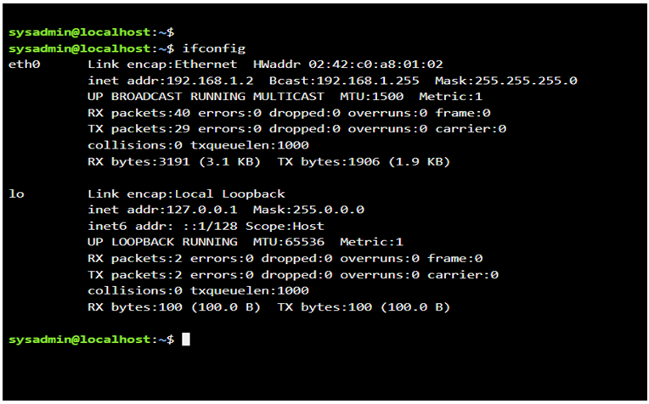
Figure 24: Command ifconfig

Example 10:
In Linux, as shown below, the 'whoami' command prints the username of the current effective user (the account your shell session runs under). The date command displays the current date and time separately.

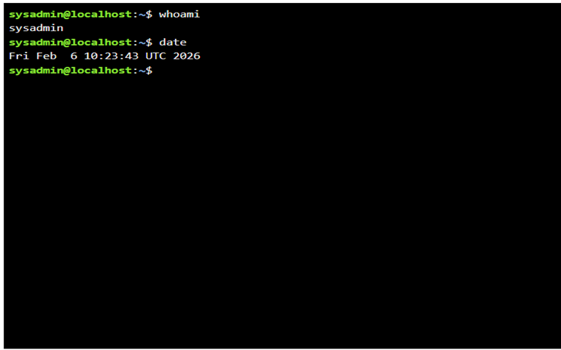
Figure 25: Command whoami

Use of Windows OS scripts
Batch scripting in Microsoft Windows automates administrative tasks by executing command-line instructions with cmd.exe. Batch files (.bat) perform file management, backups, software installation, and system configuration. They improve efficiency, reduce errors, and support routine maintenance in enterprise and personal computing environments [9].

Example 1:
A batch script is a method of automating tasks in Windows using a plain text file. It can, for example, add five numbers and run in the Windows Command Prompt. The set /p command prompts the user to input values (e.g., Num1 to Num5), and set /a Total=Num1+Num2+Num3+Num4+Num5 calculates the total. `echo %total%'Displays' the result, 'pause' waits for a keypress before continuing, and '@echo off' hides command output. The example below shows this script and its output.
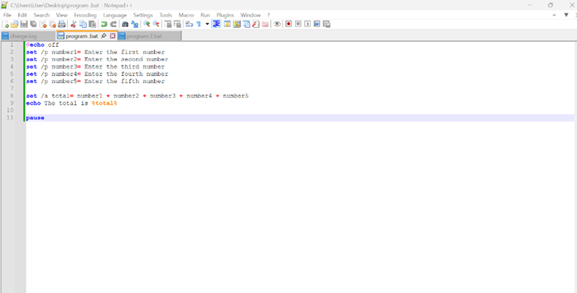
Figure 26: script to add five number
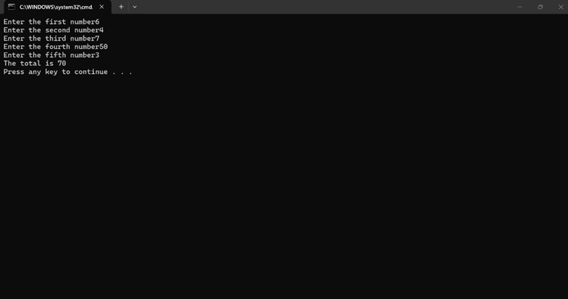
Figure 27: output of the script

Example 2:
Batch scripting IF/ELSE statements enable conditional logic by executing different command blocks based on tests such as numeric comparisons, string equality, or file existence. The syntax uses IF conditions (true commands) and ELSE (false commands), with parentheses grouping multiple lines. A practical example is shown in the screenshot below, which checks whether a user is old enough to vote in an election. The user enters their age, and if it is at least 18, as specified in the IF condition, the script outputs that they can vote; otherwise, it outputs that they cannot vote.
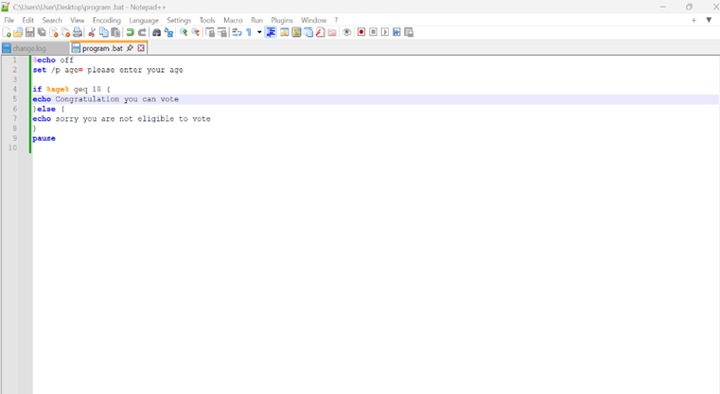
Figure 28: if and else
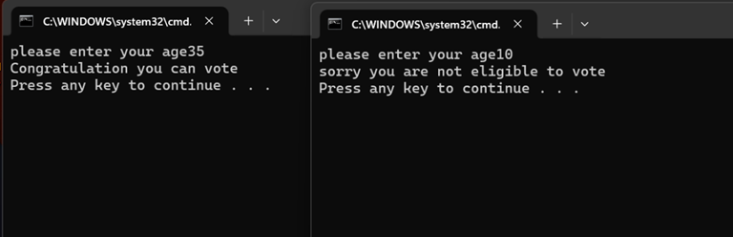
Figure 29: output if and else

Use of Linux OS scripts
Bash scripting in Bash on Linux automates system administration, file management, and process control through executable shell commands. It supports task scheduling, backups, text processing, and DevOps workflows, improving efficiency and reliability in server environments [10].

Example 1:
Bash scripts are simple text files containing commands that run sequentially on Linux. They start with a line like #!/bin/bash to pick the right program to run them.
Basic commands include "echo" to show messages, like "Enter a number". Use `read '' to let the user type in numbers, like `read num1 ''. Then multiply with * inside $(( )), for example, total=$((num1 * num2 * num3)). These scripts save time, reduce errors, and help with jobs like managing files or servers. People use them a lot in server work and DevOps to do tasks the same way every time.
The script below multiplies three numbers. It uses echo to tell the user what to type. The 'read' command gets the numbers one at a time. The total command multiplies them to make a total, then the echo shows the answer at the end.

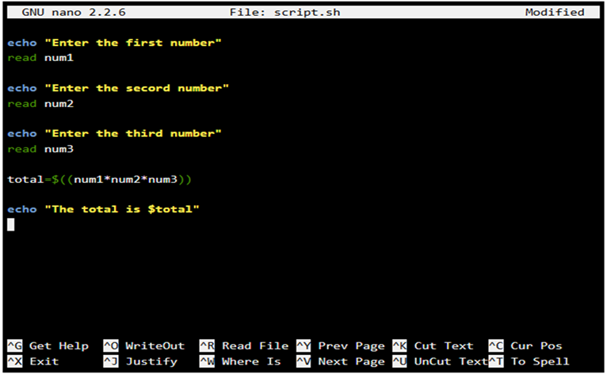
Figure 30: BASH script to multiply three numbers
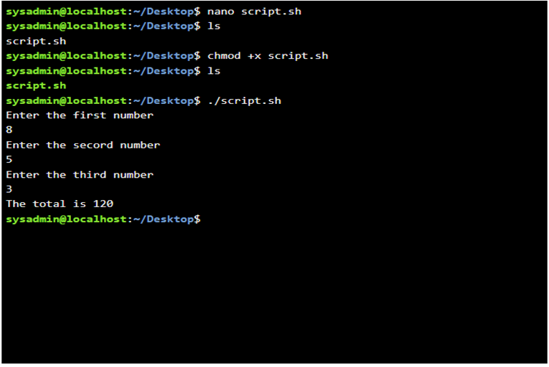
Figure 31: Output of the script to multiply three numbers

Example 2:
Loops repeat a set of commands multiple times until a condition stops them. A for loop in Linux Bash goes through a list of items (such as numbers or words) and runs commands for each one. The example below shows that for ((k=1; k<=12; k=k+2)), k=1 starts k at 1, k<=12 checks if k is 12 or less (the loop keeps going), and k=k+2 adds 2 to k each time (steps by 2). And "do" and "done" commands hold inside the loop. The `echo` command prints $k, and the output shows that the loop started from 1, 3, 5, 7, 9, and 11. It's stopped at 11 because the next value (13)>12.
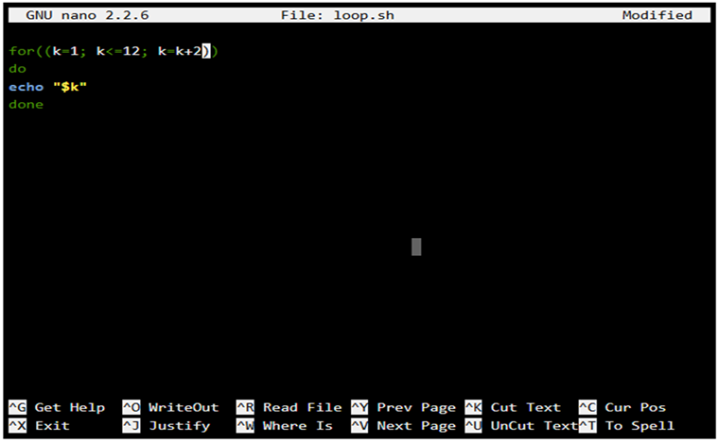
Figure 32: script for loop
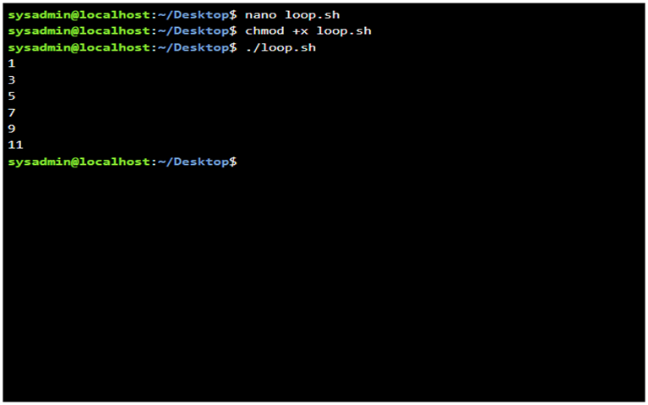
Figure 33: Output of the loop

Conclusion
The report covers OS functions (task, app, file, device, security management) with screenshots, plus 10 Windows CLI examples (dir, cd, mkdir, etc.), 10 Linux CLI demos (ls, pwd, etc.), Windows batch scripts (add numbers, IF/ELSE), and Linux Bash scripts (multiply numbers, for loop). Tasks demonstrate CLI/scripting proficiency for a system admin.

References

[1] | A. a. G. P. B. a. G. G. Silberschatz, Operating system concepts, John Wiley \& Sons, 2019.
[2] | W. Stallings, Operating systems: internals and design principles, Prentice Hall Press, 2011.
[3] | A. a. I. A. a. R. M. E. a. S. D. A. Allievi, “Windows internals, part 2,” Microsoft Press, 2021.
[4] | C. Huffman, Windows Performance Analysis Field Guide, Elsevier, 2014.
[5] | C. a. L. P. Brinkhoff, Mastering Microsoft Intune: Deploy Windows 11, Windows 365 Via Microsoft Intune, Copilot and Advance Management Via Intune Suite, Packt Publishing Ltd, 2024.
[6] | P. a. S. D. A. a. I. A. a. R. M. E. Yosifovich, Windows Internals: System architecture, processes, threads, memory management, and more, Part 1, Microsoft Press, 2017.
[7] | J. Forshaw, Windows Security Internals: A Deep Dive into Windows Authentication, Authorization, and Auditing, No Starch Press, 2024.
[8] | M. Kerrisk, The Linux programming interface: a Linux and UNIX system programming handbook, No Starch Press, 2010.
[9] | J. McLarney, The Book of Batch Scripting: From Fundamentals to Advanced Automation, No Starch Press, 2024.
[10] | A. a. B. N. H. Robbins, Classic Shell Scripting: Hidden Commands that Unlock the Power of Unix, O'Reilly Media, Inc., 2005.

Appendices
Online Course name: Linux Unhatched

Figure 34: Certificate of completion

