UNIVERSITY OF WALES: TRINITY SAINT DAVID

School of Business London Campus
Effective Team Working and Communication

Student Name: Ionut Gabriel Artan
Student Number: 1817448
Module code: BMSW4002
Module name: Effective Team Working and Communication
Lecturer:

Table of content

Introduction…………………………………………………………..3
Types of communication…………………………………………......3
Verbal communication……………………………………………….4
Non-Verbal communication………………………………………….4
Theories of communication…………………………………………..4
Shannon Weaver’s model of communication………………………...5
Berlo’s model of communication…………………………………….6
Schramm’s model of communication………………………………...6
Effective teamwork…………………………………………………...7
Conclusion……………………………………………………………7
References…………………………………………………………….8

Communication at the work place

Introduction

Teamwork is one of the reasons for which a business can run smooth, it is the impact of a group on having a common goal on which working together helps them to reach their target. You can’t build an empire without having a team at the base of it. One can never do what a team can do, in a team you can share the tasks and what one doesn’t know there might be someone else to fill that gap. The team is about connecting people, coming up with bright new ideas, share responsibilities and achieve their goal.
According to Faerch and Kasper, they theorize that the speaker begins with a goal in a communicative event, regardless of what the goal is, with the right mindset and planning it can reach the execution stage.
Communication comes in all shapes and forms and it can be expressed verbal as much as non-verbal. Nowadays especially we have access at many different ways to communicate including social media which in my opinion today is the number one form of communication.

Types of communication
The ways of communicating are countless, but there are four main ones; written, spoken, nonverbal and visual. The written communication it’s about emails, books or anything else that is typed written by hand or text messages. Verbal communication is part of our day to day routine it’s the oral way to express ourselves, our feelings or what we want to transmit. As per the nonverbal it’s about our body, they way to communicate through the body language, I find it to be a form of art, it’s intriguing to be able to show yourself and to represent who you are just by the way you walk into a room. And the visual way to communicate is about everything that we can see that is sending us a message, such as traffic signs and billboards that show us through a set of images what the message is.
In the following paragraphs I will discuss about each type of communication that I have learned throughout the module, and how I understood them.

Verbal communication

The verbal communication is the most common used, it’s our main form of expressing our needs, feelings, thoughts, teach etc. Is the basic in a work environment, best way of exchanging information and tasks that need to be completed. I would say that this is the easiest way of sending a message to another person and the most simplistic. Although, it’s important that both parties engaged in the conversation can speak and understand the same language, sometimes we can come across persons that we need to collaborate with, that can’t understand our language, therefore we are forced to use other ways of communication. A lot of help in this matter we can get from technology (google translate).

Non-verbal communication
The nonverbal communication is very important for giving the best first impression, the moment you meet someone new, or when you go for an interview it’s important to have the right dress-code, the appropriate behaviour and a posture that shows confidence, all in all we should give a lot of attention to what message we are sending about ourselves so we give the right impression.
I am working as an Uber driver so the way I am presenting myself to the customers is very important, they need to feel safe, I need to inspire them that they can feel comfortable and relaxed so they can enjoy the ride. As discussed before, I work with a lot of people as customers and many of them are tourists that I don’t speak their language or they don’t speak English, the body language and the hand signs can save us in many situations, reason for which I consider that it’s very important to know what message you want to send even if not throughout words.

Theories of communication
There are as many types and theories of communication as you can count stars, but I will be focusing on those that I came across within this module, for example the marketing, publicity, getting to know the consumers behaviour and needs, it’s about understanding your message recipients and finding ways to give your message according to how they need to hear it, what they need to hear. Another type of communication is the communication in practice, which involves the communication at the work place, it includes cross cultural communication especially in a place like London where you can find pretty much all nationalities, and this sometimes makes it difficult to communicate due to the language barrier. Throughout the history, a few experts in communication, have developed theories about communication, each from their own point of view and the experience that they have gained with the years, within this module, we have studied from closely four major experts, these are Claude Elwood Shannon and Warren Weaver, David Berlo and Wilbur Schramm, I will be discussing further on how each theory has helped me in every day work and personal activities, as well as in my team at school.

Shannon Weaver model of communication
Shannon Weaver was developed in 1948, it all started from two intelligent men, Claude Elwood Shannon which he was an American mathematician and Warren Weaver who was a man of science. The whole theory began from something as simple as an article, written by mister Shannon, the article was “A Mathematical Theory of Communication” which we can say it wasn’t accessible for everyone to understand due to the “technical” language used into the paper. Reason for which Warren Weaver rewrote the paper in a more explicit version and called it “The Mathematical Theory of Communication”. The following image is the scheme that resulted into the basic theory of communication.
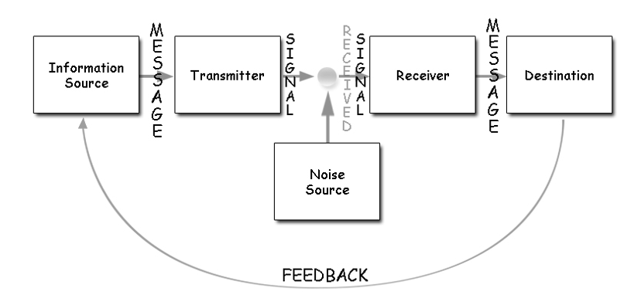
What the scheme is explaining to us is that, the sender uses a source of technological channel (telegraph/telephone) in order to send a message that he translates it into codes to be comprehensible to the mechanism and gets sent. The receiver, when getting the message, he either needs to decode the message himself or the mechanism can do it for him. Although external factors can interfere in the receipt of the message, for example, not having signal on the phone, which can delay or stop the message from coming thru.

Berlo’s model of communication

Berlo’s communication model has been inspired by Shannon Weaver’s model, his theory about communication refers to S-ender, M-essage, C-hannel, R-eciever, he considers that transmitting the message and by the time it gets to the receiver, can be influenced by many factors.
SENDER it’s the one sending the message, the message will be conceived based on the knowledge, the ability to communicate, he’s/her beliefs in relation with the religion or the law, the attitude etc. all these factors can influence the creation of the message.
MESSAGE is the text, audio, video or any other media that the sender transmits to the receiver, the message can be influenced by the content, the structure (format), the elements and the code.
CHANNEL, this refers to what the sender uses as a method of transmitting the message, can be throughout internet or telephone etc, the channel can be influence by the senses like hearing, seeing and touching.
RECEIVER, in order for the message to be properly received, the receiver has to have similar comprehension as the sender, so he can understand the message as what it’s supposed to mean, receiver must have the knowledge and the understanding.

Schramm’s model of communication

The models we presented earlier, have been created by people that communication wasn’t their first interest or their area of expertise, whilst Wilbur Schramm studied the communication major as a primary discipline.
Wilbur Schramm was the one that came up with the model of communication in 1954, stating that the information is useless until is well put into words and carried to others. The moment that the information is delivered, it must be programmed in such a way that the receiver gets the right message. Schramm’s model focuses mostly on coding and decoding as being the two essentials for a successful communication.
Schramm’s model has thought me that when we want to send a message, it’s good to know who are your receivers, you can be going on and on about things that you know and use academic talk or mathematical information, it will be pointless if the receiver will not understand your message, that way, knowing your public, you will know how to send your message in a comprehensive way.

Effective Teamwork

Throughout this module and class exercises, we have learned how important is communication in building a team. I would say that a group is not a team unless they find a way to good communication, sharing information that is comprehensive for everyone so they save time and they don’t get lost in misinterpretation, discovering each other’s skills and abilities so they can be of best use in delivering the task’s that the team was in charged with, when a good communication is established in a team it helps them keeping connected and to keep up with the new information and the new tasks that come their way.
Reaching this level of communication, it gives us confidence, it helps us to stay motivated and to enjoy the satisfaction of our achievements, we have learned so much from one another, maybe not everything that has to do with school or work, sometimes because of good communication, we can even help each other with life advices. In doing our assessments, we share, we discuss, what one doesn’t know, the other one might do, the possibility of having so many ways of communication in this century is giving us a lot of opportunities, we have created our chat group so we can always keep in touch and help when one of us it’s in need.

Conclusion

We all have a basic knowledge about communication, and we all use some of the methods daily and without special training or without giving it so much importance, this module, has helped me understand better, I have achieved a higher level in my life and understood more ways of communication. Thanks to all the experts that have managed throughout centuries to find the best ways of explaining communication, in mathematical ways, psychological methods, philosophical etc. all these have brought us today.
We have found ways and methods to send our messages to those that need to receive it in the best possible way. I can say that I have a better understanding, and this helped us build our team and keep us united.
The understanding of this module gives me a better perspective for my future and for my plans, it’s helping me in my personal life, at work I have started to make some changes and to pay more attention to my attitude and my posture so I can be more appealing to my customers. And for when I will open my business, the knowledge that I gained so far will help me create better relationships with my staff, with my suppliers and not the least, with my customers.

References

Adair, J.E. “Effective Teambuilding: How to make a winning team” Pan Books publication, London (2009)

Berlo D “The process of communication: An introduction to theory and practice.” Published by Rinehart and Winston. New York (1960).

Berlo’s SMCR Model of Communication, accessed on 18.08.2019 at: https://www.businesstopia.net/communication/berlo-model-communication

Morgan P. “The Business Student’s Guide to Study and Employability” Sage Publications London (2016)

Schramm W. “How communication works. In W. Schramm edition, The process and effects of mass communication.”: University of Illinois Press. Urbana, IL (1954)



