Taylor Dawn Hodges
2008862@uwtsd.student.ac.uk
BSc Computing (Software Engineering)
Lecturer: M Dacey and T Bashford
Due: 19/11/21
Advanced Software Development (ACCB5011)
OOP PROGRAMMING (C++)

Contents
Table of figures 2
1 Intro 3
2 Game features 3
3 Importance of OOP 5
3.1 Clear structure and ease of maintenance 5
3.2 Quicker to code 6
3.3 Effectively simulate the real world 7
3.4 Ease of understanding code 7
3.5 More efficient than procedural programming 8
3.6 Reusable code 8
3.7 Reduced repetition 8
3.8 Avoid global variables 9
3.9 Classes manage their objects 10
3.10 Construct and destruct 10
3.11 Encapsulation and security 11
3.12 Inheritance 12
3.13 Polymorphism amd class-specific behaviours 12
4 Testing 14
4.1 Number of rounds 14
4.2 Coordinate input 15
4.3 Round results 16
4.4 Game winner 16
4.5 Play again 17
5 Game demo 18
6 Conclusion 18
Appendix 19
Bibliography 31

Table of figures
Diagram 1: Classes and inheritance of noughts and crosses program 3
Diagram 2: Private attributes and public methods in classes of noughts and crosses program part 1 4
Diagram 3: Private attributes and public methods in classes of noughts and crosses program part 2, screen classes 4

Screenshot 1: Board.h, showing its relevant methods and attributes in its file. 5
Screenshot 2: A plan to identify potential problems to avoid in the construction of the noughts and Crosses game. 6
Screenshot 3: Board.h, board class showing its relevant methods and attributes used to manage the board. 7
Screenshot 4: Source.cpp, the main program using various classes to get, set, and print object attributes using methods. 7
Screenshot 5: Player.cpp, constructor. 8
Screenshot 6:Player constructor being called with a loop. 8
Screenshot 7: Board.h, board class showing its private attribute _board. 9
Screenshot 8: Player.cpp, public methods used to get or set attributes 10
Screenshot 9: Player.cpp, constructor. 10
Screenshot 10: Source.cpp, deleting of objects 11
Screenshot 11: an example of a deconstructor in the screen class. 11
Screenshot 12: Calling the deconstructor. 11
Screenshot 13: Player.h, the player class has both private attributes and public methods. 12
Screenshot 14: use of inheritance in the start screen. 12
Screenshot 15: Screen.cpp, shows base class method “PrintMessage”. 12
Screenshot 16: StartScreen.cpp, shows derived class method "PrintMessage" using polymorphism. 12
Screenshot 17: RulesScreen.cpp, shows derived class method "PrintMessage" using polymorphism. 12
Screenshot 18: EndScreen.cpp, shows derived class method "PrintMessage" using polymorphism 13

Table 1: Test Table: Number of rounds 14
Table 2: Test Table: Coordinate input 15
Table 3: Test Table: Round results 16
Table 4: Test Table: Game winner 17
Table 5: Test Table: Play again 17

1 Intro
“A programming paradigm is the structure and approach of a programming language.” [1] There are various programming paradigms including imperative, procedural, Object-oriented programming (OOP), etc. available in various languages.
In this assignment, C++ is used with the OOP paradigm to construct a 2-player game, with classes, appropriate attributes and methods, use of encapsulation, inheritance, and polymorphism.

2 Game features
Noughts and Crosses app:
- The app begins by printing a start message and the rules, before asking for the players’ names and the number of rounds (1-9).
- The two players take turns to place their pieces on the 3x3 board. The first player to get three in a row wins that round and scores a point.
- The winner of the game is the player with the highest score by the end of the last round.
- Play again (Y/N)? If the game is played again, the scores reset to 0 as new player instances are created.

The game includes nine classes:

Diagram 1: Classes and inheritance of noughts and crosses program
Of these classes, the screen is a base class for the derived classes start screen, rules screen, and end screen.

Each class has individual attributes and methods.

Diagram 2: Private attributes and public methods in classes of noughts and crosses program part 1

Diagram 3: Private attributes and public methods in classes of noughts and crosses program part 2, screen classes
These screen classes use inheritance and polymorphism to override the “PrintMessage” function.

3 Importance of OOP
Procedural programming is the first programming paradigm that most developers learn. It is constructed from “sequential execution of instructions” [2], meaning a sequence of many loose functions in a file with the main. As some programmes are thousands of lines long, and the bigger the file, the more complicated it becomes: “extremely large applications can become difficult to maintain by one developer,” [3] This is where OOP is commonly the preferred method.
“The main aim of OOP is to bind together the data and the functions that operate on them so that no other part of the code can access this data except that function.” [4]
OOP is a fundamental programming paradigm structured around the concept of real-world “objects” with “classes” to manage their data and functions, rather than functions or logic [5] [6] [7]. OOP incorporates features such as inheritance and polymorphism to increase functionality while decreasing code and consider encapsulation as a means of securing attributes and methods.
The following are some of the benefits and important qualities of OOP.

3.1 Clear structure and ease of maintenance
The use of OOP includes classes (used as blueprints) to construct instances of objects with relevant attributes and methods [8]. Using classes ‘cleans up’ code putting functions in relevant files, as opposed to procedural programming: according to w3schools, “OOP provides a clear structure for the programs.” [9]
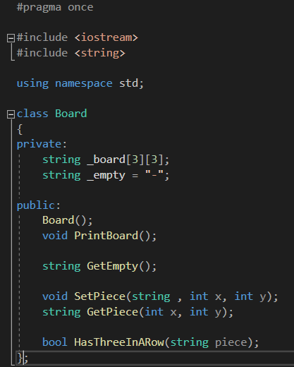
Screenshot 1: Board.h, showing its relevant methods and attributes in its file.
The use of OOP has grouped the relevant attributes and methods for the board together in a class, this means it is easier to maintain.

3.2 Quicker to code
OOP requires planning to consider what classes are needed to manage their objects, this can then be translated into code more efficiently and effectively than procedural programming: “A developer is able to create an application at least 20 times faster using OOP when compared with the procedural programming approach.” [2]
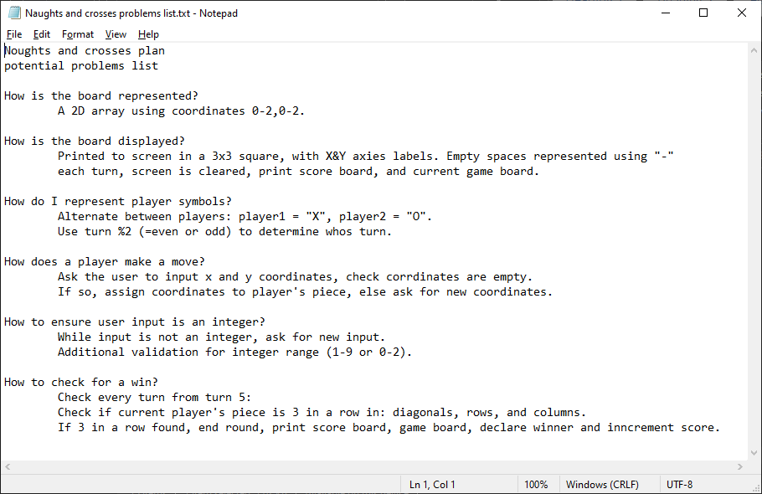
Screenshot 2: A plan to identify potential problems to avoid in the construction of the noughts and Crosses game.
After creating a plan, the construction of the program was efficient and effective, completing writing in just a few days. Overall OOP, including planning time, is much faster than procedural programming, and continues to be faster as the code gets bigger and bigger.

3.3 Effectively simulate the real world
By considering classes as ‘managers’ of their objects, we can imagine how they need to be grouped.
Object-oriented programming groups things around nouns, such as customer and invoice, which you’ll recognize as objects. In contrast, procedural programming groups things around verbs. A verb in the real world is a task [10].
The concept of modelling classes on nouns (objects) and their attributes is one that the human brain can grasp more than verbs (procedures), this is because they are processed in different parts of the brain. Studies have shown that there is “a positive correlation between activation of certain parts of the brain and the efficiency of learning new nouns, but not new verbs.” [11] Therefore, writing in object-oriented programming is easier to mentally visualise than procedural programming.
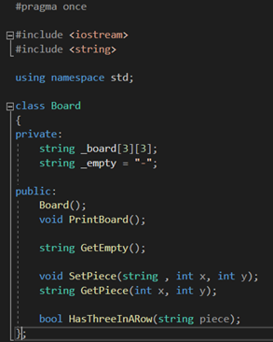
Screenshot 3: Board.h, board class showing its relevant methods and attributes used to manage the board.

3.4 Ease of understanding code
Furthering the clear structure and logical concepts behind OOP, it is fair to say it is easier to inherit and understand OOP projects than procedural code. This is valuable as a group of people will work on one larger program, therefore it is crucial that everyone can follow others’ code. OOP offers more effective team working and quicker writing time.
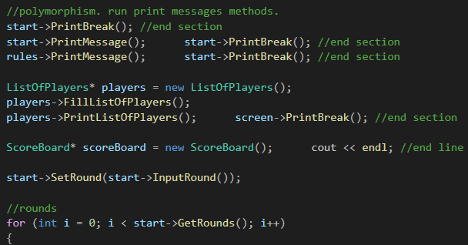
Screenshot 4: Source.cpp, the main program using various classes to get, set, and print object attributes using methods.
The created methods are named appropriately to tell the reader what they do, along with the parameter.

3.5 More efficient than procedural programming
Due to the groups of classes and individual files, it is easier to maintain OOP, therefore reducing the development time:
“Any complex application can be developed in a more manageable and maintainable way by using object-oriented programming (OOP). It is more efficient than procedural programming for developing large and complicated applications.” [12]
OOP can also reduce development time by reusing code. E.G, my board, player, and other classes could be reused to create a Connect-4 game with minimal changes required.

3.6 Reusable code
“OOP makes it possible to create full reusable applications with less code and shorter development time.” [9] Once a class has been created, it can be repeated everywhere, including in a completely different project.
I have not used this feature in this assignment; however, it is now possible to reuse classes from this project in future projects. E.G, in a Ludo app, I may use the player class for 2-4 players with a name, a score, and a piece.

3.7 Reduced repetition
Don't repeat yourself (DRY) “Every piece of knowledge must have a single, unambiguous, authoritative representation within a system.” [13] Reducing repetition is very important as it reduces the chance of errors. It also reduces the amount of data in a file, therefore increasing the ability to read and debug code, and increasing execution time.
Since a class works like a blueprint for creating an object, it can be replicated for as many instances as desired without repeating code.
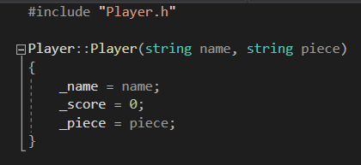
Screenshot 5: Player.cpp, constructor.

Screenshot 6:Player constructor being called with a loop.
By using classes, I can construct as many players as I need, in any project.

3.8 Avoid global variables
By using classes and private attributes, the use of global variables can be eliminated, this is ideal as global variables are insecure variables that can be manipulated from anywhere.
Screenshot 7: Board.h, board class showing its private attribute _board.
The board cannot be manipulated by any class except the board. To manipulate the private attribute board, the public getters and stters must be used instead.

3.9 Classes manage their objects
Classes are like managers of their objects, they use their “get” and “set” methods to manipulate their individual instances of objects and their attributes.
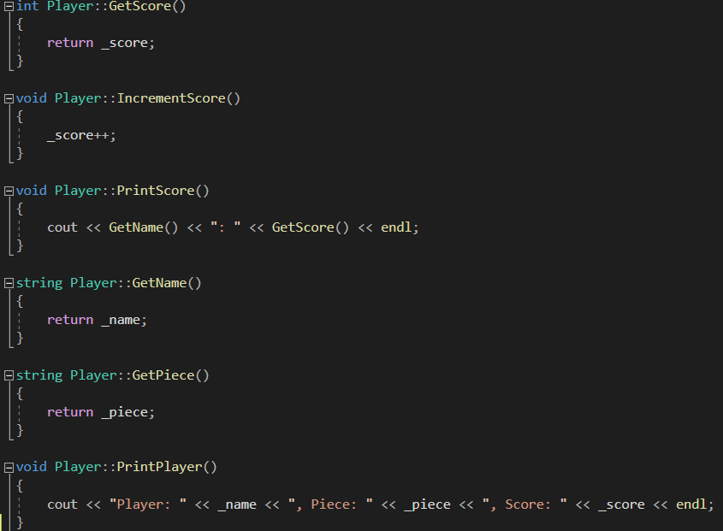
Screenshot 8: Player.cpp, public methods used to get or set attributes
I have used many classes as many managers of various objects, inputs, outputs, etc. By doing so, also makes it easier to find my functions as all player methods are in the player class.

3.10 Construct and destruct
Classes enable the use of constructors and destructors. These can be used to create many specific constructors or destructors for an object instance. Destructors are used to automatically delete an object; this is useful for memory management; it ensures no memory leaks.
Screenshot 9: Player.cpp, constructor.
The Player constructor requires a name and piece but automatically sets the score to 0.
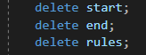
Screenshot 10: Source.cpp, deleting of objects
An alternative to deleting objects could be to create destructors. This would be preferred in larger code where it might be more difficult to keep track of deleting objects, and also allows the user to specify code which will run every time an object instance is destroyed.
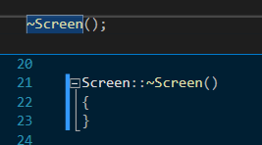
Screenshot 11: an example of a deconstructor in the screen class.

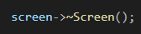
Screenshot 12: Calling the deconstructor.

3.11 Encapsulation and security
Access Specifiers such as private is used in classes to protect their attributes from unauthorised access. This is important to consider as users could try to change the value of an attribute if they were not protected: “common object-oriented design patterns intended to prevent clients of an interface from accessing implementation details, can also be used to prevent malicious code from accessing sensitive resources.” [14]
Commonly used properties “get” and “set” is used to read and write private attributes in a class without increasing access to the attributes [15] [16].
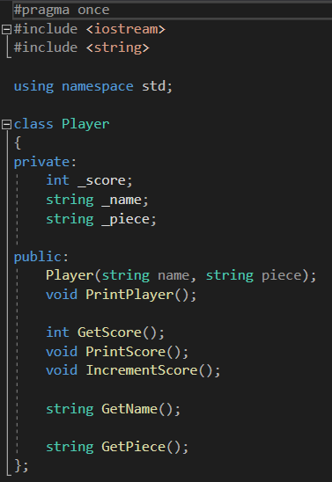
Screenshot 13: Player.h, the player class has both private attributes and public methods.
In the player class, the name, score, and pieces must be secure so that users cannot manipulate them on their own accord. Get and set methods have been created to allow a safe path for their read and write ability.

3.12 Inheritance
Using inheritance can further reduce repetition. This works by a derived class (child) inheriting attributes and methods from the base class (parent), making them callable from the derived class, reducing repetition: “It is useful for code reusability: reuse attributes and methods of an existing class when you create a new class.” [17]
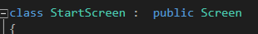
Screenshot 14: use of inheritance in the start screen.

3.13 Polymorphism amd class-specific behaviours
Polymorphism is a feature in inheritance where a derived class can overwrite a function in a base class for desired differences in a method: “This allows us to perform a single action in different ways.” [18] Polymorphism can be used to run the same function through several different child classes and achieve their bespoke function.
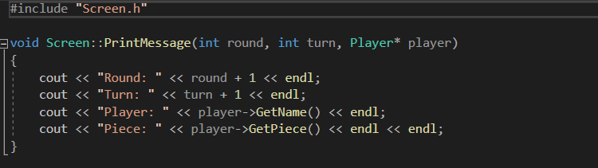
Screenshot 15: Screen.cpp, shows base class method “PrintMessage”.

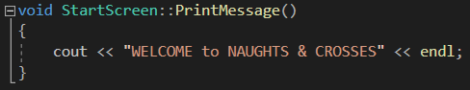
Screenshot 16: StartScreen.cpp, shows derived class method "PrintMessage" using polymorphism.

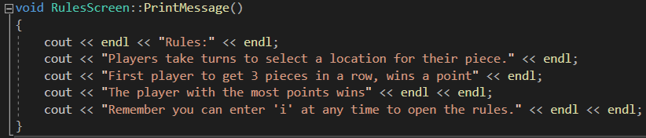
Screenshot 17: RulesScreen.cpp, shows derived class method "PrintMessage" using polymorphism.

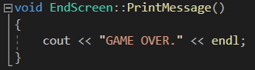
Screenshot 18: EndScreen.cpp, shows derived class method "PrintMessage" using polymorphism
I have used polymorphism to change the “PrintMessage” function to specialise it in accordance with the derived class.

4 Testing

4.1 Number of rounds
The user inputs number of rounds, this must be an integer inclusively between 1-9. Any other inputs should not be accepted and require another input.
#. | Description | Expected | Actual | P/F | Image
1 | String input | Reject, ask for another input | As expected | P
2 | Float | Reject, ask for another input | As expected | P
3 | Negative integer | Reject, ask for another input | As expected | P
4 | Integer out of range | Reject, ask for another input | As expected | P
5 | Integer within range | Accepts and starts the game | As expected | P | Prints the ClearScreen function and starts the game.
Table 1: Test Table: Number of rounds

4.2 Coordinate input
The user inputs number of rounds, this must be an integer inclusively between 0-2. An input of “I” will print the rules, any other inputs should not be accepted and require another input. Furthermore, any input board coordinates that are unavailable will not be accepted and will ask for new inputs.
#. | Description | Expected | Actual | P/F | Image
6 | Input “i” | Prints rules message before proceeding | Did not run rules message, asked for another input | F | Has since been rectified see below.
7 | Input “i” or “I” | Prints rules message before proceeding | As expected | P | 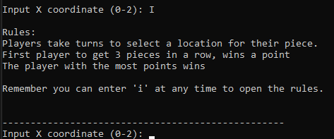
8 | String input | Reject, ask for another input | A string was accepted and while loop rand forever | F | Has since been rectified see below.
9 | String input | Reject, ask for another input | As expected | P
10 | Float | Reject, ask for another input | As expected | P
11 | Negative integer | Reject, ask for another input | As expected | P
12 | Integer out of range | Reject, ask for another input | As expected | P | Message now reads “Not a valid integer (0-2), please try again.”
13 | Integer within range | Accepts and repeats for two inputs | As expected | P | 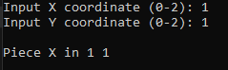
14 | Inputting unavailable coordinates | Asks for new coordinates | As expected | P | 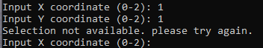
Table 2: Test Table: Coordinate input

4.3 Round results
The player who first gets three in a row is declared the winner of that round and their score is incremented. If the round is a tie, no players are awarded points. The score and board are printed to screen.
#. | Description | Expected | Actual | P/F | Image
15 | One winner | Prints winner message, scoreboard and game board | As expected | P | 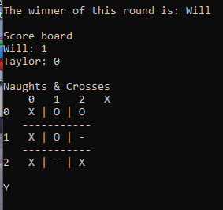
16 | A draw | Prints draw message, scoreboard and game board | As expected | P | 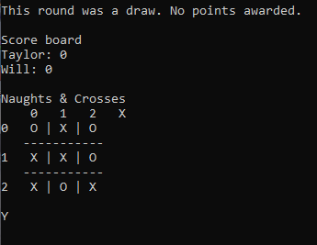
Table 3: Test Table: Round results

4.4 Game winner
The player who gets the highest score by the end of the last round is declared the winner. If the score is tied, both players are winners. The score is printed on the screen.
#. | Description | Expected | Actual | P/F | Image
17 | One winner | Prints winner message and score | As expected | P | 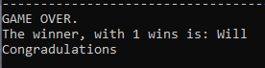
18 | A draw | Prints draw message and score | As expected | P | 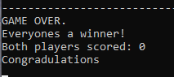
Table 4: Test Table: Game winner

4.5 Play again
After the game is complete, the game asks for a “play again” input. If the user inputs “Y” or “Yes” in any case, the game will start over, otherwise the game is over.
#. | Description | Expected | Actual | P/F | Image
19 | Input “Y” or “y” | Starts game again | As expected | P | 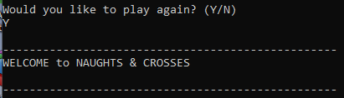
20 | Input “YES”, “Yes” or “yes” | Starts game again | As expected | P | 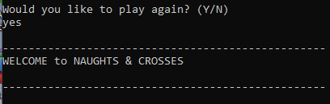
21 | Input anything else | Game ends | As expected | P | 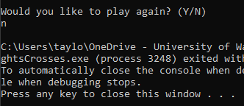
Table 5: Test Table: Play again

5 Game demo
https://youtu.be/zdwi3tJ9zxA
The video includes two games.
Game one: happy-path testing.
- Firstly, the rules are called.
- One round, the game is played and ends in a draw.
- The results are announced correctly.
- This works as expected.

Game two: alternative-path testing.
- Testing coordinate inputs. Only 0, 1 and 2 are accepted: all integer inputs reject strings, floats, negative numbers, and integers outside of the stated ranges.
- Two rounds, one draw and one win.
- The correct winner is announced, and the scoreboard is correct.
- The game works as expected.

6 Conclusion
In conclusion, it may take longer to learn OOP over procedural programming, however, in the long run it will be more time efficient and beneficial. OOP is a well-structured programming paradigm that works well especially when working as a team. It is a good strategy for developers as classes are reusable outside of the project which in turn cuts down development time.
In using OOP for this program, it quickly made many files, which seems overwhelming, however, there is minimal but relevant code in each file; this made it quick and easy to find the functions I was looking for, and where to locate new functions.
It is recommended to use OOP over procedural programming as the structure makes it easy to find and understand everything, this is vital when working in teams so that each member can take a section to work on and be able to understand others’ sections for when they are ill, etc.
In the writer of this reports opinion’s, OOP is a valuable skill to have, and is one of the most useful programming paradigms; all new developers should attempt OOP paradigm as it will build their pre-existing skills whilst giving their code a logical structure, great for maintaining.
Overall OOP will improve over time and will become very good for shorter time constraints especially once several classes have been constructed for reuse.

Appendix

Source.cpp
#include <string>
#include <iostream>

#include "Screen.h" //parent. PrintMessage()
#include "StartScreen.h" //child start message
#include "RulesScreen.h" //child rules message
#include "EndScreen.h" //child end message
#include "Board.h"
#include "Coordinates.h"
#include "Player.h"
#include "ListOfPlayers.h"
#include "ScoreBoard.h"

using namespace std;

int main(int argc, char* argv[])
{
Screen* screen = new Screen();
StartScreen* start = new StartScreen();
EndScreen* end = new EndScreen();
RulesScreen* rules = new RulesScreen();

//play again loop
do
{
//polymorphism. run print messages methods.
start->PrintBreak(); //end section
start->PrintMessage(); start->PrintBreak(); //end section
rules->PrintMessage(); start->PrintBreak(); //end section

ListOfPlayers* players = new ListOfPlayers();
players->FillListOfPlayers();
players->PrintListOfPlayers(); screen->PrintBreak(); //end section

ScoreBoard* scoreBoard = new ScoreBoard(); cout << endl; //end line

start->SetRound(start->InputRound());

//rounds
for (int i = 0; i < start->GetRounds(); i++)
{
int turn = 0;
bool threeInARow = false;
Board* board = new Board();
Coordinates* coordinates = new Coordinates;
Player* player = players->GetPlayersTurn(turn);

//turns
while (turn < 9 && threeInARow == false)
{
screen->ClearScreen();
scoreBoard->PrintScoreBoard(players->GetListOfPlayers()); screen->PrintBreak(); //end section

//find current player
player = players->GetPlayersTurn(turn);

//print round, turn, player name, piece
screen->PrintMessage(i, turn, player);
board->PrintBoard();

//input coordinates. if coordinate is not empty, input again
coordinates->SetCoordinates(board, player);

//pause
cin.get(); cin.get(); screen->PrintBreak(); //end section

//from turn 5, check for winner
if (turn >= 4 && board->HasThreeInARow(player->GetPiece()))
{
threeInARow = true;
player->IncrementScore();
break; //break from while loop. no increment
}
turn++;
}
screen->ClearScreen();

scoreBoard->DeclareWinnerOfRound(player, threeInARow);

scoreBoard->PrintScoreBoard(players->GetListOfPlayers());
board->PrintBoard();

//pause
cin.get();

delete board;
}

screen->PrintBreak();
end->PrintMessage();

scoreBoard->DeclareWinnerOfGame(players->GetListOfPlayers(), end);

//pause
cin.get();

} while (end->PlayAgain());

delete start;
delete end;
delete rules;

screen->~Screen();

return 0;
}

Board.h
#pragma once

#include <iostream>
#include <string>

using namespace std;

class Board
{
private:
string _board[3][3];
string _empty = "-";

public:
Board();
void PrintBoard();

string GetEmpty();

void SetPiece(string , int x, int y);
string GetPiece(int x, int y);

bool HasThreeInARow(string piece);
};

Board.cpp
#include "Board.h"

Board::Board()
{
for (int x = 0; x < 3; x++) //rows
{
for (int y = 0; y < 3; y++) //columns
{
_board[x][y] = _empty;
}
}
}

void Board::PrintBoard()
{
cout << endl << "Noughts & Crosses" << endl; //title
cout << " 0 1 2 X" << endl; //x axies

for (int x = 0; x < 3; x++) //rows
{
cout << x << " "; //y axies & frame
for (int y = 0; y < 3; y++) //columns
{
cout << _board[x][y];
if (y !=2){cout << " | ";} //internal horizontal grid
}

if (x !=2){cout << endl << " -----------" << endl;} //internal vertical grid
}
cout << endl << endl << "Y" << endl << endl; //y axies title
}

string Board::GetEmpty()
{
return _empty;
}

void Board::SetPiece(string piece, int x, int y)
{
_board[y][x] = piece;
}

string Board::GetPiece(int x, int y)
{
return _board[y][x];
}

bool Board::HasThreeInARow(string piece)
{
bool ThreeInARow = false;
//diagonal 1
if (_board[0][0] == piece && _board[1][1] == piece && _board[2][2] == piece)
{
ThreeInARow = true;
}
//diagonal 2
else if (_board[0][2] == piece && _board[1][1] == piece && _board[2][0] == piece)
{
ThreeInARow = true;
}
else
{
for (int c = 0; c < 3; c++)
{
//rows
if (_board[0][c] == piece && _board[1][c] == piece && _board[2][c] == piece)
{
ThreeInARow = true;
break;
}
//columns
else if (_board[c][0] == piece && _board[c][1] == piece && _board[c][2] == piece)
{
ThreeInARow = true;
break;
}
}
}
return ThreeInARow;
}

Coordinates.h
#pragma once
#include "Board.h"
#include "Player.h"

class Coordinates
{
private:
int InputCoordinate(string variable);
public:
void SetCoordinates(Board* board, Player* player);
};

Coordinates.cpp
#include "Coordinates.h"
#include "RulesScreen.h"

RulesScreen* rules = new RulesScreen;

int Coordinates::InputCoordinate(string variable)
{
string checkint;
int c = 3;

do
{
cout << "Input " << variable << " coordinate (0-2): ";
cin >> checkint;

if (checkint == "i" || checkint == "I") //open rules
{
rules->PrintMessage(); rules->PrintBreak(); //end section
}
else if (checkint.length() > 1 || isdigit(checkint[0]) == false) //length & data type validation
{
cout << "Not a valid Integer (0-2), please try again. ";
}
else
{
c = stoi(checkint); //string to int
}

} while (c < 0 || c > 2); //value validation

return c;
}

void Coordinates::SetCoordinates(Board* board, Player* player)
{
int x = InputCoordinate("X"), y = InputCoordinate("Y");

while (board->GetPiece(x, y) != board->GetEmpty())
{
cout << "Selection not available. please try again." << endl;
x = InputCoordinate("X");
y = InputCoordinate("Y");
}

board->SetPiece(player->GetPiece(), x, y); //set piece at cooordinates
cout << endl << "Piece " << player->GetPiece() << " in " << x << " " << y << endl << endl;
}

Player.h
#pragma once
#include <iostream>
#include <string>

using namespace std;

class Player
{
private:
int _score;
string _name;
string _piece;

public:
Player(string name, string piece);
void PrintPlayer();

int GetScore();
void PrintScore();
void IncrementScore();

string GetName();

string GetPiece();
};

Player.cpp
#include "Player.h"

Player::Player(string name, string piece)
{
_name = name;
_score = 0;
_piece = piece;
}

int Player::GetScore()
{
return _score;
}

void Player::IncrementScore()
{
_score++;
}

void Player::PrintScore()
{
cout << GetName() << ": " << GetScore() << endl;
}

string Player::GetName()
{
return _name;
}

string Player::GetPiece()
{
return _piece;
}

void Player::PrintPlayer()
{
cout << "Player: " << _name << ", Piece: " << _piece << ", Score: " << _score << endl;
}

ListOfPlayers.h
#pragma once
#include "Player.h"

class ListOfPlayers
{
private:
Player** _listOfPlayers = new Player * [2];

public:
void FillListOfPlayers();
void PrintListOfPlayers();
Player** GetListOfPlayers();

Player* GetPlayersTurn(int turn);
};

ListOfPlayers.cpp
#include "ListOfPlayers.h"

void ListOfPlayers::FillListOfPlayers()
{
string name, listOfPiece[2] = { "X", "O" };

for (int i = 0; i < 2; i++)
{
cout << "Player " << i + 1 << ", input name: ";
cin >> name;
_listOfPlayers[i] = new Player(name, listOfPiece[i]);
}
}

void ListOfPlayers::PrintListOfPlayers()
{
cout << endl;
for (int i = 0; i < 2; i++)
{
_listOfPlayers[i]->PrintPlayer();
}
}

Player** ListOfPlayers::GetListOfPlayers()
{
return _listOfPlayers;
}

Player* ListOfPlayers::GetPlayersTurn(int turn)
{
return _listOfPlayers[turn % 2];
}

ScoreBoard.h
#pragma once
#include "ListOfPlayers.h"
#include "EndScreen.h"

class ScoreBoard
{
public:
void PrintScoreBoard(Player** players);

void DeclareWinnerOfRound(Player* player, bool threeInARow);
void DeclareWinnerOfGame(Player** players, EndScreen* end);
};

ScoreBoard.cpp
#include "ScoreBoard.h"
#include <math.h>
#include <algorithm>

void ScoreBoard::PrintScoreBoard(Player** players)
{
cout << "Score board" << endl; //title
for (int i = 0; i < 2; i++)
{
players[i]->PrintScore();
}
}

void ScoreBoard::DeclareWinnerOfRound(Player* player, bool threeInARow)
{
if (threeInARow == true)
{
cout << "The winner of this round is: " << player->GetName() << endl << endl;
}
else
{
cout << "This round was a draw. No points awarded." << endl << endl;}
}

void ScoreBoard::DeclareWinnerOfGame(Player** players, EndScreen* end)
{
int score1 = players[0]->GetScore(),
score2 = players[1]->GetScore();

if (score1 > score2) //if player 1 score > player 2 score
{
end->PrintWinner(players[0]);
}
else if (score1 < score2) //if player 1 score < player 2 score
{
end->PrintWinner(players[1]);
}
else //else must be draw
{
end->PrintWinners(score1);
}
}

Screen.h
#pragma once
#include <iostream>
#include <string>
#include "Player.h"

using namespace std;

class Screen
{
public:
virtual void PrintMessage(int round, int turn, Player* player);

void ClearScreen();
void PrintBreak();

~Screen();
};

Screen.cpp
#include "Screen.h"

void Screen::PrintMessage(int round, int turn, Player* player)
{
cout << "Round: " << round + 1 << endl;
cout << "Turn: " << turn + 1 << endl;
cout << "Player: " << player->GetName() << endl;
cout << "Piece: " << player->GetPiece() << endl << endl;
}

void Screen::ClearScreen()
{
cout << endl << endl << endl << endl << endl << endl << endl << endl << endl << endl << endl << endl << endl << endl << endl << endl << endl << endl << endl << endl << endl;
}

void Screen::PrintBreak()
{
cout << endl << "--------------------------------------------------" << endl;
}

Screen::~Screen()
{
}

StartScreen.h
#pragma once
#include "Screen.h"

class StartScreen : public Screen
{
private:
int _rounds;

public:
StartScreen();

void PrintMessage();
int InputRound();
int GetRounds();
void SetRound(int rounds);
};

StartScreen.cpp
#include <iostream>
#include "StartScreen.h"

StartScreen::StartScreen()
{
_rounds = 1;
}

void StartScreen::PrintMessage()
{
cout << "WELCOME to NOUGHTS & CROSSES" << endl;
}

void StartScreen::SetRound(int rounds)
{
_rounds = rounds;
}

int StartScreen::GetRounds()
{
return _rounds;
}

int StartScreen::InputRound()
{
string checkint;
int rounds = 0;

do
{
cout << "Input number of rounds (1-9): ";
cin >> checkint;

if (checkint.length() > 1 || isdigit(checkint[0]) == false)//length & data-type validate
{
cout << "Not Integer 1-9, please try again. ";
}
else
{
rounds = stoi(checkint); //string to int
}

} while (rounds < 1 || rounds > 9);

cout << endl;
return rounds;
}

RulesScreen.h
#pragma once
#include "Screen.h"

class RulesScreen : public Screen
{
public:
void PrintMessage();
};

RulesScreen.cpp
#include "RulesScreen.h"

void RulesScreen::PrintMessage()
{
cout << endl << "Rules:" << endl;
cout << "Players take turns to select a location for their piece." << endl;
cout << "First player to get 3 pieces in a row, wins a point" << endl;
cout << "The player with the most points wins" << endl << endl;
cout << "Remember you can enter 'i' at any time to open the rules." << endl << endl;
}

EndScreen.h
#pragma once
#include "Screen.h"

class EndScreen : public Screen
{
public:
void PrintMessage();

void PrintWinner(Player* player);
void PrintWinners(int score);

bool PlayAgain();
};

EndScreen.cpp
#include "EndScreen.h"
#include "Player.h"

void EndScreen::PrintMessage()
{
cout << "GAME OVER." << endl;
}

void EndScreen::PrintWinner(Player* player)
{
cout << "The winner, with " << player->GetScore() << " wins is: " << player->GetName() << endl;
cout << "Congradulations" << endl;
}

void EndScreen::PrintWinners(int score)
{
cout << "Everyones a winner!" << endl;
cout << "Both players scored: " << score << endl;
cout << "Congradulations" << endl;
}

bool EndScreen::PlayAgain()
{
bool again = false;
string input;

cout << "Would you like to play again? (Y/N)" << endl;
cin >> input;

if (input=="Y" || input == "y" || input == "yes" || input == "Yes" || input == "YES")
{
again = true;
}

return again;
}

Bibliography

[1] | BBC Bitesize, “Programming paradigms - Contemporary trends in software development - CCEA - GCSE Digital Technology (CCEA) Revision,” BBC Bitesize, [Online]. Available: https://www.bbc.co.uk/bitesize/guides/zc8pjty/revision/1. [Accessed 17 November 2021].
[2] | J. S, “Difference Between OOP and Procedural Programming | Difference Between,” differencebetween, 13 March 2018. [Online]. Available: http://www.differencebetween.net/technology/software-technology/difference-between-oop-and-procedural-programming/. [Accessed 16 November 2021].
[3] | V. Harvey, “What is Procedural Programming? (with picture),” EasyTechJunkie, [Online]. Available: http://www.easytechjunkie.com/what-is-procedural-programming.htm. [Accessed 16 November 2021].
[4] | “Introduction of Object Oriented Programming,” GeeksforGeeks, 11 September 2020. [Online]. Available: https://www.geeksforgeeks.org/introduction-of-object-oriented-programming/. [Accessed 16 November 2021].
[5] | tutorialspoint, “What is object-oriented programming (OOP)?,” tutorialspoint, [Online]. Available: https://www.tutorialspoint.com/What-is-object-oriented-programming-OOP. [Accessed 15 November 2021].
[6] | E. Doherty, “What is Object Oriented Programming? OOP Explained in Depth,” Educative, 15 April 2020. [Online]. Available: https://www.educative.io/blog/object-oriented-programming. [Accessed 15 November 2021].
[7] | P. Pedamkar, “What is OOP? | Principles With Examples | Advantages & Disadvantages,” EDUCBA, 3 June 2019. [Online]. Available: https://www.educba.com/what-is-oop/. [Accessed 15 November 2021].
[8] | Moumita, “What is object-oriented programming (OOP)?,” TutorialsPoint, 14 Febuary 2018. [Online]. Available: https://www.tutorialspoint.com/What-is-object-oriented-programming-OOP. [Accessed 15 November 2021].
[9] | w3schools, “C++ OOP (Object-Oriented Programming),” w3schools, [Online]. Available: https://www.w3schools.com/cpp/cpp_oop.asp. [Accessed 15 November 2021].
[10] | J. Keogh, “Chapter 8: Real-World Modeling | OOP Demystified,” in OOP Demystified, New York, Mario Giannini, 2006, p. 130.
[11] | Plataforma SINC, “Nouns and verbs are learned in different parts of the brain,” ScienceDaily., 2010.
[12] | F. Yesmin, “Classes and Objects in PHP Examples,” linuxhint, January 2021. [Online]. Available: https://linuxhint.com/class_objects_php/. [Accessed 16 November 2021].
[13] | A. H. a. D. Thomas, The pragmatic programmer: from journeyman to master, USA: Addison-Wesley Longman Publishing Co., Inc., 2000.
[14] | Object-Oriented Security, “Object-Oriented Security,” Object-Oriented Security, [Online]. Available: http://www.object-oriented-security.org/. [Accessed 15 November 2021].
[15] | tutlane, “C# Properties (GET, SET) - Tutlane,” tutlane, [Online]. Available: https://www.tutlane.com/tutorial/csharp/csharp-properties-get-set. [Accessed 15 November 2021].
[16] | w3schools, “C++ Encapsulation and Getters and Setters,” w3schools, [Online]. Available: https://www.w3schools.com/cpp/cpp_encapsulation.asp. [Accessed 15 November 2021].
[17] | w3schools, “C++ Inheritance,” w3schools, [Online]. Available: https://www.w3schools.com/cpp/cpp_inheritance.asp. [Accessed 15 November 2021].
[18] | w3schools, “C++ Polymorphism,” w3schools, [Online]. Available: https://www.w3schools.com/cpp/cpp_polymorphism.asp. [Accessed 15 November 2021].
[19] | “Don't repeat yourself,” Wikipedia, 11 November 2021. [Online]. Available: https://en.wikipedia.org/w/index.php?title=Don%27t_repeat_yourself&oldid=1054705452. [Accessed 15 November 2021].

