THE WAY WE LIVE NOW Evaluation Form

Name: DOROTA KONEFAL

Please evaluate your work in relation to the two criteria below.

FINAL WORK:
From the final edit of 6-10 images, select & insert what you consider to be the 3 images that most successfully demonstrate your response to the project title. Please evaluate how resolved the final work seems and explain the conceptual relationship between the work and the original title. (100-150 words)

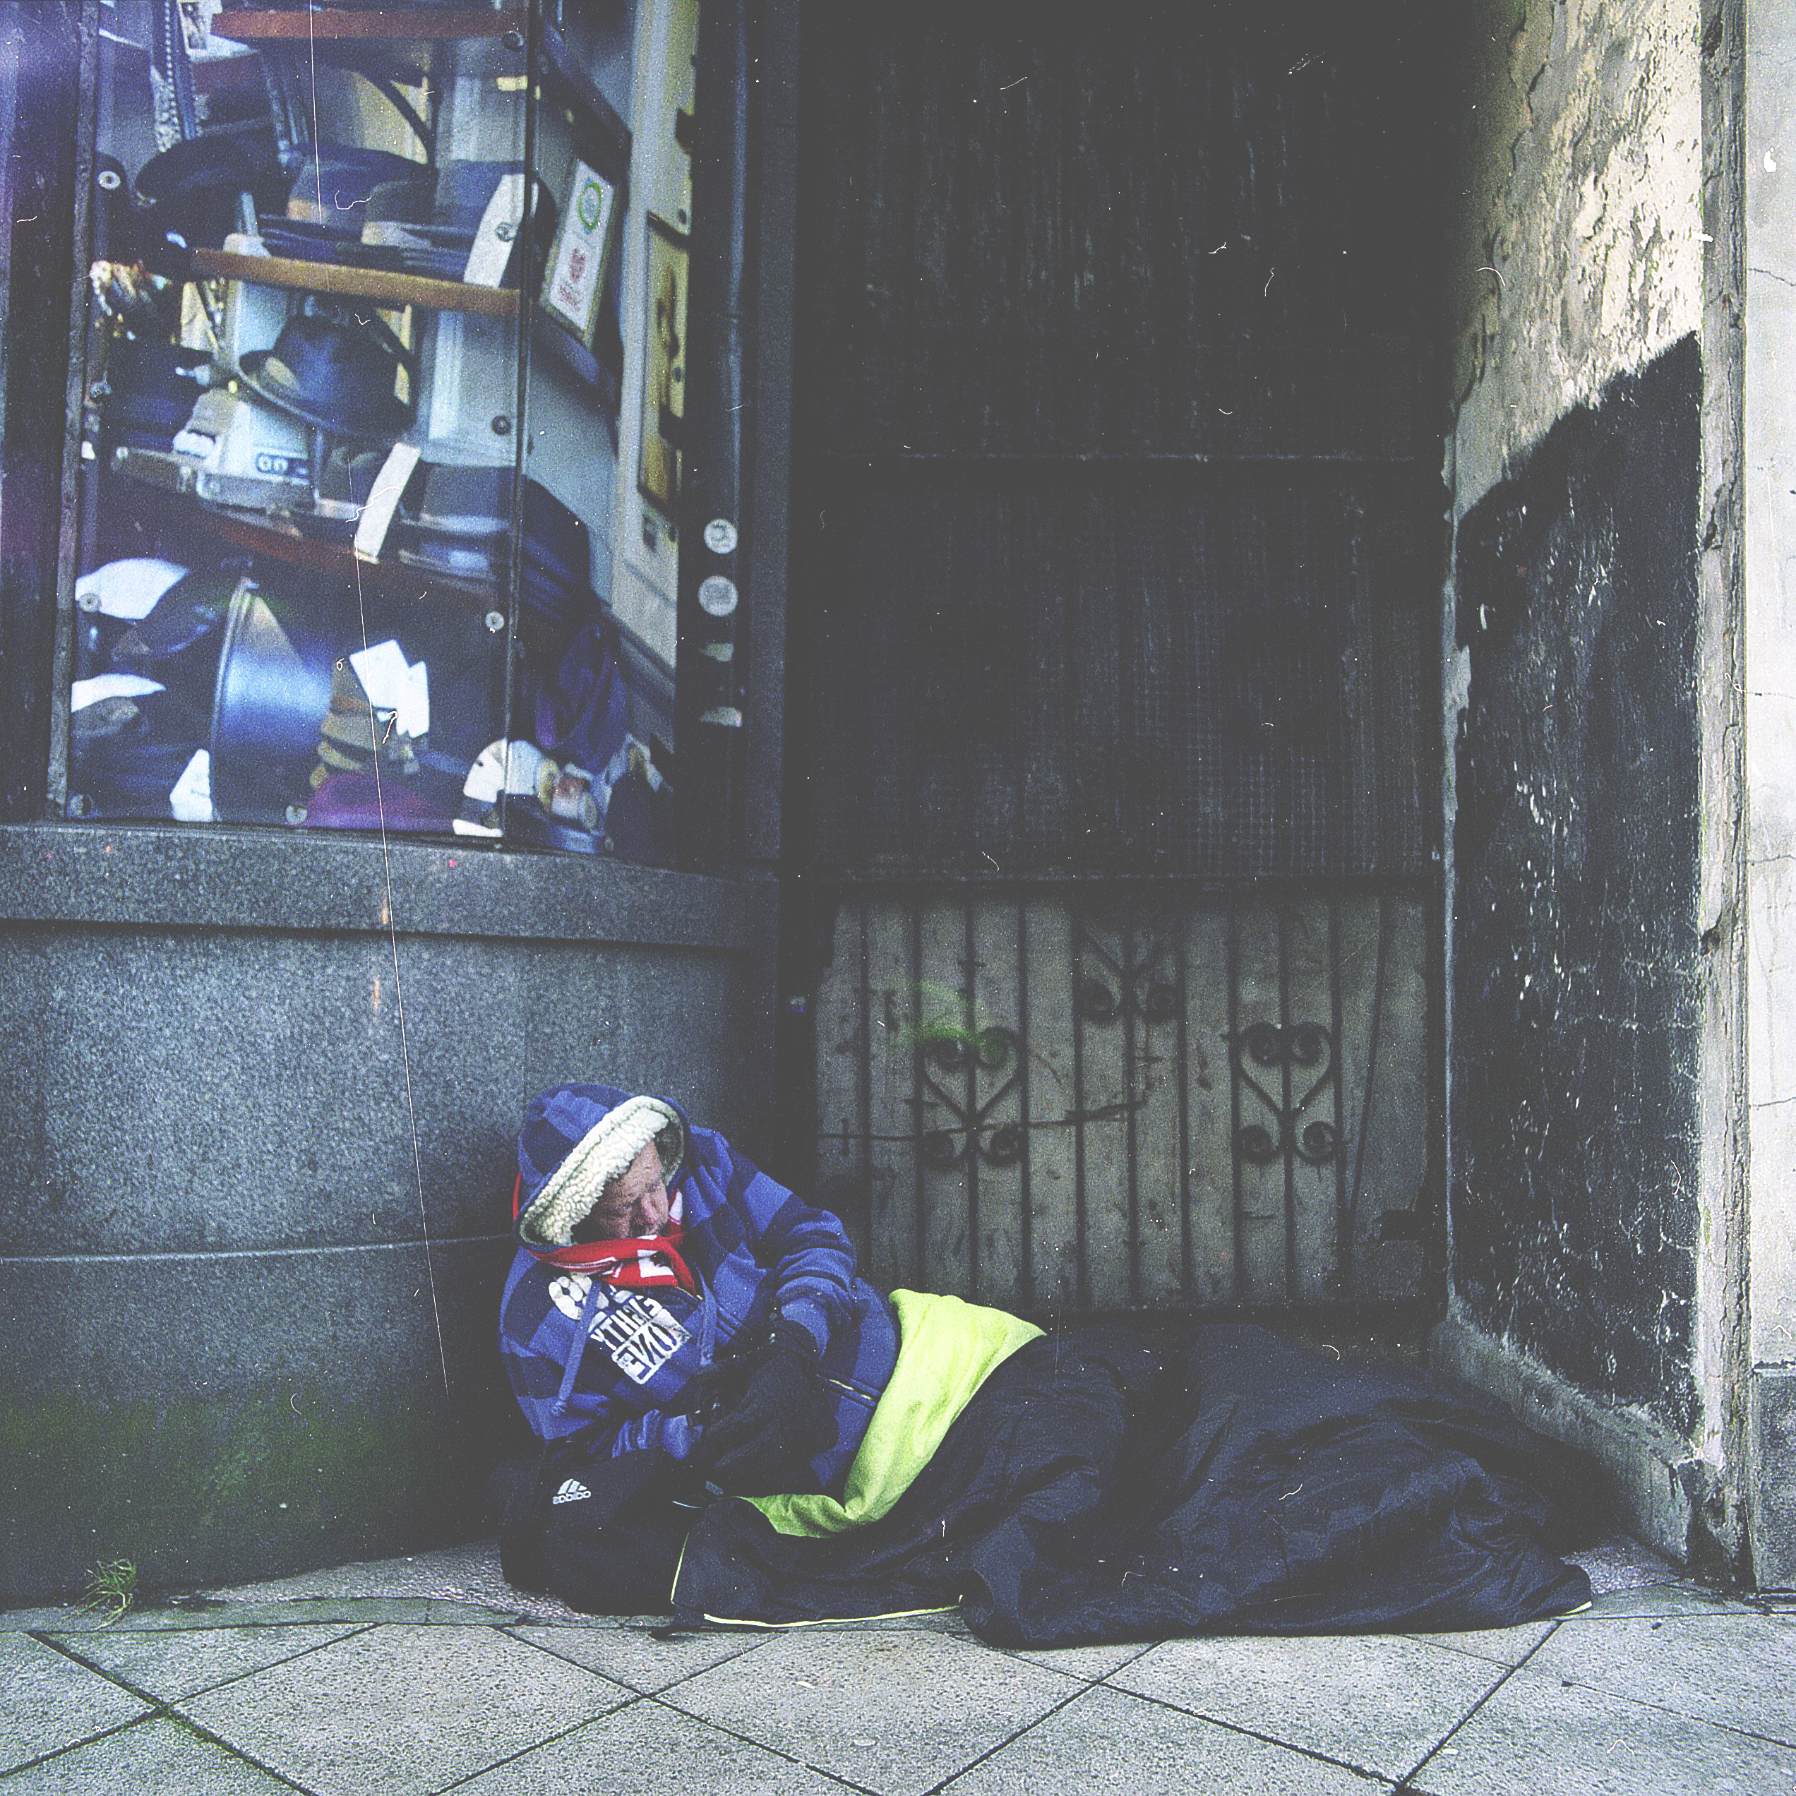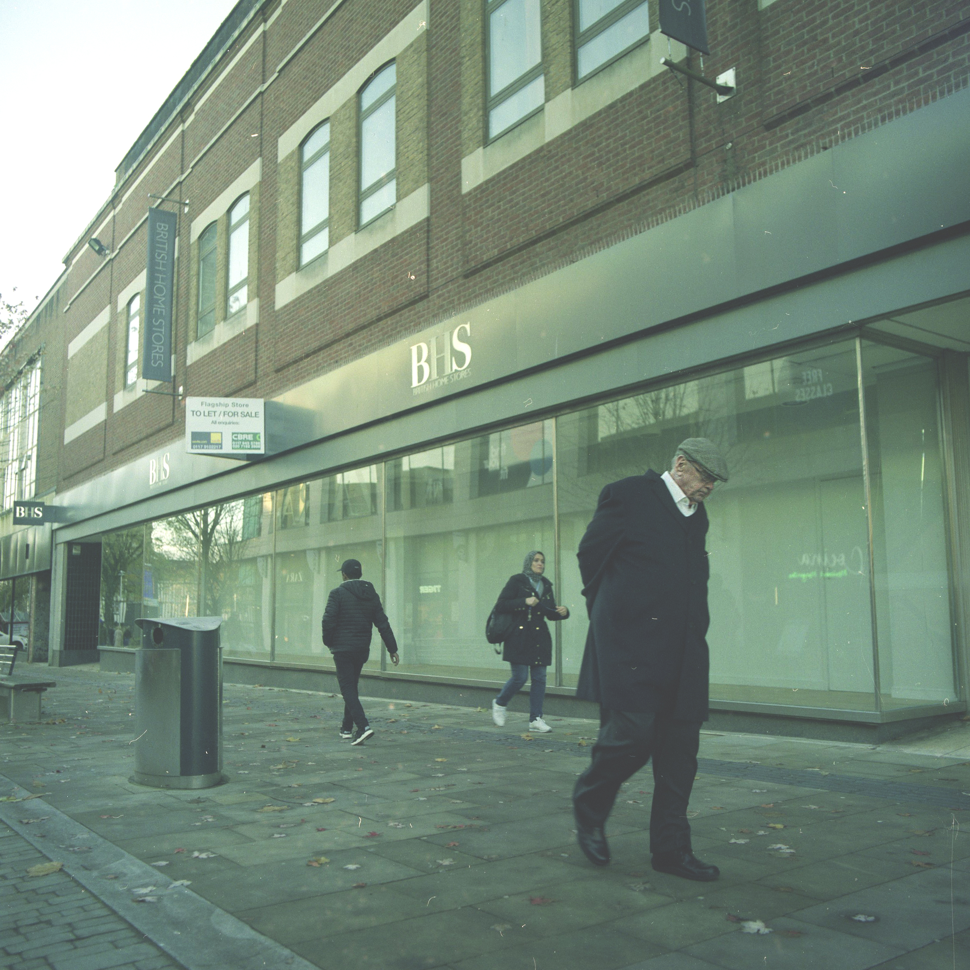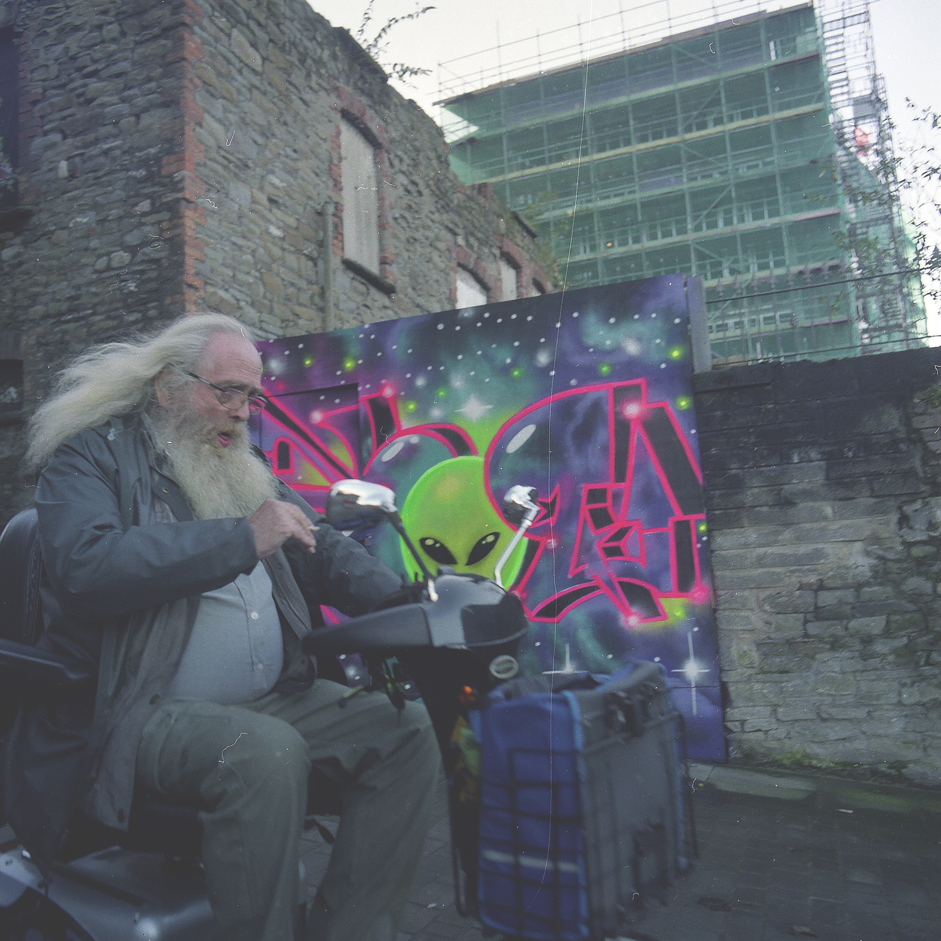

In this project I wanted to show that we are all equal by taking pictures of different people.
I decided to do street photography, because I think that’s the best idea to focus on human beings, concentrate on their gestures, the way they are walking, moving and how their facial expressions look. Each person has their individual mask, that they’re wearing every single day, but we’re all the same inside. No matter if we are homeless, fat, old, ugly, black or gay, what matter is that we all have hearts.
I’m quite happy with the results, because I think that this pictures are showing everything that I wanted include in my project. I took all the photos in the city centre- that’s another thing that is very important, because that also shows that all this people that are completely different are at the same time in same city.

RESEARCH:
Please identify the 3 pieces of research that have most influenced your project and discuss how they affected the development of your work. (100-150 words)

I decided to search some inspirations on the internet and I found lot of good photographers that are doing street photography. They are focusing on people and their behaviours. They influenced me, because their street photography is different than other people. Their photos are simple but they were taken in the way that shows everything that is the most important in this type of photography – humans. These photographers are taking pictures when they are really close to the person. It’s a mix of street photography and portraits. Usually they are taking pictures of people that are in work, they are going to work, or are coming back from shops or people that are just waiting for someone. We can say that they are coming with their photography in people’s lives. That’s why I wanted to do similar photos that they are taking.

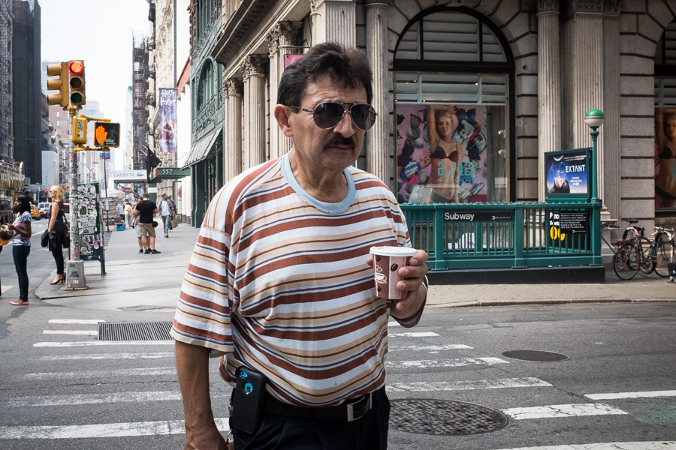 JAMES MAHER
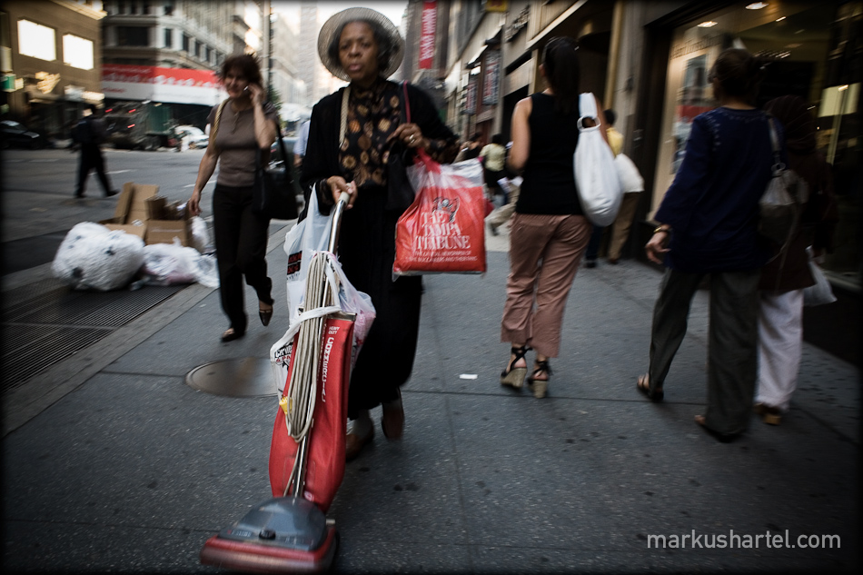 MARKUS HARTEL
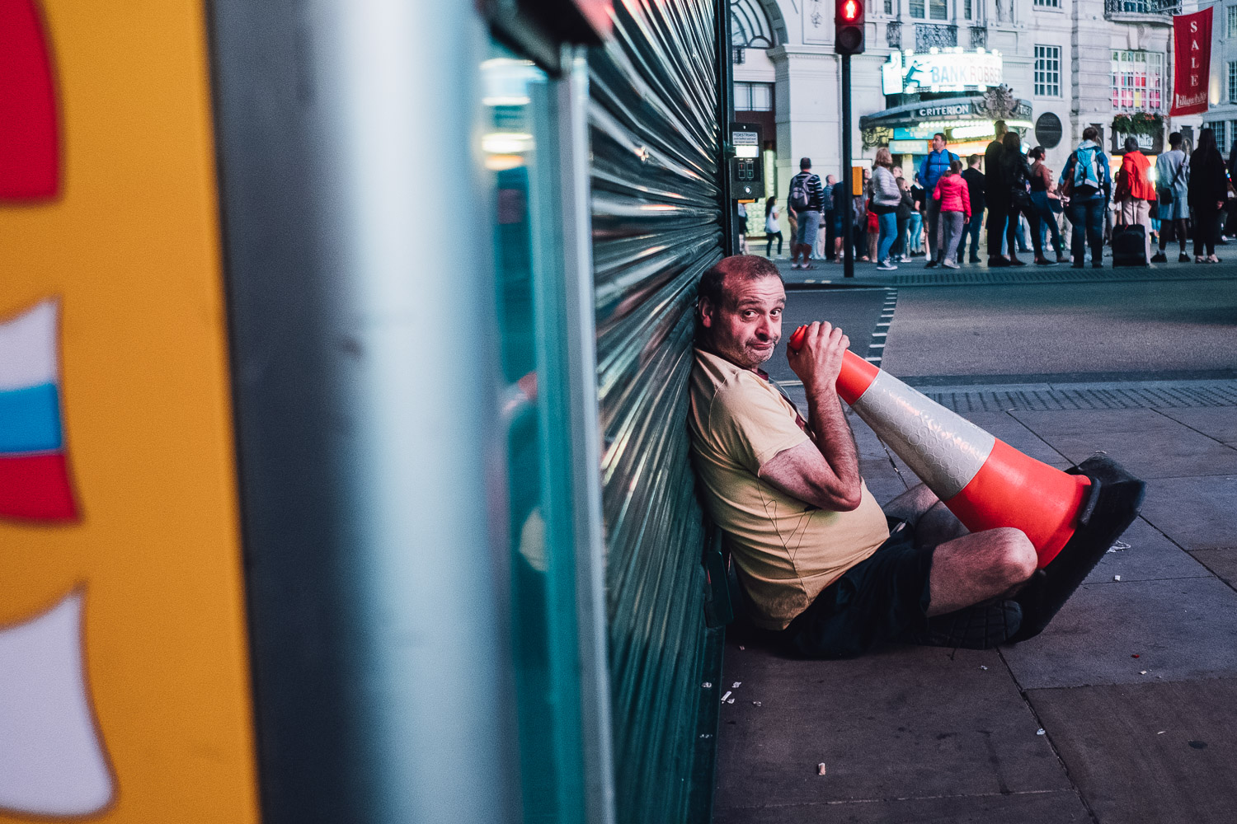 JAMES BROKENSHA

PLEASE SUBMIT TO MOODLE BY 12 NOON ON MONDAY 20th NOVEMBER

