

University of Wales Trinity Saint David
School of Engineering

Connecting Rod Accelerations, Forces and Displacements

Michael Anderson
P151178

02/10/2019

Advanced Engine Design
M6X00410

Malcolm McDonald
Contents
1. Introduction 6
2. Background Research 6
3. Basic Methodology and Equation Derivations 7
4. Analysis 15
a. Peak Gas Force (N) 15
b. Piston Acceleration (m/s²) 16
c. Max Inertia Forces on the Con-Rod (N) 17
d. Highest Net Compressive Force on Con-Rod (N) 18
e. Highest Net Tensile Force on Con-Rod (N) 19
f. Maximum Compressive and Tensile Con-Rod Stresses (N/mm²) 20
g. Ultimate Tensile Stress (UTS) 21
h. Powder Forged Steel Con-Rod Stretch and Squish Distances (mm) 22
i. Titanium Con-Rod UTS Safety Factors and Displacement Distances (mm) 23
j. Power (KW) and Torque (Nm) 25
References 26
5. Appendix 28
a. First and Second Order Inertia Forces (N) 28
b. Side Force (N) 29
a. Side Friction (N) 30
b. Ring Force (N) 31
c. Ring Friction (N) 32
d. Work Done Per Cycle Minus Frictional Losses (J) 33
e. Power Lost Per Cycle (W) 34
f. IMEP (Bar) 35
g. FMEP (Bar) 36
h. BMEP (Bar) 37

Equation 1 - Gas Force Equation 7
Equation 2 - Piston Movement Equation 1 8
Equation 3 - Piston Movement Equation 2 8
Equation 4 - Piston Acceleration Equation 8
Equation 5 - Inertia Force Equation 8
Equation 6 - Net Force Equation 8
Equation 7 - Con-Rod Angle (Phi) Equation 9
Equation 8 - Rod Force Equation 9
Equation 9 - Side Force Equation 10
Equation 10 - Radial (Ring) Force Equation 10
Equation 11 - Side Friction Force Equation 10
Equation 12 - Radial (Ring) Force Equation 10
Equation 13 - Frictional Work Done Per Degree of Crank Rotation Equation 10
Equation 14 - Total Frictional Work Done Per Degree of Crank Rotation Equation 10
Equation 15 – Total Frictional Work Done Each Cycle Per Cylinder Equation 10
Equation 16 - Total Engine Frictional Work Done Each Cycle Equation 10
Equation 17 - Power Lost Each Cycle Per Cylinder Equation 11
Equation 18 - Total Engine Power Lost Per Cycle Equation 11
Equation 19 - Gas Force Work Done Per Degree of Crank Shaft Rotation Equation 11
Equation 20 - Total Gas Work Done Per Cycle Equation 11
Equation 21 - Total Work Done Including Frictional Losses Per Cycle Equation 11
Equation 22 - Instantaneous Torque Per Degree of Crank Shaft Rotation Equation 12
Equation 23 - Inertia Torque Per Degree of Crank Shaft Rotation Equation 12
Equation 24 - Gas Torque Per Degree of Crank Shaft Rotation Equation 12
Equation 25 - Total Gas Torque Each Cycle Per Cylinder Equation 12
Equation 26 - Total Engine Gas Torque Per Cylinder Equation 12
Equation 27 - Total Inertia Torque Each Cycle Per Cylinder Equation 12
Equation 28 - Power Produced by the Engine Equation 12
Equation 29 - Indicated Mean Effective Pressure in Bar Equation 13
Equation 30 - Frictional Mean Effective Pressure in Bar Equation 13
Equation 31 - Brake Mean Effective Pressure in Bar Equation 13
Equation 32 - Compressive and Tensile Stress Through the Con-Rod Shank Equation 13
Equation 33 - Safety Factor Equation Relative to the UTS Value 14
Equation 34 - Compressive and Tensile Displacement Equation 14

Figure 1 – Trigonometric Depiction of Piston Movement Within the Cylinder (Anderson, 2019) 7
Figure 2 - Trigonometric Depiction of Angle and Lengths within the Piston and Con-Rod Assemblies (Anderson, 2019) 9
Figure 3 - Trigonometric Depiction of Angle and Lengths within the Piston and Con-Rod Assemblies (Anderson, 2019) 11
Figure 4 - Standard Engine Gas Forces vs Crank Angle 15
Figure 5 - Modified Engine Gas Forces vs Crank Angle 15
Figure 6 - Standard Engine Piston Acceleration vs Crank Angle 16
Figure 7 - Modified Engine Piston Acceleration vs Crank Angle 16
Figure 8 - Standard Engine Con-Rod Inertia Forces 17
Figure 9 - Modified Engine Con-Rod Inertia Forces 17
Figure 10 - Standard Engine Con-Rod Forces vs Crank Angle 18
Figure 11 - Modified Engine Con-Rod Forces vs Crank Angle 19
Figure 12 - Standard and Modified Engine Compressive Stress on the Con-Rod vs RPM 20
Figure 13 - Standard and Modified Engine Tensile Stress on the Con-Rod vs RPM 20
Figure 14 - Standard and Modified UTS Safety Factors for Compression Throughout the Rev Range 21
Figure 15 - Standard and Modified UTS Safety Factors for Tension Throughout the Rev Range 21
Figure 16 - Standard and Modified Distance Compressed Throughout the REV Range 22
Figure 17 - Standard and Modified Distance Stretched Throughout the REV Range 22
Figure 18 - Standard and Modified UTS Compression Safety Factors with Titanium Con-Rod 23
Figure 19 - Standard and Modified Engines UTS Tensile Safety Factors with Titanium Con-Rod 24
Figure 20 - Standard and Modified Compression Distance Throughout the REV Range with Titanium Con-Rods 24
Figure 21 - Standard and Modified Stretched Distance Throughout the REV Range with Titanium Con-Rods 24
Figure 22 - Standard and Modified Power Throughout the REV Range 25
Figure 23 - Standard and Modified Torque Throughout the REV Range 25
Figure 24 - First and Second Order Inertia Forces 28
Figure 25 - Standard Engine Piston Acceleration vs Crank Angle 28
Figure 26 - Standard Engine Side Force Throughout the RPM Range 29
Figure 27 – Modified Engine Side Force Throughout the RPM Range 29
Figure 28 - Standard Engine Side Friction Throughout the REV Range 30
Figure 29 - Modified Engine Side Friction Throughout the REV Range 30
Figure 30 - Standard Engine Piston Ring Throughout the REV Range 31
Figure 31 - Modified Engine Piston Ring Throughout the REV Range 31
Figure 32 - Standard Engine Piston Ring Friction Throughout the REV Range 32
Figure 33 - Modified Engine Piston Ring Friction Throughout the REV Range 32
Figure 34 - Standard and Modified Engine Work Done Minus Frictional Losses 33
Figure 35 - Standard and Modified Engine Work Done Minus Frictional Losses Throughout the RPM Range 34
Figure 36 - Standard and Modified IMEP Throughout the RPM Range 35
Figure 37 - Standard and Modified Engine Values for FMEP 36
Figure 38 - Standard and Modified Engine Value for BMEP 37

Table 1 - Peak Gas Forces for Standard and Modified Engines Throughout the RPM Range 15
Table 2 - Max Inertia Force Acting on the Con-Rod Throughout the RPM Range 17
Table 3 - Highest Net Compressive Force Acting Upon the Con-Rod Throughout the REV Range 18
Table 4 - Highest Net Tensile Forces Acting on the Con-Rod Throughout the REV Range 19
Table 5 - Maximum Compressive and Tensile Stresses Subject onto the Con-Rod 20
Table 6 - Nominal Safety Factors Relative to the Ultimate Tensile Stress Values for Powder Forged Steel Con-Rods 21
Table 7 - Stretch and Squish Distances Theoretically Imposed Upon the Con-Rod 22
Table 8 - Compression, Tensile, Stretch and Squish Distances Exhibited if the Con-Rod Was Remade Using Titanium 23
Table 9 - Standard and Modified Power and Torque Values Throughout the REV Range 25
Table 10 - Standard and Modified Work Done Per Cycle 33
Table 11 - Standard and Modified Engines Power Lost Per Cycle 34
Table 12 - Standard and Modified Engine Values for IMEP 35
Table 13 - Standard and Modified Engine Values for FMEP 36
Table 14 - Standard and Modified Engine Values for BMEP 37

Introduction

This assignment involved an investigation into the connecting rods within a Ford 1.6 Ecoboost GDI engine.

Initial data within an Excel spreadsheet was provided over various engine speeds, ranging from 1000 Revolutions Per Minute (RPM) up to 6000RPM. By using different equations learnt throughout the Advanced Engine Design lectures, it was possible to calculate a multitude of variables, critical to characterising the performance of any engine design, whether it’s petrol, methanol, diesel, 2-stroke or 4-stroke operation.

The task presented was to calculate various forces, loads, stress & strains and compression & extension distances, that the factory fresh engine internal components, e.g. the connecting rods, would encounter through regular operation. These values would be compared to that of a modified engine, such as, an increase in bore, to see how the applied forces vary from those of the stock engine throughout each cycle (two revolutions), encompassing all four stages of an engine cycle, consisting of; intake, compression, combustion and exhaust.

The modified engine was kept at a 1.6 litre, using the same con-rod length, con-rod cross sectional area, piston and con-rod mass and compression ratio to accurately compare the two engines. The only changes made were by increasing the bore and decreasing the stroke, ensuring both measured 80mm, making it a ‘square engine’, where the bore/stroke value of exactly 1:1.

The piston masses were kept the same throughout, this assumes that when engine was bored out by 1mm, the original pistons were kept, but larger piston rings were used.

Background Research

The 1.6L Ecoboost engine has been used in a majority of Ford vehicles since its initial unveiling in 2009 at the North American International Auto Show, featuring in a Lincoln C concept car. The engine features a KP39 low inertia turbocharger, twin independent variable-camshaft timing, 16 valves (4 per cylinder) and D-shaped intake ports for a more efficient airflow through to the cylinders from the intake manifold. (Motor Reviewer, 2019)

This particular engine has been used in motorsport applications, such as; World Rally Championship (WRC) in Ford Fiestas and the single-seater British Formula Ford Championship, replacing the 2.0L and 1.8L Duratec engines due to better emissions, fuel consumption and similar performance characteristics, making it the better choice to have.

It hasn’t been without problems though, in 2013 and 2017, Ford recalled a significant number of vehicles using the 1.6L engine due to “coolant circulation problems” causing overheating and spontaneous combustion of the vehicles, costing the company ~$300Million. (Lynch, 2017) (Krisher, 2017) (Estrada, 2013)

Basic Methodology and Equation Derivations

To begin with, one specific RPM was selected to analyse first and would then be repeated for the remaining revolution (rev) ranges. The force created by the gas within the cylinder, made up of air molecules and fuel vapour, was calculated per degree of crank angle rotation (Theta/$θ$), to provide the resultant gas force in ‘Newtons’, applied to the boundaries, i.e. cylinder walls, cylinder head, piston, piston rings, valves, sparkplug and head gasket.

$$Gas Force=Avg Pressure*\frac{π*Bore^{2}}{4}$$
Equation 1 - Gas Force Equation

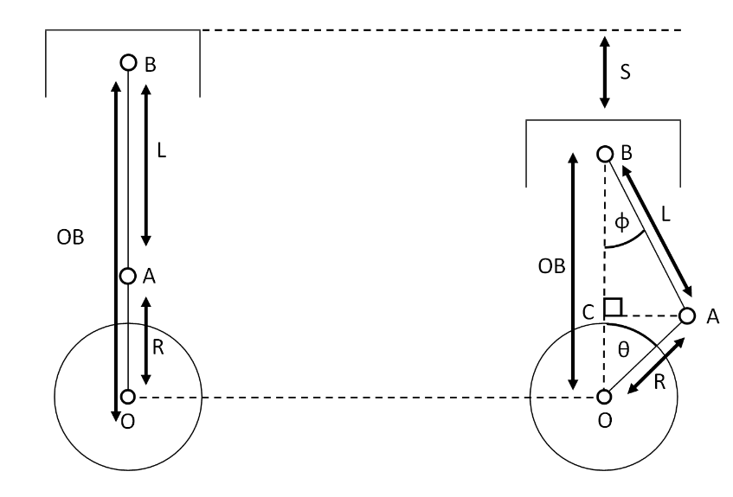
To identify how far a piston has travelled in ‘meters’ (m) per degree of crank rotation (Theta), using the derived equation below. This equation can be helpful tool to visualise how much the piston is traveling, when plotted within a graph.
Figure 1 – Trigonometric Depiction of Piston Movement Within the Cylinder (Anderson, 2019)

$$S=R+L-{OB}_{New}$$

$$OB=OC+CB$$

From triangle OAC: $OC=R*Cos(Φ)$

From triangle ABC: $CB=L*Cos(Φ)$

$$OB=R*Cos\left(θ\right)+L*Cos(Φ)$$

So, $S=R+L-R*Cos\left(θ\right)-L*Cos(Φ)$

From triangle OAC: $AC=R*Cos(θ)$
From triangle ABC: $AC=L*Sin(Φ)$

$$R*Sin\left(θ\right)=L*Sin(Φ)$$

$$Sin\left(Φ\right)=\frac{R}{L}*Sin(θ)$$

From Pythagoras’ Theorem: $Cos^{2}\left(Φ\right)+Sin^{2}\left(Φ\right)=1$

$$Cos^{2}\left(Φ\right)=1-Sin^{2}\left(Φ\right)$$

$$Cos\left(Φ\right)={\left(1-Sin\left(Φ\right)\right)}^{\frac{1}{2}}$$

$$Cos\left(Φ\right)={\left(1-\frac{R^{2}}{L^{2}}*Sin\left(Φ\right)\right)}^{\frac{1}{2}}$$

So, $S=R+L-R*Cos\left(θ\right)-L*Cos(Φ)$
Becomes: $S=R+L-R*Cos\left(θ\right)-L*{\left(1-\frac{R^{2}}{L^{2}}*Sin\left(Φ\right)\right)}^{\frac{1}{2}}$
Equation 2 - Piston Movement Equation 1
And can also be expressed as:
$$S=R+L-R*Cos\left(θ\right)-L*\left(1-\frac{R^{2}}{L^{2}}*\frac{1}{2}*Sin\left(Φ\right)\right)$$
Equation 3 - Piston Movement Equation 2

The equation below, relates to the piston movement and acceleration per degree of crank rotation angle equations, with respect to time.

$$\frac{d²s}{dθ²}=R*w^{2}*Cos\left(θ\right)+\frac{R}{L}*{R*w}^{2}*Cos(2*θ)$$
Equation 4 - Piston Acceleration Equation

To determine the inertia force being applied to the piston, per degree of crank rotation. “The cyclic operation leads to unequal gas forces, and the acceleration and deceleration of the reciprocating power-transfer components generate inertia forces” (Nigus, 2016). The inertia force can be split into two separate terms; first order and second order inertia forces, explained within the appendix.

$$Inertia Force=Piston Mass*\left(\left(R*w^{2}*Cos\left(θ\right)\right)+\left(\frac{R}{L} * R*w^{2}*Cos\left(2*θ\right)\right)\right)$$
Equation 5 - Inertia Force Equation
First Order Second Order

The net force is the total force which is being applied to the top of the piston at any given point throughout its motion within the engine cylinder during operation.

$$Net Force=Gas Force-Inertia Force$$
Equation 6 - Net Force Equation

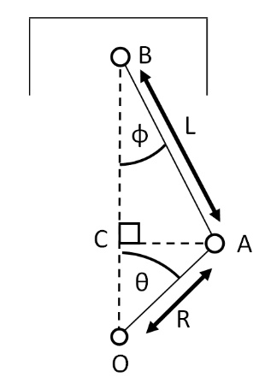
Simple trigonometry is required in order to ascertain the angle of the con-rod (Phi/$Φ$) throughout the engine’s rotation. This is one of the few characteristics that, although changes due to crank angle, remains constant each cycle, regardless of engine speed, unless the con-rod length is changed.
Figure 2 - Trigonometric Depiction of Angle and Lengths within the Piston and Con-Rod Assemblies (Anderson, 2019)
$AC=R*Sin(θ)$

$$AC=L*Sin\left(θ\right)$$

So, S$in\left(Φ\right)=\frac{R}{L}*Sin\left(θ\right)$

Becomes: $Φ={Sin}^{-1}\left(\frac{R}{L}*Sin\left(θ\right)\right)$
Equation 7 - Con-Rod Angle (Phi) Equation

The force that is exerted through the length of the con-rod, can be calculated by resolving the all piston forces vertically by considering Newtons Third Law of motion, "For every action, there is an equal and opposite reaction." (Lucas, 2017).

Resolving vertically: $Net Force=Rod Force*Cos(Φ)$

Rearrange for Rod Force: $Rod Force=\frac{Net Force}{Cos(Φ)}$

Or: $Rod Force=\frac{Gas Force-Inertia Force}{Cos(Φ)}$
Equation 8 - Rod Force Equation

As the piston is moving in a linear motion, the force applied to it by means of the con-rod angle, pushes it sideways onto the cylinder wall, this can be determined by using the formula below.

Resolving vertically: $Net Force=Rod Force*Cos(Φ)$ - Equation 1

Resolving horizontally: $Side Force=Rod Force*Sin(Φ)$ - Equation 2

Dividing 1 by 2: $\frac{Rod Force*Sin(Φ)}{Rod Force*Cos(Φ)}=\frac{Side Force}{Rod Force}$

Rod Force cancels, leaving: $\frac{Sin\left(Φ\right)}{Cos(Φ)}=Tan(Φ)$
So, $Side Force=Net Force*Tan(Φ)$
Equation 9 - Side Force Equation

Each individual piston ring incurs a force due to the pressure of the gas within the combustion chamber seeping through the small gap between the piston rings and the ring grooves of the piston, pressing the ring outwards into the cylinder wall.

$$Radial \left(Ring\right) Force=Pressure* π*Diameter*Height$$
Equation 10 - Radial (Ring) Force Equation

Assuming a frictional coefficient $(μ)$ of ‘0.1’, due to the smooth surface of the cylinder wall and a thin layer of oil to lubricate the metal parts, reducing wear. In separate equations, both the ring/radial and the piston side forces (N) can be multiplied by the coefficient of friction, resulting in values for the frictional forces being applied in the opposite direction of motion (N).

$$Side Frictional Force= μ*Side Force$$
Equation 11 - Side Friction Force Equation
$$Radial \left(Ring\right) Frictional Force= μ*Radial \left(Ring\right) Force$$
Equation 12 - Radial (Ring) Force Equation

Both the side and radial frictional forces are used to calculate their respective work done for each degree of crank rotation. This will result in work done per degree of crank shaft rotation in ‘Joules’ for both the side and radial frictions individually, they can be added together to determine the overall work done per degree.

$$Frictional Work Done Per Degree=\left(\frac{Frictional Force 1+Frictional Force 2}{2}\right)*(S1-S2)$$
Equation 13 - Frictional Work Done Per Degree of Crank Rotation Equation

$$Frictional WD Per Degree=Side Friction Work Done+Radial \left(Ring\right)Friction Work Done$$
Equation 14 - Total Frictional Work Done Per Degree of Crank Rotation Equation

The sum of the overall work done by frictional forces, shows how much energy (Joules) has been exerted throughout the two engine cycles (720⁰). This figure can be multiplied by the number of cylinders within the engine, to find out the total frictional work done by the engine.

$$Cylinder Work Done=\sum_{-360 to+360}{Work Done Per Degree}$$
Equation 15 – Total Frictional Work Done Each Cycle Per Cylinder Equation

$$Engine Work Done=\sum_{-360 to+360}{Work Done Per Degree}*No. Cylinders$$
Equation 16 - Total Engine Frictional Work Done Each Cycle Equation

This number equates to the power lost per cylinder in ‘Joules per second per cylinder’, multiplying this by the number of engine cylinders will give you the overall power lost per cycle at that RPM range in ‘Joules per second’ or ‘Watts’

$$Power Lost Per Cycle=\sum_{-360 to+360}{Frictional Work Done Per Degree}*\frac{RPM}{120}$$
Equation 17 - Power Lost Each Cycle Per Cylinder Equation

$$Total Engine Power Lost=\sum_{-360 to+360}{Work Done Per Degree}*\frac{RPM}{120}*No. Cylinders$$
Equation 18 - Total Engine Power Lost Per Cycle Equation

Using the gas force (N) calculated previously, the average gas force per degree (N/⁰) can be determined to understand how much work is done by the gas force to move the piston per degree.

$$Gas Work Done Per Degree=\left(\frac{Gas Force 1+Gas Force 2}{2}\right)*(S1-S2)$$
Equation 19 - Gas Force Work Done Per Degree of Crank Shaft Rotation Equation

By totalling the sum of the gas work done over the 720⁰ of crank rotation, results in the entire work done by the gas on the piston in ‘Joules’.

$$Total Gas Work Done=\sum_{-360 to+360}{Gas Work Done Per Degree}$$
Equation 20 - Total Gas Work Done Per Cycle Equation

The total frictional force work done over the two engine cycles, is subtracted from total gas work done, leaving the total work done on the piston over the four strokes.

$$Total Work Done=Total Gas Work Done-Total Friction Work Done$$
Equation 21 - Total Work Done Including Frictional Losses Per Cycle Equation

The instantaneous torques (torque per degree of crankshaft rotation) can be equated by taking the individual forces (N); gas, and inertia, and multiplying them by the perpendicular distance between the direction that the rod force is acting upon and the centre of the crank shaft (m). The instantaneous torques can be individually totalled over the crank angle range of -360⁰ to +360⁰ to provide the value of torque produced over the two engine cycles to give values for gas and inertia torques per cycle.
Figure 3 - Trigonometric Depiction of Angle and Lengths within the Piston and Con-Rod Assemblies (Anderson, 2019)
As, $OA=R$

And, $OAB= θ+ ∅$

From triangle OAB: $OB=OA*Sin(θ+∅)$

So, $OB=R*Sin(θ+∅)$
Which gives:
$$Instantaneous Torque=Perpendicular Force*R*Sin(θ+∅)$$
Equation 22 - Instantaneous Torque Per Degree of Crank Shaft Rotation Equation

This can be used in the following ways:

$$Inertia Torque=Inertia Force*R*Sin(θ+∅)$$
Equation 23 - Inertia Torque Per Degree of Crank Shaft Rotation Equation

$$Gas Torque=Gas Force*R*Sin(θ+∅)$$
Equation 24 - Gas Torque Per Degree of Crank Shaft Rotation Equation

The total gas torque is the total torque produced by the cylinder per cycle, it can then be multiplied by the number of cylinders providing a value for torque produced by the entire engine, negating frictional and heat loses.

$$Total Gas Torque Per Cycle=\sum_{-360 to+360}{Gas Torque Per Degree}$$
Equation 25 - Total Gas Torque Each Cycle Per Cylinder Equation

$$Engine Gas Torque Per Cycle=\sum_{-360 to+360}{Gas Torque Per Degree}*Cylinders$$
Equation 26 - Total Engine Gas Torque Per Cylinder Equation

The total inertia torque over the 720⁰ should equal 0. For as much positive inertia torque that is produced, there is an equal and opposite negative inertia torque. Newton’s second law states "The force acting on an object is equal to the mass of that object times its acceleration." (Lucas, 2017) Since each RPM range that is being examined is at a constant angular velocity, there is no acceleration, hence the total of the inertia torque is equal to 0.

$$Total Inertia Torque Per Cycle=\sum_{-360 to+360}{Inertia Torque Per Degree}=0$$
Equation 27 - Total Inertia Torque Each Cycle Per Cylinder Equation

The power produced by the engine in ‘Kilowatts’ (KW) is derived from the total gas torque values from all the cylinders in the engine at each RPM, since power is directly related to work done per unit of time. The output of this equation is ‘Watts’ (W), the final value is divided by 1000 to put this into KW for a more accurate depiction.
$$Power=\frac{Total Engine Gas Torque*\frac{2*π*RPM}{4}}{1000}$$
Equation 28 - Power Produced by the Engine Equation
The Indicated Mean Effective Pressure (IMEP) is “the measure of the work output for the swept volume of the engine, The result is a fundamental parameter for determining engine efficiency as it is independent of speed, number of cylinders, and displacement of the engine.” (Martyr, 2012).

As, $Work Done=Pressure*∆ Volume$

$$\sum_{-360 to+360}{Gas Work Done}=IMEP*Cylinder Displacement$$

Rearrange to make IMEP the subject:

For IMEP in Pascals: $IMEP=\left(\frac{\sum_{-360 to+360}{Gas Work Done}}{Cylinder Displacement}\right)$

For IMEP in Bar: $IMEP=\frac{\left(\frac{\sum_{-360 to+360}{Gas Work Done}}{Cylinder Displacement}\right)}{{10}^{5}}$
Equation 29 - Indicated Mean Effective Pressure in Bar Equation

The Friction Mean Effective Pressure (FMEP) is “the lost mechanical work is regarded as “friction” work. It has the generic name “friction” but it contains all the engine losses: pumping losses, actual friction (mechanical rubbing) losses and auxiliary devices (accessory) losses.” (X-Engineer, 2019).

For FMEP in Pascals: $FMEP=\left(\frac{\sum_{-360 to+360}{Frictional Work Done}}{Cylinder Displacement}\right)$

For FMEP in Bar: $FMEP=\frac{\left(\frac{\sum_{-360 to+360}{Frictional Work Done}}{Cylinder Displacement}\right)}{{10}^{5}}$
Equation 30 - Frictional Mean Effective Pressure in Bar Equation

Brake Mean Effective Pressure (BMEP) can be evaluated by subtracting the FMEP away from the IMEP. It is also possible to get the same result by taking the previous output for total work done onto the piston, including frictional loses, and dividing it by the cylinder displacement.

For BMEP in Pascals:
$BMEP=\left(\frac{\sum_{-360 to+360}{Gas Work Done-\sum_{-360 to+360}{Frictional Work Done} }}{Cylinder Displacement}\right)$

For BMEP in Bar:
$BMEP=\frac{\left(\frac{\sum_{-360 to+360}{Gas Work Done- \sum_{-360 to+360}{Frictional Work Done}}}{Cylinder Displacement}\right)}{{10}^{5}}$
Equation 31 - Brake Mean Effective Pressure in Bar Equation

The maximum compressive and tensile stress through the con-rod shank, describes how much force is being applied per millimetre squared of area.

$$Stress in Rod Shank=\frac{Compressive/Tensile Load}{Cross-sectional Area}$$
Equation 32 - Compressive and Tensile Stress Through the Con-Rod Shank Equation

Relative to the Ultimate Tensile Stress (UTS) the safety factor describes how close the component is to bending/breaking while under its highest compressive and tensile loads.

$$Safety Factor=\frac{UTS}{Compressive/Tensile Stress}$$
Equation 33 - Safety Factor Equation Relative to the UTS Value

The compression and stretch distances can be calculated by taking the stresses induced onto the con-rod shank (N/mm²), the Young’s Modulus of the material (GPa), the con-rod length (mm) and cross-sectional area (mm²).

As, $Stress=\frac{Force}{Area}$

And, $Strain=\frac{Displacement}{Length}$

Young’s Modulus (E) is defined as: $E=\frac{Stress}{Strain}$

So, $E=\frac{\frac{F}{A}}{\frac{x}{L}}=\frac{F*L}{x*A}=\frac{F}{x}*\frac{L}{A}$

This can be rearranged for the compressive and tensile displacement as:

$$x=\left(\frac{F*L}{E*A}\right)$$
Equation 34 - Compressive and Tensile Displacement Equation

This completed the table of results for one RPM range, this process was repeated for every RPM from 1000 to 6000, producing graphs to visually compare and analyse the data that had been formulated.

The task now required us to uncover how the data transformed if the engine was modified in any way, then incorporating the new modified values for the corresponding equations they are used in.

The section below will analyse both the formulated data and graphical data to see how the engine modifications affect the overall engines performance in comparison to the stock engine. Those not included in the analysis below are shown and described within the appendix.

Analysis

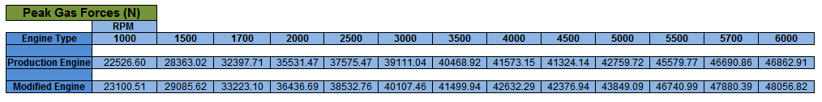
Peak Gas Force (N)
Table 1 - Peak Gas Forces for Standard and Modified Engines Throughout the RPM Range

As expected, the highest gas force encountered in both engines, happens at the highest RPM, 6000, both when the piston is accelerating the fastest and when peak pressure is at its uppermost value within the cylinder. Because there is less time for heat transfer, more heat energy is retained within the gas, boosting the pressure in the cylinder.

Comparing the standard and modified engine values, it is clear to see that the force increases in relation to the area of the cylinder, due to the increase in bore, as shown in the graphs below. This means that in the modified engine, it should, theoretically, increase the work done and the torque produced by the gas force and thus, increase the IMEP and BMEP produced by the engine.
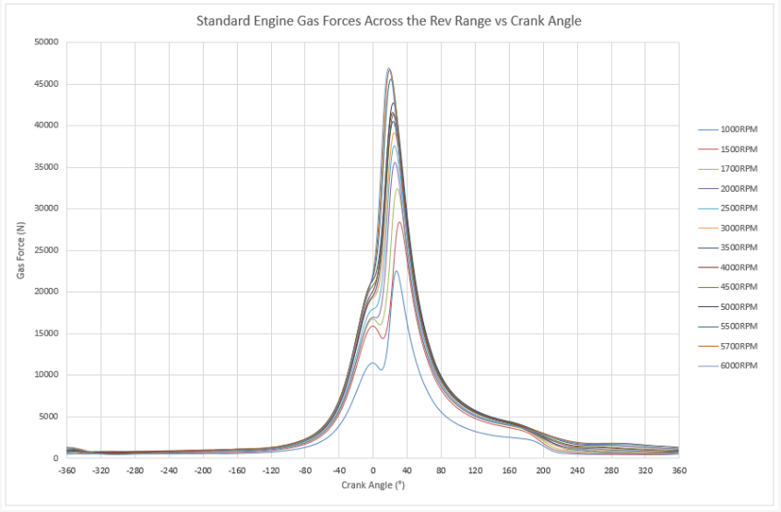

Figure 4 - Standard Engine Gas Forces vs Crank Angle

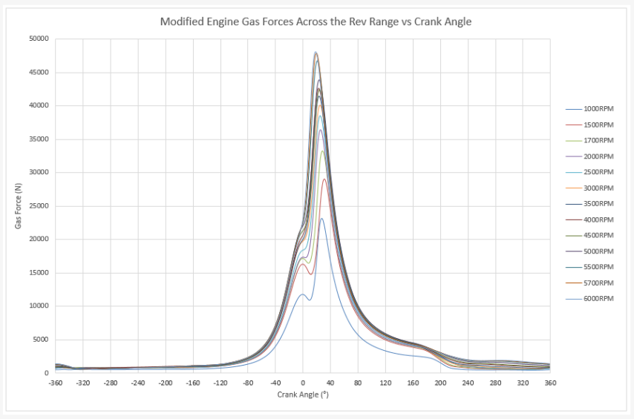

Figure 5 - Modified Engine Gas Forces vs Crank Angle

Piston Acceleration (m/s²)

The acceleration of the piston is directly related to the length of the con-rod and the crank radius (half of the stroke) and since in the modified engine, the length of the conrod was not changed, it is possible to see exactly how much the acceleration was affected purely by the change in crank radius, where the modified engine observes a slightly lower linear acceleration each cycle.

It is visible to see within both graphs, the effects the second order inertia forces have upon the piston’s acceleration when it is at Bottom Dead Centre (BDC), due to imbalance between the first and second order inertia forces “It is due to the inertia of the reciprocating assembly and has no side component.” (Taylor, 1985)
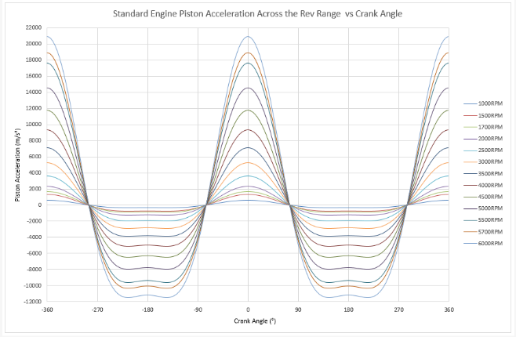

Figure 6 - Standard Engine Piston Acceleration vs Crank Angle

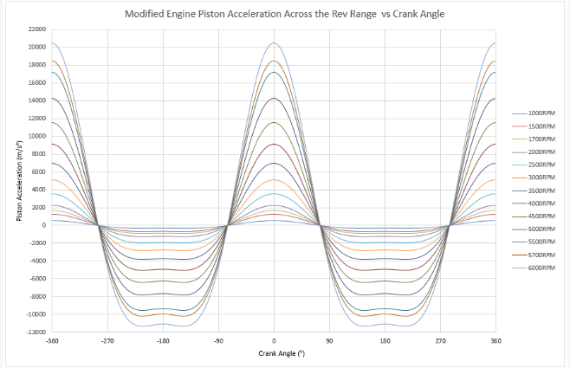

Figure 7 - Modified Engine Piston Acceleration vs Crank Angle

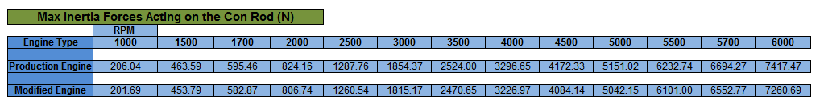
Max Inertia Forces on the Con-Rod (N)
Table 2 - Max Inertia Force Acting on the Con-Rod Throughout the RPM Range
The inertia forces in both the standard and modified engines at each RPM can be seen in the table above. It is evident that by decreasing the stroke of the engine, the inertia forces that are exerted upon it, are reduced. As mentioned before, it is possible to see the effect the second order inertia forces have while the piston is at BDC, the little ‘wobble’, shown on the graphs below, becomes more apparent the higher the RPM, caused by the second order inertia forces counteracting the first order at BDC, expanded upon in the appendix.

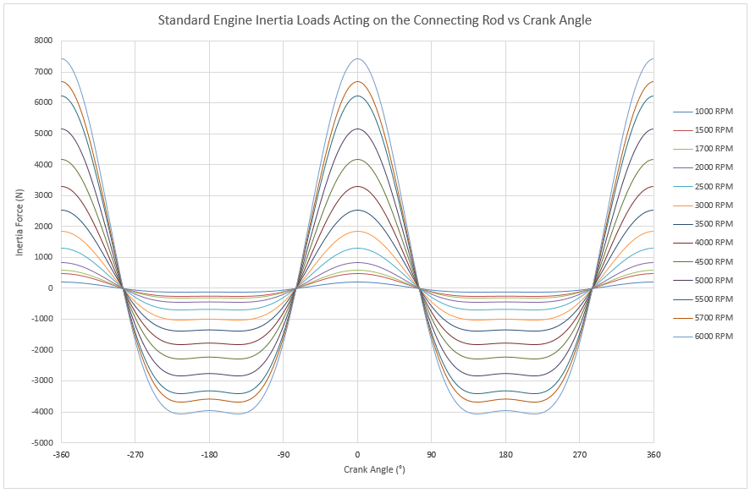

Figure 8 - Standard Engine Con-Rod Inertia Forces
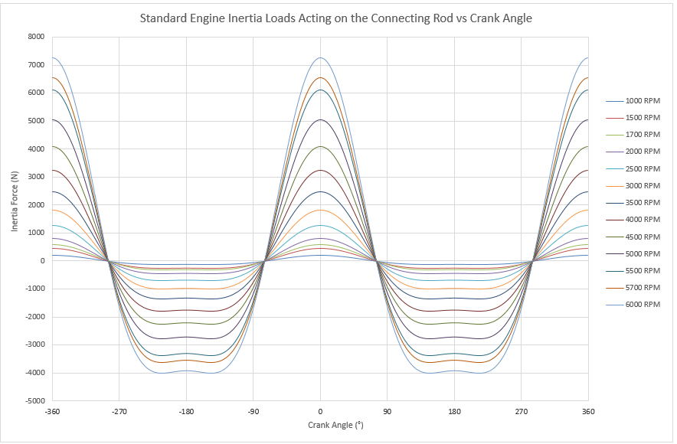

Figure 9 - Modified Engine Con-Rod Inertia Forces


Highest Net Compressive Force on Con-Rod (N)
Table 3 - Highest Net Compressive Force Acting Upon the Con-Rod Throughout the REV Range
The compressive forces acting upon the con-rod increases, since this value directly correlates to both the shortened stroke which slightly reduces the con-rod angle per degree, and the increased bore, which in turn, increases the gas force acting on the piston, therefore, applies a greater force onto the con-rod. Since the con-rod forces are a product of both the gas and inertia forces, the graphs below depict a hybrid between the two forces previously shown.

The peaks occur during combustion, when the gas pressure is at its highest in the cylinder, corresponding to the most force being applied through the con-rod, this causes an equal and opposite force that compresses it between the piston and the crankshaft. If the crank shaft didn’t have the ability to rotate, or the cylinder was full of water, the con-rod would buckle. The modified engine values follow the same trend that the standard engine does but to a slightly higher degree and they both peak at 5700 RPM.

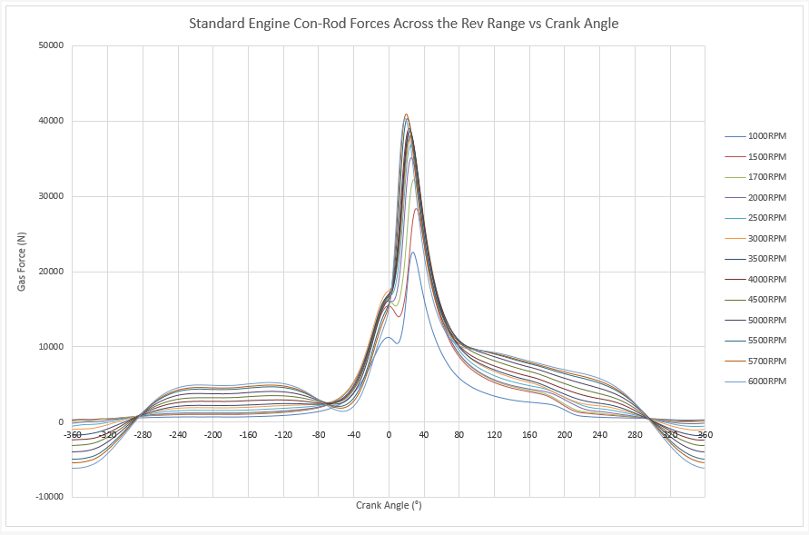
Figure 10 - Standard Engine Con-Rod Forces vs Crank Angle


Highest Net Tensile Force on Con-Rod (N)
Table 4 - Highest Net Tensile Forces Acting on the Con-Rod Throughout the REV Range
As with the compressive force applied to the con-rod, the tensile force is the opposite where the con-rod is being pulled apart. The negative values on the graphs at the higher RPMs, stem from when the inertia force overcomes the gas force, resulting in a negative value at TDC during the beginning of the intake stroke, caused by the vacuum within the cylinder after the exhaust gas has been evacuated.

The signs of the values you see in the table above have been reversed (negative to positive values) to provide an accurate read of the direction of force applied, i.e. the values at the lower RPMs represent the con-rod actually being compressed, whereas, the values at the higher RPMs show the con-rod being stretched. The modified engine data above shows an increase in compressive forces at lower RPMS but then a decrease in tensile forces at the higher RPMs.

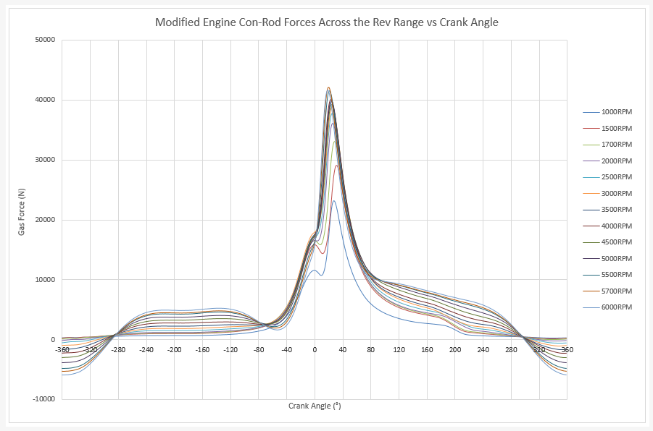
Figure 11 - Modified Engine Con-Rod Forces vs Crank Angle

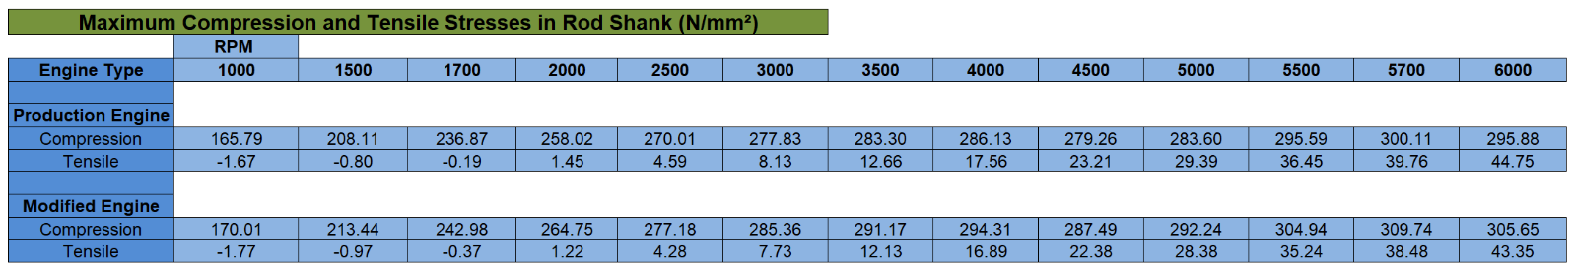
Maximum Compressive and Tensile Con-Rod Stresses (N/mm²)
Table 5 - Maximum Compressive and Tensile Stresses Subject onto the Con-Rod
The values shown above compare the stresses acting on the con-rod for both the modified and standard engines. It is clear to see that due to the change of the bore and stroke, the compressive stress is greater on the modified engine than the standard, on the other hand, the tensile stresses exerted upon the con-rod actually reduce due to the same modifications. This implies that appropriate action will need to be taken in accordance to which factor is more important, i.e. if your current con-rod is experiencing too much tensile force/stress, reducing the stroke may be the solution.

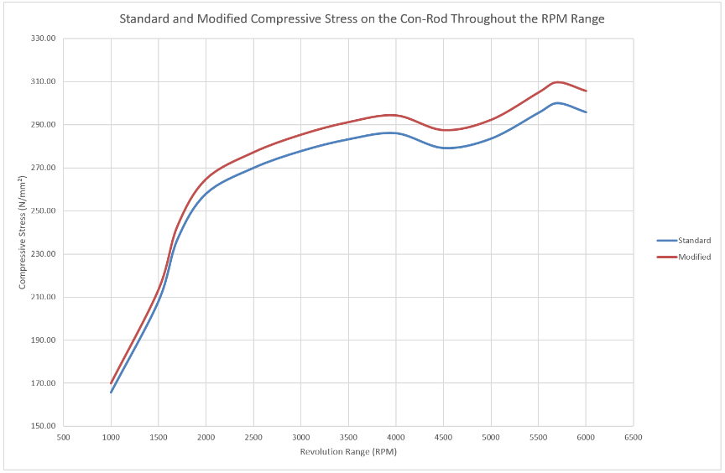

Figure 12 - Standard and Modified Engine Compressive Stress on the Con-Rod vs RPM
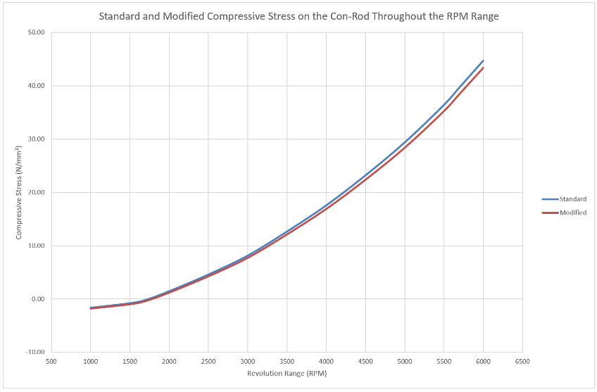

Figure 13 - Standard and Modified Engine Tensile Stress on the Con-Rod vs RPM

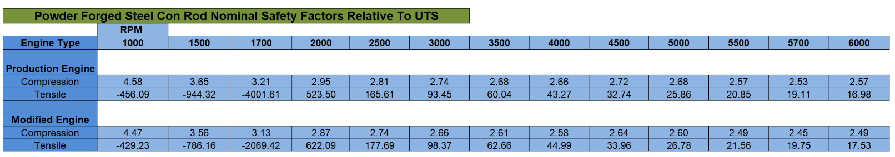
Ultimate Tensile Stress (UTS)
Table 6 - Nominal Safety Factors Relative to the Ultimate Tensile Stress Values for Powder Forged Steel Con-Rods
Using the UTS value for PMET 4206F Powder Forged Steel of 760 MPa that the con-rod is rated to before it exceeds its yield strength. It is evident to see the reverse pattern emerging compared to the previous stress values, where the compression safety factor is higher on than the standard engine and the tensile safety factor is higher on the modified engine. With regards to the safety factor ratio, the higher the number is the better, meaning that the force exerted onto the con-rod is further away from its bending/breaking point.

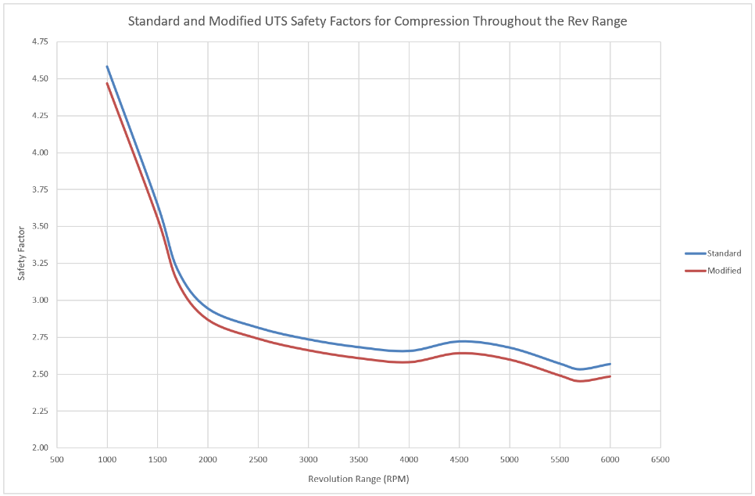

Figure 14 - Standard and Modified UTS Safety Factors for Compression Throughout the Rev Range

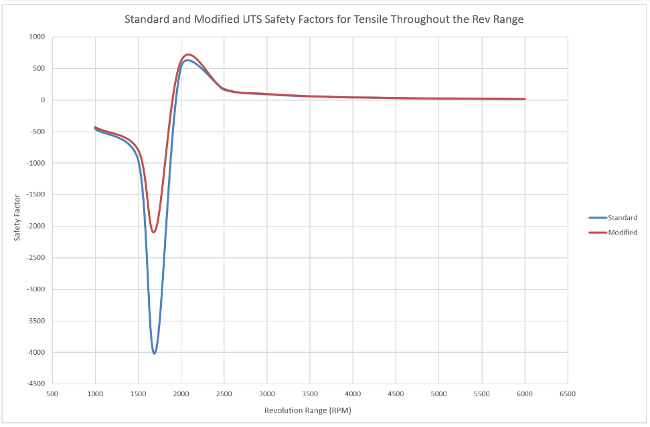

Figure 15 - Standard and Modified UTS Safety Factors for Tension Throughout the Rev Range

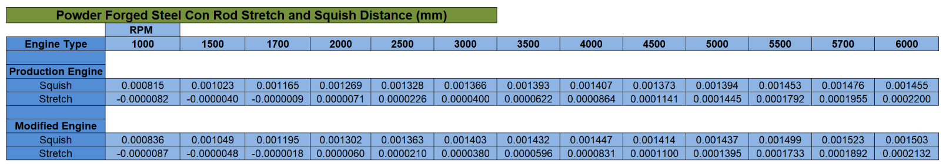
Powder Forged Steel Con-Rod Stretch and Squish Distances (mm)
Table 7 - Stretch and Squish Distances Theoretically Imposed Upon the Con-Rod
The tabled values display the same pattern exhibited by the compression and tensile stresses. The stresses discussed previously are the only variable in the equation that do not remain constant. By keeping the same con-rod length (134mm), cross-sectional area (136.26mm²) and Young’s Modulus value (200 GPa), the changes illustrated in the table above, are purely due to the increase in force exerted onto the con-rod in the modified engine throughout each cycle. These values show that the compressive distance is higher throughout the RPM range in the modified engine, but with stretch due to tension, the modified engine has higher values at the lower RPMs, this then switches to the standard engine have higher values from 2000RPM up to 6000RPM where the modified becomes the highest again.
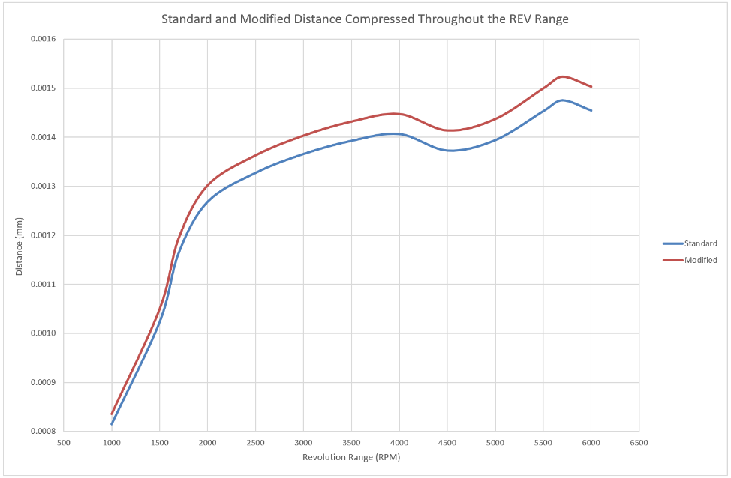

Figure 16 - Standard and Modified Distance Compressed Throughout the REV Range
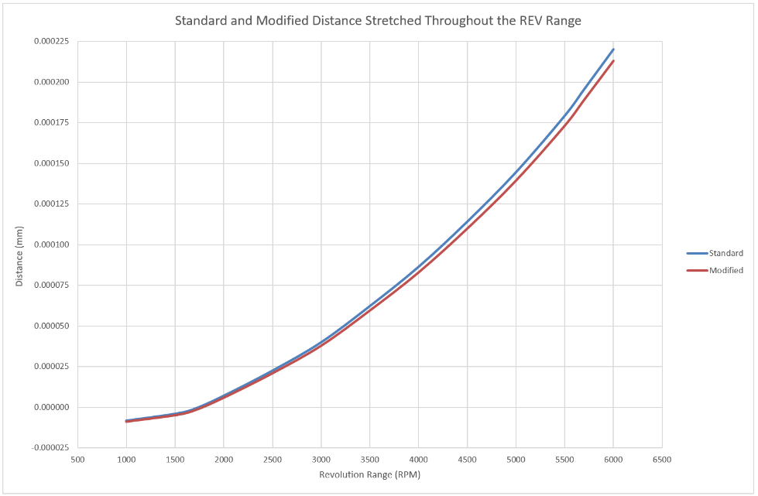

Figure 17 - Standard and Modified Distance Stretched Throughout the REV Range

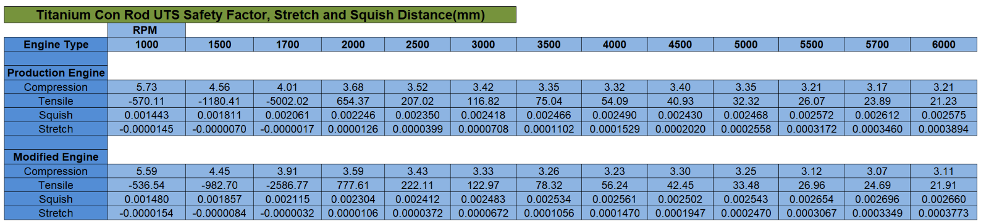
Titanium Con-Rod UTS Safety Factors and Displacement Distances (mm)
Table 8 - Compression, Tensile, Stretch and Squish Distances Exhibited if the Con-Rod Was Remade Using Titanium
After researching the best titanium alloy used in modern con-rods, Ti-6Al-4V, a UTS value (950 MPa) and Young’s Modulus (113 GPa) was inputted into the same equations used for the Powder Forged Steel con-rods, with the same compressive and tensile forces being applied, this shows an accurate comparison between the two different materials in each engine. Between the modified and standard engines using titanium, the same pattern emerges as the steel con-rods, the standard engine has a higher safety factor for compression and, therefore, compresses less distance compared to the modified, but as before, the modified engine has a con-rod that is more resistant to tensile stress and stretches to a smaller extent.

In comparison to the steel con-rods, the titanium has a higher UTS value, which gives it a higher safety factor than the steel, making it less likely to buckle or deform under the same load, hence allowing the engine to run a higher level of boost from forced induction. Unfortunately, the Young’s Modulus value (it’s resistance to deformation) is lower than the steel, making it much more likely to stretch and compress under the same loads as steel, this would need to be accounted for in order to reduce the likelihood of the piston colliding with the valves during operation, which is in no way a good thing and will cause massive amounts of damage to a multitude of components!

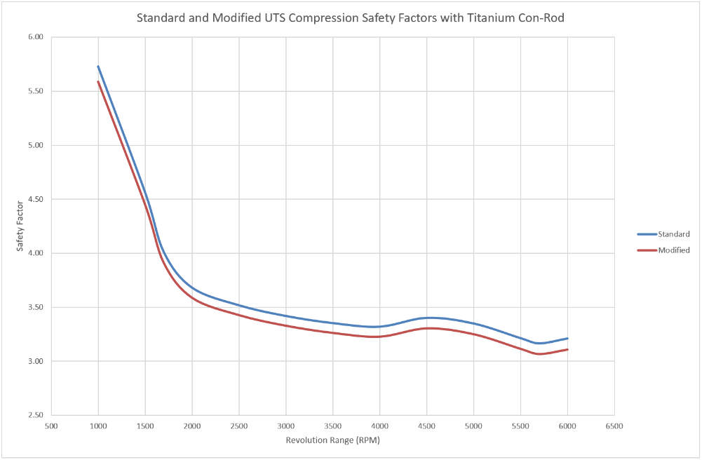

Figure 18 - Standard and Modified UTS Compression Safety Factors with Titanium Con-Rod
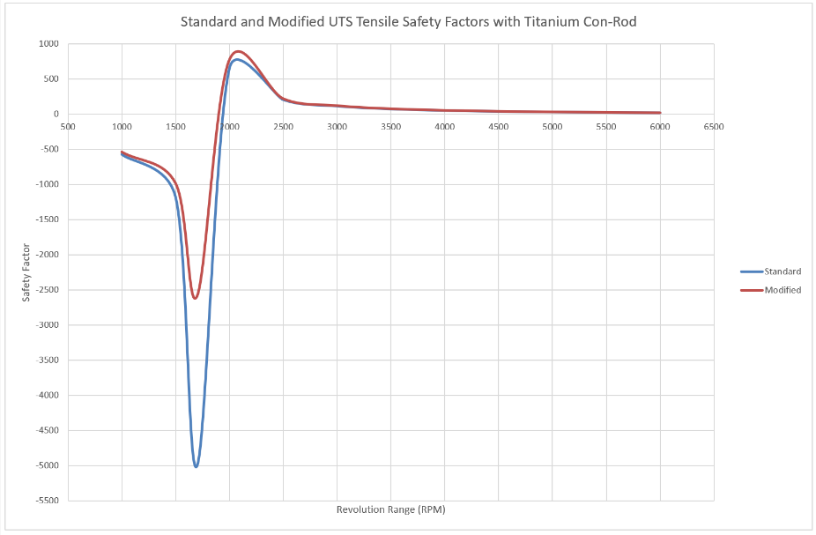

Figure 19 - Standard and Modified Engines UTS Tensile Safety Factors with Titanium Con-Rod
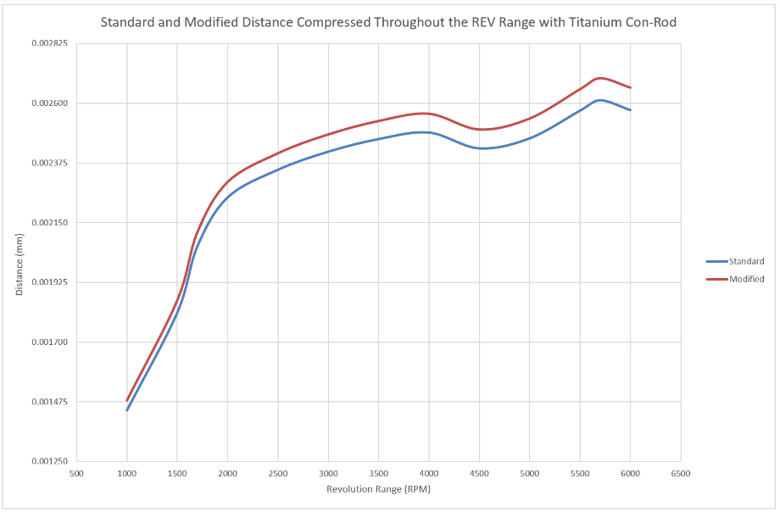

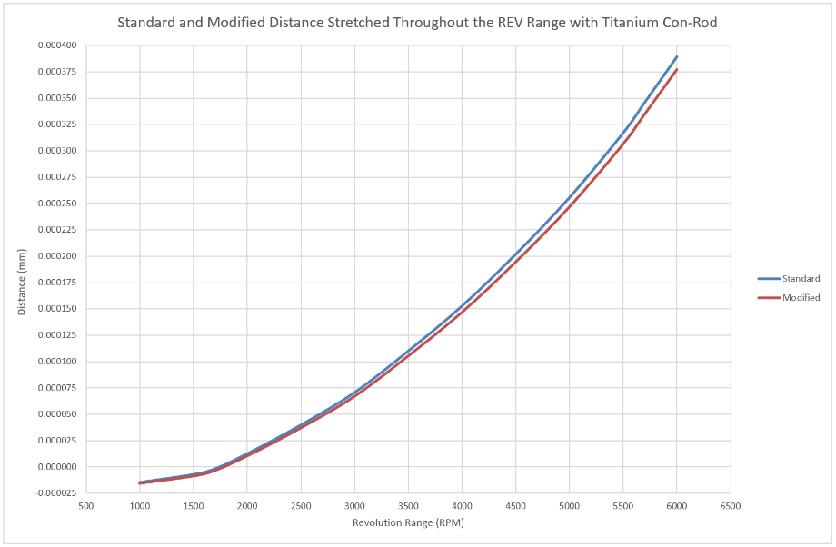
Figure 20 - Standard and Modified Compression Distance Throughout the REV Range with Titanium Con-Rods

Figure 21 - Standard and Modified Stretched Distance Throughout the REV Range with Titanium Con-Rods

References
Anderson, M., 2019. Trigonometric Depiction of Angle and Lengths within the Piston and Con-Rod Assemblies. [Art] (UWTSD Swansea).
Anderson, M., 2019. Trigonometric Depiction of Piston Movement Within An Engine Cylinder. [Art] (UWTSD Swansea).
Duy, D. V. N. a. V. N., 2018. Numerical Analysis of the Forces on the Components of a Direct Diesel Engine, Hanoi: Viettel Research and Development Institute.
EPI Inc., 2019. Brake Mean Effective Pressure. [Online]
Available at: http://www.epi-eng.com/piston_engine_technology/bmep_performance_yardstick.htm
[Accessed 25 10 2019].
Estrada, Z., 2013. Ford Recalls Ford Escape For Sixth Time In 18 Months Over Fire Risk. s.l.:Jalopnik.
Krisher, T., 2017. Ford recalls 570,000 vehicles for engine fire risk, door latch trouble. Detroit: The Globe And Mail.
Lucas, J., 2017. Newton's Laws of Motion. [Online]
Available at: https://www.livescience.com/46558-laws-of-motion.html
[Accessed 22 10 2019].
Lynch, J., 2017. Ford recalls 230,000 cars over potential engine fires. Detroit: The Detroit News.
Martyr, A. M. P., 2012. Engine Testing: The Design, Building, Modification and Use of Powertrain Test Facilities. 4th ed. s.l.:Elsevier Ltd..
Motor Reviewer, 2019. Ford 1.6L EcoBoost GTDI Engine Review. [Online]
Available at: https://www.motorreviewer.com/engine.php?engine_id=132
[Accessed 2019].
Nigus, H., 2016. Kinematics and Load Formulation of Engine Crank Mechanism, Magnolithe: Mechanics, Materials Science & Engineering Journal.

OpenStaxCollege, 2019. Dynamics of Rotational Motion: Rotational Inertia. [Online]
Available at: https://opentextbc.ca/physicstestbook2/chapter/dynamics-of-rotational-motion-rotational-inertia/
[Accessed 24 10 2019].
Taylor, C. F., 1985. Internal Combustion Engine: Volume 2. Second ed. Cambridge: The Massachusetts Institute of Technology.
X-Engineer, 2019. Mechanical efficiency and friction mean effective pressure (FMEP). [Online]
Available at: https://x-engineer.org/automotive-engineering/internal-combustion-engines/performance/mechanical-efficiency-friction-mean-effective-pressure-fmep/
[Accessed 25 10 2019].

Appendix

First and Second Order Inertia Forces (N)
The first order occurs once per revolution, switching between its’ highest and lowest values every 180⁰ of crank rotation, as the piston is changing direction within the cylinder. This can be counteracted by correctly balancing the crankshaft as it rotates. Whereas, the second order develops every 90⁰ of crank rotation, this happens as the con-rod angle changes direction and passes the centre line of the piston, as a result, this occurs at twice the frequency of the crankshaft’s rotation.

The piston moves further and faster in the first 90⁰ of crankshaft rotation after TDC (ATDC), than it does between 90⁰ and 270⁰ ATDC. Assuming a constant angular velocity, the con-rod angle is the highest value at 90⁰ ATDC, this causes the piston to be lower than half-way through the stroke at this point, resulting in the piston moving slower and less distance during between 90⁰ ATDC and 270⁰ BTDC, than it does between 270⁰ BTDC and 90⁰ ATDC.

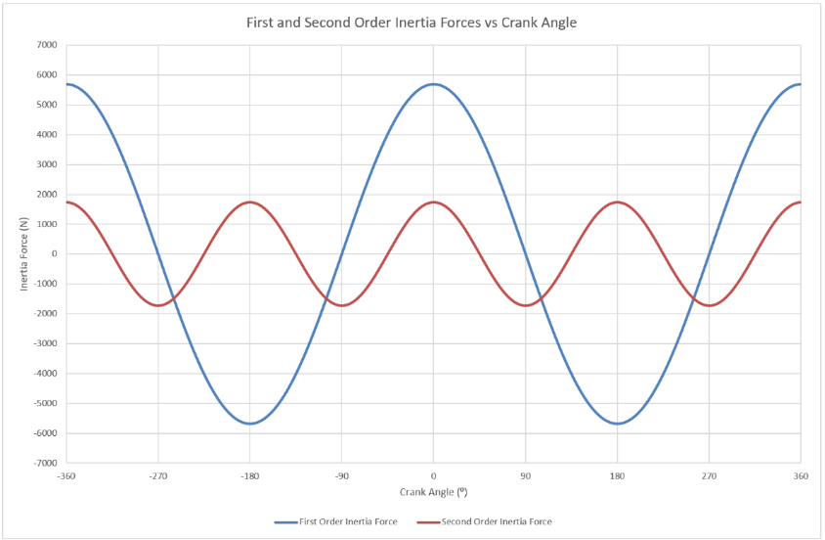
The ‘wobble’ on the negative values on both the piston acceleration and inertia force graphs can be explained by inspecting the graph below. While the piston is at TDC, both the first and second inertia forces add together, resulting in the positive peak values, on the other hand, as the piston is at BDC, the first order force is enduring a negative peak value, but the second order force is at its positive value, this counteracts the impact of the first order’s magnitude as they are acting in opposite directions.

Figure 24 - First and Second Order Inertia Forces

Figure 25 - Standard Engine Piston Acceleration vs Crank Angle

Side Force (N)

As previously exhibited by the gas forces, the peak side force occurs during the combustion process where the pressure exerted by the combusting air/fuel mixture pushes the piston against the cylinder liner.

Although the modified engine has a higher peak side force, the standard engine shows higher peaks on the other values (positive and negative) throughout each cycle. It is clear that there is a significant jump between the peak values at 1000RPM and 1500RPM, from research conducted into the 1.6L Ecoboost and the KP39 turbo, boost initiates at around 1300-1500RPM, this provides a dramatic increase on side force, the peak values then continue to stay relatively close together throughout the rest of the rev range.

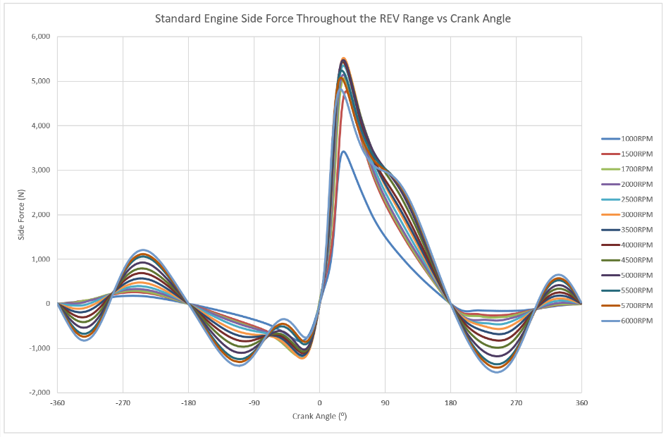

Figure 26 - Standard Engine Side Force Throughout the RPM Range

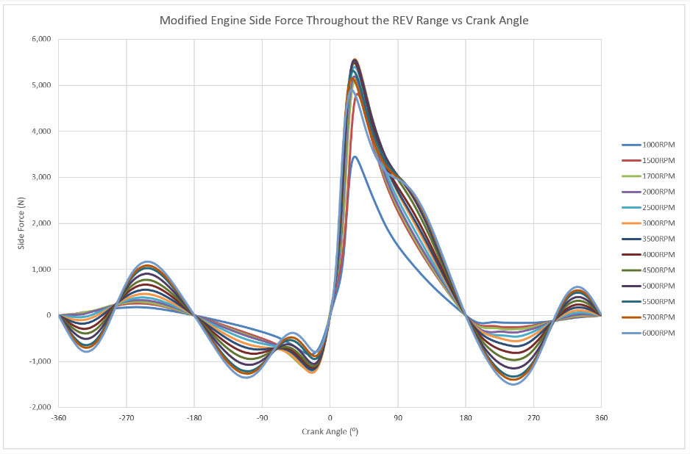

Figure 27 – Modified Engine Side Force Throughout the RPM Range

Side Friction (N)

Friction applied by the side force, resisting the direction of motion throughout the RPM range, is directly proportional to the force applied to the side of the cylinder liner. Since the coefficient of friction is ‘0.1’, the value of the frictional force is 10% of the force applied. The trend between the standard and modified is exactly as seen within the side force.

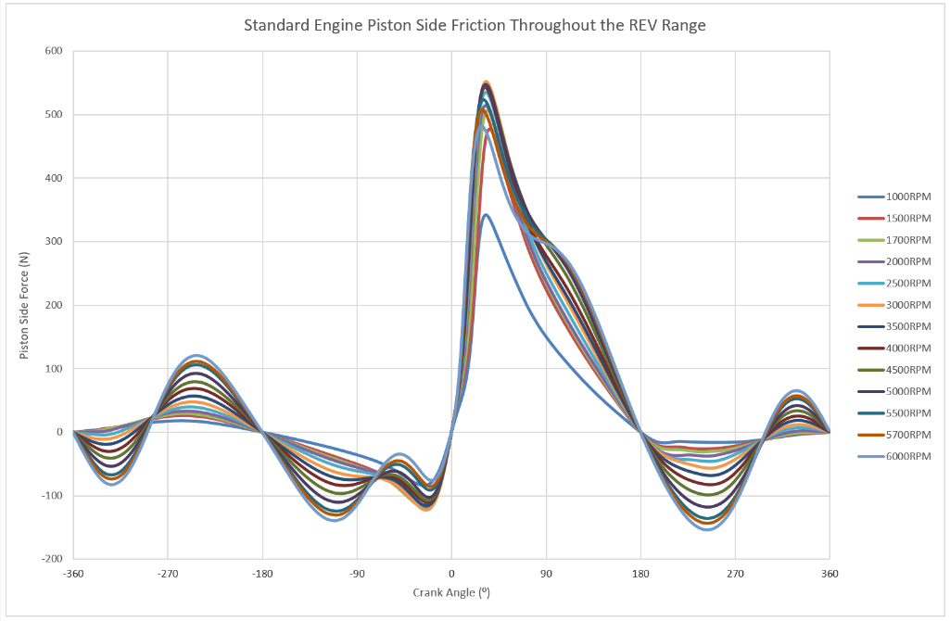

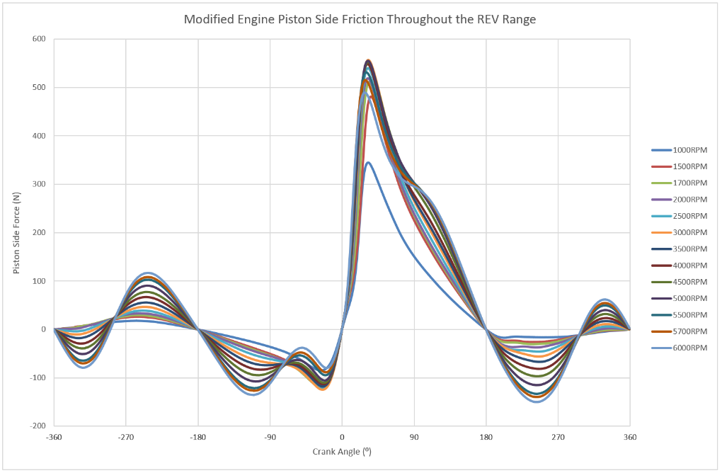
Figure 28 - Standard Engine Side Friction Throughout the REV Range

Figure 29 - Modified Engine Side Friction Throughout the REV Range

Ring Force (N)

Ring force graphs from both engines display the same pattern as the gas force graphs in the analysis previously. The modified engine presents a higher ring force, due to the increased area of the bore, and therefore, increased surface area of the piston rings.

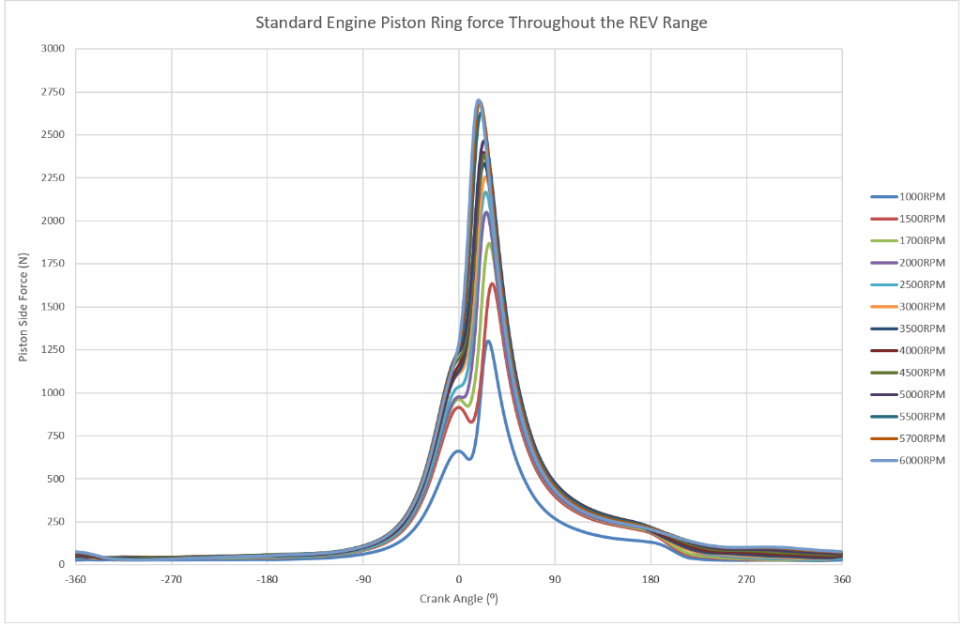

Figure 30 - Standard Engine Piston Ring Throughout the REV Range

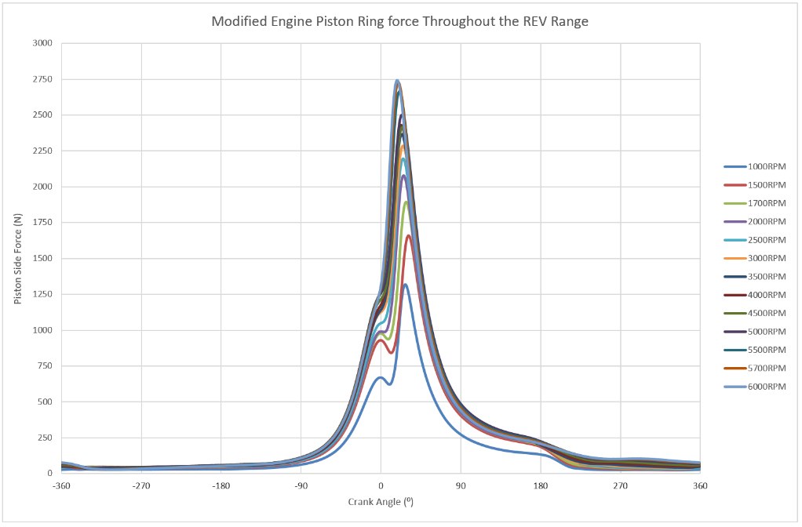

Figure 31 - Modified Engine Piston Ring Throughout the REV Range

Ring Friction (N)

Friction applied by the piston ring force, resisting the direction of motion throughout the RPM range, is directly proportional to the force applied to the side of the cylinder liner. Since the coefficient of friction is ‘0.1’, the value of the frictional force is 10% of the force applied. The trend between the standard and modified is exactly as seen within the piston ring force.

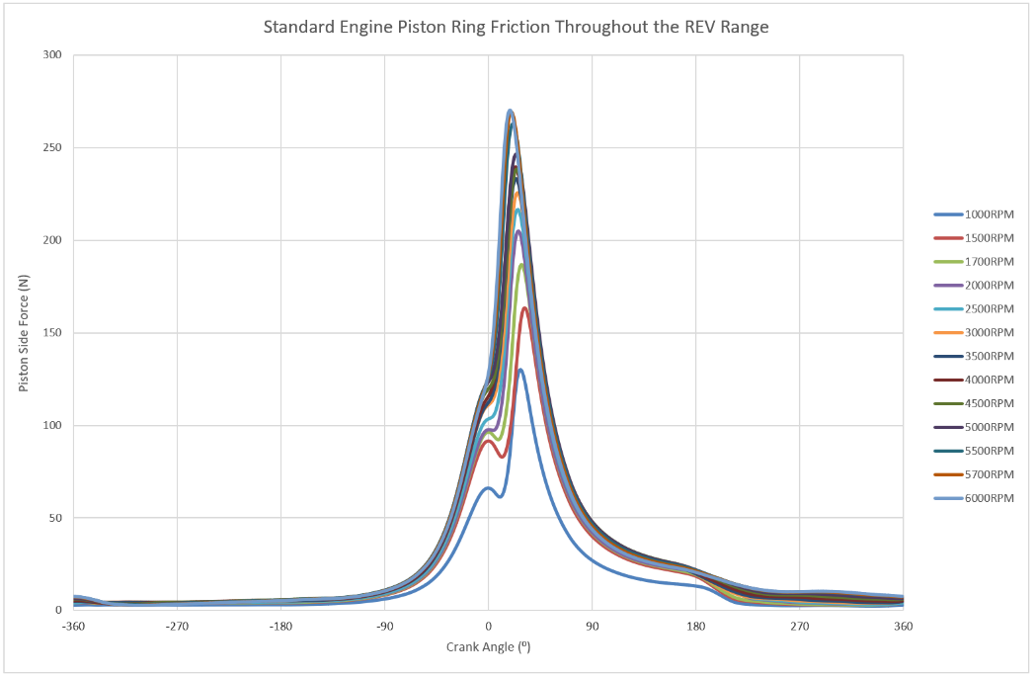

Figure 32 - Standard Engine Piston Ring Friction Throughout the REV Range

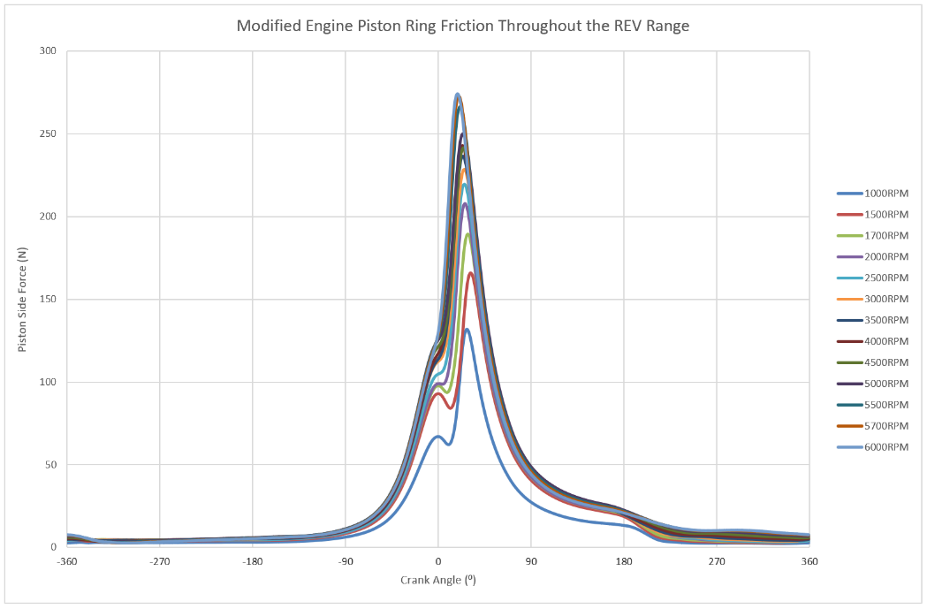

Figure 33 - Modified Engine Piston Ring Friction Throughout the REV Range

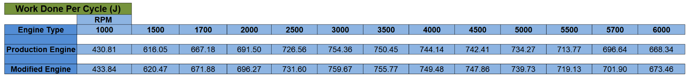
Work Done Per Cycle Minus Frictional Losses (J)
Table 10 - Standard and Modified Work Done Per Cycle
These work done values are taking into account the frictional losses due to both the piston rings and the side force. These values have been used to calculate the BMEP for both the standard and modified engines.

Due to there not being a significant change between the standard and modified engines, there is no major difference between the two when considering the work done. They follow the same trend and from 1700RPM onwards, the values carry a greater difference than at 1000RPM.

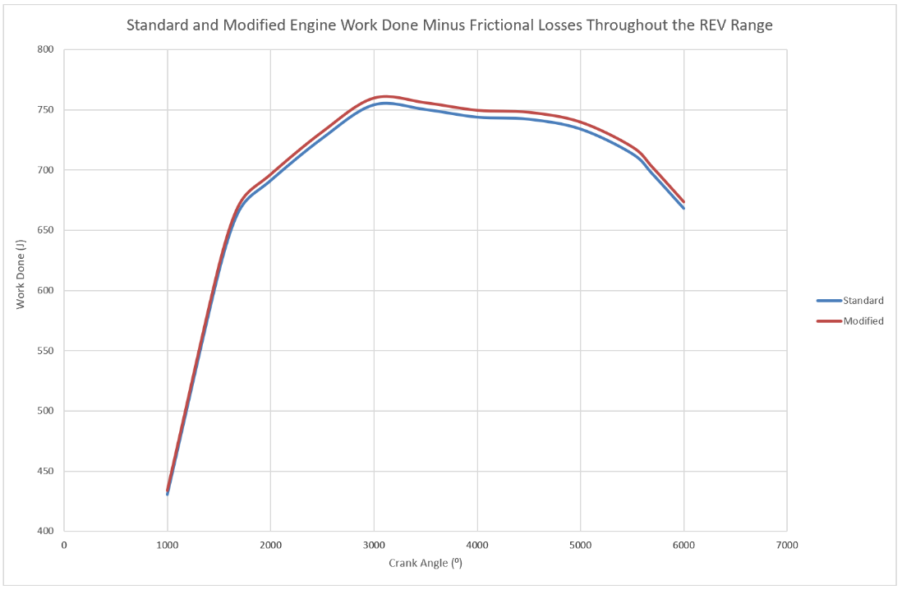

Figure 34 - Standard and Modified Engine Work Done Minus Frictional Losses

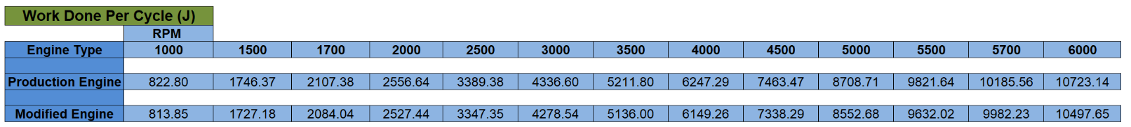
Power Lost Per Cycle (W)
Table 11 - Standard and Modified Engines Power Lost Per Cycle

These values represent the amount of power lost per cycle at each RPM for all cylinders within the engine, due to the work done by the frictional forces of the piston and ring forces. Considering that the standard engine has a slightly higher frictional work done value per degree of crank shaft rotation than the modified, meaning that the power lost per cycle due to friction is also higher, this proves that by increasing the bore and shortening the stroke, will reduce the amount of power lost to friction.
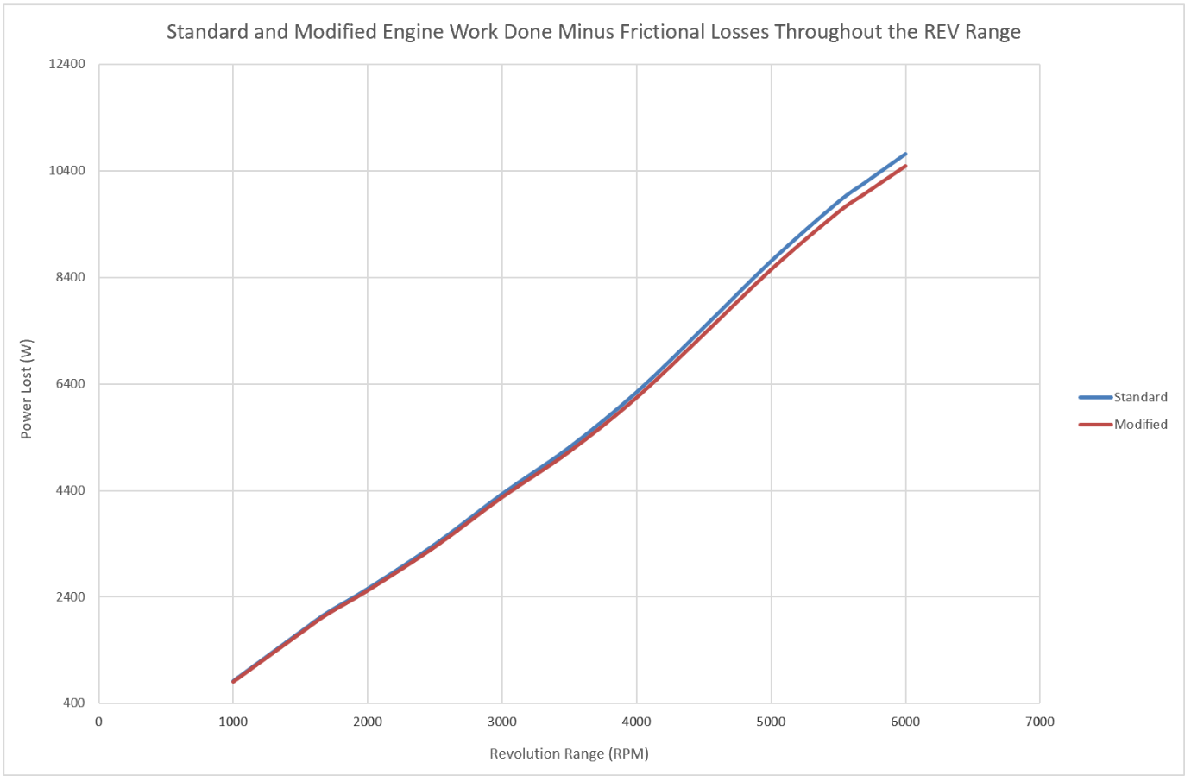
Figure 35 - Standard and Modified Engine Work Done Minus Frictional Losses Throughout the RPM Range

IMEP (Bar)
Table 12 - Standard and Modified Engine Values for IMEP
The IMEP values above show that the modifications made to the engine compared to the standard, show that more work is done through the swept volume of the cylinder. This value can be considered as a form of efficiency, negating frictional, mechanical and heat losses. The modified engine carries a near constant 0.1 higher value as opposed to the standard engine, following the same trend throughout the RPM range.

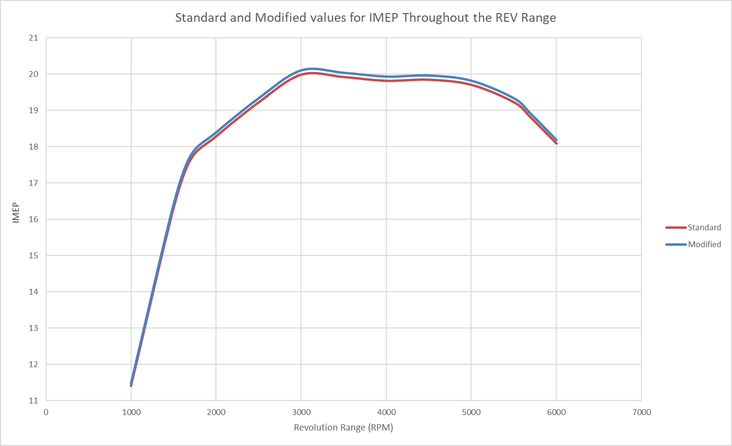
Figure 36 - Standard and Modified IMEP Throughout the RPM Range

FMEP (Bar)
Table 13 - Standard and Modified Engine Values for FMEP

FMEP represents the frictional losses due to frictional work done throughout each cycle. As seen previously, the modified engine sees a reduction in frictional work done compared to the standard engine, henceforth, the modified engine’s FMEP values are slightly lower than the standard engine.

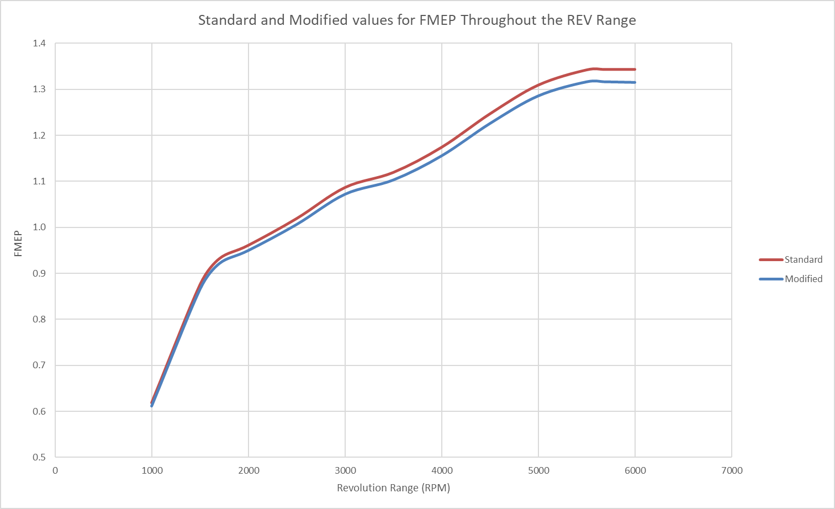
Figure 37 - Standard and Modified Engine Values for FMEP

BMEP (Bar)
Table 14 - Standard and Modified Engine Values for BMEP
BMEP can be defined as “the average (mean) pressure which, IF imposed on the pistons uniformly from the top to the bottom of each power stroke, would produce the measured (brake) power output.” (EPI Inc., 2019).

This uses the value for IMEP then subtracting the FMEP losses to result in the BMEP, representing the more accurate value for efficiency within the engines.
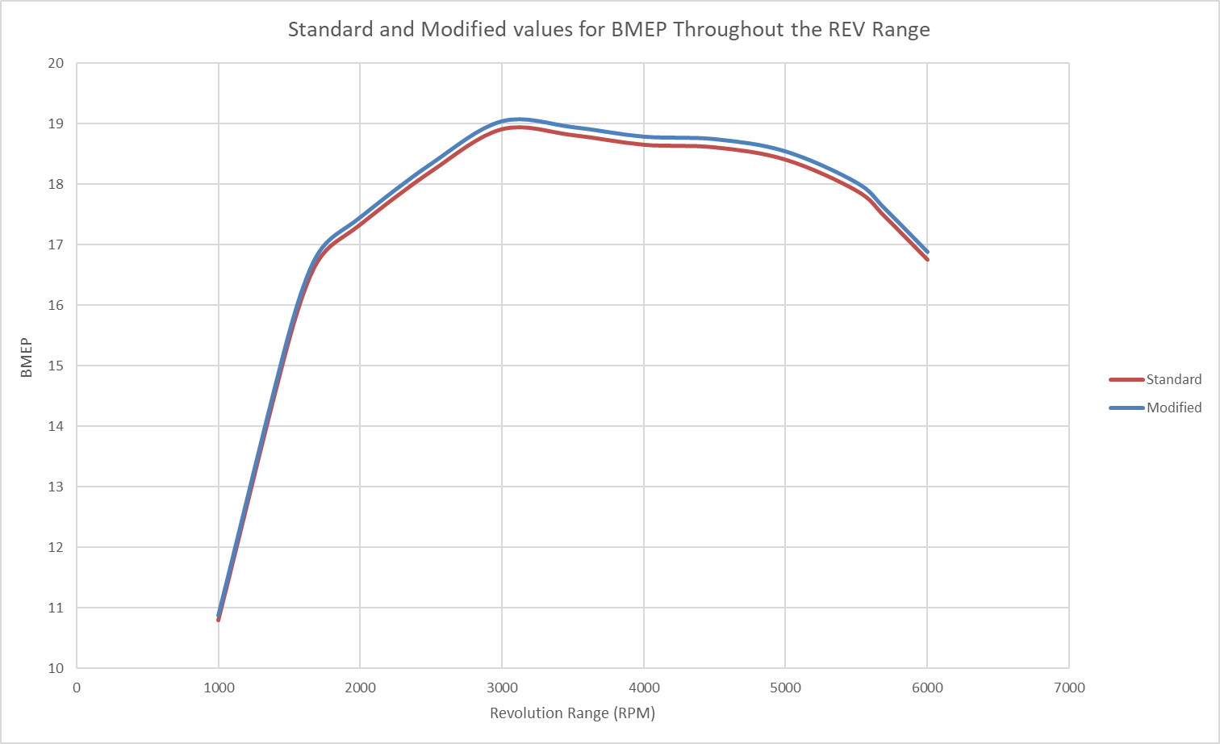
Figure 38 - Standard and Modified Engine Value for BMEP


Power (KW) and Torque (Nm)
Table 9 - Standard and Modified Power and Torque Values Throughout the REV Range
The torque values shown above, are the totals of the gas torque for all cylinders, produced throughout each RPM. The power shown above is derived by using the torque produced by the gas force from all cylinders, this is however without taking frictional losses into account.
It is clear to see that the modified engine gains only a slight increase in both power and torque but follows the same trend as the standard engine, showing that by increasing the bore and decreasing the stroke can improve performance of the engine, however, minimal in comparison.
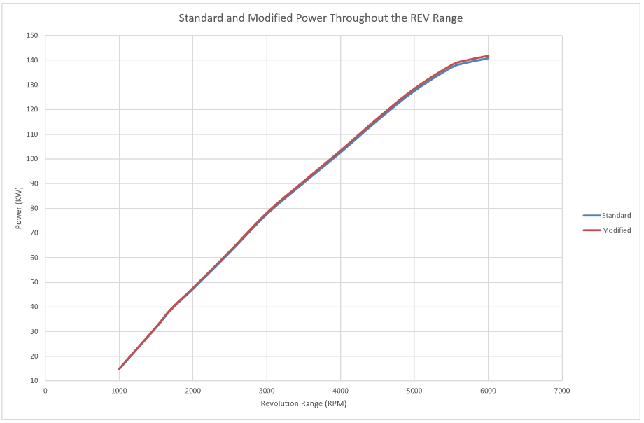

Figure 22 - Standard and Modified Power Throughout the REV Range

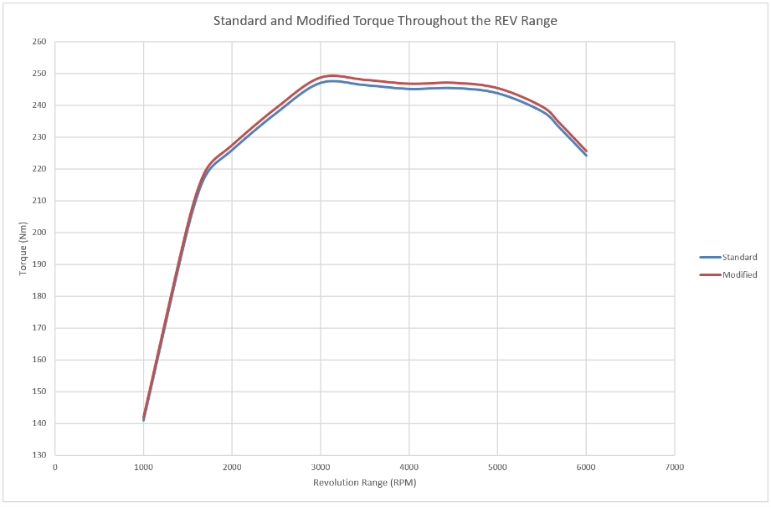

Figure 23 - Standard and Modified Torque Throughout the REV Range

