  Component One:  What are the key skills required when working in the housekeeping team? 750 words (+/- 10%)  Contribution to Overall Module Assessment: 25% | Student No: | Saima Aamir  2117592
 | Module Title: | Operating Hotel Facility
 | Module Code: | BMIH4006
 | Lecturer: | Lola Villard
In the realm of the hospitality industry, effective housekeeping plays a vital role in ensuring guest satisfaction and the overall success of any establishment. As a member of a housekeeping team, I have gained firsthand experience and industry insights, allowing me to appreciate the importance of possessing certain key skills. In this student journal, I will delve into the topic of the essential skills required when working in a housekeeping team, drawing from my personal experiences, providing examples, and highlighting the significance of effective communication, attention to detail, time management, problem-solving, and teamwork.

Effective communication is vital for the success of any team, including the housekeeping team. Communication plays a critical role in ensuring that tasks are completed efficiently and effectively. Team members must have excellent communication skills to relay information about room status, guest requests, and inventory levels. Effective communication also involves active listening and responding to the needs of other team members. Stankovic and Bisenic (2017) found that effective communication was essential in the housekeeping team for the successful completion of tasks.

Attention to detail is another critical skill for housekeeping team members. Housekeeping team members must have an eye for detail to ensure that guest rooms are spotless and that all amenities are in place. Attention to detail is also essential for ensuring that public areas and back-of-house spaces are clean and organized. Inaccurate or incomplete cleaning can lead to guest complaints and a negative impact on the hotel's reputation. Radojevic (2019) emphasizes the importance of attention to detail in the housekeeping team for guest satisfaction.

Time management is crucial in the housekeeping team. Team members must prioritize tasks and allocate their time efficiently to ensure that guest rooms are cleaned promptly, and public areas are presentable. Time management skills also involve multitasking, working under pressure, and meeting tight deadlines. Efficient time management is essential to ensure that housekeeping services are delivered on time and to the highest standard. Berezina, Shokirova, and Bilgihan (2020) found that time management skills were critical in the housekeeping team for meeting guest demands.

Problem-solving skills are crucial in the housekeeping team. Team members must be able to identify and resolve problems efficiently to ensure guest satisfaction. Examples of problems that may arise in the housekeeping team include guest complaints, equipment malfunctions, and staff shortages. Effective problem-solving requires critical thinking, creativity, and the ability to make decisions quickly. Aren (2017) highlights the importance of problem-solving skills in the housekeeping team for ensuring guest satisfaction.

Teamwork is critical for the success of the housekeeping team. Team members must work together to ensure that all tasks are completed on time and to the highest standard. Effective teamwork involves collaborating, communicating, and supporting each other to achieve common goals. Positive teamwork leads to improved job satisfaction, productivity, and guest satisfaction. Hua and Gursoy (2019) found that teamwork was essential in the housekeeping team for achieving high levels of guest satisfaction.

During my work experience I was able to observe and learn about the key skills required when working in the housekeeping team. I found that effective communication was essential to ensure that tasks were completed efficiently and that guest needs were met. Attention to detail was also critical in ensuring that guest rooms were spotless and that all amenities were in place. Time management was necessary to ensure that housekeeping services were delivered on time, and problem-solving skills were needed to resolve any issues that arose. Positive teamwork was also critical in ensuring that all tasks were completed on time and to the highest standard.

The theoretical knowledge gained from this academic student journal can be applied in practice when working in the housekeeping team. For example, effective communication skills can be applied when conveying information about room status, guest requests, and inventory levels. It can also help in active listening and responding to the needs of other team members. As a housekeeping team member, I can apply this knowledge to ensure that all team members are on the same page, and we work towards achieving the desired results efficiently.

The topic of the essential skills required when working in the housekeeping team is crucial in the hospitality industry. As mentioned earlier, effective housekeeping is essential for guest satisfaction, which is critical for the success of any hospitality business. It is therefore vital that housekeeping team members possess the necessary skills to ensure that guests are satisfied with their stay.

Moreover, in the current COVID-19 pandemic, the importance of maintaining high standards of cleanliness and hygiene cannot be overstated. Housekeeping team members are at the forefront of ensuring that all areas of the hotel are clean and safe for guests and other team members. By possessing the essential skills discussed in this academic student journal, housekeeping team members can ensure that they maintain the highest standards of cleanliness and hygiene to prevent the spread of the virus.

Conclusion:
working in the housekeeping team requires a combination of essential skills, including effective communication, attention to detail, time management, problem-solving, and teamwork. These skills are crucial for ensuring guest satisfaction which is critical for the success of any hospitality business. Through personal experience and industry insights, it is evident that possessing these skills is essential for the housekeeping team to perform successfully. As the hospitality industry faces unprecedented challenges during the COVID-19 pandemic, maintaining high standards of cleanliness and hygiene is crucial. Therefore, housekeeping team members must possess these skills to ensure that they maintain the highest standards of cleanliness and hygiene to prevent the spread of the virus.

References:

Word Count

Component Two:
Contribution to Overall Module Assessment: 25%
In this scenario – You have just been promoted to team leader for a floor within the hotel. A guest complains that on their arrival, their room had not been properly cleaned. Create an action plan and answer the following questions.

Problem | Why did it happen? | What are you going to do? | How will you prevent this from happening in the future? | What measures would you introduce to improve team effectiveness?

Component Three:
Contribution to Overall Module Assessment: 50%
Your task is to create and prepare a presentation following the detailed scenario provided below.

As the floor housekeeping manager and given the recent guest complaints you need to put together a basic training presentation for your colleagues within the housekeeping team to get the best out of them, ensure that brand standard is being achieved and that Health and Safety procedures are also being followed.

Basic training Presentation
for housekeeping team
Module: Operating Hotel facility (BMIH4006)
Lecturer: Lola Villard
Student ID: 2117592
Student name: Saima Aamir

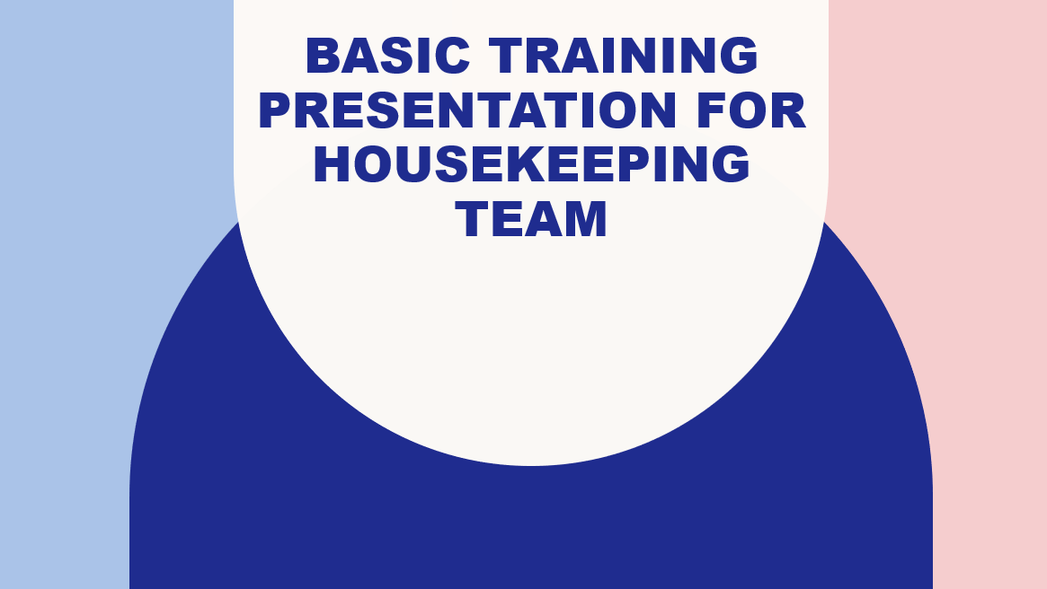
Training Notes:
Hello everyone, my name is Saima Aamir and I am the floor housekeeping manager. Today, I want to discuss some important topics related to our housekeeping duties. As you all know, our work plays a crucial role in the overall guest experience at our hotel. Therefore, it is essential that we are meeting brand standards and following health and safety procedures.

The purpose of this presentation is to provide you with a refresher on the standard procedures we should be following and to address recent guest complaints. By the end of this presentation, you will have a better understanding of the expectations and standards we need to meet to ensure guest satisfaction and safety.

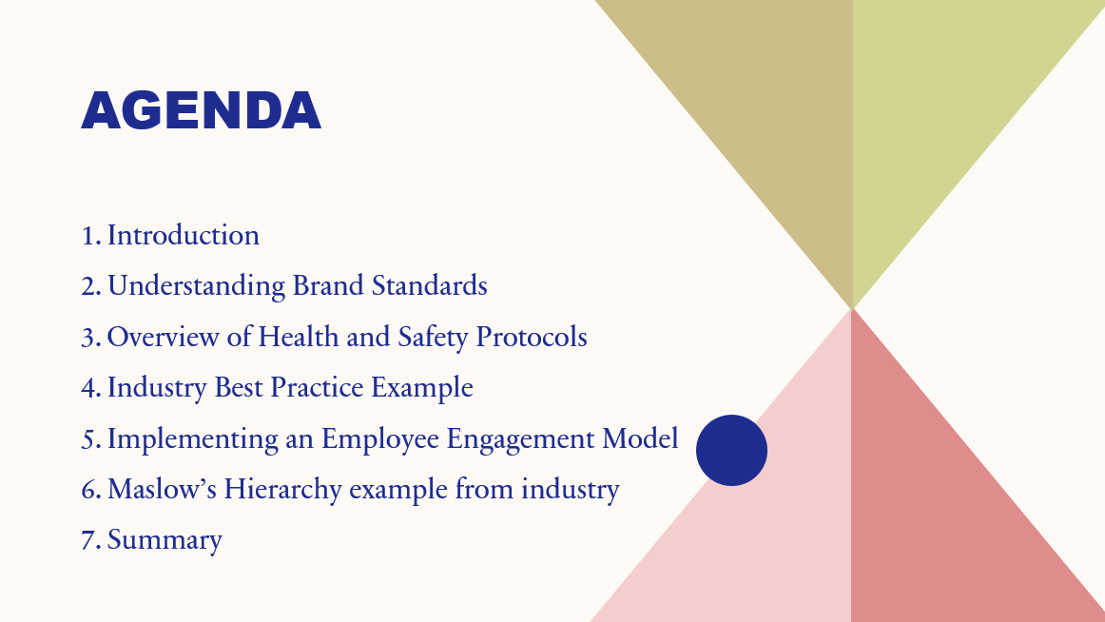Please feel free to ask any questions you may have during or after the presentation. Let's begin.
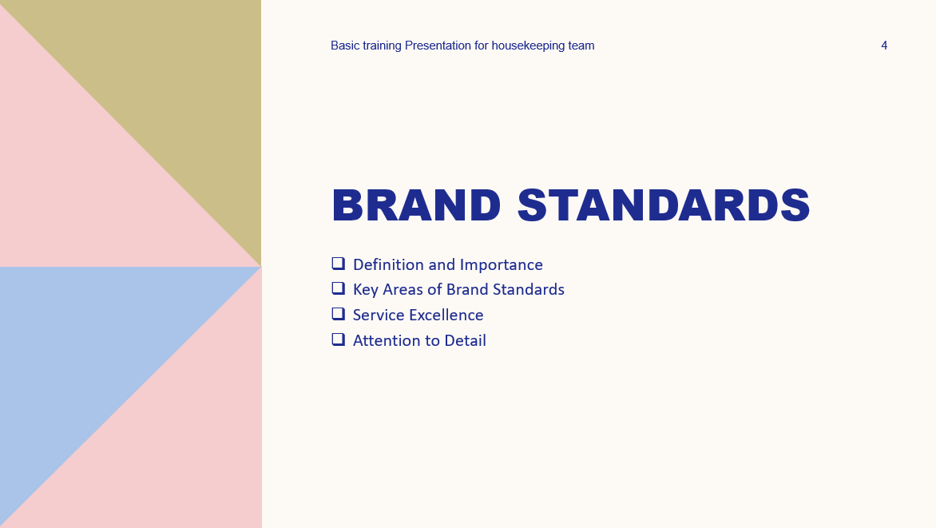

Training Notes: As the Hotel Trinity Floor Housekeeping Manager, it's important that we provide our guests with a consistent and exceptional experience. That's why we have established brand standards that our housekeeping team is expected to adhere to.

These brand standards include maintaining a clean and organized appearance throughout the hotel, delivering exceptional guest experiences, and paying attention to the details that matter to our guests.
"Brand standards are guidelines and criteria that define the desired guest experience and reflect the values and identity of a hotel" (Smith, 2019). They ensure consistency, quality, and a cohesive brand image across all aspects of the property. Adhering to brand standards is crucial as it creates familiarity, builds trust with guests, and leads to their satisfaction, loyalty, and positive reviews (Johnson, 2020). The housekeeping team plays a pivotal role in upholding these standards by ensuring cleanliness, providing exceptional service, and contributing to a positive guest experience (Brown, 2018). Overall, brand standards are the foundation of a hotel's identity, reputation, and success (Miller, 2021).

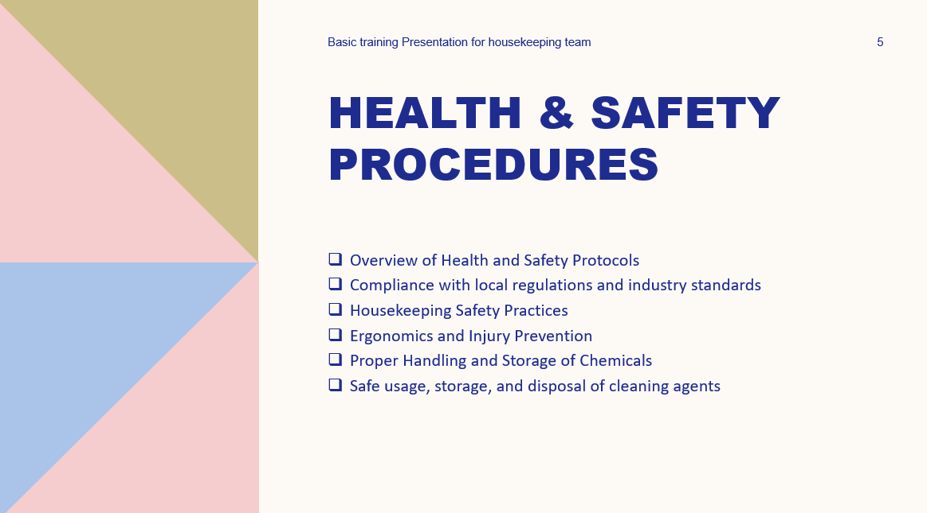
Training Notes:
Health and Safety in our housekeeping department. As members of this team, it is crucial that we prioritize the well-being of both ourselves and our guests. This training session aims to equip you with the necessary knowledge and skills to maintain a safe working environment and prevent potential hazards.
First and foremost, let's emphasize the importance of Health and Safety in our daily tasks. By adhering to proper procedures, we not only protect our physical well-being but also contribute to guest satisfaction and the overall reputation of our hotel. Each one of us plays a vital role in upholding Health and Safety standards and promoting a culture of safety throughout our department.
Throughout this training, we will address potential risks and hazards associated with our housekeeping tasks. These can include exposure to cleaning chemicals, physical strain from lifting heavy objects, Electrical hazards, Sharps and biohazardous materials, slips and falls, and ergonomic issues. Understanding these risks is the first step in effectively identifying and addressing potential hazards in our work environment.
To mitigate these risks, we will provide guidelines on how to properly handle cleaning chemicals. This includes ensuring proper storage, understanding appropriate usage, and the importance of wearing personal protective equipment (PPE) such as gloves and goggles. By following these guidelines, we can minimize the risk of chemical-related incidents and protect our health.
Accident prevention is another crucial aspect of Health and Safety. We will discuss the significance of maintaining clean and clutter-free work areas, promptly addressing spills, and using caution signs when necessary. Additionally, regular equipment inspections and reporting any maintenance issues are essential to create a safe working environment.
Throughout this training, I encourage active participation and questions. Your engagement is vital in ensuring that we all fully understand and implement the Health and Safety practices discussed. Remember, Health and Safety is a shared responsibility, and each one of you plays a crucial role in upholding it.

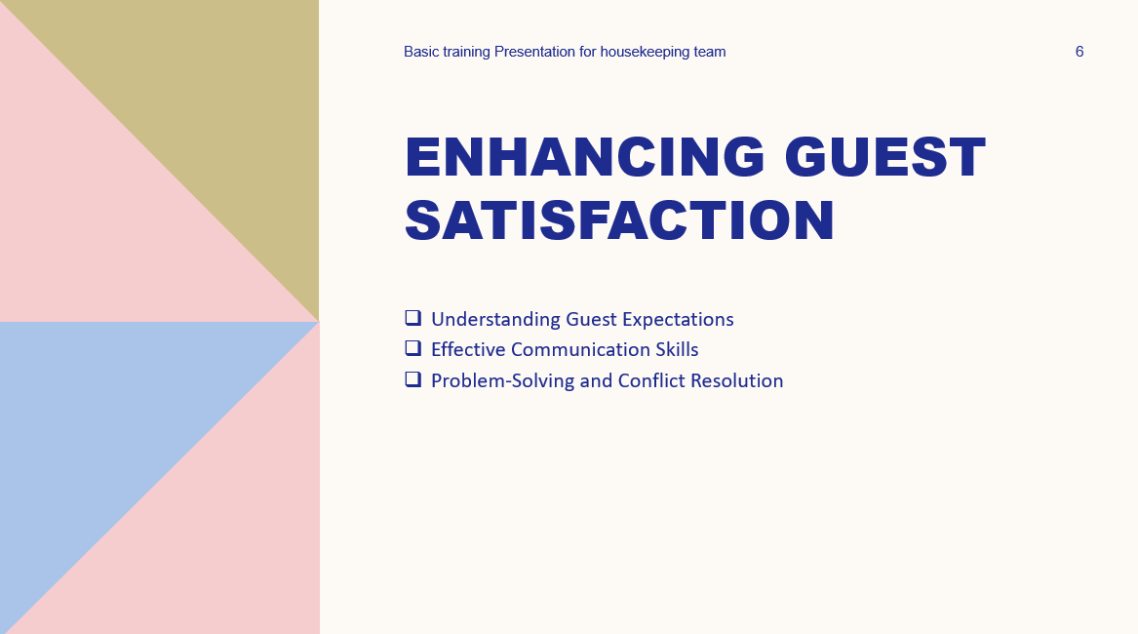
Training Notes:
As you are aware, we have received some guest complaints regarding our housekeeping services. While it's disheartening to hear about these issues, it's crucial that we view them as an opportunity for growth and improvement (Johnson, 2020). Guest feedback is a valuable source of information that helps us understand our strengths and areas where we need to focus our efforts (Miller, 2021). By acknowledging and addressing the recent guest complaints, we can learn from them and take necessary steps to enhance our performance.
Our guests' satisfaction is the cornerstone of our success as a hotel. Each guest who stays with us expects exceptional service and a memorable experience. When we receive complaints, it indicates that we have fallen short of meeting these expectations. However, it also presents an opportunity for us to analyse the feedback, identify areas for improvement, and take proactive measures to ensure that such issues do not recur.
Addressing guest complaints demonstrates our commitment to providing outstanding service. It shows that we value our guests' opinions and are dedicated to making their stay as pleasant as possible (Brown, 2018). By taking their feedback seriously and implementing necessary changes, we can strengthen our reputation and build guest loyalty (Johnson, 2020).

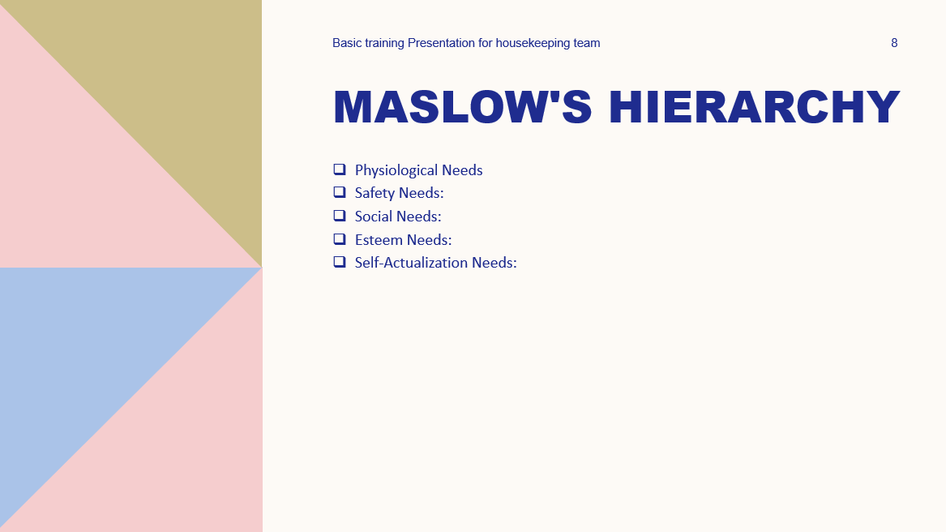

Training Notes:

Below is an example of Maslow’s Hierarchy employee engagement model and example from the industry of Accor hotel
Physiological Needs:
Accor Hotels ensures that employees' basic physiological needs are met by providing competitive wages, comfortable and safe working conditions, and access to amenities such as break areas, meals, and clean and well-maintained facilities. This creates a foundation for employees to focus on their work and deliver exceptional hospitality services.
Safety Needs:
Accor Hotels prioritizes the safety and security of its employees by implementing robust safety protocols, training programs on emergency procedures, and workplace safety measures. By creating a secure work environment, employees feel protected and can perform their duties with peace of mind.
Social Needs:
Accor Hotels recognizes the importance of fostering a sense of belonging and positive relationships among employees. They encourage teamwork, open communication, and collaboration through regular team-building activities, social events, and initiatives that promote a strong sense of community within the hotel. This creates a supportive and cohesive work culture.
Esteem Needs:
Accor Hotels values and acknowledges the contributions of its employees. They have implemented an employee recognition program that rewards outstanding performance, exceptional customer service, and innovative ideas. Additionally, the company provides opportunities for career growth and development, allowing employees to take on new responsibilities and advance within the organization. This fosters a sense of achievement, self-worth, and professional growth.
Self-Actualization Needs:
Accor Hotels supports employees in reaching their full potential by offering training and development programs, mentoring opportunities, and career advancement paths. Employees are encouraged to take ownership of their work, contribute their ideas, and innovate in their respective roles. By providing a stimulating work environment that encourages creativity and autonomy, Accor Hotels helps employees achieve self-actualization and personal fulfilment.

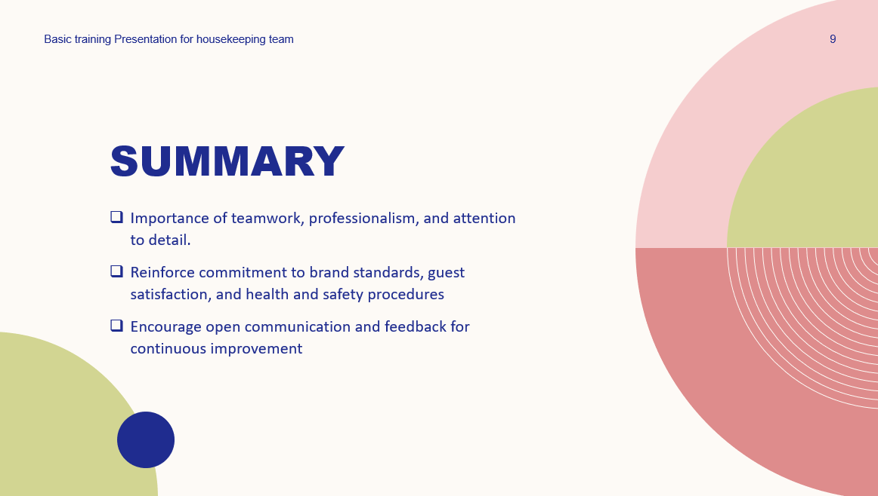

Training Notes: As the Floor Housekeeping Manager at Hotel Trinity, it is crucial to uphold brand standards, prioritize Health and Safety, and address guest complaints. Brand standards ensure consistency and guest satisfaction, while Health and Safety procedures protect both employees and guests. Guest complaints provide opportunities for improvement and addressing them demonstrates our commitment to exceptional service. Maslow's employee engagement model highlights the importance of meeting employee needs for enhanced engagement and performance. By adhering to these principles, we can provide an outstanding guest experience, strengthen our reputation, and achieve success as a team.



Training Notes:
You are welcome to ask any question regarding the training/presentation.

References

Operating Hotel Facilities BMIH4006
A Presentation NOTE
on basic training for housekeeping team
Student Name : Saima Aamir
Student ID : 2117592
Lecturer’s Name : Kathryn Robert

We are thrilled to inform you about the upcoming Basic Training Program, which will focus on reinforcing our brand standards and enhancing health and safety measures within our housekeeping operations. This training will play a crucial role in ensuring that we consistently deliver a superior guest experience while prioritizing the well-being of our team members.

During the training, we will emphasize the following key areas:

Brand Standards:
Our brand is synonymous with excellence, and as members of the housekeeping team, you play a pivotal role in upholding these standards. We will delve into the specific brand guidelines, including cleaning protocols, room setup, and attention to detail. By aligning our practices with the brand standards, we can ensure that every guest or resident receives a consistent and memorable experience.

Health and Safety Measures:
The health and safety of both our guests or residents and our team members are of utmost importance. This training will focus on educating you about the latest health and safety regulations, guidelines, and best practices. Topics such as proper use of personal protective equipment (PPE), safe handling and storage of cleaning agents, and procedures to minimize the spread of infectious diseases will be covered. By adhering to these measures, we can create a safe environment for everyone.

Quality Assurance:
Maintaining a high level of cleanliness and order is essential for our brand reputation. We will provide you with comprehensive training on quality assurance processes, including thorough inspections, corrective actions, and reporting procedures. By consistently delivering exceptional cleanliness standards, we can exceed guest or resident expectations and enhance their overall experience.

Continuous Improvement:
In addition to the basic training, we encourage you to actively participate in ongoing learning and development opportunities. This may include attending refresher courses, engaging in peer-to-peer knowledge sharing, and staying updated with industry trends. Emphasizing continuous improvement will ensure that our housekeeping team remains at the forefront of industry standards and best practices.

We believe that this Basic Training Program, centered on brand standards and health and safety measures, will further empower you to excel in your role and contribute to the overall success of our organization. Your dedication to maintaining brand excellence and prioritizing health and safety is truly commendable.

Thank you for your unwavering commitment. We look forward to your active engagement and participation in the training program.

Best regards,

Saima Aamir

