Research Proposal:
Title: A critical evaluation of how managers motivate employees to increase organizational productivity.

Lecturer: Arpu Kurmar
Student: Nicoleta Bichir
Student Number: 2126694


Rationale for the Study
The objective of this research is to examine the correlation between employee motivation and production within an organization. Motivation is a critical determinant that profoundly impacts employee conduct, involvement, and overall achievement, thus affecting an organization's prosperity. This research aims to thoroughly examine and evaluate managers' current motivational strategies to identify efficient approaches to enhancing motivation and productivity.

1.1 Aims:
- The goal is to determine the relationship between employee motivation and organizational productivity.
- The objective is to evaluate the effectiveness of different motivational strategies managers critically employ.
- To provide recommendations for managers on how to enhance motivation and, as a result, increase productivity.

1.2 Objectives:
- Analyse the concept of Motivation and Employee Productivity.
- Examine productivity metrics and performance data to evaluate the impact of different motivational strategies on employee productivity.
- Assess the various motivational techniques currently being utilized by managers in the organization.
- Conduct surveys and interviews to gather employee perceptions and attitudes towards the motivational strategies employed by their managers.
- Based on research findings, develop practical recommendations for managers to improve motivational strategies.

1.3 Research questions:
- What are the current motivational techniques managers use in the organization?
- How are these techniques implemented to enhance employee motivation?
- How do employees perceive the effectiveness of these motivational strategies?
- Which motivational strategies are identified as best practices in existing literature, and how do they compare to those used in the organization?
- What specific recommendations can managers make to enhance employee motivation and increase productivity?

1.4 Literature Review:
Concept of Motivation:
Personal motivation occurs when a person is motivated by someone who considers his motivation and ability to use his resources to achieve the organization's goals (Weinstein & Deci, 2013). Motivation refers to the psychological forces that drive and direct our behavior toward achieving certain goals or satisfying certain needs.
Motivation is the driving force that initiates, regulates, and sustains conduct in a person, both internally and externally. Individuals perceive motivation as a psychological attribute that propels attaining objectives, including the exertion they dedicate to a task. Motivation encompasses a range of factors that initiate, regulate, and sustain certain activities and is crucial for optimizing organizational productivity and efficacy. It may be defined as an intrinsic condition that stimulates purposeful actions, shaped by an individual's requirements, aspirations, and readiness to exert effort to accomplish predetermined objectives (Daft & Noe, 2001).

According to Dubin (2002), motivation is a complex force in building and maintaining a person who enjoys being in an organization.
Methods for inspiring and encouraging individuals Researchers have investigated numerous ideas but have increasingly emphasized the significance of employing multiple motivating strategies for the performance of employees. Motivation initiatives are defined as methods and strategies that can be employed to inspire and encourage personnel, for example:
- Wages/Salary/Increments
- Rewards
- Recognition
- Praise
- Assigning new roles
- Management Communication Style (Miller & Rollnick, 2013).

1.4.1 Model of Employee Motivation. Abraham Maslow's Hierarchy of Needs

Behavioral scientists and psychologists have created various theories to explain motivation. Several of these theories are directly related to employee performance. This research proposal will examine and critically analyze Abraham Maslow’s Hierarchy of needs.
Maslow’s Hierarchy of Needs Theory (1943)
According to Abraham Maslow's "Theory of Human Motivation," the author published a theory on what motivates human beings in 1943. The theory outlines five needs that humans have always sought to satisfy. The more fundamental life requirements a person has, the more motivated they are to fulfill them.
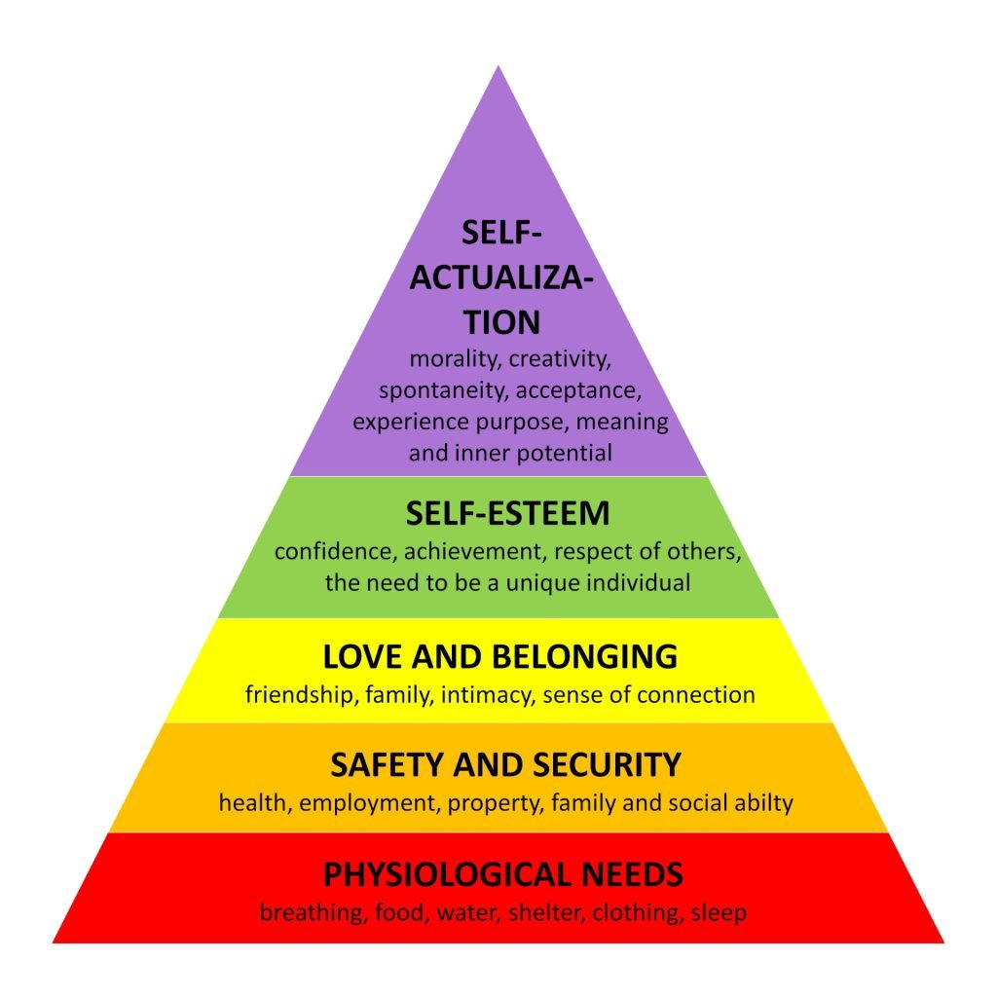
When analyzing Maslow's hierarchy, which outlines the five needs of humans further, managers may develop a comprehensive understanding of their approach and designate areas for development by organizing motivational techniques according to the needs they satisfy. Fair wages and health benefits address physiological needs, while job security and a secure work environment are implemented to address safety needs (King-Hill,2015). Through team collaboration and social events, love and belonging are cultivated, while esteem requirements are satisfied by acknowledging accomplishments and providing opportunities for personal development. Personal growth opportunities and challenging assignments are implemented to foster self-actualization. Organizations can gain insight into their motivational strategies and develop more effective strategies to accommodate the diverse requirements of their employees by evaluating these techniques following Maslow's hierarchy (Taormina & Gao, 2013). Compared to Herzberg's Two-Factor Theory, Herzberg's theory focuses more on workplace motivation, while Maslow's theory is broader in scope. He distinguishes between two types of factors: motivators and hygiene factors. Hygiene factors like pay and working conditions cannot motivate, but poor ones can cause dissatisfaction. When motivators such as success, recognition, and progress are present, they may provide delight and increase motivation (Nickerson, 2023).

1.4.2 Criticisms of Maslow’s hierarchy
Self-actualization is not linear: Initially, Maslow argued that individuals could only achieve self-actualization after meeting their basic needs. However, the inability to meet basic needs can sometimes help people identify their self-actualization goals. For instance, someone might have a stable career fulfilling their safety needs. If they lose their job, they might realize their old career was not satisfying, prompting them to pursue a more fulfilling path. In his later work, Maslow acknowledged that unmet needs could motivate self-actualization (McLeod, 2024).
According to the criticism of Herzberg's theory, hygiene factors decrease job dissatisfaction. Herzberg, Mausner, and Snyderman used the term hygiene to describe how medical hygiene operates to remove health hazards from the environment. As a result, the theory has encountered numerous criticisms since its inception. One major critique is that the theory oversimplifies the complex nature of work motivation by categorizing factors into just two groups. Accordingly, critics argue that the distinction between hygiene factors and motivators is not always clear-cut, as some factors could act depending on the individual and context (Alshmemri, 2017).
In conclusion, motivational theories such as Maslow's Hierarchy of Needs and Herzberg's Two-Factor Theory provide distinct perspectives on the factors influencing human behavior. Although these theories have distinct characteristics and get specific critiques, they collectively contribute to our comprehension of motivation by emphasizing its intricate and diverse nature, influencing people in every aspect of their lives (Robbins & Judge, 2013).

1.5 How do employees perceive the effectiveness of motivational strategies?
A case study at a mid-sized manufacturing company recently implemented a new employee motivation program to boost engagement and productivity (Bekesi & Coturbas, 2020). The program included key components:
Increased financial incentives: Employees were eligible for higher bonuses and pay raises based on individual and team performance metrics.
The work environment is the conditions under which employees must perform their duties. Work schedules, reporting hours, supervisors, work, and flexibility constitute these conditions (Lee & Chan, 2015). This emphasizes considering employees' different requirements and preferences when creating workplaces. Employees who face poor working conditions are likelier to experience negative performance outcomes, making favorable working conditions essential for optimal productivity and job satisfaction (Nethi, 2020).
Expanded professional development and Empowering employees: The company invested in more training opportunities and tuition reimbursement to support employee growth. Empowerment is broader than traditional centralization, delegation, and collaborative leadership conceptions. The server with increased authority can customize the service encounter according to the individual expectations of each guest. Furthermore, they can take any required measures to prevent or resolve service failures (Lee & Chan, 2015)
Improved communication: Managers were trained to provide more frequent feedback and recognition to their teams. This is essential for motivation, and feedback must be done quickly, constructively to correct poor performance and positively praise good performance.
Enhanced benefits: The company expanded health insurance coverage and added new perks like gym memberships and free snacks (Armstrong, 2014).
After six months, the organization conducted an anonymous employee questionnaire to gauge perceptions of the new motivation program. Accordingly, the outcomes are:
- 75% of employees felt the expanded benefits were a positive motivator, with many citing the gym memberships as a major perk (Shuck & Roberts, 2018).
- Only 45% of employees felt the financial incentives were effective, with some expressing skepticism about the fairness of the performance metrics.
- 60% of employees reported that the increased communication from managers made them feel more valued and motivated.
- 80% of employees expressed that professional development opportunities were a strong motivator, as they saw them as investments in their long-term growth (Bekesi & Coturbas, 2020).
The questionnaire results highlighted some important gaps in employee perceptions. Employees wanted more transparency around the bonus structure and a stronger link between pay and performance. They increased communication around the bonus criteria, provided more training for managers on giving feedback, and expanded tuition reimbursement (Link, 2022). This case study underscores the importance of soliciting employee feedback and tailoring motivational approaches to meet their needs and perceptions (Bekesi & Coturbas, 2020).

2. Methodology

2.1 What is the research Methodology?
Research, commonly acknowledged, indicates the act of obtaining information. It can also be described as a comprehensive and rigorous investigation of relevant information on a certain subject. Clifford Woody states that research involves clearly describing and refining issues, developing hypotheses or proposed solutions, and gathering, organizing, and assessing data. Research aims to discover answers to questions by applying scientific procedures (Kothari, 2004). To identify the research methodology in more detail, it is necessary to scrutinize the research strategy and collect and analyze data thoroughly. The literature review employs a survey and questionnaire as its research method. Additionally, using these two methods, surveys and questionnaires, facilitates the identification of specific areas for improvement in the company's motivational approaches (Walliman, 2006).
This literature study has utilized two research methodologies: descriptive and correlational.
This quantitative, correlational research method allows us to examine and understand the relationships between motivational strategies (financial incentives and professional development) and employee perceptions and outcomes. This approach is practical and ethical for studying real-world settings where experimental manipulation might not be feasible or appropriate.
Descriptive research collects information to provide an in-depth description of the current condition of employee attitudes regarding different incentive methods. Utilizing questionnaires to collect employee perceptions regarding enhanced benefits, financial rewards, possibilities for professional growth, and enhanced communication offers an extensive overview of employee attitudes and motivations (Ortlieb, 2021).

2.2 Ethical
The participants in the research were human beings. The primary goal of engaging individuals in research is to gather data. Researchers are obligated to safeguard the life, health, dignity, integrity, privacy, and confidentiality of personal information of those participating in the study. The Belmont Report provides a framework for evaluating research using ethical principles.
- Respect for people means recognizing people's right to be independent and keeping those who don't have it safe. To ensure that all employees who participated in the case study were fully informed about the purpose of the research and how their data would be used.
- Beneficence means, first, no harm, maximizing possible benefits, and minimizing possible harms.
- Justice for each person and society
Communicating about and addressing these ethical concerns is crucial to ensuring that the study respects the rights and well-being of all participants (Camille, 2016).
Moving on to research, ensuring the reliability and validity of findings is crucial for effective writing. Researchers should prioritize the reliability and validity of their instrumentation when conducting investigations. One way to achieve measurement validity and reliability is to improve the quality of item writing, consistently provide reliable data in different research, establish solid theoretical foundations for construct measurement, and accurately operationalize constructs (Thanasegaran, 2009). The research employs a standardized questionnaire to present the same questions to all participants, ensuring consistent data collection. The questions on the questionnaire are based on well-known theories, like Maslow's Hierarchy of Needs and the motivational strategies found by different researchers (Weinstein & Deci, 2013; Miller & Rollnick, 2013), to make sure that the concepts being measured are a good representation of the idea of motivation.

2.3. What recommendations can managers make to enhance employee motivation and increase productivity?
Offering flexible work schedules, such as remote or hybrid options and additional PTO, can significantly motivate employees by enhancing their autonomy.
Flexibility in work schedules enables employees to maintain a healthy work-life balance and better attend to their personal and family needs, improving overall well-being and increasing work motivation.
Based on the insights from the 2021 Jabra report and the Gartner Digital Worker Experience Survey report on hybrid work, 59% of respondents valued flexibility more than salary or other benefits, and 75% preferred to work for companies that allow them to work from anywhere.
Flexibility is beneficial for both employees and employers. The 2021 Gartner Digital Worker Experience Survey revealed that 43% of respondents felt more productive with flexible working hours, and 30% reported increased productivity due to reduced or eliminated commuting time
According to the previous questionnaire, 60% of employees felt more valued and motivated due to increased communication from managers. In this field, it can lead to more recommendations, potentially increasing future scores. Promoting open communication helps foster an environment where employees feel comfortable sharing their ideas, concerns, and feedback with managers without fear of repercussions. Recognizing Contributions encourages managers to consistently acknowledge and value employees' efforts, regardless of their size, fostering a gratitude culture (Bekesi & Coturbas, 2020).

3. Appendix 1 Quantitative Survey – Questionnaire
The following questionnaire will require approximately 5 minutes to complete. To ensure that all the information will remain confidential, please do not include your name:
- How long have you been working for your current employer?
  - 0-3 years
  - 3-6 years
  - 6-10 years
  - Over 10 years
- How old are you?
  - 18-34
  - 35-44
  - 45-54
  - 55-64
- What is your current employment status?
  - Full-time
  - Part-time
  - Zero hours-contract
  - Contract Worker
- Do you have the necessary resources to perform your job effectively?
  - Strong
  - Agree
  - Disagree
  - Strongly Disagree
- Do you clearly understand what is expected of you in your role?
  - Strongly Agree
  - Agree
  - Disagree
  - Strongly Disagree
- Do you feel secure in your job?
  - Strongly Agree
  - Agree
  - Disagree
  - Strongly Disagree
- How well do you feel you are compensated by your current employer?
  - Excellent
  - Above Average
  - Average
  - Below Average
- Is recognition of your work important to you, and does it impact your performance?
  - Strongly Agree
  - Agree
  - Disagree
  - Strongly Disagree
- How often do you receive informal feedback on your performance?
  - Never
  - Once a year
  - Once a month
  - Weekly
- Does the company provide opportunities for your professional and personal development?
  - Strongly Agree
  - Agree
  - Disagree
  - Strongly Disagree
- Does the company support you in balancing your personal life with work?
  - Strongly Agree
  - Agree
  - Disagree
  - Strongly Disagree
- How would you describe your relationship with your co-workers?
  - Excellent
  - Above Average
  - Average
  - Below Average
- How would you describe your relationship with top management in your company?
  - Excellent
  - Above Average
  - Average
  - Below Average
- Do you feel that the company values your work?
  - Strongly Agree
  - Agree
  - Disagree
  - Strongly Disagree

4. Reference list:
Alshmemri, M., Shahwan-Akl, L., and Maude, P., 2017. Herzberg's two-factor theory. Life Science Journal, 14(5), pp. 12–16. Accessed at: [04 July 2024}
Armstrong, M. (2014). Armstrong's Handbook of Human Resource Management Practice, 13th ed. London. Available at: Armstrong's Handbook of Human Resource Management Practice | Kogan Page [Accessed: 17 June 2024].
Bekesi, D.G. and Coturbaş, L. (2020). 'Employees' Perceptions Regarding The Strategies For Motivating Human Resources Within A Private Organization In Oradea', Annals of the University of Oradea, Economic Science Series, 29(2), pp. 42–54. Available at: http://anale.steconomiceuoradea.ro/volume/2020/n2/003.pdf [Accessed: 13 June 2024].
Dubin, R. (2002). Personal Motivation. McGraw-Hill Education.
DTS (2016), Human Performance Technology. Praise & Criticism: Hierarchy of Needs (Maslow). January 27. Available at: https://blog.hptbydts.com/in-a-nutshell-hierarchy-of-needs-maslow Accessed: [June 13, 2024].
Gartner. (2021). Digital Worker Experience Survey. [online] Available at: www.gartner.com Accessed at: [07 June 2024].
Jabra. (2021). Hybrid Ways of Working: 2021 Global Report. [online] Available at: www.jabra.com Accessed at: [07 June 2024].
King-Hill, S. (2015). Critical analysis of Maslow's hierarchy of needs. The Step Journal (Student Teacher Perspectives), 2 (4), 54–57. Accessed at: [27 June 2024]. Available at: https://insight.cumbria.ac.uk/id/eprint/2942/1/KingHill_CriticalAnalysisOfMaslows.pdf
Kothari, C. R. (2004). Research methodology. Accessed at: [ 26 June 2024]
Lee, S., Back, J. & Chan, W. (2015). Quality of Work Life and Job Satisfaction among Frontline Hotel Employee: A Self-Determination and Need Satisfaction Theory Approach. International Journal of Contemporary Hospitality Management. 5 (5), p. 768-789.
Link, A. (2022) Performance-Based Compensation: What It Is and How To Approach It, COMPENSATION & BENEFITS. Available at: https://www.shrm.org/resourcesandtools/tools-and-samples/toolkits/pages/performancebasedcompensation.aspx Accessed: [14 June 2024).
McLeod, S. (2024, January 24). Maslow's Hierarchy of Needs. Simply Psychology. Accessed at: https://www.simplypsychology.org/maslow.html. Accessed at:[26 June 2026]
Miller, W. R., and Rollnick, S. (2013). Motivational Interviewing: Helping People Change, 3rd ed. Guilford Press.
Nethi, S. (2020). 'A literature review on Employee motivation', Journal of Engineering Sciences, ISSN NO: 0377–9254, Vol. 11(6), pp. 1247–1255. Available at: www.jespublication.com [Accessed: 14 June 2024).
Okine, B., Asare, G. and Addeh, A. (2021). 'Motivational strategies employed by managers within organizations,' Journal of Economic and Sustainable Development, 12(16), pp. 91-98. Doi: 10.7176/JESD/12-16-11.
Ortlieb Evan, (2021). The four types of quantitative research design. Accessed at: [27 June 2024]. Available at: www.youtoube.com
Robbins, S.P. & Judge, T.A. (2017). Organizational Behaviour, 17th end. Pearson Education Limited, Upper Saddle River. Available at: Organizational behavior | WorldCat.org Accessed: [15 June 2024).
Shuck, B., Roberts, T.P. and Zigarmi, D. (2018). 'Employee Perceptions of the Work Environment, Motivational Outlooks, and Employee Work Intentions: An HR Practitioner's Dream or Nightmare?', Advances in Developing Human Resources, 20(2), pp. 197–213. Doi: 10.1177/1523422318757209.
Taormina, R.J. and Gao, J.H. (2013). 'Maslow and the Motivation Hierarchy: Measuring Satisfaction of the Needs', American Journal of Psychology, 126(2), pp. 155–177. Doi: 10.5406/amerjpsyc.126.2.0155
Thanasegaran, G. (2009). Reliability and Validity Issues in Research. Integration & Dissemination, 4. Accessed at: [30 June 2024]. Available at: https://research.ebsco.com/c/onvpsy/search/details/ygvbda4ey5?db=bth
Walliman, N (2006) Social research methods. London: Sage. Accessed at: [01 July 2024]
Weinstein, N., Ryan, R. M., & Deci, E. L. (2013). Motivation, meaning, and wellness: A self-determination perspective on creating and internalizing personal meanings and life goals. In The human quest for meaning (pp. 81–106). Routledge. Accessed at: [26 June 2024]
Yip, Camille1; Han, Nian-Lin Reena2; Ban Leong1, 3, Legal and ethical issues in research. Indian Journal of Anaesthesia 60(9): p 684-688, September 2016. | DOI: 10.4103/0019-5049.190627

