A Critical Examination of Airbnb as part of the Sharing Economy

Name: Jordan Evans
Student Number: 1808395
Programme of Study: BA Business and Management
Module: Digital Business
Tutor: Dr Roisin Mullins
Date: 7/3/21
Word Count: 2692

Introduction
The sharing economy concept has been embraced by governments, entrepreneurs and commentators as delivering new forms of opportunity for local and national economies (Crommelin, L. et al., 2017). Airbnb, the most successful online peer- to-peer accommodation platform, has fully embraced the concept of the sharing economy however is often criticised by regulators and policy makers (Quattrone, G. et al., 2016) on its actual ‘sharing’ activities. To further investigate the matter, this report will critically examine Airbnb as an example of the sharing economy with the use of academic references and models.
The internet has seen many steps of evolution since the introduction of the world wide web in 1992, which has spurred new business models and marketplaces which otherwise wouldn’t exist. In more recent years, the term ‘sharing economy’ has become a popular buzz word in public media (Hern, A. 2015). The new players, such as Airbnb, revolutionised the way we see this phenomenon, as with a few years’ development, it has topped the world leading traditional international hotel chains and is expanding seamlessly to the world (Clampet, J. 2015). So what exactly is the ‘sharing economy’?
As described by (Schor, J., Fitzmaurice, C. 2015), the sharing economy is the peer to peer sharing of access to underutilised goods and services, which prioritizes utilization and accessibility over ownership. There are a range of activities which are included in the sharing economy, and therefore defining the phenomenon to encompass the whole meaning can be difficult, it is seen as closely related to the ‘circular economy’ and ‘collaborative economy’ with no clear distinction between consumption and production activities (Codagnone, C., Martens, B. 2016). Furthermore, (Frenken et al. 2015) define the sharing economy as “consumers granting each other temporary access to under-utilised physical assets, possibly for money.” (Frenken et al. 2015) also distinguish the sharing economy from other economic forums by three elements: sharing is about consumer-to-consumer, sharing is about temporary access, sharing is about the more efficient use of physical assets. Given these guidelines, we can evaluate the true position of Airbnb as part of the sharing economy.
Airbnb Landscape
As the most prominent hospitality firm in the sharing economy, Airbnb is an online rental marketplace that provides short-term accommodations to guests as an alternative to hotels (Xie, K., Mao, Z. 2017). Airbnb currently operate in more than 100,000 cities in 220 countries (Folger, J. 2021).
Airbnb differ from hotels and bed & breakfasts as they do not own properties, instead they act as an intermediary between those who want to rent out space and those who are looking for space to rent (Rawes, E., Lacoma, T. 2021), Airbnb are know as the facilitator on the peer-to-peer marketplace, as without the use of Airbnb technology the interactions between hosts and guests would not occur.
Launched on August 11th 2008, Airbnb amassed a revenue of $3.4 billion in 2020, which was down from $4.7 billion in 2019 (Curry, D. 2021), however being expected as the tourism and hospitality industry was one of the greatest affected as a result of the coronavirus pandemic. Airbnb priced its IPO at $68 a share on December 10th, 2020 giving it a valuation of $47.3 billion on a fully diluted basis (Nath, T. 2020). A key factor which separates Airbnb form a bulk of the multi-billion dollar start ups is that it is cash flow positive… whereas most companies are forced to burn cash quickly to capture a larger share of the market quickly (Forbes, 2018). Similarly, virtually every unicorn IPO that has gone public in the past couple of years has not come close to making a profit (Meyers, L. 2020). This includes companies such as Uber, Lyft and Beyond Meat, all of which have reported significant losses and are yet to see any profit which further emphasizes the true effectiveness of the Airbnb business model which will be discussed later on in the report.
Airbnb Competition
Being a relatively new company compared to many of its competitors (Booking.com, Marriott, Hilton), Airbnb have hit the holiday rental market by storm. Established in 2008, Airbnb have been able to capture a market share upwards of 20% (Clifford, R. 2020) which makes them the current leader in the home-sharing market (Lock, S. 2021).
Over 50% of Airbnb users in 2016 used Airbnb to replace a traditional hotel stay (iPropertyManagement, 2021), this solidifies that customers are placing more value upon the authentic and cheaper experiences of Airbnb rather than traditional hotels. Below is a graph from (Haywood, J., et al. 2017) which shows raw number of listings from lodging companies as of November 2016. This number has increased much more since, however it is still useful to compare the mass amount of listings under the Airbnb portfolio in comparison to its competitors.

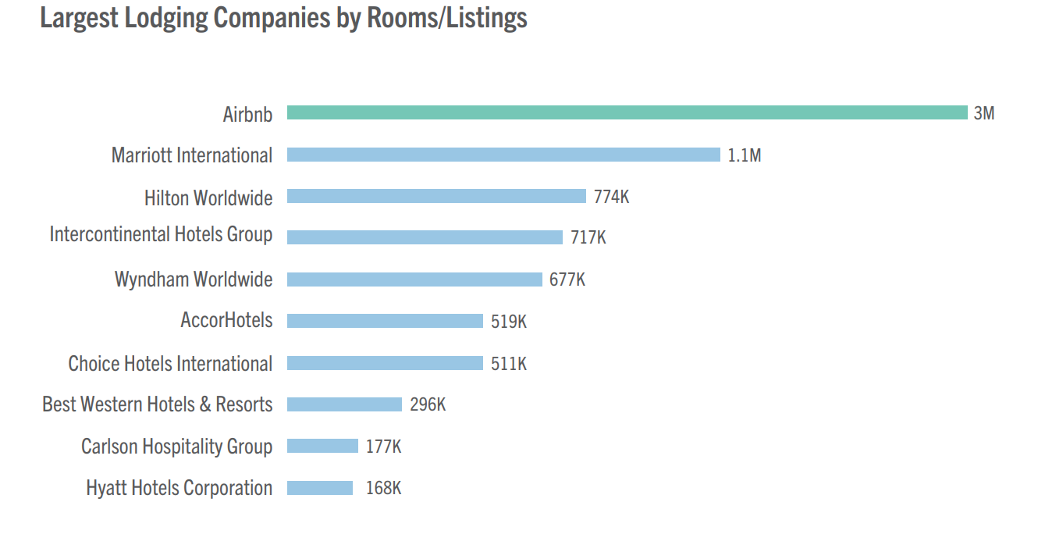
Airbnb is unique in the way that it does not own the real estate that the customers use, expansion comes from not acquiring more property but acquiring more hosts. This unique business model means that expansion is much easier, quicker, and cheaper than competitors, allowing Airbnb to turn over a larger profit and continue to expand by improving the accessibility of their service.
Airbnb Challenges
With the travel industry contributing $2.9 trillion to the GDP in 2019, that number is set to drop significantly for 2020, resulting in a likely 60-80% drop (Adams, C. 2020). There is no doubt that the coronavirus pandemic has had a dramatic impact on the travel and tourism industry, Airbnb may have lost as much as 54% of its revenue in 2020 due to coronavirus (iPropertyManagement, 2021). In an attempt to combat some of the challenges faced from coronavirus Airbnb cut 25% of its workforce, reduced marketing spending, cut bonuses, reduced executive salaries for six months and suspended all new office construction (Fortune, 2020).
Aside from challenges Airbnb have faced from COVID, lawmakers and hotel owners have been, and continue to be a massive challenge for Airbnb. The company became a Federal Trade Commission target in 2016 after three senators asked for an investigation into how companies like Airbnb affect soaring housing costs (Benner, K. 2017). Furthermore, there is growing concerning that many Airbnb listings are not following the correct health and safety procedures, fire safety procedures and also hosting others without planning permission. This has raised great concern to lawmakers and governments, with Airbnb being held responsible for not enforcing laws enough.

Airbnb Business Model
Although business models have been integral to trading and economic behaviour since pre-classical times (Teece, D. 2010), the proliferation of the concept began with the introduction of the internet in the 1990s. Professor of Management, Raffi Amit and Professor of Entrepreneurship, Christoph Zott define a business model as the ‘content, structure, and governance of transactions designed so as to create value through the exploitation of business opportunities (Amit, R., Zott, C. 2001). Similarly, (Bocken, N. et al. 2015) describe a business model as a structured way for sustainable business thinking by mapping the purpose, opportunities for value creation across the network and how to generate revenue (Bocken, N. et al. 2015). Others such as (Birkinshaw, J., Goddard, J. 2009) describe the business model simply as “how a company makes money” (Birkinshaw, J., Goddard, J. 2009).
The economic value of a technology remains latent until it is commercialized in some way via a business model (Chesbrough, H. 2010), the correct business model for a product/ service is essential to its success and therefore making it one of the most important components of operating a successful business. A primary component of the business model is the value proposition (Kopp, C. 2020), which is the fundamental point of an organisation, as without a beneficial value proposition to the customer there is no benefit, which will not make a product or service attractive.
Proposed in 2005 by Alexander Osterwalder, the business model canvas is made up of the nine building blocks of a business model. The canvas is a one-page summary describing the high-level strategic details needed to get a business successfully to the market (Juncal, S. 2020) and can be used to optimize the financial aspect of activities run by an economic entity and focuses on the value offered to customers (Dudin, M. et al. 2015). The business model canvas has been used as it beats the traditional business plan that spans across several pages, by offering a much easier way to understand the different core elements of a business (Athuraliya, A. 2021).
The page below includes a business model canvas designed for Airbnb.

  Key  Partners  - Hosts  - Users  - Investors  - Tourism partners |   Key  Activities  - Maintain consistent good feedback from customers  - Continued expansion of hosts and guests  - Always improve value propositions/ find new ones | Value  Proposition |  |   Customer  Guests  - Low cost, authentic accommodation  - Unique, different experience than hotels  - Provide customer feedback on hosts  - Provided with 100,000s worldwide accommodation  - Instant booking available  Hosts  - Booking management  - Easy payment  - Income generation  - Airbnb have large customer base  - Insurance provided  - Service training  Relationships |   Customer Segments  Hosts/ Guests  - Safety/ security  - Support  - Service  Communities  - Good neighbours  - Responsible Hosting
 |   Key  Resources  - Brand  - Mass of listings  - Data Analytics  - User Generated Content  - Algorithms, technologies | Value  Proposition |  | Channels   - Word of mouth  - Marketing  - Media Coverage  - Discounts, promo  App/ website  Host/ Guest
  Cost  - Insurance  - Payment Processing  - IT Infrastructure  - All staff, legal  - Technology  - Customer acquisition  - Discounts  Structure |  |  |   Revenue Streams  - Commission on every transaction  - 6-12% service fee to guests on every transaction  - 3-5% service fee to hosts on every transaction  - “Experiences”, Airbnb take 20% commission

Guests
- Geo-demographic
- Trip type: Business, leisure
- Rental Type: Apartment, single room
- Interest
- Reason for using Airbnb

Hosts
- Geo-demographic
- Type of accommodation
- Location type
- Reason for hosting
- Experience provided

Appraisal of Airbnb Business Model Canvas
Key Partners
The key partners which a company such as Airbnb will work with are the hosts of the accommodation as it is important to make sure they are happy with the service that Airbnb provide them with. Additionally, the users of the platform and guests to accommodation are equally as important as they need to be satisfied with the service provided from hosts and Airbnb if they were to continue using the platform. Without investors, Airbnb would not be where they are today. Airbnb has raised a total of $6Billion in funding over 19 rounds (Crunchbase, 2021). As part of Airbnb ‘experiences’, Airbnb may partner with local tourist attractions so that guests get a true feel of the local surrounding when in a specific area, this adds value by ensuring guests get the best experience and also looking to boost local economies by attracting more tourists.
Key Activities
Main activities of Airbnb are ensuring that they maintain good feedback from guests which will increase customer retention. Furthermore, continuously looking to expand their network and find more hosts which will help to attract more customers therefore providing value by having a greater choice of accommodation. It is essential for Airbnb to always look to be improving as competition in the hospitality is industry is rife.
Value Proposition
Value Proposition is the core of any business and therefore it is important that an organisation understands the value they add and aim to maintain or improve upon the value added. Airbnb have revenue streams from guests and hosts due to the service fees so there is value that can be added to both sets of users of the platform. The business model canvas above shows the nine building blocks with the relevant information in each block. Airbnb have a very cost effective business model and should continue to operate and grow as they have done over the last few years.

Strategic Formulation Framework
The Strategy-Formulation Analytical Framework (SFF) is applicable to all sizes and types of organisations and can help strategists identify, evaluate, and select strategies (O’Reilly, 2020). The 3 step process aids strategic thinking in an organisation by assessing the internal and external strengths and weaknesses as well as current position of the organisation so that it can formulate a strategy for future growth. Stage 1 of the framework consists of the EFE Matrix (PESTLE Analysis), the Competitive Profile Matrix and the IFE Matrix (SWOT Analysis), this is the basic information which is required to decide upon a strategy. Stage 2 focuses upon generating feasible alternative strategies by aligning key external and internal factors.
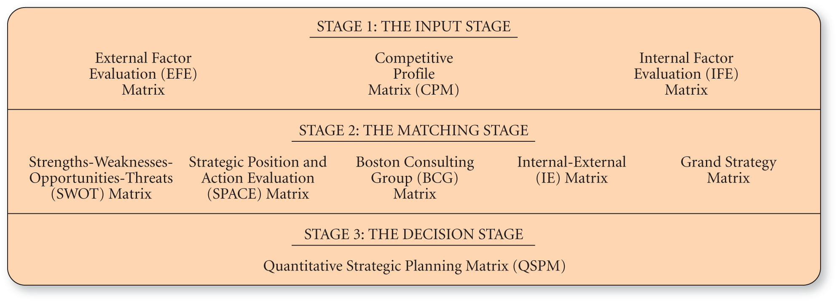
Image gathered from https://www.oreilly.com/library/view/strategic-management-a/9780134167848/images/FG_06_002.png
The Grand Strategy Matrix
The grand strategy matrix is instrumental in assisting organizations to develop feasible alternative strategies (Creately, 2021). The two-axis matrix looks as two dimensions, the market growth and the organisations competitive position within the market. The matrix allows an organisation to identify where they are currently at so that they can plan strategically to meet future goals.


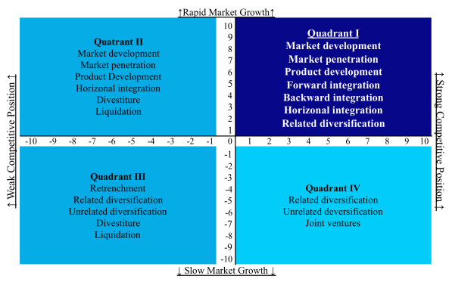
Image from https://www.mbaknol.com/wp-content/uploads/2014/05/Grand-Strategy-Matrix-Mbaknol.png

Airbnb has been placed on the grand strategy matrix below in quadrant 1. This is because Airbnb currently have a strong competitive position in a rapidly growing industry. Airbnb should continue to progress as they are by looking to expand their host network and becoming more accessible over the world. A strategy for improvement would definitley be to enforce strict regulatory rules and ensure that all hosts abide by them as there are raising concerns that Airbnb and theirs hosts are not following correct procedures which could affect their brand image and also make them vulnerable to law suits.

Tools and Systems
Airbnb use numerous amounts of tools and information systems to ensure that it can operate successfully and meet customer requirements. One system which Airbnb have adopted is strategic customer relationship management (CRM). Strategic CRM is focused upon the development of a customer-centric business culture dedicated to winning and keeping customers by creating and delivering better value than competitors (Buttle, F., Maklan, S. 2019). CRM is the strongest and most efficient approach in maintaining and creating relationships with customers (Juneja, P. 2015). Customer relationships and customer retention are essential to the success of any organisation, therefore many companies wish to implement effective CRM systems to best enhance the experience for their customers. Airbnb’s platform, website, mobile and social media are a complete package with respect to CRM (Akshay, D. 2014). Airbnb CRM is very advanced and ensures interaction with customers, travellers and hosts. Automated welcome emails, e-mail postcards with events in an area where a customer has booked, feedback forms are just a few examples which prove that Airbnb have strong CRM set in place in order to attract and retain as many customers as possible.
Furthermore, Airbnb have moved their MySQL database to Amazon Web Services as it simplifies much of the time-consuming administrative tasks typically associated with databases (AWS, 2021). AWS is an example of an Enterprise Resource Planning (ERP) system which is a business management system that comprises integrated sets of comprehensive software, which can be used, when successfully implemented, to manage and integrate all the business functions within an organisation (Sehab, E. et al. 2004). ERP is now considered to be the price of entry for running a business, and at least at present, for being connected to other enterprises in a network economy to create “business to business” electronic commerce (Boykin, R. 2001). Airbnb are using the most up to date and efficient systems to ensure that they provide the best possible service and therefore adding value to their customers.

Conclusion
Overall, this report began by stating what the sharing economy is with definitions from theorists. The report has also analysed the current landscape of Airbnb, its financial situation, competitors, and challenges that are faced by the company. Definitions of a business model were discussed along with business model canvas for an in depth look at the value proposition of Airbnb and the nine pillars to their success. Furthermore, the strategic formulation framework was applied to Airbnb using the Grand Strategy Matrix. Finally, some systems which Airbnb have adopted in order to reach their goals. To conclude, Airbnb are a relatively new organisation and have truly adopted the concept of the sharing economy and were one of the only unicorn companies to sustain being profitable. The business model, emphasis on customer service, unique experiences, lower price than competitors and advantages to the environment have allowed the organisation to expand globally and continue to do so, despite coronavirus having a drastic affect on the global tourism industry.

References
Adams, C. (2020) How the Coronavirus Pandemic Has Impacted the Travel Industry. Online article retrieved from https://medium.com/swlh/how-the-coronavirus-pandemic-has-impacted-the-travel-industry-bce8d15bab55 accessed on 06/03/21 at 00:23
Akshay, D. (2014) Customer Relationship Management- Airbnb. Online article retrieved from https://daveakshay.wordpress.com/2014/10/30/customer-relationship-management/. Accessed on 07/03/21 at 19:47
Amit, R., Zott, C. (2001) Value creation in e-business. Strategic Management Journal. Vol. 22, pp. 493-520
Athuraliya, A. (2021) The Easy Guide to the Business Model Canvas. Online article retrieved from https://creately.com/blog/diagrams/business-model-canvas-explained/ accessed on 07/03/21 at 16:04
AWS (2021) Airbnb Case Study. Online article retrieved from https://aws.amazon.com/solutions/case-studies/airbnb-case-study/ accessed on 07/03/21 at 21:41
Benner, K. (2017) Inside the Hotel Industry’s Plan to Combat Airbnb. Online article retrieved from https://www.nytimes.com/2017/04/16/technology/inside-the-hotel-industrys-plan-to-combat-airbnb.html?login=email&mtrref=www.nytimes.com accessed on 06/03/21 at 00:10
Birkinshaw, J., Goddard, J. (2009) What is your management model? MIT Sloan Management Review, pp. 81-90
Bocken, N., Rana, P., Short, W. (2015) Value mapping for sustainable business thinking. Journal of Industrial and Production Engineering, 32(1), pp. 67-81
Boykin, R. (2001) Enterprise resource-planning software: a solution to the return material authorization problem. Computers in industry, Vol. 45, pp. 99-109
Buttle, F., Maklan, S. (2019) Customer relationship management: concepts and technologies. Routledge, pp. 5
Chesbrough, H. (2010) Business model innovation: opportunities and barriers. Long Range Planning, 43(2), pp. 354-363
Clampet, J. (2015) What’s an Airbnb Listing Worth in 2015? Online article retrieved from https://skift.com/2015/06/19/whats-an-airbnb-listing-worth-in-2015/ accessed on 03/03/21 at 17:52
Clifford, R. (2020) Competitors For Airbnb: Who’s Stealing Market Share From The Industry Giant? Online article retrieved from https://www.smartbnb.io/competitors-for-airbnb/ accessed on 07/03/21 at 00:15
Creately (2021) Grans Strategy Matrix- Definition, Usage & Templates. Online article retrieved from https://creately.com/usage/grand-strategy-matrix/ accessed on 07/03/21 at 22:36
Codagnone, C., Martens, B. (2016) Scoping the sharing economy: Origins, definitions, impact and regulatory issues. Institute of Prospective Technological Studies Digital Economy Working Paper, pp.6
Crommelin, L., Troy, L., Marting, C., & Pettit, C. (2017) Is Airbnb a Sharing Economy Superstar? Evidence from Five Global Cities. Urban Policy and Research, 36(4), pp. 429-444
Crunchbase (2021) Airbnb. Online article retrieved from https://www.crunchbase.com/organization/airbnb/company_financials accessed on 07/03/21 at 16:45
Curry, D. (2021) Airbnb Revenue and Usage Statistics (2021). Online article retrieved from https://www.businessofapps.com/data/airbnb-statistics/ accessed on 05/03/21 at 23:45
Dudin, M., Kucuri, G., Fedorova, I., Dzusova, S., Namitulina, A. (2015) The innovative business model canvas in the system of effective budgeting. Asian Social Science, 11(7), pp. 290-296
Folger, J. (2021) Airbnb: Advantages and Disadvantages. Online article retrieved from https://www.investopedia.com/articles/personal-finance/032814/pros-and-cons-using-airbnb. Accessed on 05/03/21 at 23:24
Forbes (2018) As A Rare Profitable Unicorn, Airbnb Appears To Be Worth At Least $38 Billion. Online article retrieved from https://www.forbes.com/sites/greatspeculations/2018/05/11/as-a-rare-profitable-unicorn-airbnb-appears-to-be-worth-at-least-38-billion/?sh=63898fb52741 accessed on 06/03/21 at 22:34
Fortune (2020) Airbnb’s IPO filing reveals huge COVID impact. Online article retrieved from https://fortune.com/2020/11/16/airbnb-ipo-initial-public-offering-coronavirus-impact/ accessed on 07/03/21 at 00:43
Frenken, K., Meelen, T., Arets, M., van de Glind, P. (2015) Smarter regulation of the sharing economy. Online article retrieved from https://www.theguardian.com/science/political-science/2015/may/20/smarter-regulation-for-the-sharing-economy accessed on 04/03/21
Haywood, J., Mayock, P., Freitag, J., Owoo, K., Fiorilla, B. (2017) Airbnb & hotel performance. STR Publication. pp.9
Hern, A. (2015) Why the Term ‘Sharing Economy’ Needs to Die. Online article retrieved from https://www.theguardian.com/technology/2015/oct/05/why-the-term-sharing-economy-needs-to-die accessed on 03/03/21 at 17:35
iPropertyManagement (2021) Airbnb Statistics. Online article retrieved from https://ipropertymanagement.com/research/airbnb-statistics accessed on 06/03/21 at 22:56
Juncal, S. (2020) How to Build a Product Roadmap Based on a Business Model Canvas. Online article retrieved from https://www.productplan.com/business-model-canvas/ accessed on 05/03/21 at 12:28
Juneja, P. (2015) Importance of Customer Relationship Management. Online article retrieved from https://www.managementstudyguide.com/importance-of-crm.htm accessed on 07/03/21 at 19:40
Kopp, C. (2020) What is a Business Model? Online article retrieved from https://www.investopedia.com/terms/b/businessmodeln accessed on 05/03/21 at 12:13
Lock, S. (2021) Airbnb- statistics and facts. Online article retrieved from https://www.statista.com/topics/2273/airbnb/ accessed on 07/03/21 at 00:17
Meyers, L. (2020) Airbnb Isn’t Just Any Unicorn About to IPO. It Actually Makes Money. Online article retrieved from https://www.ccn.com/airbnb-isnt-just-any-unicorn-about-to-ipo-it-actually-makes-money/ accessed on 07/03/21 at 00:22
Nath, T. (2020) How Airbnb Makes Money. Online article retrieved from https://www.investopedia.com/articles/investing/112414/how-airbnb-makes-money.asp#citation-17 accessed on 06/03/21 at 00:01
O’Reilly (2020) The Strategy-Formulation Analytical Framework. Online article retrieved from https://www.oreilly.com/library/view/strategic-management- accessed on 07/03/21 at 22:48
Panchal, M. (2020) How Does Airbnb Make Money? -Airbnb Business Model Explained. Online article retrieved from https://www.apurple.co/airbnb-business-model-know-how-does-airbnb-work/ accessed on 05/03/21 at 12:53
Quattrone, G., Proserpio, D., & Quercia, D. (2016) Who benefits from the “Sharing” economy of Airbnb? Proceedings of the 25th International conference on world wide web, pp. 1385- 1394
Rawes, E., Lacoma, T. (2021) What is Airbnb? What to know before becoming a guest or host. Online article retrieved from https://www.digitaltrends.com/home/what-is-airbnb/ accessed on 05/03/21 at 23:34
Schor, J., Fitzmaurice, C. (2015) Collaborating and connecting: the emergence of the sharing economy. Handbook of Research on Sustainable Consumption, UK, pp. 410
Shehab, E., Sharp, M., Supramaniam, L., Spedding, T. (2004) Enterprise Resource Planning. Business Process Management Journal. Pp.359-386
Teece, D. (2010) Business models, business strategy and innovation. Long Range Planning, Vol.43, pp. 172-194
Xie, K., Mao, Z. (2017) The impacts of quality and quantity attributes of Airbnb hosts on listing performance. International Journal of Contemporary Hospitality Management, Vol. 29, pp.9

