Module code: LCBB4005
Module Title: The Global Business Environment - Assessment 2

Environmental analyses of the H&M Group and changes it has made within the business model to create
sustainable fashion

Student’s name: Catalina Maxim
Student’s ID: 2011531
Lecturer’s name: Dr John-Paul Okeke

Table of contents
Introduction ……………………………………………………………………….. 3
State of the global fashion industry …………………………………………….. 4
H&M Group’s background ………………………………………………………. 4
H&M Porter’s Five Forces analysis ………………………..…………… 5
Case study ………………………………………………………………………… 7
Stakeholder’s influence on the company’s activity …….……………… 8
Changes implemented within the H&M’s business model …..……….. 9
Competitive advantage acquired after these changes ……….………. 11
Recommendations ……………………………………………………………….. 11
Conclusion ………………………………………………………………………... 12
Reference list …………………………………………………………………….. 13

Introduction
This report has the destination to investigate the environmental surroundings of H&M Group. This company is an important player in the global industry of fashion, an active promoter of fast-fashion and, since 2017, a sustainable fashion pioneer and coordinator (H&M Group, 2021a).
The essay is based on a specific case study, and namely, the viscose pollution from factories in Asia, that supply H&M with the crafted garment pieces (The Guardian, 2017).
In addition, were highlighted the company’s engagement with its stakeholders towards the sustainable manufacturing of its fashion products and changes undertaken by the company to reduce the rate of pollution that results from the fashion industry.

State of the global fashion industry
The contemporary fashion industry is identified as the second massive global environmental polluter, being surpassed only just by the oil industry (Sustain your style, 2017).
According to WWF - World Wildlife Fund (2021a), around half of all textiles are produced with cotton, the most profitable harvest worldwide, that accounts about 7% of all workforce from the developing countries and provides source of existence for over 250 mln people.
Although, the cotton crop is highly demanded by apparel and footwear manufacturers, the cotton growing and processing methods are harmful for the environment, resulting with exaggerated consumption of water, soil degradation caused by agrochemicals and conversion of habitat. The waste and pollution of water as a result of cotton production processes, had a major negative impact on important ecosystems from the areas it is originated, such as the Aral Sea in Central Asia, the Indus Delta in Pakistan and the Murray Darling River in Australia (WWF, 2021a).
Another issue provoked by cotton processing is the scarcity of water, in the areas of growing, caused by the released chemicals and microplastics into the rivers and oceans. In consequence, the society in number of 1.1 bln people lacks the direct access to water and another 2.7 bln people confronts with water scarcity at least one month a year (WWF, 2021b).
In the same context, the fashion industry is currently responsible for 8.1% of global greenhouse gas emissions, that is expected to raise to 60% by 2030, if no actions will be undertaken (Vox, 2019).

H&M Group’s background
Hannes and Mauritz (H&M) is a Swedish-based public limited company, founded in 1947, that aims to create sustainable changes alongside its value chain production, starting with designing, sourcing of the raw materials, manufacturing, logistics, retailing and ending with recycling and upcycling of the production overstocks (H&M Group, 2021a).
The company counts 4372 stores in 74 markets around the world and forms a multi-brand mix with 7 other famous brands: COS, AFound, Weekday, Arket, H&M Home, &other stories and Monki (H&M Group, 2021b).
Due to Covid-19 pandemic, H&M Group faced the forced acceleration of already rolling transformation of the industry, into a sustainable business, focusing on the omnichannel sales and fast digitalisation (H&M Group, 2021c).

H&M Porter’s Five Forces analysis
At this stage, was analysed the competitive environment of H&M Group, by applying the Porter’s Five Forces model, that allows the company to apply the suitable strategies for the future (Mind Tools, 2021):
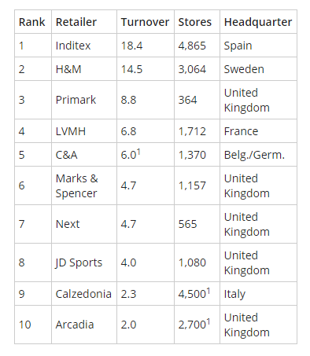
Industry rivalry (high)
On the fashion retail market are identified a big number of competitors, therefore the rivalry within the industry is very high. According to Retail-Index (2021), the closest H&M’s competitors are LVMH, C&A, Marks & Spencer, Arcadia, Next, Primark etc., being surpassed just by Inditex (Zara).
H&M and Zara are in constantly competition for the leadership in the fast-fashion market, that provides mass-production of trendy garment pieces, at low prices (Forbes, 2020). This impacted negatively both companies, during pandemic times, as it resulted with closed physical stores and excessive overstocks.
Source: Retail-Index, 2021
Bargaining power of buyers (high)
Customers of all the times represented a strong impulse for businesses from the fashion industry. During the Covid-19 outbreak, besides the accelerated digitalisation, H&M confronted with shifting customer preferences, which demand a strong, sustainable and accessible brand.
The 2020 financial year resulted for H&M with a net decrease of 58 shops, compared to the 108 stores net increase in 2019. Therefore, the business has focused its efforts on the omnichannel sales, that is meant to cover all the accessible ways of retailing (H&M, 2020b).
According to H&M’s Markets & Expansion report (2021d), the 2021 financial year is forecasted with a 250 stores net decrease, planning to open new stores in the growing markets. For example, in March this year, H&M launched e-commerce in Qatar and entered the online platform Zalora, covering Indonesia, Philippines, Malaysia and Singapore markets. The company also aims to enter Panama via franchise.
Bargaining power of suppliers (high)
H&M Group is highly dependent on its supplying source, because of the lack of its own factories. The company works closely with about 850 independent suppliers, based across Asia and Europe, thus directly depending on their offer and pricelist (Harvard Business School, 2015).
The same source cited that the company engages and communicates with its suppliers through Production Executive Offices. Before the global pandemic, H&M was manufacturing anticipated 80% of its apparel inventory and other 20% based on the actual market tendencies. While a lot of major fashion retailers, due to the installed pandemic, refused to pay for their in-progress orders, H&M was one of the less that continued to respect their obligations towards the suppliers (McKinsey, 2021).
Since 2017, the company is gradually developing its own sustainable source of raw materials, by recycling the used products and materials, reusing and creating the new ecological harmless textiles (H&M Group, 2020a).
Threat of new entry (low)
Although, there is a high competitiveness on the fashion market, the threat of new entrants is very low, especially during challenging and uncertain times. H&M Group has developed, since its foundation, the ability to offer the suitable fashion items to customers’ expectations. The company is constantly adapting the organisational structure to the customer’s needs, in order to anticipate its competitors and to maintain the leadership position on the fashion market (H&M Group, 2021b).
Threat of substitutes (low)
The threat of substitutes within the fashion industry, is low to zero, because of the lack of things that could replace the clothing and footwear. Therefore, the companies like H&M Group, that managed to conquer this market, will be hard to be replaced by other goods, rather than by its competitors.

Case study

In 2017, H&M Group was linked to an environmental pollution investigation, realised by Changing Markets Foundation. According to its report, H&M and three other major fast-fashion brands, were sourcing their viscose raw materials from factories localised in India, China and Indonesia and which caused colossal environmental harm, including air and water pollution with contaminated waste. The most affected region by the viscose production was province Jiangxi that contaminated lake Poyang, China’s largest freshwater source, and affected dramatically its ecosystem (The Guardian, 2017).
The viscose production is a cheap alternative to cotton, polyester and silk and is based on carbon disulphide processing, which according to the same report “is harming both factory workers and people living near viscose plants. The toxin has been linked to skin conditions, heart diseases, birth defects, severe mental health problems and even cancer”. Other attributed to viscose chemicals are caustic soda and sulphuric acid (Changing Markets Foundation, 2017).

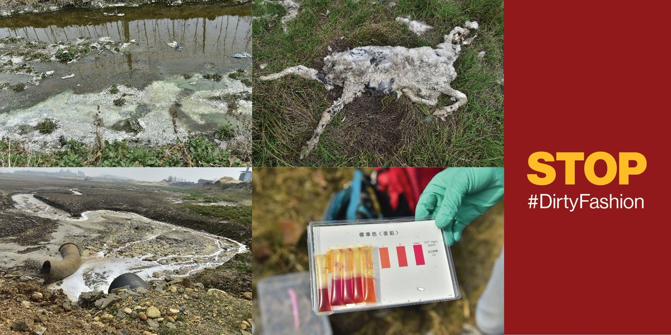
Source: Changing Market Foundation, 2018
As a response to the Guardian’s polluting question, most of the major brands agreed that the viscose manufacturing impact is an industry-known problem and they were looking for sustainable methods of supplying their raw materials.

Stakeholder’s influence on the company’s activity
H&M Group believes that the eco-friendly changes are possible only through building durable and long-term relationships with the stakeholders, such as partners, suppliers, employees, landlords, employees and customers. As follows, is described the company’s engagement with some of its stakeholders (H&M Group, 2021d):
- Researchers – H&M collaborates with peers, nongovernmental organisations, experts, innovators and trade unions with the purpose to follow the constantly raising standards, upcoming innovations and actual local or global concerns;
- Suppliers – are represented by commercial and non-commercial goods providers, franchisers and e-commerce platforms, playing a key role in their value chain. Partnering with them helps H&M to be updated with the industry’s challenges and standards and to explore the discovered opportunities.
- Employees – also named colleagues by H&M, they bring the innovation, diversity and responsibility into the business. The employees are highly appreciated by the company;
- Customers – the company engages with its customers in order to better comprehend their needs, preferences and stimulants and in the end to offer them sustainable goods.

Changes implemented within the H&M’s business model
Since 2017, when H&M was cited in the Changing Market Foundation’s ecological investigation, the company has made an enormous effort to adopt a new, sustainable business model.
Despite the fact, that 2020 year was a though pandemic year, which brought an astronomical income loss, the unexpected challenges only accelerated the transformational processes within H&M Group, such as circularity, digitalisation, inclusion and diversity, and forced the company to focus on two capital directions (H&M Group, 2020a):
- Innovation approach was H&M’s solution to environmental and social problems, aiming to create an entirely circular business model, based on the use, reuse and recycling of their products.
- Transparency leads to an accountable and trustable bond with the customers.

According to H&M’s Sustainability Performance Report (2020a), the company’s circular approach supposes to create a circular ecosystem, that impacts positively the environment and natural resources. The model covers three areas:
- Circular products: obtaining durable products and textiles, from sustainable and recycled sources, that can recirculate multiple times. For example: company disposes of a Circular Innovation Lab, that creates new, eco-friendly textiles; “bottle2fashion” project transforms the plastic bottles into kids’ hoodies and joggers; since 2011 partnerships with WWF to save water and maintain it drinkable.
- Circular supply chains: organising suppliers into recirculating systems, such as: 3D designing, virtual showrooms, tracing the products from sourcing to recycling, via workstreams (Tex.IT project and the UN Economic Commission for Europe).
- Circular customer journeys: offering customers the opportunity to practise the circular fashion, with reused, repaired and recycled fashion products. Examples of circular journey within H&M: denim collection Lee x H&M, made of 100% recycled cotton jeans; online platform “Itsapark” where the consumers can buy pre-owned H&M sub-brands; retailer collects the pre-owned items from customers and recycles them, in exchange of an in-store voucher.

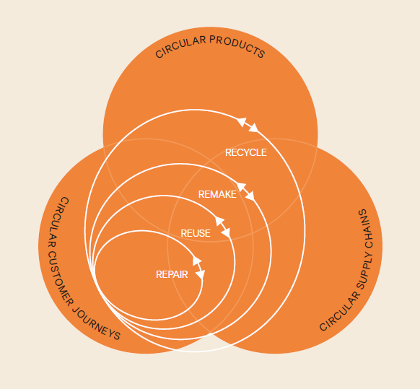
Source: H&M Group, 2020

Competitive advantage acquired after these changes
The new challenges, that Covid-19 outbreak brought, forced the H&M Group to accelerate all the transformational processes, that were already happening inside the company before the pandemic.
According to McKinsey’s (2021) report, the fashion giant managed to acquire a huge competitive advantage by focusing on a circular business model. Alongside sustainability, the accelerated digitalisation assured the increase of the company’s profitability in shorter terms than expected.
In the same context, the omnichannel retail, covering the online, e-commerce and in-store distribution channels, offers to H&M an advantage on the competitive market.

Recommendations
The present report highlighted all the strong and weak forces through Five Forces analysis. As a recommendation addressed to H&M Group, would be to systematically control and monitor the strong powers within the industry, as they have a high impact on the retailer’s activity.
The biggest concern remains the rivalry force, that in combination with financial loss, can easily remove the company from the market. It is advisable that the company keeps investing in innovation, technologisation and sustainability to maintain the front position.
Although the threat of low customer’s bargaining power has a high impact, within the fashion industry, it can be surpassed by applying the adaptive and engaging strategy, offering, simultaneously, excellent customer service.
Also as a recommendation would be that H&M should diminish the tight attachment towards its suppliers and this would be possible by reducing the list of suppliers, to adopt the customer-focused production and better inventory management.

Conclusion
To sum up, this essay brought in light the H&M’s strong and weak competitive forces, alongside the fashion industry’s challenges and opportunities and the company’s response to the environmental polluting investigation, in 2017.
It is remarkable the colossal hard work done by the company, during the last decade. H&M is highly sensible to the surrounding communities, practising the Corporate Social Responsibility, that enhanced especially after the pollution investigation.
In conclusion, the activity of a fashion retailer isn’t just about the apparel and accessories sale, but is closely correlated to the company’s beyond the sales efforts, which impacts positively on the brand image and the company’s trustability. This ends up with the increased profitability and a long- term market domination.

Reference list
Changing Markets Foundation, 2017. [online] Available at: http://changingmarkets.org/wp-content/uploads/2017/06/CHANGING_MARKETS_DIRTY_FASHION_REPORT_SPREAD_WEB.pdf [Accessed 28 April 2021].
Forbes, 2020. Fast Fashion Leaders H&M And Zara; Weathering The Pandemic. [online] Available at: https://www.forbes.com/sites/shelleykohan/2020/03/30/fast-fashion-leaders-hm-and-zara-weathering-the-pandemic/?sh=2b29ac5117a2 [Accessed 2 May 2021].
Harvard Business School | Digital Initiative. n.d. H&M: How Fast Fashion Translates into Low Prices and Success - Technology and Operations Management. [online] Available at: https://digital.hbs.edu/platform-rctom/submission/hm-how-fast-fashion-translates-into-low-prices-and-success/ [Accessed 2 May 2021].
H&M Group, 2020a. Sustainability Performance Report [online] Available at: https://hmgroup.com/wp-content/uploads/2021/03/HM-Group-Sustainability-Performance-Report-2020.pdf [Accessed 31 April 2021].
H&M Group, 2020b. Annual report [online] Available at: https://hmgroup.com/wp-content/uploads/2021/04/HM-Annual-Report-2020.pdf [Accessed 29 April 2021].
H&M Group, 2021a. Vision and Strategy - H&M Group. [online] Available at: https://hmgroup.com/sustainability/leading-the-change/vision-and-strategy/ [Accessed 1 May 2021].
H&M Group, 2021b. H&M - H&M Group. [online] Available at: https://hmgroup.com/brands/hm/ [Accessed 1 May 2021].
H&M Group, 2021c. About us - H&M Group. [online] Available at: https://hmgroup.com/about-us/ [Accessed 1 May 2021].
H&M Group. 2021d. Markets and expansion - H&M Group. [online] Available at: https://hmgroup.com/about-us/markets-and-expansion/ [Accessed May 2021].
Mckinsey, 2021. The State of Fashion. [online] Available at: https://www.mckinsey.com/~/media/McKinsey/Industries/Retail/Our%20Insights/State%20of%20fashion/2021/The-State-of-Fashion-2021-vF.pdf [Accessed 30 April 2021].
Mind Tools, 2021. Porter's Five Forces: - Understanding Competitive Forces to Maximize Profitability. [online] Available at: https://www.mindtools.com/pages/article/newTMC_08.htm [Accessed 1 May 2021].
Retail-index, 2021. Fashion & Clothing Retailers in Europe. [online] Available at: https://www.retail-index.com/Sectors/FashionClothingRetailersinEurope.aspx?gclid=Cj0KCQjwp86EBhD7ARIsAFkgaki1gO2okgIG0d3mtPpwsHJP9qqJ-JKMsV_T4YEMqZ4JWpcea51Wzx8aAsbuEALw_wcB [Accessed 30 April 2021].
Sustain Your Style, 2017. Environmental Impacts of the Fashion Industry. [online] Available at: https://www.sustainyourstyle.org/old-environmental-impacts [Accessed 29 April 2021].
The Economic Times, 2020. Hennes & Mauritz overtakes rival Zara to become India's largest clothing brand. [online] Available at: https://economictimes.indiatimes.com/industry/cons-products/garments-/-textiles/hennes-mauritz-overtakes-rival-zara-to-become-indias-largest-clothing-brand/articleshow/78985633.cms?from=mdr [Accessed 1 May 2021].
The Guardian, 2017. H&M, Zara and Marks & Spencer linked to polluting viscose factories in Asia. [online] Available at: https://www.theguardian.com/sustainable-business/2017/jun/13/hm-zara-marks-spencer-linked-polluting-viscose-factories-asia-fashion [Accessed 1 May 2021].
WWF - World Wildlife Fund, 2021a. Coton| Industries| WWF. [online] Available at: https://www.worldwildlife.org/industries/cotton [Accessed 31 April 2021].
WWF - World Wildlife Fund, 2021b. Water scarcity| Threats| WWF. [online] Available at: https://www.worldwildlife.org/threats/water-scarcity [Accessed 31 April 2021].

