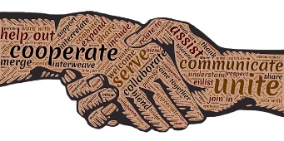
EffeCtive Team-work and communication
BMSW4002

Mr Leighton Fernandes (1915091)
University of Wales Trinity Saint David (UWTSD)
12th June 2020
Lecturer: Melanie Squire

1.0 Executive Summary

This report will show an account of how to build diverse teams that do not lead to conflicts, and ways handle a concert of personalities that comes with such teams. This paper analysis the importance of teamworking and communication

Table of Contents
1.0 Executive Summary 1
2.0 Terms of Reference 3
3.0 Procedure 3
4.0 Introduction 4
5.0 Findings 5
5.1 The importance of teamwork 5
5.2 Tuckman and Belbin theories 5
5.3 How to use teamwork theories to improve the performance of a team in the workplace. 8
5.4 Belbin questionnaire 8
5.5 The differences between groups and teams 9
6.0 Conclusion 11
7.0 Recommendations 11
8.0 References 11
9.0 Appendices 13
10.0 Acknowledgements 13

2.0 Terms of Reference
This report was requested by my Lecturer Melanie Squire for my first academia year of University. This report was requested on the 8th May 2020 and must be submitted by the 12th June 2020 before 4:00pm. I have been asked to prepare a report to present to the business owners outlining the importance of team-working and how teamwork theories can improve the performance of the team in the workplace. This report will show an account of my personal understanding of the subject Effective Teamwork and Communication. I Leighton Pedro Fernandes will compile this report. I will attempt to present an elevation of teamwork theories in relation to group dynamics and the process an individual will go through in the stages of team development. I will be examining Belbin’s theory of team roles, and Bruce Tuckman’s model of team stages.

3.0 Procedure
Various steps in writing this report has come from taking notes in lectures and from first-hand experience as well as researching questionnaires, books, journals and websites. I will be using the Belbin questionnaire to show a clearer understanding of how teamwork theories can improve the performance of a team to benefit organisations.

4.0 Introduction
In this current world, it is not unusual to see individual working in teams, to accomplish goals and tasks. Ever since a child parents and teaches encourage people through different methods to make individuals work as a team. Whether it is through team-based activities in nursery school. For example, four-way tug of war or playing football in a team in infant school. Mentors and guides start introducing young people the value of working in teams to achieve a common goal. According to Maund ,(2017) recent research had Identified that interpersonal communication skills are critical attributes for new employees and manages seeking promotion. However, analysing the importance of interpersonal communication in the workplace, our knowledge and skills on the subject are limited. Indicating that effective communication is a vital part of everyday survival.
Progressive businesses are increasingly realising the value of collaboration and looking for ways to encourage the development within their teams, both traditional and virtual. According to Melony, (2008) teams that communicate complete projects in a quicker and more efficient amount of time than others. Cooperating on various tasks reduces workload for all employees by enabling them to share responsibility and ideas. According to Angelo, (2014) effective teamwork is essential in all businesses and organization who rely upon successful teamwork to make the performance of an organisation efficient and successful in meeting the needs of their clients. It is a synergistic process that relies upon all team members to contribute and participate in order to promote and nurture a positive, effective team environment. Angelo, (2014)
Team members must be flexible enough to adapt to working in a cooperative working environment where goals are achieved through collaboration and social interdependence rather than individualised, competitive goals. According to Nielsen, (2008) companies should strive to involve their employees in decision making and emphasise the importance of sharing information and communicating openly and honestly. Efficient communication is significant for manages in organisations and is the basic functions of management. When communication is effective it encourages better performance and job satisfaction.
Effective communication allows team members to understand their roles and to understand the roles of everybody else on the team. Teamwork produces outcomes that make better use of resources that yield richer ideas. Since teams combine the efforts of individuals, they can accomplish more than an individual working alone Maund, (2017). According to Kashyap, (2019) effective communication and collaboration in unknown surroundings can be a tough place for one to understand when adding another several different personalities from diverse ethnic backgrounds with different views to the formula. The result could be successful learning experience or an awful one. Bringing people together does not necessarily mean that they will work efficiently as a team and make the right decisions.

5.0 Findings

5.1 The importance of teamwork

According to McQuerrey, (2019) a teamwork environment provides an atmosphere that promotes friendship and honestly. Honesty builds trust that motivates employees to collaborate, cooperates and support each other to work harder to solve difficult problems. Individuals posses’ different talents, communication skills, strengths, weaknesses and habits. Teamwork provides a chance for individuals to come together and start brainstorming exchanging and growing on each other’s ideas Maund, (2017). Teams combine the efforts of several contributors and in effect they will complete tasks and activities faster than groups and individuals. Failures of human connection can become amplified in professional settings. In business transactions, especially these involving substantial amounts of money. So, a small miscommunication can have devastating impacts. If a company fails to layout a clear set of objectives the employees taking on the task will probably fail. It is important for businesses to communicate clear, consistent and honest as a lack of trust amongst employees will lead to miscommunication. Teamwork play a substantial role to make the performance of an organisation efficient and successful. According to Tuckman, (1977) forming good efficient team is not an easy task as teams go through several emotions while going through the stages of team developmen

5.2 Tuckman and Belbin theories

Tuckman
According to Sidwell, (2008) The study of groups has long been a great interest in behavioural science. One prime study of note is Tuckman’s (1965) model, which manufactured an impressionable four-stage model which aimed to point out familiar concepts and changes in group life over time Tuckman, (1977). This model was advanced further by Tuckman and Jenson in (1977), leading to the modelling of the 5-stage model describing group change and the process therein. To get a greater understanding of the effectiveness of the Tuckman and Jensen (1977) model, one will have to analyse the advantages and the disadvantages by discussing other models to inform the conclusion of how effective the model is in understanding the process a group of individuals go through based on stages of team development.
The four key phases of group development of Tuckman (1965) model: “Forming, storming, norming and performing. With, adjourning being added by Tuckman and Jenson in (1977).

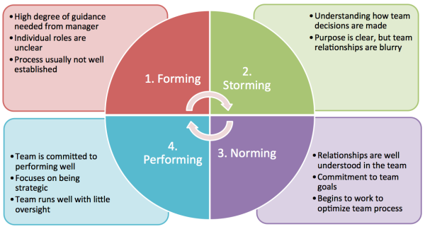
Spiegelman, (2018)

The Tuckman theory indicates that a manager is only as successful as his/her team. That is why it is important for managers to understand and have a thorough understanding of group dynamics and the behaviours of his/her team and most importantly group development. Tuckman’s model indicates that every group are either in one of the four stage, Forming, Storming, Norming or Performing. The writer’s opinion is that’ each stage of Tuckman’s theory is not only necessary but a heathy part of teams development. Effectively, the team can face challenges and identify solutions and deliver the results. With this model manages can successfully manage their team at each stage:
1. Forming, At this stage a manger should interact with the team as the team is forming, and it’s important to set ground rules in writing by providing the team with a written document that outlines roles, responsibilities and goals to avoid any misconceptions.
2. Storming, at this stage of group development team members are more comfortable with each other and they start to speak out. Conflicts at the stage is inevitable and the manages reactions to this are crucial. To make sure the team comes out of this stage managers must be supportive as possible while listening to team members carefully and encouraging them to resolve their own conflicts by stepping in if one know he/she can help, while holding them accountable for their behaviours, action and responsibilities.
3. Norming, during this stage team members will start to settle into more normal behaviours and find mutual ground. So, managers are relied on much less. Yet, the team is not yet completely independent.
4.Performing, at this stage the team turn into a high performing unit that can accomplish goals with minimal conflict. Everyone is knowledgeable and driven to get the job done. But even though the team is at its best the project manager is still highly involved. During this stage I will continue documenting asking questions and paying constant attention in order to prevent the team from progressing.

Belbin
Dr Meredith Belbin (1965) started his first experiments on observable behaviour of teams in Cambridge, (Uk) which led to the modelling of ‘9 Belbin team roles’ that describe the unique contribution of an individual in a team Belbin,(1981). According to Belbin Associates, (2020) each member of the team needs to have access to the 9 team roles to become a high-performance team. According to Morgan, (2017) the research done by Belbin and others in the 1970s suggested that two factors were important: (1) the knowledge an individual will bring to the group – their occupational functions; but, mainly the skills and abilities that employees bring to the task at hand. The team roles listed below came from research carried out by Belbin and his associates Belbin, (1981). Look at the description given below: these describe the personal donations an individual would bring to the team and their allowable areas to improve. The two factors are used when employing this model.

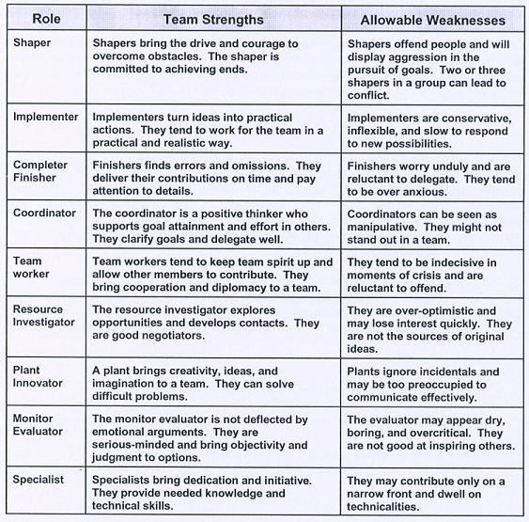

According to Dr Meredith Belbin “A team role is a tendency to behave, contribute and interact with other in a particular way.
Indeed, this this important because it means that a team role is not a description of your personality. But, its how a person behaves, and it is something one can change, its not who we are. For example, in one team a person can be the shaper who is pushing and motivating everybody or in another team an individual can be way more in the background. For instance, the Specialist taking care of every single detail makes sense and its compliant with the rules that there are. That is important to notice because it really describes how people interrelate.
According to Cummings at al, (2015) The first methodical study of group development was carried out by Kurt Lewin (1890-1947) a social phycologist, who established phrase “Group dynamics”. Lewin’s immense work surrounded studies of leadership styles and their effects on group decision-making, the development of the force field theory. the unfreeze/change/refreeze change management model and the action research approach to research, and the group dynamics approach to training. According to Hussain, (2018) Lewin’s field theory proposed that behaviour is the result of the individual and environment. Till this day his this theory has a big influence social psychology, assisting organisations to individual traits and the environment interact to cause behaviour Lewin’s Legacy,(2009)

5.3 How to use teamwork theories to improve the performance of a team in the workplace.

Characteristics of Effective Teamwork will help individuals and their teams sustain that performance. The value of Tuckman’s model is that it helps us understand that teams evolve. It also helps us to consider how they may encounter different problems at different stages of their development. It helps manager

5.4 Belbin questionnaire
The Belbin Team-Role Self-Perception Inventory (BTRSPI) is a well-established method for forming groups in both the workplace and higher education and breaks down the various roles assumed by individuals within a team. The quiz is sets out to establish the role an individual plays with in a team and points are added up under each team role, with the highest score becoming the primary role with the possibility of a second-high score becoming a secondary team role secondary team role Tuckman, (1977).
I have recently completed the Belbin questionnaire. My results from the quiz indicated that I was a Shaper SH, with a high score of 12 becoming my primary team role. Which generally means I like to push myself and others to achieve the result despite many challenges that come my way. I would agree with this as I always remain positive and thrive under pressure. This is a blessing and a curse at the same time as I like to challenge myself and wait till last minute to get tasks done feeling that rush of pressure that makes me think and work harder. This is not good as it could be an expense organisation and most importantly it will put my team under pressure as others in my team might have vulnerable team roles. My second-high score was a resource investigator RI, with a high score of 11 this becoming my secondary team role. This means that I have a talent for networking, resource investigators are positive and enthusiastic people who like to explore new opportunities and investigate new developments who have outgoing personalities. Although they may not necessarily come up with new ideas themselves, they are skilled at picking up ideas from others. I would agree with this result as I enjoy making new business contacts and carrying out negotiations. I also thrive in group atmosphere as I like to elaborate on other ideas making me add to them ideas and think of my own. But i think that every great idea stemmed from another. So, I think it is a very hard task to make up idea that never been done before.

5.5 The differences between groups and teams

According to Dr Peter Morgan Associate Dean for Degree Programmes at the Nottingham University Business School in China, writes that working in effective teams are emotionally different from working in groups and examined the attitudes and behaviours of the two, and the ways in which certain attitudes can effect behaviours in individuals working with one another. While Universities discuss ‘group working’ (e.g. group work assignments) employers talk about Team-working. The research suggests that’ there are crucial imbalances between the two and are important overlaps in terms of human behaviour as one’s feelings, emotions and behaviours - and others’ perceptions of our behaviours will impact on how individuals are able to work well with others, Morgan, (2017).

GROUPS
the definition of a group is the connection of two or more individuals sharing information with each other to achieve their independent goals and in a group:
- Values varies
- Commitment varies
- Roles are not clearly defined
- Leader is strong
- Rules are not developed
- Every individual is accountable

For example, in a group the values of each member vary, and the level of commitment also vary as some group members have a very high level of commitment toward the goal and other have a lower level of commitment. The roles in groups are not that clearly defined before the task have started and the leader of the group will be in charge coordinating how an individual will do their work. Rules are not developed before the task has started. Every individual is accountable for their own actions according to Katzenbach et al (2009) founder and co-leader of the Katzenbach centre at Booz & Company.
According to Bruce Martin, et al (2017) an Associate Professor and Department Chair in the Department of Recreation & Sport Pedagogy at Ohio University. States that’ a group is not bound together by a common goal and without that goal they are simply a group of individuals sharing information working toward an independent goal. For instance, if a person has an Individual goal then that person will generally be more dedicated to the things that will benefit them individually and the group as a whole.

TEAMS
In the workplace, a team is when two or more people work together towards a common goal by sharing their ideas and skills that benefits the team and can occur in a traditional office or between members of a virtual team. In a team:

- Shared mission
- Strong commitment
- Roles are clearly developed and discussed
- Rules are clearly identified
- Collective responsibility of every member
- Common goals
- Shared leadership roles
- Individual and mutual accountability
- Equality of every member

For example: Every team member has a common goal, shared mission and vision with a strong commitment toward their goal. Roles are clearly developed and discusses before the starting of the task and everyone will have to follow the rules which are clearly identified. There is a collective responsibility for every member of the performing of the task. There are common goals in teams with every team member working toward that common goal. There is a shared leadership role which means there is no leader as leadership will rotate. In teams’ individual members are also accountable for their own work, the team is also accountable. There is equality of every member in the team. Meaning, every team member is considered equal according to Day, (2011) a professor Emeritus at the school of Education in the University of Nottingham, UK.
No individual can accomplish something if the team fails. Teams will succeed or they will fail together as they have a shared passion bounded by a common goal. Team members are mutually independent of each other like a necklace, we are only as strong as our weakest link Squire, (2020.
.
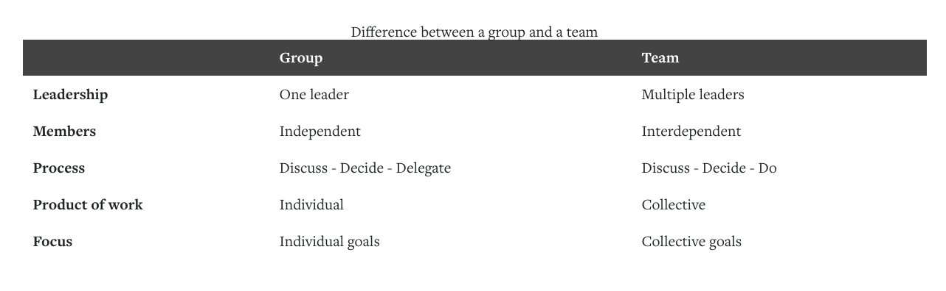

6.0 Conclusion
There is no doubt that Tuckman’s theory is useful as it describes the ways that people are working together and helping group members to understand the stages in which individual go through in group development and this theory helps managers in organisations to predict the stages of development to intervene and address those issues in the group. Although Tuckman model is paramount in group development it do not mention any factors on how to help the group while going though these situations and simply just describing situations a stages and I believe that it cannot be solely relied on, on its own. Tuckman’s model gives no direction and has a lack of detail going through the stages on how to help managers coach their team. I believe that adding other theories to this like Belbin and Tubbs model. Organisations can get a greater understanding and guidance to manage their teams. As these other models have a lot more detail making it easier for managers to understand the process that new groups go through.

7.0 Recommendations

8.0 References

BELBIN Associates. (2020). The Nine Belbin Team Roles. Available: https://www.belbin.com/about/belbin-team-roles/. Last accessed 11th june 2020.
Belbin, R.M. (1981) Management teams: Why They Succeed or Fail. London:Heinemann.
Bruce Martin, Mary Breunig, Mark Wagstaff, Marni Goldenberg, (2017). Outdoor Leadership: Theory and Practice. united states: Human Kinetics. 167-183.
day (2011). Successful School Leadership. united kingdom: McGraw-Hill Education (UK), 2011. 13-23.
Dossetto, F. 2019. Hot jar. 24 april . 5 of our favorite virtual team-building activities to grow a strong remote team. [Online]. [29th May 2020]. Available from: https: //www.hotjar.com/blog/virtual-team-building-activities/
Dr Peter Morgan. (2017). Personal Development and Learning. In: Kirsty Smy the business student's guide to study and employability. London: SAGE Publications Ltd. 202-206
Gabriel Angelo. (2014). What is communication . In: SN & NS Publications The 7 Effective Communication Skills: How to be a Better Communicator NOW. United States: Seisnama, 2014. 1-27.
John Nielsen. (2008). Group Dynamics . In: Effective Communication Skills: The Foundations for Change. United States : Xlibris Corporation, 2008. 49-50.
Katzenbach et al (2009). The Discipline of Teams. united states: Harvard Business Review Press, 2009. 1-13.
Lewin's Legacy. (2009). The Vision. Available: https://www.ntl.org/about-us/ntl-legacy/. Last accessed 11th june 2020.
Lisa McQuerrey. (2019). How to Work Effectively in a Team Environment. Available: https://smallbusiness.chron.com/work-effectively-team-environment-57331.html. Last accessed 6th June 2020.
Maund, A. Schriek, M. and Tinkler. (2017). Interpersonal Communication in the Workplace:A Largely Unexplored Region. In: Maund, A. Schriek, M. and Tinkler Certificate in Higher Education:Skills for the Workplace Student Yearbook. London: SAGE Publications Ltd. 458-478.
Melanie Squire. (2020). Effective Teamwork and communication. University of Wales Trinity Saint David. In class Citation 8th May 2020.
Melony E. Sorbero, Donna O. Farley, Soeren Mattke, Susan Lovejoy. (2008). Team Work behavior. In: Melony E. Sorbero, Donna O. Farley, Soeren Mattke, Susan Lovejoy Outcome Measures for Effective Teamwork in Inpatient Care: Final Report. United States: Rand Corporation, 2008. 4-11.
Moseley, C. 2019. Jostle Blog. 28th march. 7 reasons why collaboration is important. [Online]. [31 May 2020]. Available from: https://blog.jostle.me/blog/why-collaboration-is-important.
Sandeep Kashyap. (2019). Here’s How Effective Communication is in the Hands of 73% of Professionals. Available: https://www.proofhub.com/articles/effective-communication. Last accessed 11th june 2020.
Sidwell, L. 2008. Negativentropy. 24 april. Tuckman and Jensen (1977) Model. [Online]. [11 June 2020]. Available from: https://negativentropy.wordpress.com/tuckman-and-jensen-1977-model/
Stephen Cummings, Todd Bridgman, Kenneth G Brown. (2015). Sage journals. Unfreezing change as three steps: Rethinking Kurt Lewin’s legacy for change management . 69 (1), 33-60.
SyedTalibHussain,ShenLeiTayyaba,AkramMuhammad,JamalHaiderSyed, HadiHussain,MuhammadAli . (2018). Journal of Innovation & Knowledge. Kurt Lewin's change model: A critical review of the role of leadership and employee involvement in organizational change. 3 (3), 123-127.
Tom Spiegelman. (2018). Mentoring Engineers Through An Engineering Fellowship Program. Available: https://www.digitalocean.com/blog/mentoring-engineers-through-an-engineering-fellowship-program. Last accessed 11th june 2020.
Tuckman, B. & Jensen, M, (1977). Stages of Small-Group Development Revisited, Group Organization Management. Vol. 2. p419-427

9.0 Appendices

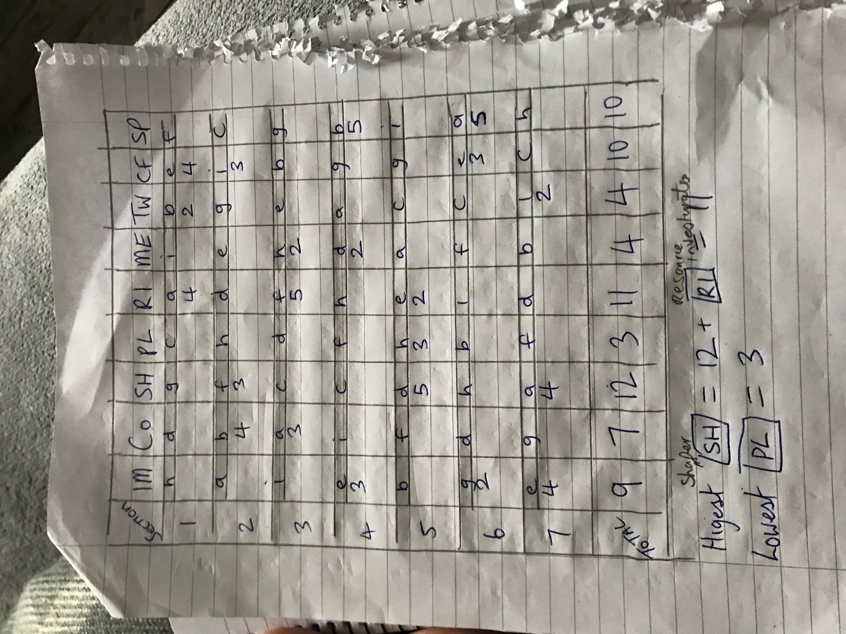

10.0 Acknowledgements

I would like to thank the University of Wales Trinity St David for making it possible for me to study in these unprecedented times. I give deep appreciation and respect to my lecturer Melanie Squire. I would also like to thank Beth Downing for her support.

