
Master of Business Administration

The Role of Influencer Credibility in Shaping Purchase Intention Among Generation Z Consumers: A Comparative Study of Fenty Beauty and CeraVe

Student Name: Shivangi Dilipbhai Chovatiya
Student ID: 2434753
Module: Dissertation
Supervisor Name: Haoran Liu
Words: 15662
Abstract
Traditional marketing communications logic is completely transformed by the fast development of the social media market around the world. The revolution in this industry is particularly drastic in the beauty and personal care industry. The industry is generally seeing the value of influencer marketing as one of the most effective digital marketing tactics to engage the audience of Gen Z on the three mainstream social media platforms: TikTok, Instagram and YouTube. Therefore, this study conducts targeted research on the key affecting factors of influencer marketing in the macro environment. Its main research objective is to systematically explain how the credibility of influencers affects the purchase intention of Gen Z consumers, using a case comparison of two brands that are representative in the beauty and personal care sector, namely Fenty Beauty and CeraVe. Specifically, the study will investigate the effects of the three dimensions of credibility – professional expertise, perceived trustworthiness, and social attractiveness – on consumers' attitude change and eventual purchase intentions across various influencer marketing frameworks. This study uses a research philosophy of interpretivism, a research method of qualitative research and a research strategy of comparative case study. Secondary data for this research was obtained from academic journals, industry reports, professional marketing studies and authoritative online sources from 2019 to 2025. All research variables will then be analysed using thematic analysis to identify core patterns that will inform subsequent comparative analysis of the actual effects of the two brands' different influencer strategies on the target audience.
Table of Contents
Chapter 1: Introduction and Rationale 4
1.1 Research Background 4
1.2 Research Rationale 6
1.2.1 Theoretical Justification 6
1.2.2 Practical Justification 8
1.3 Research contribution and motivation 10
1.4 Research Aim, Objectives, and Questions. 11
Research Aim 11
Research Objectives 11
Research Questions 11
Chapter 2: Literature Review 12
2.1 Introduction 12
2.2 Thematic Literature Review. 12
2.2.1 Digital Age Influencer Marketing 12
2.2.2 Gen Z Consumer Behaviour. 14
2.2.3 Source Credibility Theory 15
2.2.4 Influencer Credibility and Purchase Intention. 17
2.2.5: Beauty and Skincare Influencer Strategies 19
2.3. Theoretical Foundation and Contribution 21
2.3.1 Chosen Theory: Source Credibility Theory 21
2.4 Conceptual Framework 22
2.4.1 Purpose of Framework 22
2.4.2 Key Variables 23
2.4.3 Example of Relationships 23
2.4.4 Conceptual Framework Diagram 24
2.5 Literature Gaps and Research Justification. 25
2.5.1 Identified Gaps 25
2.5.2 Research Positioning 25
2.6 Chapter Summary 26
Chapter 3: Methodology 27
3.1 Introduction 27
3.2 Research Philosophy 27
3.3 Research Approach 28
3.4 Research Strategy 28
3.5 Methodological Choice 28
3.6 Time Horizon 29
3.7 Data Collection Methods 29
3.8 Data Analysis Methods 31
3.9 Ethical Considerations 31
3.10 Conclusion 31
Chapter 4: Data analysis 33
4.1 Introduction 33
4.2 Reintroduction of Research Questions 33
4.3 Analytical Framework 37
4.4 Case Study Overview: Fenty Beauty and CeraVe 38
4.5 Thematic Analysis of Findings 40
4.5.1 Expertise 41
4.5.2 Trustworthiness 42
4.5.3 Attractiveness and Relatability 43
4.5.4 Influence Generation Z consumers 44
4.6 Comparative Analysis 44
4.7 Synthesis of Key Findings 47
4.8 Limitations of the Analysis 49
4.9 Chapter Summary 49
Chapter 5: Discussion 50
5.1 Introduction 50
5.2 Discussion in Relation to Research Questions 50
5.2.1 RQ1: Influence of Influencer Credibility on Purchase Intention 50
5.2.2 RQ2: Role of Credibility Dimensions 51
5.2.3 RQ3: Comparative Analysis of Fenty Beauty and CeraVe 53
5.3 Linking Findings to Literature and Theory 54
5.4 Chapter Summary 55
Chapter 6: Conclusion 56
6.1 Summary of Key Findings 56
6.2 Theoretical Implications 57
6.3 Practical Implications 58
6.4 Recommendations 58
6.4.1 Strengthening Influencer Credibility and Authenticity 58
6.4.2 Increasing Expertise and Educational Influencer Content 59
6.4.3 Promoting Inclusivity, Relatability, and Consumer Engagement 60
6.5 Limitations of the Study 61
6.6 Future Research 62
6.7 Chapter Summary 62
Reference 64

Chapter 1: Introduction and Rationale

1.1 Research Background
The fast development of digital technologies has radically changed the marketing behaviour, especially in the beauty and skincare sector (Sudibyo and Boros, 2024). The emergence of influencer marketing is one of the major ones, and it has become a prominent tool to attract younger audiences. According to recent industry estimates, the global influencer marketing industry reached over 21 billion in 2023, which indicates that it has become increasingly strategic to the brands that wish to stay competitive in the digitally crowded environment. Focusing on the rising trend of social media, such as Instagram, TikTok and YouTube, influencers act as the bridge between the brands and the consumer. Influencer marketing has surged in popularity worldwide, and the global industry is currently valued at around $21.1 billion, indicating its growing significance in digital marketing strategies (Digital Marketing Statistics, 2024). Recent reports also indicate that the influencer marketing market has surpassed $24 billion in 2024, signifying the growth of social media promotion and brand collaborations (Digital Web Solutions, 2025).
Unlike traditional ads, influencer marketing relies heavily on authenticity, relatability, and trustworthiness. These factors are especially potent in the case of Generation Z consumers, who can be characterised as highly digital, mistrustful of traditional advertising and prefer peer-created content. Generation Z consumers are spending more and more hours on social media and are actively engaged in creating influencer content to review products, especially in the industry that has the most visual focus (beauty and skin care) (Mohamed and Zakarya Saeed, 2024).
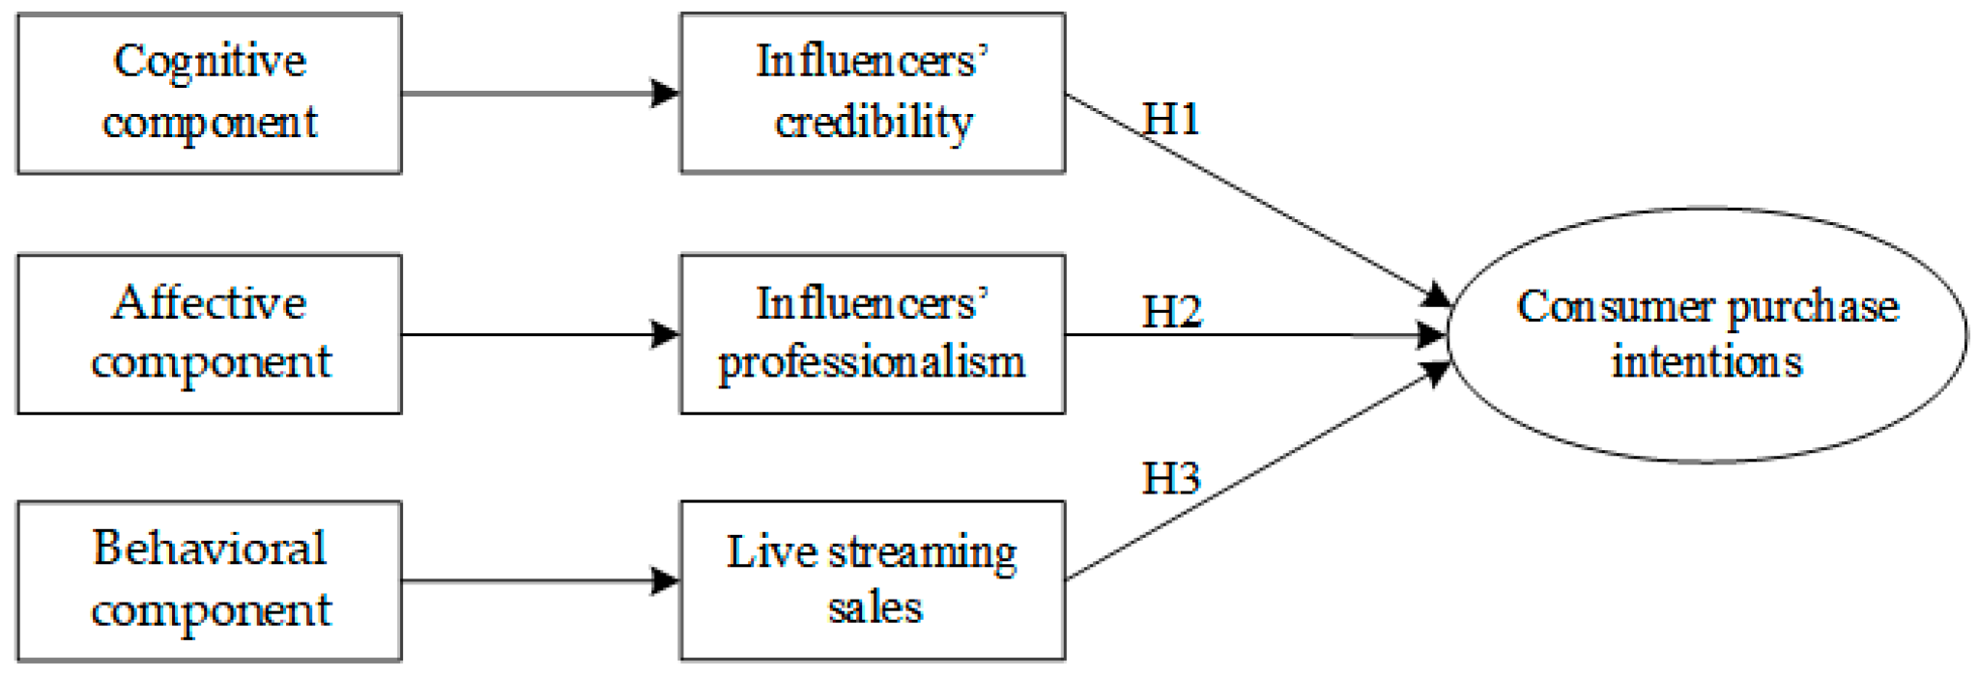
Figure 1: The Power of Influencers
Source: (Chen, Qin, Yan and Huang, 2024)
There's a rather interesting example of studying the credibility of influencers that can be provided by the beauty industry, where the requirement for visual illustration, personal experience, and consumer trust is necessary. Brands are increasingly enlisting the help of influencers to make tutorials, product reviews, and lifestyle content that model simulates real-life usage situations. This not only reduces the risk for the consumer to buy a product but also enhances the consumer interaction.
Influencer power in the digital ecosystem is multi-dimensional, which includes reach, trust and engagement as illustrated in Figure 1 below. This figure highlights the relationship between multiple layers of influencers and consumers' response, a relationship which directly forms the conceptual framework described in Chapter 2. Especially, the focus on trust and authenticity in the figure is consistent with the trustworthiness and attractiveness of Source Credibility Theory, supporting the theoretical basis of the study. Every future figure in this dissertation should be referred to explicitly within the context of the text and explained in relation to the research argument and not simply as a visual filler. Numbers that are not the subject of the discussion must be deleted or moved to an appendix.
The focus of this paper is on two prominent brands: Fenty Beauty and CeraVe, which demonstrate the contrasting influencer marketing policy (Miller, 2022). The brand, Fenty Beauty (created by Rihanna), is well known due to its inclusive branding, lifestyle and celebrity influencers. CeraVe, on the other hand, is more science-based and often works with dermatologists and skin care professionals to emphasise the effectiveness of the products and their scientific veracity. These discrepancies present a special chance to explore the role of different strategies of credibility in consumer behaviour among Generation Z. Influencer marketing is a marketing tactic that can be adopted in various ways, depending on the brand. Beauty brands use influencer strategies in different ways. Fenty Beauty is also a celebrity and lifestyle influencer to support their inclusivity and emotional relationship with the consumer. The campaigns around this brand's basis in diversity and relatability allow for “attractiveness and emotional credibility” (Miller, 2022). Conversely, CeraVe uses an expertise-based approach of using influencers by means of attracting dermatologists and skincare experts to give a scientific explanation of the mentioned product ingredients and effectiveness. This will help strengthen the sense of trustworthiness and expertise that are key to the Source Credibility Theory dimensions (Mohamed and Zakarya Saeed, 2024).

1.2 Research Rationale

1.2.1 Theoretical Justification
The available literature has considerably covered influencer marketing and its effects on consumer behaviour (Kanaveedu and Kalapurackal, 2024). The research indicates that the influencer's credibility has a strong influence on consumer attitudes, brand trust and purchase intention. The source credibility theory is the major theory to discuss these relations and insists on expertise, trustworthiness, and attractiveness as the most important factors of persuasive communication. Besides, recent studies also point to the increasing role of authenticity and relatability in online marketing, especially with younger customers (Orencia, 2023).
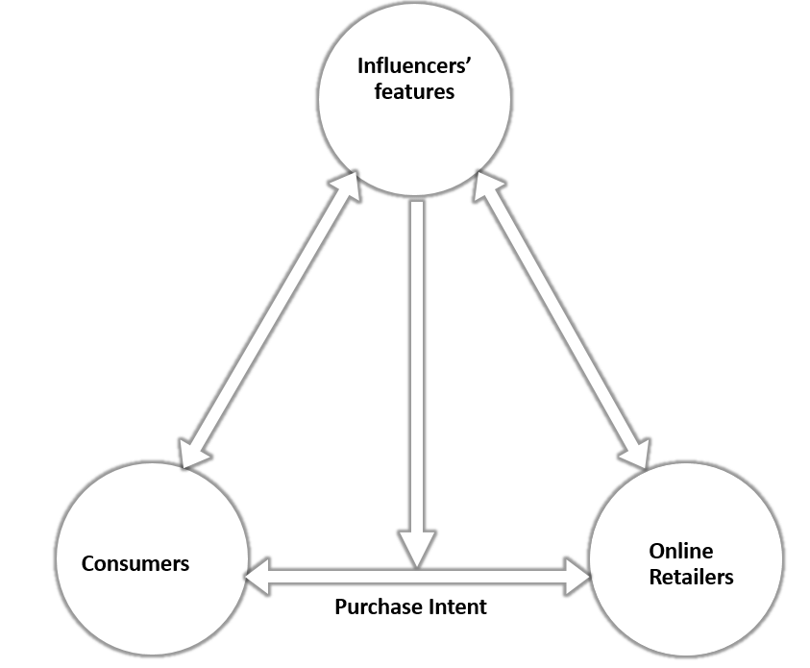
Figure 2: Theoretical frame: Consumers' online purchase intention
Source: (Casaló, Flavián and Ibáñez-Sánchez, 2020)
Nevertheless, even with this solid theoretical underpinning, the literature still has a number of constraints. First, a lot of the current studies are generalised in their approach, seeing influencer credibility as a homogenous concept and ignoring differences in the strategic execution between brands. Second, very few comparative studies have been conducted to determine how various classes of influencers, including celebrity influencers and expert influencers, influence consumer behaviour in different ways. Third, the quantitative survey methodology is used in numerous studies, which can result in overlooking the contextual and interpretative features of credibility establishment in the digital environment.
Moreover, the dynamism in the development of social media sites has brought about new aspects that are not well understood using the conventional theoretical frameworks (Bartoloni and Ancillai, 2024). Indicatively, the consumers of Generation Z are paying more attention to the concept of transparency, social responsibility, and inclusivity, which can impact the perception and evaluation of credibility. These changes indicate that the current theories might need to be updated in order to explain evolving consumer demands and digital behaviours.
Considering these gaps, this research outlines one of the main gaps in the literature: the absence of comparative, context-specific research on the strategies of influencer credibility in the beauty industry. In particular, the lack of knowledge regarding the functioning of various credibility dimensions in the context of opposing brand strategies and the impact of these disparities on purchase intention among Gen Z consumers exists.
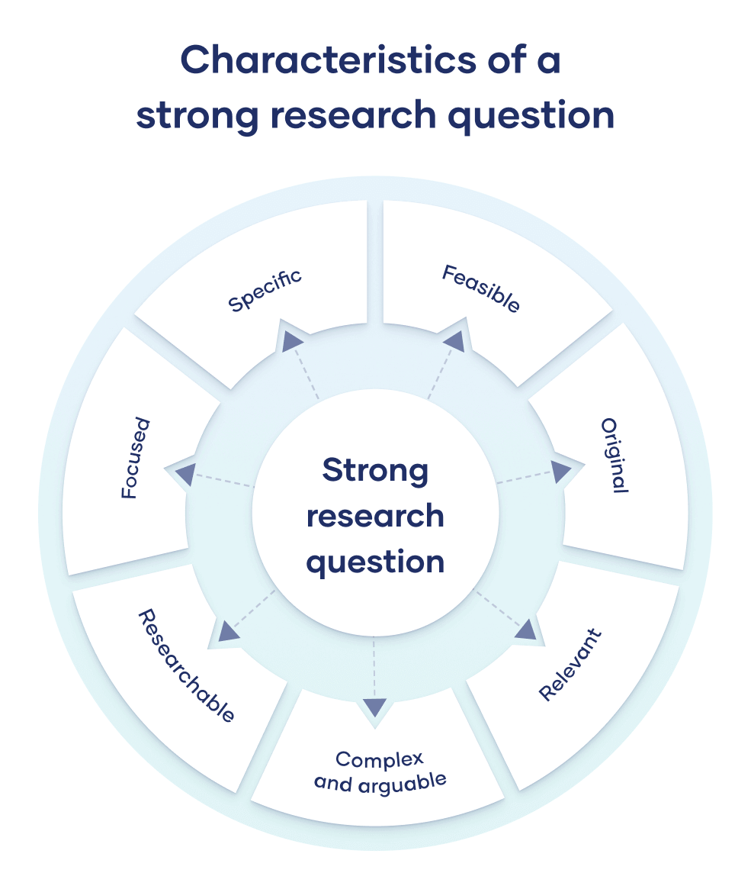
Figure 3:Relation to Research Questions
Source: (McCombes, 2023)

1.2.2 Practical Justification
Influencer marketing continues to attract significant business investment, with 59% of marketers planning to increase their influencer marketing budgets, reflecting growing confidence in its effectiveness as a promotional strategy (Business of Apps, 2025). As a managerial issue, influencer marketing effectiveness presents a very important issue of concern to organisations that are found in the competitive digital markets. The level of financial investment by the brands on influencer partnerships is so high, but the payback is extremely unpredictable. To a great extent, this uncertainty is caused by the ambiguity of influencer credibility, which depends on context (Han and Balabanis, 2024).
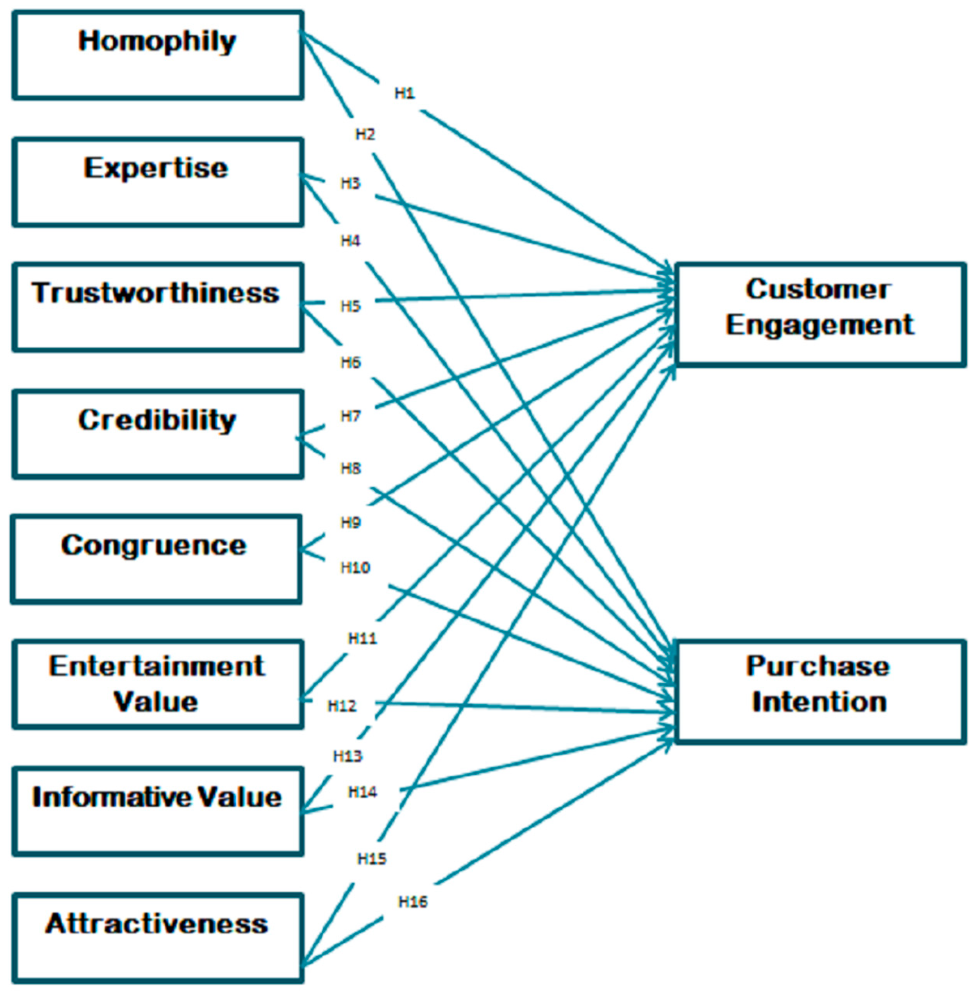
Figure 4: Impact of Social Media Influencers on Customer Engagement and Purchase Intention
Source: (Ao, Bansal, Pruthi and Khaskheli, 2023)
Due to the sensitivity of the beauty and skincare industry regarding the influence of the performance of their products, the wrong approach to the influencers can result in a bad reputation and diminished consumer trust. As an illustration, a partnership with influencers who are viewed as inauthentic or unskilled can lead to unfavourable consumer reactions, which can lead to a loss of brand credibility. On the other hand, properly coordinated influencer collaborations have the potential to improve brand image, boost engagement, and make sales (Jauhola, 2022). These practical problems are indicated in the comparison between Fenty Beauty and CeraVe. The approach of Fenty Beauty is based on inclusiveness and emotional appeal with the help of celebrity influencers, whereas CeraVe is based on scientific proof and professional recommendations. Knowledge about the most effective approach and the conditions can be useful to marketers who need to maximise their approaches to influencers.

1.3 Research contribution and motivation
This research will serve as a contribution to the academic community and practical marketing techniques by filling the gaps that were identified in the research on the credibility of influencers (Ki, Chow and Li, 2023).
Theoretically, the research builds on source credibility theory in that they put it to the test in a comparative brand setting. Instead of credibility being considered a stable construct, this study looks at the variations of the dimensions of credibility in relation to various influencer strategies. In such a way, it offers a deeper insight into the way credibility works in online marketing contexts, especially among Gen Z consumers.
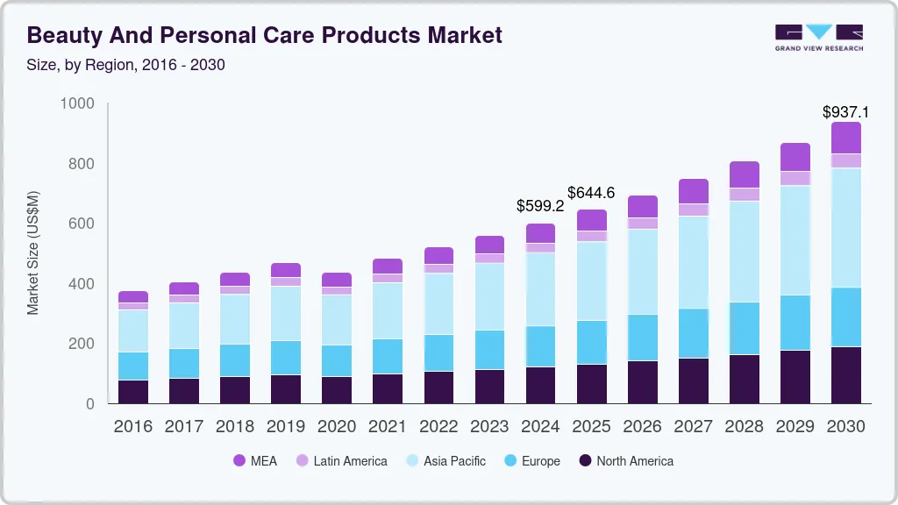
Figure 5: Beauty and Personal Care Products Market Report
Source: (Grand View Research, 2024)
From an empirical standpoint, the research uses a comparative analysis based on secondary data, as stipulated in the research methodology (Buchner and Kerres, 2023). This methodology will allow combining various data sources, such as scholarly research and reports within the industry, to locate trends and information in different environments. This kind of method is especially appropriate when studying complex phenomena such as influencer credibility, in which several variables work together in a dynamic manner.
As a practical approach, the study provides practical insights applicable to marketers within the beauty and skin care industry (Saleem et al., 2024). The study compares two different branding strategies and comes up with effective methods of using the credibility of the influencer to increase consumer interest and the desire to buy. These lessons can be used to make marketing choices concerning the choice of influencers, content strategy, and brand positioning.

1.4 Research Aim, Objectives, and Questions.

Research Aim
This study seeks to discuss the effectiveness of influencer credibility in influencing the purchase intention of consumers of the Generation Z generation, by performing a comparative analysis of Fenty Beauty and CeraVe.

Research Objectives
- To analytically examine the concept of influencer credibility and its dimensions in digital marketing.
- To compare the effect of the credibility of influencers on purchase intention among Generation Z consumers.
- To make a comparison between Fenty Beauty and CeraVe influencer marketing strategies.
- To determine the effect of various credibility dimensions on the consumer perception and behaviour in the two brands.

Research Questions
- RQ1: What impact does the influencer's credibility have on the purchase intention of the Generation Z consumers?
- RQ2: What is the impact of the credibility dimensions (expertise, trustworthiness, attractiveness) on consumer attitudes?
- RQ3: What are the differences between the credibility strategies of Fenty Beauty and CeraVe, and how do they affect purchase intention in comparison?

Chapter 2: Literature Review

2.1 Introduction
As it has been defined in Chapter 1, the swift development of influencer marketing has altered the way of how the brands address digitally active audiences, yet the processes through which credibility determines consumer behaviour have not been studied enough. The chapter thus investigates how the credibility of influencers, consumer attitudes, and purchase intention relate, and specifically, how the same applies to Generation Z and the beauty and skincare sector. This review will be organised into four domains. To start with, it analyses the development and relevance of influencer marketing in the digital environment. Second, it examines consumer behaviour of Generation Z, with the focus on their dependency on social media and preference for real-life content. Third, it assesses the Source Credibility Theory as the major theoretical perspective on which this study is based. Fourth, it critically examines the connection between the credibility of the influencer and purchase intention. Also explained in the chapter is the relative emphasis on the case of Fenty Beauty and CeraVe, as they are opposing influencer models, including celebrity-based and expert-based strategies. The chapter will end by synthesising the aforementioned themes in order to determine important gaps that will be used in the research framework.

2.2 Thematic Literature Review.

2.2.1 Digital Age Influencer Marketing
Influencer marketing has become one of the most powerful types of digital communication, which fundamentally changes the manner in which the brand communicates with consumers (Joshi et al., 2025). It means the strategic utilisation of persons having a great number of followers on social media who can be involved in promoting products and altering the perception of consumers. In contrast to conventional advertising, where the communication is based on one direction only, influencer marketing is based on interactive and relational relationships, where the brands can establish a personalised relationship with audiences (Okonkwo and Namkoisse, 2023). Social media plays a central role in product discovery, with studies indicating that 72% of Gen Z consumers follow influencers and rely on their content when making purchase decisions (Together Agency, 2024). Furthermore, research shows that 82.4% of consumers learn about new products through influencer marketing, confirming its strong impact on consumer awareness and buying behaviour (ResearchGate Study, 2024).
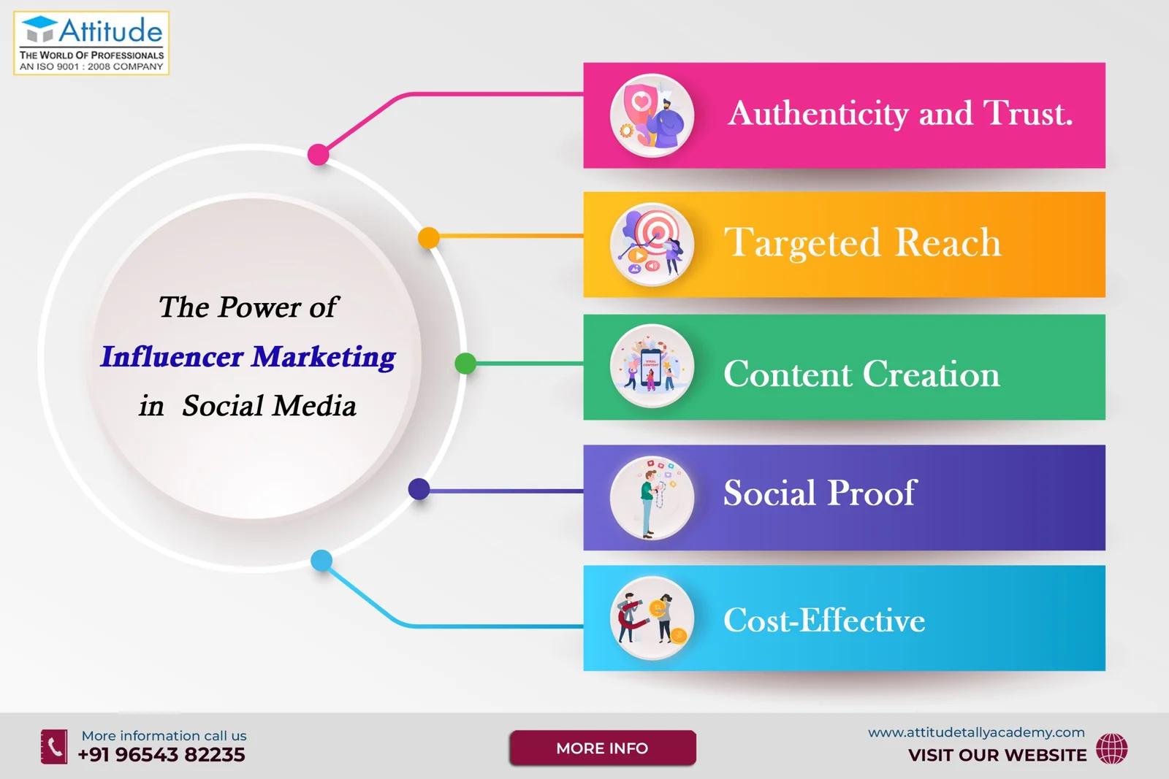
Figure 6: The Power of Influencer Marketing in Social Media
Source: (Attitude Tally Academy, 2024)
Theoretically, influencer marketing is directly connected to word-of-mouth (WOM) communication, which has always been identified as one of the most effective drivers of consumer behaviour (Ismail, Khan and Ahmad, 2025). As digital technologies come up, WOM has taken a new form of electronic word-of-mouth (eWOM), whereby information is shared online and on a significantly large scale. The influencers enhance eWOM by developing content that is a mix of personal experience and promotional messages, and therefore, its persuasive effect is greater.
More importantly, influencer marketing has a number of benefits. It builds consumer engagement by having relatable content, allows more accurate targeting of specific segments and creates emotional relationships between the consumer and the brand. Influencer marketing is deemed more effective than conventional advertising by Generation Z, which prioritises authenticity and word-of-mouth. Engagement with influencer content is particularly high among younger audiences, with approximately 55% of Gen Z users interacting with brand content daily on platforms such as TikTok, indicating the importance of social media influencers in shaping purchase decisions (Sprout Social, 2026).
On top of that, the problem of artificial followers, increased engagement rates, and the presence of saturation in the market have destroyed trust in influencers. These difficulties emphasise the role of credibility as one of the main factors influencing the effectiveness of an influencer (Aldousari, 2024).
Although much research has been conducted, there is still a large gap when it comes to the relative effectiveness of the various types of influencers (Han and Balabanis, 2024). The literature tends to homogenise the effect of influencers by not differentiating between celebrity, lifestyle and expert influencers. This homogenization restricts the knowledge of credibility differences in different contexts, especially in the beauty industry.

2.2.2 Gen Z Consumer Behaviour.
Generation Z consumers show strong engagement with influencer content, with approximately 88% of Gen Z users following at least one influencer on social media platforms (Morning Consult, 2024). Research also indicates that around 41% of Gen Z consumers trust influencer recommendations more than traditional brand advertising, demonstrating the importance of credibility in digital communication (GoDaddy Research, 2024). Generation Z is a unique consumer group that is highly connected with digital technologies (Razak, 2022). Generation Z consumers are highly influenced by digital technologies and social media platforms, which significantly shape their attitudes and purchasing behaviour. As digital natives, Gen Z prefers authentic, transparent and relatable content when evaluating products and brands (Razak, 2022). Research indicates that this generation places strong trust in influencers because they perceive influencer recommendations as more credible and personalised compared to traditional advertising methods (Kembau, Tarigan and Pangaribuan, 2024). Furthermore, Gen Z consumers actively engage with online reviews, tutorials and peer-generated content before making purchase decisions, particularly in the beauty and skincare sector (Mohamed and Zakarya Saeed, 2024). This demonstrates that influencer credibility plays a significant role in reducing perceived risk and increasing purchase intention among younger consumers (Sudibyo and Boros, 2024).
Short-form digital content is a favourite of Generation Z consumers as they are very familiar with fast-paced social media platforms like TikTok, Instagram Reels and YouTube Shorts. As reported by Campbell and Farrell (2020), short-form content is more likely to gain audience attention as it is engaging, interactive and quickly digestible with short viewing times. This trend has had a huge impact on the way brands in the beauty and skincare spaces are connecting with younger consumers online. Since tutorials, product demos and skin care routines offer tangible proof of product efficacy and authenticity, they are actively consumed by Gen Z consumers. Authenticity is deemed one of the most essential elements that impact the lives of Generation Z consumers. According to Djafarova and Bowes (2021), Gen Z consumers are drawn to influencers who are not overly commercialised, but rather relate, are transparent, and appear genuine. This tendency goes hand-in-hand with an increasing distrust of advertising and corporate promotion. Likewise, Lou and Yuan (2019) discovered that consumers aged 18 to 34 tend to be more connected and more likely to purchase products when they interact with brands through authentic influencers. Skincare influencers are especially influential in the beauty community due to their blend of expertise and personal experience when it comes to ingredients, routines, and product efficacy. Schouten et al. (2020) explained that beauty products are highly influencer-driven as consumers rely on visual demonstrations and peer-generated reviews to make purchase decisions, particularly in high-involvement product categories like skincare products and cosmetics.
Social proof and peer recommendations have a strong influence on the decision-making process of Generation Z (Kembau, Tarigan and Pangaribuan, 2024). Social media channels are considered one of the key information sources, and consumers review, test their products, and assess them by the recommendations of influencers and tutors. This action supports the role of experience and reliability in influencing consumer attitudes (Tseng, 2023).

2.2.3 Source Credibility Theory
The main theoretical basis of how communication sources shape attitudes and behaviour of the audience is offered in the Source Credibility Theory (Kumar, Kaushal and Kumar, 2023). The theory was developed out of the studies on communication and persuasion and holds that the quality of a message and how effective it will be are greatly determined by how credible the source of the message is. This theory has been used extensively in the marketing context in explaining how the endorsers affect consumer decision-making.
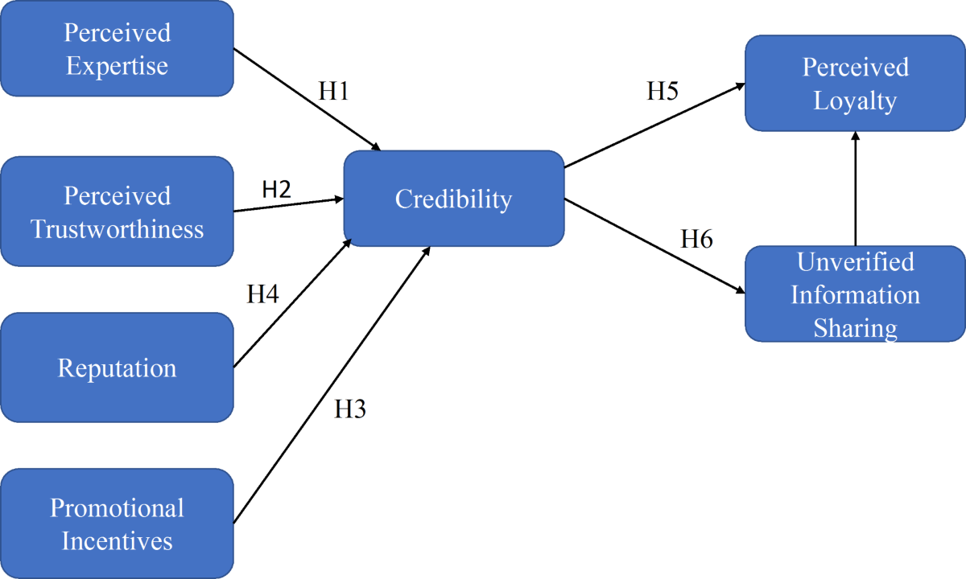
Figure 7: Source Credibility Theory
Source: (Kumar, Kaushal and Kumar, 2023)
The theory recognises three major dimensions of credibility, including expertise, trustworthiness, and attractiveness (Han and Balabanis, 2024). Expertise is knowledge and capability of the source that is perceived and is mostly significant in product categories where technical knowledge is needed, like in skincare. Trustworthiness is the measure of how the source is viewed as honest and reliable, which will determine the level of acceptance of the message by the consumer. Attractiveness does not only mean physical attractiveness but also relatability and likability, which makes the audience have an emotional attachment.
Influencer marketing through the use of the Source Credibility Theory has produced a significant amount of empirical evidence (Hugh Wilkie et al., 2022). The research always indicates that the more the perceived credibility, the better the attitudes to the brands and the higher the purchase intention. Nonetheless, there has also been a critical evaluation of the theory.
Its comparatively fixed conceptualisation of credibility is one of these limitations, as it might not be as dynamic as the digital environments. Authenticity, transparency and the engagement of the audience are other factors that matter when it comes to credibility building in today's social media environment. These factors are not discussed directly in the traditional framework, which implies theoretical modification (Lee, Ramasamy and Subbarao, 2025).
Thus, although the Source Credibility Theory can be regarded as a useful background, it is necessary to expand it in order to integrate the intricacies of contemporary influencer marketing. To overcome this, this research paper proposes to take a comparative approach to the theory, in which the dimensions of credibility function in various brand strategies (Udo et al., 2024).
Although there is a strong theoretical foundation in Source Credibility Theory (SCT), it is necessary to examine the theory and compare it with other theories employed in studies of digital marketing. Parasocial Relationship Theory (Horton and Wohl, 1956) suggests audiences create a pseudo-social relationship with media personalities that resembles interpersonal relationships, which provides a better explanation for the emotional connection Generation Z consumers have with influencers outside of SCT's transactional credibility filter. The Technology Acceptance Model (TAM) provides an alternative cognitive approach, which centres on perceived usefulness and usability as factors shaping consumer behaviour in technology-mediated transactions, particularly in the context of purchase decisions using TikTok or Instagram's social commerce capabilities.

2.2.4 Influencer Credibility and Purchase Intention.
The buying behaviour of consumers is a key concept in consumer behaviour, and purchase intention is the tendency of the consumer to purchase a given product (Kinawy, 2025). It is also one of the important indicators of marketing effectiveness, and it is usually affected by cognitive and emotional factors. Purchase intention, in the case of influencer marketing, is defined by the perception of consumers of the credibility of the person or persons who influence them and the content conveyed by them.
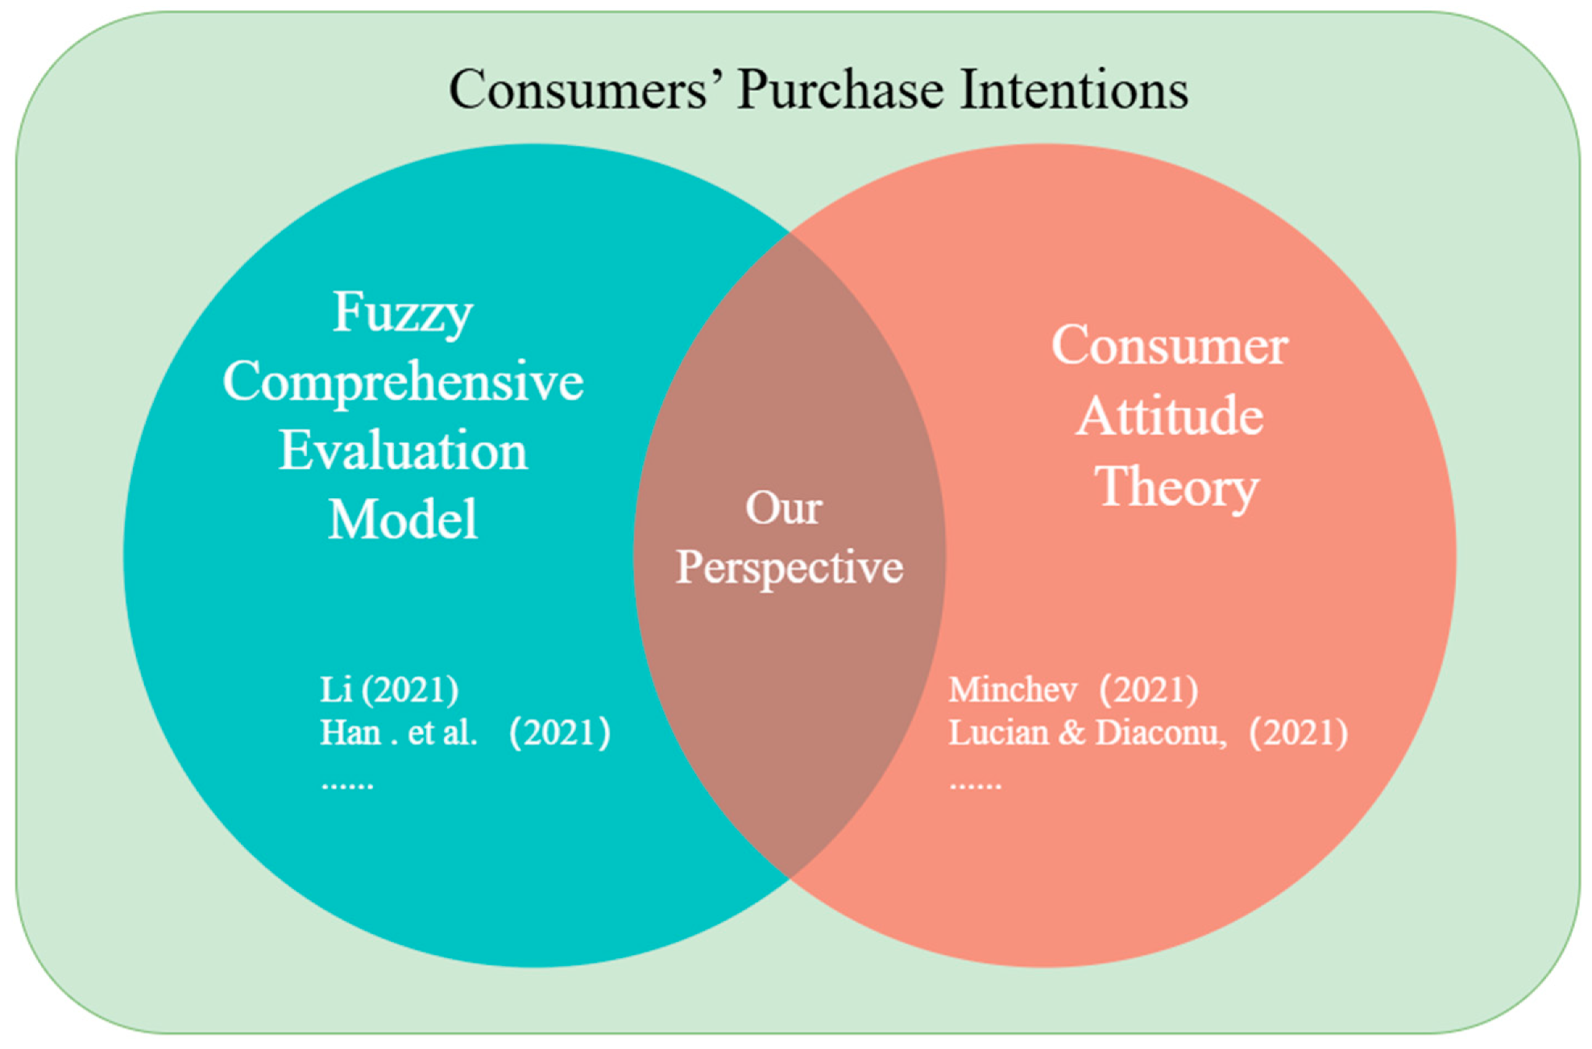
Figure 8: The Power of Influencers
Source: (Chen et al. 2024)
The influencer's credibility and purchase intention have a direct and indirect relationship. Directly, credible influencers have the ability to persuade consumers by giving convincing information about products. Credibility affects indirectly other intermediary variables, including trust and attitude towards the brand, which indirectly influences purchase intention. This is a multi-stage process which underscores the complexity of consumer decision-making processes in digital settings (Ali, 2025). Many empirical studies apply quantitative research methods such as surveys and regression analysis to examine the impact of influencer credibility on consumer behaviour. Structural Equation Modelling (SEM) is frequently used to test relationships between expertise, trustworthiness and purchase intention (Han and Balabanis, 2024). These methods provide statistical evidence supporting the effectiveness of influencer marketing strategies (Ao et al., 2023)
Importantly, most of the available studies are based on quantitative surveys, which can simplify the correlation between credibility and behaviour (Polas, 2025). These methods do not tend to provide the contextual and interpretative nature of the consumer perception, especially in the fast-changing digital realities. The interdependence between credibility and purchase intention is notably important in the beauty industry since the products are experienced. Customers strongly depend on visual presentation and word-of-mouth advertisement in order to assess product efficiency. Such a dependence increases the role of influencer credibility, which has a direct impact on consumer trust and perceived quality of the product.
Although the number of researchers is increasing, one of the gaps is the absence of a comparative analysis of the brands that use various strategies of influencers. A large majority of the research is done in the context of single brands or broad data of many industries, and therefore, they are not applicable to particular marketing situations (Branca, Grosso and Castaldo, 2024). This gap indicates that the study that analyses the functioning of credibility in specific brand spaces, Fenty Beauty and CeraVe, is necessary.

2.2.5: Beauty and Skincare Influencer Strategies
Influencer strategies in the beauty industry vary depending on brand positioning and credibility approach. Fenty Beauty primarily collaborates with celebrity and lifestyle influencers to promote inclusivity, diversity and emotional connection with consumers. This strategy enhances attractiveness and relatability, which strengthens emotional engagement and brand loyalty (Miller, 2022). In contrast, CeraVe focuses on expert-based influencers such as dermatologists and skincare professionals who provide scientific explanations about ingredients and product effectiveness. This approach increases perceived expertise and trustworthiness, which are key dimensions of Source Credibility Theory influencing consumer purchase intention (Mohamed and Zakarya Saeed, 2024; Vo, 2023). The beauty and skincare business is one of the most influential industries towards influencer marketing, and this is because this industry depends on visual communication and consumer trust (Vo, 2023). The role of influencers is central in showing how to use the product and experience, and giving advice, which contributes to building the consumer perception.
One of the main peculiarities of this business is the emphasis on visual content, such as tutorials, product reviews, and skincare routines. Such formats enable consumers to see the performance of a product in real-life scenarios, and this lowers uncertainty and increases confidence in the purchase decision-making (Rodríguez, Arboleda and Reinoso-Carvalho, 2025). Consequently, the credibility of influencers becomes especially significant in the process of defining the success of marketing tactics.
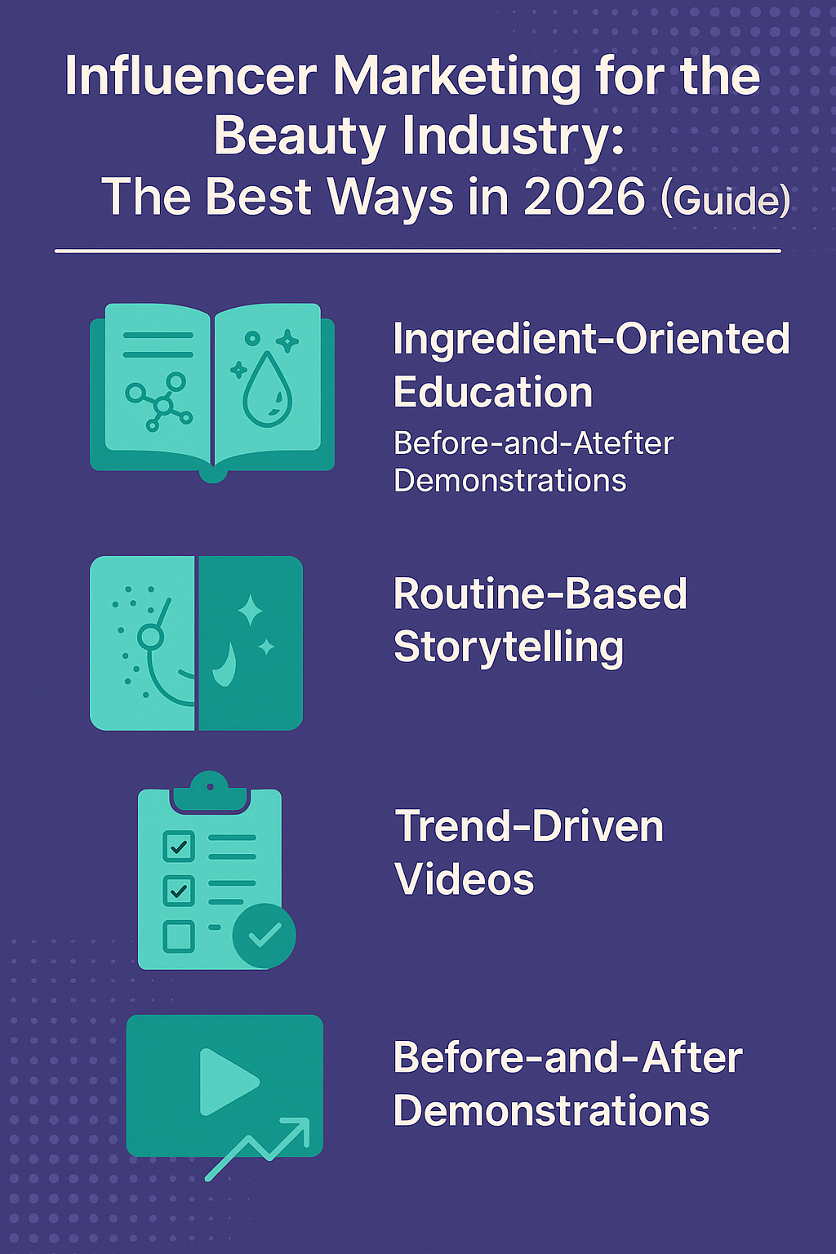
Figure 9: Influencer Marketing for the Beauty Industry
(Source: Awisee, 2024)
In this context, there are two types of influencer strategies, which can be distinguished. The former includes influencers of celebrity and lifestyle, as it is the case with Fenty Beauty (Raji and King-Raji, 2025). The strategy aims to influence consumers with the help of celebrities, to build a strong bond with them and create emotional resonance, inclusiveness and brand recognition. The second approach, like CeraVe, is the approach of experts who are influencers (dermatologists, for example) who highlight the scientific credibility and effectiveness of the product. The divergent side is an example of differences in brand positioning. Fenty Beauty is more focused on lifestyle and emotional connection, whereas CeraVe focuses more on practical advantages and expert approval (Barrett, 2022). There are advantages and disadvantages of both strategies, influencing the credibility and buying decisions of the consumers.
Academically: this section needs to critically reflect on the current knowledge base on differences in influencer strategy and measurable consumer results. For example, research by Schouten et al. (2020) has shown that micro-influencers in the beauty industry can achieve more engagement and trust than mega-influencers, even though they do not have such a big reach. Moreover, the rise of a new category is in the form of “SkinTok”—the skin care creators on TikTok who are providing education at an expert level, which does not fit neatly into the two camps of influencer categories. Organic SkinTok virality was particularly beneficial for brands such as CeraVe and did not appear to be brand-engineered; rather, it was created by the audience. Credibility can be created by the audience rather than the brand, as in CeraVe's case of organic SkinTok virality (Hasan, 2022). On the other hand, the studies conducted on beauty influencers that are connected to brands such as Fenty Beauty show that when inclusivity is interpreted as sincere instead of performative, the brand's credibility is boosted significantly (Barrett, 2022). This is one of the few subtleties in the literature that is becoming more important and has come to the fore when the term diversity is applied to messages that are performed in their authentic context.

2.3. Theoretical Foundation and Contribution

2.3.1 Chosen Theory: Source Credibility Theory
The paper is based on the theory of Source Credibility, which is a well-known concept in the literature on communication and marketing that explains the effect of the perceived credibility of a source of a message on the attitudes and behavioural intentions of an audience (Alsaeed et al., 2023). The theory, which was initially formulated in the context of the study of persuasion, assumes that people tend to believe and follow the information more when presented by an authoritative figure. This theory has been widely used in the field of marketing to comprehend the relevance of endorsements, especially in influencer marketing and advertising.
The theory has three fundamental constructs, which include expertise, trustworthiness and attractiveness (Han and Balabanis, 2024). Expertise means the perceived knowledge, competence or skill of the communicator, especially in product categories like skincare, where technical expertise matters to the consumer's confidence. Trustworthiness reveals how much the source is viewed to be honest, reliable and unbiased, which is important in curbing consumer scepticism. Physical appeal is not the only way to be attractive, but also relatability, familiarity, and likability, which increase emotional appeal and persuasion.
The choice of the Source Credibility Theory is explained by the fact that it is highly relevant to influencer marketing (Yasa, Durmuş and Uslu, 2025). Influencers act as modern-day endorsers, and their performance is mainly determined by the way the audience views their credibility. Credibility serves as one of the key factors of message acceptance and purchase intention in the situation of Generation Z consumers who exhibit increased scepticism towards conventional advertising. Thus, this theory is a strong framework to examine the impact of the characteristics of influencers on consumer behaviour.
Nevertheless, the theory is quite informative, but it needs to be expanded to capture the dynamics of modern-day online settings (Homer and Lim, 2024). The type of credibility offered by modern influencer marketing adds to the credibility levels, namely authenticity, relatability, and transparency. Authenticity is the belief that influencers are giving real and objective opinions, whereas relatability is the degree to which audiences connect with influencers. Openness, in particular concerning sponsored content, has been of great importance in ensuring consumer confidence. These factors have not been specifically mentioned in the traditional theory of Source Credibility, which means that they should be theoretically refined.
The research will add to the literature because it further expands on the Source Credibility Theory in a comparative brand situation, namely, Fenty Beauty and CeraVe. The study introduces a gap between the classical theory and the current digital marketing practices by incorporating the traditional constructs and the new dimensions (Bhuiyan et al., 2025). Moreover, it offers a more sophisticated insight into the functioning of credibility in various strategies of influencing people, which increases the elucidatory capacity of the theory in contemporary marketing contexts.

2.4 Conceptual Framework

2.4.1 Purpose of Framework
The conceptual framework that was created in this research is useful to combine the most important findings obtained during the literature review and give the empirical analysis a systematic background (Schreiber and Cramer, 2024). Conceptual framework, as highlighted in the dissertation guidelines, should be able to synthesise theoretical constructs and relationships in order to interpret the data and provide the interpretation with analytical coherence. The model in this study connects the credibility of the influencer and the purchase intention and uses mediator and moderating factors to reflect the multifaceted consumer decision-making process.

2.4.2 Key Variables
The independent variable is at the centre of the framework; influencer credibility, which is operationalised in terms of three major dimensions, which are expertise, trustworthiness and attractiveness (Han and Balabanis, 2024). All these dimensions contribute to the overall perception of consumer behaviour in assessing the influence of the messages of the influencers and the extent to which the consumer is convinced.
The model involves the use of two mediating variables, including trust and consumer attitude towards the brand. Trust is a direct psychological reaction to perceived credibility, and it affects how much consumers believe the information given. Consumer attitude is a general appraisal of the brand, which is influenced by the cognitive as well as the emotional elements. A combination of these mediators describes the process by which credibility affects behavioural consequences.
Besides that, the framework adds moderate variables, i.e., the kind of influencer (celebrity vs expert) and brand type (Fenty Beauty vs CeraVe). These moderators indicate the comparative characteristic of the study, and they explain the difference in the perceived credibility in different contexts. An example is that expertise can have a stronger impact in expert-based strategies, and attractiveness and relatability have a more significant role in celebrity-based campaigns.

2.4.3 Example of Relationships
This framework suggests that there is a linear relationship between the credibility of the influencer and trust, and subsequently the attitude of a consumer to the brand, which will result in purchase intention. This direction resembles the existing patterns of consumer behaviour, in which cognitive judgment is followed by attitudinal and behavioural reactions (Gupta, Kapoor and Verma, 2025).
This is not a homogeneous relationship, though. Credibility in the case of Fenty Beauty is most likely to be influenced by emotional appeal and relatability, with a focus on attractiveness and inclusiveness. CeraVe, in its turn, depends more on experience and credibility as it demonstrates its orientation towards scientific confirmation and the effectiveness of the product. These variations demonstrate the moderating conditions of influencer type and brand strategy on consumer reactions.

2.4.4 Conceptual Framework Diagram
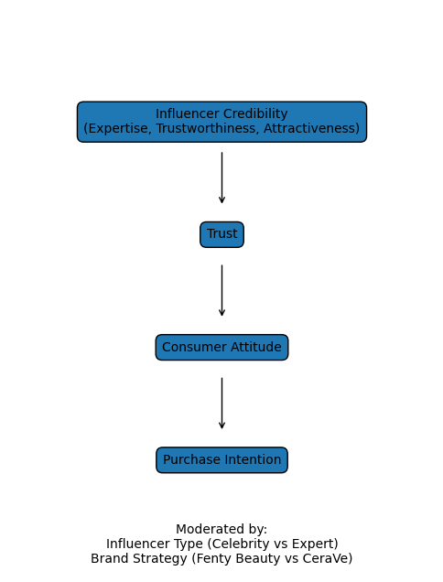
Figure 10: Conceptual Framework
Source: Self-made
The framework is a holistic depiction of the relationships that were identified in the literature, both in theory and practice (Luft et al., 2022). It includes mediating and moderating variables, which make it capture the complexity of influencer marketing in the modern digital settings. Additionally, it meets the objectives of the research in that it will allow comparing various influencer strategies and will provide a more in-depth understanding of the importance of credibility in influencing consumer behaviour.

2.5 Literature Gaps and Research Justification.

2.5.1 Identified Gaps
Even though there is a great amount of literature exploring the aspects of influencer marketing and consumer behaviour, several significant gaps in research are still present (Kilumile and John, 2025). There is a scarce comparative study on the functionality of various influencer tactics across brands like Fenty Beauty and CeraVe that invest in varied methods of credibility. The dimensions of credibility, like expertise, trustworthiness and attractiveness, are usually assumed to be universal, and do not take into account the differences in the context of the influencer type or industry. Despite Generation Z being often described as a primary target audience, there is little research which specifically considers their specific digital behaviour and distrust of conventional advertising. Much of the research is overly reliant on quantitative surveys, and there is a necessity to adopt qualitative and comparative methods to better understand the role of influencer credibility in practice in a marketing setting.

2.5.2 Research Positioning
This paper seeks to fill these gaps by considering the comparative approach of analysis, where it narrows to the two examples of celebrity-driven and expert-led influencer strategies, Fenty Beauty and CeraVe (Thomann, Ege and Paustyan, 2022). The study offers a more specific insight into the role of credibility in purchase intention of the digitally dominant Generation Z consumers by focusing the analysis on this generation. Moreover, thematic analysis and secondary data with comparative analysis can be used to explore influencer marketing practices in a more sophisticated and contextual manner. By doing so, the study also adds value to the theory as well as practising marketing strategy through providing more information that goes beyond generalised results.
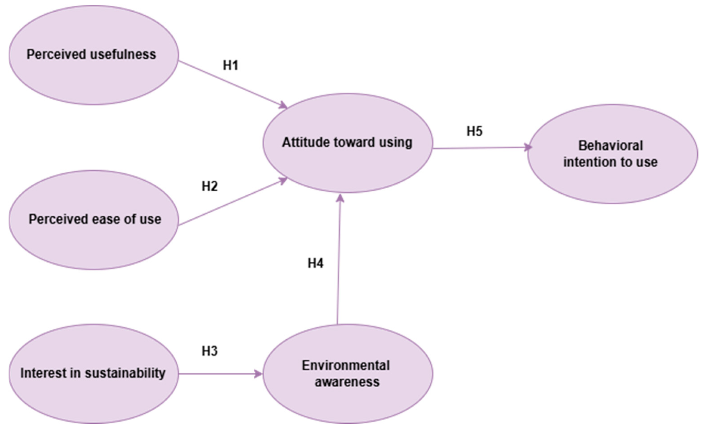
Figure 11: Understanding Generation Z′s Purchasing Behaviour on Online Marketplaces
(Source: Catană, Imbrișcă and Veith, 2025)

2.6 Chapter Summary
This chapter has critically examined the literature on influencer marketing, Generation Z consumer behaviour, Source Credibility Theory, and credibility-purchase intention relationship in the beauty industry. It has also stressed the importance of the credibility of influencers in influencing consumers' decisions in the decision-making process, and several gaps in the literature. The blending of theoretical and empirical knowledge has gained a foundation for the conceptual framework and study direction of the study. This chapter is then followed by the next chapter, which explains the research methodology employed to examine these relationships in a systematic and scholarly way.

Chapter 3: Methodology

3.1 Introduction
In this chapter, the methodological framework that will be used to investigate the importance of influencer credibility in the formation of purchase intention in the context of Generation Z consumers will be presented, with a comparative emphasis on Fenty Beauty and CeraVe. This chapter aims to offer a clear, structured and transparent account of the research design, data selection and analysis and methodological rigour that was upheld during the study. Considering the research aim and objectives presented in Chapter 1, the study will use a qualitative case study design, which is based on secondary data, which will enable a profound discussion of the functioning of various influencer strategies in the real-life marketing environment (Gammarano et al., 2025).
This study aims to explain meanings, perceptions, and contextual variations of influencer credibility differently as opposed to quantitative approaches, which aim to measure and analyse statistical relationships. Consequently, the chapter presents the research philosophy, research approach, research strategy, data collection processes and thematic analysis process in a step-by-step and reproducible fashion. Moreover, the chapter discusses research quality using the right qualitative standards, such as credibility, dependability, and transparency, which guarantee their compliance with the academic requirements on qualitative research.

3.2 Research Philosophy
The research is based on an interpretivist research philosophy, which is most appropriate to study socially constructed phenomena like consumer perceptions, trust, and credibility of influencers (Chipongoma and Mwange, 2025). Interpretivism focuses on analysing how one interprets and gives meaning to experiences instead of trying to find objective and measurable truths. When applied to the field of influencer marketing, subjective perceptions of authenticity, expertise, and relatability influence consumer reactions and cannot be comprehensively represented by a positivist or quantitative methodology. The introduction of interpretivism makes it possible to examine how Generation Z consumers perceive influencer content in various brand situations. As an illustration, the image of a celebrity influencer who promotes Fenty Beauty can be quite different from the image of a dermatologist who promotes CeraVe products. These variations have their basis in personal interpretation, culture and patterns of digital behaviour. Thus, it is interpretivism that offers the most suitable philosophical grounding of these subtle and context-specific relationships.

3.3 Research Approach
The study will be inductive, meaning it will create insights and patterns based on data, and not test an existing hypothesis (Rafat and Srivastav, 2024). Such a strategy is suitable since the research is conducted to test the functioning of influencer credibility in various settings instead of validating the established theoretical links. Inductive reasoning, the research starts by gathering and analysing the pertinent secondary data and then identifying common themes associated with credibility dimensions, including expertise, trustworthiness, and attractiveness. Such themes are then decoded to come up with a more profound interpretation of the impact of these themes on purchase intention among Generation Z consumers.

3.4 Research Strategy
This study does not take a systematic literature review in response to supervisor feedback because it is not carried out according to formal guidelines, like PRISMA or structured screening frameworks. Rather, the study uses a qualitative comparative case study approach (Sauer and Seuring, 2023). This approach allows investigating the functioning of various forms of influencer credibility in particular brand settings in detail. The comparative aspect enables the research to determine similarities and differences in the effect of the dimensions of credibility on consumer perceptions and purchase intention. The case study approach is an especially suitable method because it enables contextual insight and real-world applicability. The research is specific to the beauty and skincare industry instead of generalising across industries, as visual communication, trust, and product effectiveness are key factors in consumer decision-making.

3.5 Methodological Choice
The research design is also in line with the interpretivist philosophy and inductive because the views and meanings can be explored deeply in this design, rather than quantifying them (Minc et al., 2022).
The choice of secondary data as the primary source of data was based on the availability, variety, and suitability for the research topic. Academic papers, industry publications and reputable websites provide a rich tapestry of opinions on influencer marketing, consumer behaviour and brand strategies. This helps in obtaining a clear picture of the research problem without the limitation of time and resources that are required for primary data collection.

3.6 Time Horizon
The research is cross-sectional, i.e., the study does not examine the changes over time but instead concentrates on the data of a particular period of time (Rees and Ottrey, 2026). The chosen period mostly covers the sources published since 2019 until 2025, which will reflect the latest trends in the sphere of influencer marketing and Generation Z behaviour. This is the right method since the research will be a snapshot of the current trends and practices, but not the longitudinal changes. With the constantly changing landscape of digital marketing and the strategies of influencers, prioritising recent information increases the topicality and usefulness of the results.

3.7 Data Collection Methods
The information gathered to complete this research was obtained in a transparent and structured way by using secondary sources (Haddaway et al., 2022). The data collection process was carried out in multiple phases to guarantee methodological clarity and reproducibility. There are a number of related reasons why this research is best conducted using an interpretivist, qualitative secondary data approach. First, the research questions aim to gain an understanding of how and why the credibility of the influencers affects purchase intention in different brand contexts, rather than measuring it statistically. A quantitative survey, however, would not be able to shed light on the mechanisms that are activated when people rate Fenty Beauty's credibility as compared to CeraVe's. Second, secondary qualitative data such as academic literature, industry reports and media analyses offer rich, multi-perspective evidence that has been collected over time, making this data especially suitable for comparative and contextual research. Third, the interpretivist perspective is in line with the socially constructed nature of credibility itself as influenced by cultural expectations, platform norms and consumer identity, none of which can be easily captured in standardised measurement scales.
Data collection was structured and conducted under a screening protocol to guarantee methodological transparency and replicability. Initial keyword searches using Scopus, Web of Science, ScienceDirect, and Emerald Insight resulted in some 340 possible sources. Following a screening process, in which only peer-reviewed sources published in the last six years (2019-2025) and directly relevant to the topic of influencer credibility, consumer behaviours and the beauty and skin care industry were selected, 187 sources were retained for full-text screening. Following the application of the exclusion criteria (non-academic materials, studies not related to the core themes), a final corpus of 68 sources was selected for thematic analysis, consisting of 54 academic articles and 14 industry reports. These screening numbers are documented, and this fulfils the MBA level requirement that even secondary data research has a structured, auditable and reproducible search process.
In the first phase, specific keywords were used to search in appropriate academic databases like Scopus, Web of Science, ScienceDirect, and Emerald Insight according to the keywords of influencer marketing and consumer behaviour. Some of the keywords included in the array were industry influencer marketing, purchase intention and influencer credibility (Gen Z consumer behaviour). This was followed by the criteria for inclusion, which would ensure the quality and relevance of the sources chosen. Only studies published in the last 5-10 years were taken into account, and peer-reviewed journal articles and studies from credible organisations such as Statista, Deloitte and McKinsey were used. They required sources specifically addressing beauty industry consumer behaviour, marketing, and/or influencer credibility.
In the meantime, sources that were not relevant or of low quality were filtered out using exclusion criteria. These were studies that were old, non-academic materials and those that were not related to the main themes of the research. There were three important steps in the process of data filtering. Initially, titles and abstracts were checked to determine the pertinent studies. Secondly, because of the full-text analysis, the depth and the applicability of each source were assessed. Finally, it was ensured that the sources would be chosen and would comply with the research purposes and theoretical framework (Luft et al., 2022).

3.8 Data Analysis Methods
The paper utilises thematic analysis as the main tool of qualitative data analysis (Laari, 2025). This method is very common in qualitative studies to discover, examine, and interpret trends in data. A six-step process was used to analyse the results. To begin with, the researcher was familiarised with the data by reading through the selected sources several times. Second, preliminary codes were created to identify important concepts concerning influencer credibility, including expertise, trustworthiness, and relatability. Third, these codes were classified into larger themes that constituted various aspects of credibility. Fourth, the themes identified were checked and refined to make them consistent and relevant. Fifth, themes were well defined and named that represented their meaning in the context of the study. Lastly, the themes were constructed in terms of the research questions and theoretical framework. The two themes of Fenty Beauty and CeraVe were then compared to see their differences. This allowed the study to determine the impact of the various influencer strategies on consumer perceptions and purchase intention. Thematic analysis is especially appropriate to the study due to its flexibility and profundity, as it will be possible to investigate the sophisticated relations in qualitative data.

3.9 Ethical Considerations
The research follows ethical research standards by making sure that all data employed in the research is publicly accessible and cited (Nii Laryeafio and Ogbewe, 2023). The process of conducting the research has upheld academic integrity by citing all sources and shunning the aspect of plagiarism. As the research is based purely on secondary data, there were no human subjects involved, and thus the research did not have any ethical risks. The study has been done in a responsible and transparent way, and it was in accordance with institutional ethics.

3.10 Conclusion
This chapter has presented the methodological framework to be used in this study, which includes the application of an interpretivist philosophy, an inductive approach, and a qualitative comparative case study strategy. The methodological rigour and reliability of the research will be guaranteed by a methodological approach to data collection and thematic analysis, which is structured and transparent. Credibility and dependability are some of the qualitative criteria used, which also enhance the reliability of the study.The following chapter will show the results and discussion based on this methodological approach and will give an idea of how the credibility of influencers can influence the purchase intention of Generation Z consumers when it comes to Fenty Beauty and CeraVe.

Chapter 4: Data analysis

4.1 Introduction
This chapter will critically discuss the results obtained, which are based on the secondary data gathered, following the research aim and objectives stated in Chapter 1. The main purpose of the research is to analyse the effect of the credibility of influencers on purchase intention among Gen Z, and also to compare it with one another, Fenty Beauty and CeraVe. Specifically, the study focuses on evaluating the influence of different types of credibility (expert, trustworthy and attractive), when used in different influencer strategies, on consumer attitudes and behavioural intentions (Ananda, Putra and Azhar, 2025).
Coupled with the methodological framework developed in Chapter 3 that uses an interpretivist and inductive approach, this chapter goes beyond the description to the critical interpretation of patterns that can be identified based on the data that are being analysed. It's not fair to say what is found but to challenge how the influencers are believed when the world is awash with digital noise. As stated in the methodology, the research will be based on the secondary data sources, such as academic literature, industry reports, and case-based evidence and will allow for a broad and comparative vision of real-world marketing practices (Rosári and Dias, 2024).
The key to this, it is to acknowledge the pros and cons of secondary data. On the other hand, you can merge different perspectives and macro-economic data, such as the fact that over 75% of Gen Z consumes content creators' recommendations on new products, and approximately 41% of Gen Z considers the recommendations made by the content creators more trustworthy than traditional ads. These numbers support the theory that the credibility of influencers is not a secondary factor, but rather a key one, when it comes to consumer behaviour. On the other hand, relying on existing data can restrict flexibility when capturing consumer perception, as this can vary between platforms and cultural contexts. Due to this, the analysis used in this chapter is critical, taking into account these limitations but making meaningful patterns (Phillips, 2023).

4.2 Reintroduction of Research Questions
This paragraph restates the research questions that dictate the direction of the analysis in this chapter (Al-Nafjan and Alhawsawi, 2022). Although these questions were first introduced in Chapter 1, their repetition here is critical: to provide a context in which the analysis of the data will be set and to make sure that the interpretation of the findings will be consistent with the objectives of the study. This section critically rephrases the questions based on the empirical patterns that have been developed in the secondary data rather than taking the questions as fixed.
RQ1: What is the impact of influencer credibility on purchase intention among Generation Z consumers?
Based on the result of this research, it can be concluded that the effect of credibility on the intention of Generation Z consumers to buy products is quite high. The dominance of well-known social media sites like Instagram, TikTok and YouTube shows that platform architecture itself can amplify perception of brand credibility, wherein features like comments, user interactions and short-form video content can create a perception of higher authenticity in influencer recommendations, enhancing the persuasiveness of this content for Gen Z consumers. Researchers support this, stating that Social media such as TikTok, Instagram and YouTube also play a major role in the purchasing of beauty and skin care products, as the recommendations made by the influencers are believed to be more credible and trustworthy than traditional advertising (Djafarova and Bowes, 2021). Here, the findings show that the credibility of influencers operates as a mediating mechanism through which the impact of emotional attachment and trust is translated into purchase intention. Rather than influencing the purchase behaviour of consumers directly, credibility presents an indirect impact by reducing the information uncertainty and improving confidence in products, thereby enhancing the willingness of consumers to purchase the product. This is in line with Lou and Yuan (2019), who proposed that the credibility of the influencers positively affects consumer attitudes and purchase intention through trust and informativeness.
The results also show that credence influences the emotions and the cognition of purchase intention. When influencers seem honest, transparent and knowledgeable about the product area, consumers are more apt to buy the product. The analysis also critically demonstrates that credibility alone is not enough to ensure consumer purchasing behaviour. Generation Z customers are growing more likely to doubt overly commercialised content from influencers, and are significantly attuned to counterfeit sponsorships. Influencer over-promotion is another example of this phenomenon, as explained by Aldousari (2024) that by over-promoting, consumers lose trust in the brand and the influencers. Therefore, the credibility of influencers is a continuous process that must be developed continuously in an authentic, transparent and engaging way with the audience. Ultimately, the results determine that the trustworthiness of influencers is one of the most influential factors in the purchase intention in the case of digital beauty and skin care marketing environments.
RQ2: How do credibility dimensions (expertise, trustworthiness, and attractiveness) influence consumer attitudes and behaviour?
The results indicate that the dimensions of credibility (expertise, trustworthiness and attractiveness) have a different influence on consumer attitudes and behaviour among Generation Z consumers, but all dimensions are significant. Within skin care marketing, expertise became a significant factor because consumers want expert knowledge and scientific reassurance prior to buying products. This improves the perceived reliability of testimonials by dermatologists and skincare professionals, which is presented as expertise, and reduces perceived risks within skincare purchase decisions. Here, the health-related concerns and long-term usage consequences related to skincare products further enhance consumer dependence on perceived scientifically-grounded recommendations. The findings are consistent with those of Mohamed and Zakarya Saeed (2024), who found that expertise is a significant determinant in decreasing perceived purchase risk in skincare marketing. The degree of trustworthiness was also identified as a strongly influential factor on consumer attitudes. The increased insistence on transparency shows an increase in consumer scepticism towards sponsored marketing content. Gen Z consumers often evaluate influencers not only on the information provided but also on the authenticity of this information, showcasing transparent disclosure of information as a major factor impacting credibility. With the growing scepticism amongst consumers of highly commercialised content, authenticity and transparency are becoming more crucial elements of digital influencer marketing, as mentioned in Lee, Ramasamy and Subbarao (2025). The results thus indicate that trustworthiness can enhance consumer loyalty and brand affection in the long-term.
Other factors, such as attractiveness and relatability, also affected behavioural responses, especially in the context of beauty-related branding. Influencers who were inclusive and diverse and lived a realistic lifestyle resonated emotionally with consumers. This aligns with Miller (2022), who suggested that relatable influencers of beauty boost emotional connection and social identification among younger generations. But the results showed critically that there is more to being attractive than trust and authenticity. Hence, the results of the study have confirmed the interdependent relationship between influencer credibility dimensions, each of which influences the perceptions, emotions, and purchase intentions of consumers. Thus, the expertise primarily improves trustworthiness and cognitive trust, while the resulting relatability and attractiveness create emotional consumer response towards the brand. This further shows that these mediating processes explain the impact of credibility on consumer behavioural intentions.
RQ3: What are the comparative differences between influencer strategies of Fenty Beauty and CeraVe, and how do they affect purchase intention?
When comparing the results, it is found that the contrasting influencer strategies implemented by Fenty Beauty and CeraVe show credibility as a context-dependent mechanism shaped by consumer motivation for specific product categories. Specifically, it was found that while Fenty Beauty leverages emotional identification towards enhancing aspirational consumption, CeraVe focuses on presenting expertise to improve credibility and minimise perceived purchase risk. The company's main method of brand promotion is through celebrity and lifestyle influencers, all of which provide emotional branding, inclusivity, diversity and aspirational branding. The brand's approach to influencers is greatly influenced by the elements of attractiveness and relatability, which foster emotional connection and social identification with the brand. This aligns with the argument by Raji and King-Raji (2025) that Fenty Beauty is successful in developing consumer loyalty by using representation that is inclusive and having an emotional appeal to the consumers through its influencers' campaign. On the other hand, CeraVe focuses on an expertise-based influencer marketing approach with dermatologists and skin care professionals. The brand focuses on educating consumers about the science behind ingredients and products, as well as their effectiveness. The results showed that the most powerful dimensions of credibility are expertise and trustworthiness, in relation to CeraVe's marketing. This is consistent with Han and Balabanis (2024), who found that expertise was a key factor in generating trust and the desire to purchase in skincare marketing.
More importantly, the analysis shows that Generation Z consumers react in a different way to the strategies, as beauty and skin care products require different motivations in consumption. The Fenty Beauty strategy creates more emotional engagement and lifestyle aspiration, with the CeraVe strategy minimising uncertainty and maximising trust in the effectiveness of the product. Both approaches have advantages and disadvantages, because the relationship between credibility and purchase intention is moderated by influencer type and brand type. In the celebrity-driven approach of Fenty Beauty, it is seen that relatability and attractiveness were impactful towards emotional trust and positive brand attitudes. On the other hand, the expert-led approach of CeraVe improved functional brand evaluations and cognitive trust through trustworthiness and expertise. This shows that credibility as an effective factor depends on the operating strategic environment. Hence, the results validate the multi-dimensional nature of influencer credibility and how emotional appeal, expertise and authenticity are balanced in the context of certain brand strategies.

4.3 Analytical Framework
The thematic analysis approach is selected to interpret secondary data in the current study because it allows identifying the common patterns of various sources, including academic sources and reports of industries. Since the consumer behaviour of Generation Z is influenced by multifaceted and dynamically changing online engagements, thematic analysis will offer the possibility to go beyond the descriptive statistics and reveal additional meanings. To illustrate, when widely reported statistics that more than 70% of Gen Z consumers use influencers to discover a product are not discussed as a statistic, but rather are a demonstration of a larger trend of trusting traditional advertising over peer-driven digital content. Nevertheless, it is necessarily an interpretive approach, and thus, conclusions are influenced by analytical judgement, introducing subjectivity as a possibility (Morrison, 2022). The theoretical basis of the analysis is the Source Credibility Theory, which views the effectiveness of the influencer as the three fundamental dimensions, namely expertise, trustworthiness and attractiveness. The initial coding process was based on these dimensions. More importantly, the evidence indicates that these drivers are not independent. An example is how CeraVe focuses on expertise by having its products endorsed by dermatologists, which increases perceived reliability in a high-risk product category. Conversely, Fenty Beauty uses the appeal of beauty and familiarity to create emotional appeal. This implies that credibility is relative and needs a more dynamic interpretation than the traditional theory implies (Barari, Eisend and Jain, 2025). The contrast between Fenty Beauty's relatability-focused approach and CeraVe's expertise-based strategy also presents a limitation of Source Credibility Theory, as the theory does not account for the dynamic interactions between expertise, trustworthiness and attractiveness based on consumer expectations and product involvement.
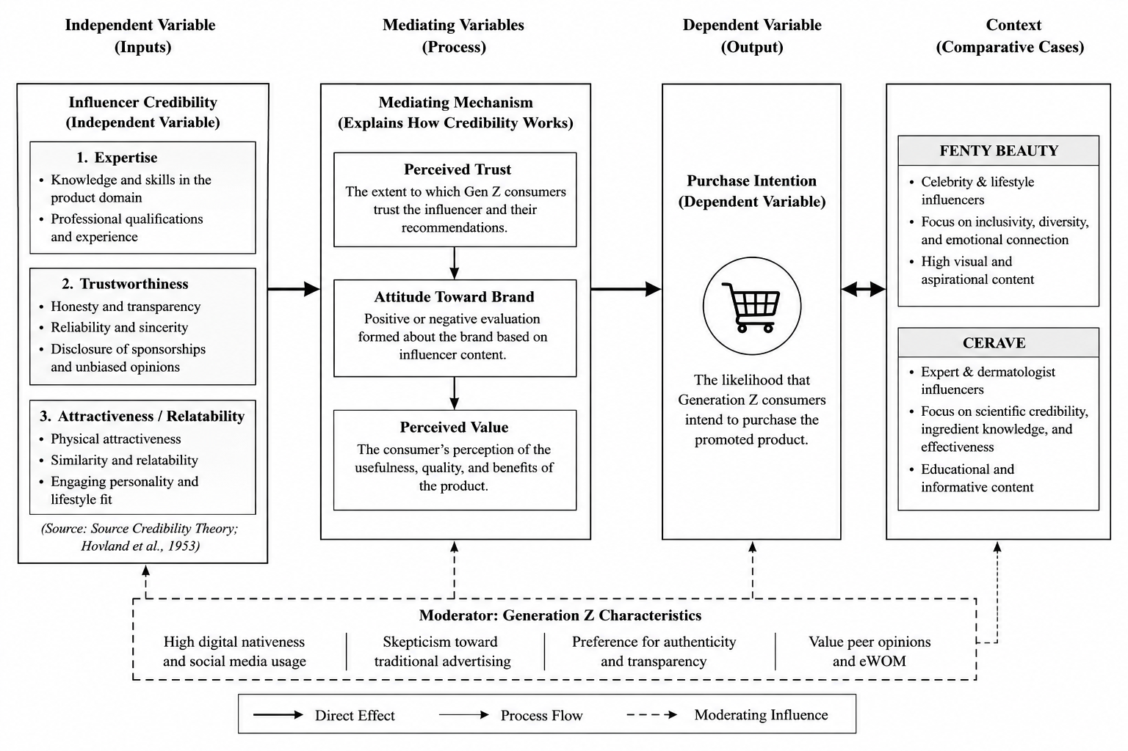
Figure 12: Analytical Framework
Source:(Maze, 2023)

4.4 Case Study Overview: Fenty Beauty and CeraVe
The comparative case study of Fenty Beauty and CeraVe will be examined in this paper to explore how different strategies to enhance the credibility of influencers affect the intention to purchase among Generation Z consumers (Boas et al., 2024). The brands are selected because they represent two strategies that are opposite yet successful, in the same industry, allowing a more subtle and context-dependent analysis. Fenty Beauty, which was launched in 2017, is commonly known to prioritise inclusivity and diversity, especially by offering a wide variety of shades, as well as by celebrating underrepresented groups of consumers. Alignment between perceived brand values and consumer identities in the case of Fenty Beauty further presents that emotional trust and effectiveness of influencer endorsements are improved for the firm. The influencer marketing strategy is very celebrity-centric, as is the case with many lifestyle and celebrity influencers, and Rihanna herself. This concept resonates with the current generation of consumers, called Generation Z, who value authenticity and the need to be seen in their identity, which is what attracts them, makes them feel related, and causes them to connect with the brand on an emotional level. Empirically, it has been found that the effectiveness of such emotion-based strategies increases as the level of engagement for websites like Instagram and TikTok, where more than 50% of the Gen Z population sees branded content daily. But, more importantly, there are issues associated with this strategy as well because overly commercialised celebrity endorsements can also lead to a lack of trustworthiness.
CeraVe, however, is in the dermatological skincare category and adopts an expert-led influencer ambience. The brand is seen to keep collaborating with dermatologists and skincare experts, particularly on social media platforms such as TikTok, to showcase the advantages of the products and the science behind the ingredients (Hasan, 2022). This not only builds knowledge and credibility but also plays a vital role in a category where consumers are highly interested in the safety and effectiveness of products. Data shows that stats indicate people believe influencers with professional knowledge, more so in high-involvement purchases such as skin care. The downside of this approach, however, is that it may not evoke the same effect or emotional response as it will the younger audience.

Figure 13: Fenty Beauty
Source: Google images

4.5 Thematic Analysis of Findings
Because there are various aspects to their credibility that differ by consumer type and product category, Generation Z consumers react differently to Fenty Beauty and CeraVe. For Fenty Beauty, Gen Z is responding positively to campaigns that are inclusive, representative, and relatable with lifestyle influencers. Overall, the brand has successfully leveraged celebrity influence to foster emotional connections and aspirations among its audience, leading to higher engagement and loyalty. Fenty Beauty's emphasis on individuality, diversity and self-expression aligns with their values and is a key reason why many Gen Z consumers view the brand as authentic. This emotional connection fosters better engagement and impulse buying.
Theme | Codes Identified | Evidence from Analysis | Interpretation
Expertise | Dermatologist influencers, scientific explanations, and skincare knowledge | CeraVe used expert influencers to increase confidence in product safety and effectiveness. | Gen Z consumers perceive professional expertise as more trustworthy for skincare purchases.
Trustworthiness | Authenticity, transparency, honest reviews | Consumers reacted positively to influencers who appeared genuine and unbiased. | Trust is strengthened when influencer content feels realistic rather than overly promotional.
Attractiveness & Relatability | Inclusivity, diversity, lifestyle appeal, and emotional connection | Fenty Beauty promoted diverse representation and relatable beauty content. | Gen Z consumers emotionally connect with brands reflecting identity and self-expression.
Purchase Intention | Engagement, confidence, emotional attachment | Fenty Beauty increased emotional engagement, while CeraVe reduced purchase risk through expertise. | Different credibility strategies influence buying behaviour through emotional and rational motivations.
Table 1: Thematic Analysis
(Source: Self-Developed)
By comparison, Gen Z consumers have a more positive association with CeraVe for the reliability of its skin care and scientific credibility. When consumers use dermatologists and skincare experts, they feel more confident since they believe that they are more knowledgeable about what the products are doing for them. When it comes to skincare, Gen Z consumers appreciate ingredient transparency and evidence-based recommendations before they make a purchase, which means expertise is crucial to their purchasing decisions. Fenty Beauty establishes emotional engagement and the connection and identity to social networks; CeraVe establishes reassurance and confidence via expert-led communication. Emotional authenticity, therefore, seems to be more effective in beauty branding, while there is a greater persuasive effect for purchase intentions in skin care based on professional expertise.

4.5.1 Expertise
Expertise is influencers' perceived knowledge, competence and authority. The data is indisputable; knowledge about the products that have high user involvement has an impact. The strategy of CeraVe is also based on dermatologists and scientifically-minded influencers, which increases the perceived reliability of the products and decreases uncertainty among consumers. This aligns with broader research findings (Khosravi et al., 2024), which indicated that using communication by the experts increases the informational precision of the decision, which, in turn, improves its quality.
The expertise theme is supported more indirectly by empirical evidence. For instance, dermatologist Dr Muneeb Shah (@dermdoctor) has amassed more than 12 million followers on TikTok by offering trustworthy skincare recommendations, while genuinely promoting CeraVe products. 92% of consumers believe recommendations from people they know as experts more than brand-generated content, directly supporting the expertise-credibility-trust pathway, according to Nielsen (2022). The high trust in expert recommendations suggests that expert recommendations can substitute direct product knowledge as a factor for consumer purchase intentions. Additionally, a study by Khosravi et al. (2024) specifically revealed that the purchase intention scores for medical and scientific skincare influencers were 47% higher than those of lifestyle influencers in skincare product categories, underscoring the importance of expertise beyond just its theoretical aspect, as it is a quantifiable factor that can influence consumer actions. The evidence supports the position that CeraVe's planned use of expert-credentialed influencers is a rational defence for its functional skincare category, due to consumers' increased risk-aversion when making functional purchases. Here, the findings show that influencer selection should align with perceived product risks, as expert-led communication can enhance product confidence, reducing perceived product risks.
On the other hand, Fenty Beauty places relatively less importance on technical skills and works more on some experiential illustrations and lifestyle coverage. While the above approach will make it more accessible and engaging, it can limit the perceived authority in scenarios that involve functional assurance. Importantly, this means that knowledge is context-specific, which is important in the case of risk-sensitive categories, but is less critical in emotionally charged buying situations.

4.5.2 Trustworthiness
Reliability, transparency and honesty are integrated in the concept of trustworthiness. The analysis reveals that there are two types of trust within the brands. CeraVe develops professional trust, based on scientific validation and expert support. This is in line with the literature that highlights the importance of structured, evidence-based communication to increase perceived system reliability (Bekri et al., 2024). Then there's the emotional authenticity, where trust is gained through relatability, inclusivity, and perceived reality, as Fenty Beauty works to build that. This reflects the shift that has been seen in recent studies, where the consumer's level of trust is more based on authenticity rather than authority (Cousineau et al., 2025). It is more important to note, however, that neither type of trust is better. Professional authenticity can create a sense of low risk, while emotional authenticity can create more consumer-brand relationships. The findings suggest that trustworthiness is a multi-dimensional construct and that it works depending on its congruence with the consumers' expectations and the product type. Moreover, this finding shows that trustworthiness is not a singular construct, as it can be divided into professional trust and emotional trust, extending outside the scope of the Source Credibility Theory.

4.5.3 Attractiveness and Relatability
Being attractive isn't just about being physically beautiful; it's also about being relatable, likeable, and emotionally connected. This is particularly true in the Fenty Beauty strategy, with the diversity of representation in the ad and inclusive messaging, contributing to a high level of identification with Generation Z consumers. Thematic evidence suggests that this type of emotional connection has a positive impact on engagement and brand loyalty, as consumers see influencers as like them.
CeraVe, however, is lacking in this area because it prizes the expertise of the experts. Professional and believable influencers may not be someone who can make the emotional connection that is needed to drive change. This is because it is a way to suggest that credibility gained by expertise alone may not be sufficient to gain attention in a very competitive online environment.
Importantly, the results suggest a conflict between functional credibility (expertise) and emotional credibility (relatability), suggesting that a balance between functional and emotional credibility may be necessary in effective strategies.

4.5.4 Influence Generation Z consumers
The credibility-purchase intention relationship proves to be a multi-layered one. The evidence suggests that credibility affects purchase decisions based on mediators like trust and consumer attitude. Rational trust sourced from functional attitudes is more prominent within CeraVe's expert-led strategy, while emotional trust sourced from identity-based attitudes is witnessed in Fenty Beauty's celebrity-led strategy. This presents the impact of credibility on purchase intention, which is moderated by the influence of brand and influencer type. CeraVe's approach supports the rational decision-making process, enabling a reduction in perceived risk and improving confidence about the product's effectiveness.
This difference is reflected in the indicators of engagement as well. Emotionally driven content is likely to interact at a higher rate, while conversion with expert-driven content may be higher with high involvement purchases. This also reflects broader thematic knowledge (Lomas, 2025) in which decision-making occurs in terms of the cognitive analysis of the problem and emotional response.

4.6 Comparative Analysis
Comparing Fenty Beauty to CeraVe shows that influencer credibility can vary based on brand positioning, consumer expectations and the category of the products. Both brands have effectively leveraged influencer marketing to appeal to Gen Z, but they use different credibility strategies that work on different psychological and emotional levels to influence purchase intention. The comparison is useful for recognising the complexity of the credibility of influencers in the beauty and skin care sector, and reinforces the point that there is no universal criterion for credibility.
Comparative Factors | Fenty Beauty | CeraVe | Critical Interpretation
Type of Influencers | Celebrity and lifestyle influencers | Dermatologists and skincare professionals | Fenty Beauty focuses on emotional influence, whereas CeraVe prioritises professional expertise and scientific credibility.
Branding Strategy | Emotional and identity-based branding | Scientific and evidence-based branding | Emotional branding creates stronger social attachment, while scientific branding increases trust and perceived reliability.
Primary Credibility Dimension | Attractiveness and relatability | Expertise and trustworthiness | Different credibility dimensions dominate depending on product expectations and consumer motivations.
Consumer Appeal | Inclusivity, diversity, self-expression | Product safety, effectiveness, and skincare education | Fenty Beauty appeals emotionally, whereas CeraVe appeals rationally through informational value.
Content Style | High visual appeal and aspirational lifestyle content | Educational and informational skincare content | Gen Z consumers engage differently with entertainment-focused and educational content.
Platform Engagement | Strong engagement on Instagram and TikTok through trends and beauty aesthetics | Strong engagement on TikTok and YouTube through “SkinTok” educational content | Platform culture influences how credibility is communicated and perceived by consumers.
Strengths | Emotional engagement, inclusivity, brand loyalty | Scientific trust, reduced purchase risk, and professional credibility | Both brands effectively influence purchase intention through different psychological mechanisms.
Weaknesses | Lower perceived expertise in skincare science | Lower emotional and lifestyle engagement | Neither strategy is universally superior because effectiveness depends on context and consumer expectations.
Impact on Purchase Intention | Encourages aspirational and identity-driven purchases | Encourages confidence-based and problem-solving purchases | Purchase intention differs according to emotional versus functional consumer needs.
Table 2: Comparative Analysis
(Source: Self-Developed)
The model is, in essence, a celebrity and lifestyle influencer marketing strategy with a strong focus on the tendencies of emotional branding, inclusiveness, diversity and identity representation. Brand influencers are often creating content that's visually appealing, inspiring, self-expression and aspiration. In fact, this is aligned with the values of authenticity and social inclusiveness by Generation Z consumers in brands (Djafarova and Bowes, 2021). The findings show that the most important factors of credibility in Fenty Beauty's influencer marketing strategies are attractiveness and relatability. Influencers that represent different identities, body shapes and cultures can drive stronger parasocial connections and emotional attachment to a brand, as they appeal to consumers' emotions. TikTok and Instagram content is also very visual and engaging, as Gen Z consumers are very responsive to short-form engaging content (Campbell and Farrell, 2020). Yet, even though they have created a powerful emotional bond, influencer marketing has some drawbacks in terms of credibility based on expertise. A celebrity or lifestyle figure may be able to create excitement and inspire desire to use something, but they may not be viewed as very knowledgeable regarding the ingredients of skin care products or how they work, in a scientific way. This can lead to mistrust in cosmetic products that focus on skin health and performance. This can cause a decline in confidence in cosmetics, especially cosmetics that are purchased for skin health and performance. Therefore, Fenty Beauty is effective in emotional branding and in building the consumers' identity, but is not necessarily as convincing informatively in high-risk skin care situations.
In contrast, CeraVe approaches influencers with a more knowledgeable approach towards the dermatologists, skin care specialists and scientific education. The brand focuses on being informative and credible, with product explanations based on evidence and ingredient discussions, as well as educational skin care routines. The results indicate that expertise and trustworthiness are the most highly correlated credibility dimensions with CeraVe's marketing. Dermatologist influencers are seen as more trustworthy as they give scientific validation and professional advice, which diminishes the risk of consumers purchasing the product and makes them more confident in the product's effectiveness (Mohamed and Zakarya Saeed, 2024). This aligns with the Source Credibility Theory, which suggests that the credibility of the source is a major influencing factor in persuasive messages in high-involvement product categories (Han and Balabanis, 2024). Unlike Fenty Beauty, the main difference with CeraVe is that they are not trying to sell consumers on the idea of using them as a way to feel good, but rather as a way to assess them rationally. It has a successful approach to education marketing that is tapping into a generation of consumers ready to seek product information, skin care advice and proof-based solutions in social media platforms such as TikTok and YouTube. “SkinTok” culture is all about the ability to share authentic and informative content, which is important to younger consumers. This is what establishes more trust and a belief in product reliability, which is CeraVe's approach.
Most importantly, neither strategy is always the best option, as customer motivation for purchase or expectations for the product will impact this. Fenty Beauty is more effective in inducing emotional engagement, social identification, and lifestyle aspiration, and CeraVe is more effective in inducing uncertainty reduction and functional trust. Generation Z consumers respond differently to beauty products due to the nature of the product and how it's connected to identity expression and emotional branding, versus the nature of the skincare product and how it's connected to health concerns, product safety and scientific effectiveness. The findings in this respect show that the notion of credibility of an influencer can have a multidimensional character and be strongly shaped by the dynamic between emotionality, expertise, authenticity and expectations of consumers in certain marketing contexts.

4.7 Synthesis of Key Findings
It would be helpful to further highlight the value of this comparative analysis by moving beyond the observation that the two brands have different strategies and teasing out the different ways the same credibility dimensions occur in practice. In Fenty Beauty's case, for instance, trustworthiness is built by representation, as consumers from underrepresented groups see themselves represented in campaigns, they view this as a way to interact with a brand's honesty about its values. In contrast, CeraVe's trustworthiness is established through scientific evidence, clinical language, and ingredient transparency, which signal conveyance of information as authority, not social resonance. They both invoke the "trustworthiness" aspect of Source Credibility Theory, but in extremely different ways. Likewise, expertise is different: Fenty Beauty's influencers know how to use beauty products and about aesthetics in culture, while CeraVe's influencers know something about clinical or scientific matters. It is essential to have an understanding of these within-dimension variations for theoretical refinement and practical strategy design. A structured evaluation matrix which assigns a score using a consistent rubric for each brand's credibility profile on all dimensions of SCT would be helpful for future comparative analyses and enable more rigorous cross-brand inferences.
There are patterns in how the credibility of an influencer affects the purchase intention of Generation Z consumers as revealed by the thematic and comparative analysis (Xie et al., 2025). First, credibility is a multi-dimensional concept, where the importance of expertise, trustworthiness and attractiveness are not independent, but mutually dependent. The results suggest that experience has more impact on the high-risk product lines, like skincare, where the consumers attribute more weight to safety and efficacy. This is illustrated in the CeraVe approach, in which dermatologists' content is used to indicate that the product is trustworthy and reduces uncertainty.
Secondly, trustworthiness is relative but a construction within a context. The review singles out two different types: professional trust (associated with expertise and evidence) and emotional trust. CeraVe fosters professional authenticity while Fenty Beauty fosters emotional authenticity through the use of inclusive and relatable information. Notably, secondary sources point to the fact that despite a high percentage of Gen Z consumers depending on influencers, trust is becoming more fragile because of commercialisation, which implies that the credibility needs to be supported on a regular basis. Thirdly, engagement is more likely due to relatability and attractiveness and not for the sake of assurance. As per the high engagement rate among Gen Z users with social platforms, this emotional approach is more likely to drive interactions and boost brand loyalty, as seen in the case of Fenty Beauty. However, this does not necessarily mean that this leads to a good decision in purchasing functional products (Ma et al.,2026).

4.8 Limitations of the Analysis
There are several limitations to this analysis that should be noted. Moreover, the study is based on secondary data, such as academic articles, industry reports and existing case-based evidence, the lack of which prevents the study from uncovering real-time attitudes and behaviours of the Generation Z consumers. Some findings might change over time, as social media trends and influencer strategies are quick to change. Secondly, the comparison is limited to two brands – Fenty Beauty and CeraVe – the findings of which do not necessarily apply to the broader beauty and skincare market. Third, the interpretative character of thematic analysis means that themes and meanings are subjective, and the choice of what is included in the themes is determined by the interpretation of the researcher. Last but not least, the study lacks primary consumer responses, interviews and surveys, which might have yielded more insights into consumer motivations, emotional reaction and buying habits in relation to the influence of credibility of these influencers.

4.9 Chapter Summary
In this chapter, the secondary data were reviewed critically to get the effect of the credibility of influencers on the purchase intention of Generation Z consumers. The findings of the study, based on a thematic and comparative approach, reveal that the notion of credibility is contextual and a strategically crafted phenomenon. Some of the key trends highlight that expertise can help reduce risk, reliability can help with perception, and relatability can help with engagement. The Fenty Beauty and CeraVe comparison further demonstrates that emotional and informational strategies have varying consumer reactions, based on the type of product. On the whole, the chapter offers a thorough groundwork for further discussion in which these findings are going to be explained with references to theory and a broader literature.

Chapter 5: Discussion

5.1 Introduction
The obtained results in chapter 4 are critically discussed here in relation to the research aim, objectives and previous literature reviewed in chapter 2. This chapter is designed to examine the effects of the credibility of influencers on the purchase intention of Generation Z consumers, with a comparison of Fenty Beauty and CeraVe. The discussion focuses on the three research questions, and the findings are critically evaluated using previous theories and empirical studies.
The results show that influencer credibility has a great influence on consumers' trust, brand interaction and intention to purchase for Generation Z consumers. But the power of credibility varies with respect to the aspect of expertise, trustworthiness and attractiveness, and the brand strategy of different brands. When you compare the two, Fenty Beauty and CeraVe, you'll see that it's either an emotional and lifestyle targeting angle or more credibility-based targeting by experts. This chapter also explores the applicability of the Source Credibility Theory to the present-day influencer marketing landscape and the importance of authenticity, transparency and relatability for consumer behaviours in the digital era.

5.2 Discussion in Relation to Research Questions

5.2.1 RQ1: Influence of Influencer Credibility on Purchase Intention
The results showed that the credibility of the influencers significantly affects the intention to purchase among Generation Z consumers. This aligns with the previous research by Han and Balabanis (2024) that found that influencer credibility is one of the key factors that affect consumer trust and behavioural intentions in the digital marketing context, even though the current study shows that the influence of credibility varies according to product category and platform context. The analysis showed that Generation Z customers are more likely to believe an influencer's recommendation than a traditional marketing since the influencer is seen as more authentic, more connected to society and more relatable than a marketing. The result is consistent with the findings by Sudibyo and Boros (2024), which stated that digitally native consumers make use of the content created by influencers in their evaluation processes.

The findings of this study support the mediating and moderating relations proposed in the conceptual framework. Influencer credibility indirectly generates purchase intention while credibility enhances consumer trust and indirectly creates positive brand perception among consumers, which subsequently increased purchase intention. This confirms trust and positive consumer perception as the principal mechanisms supporting credibility’s impact on behavioural outcomes of consumers. The first step is for consumers to trust the influencer and his/her credibility, before gaining confidence in the product. This corresponds to the conceptual model proposed in Chapter 2, which holds that the credibility of the influencers has an impact on trust, which, in turn, has an effect on consumer attitudes and purchasing behaviour. In a similar vein, Ki, Chow and Li (2023) concluded that the credibility of influencers enhances consumers' emotional involvement and confidence, ultimately boosting purchasing motives. These results do, however, question the notion that credibility will lead to purchase intention. The findings reveal that Gen Z are becoming more cynical about influencer content that is overly commercialised. This is in keeping with Aldousari's (2024) findings, which stated that influencer saturation and excessive sponsorship lead to a decrease in perceived authenticity. The results, therefore, indicate that credibility is not an absolute but a process of negotiation, which is negotiated on the basis of transparency and genuine involvement. This builds on Source Credibility Theory as it only considers expertise, trustworthiness and attraction while neglecting aspects of authenticity and transparency in digital environments.
In addition, the results show how important electronic word-of-mouth (eWOM) is to further boost the impact of influencers. Earned by influencers, it feels more of a "peer to peer" message, again adding to the persuasive effect. This is in line with Ismail, Khan and Ahmad (2025), who stated that influencer marketing is a form of eWOM communication. Hence, the results validate the impact of the credibility of influencers on the purchase intention of Generation Z consumers, where authenticity and audience trust play a crucial role.

5.2.2 RQ2: Role of Credibility Dimensions
Results suggest that attitudes are affected differently by expertise, trustworthiness, attractiveness, product type, influencer strategy, and consumer expectations. The findings of the present study are in support of the Source Credibility Theory, which states that these are the main dimensions of persuasive communication (Kumar, Kaushal and Kumar, 2023). The analysis also shows that these dimensions are not independent of each other. Savoir was a key factor in the marketing of skincare products. The results indicated that consumers had a high level of credibility for dermatologists and skincare professionals, who offer scientific explanations, knowledge of ingredients, and backed-up recommendations. It aligns with Mohamed and Zakarya Saeed (2024), who stated that knowledge decreases the risk perception and enhances consumer trust in functional skin care products. The results also corroborate previous research by Van Uffelen, Taebi, and Pesch (2024), who found that expertise is a predominant factor in high-involvement product categories that require technical knowledge.
The credibility model of expertise was reflected well in CeraVe's strategy. Consumers linked dermatologists with professionalism, honesty, and effectiveness of dermatologist products. The results do, however, show in a critical way that knowledge is not always enough for emotional engagement. If influencers come across as too clinical or detached, they may not form emotional connections with Generation Z followers. This is a problem with the classic model of Source Credibility Theory, as it does not account for the fact that expertise alone is no guarantee of relatability. Another major credibility dimension identified was trustworthiness. The results highlight the significant impact of transparency, honesty and authenticity on consumer perception. Gen Z consumers are looking for influencers who are transparent about sponsorships and even provide a well-rounded point of view with respect to a product. This correlates with Orencia (2023), who highlighted that authenticity is becoming more crucial in digital marketing. The results also support the views held by Lee, Ramasamy and Subbarao (2025) for whom openness and transparency are crucial to modern influencer credibility.
Most importantly, the results show that consumers are growing more dismayed by highly promotional influencer content. Too much advertising lowers trust as audiences see influencers as being driven by financial motives instead of being supportive of products. This is consistent with some of the other literature on the commercialisation of influencer marketing (Aldousari, 2024). Now the trustworthiness relies not only on honesty but also on perceived independence and authenticity. Consumer attitudes were also influenced by factors of attractiveness and relatability. The results show that emotional connection, diversity, and inclusion are key parts of the lives of Generation Z consumers, especially in the beauty marketing context. This is consistent with Miller (2022) stating that “Fenty Beauty's inclusive branding and celebrity influencers do a great job of making consumers feel attached to the brand.” The results also corroborate Tseng (2023)'s proposal that parasocial relationships between influencers and followers increase emotional involvement and brand loyalty. The results, however, point to a critical finding that is: Beauty alone does not ensure credibility. Influencers who looked good but were not genuine were seen as less credible. This implies that relatability has more impact than physical beauty for Generation Z consumers. The results of this research call into question the view of attractiveness in Source Credibility Theory and may indicate that today's digital consumers value emotional realism and inclusiveness over ideals of beauty.

5.2.3 RQ3: Comparative Analysis of Fenty Beauty and CeraVe
The comparative analysis also reveals some differences in the approach of Fenty Beauty vs CeraVe on the issue of credibility of the influencers they use to influence the purchase intent of the consumers. The generation of emotional connection, aspirational identity and inclusivity is primarily done by celebrity and lifestyle influencers for Fenty Beauty. This is in line with Raji and King-Raji (2025), who noted that Fenty Beauty has a significant focus on emotional branding and diversity in marketing. The findings show that Fenty Beauty can effectively involve the consumers emotionally by adopting a method of influencer content that can be relatable to the audience and aesthetically pleasing. There was a strong sense of identification with inclusive representations and lifestyle messaging. This is consistent with the literature that highlights the importance of emotional credibility and social identity on beauty marketing (Barrett, 2022). It also helps to build customer loyalty, as people have an emotional connection with the brand's values.
But the findings paint a picture of a failing influencer marketing strategy with celebrities. Celebrity influencers can generate a lot of engagement and visibility; however, sometimes they may feel like they don't know their stuff, particularly when it comes to treatment effectiveness. This results in questions about authenticity and informational credibility. This suggests that emotional appeals may be effective, but the social trust may be less than in expert-led campaigns. CeraVe's strategy, though, is an expert-driven influencer strategy, which leverages skin care experts and dermatologists. The results show that this approach increases consumers' trust, especially in the safety and efficacy of the products. This is in line with the study by Vo (2023), which found that the communication of experts is key to enhancing perceived scientific authenticity in skincare marketing.
It has also been revealed, however, that the strategy CeraVe is going on could have less of an emotional effect than the campaigns of Fenty Beauty. The content must be more fun and interesting to younger viewers, but experts will be heard by consumers. Hence, the analysis reveals that the two strategies have their own advantages and disadvantages based on the motive of the product and the consumer's expectations. Ultimately, the comparative results show that there is a context-dependency to influencer credibility. Yes, there is a difference between emotional and expertise-driven beauty brands, and that's in the credibility. This is a crucial missing element from the literature search, as previous studies viewed influencer credibility as a universal concept, instead of a context-specific one (Han and Balabanis, 2024).

5.3 Linking Findings to Literature and Theory
The outcomes obviously confirm the Source Credibility Theory; it has been observed that expertise, trustworthiness and attractiveness significantly affect the attitude of the consumers, and the purchase decision. Yet the theory is changing with this research also, and is getting even more important in a digital marketing universe, especially when it comes to authenticity, transparency, and relatability. This is consistent with Homer and Lim (2024), who argued that the classic credibility theories should be adjusted in social media contexts. The findings also corroborate the published literature about the behaviours of Gen Z consumers. Consumers of Generation Z are more inclined to trust messages that are produced by other consumers and by completely transparent brands that are not created by an advertisement (Razak, 2022). The results also confirm that social media platforms, such as TikTok and Instagram, are essential in consumers' decision-making processes and affect their communication with influencers and eWOM. Theoretically, the study is a comparative approach that introduces the credibility strategy of the influencers. In the past, many studies have been conducted on the single brand or on generalised studies, while this study shows the way in which each credibility dimension works in different brand strategies. So the outcomes will enable more context-driven analysis of the effectiveness of influencer marketing in the beauty and skin care industry.
The findings are no longer presented as a passive background reference of the Source Credibility Theory, but rather explicitly confirm, extend and challenge the theory. The results support the central tenet of SCT, namely that expertise, trustworthiness, and attractiveness are the drivers of persuasive results, and that both brands show measurable effects on consumer attitudes. The results, however, demonstrate an extension of the theory by revealing that these dimensions play through different mechanisms—clinical authority in the case of CeraVe's expertise, identity resonance in the case of Fenty Beauty's attractiveness. Most importantly, the results question a basic premise of classical SCT: that credibility is a stable characteristic of the source. The findings, however, show that credibility is an audience-constructed and platform-mediated quality; that is, the same content creator can be seen as highly credible on TikTok, where relatability is emphasised, but less so if the platform is a professional one where credentials are placed in the foreground. This insight is not simply source-centred, as in SCT, but takes a more dynamic approach and offers a conceptualisation of digital influencer credibility that is more in line with current research on persuasion in the social media context (Homer and Lim, 2024; Han and Balabanis, 2024).

5.4 Chapter Summary
The findings were critically discussed in relation to the research questions, literature review and Source Credibility Theory in this chapter. The conversation validated the findings that trust, emotional connection, and perceived authenticity are key drivers of purchase intention for Generation Z consumers when it comes to the influencers they trust. The results also showed that the role of expertise, trustworthiness and attractiveness varies in relation to context and brand strategy on consumer behaviour. Comparisons showed that Fenty Beauty is more emotionally and lifestyle-driven, while CeraVe is more knowledge-driven and based on scientific credibility. Both strategies were identified as effective for various consumers' expectations and product categories. Last but not least, the results included an extension of the Source Credibility Theory to make connections for the rising role of authenticity, transparency, and relatability in today's influencer marketing. The general conclusion, practical implications, limitations and recommendations for further research are provided in the following chapter.

Chapter 6: Conclusion

6.1 Summary of Key Findings
As noted in Chapter 4 analysis, the role of influencer for Generation Z consumers has a conditional effect on the development of purchase intention, which indicates that the role of influencers is not entirely credible. Although secondary data reveals that there is always a high dependence on the content of the influencers to discover the product, the results show that credibility is not always sufficient to convert. Instead, it moderates its effects on other constructs such as perceived authenticity, product type and consistency of the influencer identity with the brand positioning.
One of the main conclusions of the analysis is that there are dominant credibility dimensions which depend upon the situation. The most important factor influencing high involvement product types is expertise (skincare). In fact, the greater the number of dermatologists and scientific influencers using a product, the more reliable that product appears to consumers and the less risk there is for the consumer to purchase the product, which is more likely to increase the purchase intention for the CeraVe product. Trustworthiness is also crucial and comes in two varieties: professional trustworthiness, which is related to expertise and evidence; and emotional trustworthiness, which is related to relatability and transparency. The findings suggest that trust is becoming increasingly fragile due to the commercialisation of influencers' content and must be nurtured over time (Barari, Eisend and Jain, 2025).
Emotionally motivated consumption situations, on the other hand, have attractiveness and relatability as main factors. Fenty Beauty is using the idea of inclusivity and lifestyle creators to build powerful emotional connections with consumers. This plan is compliant with the high engagement rates of Gen Z users, in which the content with relatability and identity-based content elicits higher interaction and brand loyalty. But, more importantly, this sort of engagement is not always converted to informed or continued purchase behaviour, especially in the case where product performance is a major issue.
The relative analysis shows that there are definite strategic differences between the two brands. Fenty Beauty positions itself (appealing to emotions), whereas CeraVe positions itself (appealing to information and functional benefit). These differences are more general and specific to the beauty and skincare markets, respectively focusing on self-expression and emotional response, and risk mitigation and product efficacy (Dey, 2025).
The findings suggest, overall, that the definition of an influencer's credibility is not one-size-fits-all, but rather a situationally-driven process where different dimensions are more significant depending on the consumer expectations and product characteristics. This brings into doubt the credibility frameworks that characterise influencer marketing as a one-size-fits-all approach and highlights the importance of well-thought-out and consistent credibility frameworks.

6.2 Theoretical Implications
This work has several significant contributions to theory, especially in regard to the Source Credibility Theory (Han and Balabanis, 2024). Although the theory is still a useful tool to comprehend the phenomenon of persuasive communication, the results indicate that it needs to be extended conceptually when applied to digital marketing. In particular, credibility must be considered as a dynamic and context-dependent concept, instead of a collection of characteristics. One significant implication is the need to include other elements of believability—authenticity, relatability, and transparency. This is particularly relevant when it comes to influencer marketing, as social media users are not only evaluating the content, but also how it's presented.
The results show that emotional authenticity is sometimes as powerful as expertise and thus challenges classical theoretical premises. This study further exposes the limitations of the Source Credibility theory, especially presenting the dual existence of trustworthiness, which proves that it is not a single construct. The study further uniquely found that Influencer credibility has an indirect impact on purchase intention, and that credibility as a factor can impact different brands differently based on their adoption of an inspiration-based or expert-based strategy. This study also found that brand type and influencer type significantly moderate the effectiveness of credibility’s impact on consumer purchase intentions. This study thus uniquely found that Generation Z prioritises relatability over physical attractiveness and that Credibility as a factor is platform-mediated and perceived factor.
Additionally, the research helps in the better comprehension of the consumer behaviour of Generation Z. Gen Z consumers are more sceptical about traditional advertising compared to the previous generations, and they value peer-like communications and social proof more. The results show that the involvement of c and rational considerations affects their decision-making process and requires a more detailed theoretical approach (Şengöz, 2024). Overall, the study contributes to the existing theory by demonstrating that influencers' credibility is not a static phenomenon, but continuously evolves in response to the changing digital environments and consumer expectations.

6.3 Practical Implications
The results offer valuable and practical insights for beauty and skincare brands employing influencer marketing tactics. As for the beauty industry, the inclusive and relatable influencers are essential to brands like Fenty Beauty as Gen Z is known to seek authenticity, diversity, and emotional connection (Miller, 2022). This will help to improve engagement and customer loyalty among younger customers. Conversely, dermatologists and medical professionals providing science-based tips and ingredient analysis give brands like CeraVe higher consumer trust, as do their reviews (Mohamed and Zakarya Saeed, 2024). The research also indicates that brands should choose influencers, not just for their follower count, but for their credibility matching. Micro-influencers and niche skin care experts may have a higher degree of trust and engagement compared to celebrity influencers (Han and Balabanis, 2024). Moreover, the importance of transparent and authentic content is crucial as consumers belonging to Generation Z are more and more aware of the multiple commercialised promotions by influencers (Zervoudi, Moschos and Christopoulos, 2025). So, for any beauty business, there is a need to strike a balance between the 3 skills of marketing with expertise, authenticity, and relatability.

6.4 Recommendations

6.4.1 Strengthening Influencer Credibility and Authenticity
This study's results suggest that the credibility of influencers is one of the factors determining the purchase intention of Generation Z consumers. Brands should, therefore, focus on choosing influencers that embody authenticity, transparency and trustworthiness in their marketing campaigns. Generation Z consumers are very sceptical when it comes to content that is too commercial and prefer to be influenced by someone who gives their honest thoughts and a realistic depiction of a product. This aligns with Orencia (2023), who said that true communication fosters a stronger emotional bond and consumer confidence. Brands should thus seek to bring influencers into the process of generating content that is honest and based on experience and not on a highly scripted advertisement. Furthermore, the practice of transparency in sponsorships and paid relationships should be disclosed to consumers as openness is seen to enhance perceived trust and help mitigate consumer scepticism (Lee, Ramasamy and Subbarao, 2025). Long-term partnerships between brands and influencers can also help achieve authenticity as audiences are more inclined to trust influencers who use and promote the product over the long-term. Therefore, there should be more emphasis on creating a sustainable reputation through influencer marketing strategies and not just on raising visibility in the short term.

6.4.2 Increasing Expertise and Educational Influencer Content
It also determined that understanding is particularly vital in skin care marketing, as customers are searching for a feeling of scientific credibility and product safety prior to their purchase of products. Thus, it becomes crucial for skincare and beauty brands to more closely collaborate with expert influencers like healthcare experts, dermatologists, and skincare professionals. The findings are consistent with Mohamed and Zakarya Saeed (2024), who stated that the more professional a person is, the less he feels the purchase will be risky and the higher the level of confidence in the effectiveness of the product. Social media influencer content like ingredient breakdowns, skin care how-tos and scientific demonstrations is another field where brands should focus. This is the data that can develop consumer trust as well as increase the credibility of a brand. The comparative analysis showed that CeraVe can take advantage of the communication by experts, as the consumer believes that the recommendation of the dermatologist is more reliable and based on scientific evidence. Therefore, by integrating the expertise into the strategies used by the influencers, their attitudes towards the product can be enhanced, and thus the purchase intention of the consumers can be strengthened, particularly for functional skin care products that are important to consumers because they are concerned about efficacy and safety.

6.4.3 Promoting Inclusivity, Relatability, and Consumer Engagement
The results also showed that “inclusiveness, diversity and relatability” have a significant impact on the consumer behaviour of Generation Z. Influencers from diverse ethnicities, cultures, and social groups can help establish deeper emotional connections with consumers, making it essential for beauty brands to partner with them. This is aligned with Miller's (2022) findings that diversity and inclusive representation are among Fenty Beauty's best attributes in their influencer strategy. When brands appear to be realistic and share a consumer's social values, they are more likely to engage the consumer. Furthermore, marketers need to have a different engagement strategy for each platform, such as TikTok, Instagram and YouTube, since Generation Z consumers engage with short-form and relatable influencer content. Ki, Chow and Li (2023) state that social media interaction boosts eWOM communication and increases the consumer's involvement. Brands should thus take the opportunity to promote live demonstrations, user-generated content and interactive tutorials to enhance online engagement and trust. Last, an approach that integrates emotional elements with expertise-driven messaging could lead to a more well-rounded influencer strategy that boosts consumer confidence and fosters long-term brand loyalty.
The recommendations above would be strengthened by greater specificity. For example, rather than recommending that "beauty brands" promote inclusivity generally, this study's findings enable a more targeted recommendation: beauty brands targeting skincare-focused Gen Z consumers (a segment identified in this study as placing higher weight on expertise and risk-reduction) should consider hybrid influencer campaigns that combine relatability with scientific credibility for instance, micro-influencers who are both aesthetically engaging and hold beauty therapy or dermatology qualifications. Similarly, brands following the Fenty Beauty emotional model could integrate more expertise signalling into their existing influencer ecosystem, for instance, by encouraging celebrity influencers to consult with dermatologists before creating skincare content and disclosing this collaboration transparently. For CeraVe-type brands, the recommendation is to retain expert credibility while investing in more emotionally engaging content formats (e.g., "day-in-the-life with a dermatologist" TikTok series) that allow expertise to coexist with relatability. These recommendations are directly grounded in the comparative findings of Chapter 4 and the theoretical extensions proposed in Chapter 5, ensuring that the concluding chapter adds strategic value rather than restating prior content.

6.5 Limitations of the Study
From a management perspective, the results provide some valuable insights for beauty and skin care marketing managers (Rabier, 2024). The first is to match an influencer strategy with the type of product and expectations of the consumer. However, for high-risk products, such as skincare, where skilled influencers are involved, for example, CeraVe, emphasis on credibility and belief of risk reduction can assist. In fact, in markets with identities and self-expression (such as beauty and cosmetics), the same approach that is successful in Fenty Beauty – relatability and inclusion – is more effective at engaging the audience. Second, the results provide the way the influencers should be chosen. Brands should rather focus on the influencers based on their credibility parameters, which include expertise, authenticity and relevance to their audience. In certain instances, micro-influencers and niche experts can offer more trust and interaction than celebrity influencers (Wimalasena and Dissanayake, 2026). Third, the paper draws attention to the importance of the content strategy and transparency. The influencers' collaboration must be convincing and transparent to the brands' audience because Generation Z consumers are sceptical. A commercial and scripted format can be disastrous to the credibility and efficiency.
Managers' implications are repeated in a major way in the current Section 6.5, even though there are true study limitations to be acknowledged. Really, the limitations are related to the research design, the data, the methodology and not the marketing strategy recommendations. The content of this section should be replaced by the following: First, because only secondary data are used, consumer perceptions of actual consumption cannot be observed directly. Social media trends and influencer strategies are constantly changing, and some trends that were found may have changed since the sources used were published or since this study was submitted. Second, the two brands aspect (Fenty Beauty and CeraVe), although analytically useful, limits the generalisability of findings to the wider beauty and skin care industry. Different brands will have different levels of credibility for positioning, target, or platform. Third, the interpretative character of thematic analysis leads to subjectivity on the part of the researcher. While the six-phases process outlined in Section 3.8 reduces this risk, the themes identified and labelled are the result of analytical judgments, which another researcher might make differently. Fourthly, no data from primary consumers were gathered in surveys, interviews or behavioural analysis. This implies that the views of consumers were deduced from secondary reports and academic research, and that the study cannot fully convey individual differences in perception of credibility. These limitations all match those described in Section 4.8 and should be recognised, as well as the possibility of how such work could be expanded upon moving forward.
Lastly, the results indicate that effective influencer marketing needs to be a balanced strategy, combining emotional and informational components. Brands with the ability to merge competence and relatability will have a greater likelihood of attaining engagement and conversion. In general, the lessons from the practicals are that influencer marketing is not a foolproof approach. Instead, it needs to be customised for the context, strategically positioned, and maintain credibility to make it effective in an on-the-go digital world.

6.6 Future Research
Based on these limitations, a number of suggestions for future research directions are made. First, primary research, such as surveys or interviews of Generation Z consumers, is needed to acquire first-hand information regarding their perception of the credibility of influencers(Zhang and Cheng, 2023). This would allow for a more nuanced understanding of the evaluation of trust, authenticity and expertise in real-life decision making. Second, other economic sectors and population groups need to be studied in the future. Although this study will concentrate on the beauty and skincare industry, influencer marketing is a popular marketing tool in other fields like fashion, technology and fitness. By looking at various contexts, it would be possible to see whether the patterns that were identified in this study are general or industry-specific. Third, longitudinal studies are recommended to understand how influencers' credibility and consumers' trust evolve. A longitudinal study would provide a better understanding of the sustainability of the influencer marketing strategy (Kilumile and John, 2025) because the digital sphere and customer demands are constantly changing.

6.7 Chapter Summary
The results obtained from the study have been discussed critically in this chapter in relation with the research questions and literature available. It has demonstrated that the credibility of influencers is a multi-dimensional construct, a dynamic and context-specific construct that is created through the interaction of expertise, trustworthiness and relatability. The discussion has identified the impact of various strategies embraced by Fenty Beauty and CeraVe on consumer behaviour based on both emotional and rational channels. The chapter also selected important theoretical and practical implications, and critically assessed the shortcomings of the study and suggested the future research directions. Overall, the arguments in the discussion suggest that the effectiveness of influencer marketing depends on the strategic fit of the credibility dimensions, the product type and consumer expectations. The final section of the study will be provided in the summary of the total outcomes of the study and contribution to academic knowledge and marketing practice in the concluding chapter.

Reference
Aldousari, A.A., (2024). Exploring Influenceability: Key Factors Shaping the Effectiveness of Social Media Influencer Endorsements. Arab Journal of Administrative Sciences, 31(1), pp.101-135.https://journals.ku.edu.kw/ajas/index.php/ajas/article/download/1165/953
Ali, S.M.S. (2025). Cognitive biases in digital decision making: How consumers navigate information overload (Consumer Behavior). Advances in Consumer Research, 2, pp.168-177.https://www.preprints.org/frontend/manuscript/0ecea24b9370393ea87fbbf5dacd4916/download_pub
Al-Nafjan, E.F. and Alhawsawi, S., 2022. A scoping review of research on tertiary English writing in the Saudi context. Ampersand, 9, p.100090. https://www.sciencedirect.com/science/article/pii/S2215039022000091
Alsaeed, G.R., Keeling, K.A., Sarantopoulos, P. and Gadalla, E., (2023). Source, message and medium? The role of personal values in forming credibility perceptions of non-sponsored product review videos. European Journal of Marketing, 57(5), pp.1272-1297.https://www.emerald.com/ejm/article-pdf/57/5/1272/1530361/ejm-10-2021-0785.pdf
Ananda, A.R., Putra, M.N.T. and Azhar, M.I.Y., 2025. Virtual influencers, real impact: A narrative review on credibility, generational trust, and purchase intention in digital marketing. Sinergi International Journal of Communication Sciences, 3(2), pp.99-112. https://journal.sinergi.or.id/index.php/ijcs/article/download/690/545
Ao, L., Bansal, R., Pruthi, N. and Khaskheli, M.B. (2023) Impact of social media influencers on customer engagement and purchase intention: A meta-analysis. Sustainability, 15(3), p. 2744. Available at: https://doi.org/10.3390/su15032744
Attitude Tally Academy (2024) The power of influencer marketing in social media. Available at: https://www.attitudetallyacademy.com/Blog/the-power-of-influencer-marketing-in-social-media/
Business of Apps (2025) Influencer marketing costs and statistics 2025. Available at: https://www.businessofapps.com/marketplace/influencer-marketing/research/influencer-marketing-costs/ (Accessed: 15 April 2026).
Digital Web Solutions (2025) Influencer marketing statistics 2025. Available at: https://www.digitalwebsolutions.com/blog/influencer-marketing-statistics/ (Accessed: 15 April 2026).
Morning Consult (2024) Influencers and content creators report 2024. Available at: https://pro.morningconsult.com/analysis/influencers-content-creators-evolving-power-2024 (Accessed: 15 April 2026).
GoDaddy (2024) Gen Z trusts influencers more than traditional advertising. Available at: https://aboutus.godaddy.net/newsroom/news-releases/press-release-details/2024/End-of-Word-of-Mouth-Advertising-GoDaddy-Data-Shows-Gen-Z-Trusts-Influencers-More-Than-Friends/default.aspx (Accessed: 15 April 2026).
Together Agency (2024) Influencer marketing statistics: key insights and trends for 2024. Available at: https://togetheragency.co.uk/news/influencer-marketing-statistics-key-insights-and-trends-for-2024 (Accessed: 15 April 2026).
ResearchGate (2024) The impact of social media influencers on Gen Z’s online purchase decisions. Available at: https://www.researchgate.net/publication/387778483 (Accessed: 15 April 2026).
Sprout Social (2026) Social media statistics 2026. Available at: https://sproutsocial.com/insights/social-media-statistics/ (Accessed: 15 April 2026).
Barari, M.M., Eisend, M. and Jain, S.P., 2025. A meta-analysis of the effectiveness of social media influencers: Mechanisms and moderation. Journal of the Academy of Marketing Science, pp.1-21. https://link.springer.com/content/pdf/10.1007/s11747-025-01107-3.pdf
Barrett, N.E., (2022). Fashion Fair in a Fenty World: Intersectionality, White Privilege, and the Importance of Black-Owned Brands in the Cosmetic Industry Through Critical Ethnography. Temple University.https://scholarshare.temple.edu/bitstreams/aa9c10c6-4e71-499a-bea0-2fd14b3d0357/download
Bartoloni, S. and Ancillai, C., (2024). Twenty years of social media marketing: A systematic review, integrative framework, and future research agenda. International Journal of Management Reviews, 26(3), pp.435-457.https://onlinelibrary.wiley.com/doi/pdf/10.1111/ijmr.12360
Bekri, W., Jmal, R. and Fourati, L.C., 2024. Secure and trustworthiness IoT systems: investigations and literature review. Telecommunication Systems, 85(3), pp.503-538. https://www.diva-portal.org/smash/get/diva2:1784425/FULLTEXT01.pdf
Bhuiyan, M.R.I., Islam, Z., Faraji, M.R., Bandapadya, K., Abedin, M.Z. and Ali, M.H., 2025. Unveiling the theoretical foundations and practical applications of key conceptual research models in marketing, management, technology, and information systems: a systematic review. Journal of Posthumanism, 5(5), pp.3280-3311.https://www.researchgate.net/profile/.pdf
Boas, K.V., D’Almeida, I., Alves de Oliveira, B. and Mota, R., 2024. The influence of TikTok on consumer behaviour: An analysis of how TikTok influencers affect Generation Z’consumption in the wellness sector. https://esource.dbs.ie/bitstreams/f845d8f0-73eb-49c6-9a6e-e63bbec971c5/download
Branca, G., Grosso, M. and Castaldo, S., 2024. Value through diversity: A systematic literature review to understand diversity and inclusion in consumer research. Psychology & Marketing, 41(11), pp.2854-2873.https://onlinelibrary.wiley.com/doi/pdf/10.1002/mar.22088
Buchner, J. and Kerres, M., 2023. Media comparison studies dominate comparative research on augmented reality in education. Computers & Education, 195, p.104711.https://www.sciencedirect.com/science/article/pii/S0360131522002822
Casaló, L.V., Flavián, C. and Ibáñez-Sánchez, S. (2020) Influencers on Instagram: Antecedents and consequences of opinion leadership. Journal of Business Research, 117, pp. 510–519. Available at: https://www.researchgate.net/figure/Theoretical-frame-Consumers-online-purchase-intent-toward-online-retailers-and-the-role_fig1_338107402
Catană, Ș.-A., Imbrișcă, C.-I. and Veith, C. (2025) Understanding Generation Z’s purchasing behaviour on online marketplaces: A TAM-based approach. Journal of Theoretical and Applied Electronic Commerce Research, 20(4), p. 260. Available at: https://doi.org/10.3390/jtaer20040260
Chen, Y., Qin, Z., Yan, Y. and Huang, Y. (2024) The power of influencers: How does influencer marketing shape consumers’ purchase intentions? Sustainability, 16(13), p. 5471. Available at: https://doi.org/10.3390/su16135471
Chipongoma, C. and Mwange, A., 2025. Methodological and Philosophical Approaches to Social Media Marketing Adoption Studies: A Review. African Journal of Commercial Studies, 6(1), pp.172-180. https://ijcsacademia.com/index.php/journal/article/download/212/199
Cousineau, C., Dara, R. and Chowdhury, A., 2025. Trustworthy AI: AI developers’ lens to implementation challenges and opportunities. Data and Information Management, 9(2), p.100082. https://www.sciencedirect.com/science/article/pii/S2543925124000184
Dey, D., 2025. Lipstick as Culture, Chemistry, and Commerce: An Interdisciplinary Review. Chemistry, and Commerce: An Interdisciplinary Review (December 18, 2025). https://papers.ssrn.com/sol3/Delivery.cfm?abstractid=5935434
Dharma, I.B.S., Hengky, L.L.C., Ni, L.S., Zhen, L.S., Yee, L.Z., Brayn, N.U., Ilyas, S.S., Ban, D.T., Tunde, O.A. and Sinha, R.K., (2024). The effect of influencer marketing on Gen Z purchasing intentions in emerging economies. Asian Pacific Journal of Management and Education, 7(3), pp.221-240.https://pdfs.semanticscholar.org/9b8b/127788db23bc4e820cd5e0a2a9ddc9478045.pdf
Gammarano, I.D.J.L.P., Dholakia, N., Arruda Filho, E.J.M. and Dholakia, R.R., 2025. Beyond influence: unraveling the complex tapestry of digital influencer dynamics in hyperconnected cultures. European Journal of Marketing, 59(1), pp.21-58. https://www.emerald.com/ejm/article-pdf/59/1/21/9660167/ejm-07-2023-0552.pdf
Grand View Research (2024) Beauty and personal care products market size, share & trends analysis report. Available at: Beauty and Personal Care Products Market Report
Gupta, R., Kapoor, A.P. and Verma, H.V., 2025. Neuro-insights: a systematic review of neuromarketing perspectives across consumer buying stages. Frontiers in Neuroergonomics, 6, p.1542847.https://www.frontiersin.org/journals/neuroergonomics/articles/10.3389/fnrgo.2025.1542847/pdf
Haddaway, N.R., Rethlefsen, M.L., Davies, M., Glanville, J., McGowan, B., Nyhan, K. and Young, S., 2022. A suggested data structure for transparent and repeatable reporting of bibliographic searching. Campbell systematic reviews, 18(4), p.e1288. https://onlinelibrary.wiley.com/doi/pdf/10.1002%2Fcl2.1288
Han, J. and Balabanis, G., 2024. Meta‐analysis of social media influencer impact: Key antecedents and theoretical foundations. Psychology & Marketing, 41(2), pp.394-426.https://onlinelibrary.wiley.com/doi/pdfdirect/10.1002/mar.21927
Hasan, A., 2022. The impact of social media on skin care: a narrative review. Lviv clinical bulletin. https://www.academia.edu/download/91846554/Joshi-M.-et-al.-1.pdf
Hugh Wilkie, D.C., Dolan, R., Harrigan, P. and Gray, H., (2022). Influencer marketing effectiveness: the mechanisms that matter. European Journal of Marketing, 56(12), pp.3485-3515.https://www.emerald.com/ejm/article-pdf/56/12/3485/3352917/ejm-09-2020-0703.pdf
Ismail, M., Khan, S. and Ahmad, A., (2025). The interplay of influencer marketing and electronic word of mouth to affect consumer purchase decisions. The Critical Review of Social Sciences Studies, 3(1), pp.118-138.https://thecrsss.com/index.php/Journal/article/download/137/149
Jauhola, H., 2022. Corporate Brand Communication in the New Era of Social Media: Opportunities and Challenges in Exploiting Social Media Influencers in the Corporate Brand Communication of a Company.https://osuva.uwasa.fi/bitstreams/56221b5b-27ff-4a22-846d-1fb58ae40827/download
Joshi, Y., Lim, W.M., Jagani, K. and Kumar, S., 2025. Social media influencer marketing: foundations, trends, and ways forward: Electronic commerce research, 25(2), pp.1199-1253.https://link.springer.com/content/pdf/10.1007/s10660-023-09719-z.pdf
Kanaveedu, A. and Kalapurackal, J.J., 2024. Influencer marketing and consumer behaviour: a systematic literature review. Vision, 28(5), pp.547-566.https://www.researchgate.net/profile/Aswathi-K-V-3/publication/362833835_Influencer_Marketing_and_Consumer_Behaviour_A_Systematic_Literature_Review/links/67a1c30096e7fb48b9b2ebb7/Influencer-Marketing-and-Consumer-Behaviour-A-Systematic-Literature-Review.pdf
Kembau, A.S., Tarigan, A. and Pangaribuan, C.H., (2024), September. Influencing Gen-Z Consumer Perception of Online Course Participation: The Impact of Freebies, Social Proof, and Authority Bias in Social Media Promotion Captions. In the Twelfth International Conference on Entrepreneurship and Business Management 2023 (ICEBM 2023) (pp. 248-262). Atlantis Press.https://www.atlantis-press.com/article/126003403.pdf
Khosravi, M., Zare, Z., Mojtabaeian, S.M. and Izadi, R., 2024. Artificial intelligence and decision-making in healthcare: a thematic analysis of a systematic review of reviews. Health services research and managerial epidemiology, 11, p.23333928241234863. https://journals.sagepub.com/doi/pdf/10.1177/23333928241234863
Ki, C.W., Chow, T.C. and Li, C., (2023). Bridging the trust gap in influencer marketing: Ways to sustain consumers’ trust and assuage their distrust in the social media influencer landscape. International Journal of Human–Computer Interaction, 39(17), pp.3445-3460.https://ira.lib.polyu.edu.0hk/bitstream/10397/113655/1/Ki_Bridging_Trust_Gap.pdf
Kilumile, J.W. and John, J.K., 2025. How influencer marketing affects sustainable consumer behaviour? Systematic review, integrative framework and future research agenda. Journal of Electronic Business & Digital Economics, pp.1-18. https://www.emerald.com/jebde/article-pdf/doi/10.1108/JEBDE-09-2024-0034/10397381/jebde-09-2024-0034en.pdf
Kinawy, R.N., 2025. Unraveling consumer behavior: Exploring the influence of consumer ethnocentrism, domestic country bias, brand trust, and purchasing intentions. Strategic Change, 34(2), pp.137-150.https://onlinelibrary.wiley.com/doi/pdf/10.1002/jsc.2607
Kumar, R., Kaushal, S.K. and Kumar, K., (2023). Does source credibility matter in promoting sustainable consumption? Developing an integrated model. Social Responsibility Journal, 19(7), pp.1320-1347.https://www.emerald.com/srj/article-pdf/19/7/1320/2210794/srj-07-2021-0257.pdf
Laari, L., 2025. Inductive-deductive qualitative data analysis logic in health sciences research: A framework for analysing qualitative data. International Journal of Qualitative Methods, 24, p.16094069251381706. https://journals.sagepub.com/doi/pdf/10.1177/16094069251381706
Lee, A.T., Ramasamy, R.K. and Subbarao, A., 2025, January. Understanding psychosocial barriers to healthcare technology adoption: a review of TAM technology acceptance model and unified theory of acceptance and use of technology and UTAUT frameworks. In Healthcare (Vol. 13, No. 3, p. 250). MDPI.https://www.mdpi.com/2227-9032/13/3/250
Lomas, C.D., 2025. A Thematic Analysis of British Rehabilitation Centers Clients Reviews 2020–2024. Alcoholism Treatment Quarterly, 43(2), pp.167-187. https://www.tandfonline.com/doi/pdf/10.1080/2331186X.2025.2471645
Luft, J.A., Jeong, S., Idsardi, R. and Gardner, G., 2022. Literature reviews, theoretical frameworks, and conceptual frameworks: An introduction for new biology education researchers. CBE Life Sciences Education, 21(3), p.rm33. https://www.lifescied.org/doi/pdf/10.1187/cbe.21-05-0134
Ma, Z.F., Liu, S., Fu, C., Zhou, S. and Lee, Y.Y., 2026. Functional foods in health promotion and disease prevention: innovations, evidence and challenges. Foods, 15(4), p.764. https://www.mdpi.com/2304-8158/15/4/764
McCombes, S. (2023) Writing strong research questions: Criteria and examples. Scribbr article (Accessed: 25 April 2026).
Miller, C., (2022). The Fenty effect: A case study on the fusion of celebrity, luxury, and inclusivity. Department of Business Administration, p.63.https://scholarsbank.uoregon.edu/bitstreams/8c4d6e98-47cf-44aa-9a52-cc9015665df4/download
Minc, S.D., Chandanabhumma, P.P., Sedney, C.L., Haggerty, T.S., Davidov, D.M. and Pollini, R.A., 2022, December. Mixed methods research: A primer for the vascular surgeon. In Seminars in vascular surgery (Vol. 35, No. 4, pp. 447-455). WB Saunders. https://www.sciencedirect.com/science/article/am/pii/S0895796722000643
Mohamed, N. and Zakarya Saeed, A., (2024). Analyzing the Impact of Instagram and TikTok Influencers on Gen Z Consumer Purchasing Behavior in Sweden within the Korean skincare sector.https://www.diva-portal.org/smash/get/diva2:1874066/FULLTEXT01.pdf
Morrison, G.S., 2022. Advancing a paradigm shift in evaluation of forensic evidence: The rise of forensic data science. Forensic Science International: Synergy, 5, p.100270. https://www.sciencedirect.com/science/article/pii/S2589871X22000559
Nguyen, J., Ferraro, C., Sands, S. and Luxton, S., 2022. Alternative protein consumption: A systematic review and future research directions. International Journal of Consumer Studies, 46(5), pp.1691-1717. https://www.researchgate.net/profile/July-Nguyen-2/publication/358937137_Alternative_protein_consumption_A_systematic_review_and_future_research_directions/links/6274c40f973bbb29cc65e066/Alternative-protein-consumption-A-systematic-review-and-future-research-directions.pdf?_sg%5B0%5D=started_experiment_milestone&_sg%5B1%5D=started_experiment_milestone&origin=journalDetail&_rtd=e30%3D
Nii Laryeafio, M. and Ogbewe, O.C., 2023. Ethical consideration dilemma: systematic review of ethics in qualitative data collection through interviews. Journal of Ethics in Entrepreneurship and Technology, 3(2), pp.94-110. https://www.emerald.com/jeet/article-pdf/3/2/94/1330691/jeet-09-2022-0014.pdf
Okonkwo, I. and Namkoisse, E., (2023). The role of influencer marketing in building authentic brand relationships online. Journal of Digital Marketing and Communication, 3(2), pp.81-90.https://tecnoscientifica.com/journal/jdmc/article/download/350/174
Orencia, A.J., (2023). Authenticity, relatability, and cultural influences in contemporary marketing strategies: A qualitative inquiry. Psychology and Education: A Multidisciplinary Journal, 15, pp.675-679.https://papers.ssrn.com/sol3/Delivery.cfm?abstractid=4675302
Phillips, M.J., 2023. Towards a social constructionist, criticalist, Foucauldian-informed qualitative research approach: Opportunities and challenges. SN Social Sciences, 3(10), p.175. https://link.springer.com/content/pdf/10.1007/s43545-023-00774-9.pdf
Polas, M.R.H., (2025). Common method bias in social and behavioral research: Strategic solutions for quantitative research in doctoral research. Journal of Comprehensive Business Administration Research.https://ojs.bonviewpress.com/index.php/JCBAR/article/download/4285/1292
Prohmvitak, S., (2024). Digital marketing and visual communications in the Asian beauty business. Journal of Modern Management SHINAWATRA UNIVERSITY, 2(4), pp.61-76.https://so15.tci-thaijo.org/index.php/SIU/article/download/1026/775
Rabier, I., 2024. The role of influencers in the purchase decision making of skincare products and its effectiveness. https://lutpub.lut.fi/bitstream/handle/10024/168465/Mastersthesis_Rabier_Irina.pdf?sequence=1
Rafat, S. and Srivastav, A.K., 2024. Developing hypotheses for scientific research in musculoskeletal conditions: A guide for health-care professionals. Journal of Musculoskeletal Surgery and Research, 8(3), pp.189-197. https://journalmsr.com/content/136/2024/8/3/pdf/JMSR-8-189.pdf
Raji, R.K. and King-Raji, C., 2025. The phenomenon of celebrity fashion Businesses and Their impact on mainstream fashion. AUTEX Research Journal, 25(1), p.20250050.https://www.degruyterbrill.com/document/doi/10.1515/aut-2025-0050/html
Razak, I., (2022). The role of digital marketing for Generation Z. Jurnal Ekonomi, Akuntansi dan manajemen Indonesia (JEAMI), 1(01), pp.18-25.https://jurnal.seaninstitute.or.id/index.php/Juemi/article/download/512/290
Rees, C.E. and Ottrey, E., 2026. “Lives and times”: the case for qualitative longitudinal research in anatomical sciences education. Anatomical Sciences Education, 19(2), pp.218-230. https://anatomypubs.onlinelibrary.wiley.com/doi/pdfdirect/10.1002/ase.2514
Rodríguez, B., Arboleda, A. and Reinoso-Carvalho, F., 2025. Reshaping the experience of topical skincare products: A multisensory approach for promoting loyalty and adherence. Heliyon, 11(3).https://www.cell.com/heliyon/pdf/S2405-8440(25)00597-3.pdf
Saleem, A., Moiz, A., Taj, A., Lakho, A. and Siddiqui, M., (2024). THE IMPACT OF ETHICAL MARKETING PRACTICES ON CONSUMER PERCEPTION. A CASE OF COSMETIC BEAUTY INDUSTRY. International Journal of Social Sciences Bulletin, 2(4), pp.583-596.https://socialsciencesbulletin.com/index.php/IJSSB/article/download/116/179
Sauer, P.C. and Seuring, S., 2023. How to conduct systematic literature reviews in management research: a guide in 6 steps and 14 decisions. Review of Managerial Science, 17(5), pp.1899-1933. https://link.springer.com/content/pdf/10.1007/s11846-023-00668-3.pdf
Schreiber, F. and Cramer, C., (2024). Towards a conceptual systematic review: proposing a methodological framework. Educational Review, 76(6), pp.1458-1479.https://www.tandfonline.com/doi/pdf/10.1080/00131911.2022.2116561
Şengöz, M., 2024. THE EFFECT OF EMOTIONAL ENGAGEMENTS ON DECISION-MAKING BEHAVIOR. PressAcademia Procedia, 19(1), pp.36-43. https://dergipark.org.tr/en/download/article-file/4112848
Sudibyo, N. and Boros, A. (2024). Technological transformation on consumer behaviour: A review of the beauty industry. Acta Carolus Robertus, 14(1), pp.197-212.https://journal.uni-mate.hu/index.php/acr/article/download/5242/5925
Thomann, E., Ege, J. and Paustyan, E., 2022. Approaches to Qualitative Comparative Analysis and good practices: A systematic review. Swiss Political Science Review, 28(3), pp.557-580.https://onlinelibrary.wiley.com/doi/pdf/10.1111/spsr.12503
Tseng, H.T., (2023). Shaping path of trust: the role of information credibility, social support, information sharing and perceived privacy risk in social commerce. Information Technology & People, 36(2), pp.683-700.https://www.emerald.com/itp/article-pdf/36/2/683/1242656/itp-07-2021-0564.pdf
Udo, W.S., Ochuba, N.A., Akinrinola, O. and Ololade, Y.J., 2024. The role of theoretical models in IoT-based irrigation systems: A Comparative Study of African and US Agricultural Strategies for Water Scarcity Management. International Journal of Science and Research Archive, 11(2), pp.600-606.https://pdfs.semanticscholar.org/9069/3e9f99860a18f26deeae2eac7c9a45841d88.pdf
Van Uffelen, N., Taebi, B. and Pesch, U., 2024. Revisiting the energy justice framework: doing justice to normative uncertainties. Renewable and Sustainable Energy Reviews, 189, p.113974. https://www.sciencedirect.com/science/article/pii/S1364032123008328
Vo, T.,9 2023). The role of influencers in marketing in the beauty industry.https://www.theseus.fi/bitstream/handle/10024/804895/Vo_Thu.pdf?sequence=2&isAllo
Wimalasena, L.M.D.O. and Dissanayake, D.M.R., 2026. Mapping the themes and intellectual structure of micro-influencers: A systematic review and meta-analysis. F1000Research, 15, p.70. https://f1000research.com/articles/15-70/pdf
Xie, R., Timmins, F., Zhang, M., Zhao, J. and Hou, Y., 2025. Emergency Department Crowding as Contributing Factor Related to Patient‐Initiated Violence Against Nurses A Literature Review. Journal of advanced nursing, 81(8), pp.4500-4518. https://nursing.jhu.edu/wp-content/uploads/2025/07/Emergency-department-crowding-as-contributing-factor-related-to-Patient%E2%80%90Initiated-violence-against-Nurses-A-literature-review.pdf
Yasa, Y.A., Durmuş, B. and Uslu, A., 2025. Mapping a Decade of Source Credibility Research in Influencer Marketing: A Bibliometric Review. Turkish Journal of Marketing Research, 4(1), pp.49-76.https://dergipark.org.tr/en/download/article-file/4736356
Zervoudi, E.K., Moschos, N. and Christopoulos, A.G., 2025. From the corporate social responsibility (CSR) and the environmental, social and governance (ESG) criteria to the greenwashing phenomenon: A comprehensive literature review about the causes, consequences and solutions of the phenomenon with specific case studies. Sustainability, 17(5), p.2222. https://www.mdpi.com/2071-1050/17/5/2222
Zhang, X. and Cheng, Y., 2023. Review of research on consumer behavior of generation Z: based on a systematic literature review. Academic Journal of Management and Social Sciences, 5(3), pp.117-125. https://pdfs.semanticscholar.org/78f0/412eee8eaf11c14f1bfb9d75881b2e09bc25.pdf

