Business Report - Comparison of Two
Hospitality Organisations

Student Name: Bianca Beatrice Matal
Student ID: 2244785
Module Title and Code: Financial Management for the Hotel Industry BMIH5007
Lecturer’s Name: Tristan Hawkins
Wordcount: 2164 Words
Executive Summary
The report below demonstrated that Shangri-La's brand image is largely Asian in character, which might make producing money in non-Asian countries such as Europe difficult at times. However, Premier Inn may decide to expand its operations in the luxury hotel industry, allowing it to serve more customers. Shangri La can increase the number of hotels in the UK, making them more accessible to customers. Both hotels are committed to being financially, socially, and environmentally conscious in order to safeguard the environment and benefit the communities in which they operate. It has been proposed that Premier Inn sell its brand utilizing hygiene standards and operations, while Shangri-La has been advised to establish additional hotels in the UK, boosting its market share.

Table of Contents

Introduction 3
1. Total Revenue 3
1.1 Comparison of Premier Inn and Shangri-La 3
1.2 Analysis 4
2. Market Position 4
3. Growth Potential 6
4. Financial Commitment to CSR 8
5. Conclusion 9
6. Recommendations 10
Reference List 11
Bibliography 14

Introduction
Competitor analysis is understood as the evaluation of the competitors that operate in the same market (Ranjan and Foropon, 2021). In this report, a comparison will be conducted between the Premier Inn and Shangri La. The report will consist of an evaluation related to total revenue, market positioning, growth potential and financial commitment towards CSR.

1. Total Revenue

1.1 Comparison of Premier Inn and Shangri-La
Criteria | Premier Inn | Shangri La
Generation of Revenue | 800 hotels across the UK (Premier Inn, 2024a) | Shangri-La has over 100 hotels globally (Shangri-La, 2024a). Only 1 hotel in the UK (Shangri-La, 2024b)
Generation of cost | Operating cost and finance cost.  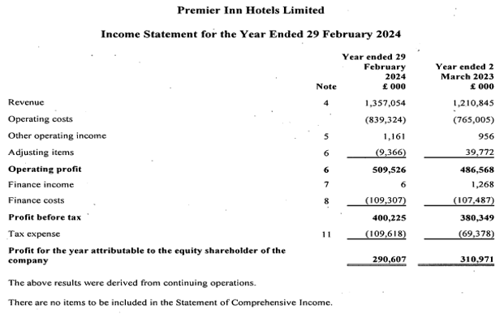  Figure 1: Premier Inn Annual Report  (Source: Premier Inn, 2024a) | Corporate and property expenses, investment and operations.  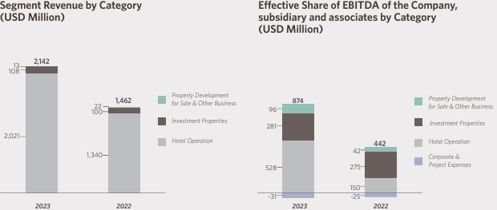  Figure 2: Shangri-La Annual Report  (Source: Shangri-La Asia, 2023)
Source of Revenue | Hotels services, food. | Food and accommodation.
Revenue Trends | 50 per cent increase in total revenue (The Guardian, 2023) | Shangri La witnessed a drop of 28 per cent in its overall revenue (Yuan, 2024)
Factors driving revenue growth or decline | - Brand Awareness  - decrease in budget hotels in the UK | Low brand image in the UK
Table 1: Comparison of Premier Inn and Shangri La
(Source: Self-Developed)

1.2 Analysis
From the above analysis, it has been understood that Premier Inn higher number of hotels when compared to Shangri La. The number of hotels of Premier Inn is noted to be 800 while for 100. The high number of hotels allows Premier Inn to accommodate a higher number of people which increases the prospect of more revenue. This illustrates that in terms of several hotels, Premier Inn has an advantage over Shangri La. According to a report, the brand awareness of Premier Inn in the UK is 93 per cent (Kunst, 2023). While, in a study, a high level of brand awareness has been related to growth in sales and revenue (Irpan and Ruswanti, 2020). Hence, a high brand image can be considered to be a factor in terms of driving revenue for Premier Inn. In contrast Shangri La primarily has a brand image of Asian heritage which can sometimes create difficulties in the generation of revenue in Non-Asian regions such as Europe. This is evident in the drop of 28 per cent in its overall revenue (Yuan, 2024). Hence in terms of brand awareness, Premier Inn can be said to have the upper hand.
According to a report, 10 per cent of the budget hotels in the UK have closed (O’Neill, 2023). This has allowed Premier Inn to enhance its pricing power by 100 per cent. Repeat guests have been noted to form 86 per cent of the overall booking of Premier Inn in 2023. As a result, the decrease in budget hotels in the UK can be deemed as a factor that fosters the revenue of Premier Inn. However, in contrast, Shangri-La is a luxury hotel with a five-star rating (Shangri-La, 2024). This does not align with the current dynamics of the UK as UK customers prefer budget hotels. It is evident, that 39 per cent of customers in the UK prefer budget hotels such as Premier Inn (Statista, 2023). From this, it can be inferred the cause in a drop in the case of Shangri La can be attributed to its expensive hotels due to its luxury features. Hence, there is a contrast between Premier Inn and Shangri-La as Premier Inn is considered a budget hotel while Shangri-La is considered a five-star hotel.

2. Market Position
Investors' concerns are reflected in the share price of Premier Inn owner Whitbread (WHB), which has plummeted by more than 10% since the beginning of the year (Akers, 2024). Given that the group's main company recently achieved record annual earnings and cash flow, as well as an entirely novel approach for its food and drink unit, pessimism may have been exaggerated.
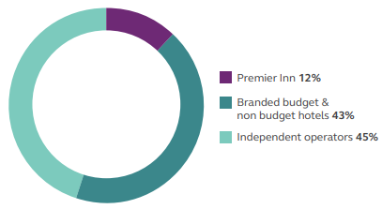
Figure 1: Market Share of Premiere Inn
(Source: Whitbread, 2023)
Premier Inn UK has a 12% market share based on room supply and is stealing business from minor businesses in what remains a favourable climate for big companies (Whitbread, 2023). Revenue share was 8.6% at the end of the year, slightly higher than in FY2023. On the other hand, Shangri-La had a market capitalization of £1.96 billion in October 2024 (Companies Market Cap, 2024). Shangri-La is now the 3890th most valuable business globally in terms of market capitalization.
Shangri-La London may create corporate programs to build partnerships with millions of business travellers that prioritize efficiency and excellence. For Shangri-La London to remain strategically competitive in the premium hotel industry, it must attract global consumers, particularly Chinese and business travellers (Medium, 2017). On the other hand, to better serve its consumers, Premier Inn has recognized two main areas within its target market: travellers with limited budgets and leisure and business visitors (Osum, 2024). Premier Inn has devised tactics to satisfy the specific needs and desires of these categories.
Overall, 53% of UK hotel consumers prefer Premier Inn. However, of the 93% of those in the United Kingdom who know Premier Inn, 57% enjoy the brand (Statista, 2023). Based on this, it has been stated that 37% of hotel clients in the UK say they are inclined to use Premier Inn again. In respect to the brand's 42% use share, this indicates that 88% of its consumers are devoted to the brand. Over the last three months, about 27% of UK hotel clients learned about Premier Inn from the media, online platforms, or marketing. In contrast, Shangri-La London has received 4.5 out of 5 stars on Google and TripAdvisor, as well as a spectacular 9.4 out of 10 on Booking.com (Medium, 2017). Shangri-La London should utilize social media accounts to convey its narrative and establish an established reputation centred on luxury and affluent London experiences.
Considering the above discussion, the following positioning map of the two hotels will be provided:
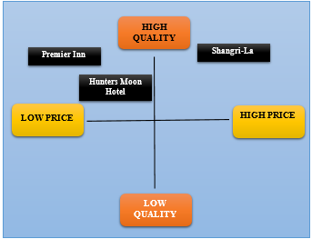
Figure 2: Positioning Map
(Source: Self-developed)
From the above figure, it is illustrated that Premier Inn belongs to the Low Price-High Quality quadrant and Shangri-La belongs to the High Price-High Quality quadrant in the positioning map. This showcases a contrasting brand positioning for the hotel brands in the market as shown in Figure 2.

3. Growth Potential
Expansion strategies
Company | Expansion strategies | Justification
Premier Inn | Premier Inn can opt to expand its operation in the luxury hospitality segment which will allow it to serve more customers. | In a report, upper-midscale and upscale hotels were noted to outperform the market with 21 per cent points (Goldstein, 2023). This showcases that the Luxury Hotel Segment is growing. Premier Inn with its already consolidated brand image can opt to enter the luxury hotel market for expansion.
Shangri La | Shangri La can increase the number of hotels in the UK allowing it to be accessible to more customers | Shangri La can open new hotels in London across various regions which will allow it to access more customers further supporting the prospect of marketing expansion.
Table 2: Comparison of Expansion Strategy of Premier Inn and Shangri-la
(Source: Self Developed)
Market opportunities
According to a report, 73 per cent of travellers have been noted to prefer eco-friendly accommodation (Mintel, 2022). This illustrates a market opportunity for both Premier Inn and Shangri La in terms of enhancing the level of sustainability of their accommodation rooms which aligns with the current market dynamics. This provides a prospect for growth in the hospitality market of the UK for both Shangri La and Premier Inn. On the other hand, it can be identified that 70 per cent of people before buying hotels consider hygiene as an important factor (Obeirne, 2022). This provides an opportunity for Shangri La as well as Premier Inn in terms of promoting and marketing its Hygiene facilities which can attract more customers and foster the growth of its accommodation facilities.
Potential barriers to growth
Premiere Inn Hotel looking to grow into the premium hotel market might encounter many challenges. Luxurious improvements and amenities necessitate a significant cash commitment. The fierce rivalry from established premium companies can make market entrance difficult. In the opinion of Kambur and Yildirim (2023), maintaining great service standards necessitates extensive employee training and recruiting, which may be expensive and time-consuming. Furthermore, economic volatility may influence the consumption of luxury experiences. Regulatory barriers and shifting tourism patterns can also impede growth efforts. Finally, brand positioning and promotional efforts to target rich customers require strategic preparation and large resources, complicating expansion plans.
On the other hand, one key impediment to growing the number of hotels in the UK is the costly nature of land and development (Saner et al. 2019). Poor availability of ideal locations raises prices, rendering it difficult for new hotels to acquire finance and achieve profitability, particularly in competitive metropolitan areas.

4. Financial Commitment to CSR
Premier Inn has given £20 million over five years to support the GOSH Charity Build It (Premiere Inn, 2024b). The Beat It. campaign aims to construct a world-class Children's Cancer Centre at Great Ormond Street Hospital, transforming cancer care and saving lives. The hotel network offers top-tier programs for education and training, making it an ideal location to advance one’s career. The company offers training options, including apprenticeship programs, to help teammates advance their careers, regardless of age or skill level. The hotel chain, which has been growing rapidly in Germany, plans to decrease every single emission, including those from the supply chain (Scope 3), to zero by the fiscal year 2050 (Hospitality Inside, 2023). All Premier Inn hotels in Germany are already powered entirely by energy from renewable sources and supplies; the Group's goal is to transition to green electricity by 2026, if feasible.
On the other hand, Shangri-La is dedicated to running in a financially, socially, and ecologically responsible way to safeguard the environment and support the areas in which it works (Shangri-La Experiences, 2024). The total revenue was USD2,141.8 million for the fiscal year ended December 31, 2023, up 46.5% (or USD679.7 million) from USD1,462.1 million in the fiscal year ended December 31, 2022 (Annual Report, 2023). This showcases an increase in the rise in revenue for Shangri-La. This increases the financial capability of Shangri-La to prioritise its CSR commitments.
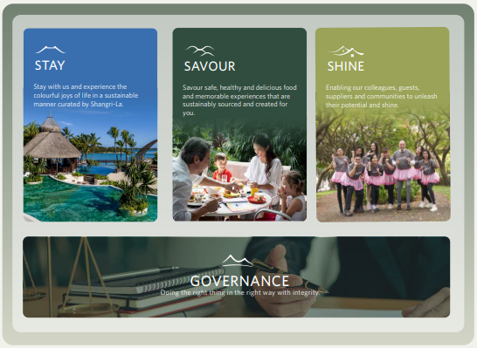
Figure 3: 'Triple S' strategy of Shangri-La
(Source: Shangri-La, 2023)
Shangri-La's 'Triple S' strategy of “Stay, Savour, and Shine” guarantees that sustainability is integrated into all aspects of the company and activities, affecting every stage of the customer's interaction with the hotel (Shangri-La, 2023). The determination to sustainability has been acknowledged and strengthened by the ratification of many “Green Loan and Sustainability Linked Loan” agreements totalling roughly USD 3.9 billion (as of December 31, 2023). Since July 2022, Shangri-La has contributed over USD 30,000 and offered the translation of USD 100,000 in various donations and wish-granting value to Make-A-Wish International, enabling the organization to fulfil 25 wishes to amazing youngsters.

5. Conclusion
In conclusion, it has been found that Premier Inn has an edge over Shangri La. Shangri-La's brand image is predominantly Asian in nature, which can make income generating in non-Asian nations such as Europe challenging at times. Premier Inn might choose to extend its operations in the premium hotel market, allowing it to offer more consumers. In contrast, Shangri-La can grow the number of hotels in the UK, making it more accessible to clients. Based on this aforementioned discussion, it has been stated that Shangri-La and Premiere Inn are committed to operating in a financially, socially, and environmentally responsible manner to protect the environment and help the communities in which they operate. It has been suggested that Premier Inn sell its brand using hygienic standards and activities while converting some of its rooms into luxury suites to provide diversity to its clients. In contrast, Shangri-La can opt to open more hotels in the UK, expanding its market share in the UK hospitality sector.

6. Recommendations
Recommendation to Premier Inn
From the findings of the report, it has been seen that the consumers in the UK have showcased a preference towards luxury hotels. While customers also prefer to stay at hotels with a high level of hygiene. This is evident in the fact that 70 per cent of people give hygiene as a preference in accommodation. In this regard, Premier Inn can market its brand through the use of hygiene standards and activities while opting to transform some of its rooms into luxury suites to offer variety to its customers. This would help the company in expanding its opportunities for growth as well as diversifying the revenues.
Recommendation for Shangri-La
It has been understood that Shangri-La has limited hotels in the UK which also limits its profitability aspects. In this consideration, Shangri-La can choose to operate more hotels in the UK which will assist in increasing its market share available in the UK hospitality sector, thereby offering suitable growth opportunities. Upper mid-scale hotels have been outperforming other hotels and hence Shangri-La has the prospect of increasing their number of hotels in the UK.

Reference List
Akers, C., (2024). It’s time to check in with this hotel leader. Available at: https://www.investorschronicle.co.uk/content/675c9c9b-98a6-5614-a382-cb1f75a13b32#:~:text=Premier%20Inn%20UK%20enjoys%20a,year%20end%2C%20slightly%20above%20FY2023. (Accessed: 28 September 2024)
Annual Report, (2023). Annual Report 2023. Available at: https://sitecore-cd.shangri-la.com/-/media/Project/Shangri-La-Group/Investor/Files/Public-Disclosures/Latest-Top-Publications/2023_Annual_Report_E.pdf (Accessed: 06 October 2024)
Companies Market Cap, (2024). Market capitalization of Shangri-La (0069.HK). Available at: https://companiesmarketcap.com/gbp/shangri-la/marketcap/#:~:text=Market%20cap:%20%C2%A31.96%20Billion,much%20a%20company%20is%20worth. (Accessed: 29 September 2024)
Goldstein, P., (2023). Strong growth in hotel revenues as seasonal demand and high inflation keep profit margins in check. Available at: https://www.knightfrank.com/research/article/2023-08-15-strong-growth-in-hotel-revenues-as-seasonal-demand-and-high-inflation-keep-profit-margins-in-check (Accessed: 03 October 2024)
Hospitality Inside, (2023). Premier Inn: "Force for Good" - more than green energy. Available at: https://hospitalityinside.com/en/Premier-Inn-Force-for-Good-more-than-green-energy (Accessed: 05 October 2024)
Irpan, I. and Ruswanti, E., 2020. Analysis of brand awareness and brand image on brand equity over customer implications to purchase intention at PT. SGMW Motor Indonesia (Wuling, Indonesia). Journal of Multidisciplinary Academic, 4(3), pp.127-134.
Kambur, E. and Yildirim, T., 2023. From traditional to smart human resources management. International Journal of Manpower, 44(3), pp.422-452.
Kunst, A., (2023). Premier Inn brand awareness, usage, popularity, loyalty, and buzz among hotel customers in the UK in 2022. Available at: https://www.statista.com/forecasts/1335699/premier-inn-hotels-brand-profile-in-the-uk#:~:text=How%20high%20is%20the%20brand,and%20the%20written%20brand%20name. (Accessed: 30 September 2024)
Mintel, (2022). UK Sustainability in Travel Market Report 2022. Available at: https://store.mintel.com/report/uk-sustainability-in-travel-market-report-2022#:~:text=28%25%20of%20UK%20adults%20agree,in%20a%20nature%2Dbased%20activity. (Accessed: 29 September 2024)
O’Neill, S., (2023). Premier Inn Expects Boost From Shrinking Independent Hotel Sector. Available at: https://skift.com/2023/10/18/premier-inn-expects-boost-from-shrinking-independent-hotel-sector/#:~:text=Premier%20Inn%20expects%20growth%20due,rise%20year%2Dover%2Dyear (Accessed: 27 September 2024).
Obeirne, S., (2022). Cleanliness top priority for holidaymakers looking to take a ‘safecation’ this summer. Available at: https://chtmag.com/cleanliness-top-priority-for-holidaymakers-looking-to-take-a-safecation-this-summer/ (Accessed: 05 October 2024)
Premier Inn, (2024a). Premier inn hotels limited filing history. Available at: https://find-and-update.company-information.service.gov.uk/company/05137608/filing history/MzQzMDA2NzMwOGFkaXF6a2N4/ (Accessed: 15 October 2024)
Premier Inn, (2024b). About us. Available at: https://www.premierinn.com/gb/en/why.html (Accessed: 26 September 2024)
Premiere Inn, (2024c). We're a Force for Good. Available at: https://www.premierinn.com/gb/en/why/force-for-good.html#:~:text=Over%20the%20next%20five%20years,care%20and%20save%20more%20lives. (Accessed: 28 September 2024)
Ranjan, J. and Foropon, C., 2021. Big data analytics in building the competitive intelligence of organizations. International Journal of Information Management, 56, p.102231.
Saner, R., Yiu, L. and Filadoro, M., 2019. Tourism development in least developed countries: Challenges and opportunities. Sustainable tourism: Breakthroughs in research and practice, pp.94-120.
Shangri-La Asia, (2023). Annual Report 2023. Available at: https://sitecore-cd.shangri-la.com/-/media/Project/Shangri-La-Group/Investor/Files/Public-Disclosures/Latest-Top-Publications/2023_Annual_Report_E.pdf (Accessed: 15 October 2024)
Shangri-La Experiences, (2024). ENVIRONMENTAL AND SOCIAL GOVERNANCE. Available at: https://www.shangrilaexperiences.com/community-and-social-impact (Accessed: 27 September 2024)
Shangri-La, (2023). SUSTAINABILITY REPORT 2023. Available at: https://sitecore-cd.shangri-la.com/-/media/Project/Shangri-La-Group/Sustainability/Images/Sustainability-Report/2023_SustainabilityReport.pdf (Accessed: 28 September 2024)
Shangri-La, (2024a). Welcome to Shangri la./ Available at: https://www.shangri-la.com/group/our-businesses/hotels-and-resorts#:~:text=Shangri%2DLa%20Group%20owns%2C%20operates,78%20destinations%20around%20the%20world. (Accessed: 27 September 2024)
Shangri-La, (2024b). Shangri-La Hotels. Available at: https://www.shangri-la.com/brand/#:~:text=Shangri%2DLa%20Hotels%20are%20five,the%20Middle%20East%2C%20and%20Europe. (Accessed: 27 September 2024)
Statista, (2023). Premier Inn brand awareness, usage, popularity, loyalty, and buzz among hotel customers in the UK in 2022. Available at: https://www.statista.com/forecasts/1335699/premier-inn-hotels-brand-profile-in-the-uk#:~:text=In%20total%2C%2053%25%20of%20UK,the%20UK%20use%20Premier%20Inn. (Accessed: 30 September 2024)
Statista, (2023). Which one of the following budget hotels would you prefer to stay in?. Available at: https://www.statista.com/statistics/688457/budget-hotel-chains-preference-in-the-united-kingdom-uk/ (Accessed: 27 September 2024)
The Guardian, (2023). Premier-inn-whitbread-pre-covid-profits-deals. Available at: https://www.theguardian.com/business/2023/apr/25/premier-inn-whitbread-pre-covid-profits-deals (Accessed: 26 September 2024)
Whitbread, (2023). The Economic Impact of Premier Inn Hotels. Available at: https://cdn.whitbread.co.uk/media/2023/08/The-Economic-Impact-of-Premier-Inn-hotels_2022-study_final.pdf (Accessed: 28 September 2024)
Yuan, Y., (2024). Shangri-La Asia posts 28.1% fall in H1 net profit on higher operating costs. Available at: https://www.businesstimes.com.sg/companies-markets/shangri-la-asia-posts-28-1-fall-h1-net-profit-higher-operating-costs (Accessed: 26 September 2024)

Bibliography
- Osum, (2024). Premier Inns Target Market Revealed. Available at: https://blog.osum.com/premier-inn-target-market/ (Accessed: 30 September 2024)
- Medium, (2017). Marketing Strategy for Shangri-La Hotel at The Shard London. Available at: https://medium.com/@xm335/business-marketing-plan-for-shangri-la-hotel-at-the-shard-london-10007f53afb4#:~:text=2.-,Target%20Global%20Customers,especially%20Chinese%20and%20business%20visitors. (Accessed: 30 September 2024)

