

MSc Software Engineering (Web Development)
Web Services
Project Proposal
M7X01702
JavaScript front-end frameworks for alcohol detection and drug misuse investigation
James Robert Tudor Jones
P138563

Contents
ABSTRACT 2
1.0 Introduction 2
2.0 Background to the Proposed Research 3
2.1 JavaScript Front-end Frameworks 3
2.11 React 4
2.12 Angular 5
2.13 Vue.JS 6
2.14 JavaScript Front-end Frameworks Conclusion 6
2.2 Alcohol and drugs and its effects in the UK 7
3.0 Aims & objectives 7
3.1 Aims 7
3.2 objectives 8
4.0 Research methods 8
4.1 Philosophy 9
4.2 Approach 9
4.3 Strategies 10
4.31 Experiment 10
4.32 software development 11
4.33 document review 12
4.4 Time Horizons 12
4.5 Data Evaluation 13
5.0 Risks and limitations 13
6.0 Resources & Planning 14
6.1 Resources Required 14
6.2 Gantt chart 14
7.0 Reference List 15

ABSTRACT
The aim of this project is to develop and investigate different frontend frameworks and compare on how they can improve or impair an application system, further data will be collected for alcohol and drug misuse purposes to be integrated with a web service application to have a prototype product that will display the data to measure and display through a backend, frontend and database system.

1.0 Introduction
The main title for the proposed project will detail as a JavaScript front-end frameworks for alcohol detection and drug misuse investigation which will aim to give informant data for DVLA educational purposes. The proposed project will be to research different JavaScript front-end frameworks, The Investigated frameworks will compare everyday frameworks used today at the DVLA and will also investigate other new technologies to be used. JavaScript is used widely for front-end development and there are many types of frameworks in place to access useful features, a taste of these features include animated graphics, interactive forms and slideshows. For years the core of making a useable, user interface would always be to use Html, CSS and JavaScript it is very easy with tools of today to make what once used to be seen as being very complex and with the use of JQuery an applications could be created, but with only using these limited languages being mentioned, they can be further enhanced with the use of frameworks such as React and angular as an example. Frameworks can open up a variety of features to create flawless front-end applications. The project will investigate why, how and what front-end frameworks are mainly used for. Further questions that can be investigated can be to hypothesise if they are needed, do they work and how different types compare. Further to the proposed project an investigation into alcohol detection and drug misuse will be researched to try and achieve information for DVLA records, an investigation on how the DVLA would use the data for statistics that could result in change of law or to enforce dangers for DVLA purposes. The project will result in a product that will gather important data and be displayed on an application with a designed front-end, backend and database. The Data will be analysed and evaluated along with having a prototype designed application to display the conclusive results.

2.0 Background to the Proposed Research
The background research that will be investigated can be broken down into sections different JavaScript front end frame-works will be inspected, alcohol and driving will be inspected along with drug misuse.

2.1 JavaScript Front-end Frameworks
There are many Front-end JavaScript frameworks that have become available for developers over the years which include:-

- Angular
- React
- Vue.js
- Ember.js
- Meteor
- Mithril
- Node.js
- Polymer
- Aurelia
- Backbone.js
The top three listed as Angular, React and Vue.JS are the most commonly used front-end Frameworks that most developers are drawn to because of the success rate and easy to use styles. React is used within the DVLA organisation.
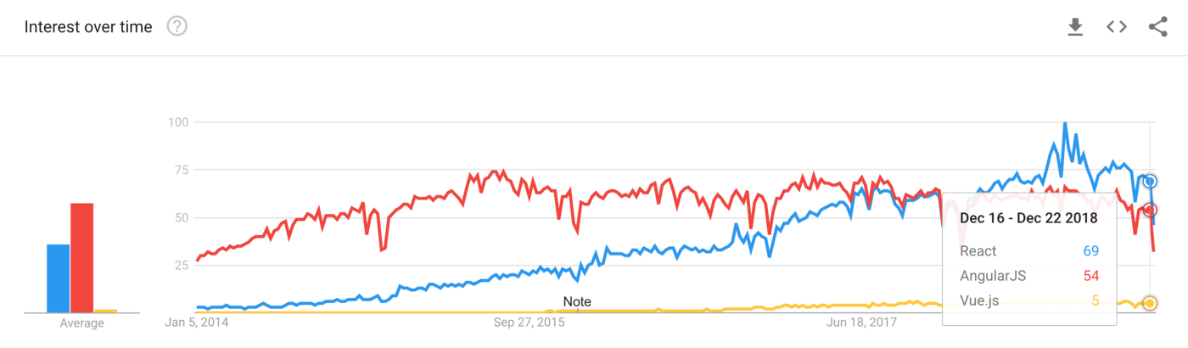

[1]
Figure 1: JavaScript Front-End Frameworks Google Statistics Usage

2.11 React


[2]
Figure 2: React.Js Logo
React.JS was created by Facebook which the new user interface created to give a fast, modular, and scalable frontend application using JavaScript. Artemij.F explains ‘Meet React.js – a JavaScript user interface library developed by Facebook. It brings profound ideas on how to work with the DOM, organize your application’s data flow, and think about user interface elements as individual components. And yet, it’s only a user interface library that makes no assumptions about the rest of your technology stack’[3] React.Js claims that their framework makes it easy and painless to create an interactive user interface. The system can be designed to have simplistic views for each state on an application, with the enhancements of updating and rendering the correct components when there is any change in data efficiently, this gives an easier debugging for the application O’Reilly explains ‘As you know now, your components worry about their state and let React render and rerender whenever appropriate. This means that given the same data (state and properties), the application will look exactly the same, no matter what changed before or after this particular data state. This gives you a great debugging-in-the-wild opportunity.’[4] The use of React can be a very good front-end developer’s tool that can create a nice stable front end with enhanced features.

2.12 Angular


[5]
Figure 3: Angular Logo

Angular being another popular JavaScript front-end framework is another system which was created as a side project in 2009. The developers who made it are Misko Hevery and Adam Abrons. Green.B, Sheshadri.S explained ‘I can trace Angular’s beginnings to 2009, on a project called Google Feedback. We’d gone through months of frustration with our development speed and ability to write testable code. At around the six months mark, we had around 17,000 lines of front-end code. At that point, one of the team members, Misko Hevery, made a bold statement that he’d be able to rewrite the whole thing in two weeks using an open source library that he’d created as a hobby’[6] it was later proved that there was a slight misjudgement and it actually took three weeks which was still and outstanding outcome. Looking at simple html is adequate for declaring documents at a static level but can falter when declaring dynamic type views within web-applications, with the use of AngularJS the html can be extended. Angular claims ‘AngularJS lets you extend HTML vocabulary for your application. The resulting environment is extraordinarily expressive, readable, and quick to develop.’[7] Angular JS is very good with working with other libraries and can be easily modified to suit what environment it is to be worked in.

2.13 Vue.JS


[8]
Figure 4: Vue.JS Logo

Vue.JS can be viewed as the latest JavaScript framework in comparison to the previous two. The first version of Vue.JS was written back in 2014 by Evan You who previously worked for google. Macrae.C explains ‘Evan You, then working at Google, wrote and released the first version of Vue.js in early 2014. At the time of writing, it has over 75,000 stars on GitHub, making it the eight most starred repository on GitHub, and that number is growing rapidly. Vue has hundreds of collaborators and is downloaded from npm about 40,000 times every day.’[9] Developer have access to greater features when using this framework to develop applications and websites, Vue claims to have a powerful faster approach to front-end work along with being a versatile and a high performance system.

2.14 JavaScript Front-end Frameworks Conclusion
Front-end development has been changing to create, enhanced interactive views, with this change there has been more complex front-end development. For many years JQuery has been dealing with front-end features but as more changes have been implement to session management, interactive sections, updating large pages frameworks have helped to manage this. Macrae.C mentions ‘Frontend development is changing. Websites are becoming richer and more interactive, requiring us as frontend developers to add increasingly complicated functionality and use more powerful tools. It’s easy enough to update a bit of text on a page by using JQuery, but as we need to do more-updating large , interactive sections of a page; handling complicated state; performing client-side routing; and simply writing and organising a lot more code-using a JavaScript framework makes out jobs a lot easier.’[9] Therefore it certainly concludes that frameworks have been proven to work effectively with frontend use, but which one of the wide variety will be the best to use and why?

2.2 Alcohol and drugs and its effects in the UK
Drink and drug driving has big implications within the UK the main factors that affect everyone are:-

- Drink Driving is deadly and killed over 9,000 people in 2016.
- Drivers at the age of 20 have the highest rates of drink and drug misuse while driving.
- 3-6 Months imprisonment.
- A minimum of 12 month driving ban.
- An unlimited Fine.
- A criminal record.
- Car insurance premium increase.
- Losing a job.
- Loss of independence.
- Having a criminal record can give difficulty to travel to countries such as the USA.[10]
From inspecting the main factors of drink or drug driving it is evident that it can have a huge effect on the person who commits the crime, implications that could change any person’s life and have years of impact afterwards. It also effects not just the person who commits the crime but also family, friends and also the victim’s family and friends.

3.0 Aims & objectives

3.1 Aims

- Critically evaluate Frontend Frameworks.
- Implement Frontend frameworks and give conclusive outcomes in comparison with each other.
- Identify frontend frameworks giving information on how they can improve or de-improve a frontend system.
- Critically evaluate drink and drug driving statistics.
- Create an application frontend, backend and database system that gathers raw data to evaluate from hardware.
- Create statistics with data for DVLA educational purposes

3.2 objectives

- Research different types of frontend frameworks, why they were designed, pros and cons of the systems, what do they work with well considering languages, basics, controls, components features (simple and stateful), navigation forms, testability, external plugins.
- Create a Frontend, backend and database application with the implementation of JavaScript frameworks and investigate and test the results and responses.
- Investigate impacts of drink and drug driving , research statistic, investigate drink and drugs impact in blood and breath, investigate the effects of ongoing drinking and drug misuse, drugs mixed with alcohol, medication with smaller amounts and NHS health systems.
- A product that measures alcohol produces data and is able to be gathered into an application to give a view of the data in an appropriate language.

4.0 Research methods
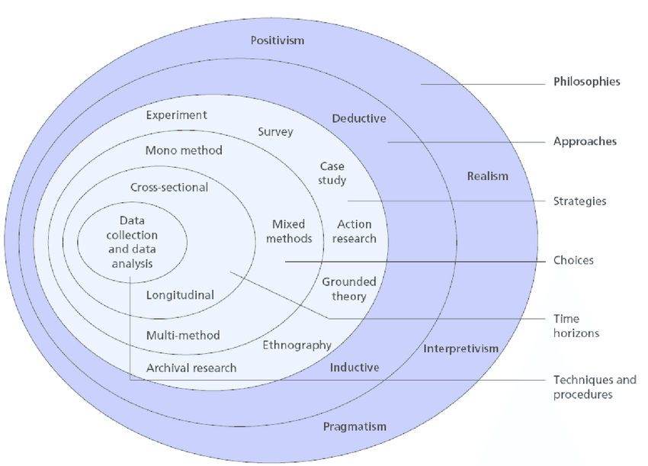
There are many types of research methodologies that can be implemented and used and within those methodologies a route can be taken to give a solid type of research method, this section will explain the type of philosophy, the given approach and the strategies that are going to be undertaken for the overall project.

[11]
Figure 5: Research onion

Fig 5 illustrates the research onion by investigating it the different layers can be broken down into philosophies, approaches, strategies, choices, time horizons, and the core being the data collection and data analysis. Although there are many parts to the layers certain parts will be chosen for this project.

4.1 Philosophy
For the philosophy layer, positivism will be chosen for this research project. Positivism is taking research and viewing it as the truth and involves justified scientific experiment research. Research-methodolgy.net explains ‘as a philosophy, positivism adheres to the view that only “factual” knowledge gained through observation (the senses), including measurement, is trustworthy. In positivism studies the role of the researcher is limited to data collection and interpretation in an objective way. In these types of studies research findings are usually observable and quantifiable.’[12] This type of the investigation is based on conclusive evidence and hard facts, although the research can be excellent, there are arguments that perceptions can be influenced with this sort of the research. Wilson.J informs ‘if you assume a positivist approach to your study, then it is your belief that you are independent of your research and your research can be purely objective. Independent means that you maintain minimal interaction with your research participants when carrying out your research.’[13] The research should aim to predict and explain, there should be no differences in logic. Although this philosophy will be used it had to be investigated where positivism relies on valid knowledge and good experience.

4.2 Approach
The approach being used for the given project will be a deductive approach. The deductive approach concerns a development which had a hypotheses based on existing theories, further to this a research strategy will test the hypothesis. Gulati.PM states ‘deductive means reasoning from the particular to the general. If a causal relationship or link seems to be implied by a particular theory or case example, it might be true in many cases. A deductive design might test to see if this relationship or link did obtain on more general circumstances’[14] The deductive approach for this project will be to prove a null hypotheses where none of the Frontend frameworks work better than the other or the hypothesis to prove one is better than the other. The advantages of using the deductive approach is that the relationship between concepts and variables can be casually explained, this approach can give generalised research finding to a certain amount. The deductive approach is good for a short time projects and with the given timeframe aligns with this project, risk can be avoided and an abundance of research is available.
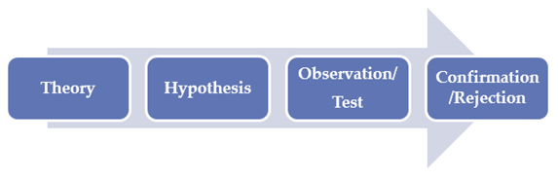

[15]
Figure 6: Deductive Approach Steps

Fig 6 illustrates a simple guide of how a deductive approach can be taken out firstly by creating a hypothesis through theory, one the theory is clarified a hypothesis can be made between a relation of two variables. The results of the hypothesis can then be tested with relevant methods such as mean, mode, median, correlation and regression etc. Then with analysing the results the outcome of the hypothesis can be confirmed or rejected at this point the hypothesis can be modified if needed. Therefore to be conclusive the deductive approach will be the preferred approach for this project.

4.3 Strategies
The strategy layer can vary and the topics depend on the type of project. This project will have three parts chosen which will include experiment, Software Development and document review these three sections can be investigated.

4.31 Experiment
An experiment strategy will be undertaken for this project. This strategy with a scientific approach will be to research and manipulate one or more variables. It will be used to control and measure any change. The aim is for the experiment method to explain the nature of the system Nunamaker.JF, Minder.C, Titus.P states ‘Use of this methodology in the engineering field in general is compared with its use specifically in computer science and computer engineering. An integrated program for conducting is research that incorporates theory building, systems development, experimentation, and observation is proposed’[16] The advantage of using this strategy is to be able to control have control of the given variables and gain insight into the instruction. Due to the type of research it enables intuitiveness and work alongside other research methods. There can be the risk of human error with this strategy along with a production of artificial results, there can also be the possibility of gaining a result which cannot be replicated. The experiment is the suited directive strategy for this project.

4.32 software development
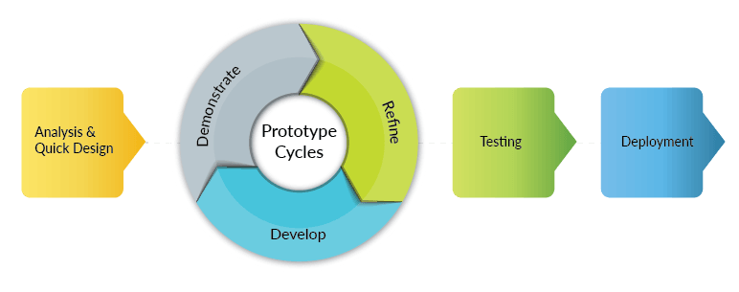
The Software development strategy that will be used for this project will be a Rapid Application Development (RAD), rather than using a traditional method such as waterfall and kind of following this strategy when looking at the Gantt chart further on, a RAD approach will allow a fast approach to building a prototype with an end delivery, Wavemaker states ‘As you would expect, RAD produced results quickly using tools that generated the application code from a high-level description or definition (in other words ‘software design specification’).’[17] Due to the time constraints within the given project to be taken over a period of 11 months, the RAD approach was chosen because of the fast delivery it can produce.

[18]
Figure 7: RAD Block Diagram
Inspecting Fig7 gives a quick example of the strategy steps with a starting point of analysis and quick design this will consider data analysis and a base code to create a prototype when hitting the prototype circle then this section can be refined and developed along with demonstrated and repeated to make a prototype to reach the minimal viable product, further to having a prototype up to the standard needed then testing will be undertaken to make sure the product stays within a range of tests that will investigated throughout the project, when Testing is complete and passed then the deployment can be undertaken. The approach comes with the benefits of ease of timescale and shorter time to market but there are a few disadvantage where speed of development could cause a poorly designed project and the need of more experienced staff and strong project management is needed if creating a big project. Due to the limitation of only one person creating this project the RAD approach will be an ideal software development strategy.

4.33 document review
The final strategy that will be investigated is the document review process. The document review will give a sound basis of what will be expected to achieve within the given project. The main points to consider will include:-
- What will be the end-Game? This includes due date, specification, costs, technicalities, complications etc. With all of these in mind the timescale should have enough breathing space to allow for problems.
- Create simple document that has an automated process, this will give a smarted strategic approach rather than creating an out of scope hard document to follow.
- The Document review should clearly state out the roles and responsibilities this may include schedules, flow of work, consistency etc.
- To make decisions clear, not to forget the main objective, manage costs, and to think about the future of the project which may be future improvements that will be made in a next generation of a project.
Document reviews can be a very handy and precise way of making sure a project runs smoothly MB.Daniels explains ‘Most litigation comes with the burden of document review. While not the sexiest of topics, document review is critical. When it goes wrong, it can be costly and embarrassing.’[19] Without a document review put in place could be very costly for a project or organisation and must be taken with the upmost respect within a business due to implications that could occur if not reviews correctly. This last strategy will be suited for the given proposed project.

4.4 Time Horizons
There are generally two types of time horizons as seen in the research onion being longitudinal and cross-sectional. A longitudinal study is evident meaning a prolonged kind of research which can be taken over the course of many years, techtarget.com proves ‘A longitudinal study is an observational research method in which data is gathered for the same subjects repeatedly over a period of time. Longitudinal research projects can extend over years or even decades.’[20]. The aim is to research the dynamics of the problem. Where Cross-sectional research is typically used where there would be time constraints and resources; any data is collected once, over a short period before being analysed and interpreted. Alan Bryman explains ‘Normally, different organizations or groups of people are selected and a study conducted to ascertain how factors differ. So it means, collecting data on more than one case at a single point of time.’ [21] Meaning this type of timed study take a snapshot of an ongoing situation. Therefore a longitudinal approach will be better suited for this project.

4.5 Data Evaluation
Looking at data evaluation one of two approached will be chosen, reference.com explains ‘Primary data is original research that is obtained through first-hand investigation, while secondary data is research that is widely available and obtained from another party. Primary data includes information collected from interviews, experiments, surveys, questionnaires, focus groups and measurements. Secondary data can be found in publications, journals and newspapers.’ [22] Primary data can be gathered by the use of questionnaires, surveys, interview, tests and market research this can be very time consuming especially with the design of this project. Secondary information can be collected from other people’s research and finding although this can save much time and effort the information cannot always be trusted and should be chosen with great care and by registered trusted sources although this type of data evaluation will be used for this project.

5.0 Risks and limitations
Within a given project risks and limitations must be adhered to. The main risks that apply while working with this project include:-
- Personal information
- Cost
- Group resources
- Lack of data
- Insufficient analysis
- Time constraint
- Control limits
- Software limitations
Although looking at the major points above there are benefits from the risks and limitations due to the lack of resources and time constraints the project is not an overall finished product but more a research project which can clearly be improved upon, if there was more time and a team working on this single driven research project there could be a potential of a successive product that can highly improve the outcome and results of the extensive core meaning of the project.

6.0 Resources & Planning

6.1 Resources Required
Resources used to successfully build and produce the project will include:-
- PC/Laptop – used for building and documented the project.
- Microsoft Word – Word Processer used to document project.
- Microsoft Excel – Used for mathematics, statistics and Gantt chart.
- IntelliJ – Backend coding IDE which will incorporate java and JavaScript.
- PostgreSQL – database to gather data and to be able to communicate with frontend.
- Research – online library, library books, journals and articles.
- DVLA – Workplace department advisories.

6.2 Gantt chart
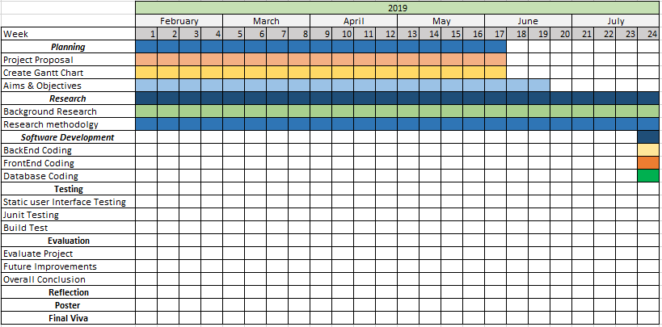
Figure 8: Gantt chart Part 1

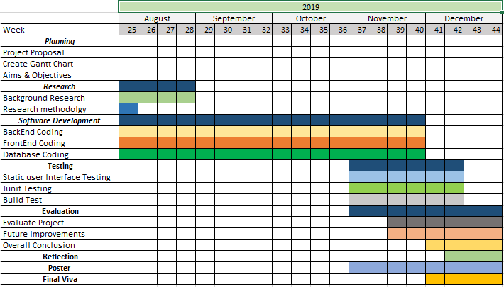
Figure 9: Gantt chart Part 2

7.0 Reference List
[1] “Top JavaScript Frameworks and Topics to Learn in 2019.” [Online]. Available: https://medium.com/javascript-scene/top-javascript-frameworks-and-topics-to-learn-in-2019-b4142f38df20. [Accessed: 30-May-2019].
[2] “React — Worldvectorlogo.” [Online]. Available: https://worldvectorlogo.com/logo/react. [Accessed: 30-May-2019].
[3] A. Fedosejev, React.js Essentials. Packt Publishing, 2015.
[4] S. Stefanov, React: Up & Running: Building Web Applications. O’Reilly Media, 2016.
[5] “Angular - PRESS KIT.” [Online]. Available: https://angular.io/presskit. [Accessed: 30-May-2019].
[6] B. Green and S. Seshadri, AngularJS. O’Reilly Media, 2013.
[7] “AngularJS — Superheroic JavaScript MVW Framework.” [Online]. Available: https://angularjs.org/. [Accessed: 30-May-2019].
[8] “Vue.js.” [Online]. Available: https://vuejs.org/. [Accessed: 31-May-2019].
[9] C. Macrae, Vue.js: Up and Running: Building Accessible and Performant Web Apps. O’Reilly Media, 2018.
[10] “7 Cold Hard Facts About Drink Driving | insurethebox.” [Online]. Available: https://www.insurethebox.com/dangers-of-drink-driving/. [Accessed: 31-May-2019].
[11] “Research process &quot; onion &quot; | Download Scientific Diagram.” [Online]. Available: https://www.researchgate.net/figure/Research-process-onion_fig1_275251741. [Accessed: 31-May-2019].
[12] “Positivism - Research Methodology.” [Online]. Available: http://research-methodology.net/research-philosophy/positivism/. [Accessed: 14-Mar-2017].
[13] J. Wilson, Essentials of Business Research: A Guide to Doing Your Research Project. SAGE Publications, 2010.
[14] P. M. Gulati, Research Management: Fundamental & Applied Research. Global India Publications Pvt. Limited, 2009.
[15] “Deductive Approach (Deductive Reasoning) - Research-Methodology.” [Online]. Available: https://research-methodology.net/research-methodology/research-approach/deductive-approach-2/. [Accessed: 31-May-2019].
[16] J. F. N. Jr., M. Chen, and T. D. M. Purdin, “Systems Development in Information Systems Research,” J. Manag. Inf. Syst., vol. 7, no. 3, pp. 89–106, 1990.
[17] “The Rapid Application Delivery (RAD) Reality – WaveMaker.” [Online]. Available: https://www.wavemaker.com/the-rapid-application-delivery-rad-reality/. [Accessed: 07-Jun-2019].
[18] “Rapid Application Development Model – WaveMaker.” [Online]. Available: https://www.wavemaker.com/rapid-application-development-model/. [Accessed: 07-Jun-2019].
[19] M. B. Daniels and K. & Spalding, “Six Tips for Managing a Document Review Team,” 2018.
[20] “What is longitudinal study? - Definition from WhatIs.com.” [Online]. Available: http://whatis.techtarget.com/definition/longitudinal-study. [Accessed: 21-Mar-2017].
[21] A. Bryman, “Barriers to Integrating Quantitative and Qualitative Research,” J. Mix. Methods Res., vol. 1, no. 10, 2007.
[22] “What is primary and secondary data? | Reference.com.” [Online]. Available: https://www.reference.com/education/primary-secondary-data-5e4a8333252bf73b. [Accessed: 22-Mar-2017].

