  Component One: Student Journal (learning log) 750 words +/- 10%  Contribution to Overall Module Assessment: 25% | Student No: | 2227451
 | Module Title: | Hotel Administration &Front Office Operations
 | Module Code: | BMIH4004
 | Lecturer: | Muhammad Cassamo
Identify key skills required to work within the hotel front office
There are several skills needed to be effective in the hotel front office and to provide outstanding customer service in daily operations. There are five key skills essential for success in this role:
1. Communication Skills: Verbal and written communication is paramount in the front office. The front desk staffs interact daily with guests, workmates, and management (Shin, et. al., 2019). Friendly and clear communication ensures the satisfaction of guests and effectively solves problems.
2. Customer Service: The front office is responsible for providing exceptional customer service. Employees have to be responsive, caring, and resilient; they must respond to guest needs promptly and with the professionalism required. Exceptional service means always exceeding the guest’s expectations, which is one of the critical elements to deliver.
3. Organisational Skills: These include handling check-ins, check-outs, reservations, and guest inquiries all at once (Salem, et. al., 2020). The tasks require strong organisational skills to be managed to be kept in a working place.
4. Problem-Solving Abilities: Every day, hotel front office staff face such challenges as dealing with guest complaints and booking problems. To address these issues in time, and provide guest satisfaction, one must have problem-solving skills. The ability to think fast and make the right choice is paramount.
5. Technical Proficiency: Most hotels employ PMS or other software to handle reservations and guest information. In addition to basic computer skills, employees must know how to use these systems. With this proficiency, front-office employees can accurately process check-ins, check-outs, and payments.
Besides the core skills, a warm personality, patience, and the ability to function effectively under pressure are important skills (Filimonau and Magklaropoulou, 2020). First and last point of contact for guests, hotel front office employees play an important role in shaping the guest experience at a property.
Using your chosen model of reflective practice, reflect on your own skills, experience and link to theoretical principles along with industry examples of the key skills identified
When I compare my skills and experiences with Kolb’s Learning Cycle (1984) of reflective practice, I discover my journey is in line with the theoretical principles of experiential learning. Using my experience at Hotel Ibis as an example, the four stages of Kolb’s cycle- Concrete Experience, Reflective Observation, Abstract Conceptualization, and Active Experimentation have contributed to my professional development.
Concrete Experience: At Hotel Ibis, I managed the front office. I interacted with guests mainly based on theoretical knowledge and had very little practical experience (Satpute and Venkatraman, 2021). Nevertheless, everyday contact with the guests provided me with numerous incidents and challenges which deepened my practical knowledge. These were concrete experiences in dealing with different guest needs and concerns.
Reflective Observation: After working at Hotel Ibis, I started to see some tendencies in guests’ behaviour and preferences and could recognize them in my experiences. For instance, I noticed that guests often enjoyed a warm welcome and personalized welcome. They were keen on quick solutions and liked clear communication. My evaluation of the situation prompted me to critically reflect on my practice to enhance service delivery.
Abstract Conceptualisation: I continued to reflect further and understood better the key principles of excellent customer service. I realized that basic communication and problem-solving skills were necessary. This stage entailed the use of prior theoretical knowledge to identify relevant concepts in the field of hospitality management. I looked at the literature on customer service, management, and communication to inform my practice.
Active Experimentation: By developing a sense of customer service principles, I began implementing trial and error in my job. I developed more personalized greetings, refined our reservation management system, and set in place a feedback mechanism for guest feedback. The initiatives were designed to improve the guest experience and improve some key skills of the front office.
I believe that Kolb’s Learning Cycle can be directly related to my role development in this journey. Practical experience, reflection, connection with theoretical knowledge, and application was the cycle that showed its value in becoming a better teacher. This spiral enabled me to hone my skills in oral communication, customer service, and problem-solving.

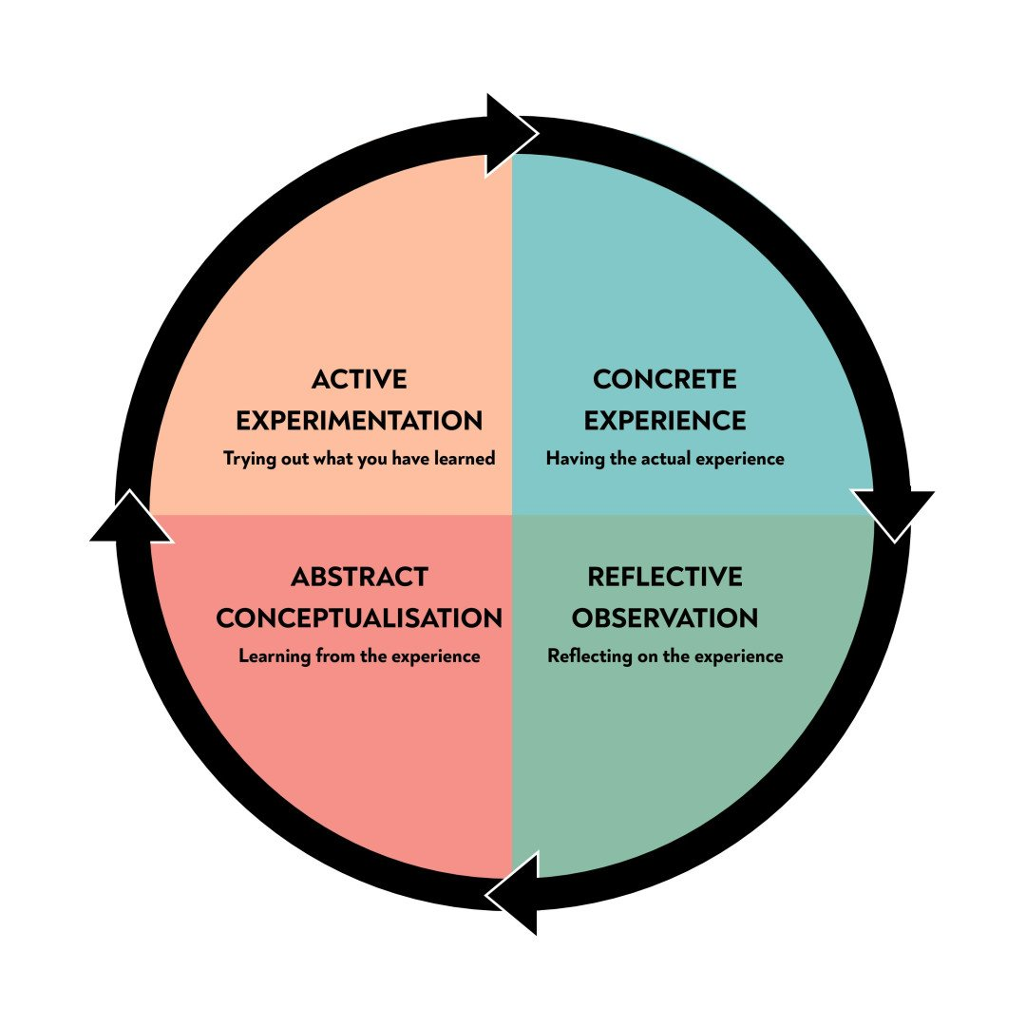
Source: (Khuadthong and Kasim, 2020)
In addition, the experience at Hotel Ibis further emphasises the relevance of these skills within the hotel’s front office (Khuadthong and Kasim, 2020). A guest should always feel valued through effective communication while customer service excellence is a sign of a memorable stay.

Component Two
Contribution to Overall Module Assessment: 25%
Trip Advisor Review Response 150 words +/-10%
Trip Advisor review
Responses to the customer
Dear Pauline,
It is great to know that you had a wonderful time here with us. We greatly appreciate your kind words about our team members. Your words encourage us to keep delivering excellent service.
In this regard, we also would like to thank you for mentioning our breakfast, knowing the meaning of the beginning of the day with a good meal.
Thank you for appreciating the beautiful sights of the city that we are so lucky to have.
We are excited to see you again soon.
Best wishes,
From: Guest Relations Manager

Screen shot of referenced Trip Advisor review used:
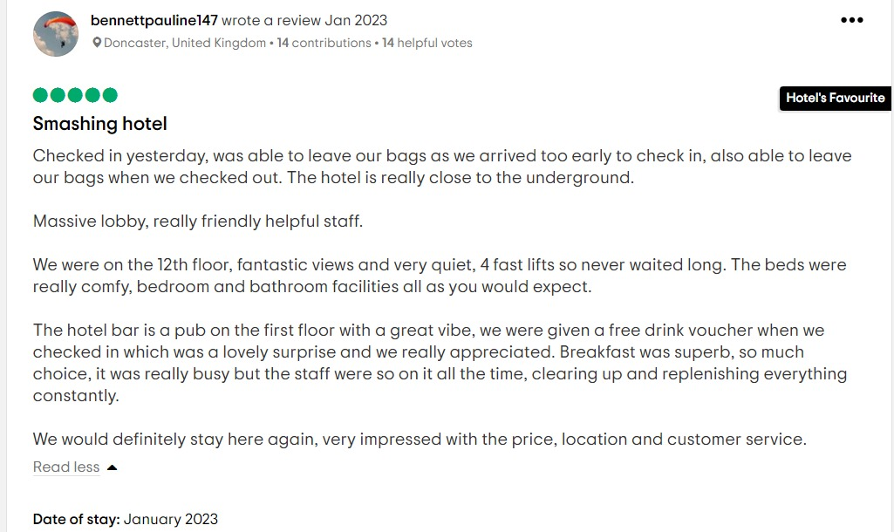
Letter of complaint response
Letter of complaint
Dear Mr. Ronald Federick,
I am penning down this letter hoping to reach you well. I also want to apologize for the sorry experience you had during your last stay in our hotel. Thank you for the opportunity to respond and for the helpful feedback.
I will begin by addressing your concerns about the breakfast quality, noise disturbance, and room cleanliness in room 205. I am sorry for the shortcomings that you experienced. Your experience with us is not what we strive to provide; as I assure you, we give great importance to your complaints.
Indeed, I understand the need to begin my day with a nice warm meal. On this matter, we have talked to our kitchen staff not to overlook the issue of temperature at breakfast time to avoid inconveniencing our visitors. This has forced us to reconsider our food service procedures so that such issues do not occur in the future. Furthermore, my apologies for the disturbance caused by the crying baby in the next room in your sleep. We are currently looking for ways of improving sound insulation in our rooms to minimize disturbances. We are focused on providing you comfort and tranquillity and we strive to improve in this area.
I also apologize that you had to experience such problems; the cleanliness of our rooms is a non-negotiable aspect. Our housekeeping team is currently undergoing further training to ensure all rooms are kept in a state of cleanliness. We appreciate your comments and they are reminders of the need to keep our guests in a clean environment.
To demonstrate our willingness to consider your concerns and win back your trust, I would like to make you an offer for your next stay with us. I will make sure that you will enjoy your stay in the hotel; by upgrading your room to the best one available and giving you a big discount on accommodation. Rest assured, please contact our reservations team with your plans for the next stay.
I am once again sorry for causing you inconvenience. Your input is important to us as we journey towards improvement, and I assure you that we have taken the necessary measures to ensure the recurrence of such problems.
Mr.Federick, thank you for pointing out these concerns. Thank you for your patronage and we look forward to your return for an improved stay. If you have any questions about a future booking, please feel free to email us.
Yours Sincerely,
Your Name
Guest Relation Manager
Hotel IBIS
Hotel Contact Information

Component Three:
Contribution to Overall Module Assessment: 50%(1000 words +/- 10%)
Element 1 – Pre-Arrival

In the present, pre-arrival management is critical to hospitality management, as it prepares the hotel to offer a comfortable, enjoyable, and pleasant stay to the guests. Relevant and current literature highlights several key elements essential for effective pre-arrival management are Reservation and Booking Management in the first step is managing reservations and bookings effectively. This would involve the use of a PMS for managing room availability, rates as well and guest preferences (Satpute and Venkatraman, 2021). The latest literature underlines the value of real-time inventory management and rate optimisation through technology. Guest Data Collection and Analysis in pre-arrival management entails collecting guest data, preferences, and special requirements. The recent research identifies data analytics and guest profiling as important features for personalizing guests’ experiences, for instance, offering tailor-made room upgrades and other amenities based on their specific preferences. Communication and Guest Engagement during the pre-arrival phase, effective communication is very important. Such studies emphasise automated confirmations, pre-arrival emails, and mobile apps that update customers on their forthcoming vacation. Creating pre-arrival engagement with guests generates excitement and gratification. Guest Security and Privacy in recent literature has shown that there is a great need for the implementation of stronger data protection measures to address data security and privacy concerns (Khuadthong and Kasim, 2020). Hotels are obliged to follow data protection rules and handle the personal data of guests with utmost care. Therefore, pre-arrival management is a complex process that includes reservations, data analysis, communication, security, and guest feedback (Hammer, 2019). Recent literature highlights that optimising this phase for enhancing guest satisfaction and loyalty is critical using technology and data-driven approaches.
Element 2 – Arrival
In the hospitality industry, the arrival phase should be effectively managed to ensure a seamless and memorable guest experience. Current literature emphasises several key elements required for successful arrival management that are Check-in Efficiency in Check-in is something that has to be made easy. Modern literature indicates that technologies such as mobile check-in and keyless entry systems should be used to reduce waiting times and make stay more enjoyable (Breznik, et. al., 2022). This is in line with the increasing trend of contactless experiences, especially in the era of COVID-19. In Personalized Greetings in Individual guest experience is another main aspect. The research emphasises the value of personalized greetings of the staff, providing welcome amenities with a guest’s note, and teaching front-line employees to address a guest personally. In Accessibility and Inclusivity in Literature has emphasised the need for accessibility and inclusivity. Hotels must ensure that they cater to different needs, including accommodations for the disabled (Okeke and Iwara, 2020). A welcoming arrival experience depends on inclusive practices, such as multilingual staff and clear signage. In summary, arrival management entails various aspects, which include efficient check-in procedures, personalization, accessibility, safety, engagement, and revenue optimisation (Renaud, 2020). Hotels must stay in touch with the present literature and trends to adapt quickly to the changing needs of guests and thus ensure a smooth arrival and the guest’s satisfaction for the long term.
Element 3 –Duration of stay

Managing the guest’s duration of stay in a hotel is a critical element of hospitality that can significantly influence the overall guest experience. Current literature highlights several key elements necessary for effective duration of stay management those are Service Consistency in Consistent quality service is imperative throughout a guest’s stay. Staff training is highlighted in contemporary literature to be the key to maintaining high service standards at guest checking to departure (O’Bree, 2020). In Guest Engagement in this requires interacting actively with the guests while they are in the house. Research proves that technology, such as mobile apps or in-room tablets, is essential for guests to ask for services, book, and receive information. This enhances convenience and personalization. In Personalized Experiences in the main theme revolves around tailoring the guest experience to individual preferences. With this in mind, contemporary literature focuses on the use of guest profiles and data analytics that allow personalized amenities and room preferences, to offer dining recommendations and thus increase customer satisfaction and loyalty (Lynch, et. al., 2020). In summary, keeping the guest duration of stay involves maintaining service consistency, interacting with guests, offering personalized experiences, presenting diverse amenities, responding to feedback actively, and adopting sustainable practices. For hotels to remain relevant in the dynamic industry, it is essential to be up to date with the current trends and research in the industry (Skačkauskienė and Vestertė, 2019).
Element 4 –Departure

The last step of managing guests is vital in the hospitality industry since it is the end of the stay where an impression of a guest’s experience. Relevant and current literature highlights several key elements required for effective departure management that are Check-Out Efficiency are this is the basic principle of streamlining the check-out process. According to the latest literature, the utilization of technology such as mobile check-out options is crucial to minimize waiting time and enhance the overall guest experience (Vallen, et. al., 2014). During this time, efficiency matters because it is what affects the guest favourably. The Billing and Payment Transparency in it is crucial to have clarity in billing and payment processes. Research shows that the bill ought to be well explained and transparent, to prevent any surprises from appearing on the charges. The current practice involves e-invoicing and mobile apps for reviewing and finalizing bills. In Expressing Gratitude in a key aim is to appreciate the guest’s stay and make them feel welcome. Modern literature acknowledges the relevance of sending a thank you note to the hotel guests, either handwritten or personalised (Wood, 2020). This positive and memorable exit is recognized since it is due to their patronage. In Luggage Handling of luggage is particularly paramount for guests with heavier bags and numerous belongings. In the present research, it has been realized that the role of porters and luggage storage services is very important so that guests can leave their luggage and take them easily. Managing the departure phase entails orderly check-out procedures, clear billing, and thanksgiving, assistance with luggage, feedback collection, and making final impressions (Williams, et. al., 2020). Therefore, if a hotel has an idea of the current trends and research in the industry, the adaptability ensures that the departure of the guest is smooth and memorable and the guest is likely to come back.

References

Breznik, K., ZupanKorže, S., Ragozini, G. and Gorenak, M., 2022. Revealing mission statements in a hotel brand sector using social network analytic approach. International Journal of Contemporary Hospitality Management.
Filimonau, V. and Magklaropoulou, A., 2020.Exploring the viability of a new ‘pay-as-you-use’energy management model in budget hotels. International Journal of Hospitality Management, 89, p.102538.
Hammer, J., 2019. This is Revenue Management: How the Best Revenue Managers Create Massive Value. Johan Hammer.
Khuadthong, B. and Kasim, A., 2020. A literature review. The Routledge Handbook of Community Based Tourism Management: Concepts, Issues & Implications, p.307.
Lynch, K., Nel, E. and Binns, T., 2020. ‘Transforming Freetown’: Dilemmas of planning and development in a West African City. Cities, 101, p.102694.
O’Bree, G., 2020. Food service in hospitality management. In Food and Society (pp. 405-415). Academic Press.
Okeke, S.U. and Iwara, H.B., 2020. Influence Of Teachers’ professional Qualification And Years Of Teaching Experience On Academic Achievement Of Students In Economics. Journal, pp.1-22.
Renaud, V., 2020. ‘Sandwich placement: been there, done that’. A final-year to first-year student employability coaching and mentoring project at Bournemouth University. Employability: breaking the mould, p.99.
Salem, R., Bahadori-Jahromi, A., Mylona, A., Godfrey, P. and Cook, D., 2020. Energy performance and cost analysis for the nZEB retrofit of a typical UK hotel. Journal of Building Engineering, 31, p.101403.
Satpute, P. and Venkatraman, D.P., 2021. The Study of Effect of Duration Control in Rooms Division on Break Even Room Revenue in Star Rated Hotels. ATITHYA: A Journal of Hospitality, 7(2).
Shin, H., Perdue, R.R. and Kang, J., 2019. Front desk technology innovation in hotels: A managerial perspective. Tourism Management, 74, pp.310-318.
Skačkauskienė, I. and Vestertė, J., 2019. Discourse on service modularity: Investigating service delivery process. Contemporary Issues in Business, Management and Economics Engineering, pp.600-607.
Vallen, G.K. and Vallen, Jerome J. (2014) Check-in check-out : managing hotel operations Ninth edition.; Pearson new international.,
Williams, K., Woolliams, M. and Spiro, J., 2020. Reflective writing.Bloomsbury Publishing.
Wood, R.C., 2020. A critique?. The Routledge Handbook of Tourism Experience Management and Marketing, p.119.

