
Personal Development Portfolio
Professional Career Development in Health and Social Care (LCHS 4009)
Assignment 2 – Component 2
Name of Student: Prince Peter Ojeabulu Okhueidiata
Student Number: 2509560
Module Code and Title: LCHS4009 – Professional Career Development in Health and Social Care
Name of Tutor:
Assignment Title: Personal Development Portfolio – Support Care Worker Role
Word Count: 2,081 words

Table of Contents
Table of Contents 2
Introduction 3
Task 1: Job Vacancy and CV 3
Job Vacancy – Nottingham City Council 3
Curriculum Vitae 5
Personal Profile 5
Education 5
Work Experience 5
Additional Training and Workshops 6
Skills and Competencies 7
Interests 7
Referees 7
Task 2: Personal Statement 8
Task 3a: SWOT Analysis – Support Care Worker Role 9
Task 3b: Personal Development Plan (PDP) 10
Task 4: Reflective Account Using Gibbs' Reflective Cycle 11
Description 12
Feelings 12
Evaluation 12
Analysis 12
Conclusion 12
Action Plan 13
References 14

Introduction
This portfolio supports my application for the Support Care Worker role at Cherry Trees, Bestwood, bringing together a tailored CV, a personal statement, a SWOT analysis and Personal Development Plan, and a reflective account of my Component 1 presentation (Skills for Care, 2025). It follows the order of Tasks 1–4, drawing on my practical experience in residential and nursing care alongside my ongoing Health and Social Care studies at UWTSD, while identifying areas for further development in each section (Skills for Care, 2025).

Task 1: Job Vacancy and CV

Job Vacancy – Nottingham City Council
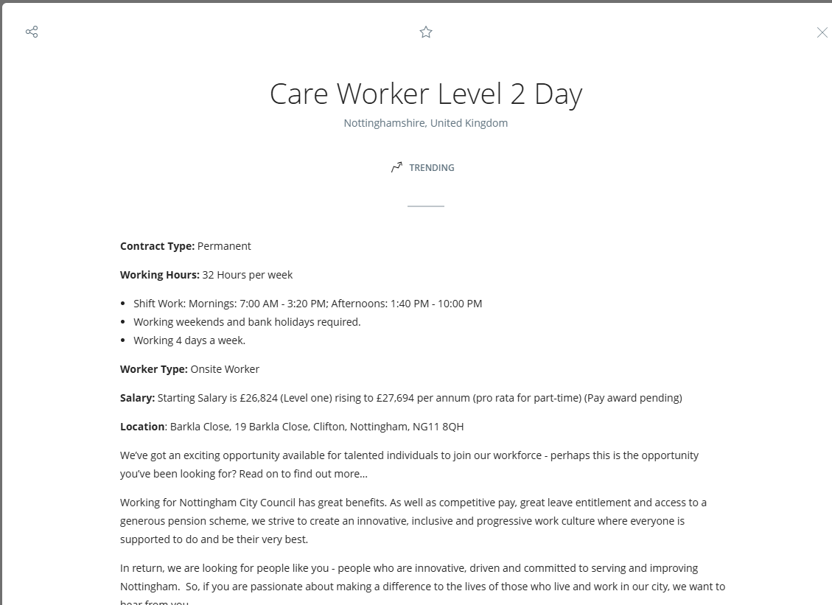.

Curriculum Vitae
Prince Peter Ojeabulu Okhueidiata
Address: Bestwood Street, Notttingham, United Kingdom | Phone: +44 7778 384285 | Email: 2509560@student.uwtsd.ac.uk

Personal Profile
I have worked in health and social care for nearly ten years, mainly in senior roles across residential and nursing care, providing personal care, supervising junior staff, and supporting the safe day-to-day running of care homes. I am currently studying for a CertHE in Health and Social Care, strengthening the theory behind my practice in safeguarding, communication, and person-centred care.

Education
- CertHE in Health and Social Care– University of Wales Trinity Saint David, Department of Health and Social Care. To be awarded: January 2027.

Work Experience
Senior Night Staff - Cherry Trees Resource Centre (Agency) | February 2024 – Present
- Providing overnight care and supervision, and ensuring adherence to health and safety regulations.
- Administering medication and supporting residents with their individual needs.
Senior Day Staff - Lacemaker Court, DCC (Agency Worker) | 2022 – Present
- Assisting with personal care and daily living activities, and supervising junior staff members.
- Communicating effectively with families and healthcare professionals.
Senior Day / Acting Duty Manager - Lady Cross, DCC | 2019 – 2021
- Managing day-to-day operations and leading a team of caregivers.
- Handling administrative duties, including care plans and documentation.
Earlier Care Experience – Beechcroft, Maple Manor Nursing Home, and Highfield Nursing Home | 2014 – 2019
- Acting Duty Manager and Support Worker roles overseeing care quality, staffing, and medication administration.
- Supporting residents with learning disabilities and older people with personal care, encouraging independence and social engagement.
- Working closely with multidisciplinary teams to provide holistic, person-centred care.

Additional Training and Workshops
- Equality, Diversity, and Human Rights
- Health, Safety, and Welfare
- Infection Prevention and Control
- Safeguarding Adults and Children
- Moving and Handling
- Basic Life Support
- Food Safety and Hygiene
- Medication Administration

Skills and competences
- Time management
- Administration
- Leadership and team management
- Effective communication with residents, families, and colleagues
- Record keeping and care plan documentation
- Awareness of safeguarding and health and safety procedures

Interests
I enjoy music, football, travelling, and regular exercise, which help me stay active, manage stress, and bring a positive, energetic attitude to work.

Referees
Available upon request.

Task 2: Personal Statement

To whom it may concern
I am applying for the Support Care Worker position at Cherry Trees, Bestwood, where I believe I can make a positive contribution. I am studying for a CertHE in Health and Social Care at UWTSD and bring almost ten years of practical experience, most recently as Senior Night Staff at Cherry Trees Resource Centre, supporting vulnerable adults and the safe running of the service.
Throughout my career, I have delivered high-quality personal care, mobility, nutrition, and medication support while encouraging residents' independence and choice. I am experienced in implementing care plans, monitoring residents' wellbeing, and maintaining accurate documentation and records to ensure continuity of care.
One of my key strengths is communication. I have worked with residents from a wide range of cultural, ethnic, religious, and social backgrounds and adapt my communication style to meet each person's needs. I communicate effectively with residents, families, colleagues, GPs, and other healthcare professionals, ensuring information is shared promptly. I am confident handing over between shifts, reporting concerns clearly, and contributing to multidisciplinary discussions.
I have a strong understanding of safeguarding and health and safety responsibilities, remaining vigilant in recognising signs of abuse, neglect, or deterioration in health, and reporting concerns promptly. I am familiar with risk assessments, infection prevention and control, moving and handling, and maintaining a safe environment for residents and staff.
My experience and training, including certification through Heartland Care Recruitment Ltd, have prepared me well for this role. I have worked across settings including Maple Manor and as Duty Manager at Lady Cross and Beechcroft, coordinating staff, mentoring colleagues, responding to incidents, and ensuring records were completed accurately. These experiences have given me a strong practical understanding of person-centred care, dignity, respect, and tailoring support to individual needs.
I would describe myself as reliable, compassionate, and approachable. I remain calm under pressure, work well independently on night shifts, and am equally comfortable as part of a team. I have good problem-solving skills, prioritise tasks effectively, and value teamwork, sharing information and contributing ideas that help improve the quality of care.
Having worked closely with Cherry Trees in recent months, including regular night shifts, I have enjoyed being part of the team and developed a good understanding of the service and its residents. I am committed to treating every individual with dignity and respect, and I am happy to work flexibly, including evenings, weekends, nights, and bank holidays.
I am committed to continuing my professional development through my university studies and workplace training. Combining my practical experience with the theoretical knowledge I am gaining makes me a strong candidate for this role, and I would welcome the opportunity to continue providing compassionate, person-centred support at Cherry Trees.

Task 3a: SWOT Analysis – Support Care Worker Role
A SWOT analysis identifies personal strengths, weaknesses, opportunities, and threats in relation to a chosen role, supporting honest self-evaluation (Skills for Care, 2025). I consider my readiness for the Support Care Worker role at Cherry Trees, which calls for practical care skills, leadership, communication, and a person-centred approach (CQC, 2010; NHS England, 2023).
Strengths | Weaknesses
Almost ten years in residential and nursing care, including personal care, medication administration, and supporting people with learning disabilities and dementia.  Acting Duty Manager experience, building leadership and admin skills (Skills for Care, 2001).  Trained in safeguarding, moving and handling, infection control, and basic life support. | My academic study is still in progress, so I'm building the theory behind practices I already carry out daily (Skills for Care, 2001).  Coming mainly from hands-on roles, I could develop my written reporting further.
Opportunities | Threats
Continuing my CertHE at UWTSD builds the theory behind my practice and a recognised qualification (Skills for Care, 2025).  Clear progression routes at Cherry Trees, building on my Duty Manager experience, plus specialist training such as dementia care. | Care work can be physically and emotionally demanding, with sector-wide staff shortages adding to workload pressure (Skills for Care, 2001).  Balancing full-time study with shift work, including nights, needs careful time management.
Overall, my clearest strength is direct, hands-on care and leadership experience, while my main gaps are academic underpinning and written documentation both addressed in the Personal Development Plan below. Staying organised and reflective should help me manage the pressures noted above.

Task 3b: Personal Development Plan (PDP)
A Personal Development Plan (PDP) identifies clear goals for developing the knowledge, skills, and confidence needed for a chosen role (Skills for Care, 2025). Building on the weaknesses identified in my SWOT analysis, my PDP focuses on three key areas that will support my progress as a Support Care Worker over the next two years.
Development Area | SMART Goal | Actions | Resources | Target Date | Monitoring & Evaluation
Safeguarding and regulatory knowledge | Complete remaining CertHE modules, focusing on safeguarding, the Care Act 2014, and CQC standards (CQC, 2010). | Attend modules and assessments; discuss learning points with my workplace supervisor. | CertHE materials; supervisor; CQC guidance. | 2 years | Track module results each term and discuss progress with my supervisor.
Leadership and management skills | Building on my Acting Duty Manager experience, complete a recognised leadership qualification, such as a Level 5 Diploma in Leadership for Adult Care, within two years. | Research and apply for a course; ask for more leadership responsibility at work to practise as I learn. | Employer training budget; course providers; line manager. | 2 years | Workplace appraisals and direct manager feedback on leadership performance.
Digital record-keeping and reporting | Build confidence with electronic care records and reporting systems at Cherry Trees, to a consistently high standard (Skills for Care, 2001). | Complete in-house systems training; ask a supervisor to review my records monthly. | Employer induction training; supervisor feedback. | 6 months | Supervisor audits, reviewed at a six-monthly check-in.
Reviewing these three goals regularly will show me where I'm closing the gaps from my SWOT analysis, and let me adjust the plan if my circumstances change.

Task 4: Reflective Account Using Gibbs' Reflective Cycle
This account reflects on my Component 1 presentation for LCHS4009, using Gibbs' Reflective Cycle (Gibbs, 1988) to think through planning and delivering a presentation on Working in Teams, applying Tuckman's model of team development.

Description
I chose Working in Teams as my topic, drawing on my experience supervising and mentoring staff as Acting Duty Manager. I explained Tuckman's stages - forming, storming, norming, and performing (Tuckman, 1965) - linking each to workplace examples such as inducting new night staff and building trust within a care team.

Feelings
I felt confident about the content, since it reflected my day-to-day experience, but nervous about presenting in an academic rather than workplace format. Once I got into examples I knew well, I settled, and afterwards felt a real sense of achievement at connecting theory to practice.

Evaluation
Using real workplace examples to illustrate Tuckman's model was a clear strength, making the theory easier to relate to practice (Tuckman, 1965). My lecturer's feedback agreed, noting my understanding of team dynamics, but suggested my presentation would have benefited from clearer academic referencing and a more structured slide layout.

Analysis
This showed me that strong practical knowledge doesn't automatically make a strong academic presentation - the two need different, complementary skills. Tuckman's model helped me see that teams develop through communication, trust, and shared goals over time (Tuckman, 1965), matching my own supervisory experience closely. It also told me that, as I move further into academic study, I need more emphasis on formal referencing and structure (NHS England, 2023).

Conclusion
Overall, this was a positive experience that showed me an academic model, Tuckman's stages (Tuckman, 1965), can be connected directly to real workplace practice. Using concrete examples from supervising night staff and building trust within my team made the theory tangible, and this came through clearly in my lecturer's feedback. At the same time, strong hands-on care experience does not automatically translate into strong academic presentation skills; I still need to develop my referencing and slide structure so my practical knowledge is presented with the same rigour as my delivery. This confirms that practical expertise and formal academic skills are complementary, and I need to invest deliberately in the latter as I progress through my studies.

Action Plan
Next time, I will pay closer attention to referencing conventions, checking citations against the university's referencing guide before submission. I will also plan my slide structure before writing content, using a simple template separating introduction, theory, examples, and conclusion. I will ask my tutor for feedback earlier, sharing a draft outline about a week before delivery, so I have time to make meaningful changes. I will keep drawing on my workplace experience, since real examples were a strength, while linking them more formally to theory. Finally, I will track this progress within my wider Personal Development Plan, reviewing my referencing and presentation structure alongside my other goals in six months' time.

References
Care Quality Commission (CQC) (2010) Regulation 9: Person-centred care. Available at: https://www.cqc.org.uk/guidance-providers/regulations-enforcement/regulation-9-person-centred-care (Accessed: 30 July 2026).
Department of Health and Social Care (2014) Care Act 2014. London: The Stationery Office.
Gibbs, G. (1988) Learning by Doing: A Guide to Teaching and Learning Methods. Oxford: Further Education Unit.
NHS England (2023) Good communication with patients waiting for care. Available at: https://www.england.nhs.uk/long-read/good-communication-with-patients-waiting-for-care/ (Accessed: 30 July 2026).
Nottingham City Council (2026) Care Worker Level 2 – Cherry Trees, Bestwood Park Estate. Nottingham City Council Careers. Available at: https://eism.fa.em2.oraclecloud.com/hcmUI/CandidateExperience/en/sites/ncc (Accessed: 30 July 2026).
Skills for Care (2001) A guide to adult safeguarding for social care providers. Available at: https://www.skillsforcare.org.uk/resources/documents/Support-for-leaders-and-managers/Managing-a-service/Safeguarding/A-guide-to-adult-safeguarding-for-social-care-providers.pdf (Accessed: 30 July 2026).
Skills for Care (2025) Statutory and mandatory training guide. Available at: https://www.skillsforcare.org.uk/resources/documents/Developing-your-workforce/Guide-to-developing-your-staff/Statutory-and-mandatory-training-guide-December-2025.pdf (Accessed: 30 July 2026).
Tuckman, B.W. (1965) 'Developmental sequence in small groups', Psychological Bulletin, 63(6), pp. 384–399.

