Work Breakdown Structure (WBS)
The WBS is a fundamental tool that helps break down the project into manageable tasks, enabling effective planning, resource allocation, and progress tracking. As part of the implementation team, I took on the responsibility of developing a comprehensive WBS for the book locker project.
By analysing the project's scope and objectives, we identified key deliverables, such as site selection, locker installation, book inventory management, and user support systems. Each deliverable was further broken down into specific tasks, creating a hierarchical structure that provided clarity and guidance for the entire team.
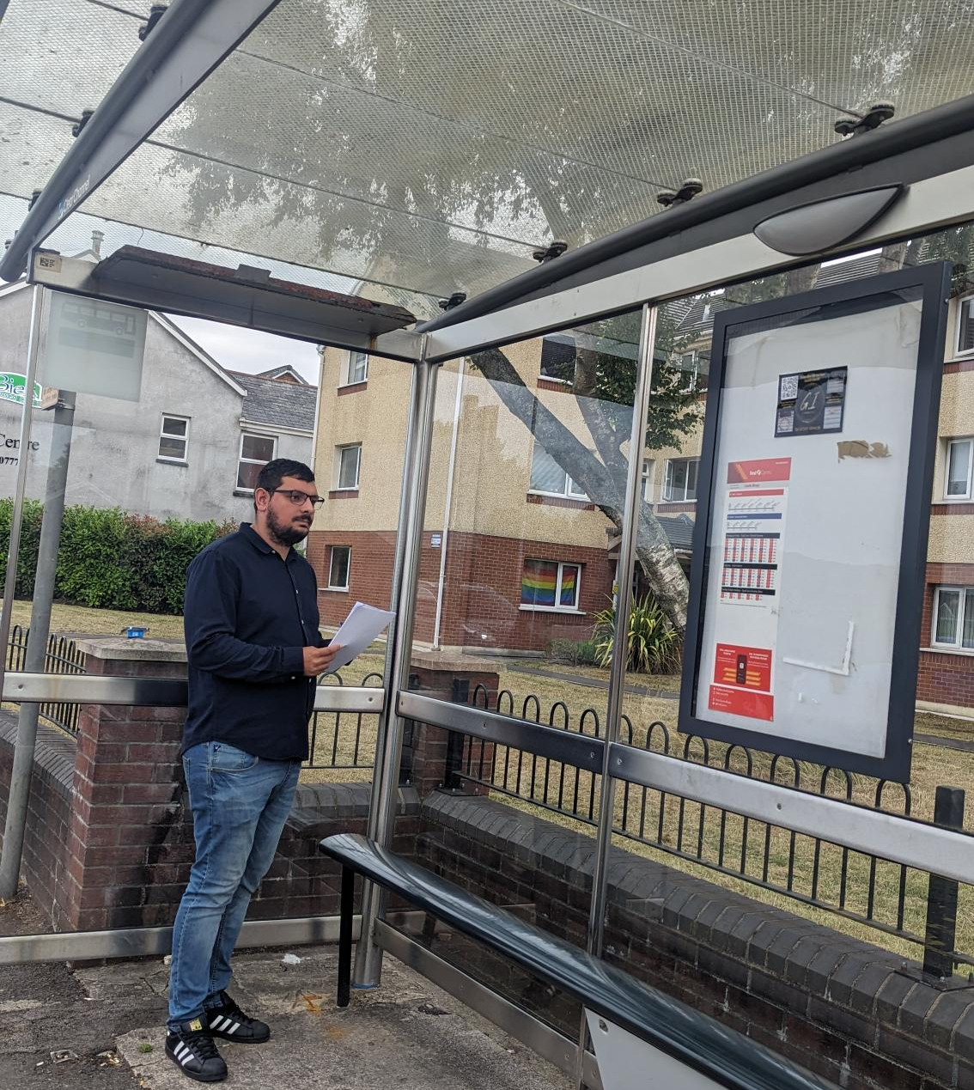
Risk Analysis
Risk analysis is crucial in identifying, assessing, and managing potential risks that may impact project success (Raftery, 2003). As the implementer, I collaborated closely with the team to conduct a comprehensive risk analysis for the book locker project.
We identified risks such as delays in locker procurement, insufficient book supply, technical issues with the lockers, and security concerns. Through a systematic approach, we evaluated the likelihood and impact of each risk, allowing us to prioritize and develop effective mitigation strategies.
Proactive risk management involved contingency planning, establishing communication protocols, and fostering collaboration with stakeholders such as local libraries and transportation authorities. Regular risk assessments were conducted throughout the project, enabling timely adjustments and minimizing the impact of unforeseen events.

Reference
Raftery, J., 2003. Risk analysis in project management. Routledge

