

The effectiveness of using Mini Plenaries to increase the involvement and engagement of pupils in Year 5 and 6.

Appendices

1803395

Appendix 1: Lesson Plans

Appendix 1A: Lesson Study 1
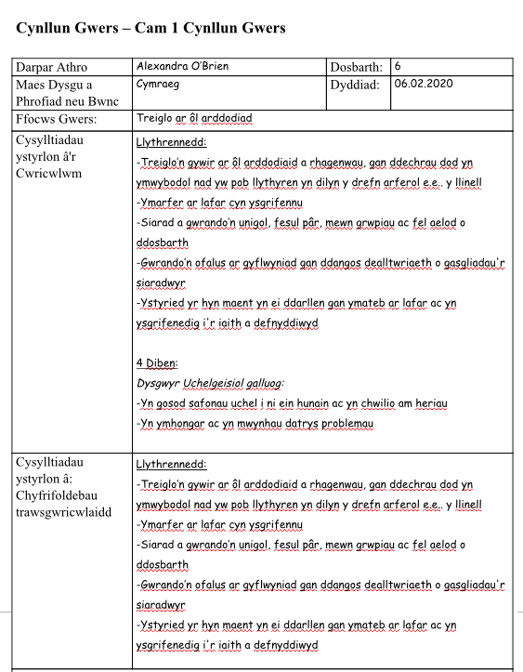

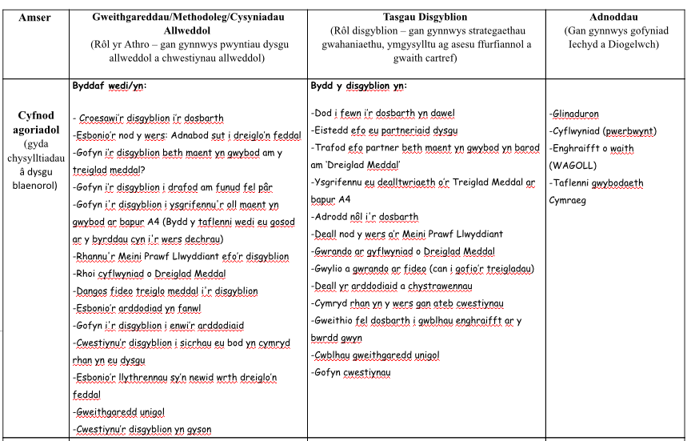
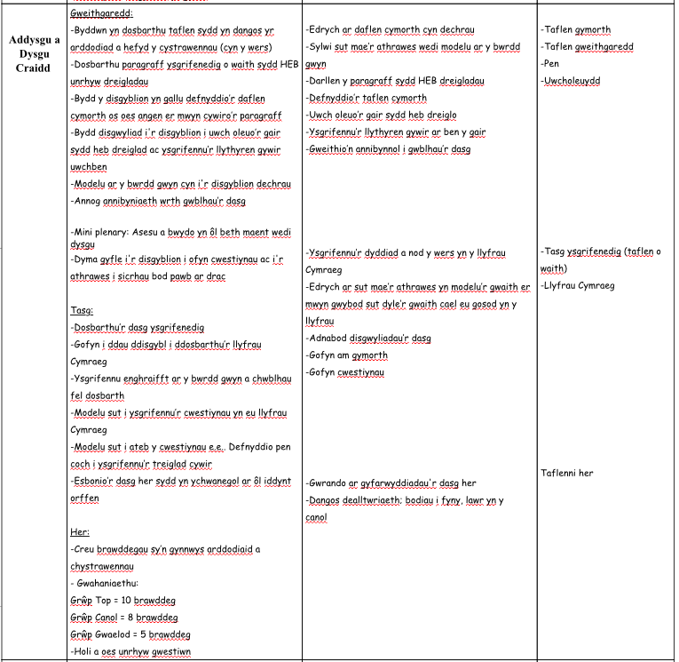

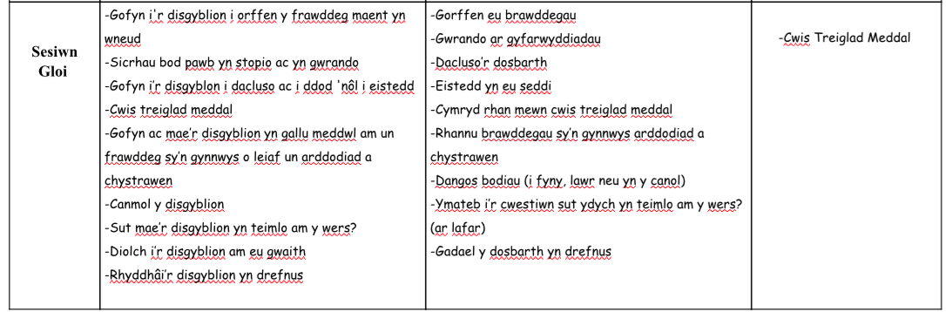

Appendix 1B: Lesson Study 2

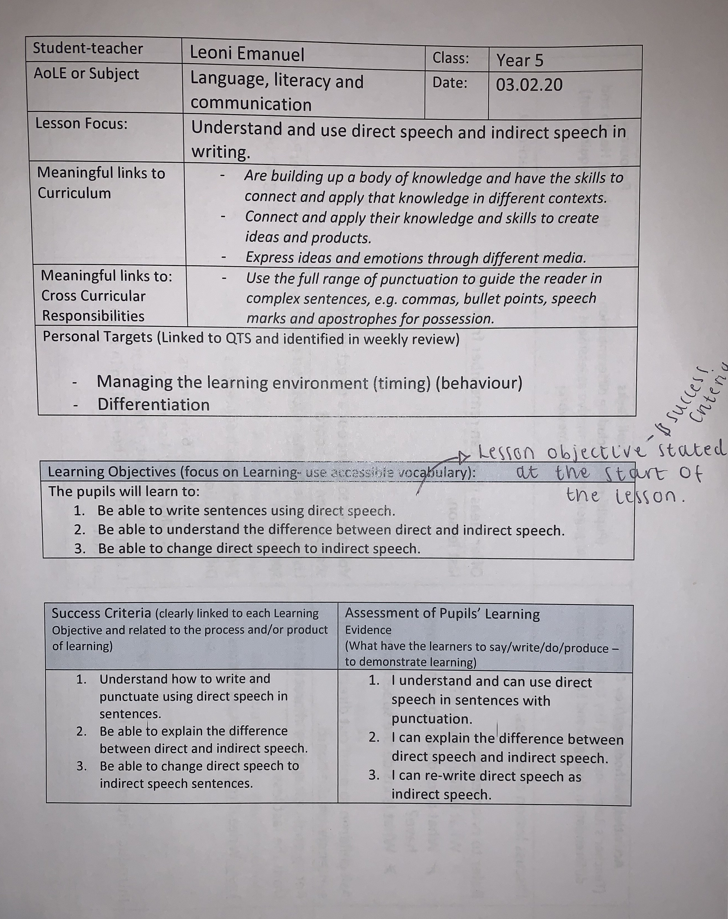

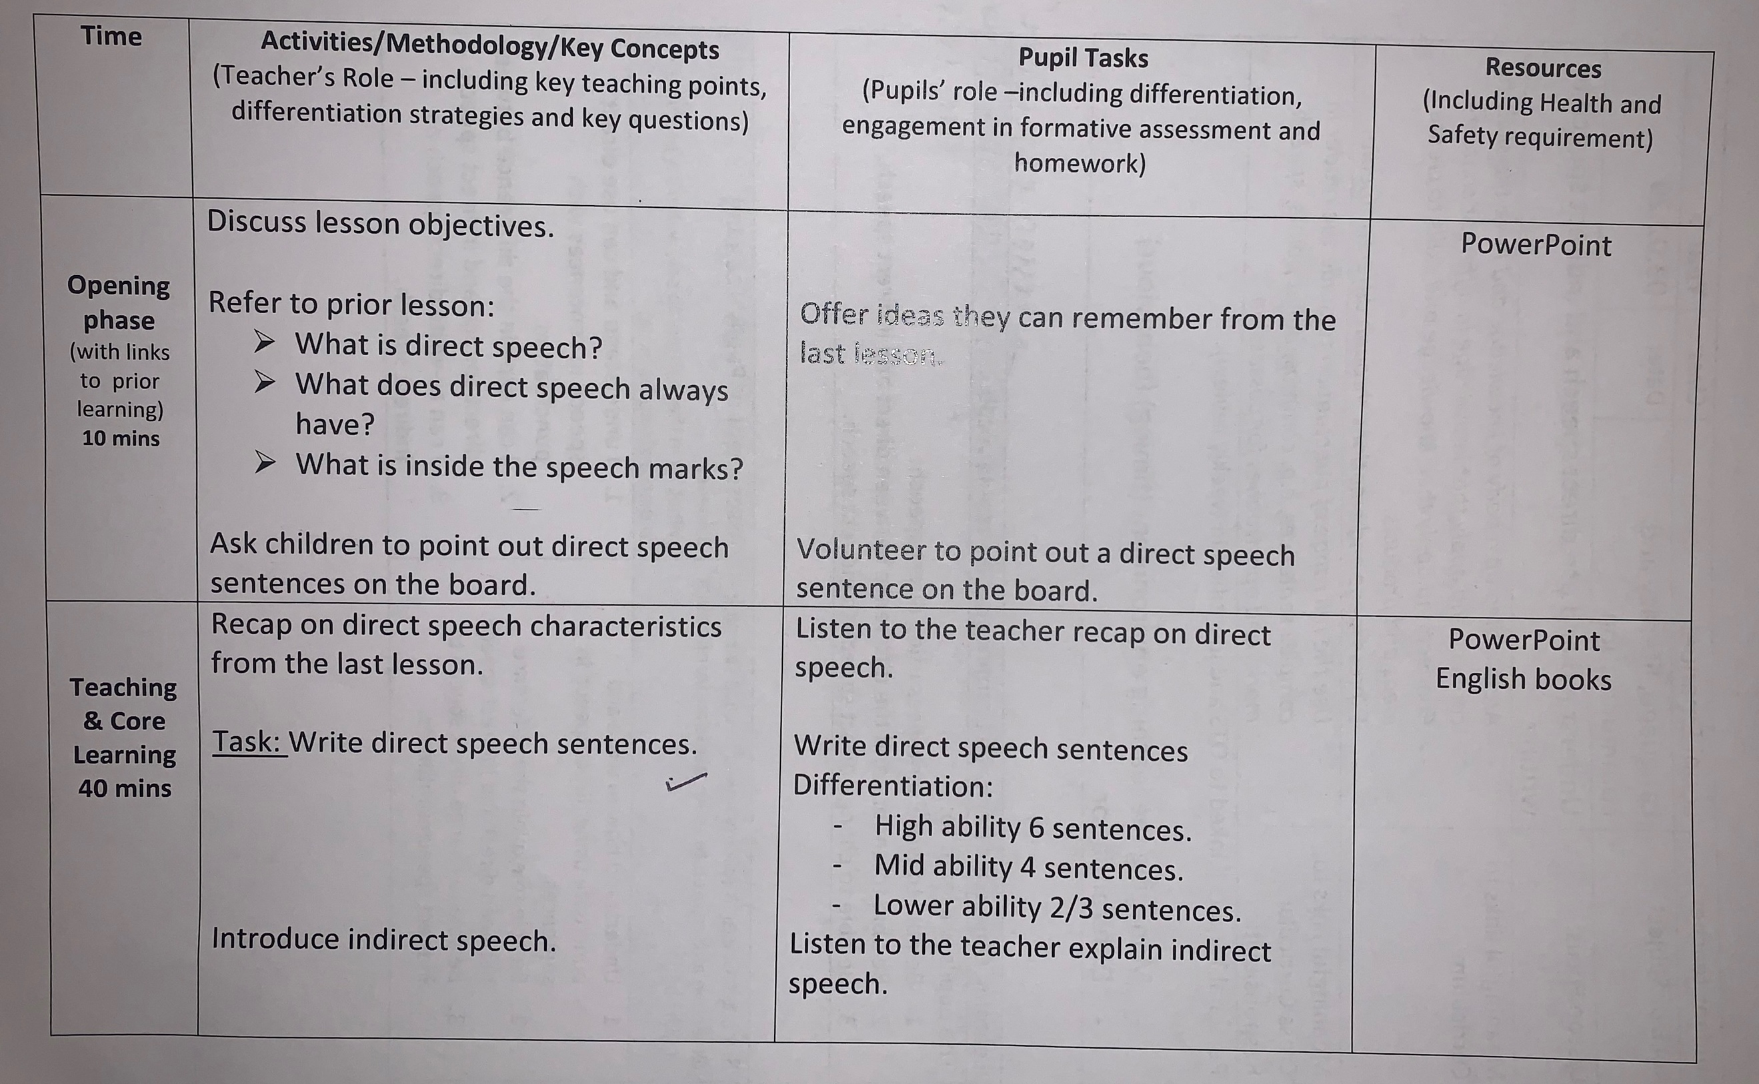

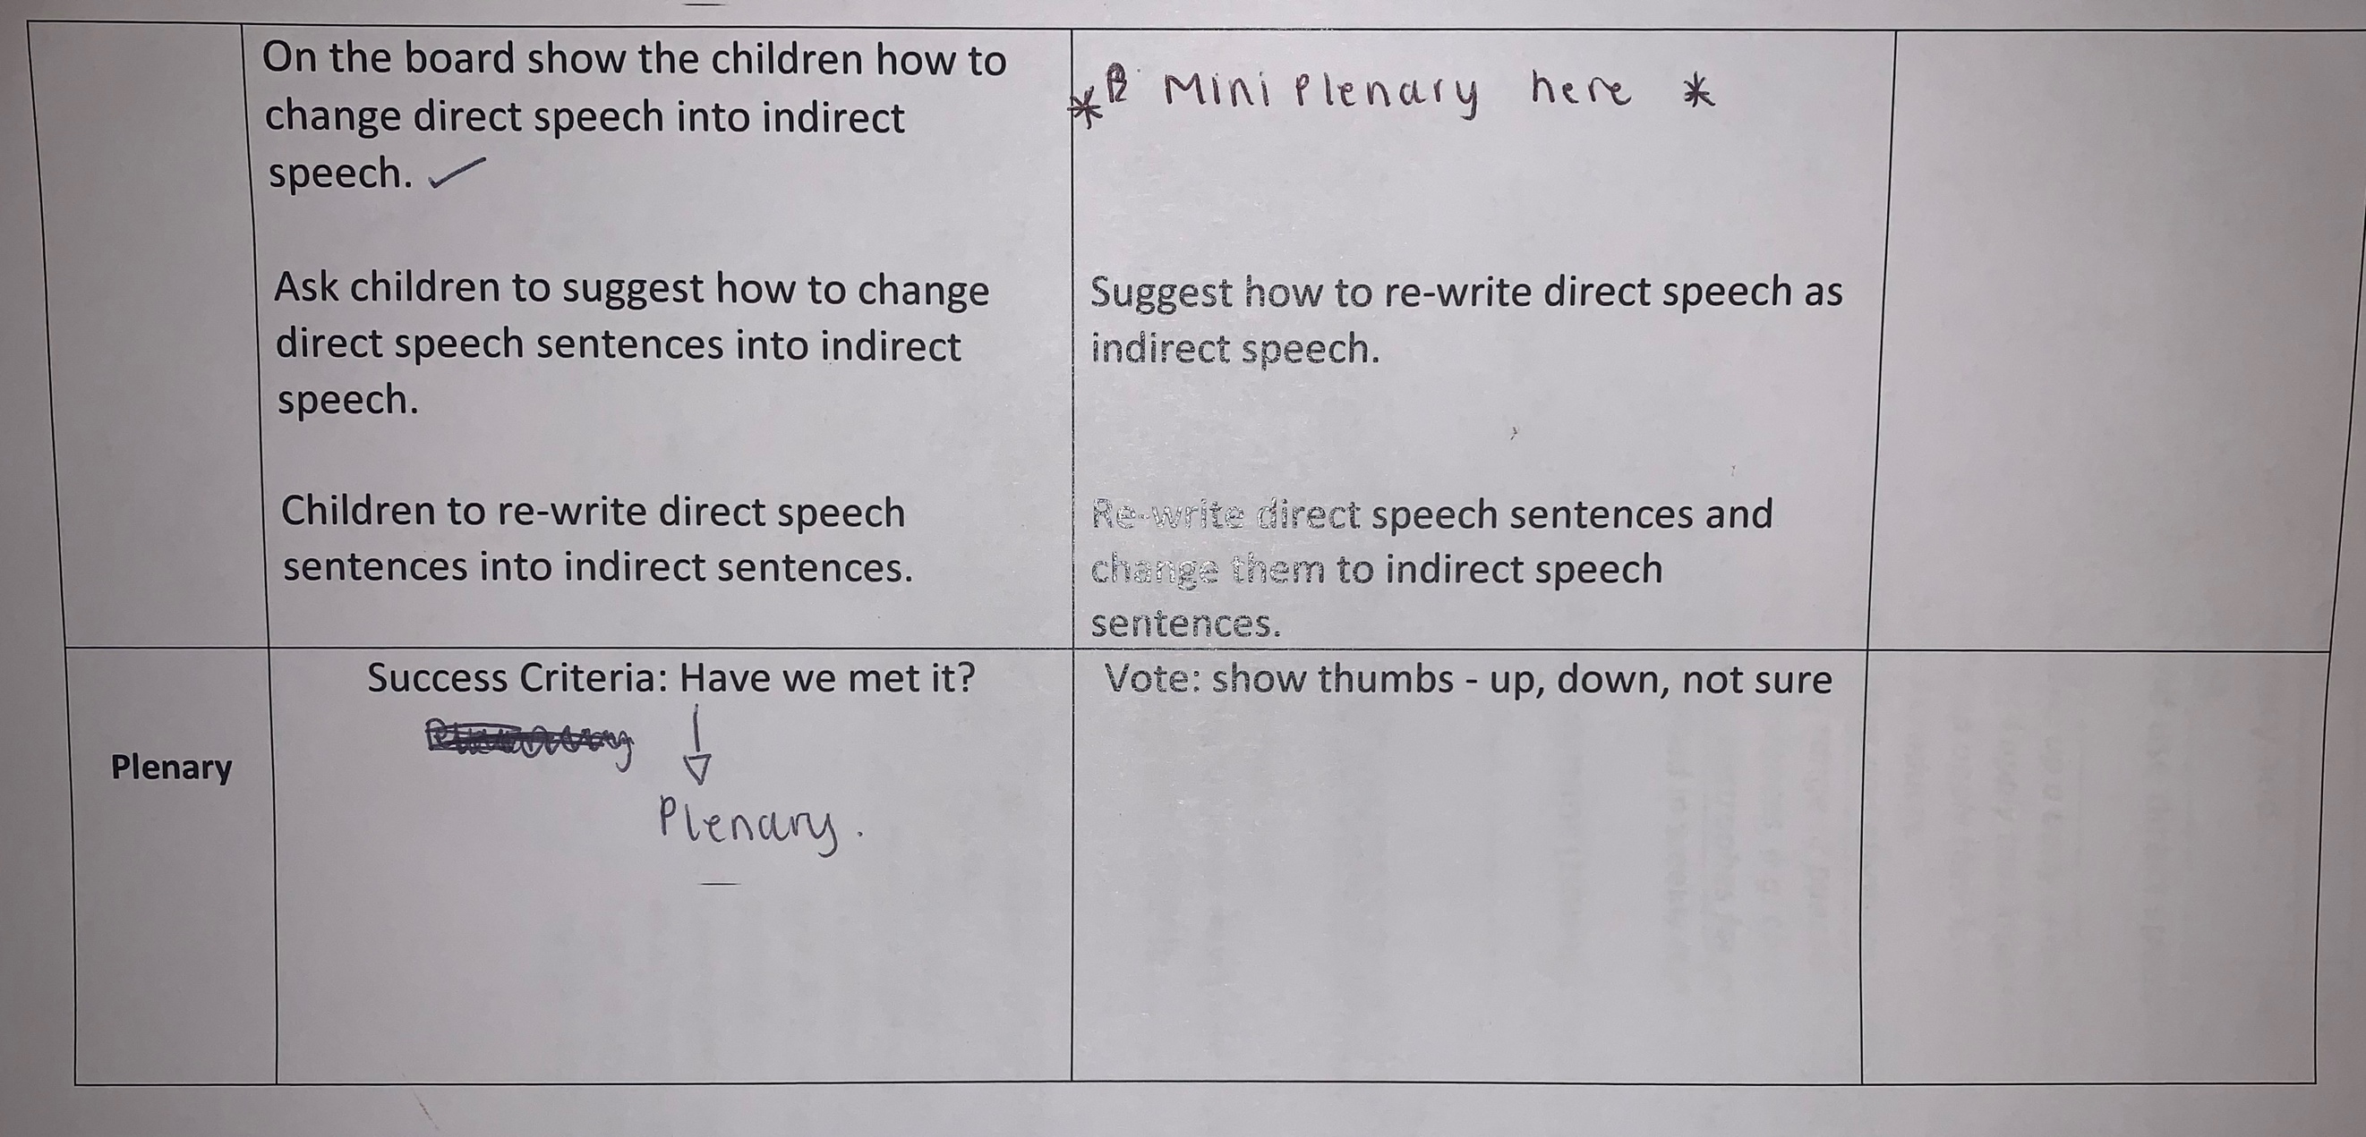

Appendix 2: Observation Timetables

Appendix 2A: Lesson Study 1

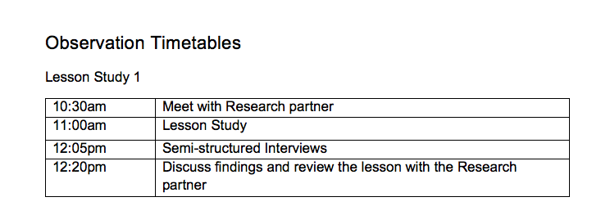

Appendix 2B: Lesson Study 2

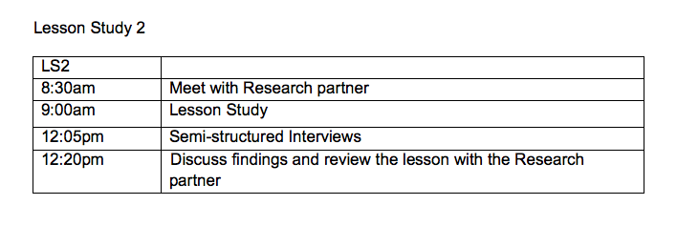

Appendix 3: Observation Sheets

Appendix 3A: General Observations

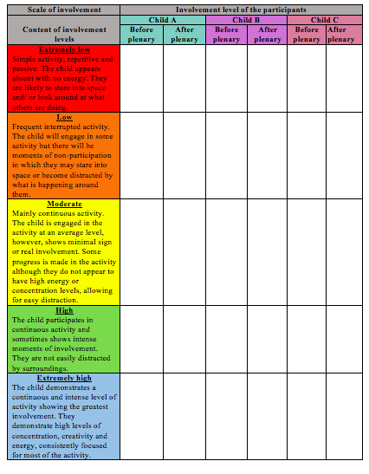

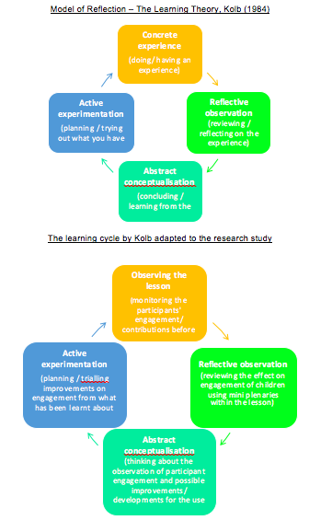

Appendix 3B: Leuven Scale Conclusions

Appendix 3B.1: Lesson Study 1
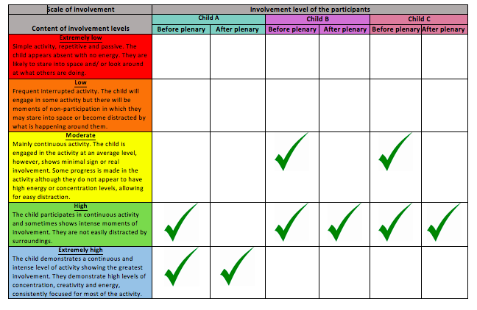

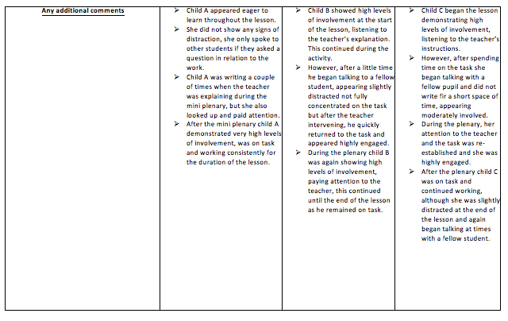

Appendix 3B.2: Lesson Study 2

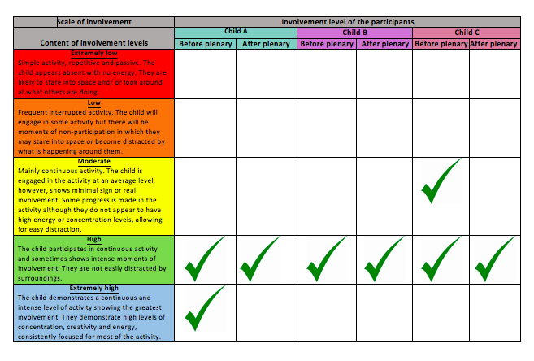

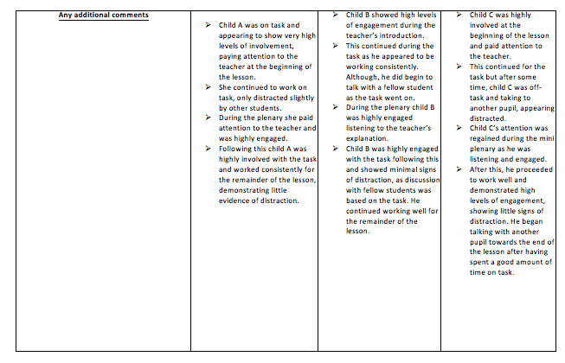

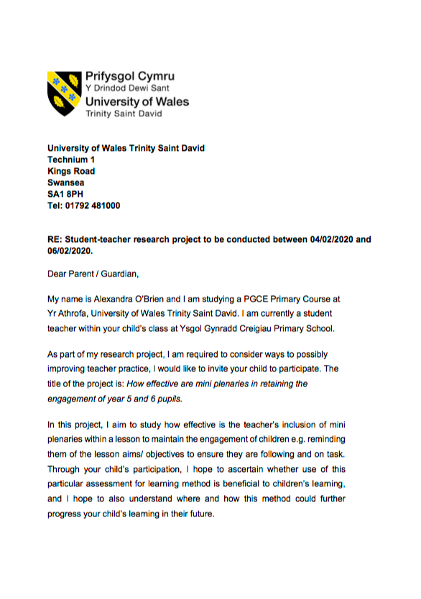
Appendix 4: Interview Consent Forms

Appendix 4A: School A

Appendix 4A.1: Parents’ consent forms



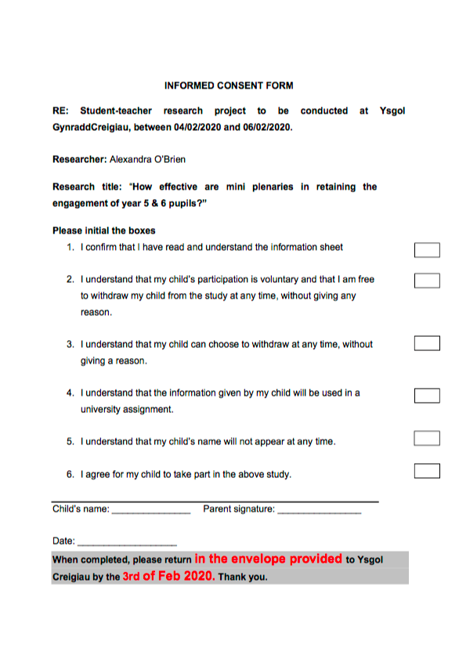

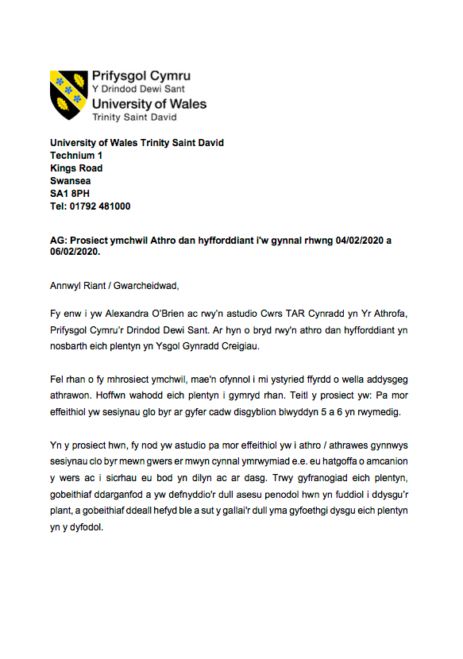

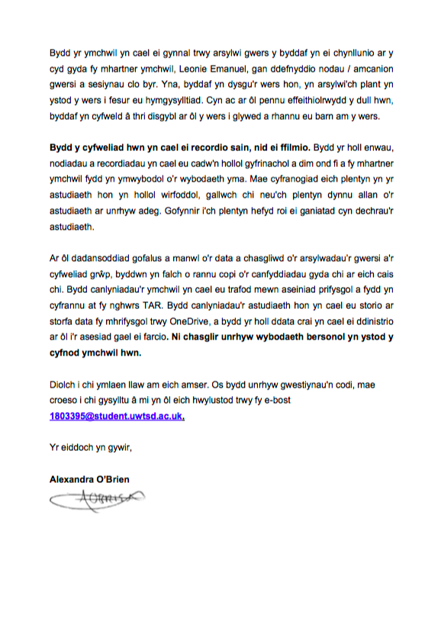

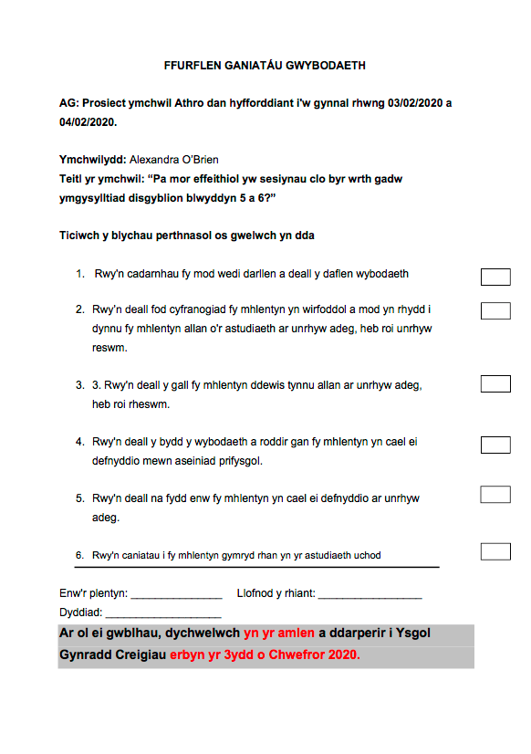

Appendix 4A.2: Child consent forms

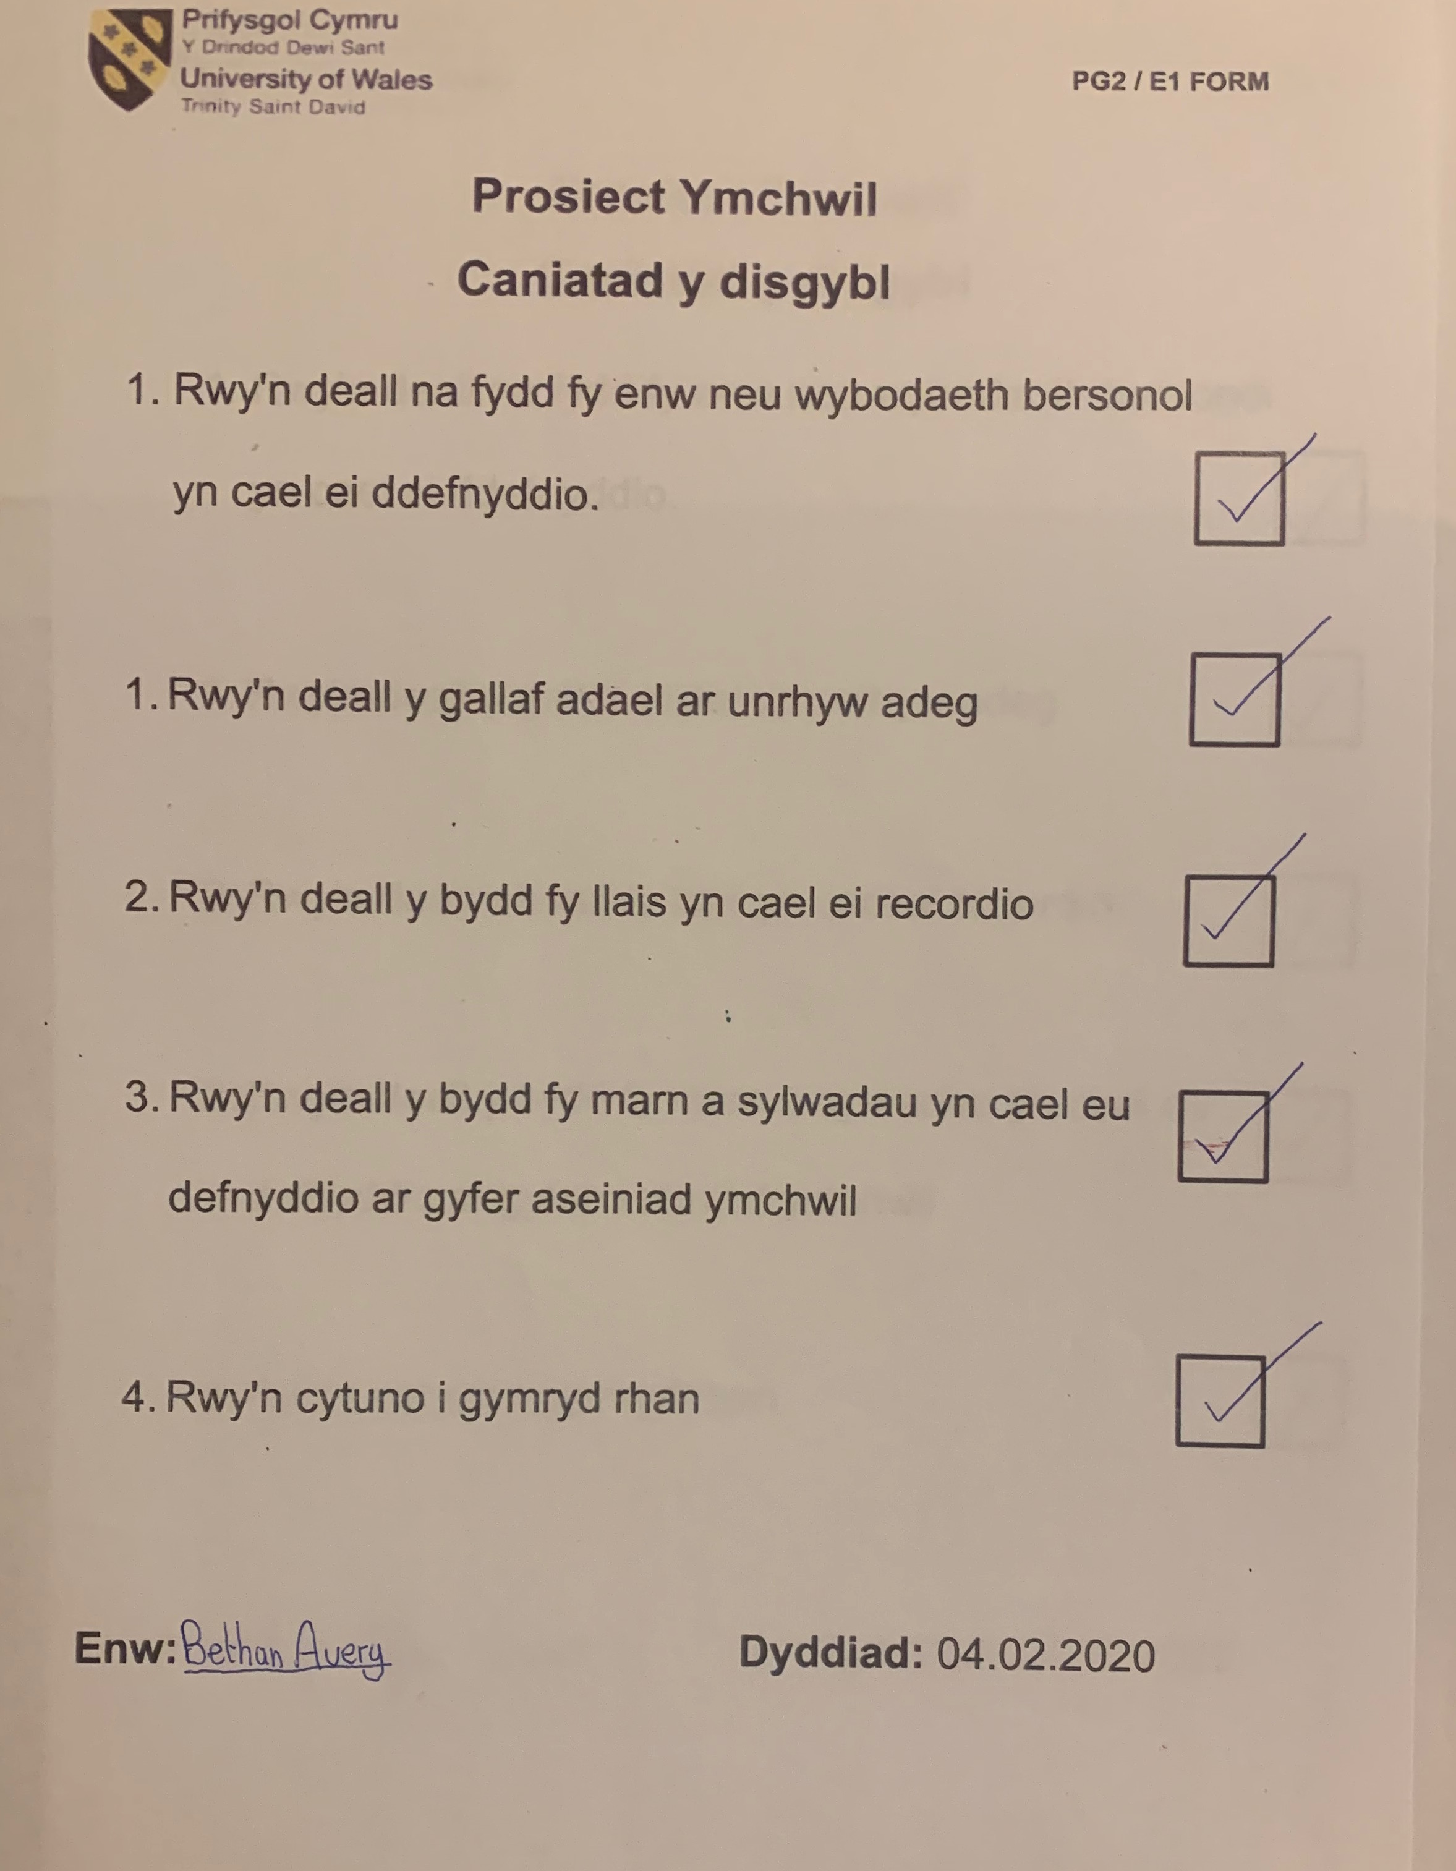

Appendix 6B: School B

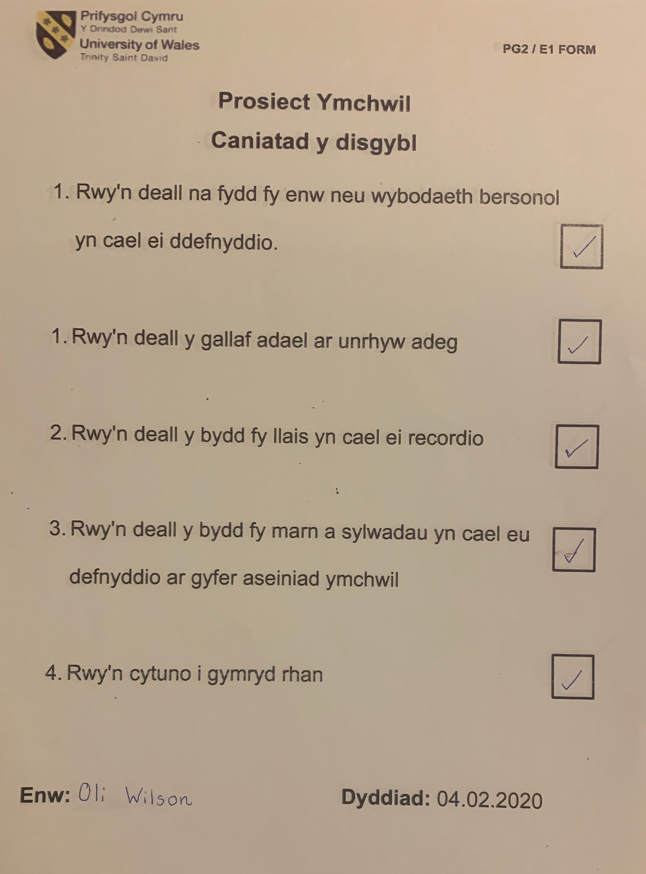

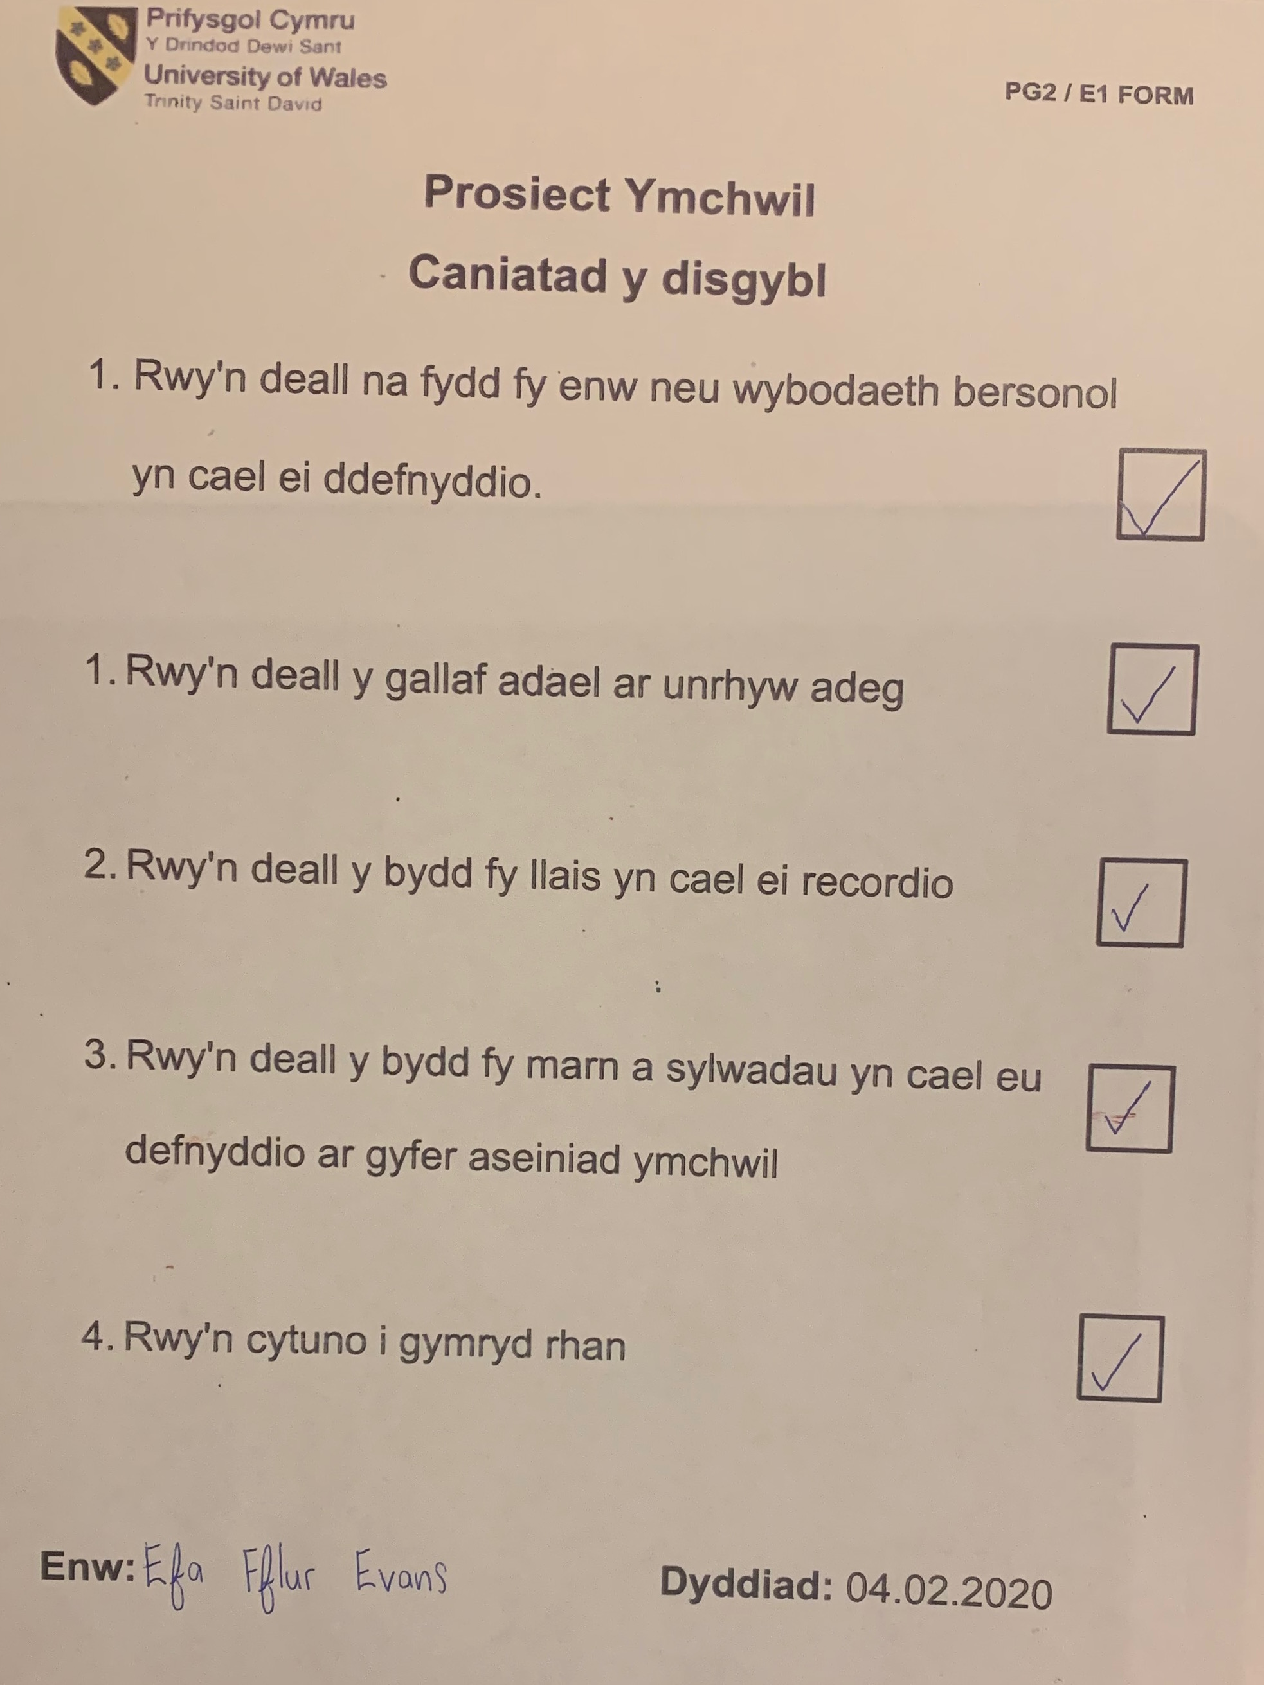

Appendix 5: Mini Plenary Resources

Appendix 5A: Plenary Sheet (before) Lesson Study 1



Appendix 5B: Plenary Sheet (after) Lesson Study 1



