
Title: Assessment 1
Human Resource Management


Student name: Harmanjot kaur
Student Id: 2239874
Programme: MBA- Masters of Business administration
Module: Human resources management
Module code: LCMB7000
Lecturer name: Gladius Kulothungan
Submitted on: 23/8/2023
Contents
Serial number | Subheading | Page number
1 | Introduction | 3
2 | The current state of the labour market in the UK | 3
3 | Challenges in the UK labour market and Recommendations | 5
4 | The emerging changes in Human Resourcing Strategies | 7
5 | Conclusion | 11
6 | References | 12

- Introduction
The labour market in the United Kingdom is a complex structure that plays a fundamental role in the country's economy. It comprises a wide variety of sectors and occupations, thus offering career possibilities to a significant number of individuals (Portes and Springford, 2023). Human resource strategies are of utmost importance in the facilitation of businesses and organizations in their efforts to effectively acquire, maintain, and cultivate a proficient and inclusive workforce. These approaches frequently encompass extensive methods for acquiring talent, implementing training and growth projects, establishing systems for monitoring performance, and launching efforts to enhance staff involvement and wellness (Ruiz and Vargas-Silva, 2018). This report will critically analyse the current labour market in the UK, identify possible challenges associated with this sector and provide suitable recommendations for the highlighted challenges. Furthermore, the report also aims to evaluate the emerging changes in Human Resourcing Strategies in the post-Covid, post-Brexit external environment.
- The current state of the labour market in the UK
- Concept of Labour market
The labour market refers to a fluid and evolving system in which individuals seeking employment present their skill sets in exchange for remuneration (Tremblay, D.G., 2016). There is significant variance observed among countries in terms of the size and makeup of their labour markets, which encompasses a wide range of industries, professions, and skills. The shifting patterns of this phenomenon are subject to various influences, including technological improvements, globalisation, changes in population, political choices, and financial factors. The salary, level of work, and opportunities for employment are influenced by the complex interaction between market and supply forces (Cazes et al, 2011). The labour market is influenced by a range of factors, including advancements in technology, governmental restrictions, shifts in population, and financial growth. As a result, it plays a vital role in the overall economic structure of a country.
- The labour market in the United Kingdom
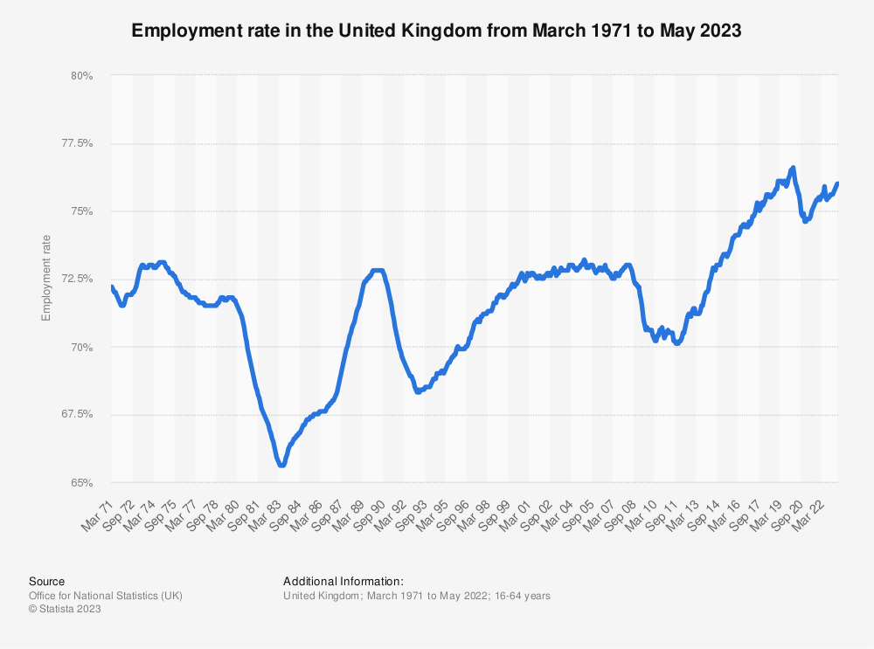
Fig 1: Labour market in the UK
Source: Statista (n.d)
The labour market in the United Kingdom holds considerable importance as it encompasses a substantial section of the country's population. Based on statistical data provided by Statista, it is seen that a significant proportion, exceeding 75%, of individuals belonging to the working-age demographic, namely within the age range of 16 to 64 years, actively participate in the labour market in the United Kingdom (Statista, n.d). The labour sector in the United Kingdom plays a significant role in facilitating employment opportunities, providing jobs to an estimated 36.8 million workers. The market consists of various prominent sectors, including services, manufacturing, and technology, and experiences continuous changes due to factors such as technological advancements, globalisation, and economic policies. As identified by Vizard (2019), the labour force within this particular market has a diverse composition of employees with varying backgrounds, encompassing individuals who are citizens of the United Kingdom, nationals of the European Union, as well as non-European Union immigrants. The presence of a diverse workforce in the market enhances its adaptability and inclusivity, resulting in the utilisation of a wide range of skills and knowledge that contribute to the advancement of the nation's economy. The market's size and valuation underscore its noteworthy impact on the national economy and its influence on employment opportunities for a considerable number of persons.

- Challenges in the UK labour market and Recommendations
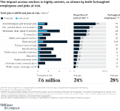
Fig 2: Impact of Covid-19 pandemic on UK’s labour market
Source: (www.mckinsey.com, n.d.)
- Challenges
The threat of Job Replacement by AI:
The growing use of artificial intelligence and robotics poses a substantial threat to the UK labour market. As technology improves, certain employment functions can become subject to automation, which could result in the elimination of a large number of workers. In 2021, the Office of National Statistics (ONS) estimated that approximately 1.5 million occupations in the UK were at high risk of being automated (Office for National Statistics, 2019). This can impact sectors such as production, retail, and logistics, where it will become easier to automate regular tasks.
Shortage of Qualified Employees:
The United Kingdom currently faces an acute shortage of competent workers in multiple sectors that is resulting in skill shortages and reduced efficiency. According to a new study conducted by Make UK, the manufacturing industry in the United Kingdom faces significant difficulty in filling vacant positions with 36% of posts proving difficult to get filled due to a shortage of suitable talents, skills, or expertise among candidates. This rate is significantly higher than the mean of 24% across every sector (www.makeuk.org, n.d.). Furthermore, sectors that involve skilled workers such as automobile construction, transportation face difficulties in hiring and keeping competent employees. This skills gap may inhibit economic expansion and invention.
The reduction in wages is a result of inflation.
Currently, the UK is facing inflationary pressures, resulting in a decline in real wages and diminished purchasing power for its workforce. As of June 2023, the inflation rate of the Consumer Prices Index (CPI) is 7.9%, surpassing the pace of wage growth (www.ons.gov.uk, n.d.). This situation has the possibility to impose financial burdens on workers, thereby impacting their quality of life and overall welfare. It is imperative for policymakers to enact strategies aimed at managing inflation, while concurrently ensuring that salaries are adjusted to align with the escalating costs of living. Efforts aimed at fostering equitable remuneration, implementing cost-of-living adjustments, and providing specific assistance to individuals with low incomes are crucial in tackling this issue and upholding the economic robustness of the labour market.
Stagflation:
The UK's labour market faces a distinct challenge in the form of stagflation, which is defined by a combination of stagnating economic development, elevated inflation levels, and increased rates of unemployment. The nation has encountered stagflationary challenges recently as a result of the disruptive effects of the COVID-19 outbreak and the uncertainties associated with Brexit (Portes and Springford, 2023). Stagflation has the potential to engender diminished firm investments, employment reductions, and a decline in consumer expenditure, so engendering a formidable milieu for workers. In order to promote economic growth while simultaneously mitigating inflation, it is imperative for policymakers to pursue a judicious equilibrium of fiscal and monetary policies. The importance of strategic planning and efficient policy coordination cannot be overstated when it comes to managing the intricate challenges posed by stagflation and ensuring the preservation of labour market stability.
- Recommendations
In order to manage the challenges highlighted in the labour market in the UK, stakeholders and policymakers can adopt the subsequent recommendations. Firstly, it is necessary to arrange systematic upskilling and retraining initiatives in order to provide workers with the appropriate abilities that match AI technology and fulfil industry requirements (Vizard, 2019). This will empower people to maintain their competitiveness and adaptability in response to automation. Furthermore, addressing the shortage of efficient employees requires coordinating the content of educational curricula with the demands of business. Also, it is essential to arrange vocational training, and the provision of assistance for apprenticeships as an approach to bridging the existing skill deficit (Jaiswal et al, 2022). Thirdly, in order to address the adverse effects of inflation on actual wages, it is necessary for authorities to prioritise the management of inflation through responsible financial measures. Additionally, they should also strive to foster equitable wage structures and implement price increases that increase the financial capacity of workers.
- The emerging changes in Human Resourcing Strategies
- Changes in the post-Covid External environment
The onset of the post-Covid era resulted in a major change in the Human resource techniques employed by organisations in the United Kingdom (Jones, 2022). During the Covid-19 pandemic, organisations were engaged in reassessing their talent management strategies in order to effectively address the various issues and possibilities that had arisen. The following changes have been noted in human resource strategies in the post-covid environment in UK organisations:
The Remote Work Revolution:
The global health crisis expedited the implementation of remote work arrangements, resulting in a profound transformation in the operational dynamics of organisations (Vyas, 2022). Organisations are increasingly adopting remote work as a sustainable long-term solution, providing employees with flexible work arrangements. According to Spicer (2023), 16% of the current UK population is working from home, 10% of workers adopting a hybrid work approach and according to this trend, a majority of UK employers are offering a flexible work approach. Consequently, contemporary human resource strategies place a higher emphasis on prioritising digital infrastructure, communication tools, and employee engagement initiatives specifically designed for remote teams.
The well-being of employees:
The Covid-19 pandemic has brought attention to the significance of employee well-being as a crucial factor in sustaining productivity and organisational resiliency. Current human resource strategies are increasingly prioritising the provision of psychological assistance, wellness programmes, and work-life harmony efforts. Organisations are actively allocating resources towards employee support programmes and virtual wellness initiatives in order to enhance the overall well-being of their employees. According to WHO, more than 60% of the global population has reported a decline in their mental health during the Covid-19 pandemic (World Health Organization, 2020). This finding underscores the pressing need for employers to take proactive measures in implementing well-being programmes.
Reskilling and upskilling
The global health crisis increased the process of digital transformation and this led to reevaluation of the necessary skill sets. Contemporary human resource strategies are increasingly prioritising the implementation of reskilling and upskilling initiatives for employees, with the aim of effectively addressing the challenges and requirements arising in the aftermath of the Covid-19 pandemic. Based on the findings of the CIPD, it has been observed that a significant proportion, specifically 62%, of companies in the United Kingdom are actively engaging in investments aimed at enhancing digital skills through training initiatives (LEARNING AND SKILLS AT WORK SURVEY 2021 in partnership with, 2021).
Improving Talent Acquisition Strategies:
The expansion of remote employment has led to the introduction of new talent acquisition practices in human resource strategies. The utilisation of online hiring procedures, online interviews, and AI-driven applicant evaluations is more prevalent and considered the norm in contemporary practises (Sen, 2020). Organisations are currently undergoing a process of reevaluating and enhancing their employer branding strategies in order to effectively demonstrate their dedication to remote work and the overall welfare of their employees. This strategic approach aims to attract highly skilled individuals from diverse geographical locations.
Emphasis is on the concepts of inclusion and diversity:
The COVID-19 pandemic has brought to the forefront preexisting inequities and discrepancies within the labour market. Contemporary human resource strategies concentrate significant emphasis on the establishment of diverse and inclusive work environments (Chen, 2021). Organisations are currently adopting inclusive recruiting practices, providing unconscious bias training, and cultivating diverse leadership representation. It is widely acknowledged by organisations that the presence of diverse teams contributes to enhanced levels of creativity, innovation, and improved decision-making capabilities.
Agile Workforce Planning
The evolving and unpredictable nature of the corporate environment requires the application of flexible workforce planning strategies. Human resource plans are centred around the development of a workforce that possesses adaptability and can effectively meet the changing demands of the market (Chen, 2021). The utilisation of short-term agreements, temporary labour, and freelancer arrangements has witnessed a growing trend in order to effectively respond to the dynamic and changing work demands.
- Post-Brexit external environment

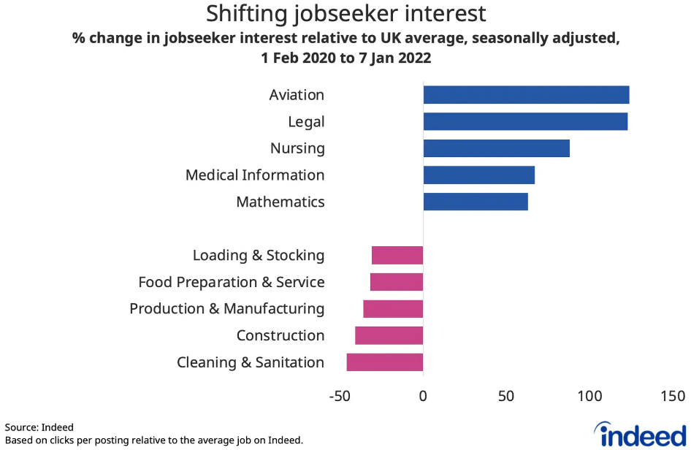
Fig 3: Post-Brexit hiring transformations
Source: (Brexit and worker expectations make hiring harder, 2022)
Organisations had to modify their human resource strategies to the changing challenges of trade, migration, and administrative settings as a result of the UK's Post-Brexit external circumstances. Brexit, which took effect on January 1, 2021, had an impact on the labour market in the UK and forced companies to reevaluate their hiring, retaining, and developing processes (Hunt and Wheeler, 2020). The following are the main adjustments in human resourcing strategies done in the post-Brexit environment:
Challenges in Retaining and Attracting Talent:
Modifications in immigration laws brought on by Brexit have an effect on the entry of people from the European Union to the UK. For EU nationals pursuing jobs in the UK, the Points-Based Immigration System has increased visa restrictions and demands for skills (Moradlou et al, 2022). Human resource initiatives have thus concentrated on drawing in and keeping talent from the UK as well as other non-EU nations. A workforce management poll found that. In order to combat the issues of talent shortage and retention, businesses are giving attractive compensation packages, improving benefits for staff, and supporting sponsorships.
Redefining Workforce Planning and Skill Requirements:
The need for specialised skills has been impacted by the uncertainty caused by the UK's exit from the EU in logistics and trade deals. The focus of human resource strategy is increasingly on workforce preparation that takes into account future shifts in market needs and regulations. Organisations are updating their standards for competencies, spending money on education and growth, and encouraging a workforce that is more mobile and adaptable. In response to Brexit, a majority of UK companies expected to boost spending on staff development (David, 2023).
Changes to Compliance and Employment Law:
After Brexit, the UK will no longer be subject to EU labour regulations or laws. HR management plans have been altered as a result to comply with UK-specific labour regulations. To negotiate the alterations and guarantee adherence to the new requirements, organisations are investing in legal guidance and HR experience. According to Feldmann and Morgan (2021), a majority of UK businesses sought outside legal counsel to handle labour concerns relating to Brexit.
Utilising Technology to Manage Talent:
Human resourcing methods are utilising technology to simplify talent management procedures in light of the complexity of Brexit and shifting immigration laws. For efficient approval of visas, personnel records management, and tracking compliance, digital HR solutions are being utilised (Cumming et al, 2020). Making decisions about hiring new employees and optimising the size of the workforce using data-driven methods has also become more commonplace.
Greater Attention Paid to UK Talent Development:
Organisations are emphasising developing domestic talent more in order to decrease their reliance on foreign talent. Investments in apprenticeship programmes, internships, and graduate programmes are made as part of human resource initiatives to build local talent and utilise the potential of the UK workforce. Furthermore, in order to encourage businesses to invest in local talent, the UK government has also developed programmes to boost skill development (GOV.UK, n.d.).
Conclusion
The labour market in the United Kingdom is an intricate framework that holds an essential position in the nation's economy, providing employment prospects to a substantial segment of the populace. The implementation of human resource strategies is crucial for the acquisition and retention of skilled and diverse staff. Nevertheless, the labour market continues to face various issues, such as the potential displacement of jobs by artificial intelligence (AI), a scarcity of proficient workers, declining wages resulting from inflation, and the repercussions of stagflation. In the wake of the Covid-19 pandemic, human resource tactics have seen significant transformations, mostly in response to the widespread use of remote work. These adaptations have entailed a heightened emphasis on employee well-being, a renewed focus on reskilling initiatives, and the implementation of better talent acquisition practices. In the context following the Brexit decision, there are several significant factors that have emerged as crucial concerns. These include the issues associated with attracting and retaining talented individuals, the need to redefine skill needs, ensuring compliance with newly established employment rules, harnessing the potential of technology, and nurturing the development of local talent. Organisations are increasingly adopting digital solutions, prioritising employee well-being, and implementing flexible workforce planning strategies in order to effectively navigate the evolving business environment.

References
Brexit and worker expectations make hiring harder. (2022). The Telegraph. [online] 2 Feb. Available at: https://www.telegraph.co.uk/business/future-of-recruitment/hiring-post-brexit/
Cazes, S., Heuer, C. and Verick, S., 2011. Labour market policies in times of crisis. In From the Great Recession to Labour Market Recovery: Issues, Evidence and Policy Options (pp. 196-226). London: Palgrave Macmillan UK.
Chen, Z., 2021. Influence of working from home during the COVID-19 crisis and HR practitioner response. Frontiers in psychology, 12, p.4177.
Cumming, D.J., Wood, G. and Zahra, S.A., 2020. Human resource management practices in the context of rising right‐wing populism. Human Resource Management Journal, 30(4), pp.525-536.
David, D. (2023). What impact has Brexit had on the UK economy? BBC News. [online] Available at: https://www.bbc.com/news/business-64450882.
Feldmann, M. and Morgan, G. (2021). Brexit and British Business Elites: Business Power and Noisy Politics. Politics & Society, [online] 49(1), pp.107–131. doi:https://doi.org/10.1177/0032329220985692.
Hunt, A. and Wheeler, B. (2020). Brexit: All you need to know about the UK leaving the EU. BBC News. [online] Available at: https://www.bbc.com/news/uk-politics-32810887.
Jaiswal, A., Arun, C.J. and Varma, A., 2022. Rebooting employees: Upskilling for artificial intelligence in multinational corporations. The International Journal of Human Resource Management, 33(6), pp.1179-1208.
Jones, M., 2022. COVID-19 and the labour market outcomes of disabled people in the UK. Social Science & Medicine, 292, p.114637.
LEARNING AND SKILLS AT WORK SURVEY 2021 in partnership with. (2021). Available at: https://www.cipd.org/globalassets/media/comms/news/as2learning-skills-work-report-2021-1_tcm18-95433.pdf.
Moradlou, H., Fratocchi, L., Skipworth, H. and Ghadge, A., 2022. Post-Brexit back-shoring strategies: what UK manufacturing companies could learn from the past?. Production Planning & Control, 33(14), pp.1319-1336.
‌Office for National Statistics (2019). Which occupations are at highest risk of being automated? - Office for National Statistics. [online] Ons.gov.uk. Available at: https://www.ons.gov.uk/employmentandlabourmarket/peopleinwork/employmentandemployeetypes/articles/whichoccupationsareathighestriskofbeingautomated/2019-03-25.
Portes, J. and Springford, J., 2023. The impact of the post-Brexit migration system on the UK labour market. Contemporary Social Science, 18(2), pp.132-149.
Ruiz, I. and Vargas-Silva, C., 2018. Differences in labour market outcomes between natives, refugees and other migrants in the UK. Journal of Economic Geography, 18(4), pp.855-885.
Sen, S., 2020. Digital HR strategy: Achieving sustainable transformation in the digital age. Kogan Page Publishers.
Spicer, A. (2023). The work from home revolution is here to stay – if you’re rich, white and live in London. The Guardian. [online] 14 Feb. Available at: https://www.theguardian.com/commentisfree/2023/feb/14/working-from-home-revolution-hybrid-working-inequalities.
Statista. (n.d.). Employment rate UK 2021. [online] Available at: https://www.statista.com/statistics/281992/employment-rate-in-the-united-kingdom/#:~:text=In%20the%20three%20months%20to.
Tremblay, D.G., 2016. Precarious work and the labour market (pp. 110-129). Social Determinants of Health. Canadian perspectives, Third edition, Toronto: Canadian Scholars Press.
World Health Organization (2020). COVID-19 disrupting mental health services in most countries, WHO survey. [online] World Health Organization. Available at: https://www.who.int/news/item/05-10-2020-covid-19-disrupting-mental-health-services-in-most-countries-who-survey.
www.makeuk.org. (n.d.). The labour shortage challenge for UK manufacturers. [online] Available at: https://www.makeuk.org/insights/blogs/the-labour-shortage-challenge-for-uk-manufacturers.
www.mckinsey.com. (n.d.). COVID-19 in the UK: The impact on people and jobs at risk | McKinsey. [online] Available at: https://www.mckinsey.com/industries/public-sector/our-insights/covid-19-in-the-united-kingdom-assessing-jobs-at-risk-and-the-impact-on-people-and-places.
www.ons.gov.uk. (n.d.). Consumer price inflation, UK - Office for National Statistics. [online] Available at: https://www.ons.gov.uk/economy/inflationandpriceindices/bulletins/consumerpriceinflation/june2023#:~:text=The%20Consumer%20Prices%20Index%20.

