Name: Samiha Hoque

Student Number: 2410268

Programme: BA (Hons) Business Management

Module: Stakeholder Engagement

Assignment Title: : Component 1: Coursework-Portfolio (4 elements)

Element 1. Introduction
Birmingham Smithfield Housing Redevelopment is one of the largest, most ambitious City Centre Regeneration projects in the United Kingdom. The £1.9bn development is being built in a partnership between Birmingham City Council and Lendlease, on a 17 hectares brownfield site next to Birmingham Bullring. The plan for the redevelopment seeks to redefine the former wholesale market site into a lively new mixed-use area of over 3000 new homes, commercial space, public parks, culture facilities, community facilities and improved transport links. The project will be delivered in four phases over a 10 year period (Birmingham City Council, 2025).
The main aim of the redevelopment is to meet Birmingham's increasing demand for quality housing whilst encouraging economic growth and enhancing environmental sustainability, and improving the quality of life for residents. The project aims to transform a neglected urban plot under utilised for its potential, into a community that is inclusive, sustainable and economically viable, capable of achieving long-term urban resilience. The scheme is also likely to provide more than 9,000 construction roles and over 10,000 full-time employment figures, which will have a large impact on Birmingham's economic growth (Birmingham City Council, 2021).
The redevelopment is very similar to the United Nations Sustainable Development Goals (SDGs), in particular SDG 11 (Sustainable Cities and Communities), SDG 9 (Industry, Innovation and Infrastructure), SDG 13 (Climate Action), SDG 8 (Decent Work and Economic Growth). The presence of sustainable buildings, green infrastructure, active travel networks and public spaces highlights the importance of building environmentally responsible and inclusive urban communities (United Nations, 2015).
Effective stakeholder engagement is essential to successful implementation as many organisations and people have different interests and expectations and different levels of influence over the project outcome. Freeman's Stakeholder Theory states that sustainable success is a balance between all stakeholders and not just the project sponsors (Freeman, 2010).

Element 2: Application to include Stakeholder Engagement Strategies

2.1 Stakeholder Identification
Identifying stakeholders is an important first step in stakeholder management since it helps project managers to identify individuals, groups and organisations that could impact a project's outcome. The Association for Project Management (APM, 2024) states that stakeholders should be identified as early as possible in a project to facilitate effective communication, minimise conflict and maximises the chances of project success.
Stakeholders have varying levels of interest, influence and expectations for the Birmingham Smithfield Housing Redevelopment Project (Serna et al., 2022, p.444). Recognising these distinctions helps project managers design their engagement approach and use resources optimally.

Table 1: Stakeholder Register
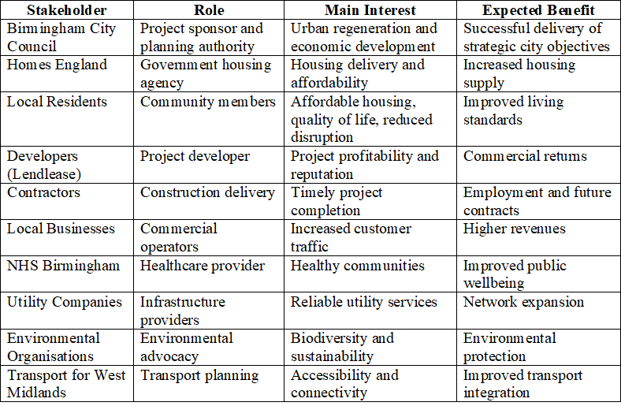
These stakeholders represent governmental, commercial, community, environmental, and infrastructure interests. Their objectives are not always aligned; therefore, proactive engagement is necessary to minimise conflict and maximise collaboration.
These stakeholders include governmental, commercial, community, environmental and infrastructure interests. They do not always have aligned objectives, so it is important to engage proactively to minimise conflict and maximise collaboration.

2.2 Power–Interest–Influence Matrix
Mendelow's Power–Interest Matrix is a pragmatic method for prioritising stakeholder engagement based on the degree of influence each stakeholder has over decisions made about the project, combined with their level of interest in the project outcomes (Mendelow, 1991).

Table 2: Example Matrix
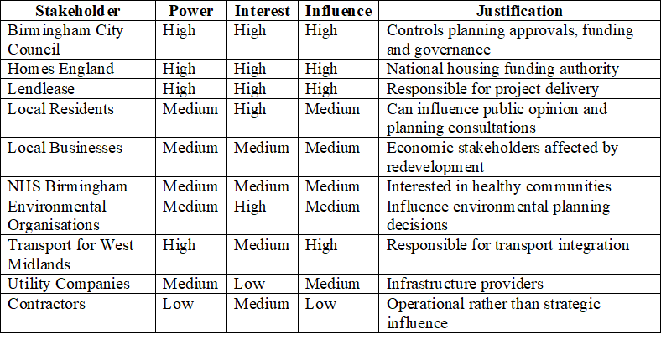
Stakeholders who have power and high interest will need regular engagement as they directly impact project approval, funding and implementation. On the other hand, stakeholders with low power need not be managed as intensely, and they should be provided enough information to ensure their trust and transparency in the management.

2.3 Mendelow Stakeholder Map
Categorising stakeholders by power and interest, the Mendelow Matrix classifies them into four management groups.

Table 3: Stakeholder Map
HIGH POWER
KEEP SATISFIED | MANAGE CLOSELY
Utility Companies | Birmingham City Council
Transport for West Midlands | Homes England
 | Lendlease
MONITOR | KEEP INFORMED
Contractors | Local Residents
Suppliers | Local Businesses
 | Environmental Groups
 | NHS Birmingham
LOW POWER

2.3.1 Manage Closely
These stakeholders have high levels of decision making power and interest in the project results. Proper meetings and reporting, as well as collaborative decision making, are key.

2.3.2 Keep Satisfied
Although these organisations have considerable influence, they are primarily interested in issues relating to their statutory responsibilities. Consultation and technical updates are thus appropriate.

2.3.3 Keep Informed
There is significant interest from residents, businesses, environmental groups and health care providers, as the project will impact their daily lives. Clear communication can alleviate resistance and enhance community acceptance.

2.3.4 Monitor
The contractors have to cooperate with each other while working on the project, but have limited influence on the strategic decisions of the project.

2.4 Communication Plan
Effective communication helps to keep people informed and ensures that there is clarity and understanding across all project phases, while helping to manage their expectations and minimise uncertainty (Koilakonda, 2023, p. 2348).

Table 4: Example Communication Plan
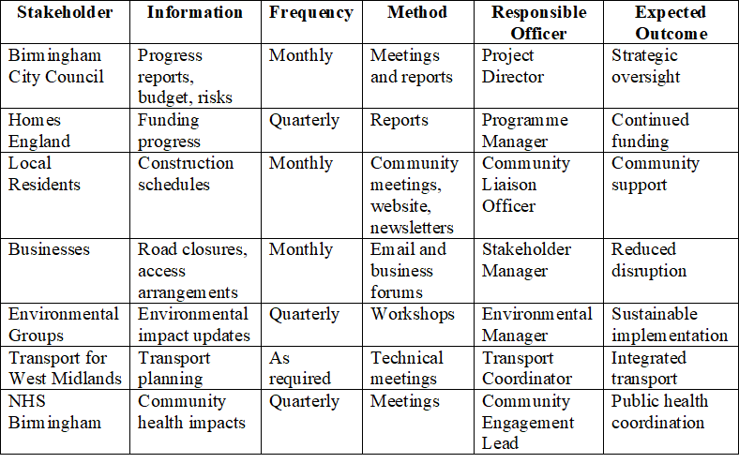

2.5 Consultation Strategy
Involving stakeholders in the project planning process through meaningful consultation can help to build project legitimacy and add to project planning. Engaging with different groups of stakeholders calls for a different approach (Albareda, 2024, p. 117).

Table 5: Consultation Strategy
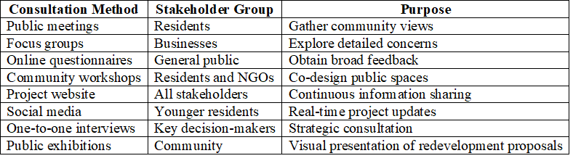

2.5.1 Analytical Discussion
Face-to-face and online methods will boost engagement and help to create an inclusive environment. Public meetings foster discussion, workshops facilitate group problem solving, and on-line surveys are used to involve those who cannot attend in person (Mashali and Eltantawy, 2020, p. 12). Adapting consultation approaches to the characteristics of stakeholders enhances the value of the feedback and a well informed decision making process.

Element 3: Ethical Considerations in Stakeholder Consultation, Participation and Feedback

3.1 Ethical Considerations in Stakeholder Consultation
Ethical stakeholder engagement is essential to the delivery of a successful housing redevelopment project, as it helps to ensure transparency, accountability, inclusiveness and public trust. There are many stakeholders involved in the Birmingham Smithfield Housing Redevelopment Project – these all have their own expectations and interests, and can be diverse and varied. It is therefore important that stakeholder consultation is carried out in an ethical manner, in line with internationally recognised ethical guidelines to ensure decisions are made in a fair, evidence-based and socially responsible way (APM, 2024).
The consultation process needs to be multi-faceted in order to make the most of the involvement of stakeholders. Open meetings offer a chance for the public to discuss the project and allow project managers to describe their redevelopment goals, expected impacts, and proposed mitigation. Community workshops involve the active participation of the community in the problem-solving process, enabling them to share their ideas with regard to housing design, availability of public amenities, transport accessibility, and environmental sustainability. The questionnaires and interviews are conducted online and in one-on-one sessions, respectively, in order to gather feedback from a wider audience and to give key stakeholders, such as local business leaders, planning officials and community representatives, the opportunity to voice their opinions in detail about the project implementation (Motalebi et al., 2025, p. 1086). These consultation approaches ensure stakeholder views are heard prior to major planning decisions being taken.
Informed consent is one of the most critical ethical rules when it comes to consultations. All stakeholders should be given comprehensive details on the aims of the consultation, how their information will be used, that the consultation is voluntary, and that there is no penalty for not taking part. This is to give transparency and to enable participants to make informed decisions about participation. In addition, there should be no forced or undue pressure on participation by project sponsors or government bodies.
Confidentiality and data protection are as important. Data gathered using questionnaires, interviews and consultation events, should be treated under the UK General Data Protection Regulation (UK GDPR) and the Data Protection Act 2018.

3.2 Addressing Bias in Stakeholder Engagement
Bias is one of the biggest risks to effective stakeholder consultation and can lead to the failure of the decisions to reflect the broader community's interests. There are several types of bias that can occur during the consultation process.
Selection bias can happen when the consultation process focuses on key audiences who are likely to be accessible, leaving out some groups, including those with little voice, such as people with disabilities, ethnic minorities, elderly residents, or low-income families. Project managers should use several approaches to consultation and make sure that consultation events will be conducted at easy-to-reach places and convenient times to reduce this risk.
Data interpretation can also be affected by researcher bias if project teams are selective about data they choose to represent that aligns with a preordained redevelopment goal. It is important to minimise this risk by systematically analysing the consultation data through transparent coding procedures, multiple reviewers if applicable, and by making clear coding decisions.
Another worry is confirmation bias where project managers may be subtly looking for information that supports their current opinions or beliefs instead of those that challenge them. Stakeholder engagement should account for positive and negative comments and build a balanced picture for decision making.
Language and cultural bias must also be taken into account among the various communities in Birmingham. Materials for consultation should be, therefore, presented in plain and understandable language and translated as needed to assure the participation of non-native English speakers. Offering interpreters and communication options is another way to increase inclusivity.

3.3 Diversity, Equity and Inclusion (DEI)
Diversity, Equity and Inclusion (DEI) are key values in today's stakeholder management. Housing redevelopment projects impact people of varying socioeconomic, cultural, ethnic and demographic statuses. It is important, then, that the stakeholder engagement process provides equal opportunities for all stakeholders to be engaged in the project decision-making process.
The Birmingham Smithfield redevelopment needs to actively involve traditionally under-represented communities such as older people, disabled people, women, youth, minority ethnic groups, refugees and low income households. These groups are often subject to obstacles to participation that can make their voice not be heard (Uysal, N., 2024, p. 300).
Therefore, accessibility must be built in to all phases of consultation with stakeholders. Public meetings should be conducted in accessible meeting rooms with hearing assist devices if needed. Accessibility should be followed on digital consultation platforms and where necessary, large print and alternative formats should be used in print.
Inclusive consultation not only meets ethical obligations and can also help to improve project outcomes by ensuring that it involves a broader range of experiences, knowledge and community priorities in redevelopment planning. Experience has repeatedly proven that involving stakeholders in the process of building infrastructure projects helps to build project legitimacy and lessen or eliminate opposition and public rejection.

3.4 Stakeholder Feedback Collection and Review
Input from stakeholders is a valuable source of information for project design support within the community. To gather feedback, both qualitative and quantitative approaches should be adopted to gain a broad understanding of stakeholder views.
A combination of questionnaires and interviews, workshops and focus groups can yield both quantitative data on stakeholder satisfaction, priorities and perceived project benefits and qualitative data regarding community concerns and expectations. Digital engagement platforms can also provide ongoing feedback over the life of the project.
Responses should be analysed and categorised systematically and grouped into primary themes, including housing affordability, environmental sustainability, transport, public safety, economic opportunities and community facilities. Questionnaire results can be summarised using statistical analysis and thematic analysis can be used to find patterns in qualitative answers.
Project managers should disseminate project consultation results to stakeholders via newsletters, project websites, community meetings and progress reports. Having a system in place that shows how the feedback from the stakeholders has helped shape project decision-making improves transparency and builds trust within the project team and the community.

Element 4: Conclusion and Reflection

4.1 Conclusion
Birmingham Smithfield Housing redevelopment Project illustrates that effective stakeholder management is just as crucial as technical know-how and funding for infrastructure development. The interests of the stakeholders, their expectations and their degree of influence are different at various stages of the project life cycle, and have to be identified and dealt with accordingly. Establishing a stakeholder management plan helps project managers to plan for future situations where conflict may arise, foster collaboration and develop trust between stakeholders.
This portfolio established the key stakeholders for the redevelopment project, which were Birmingham City Council, Homes England, local residents, developers and contractors, environmental organisations, local businesses, transport authorities, utilities and healthcare organisations. Stakeholder identification is a critical part of effective project planning as each stakeholder plays a unique part in the success of the project. Theories that were applied for stakeholders' management are Freeman's Stakeholder Theory and Mendelow's Power–Interest Matrix, which helped to classify stakeholders into their levels of influence and interest for prioritisation of engagement strategies.
Communication plan prepared for the project illustrates how critical timely, accurate and transparent communication is through multiple communication channels. Opportunities for meaningful participation and collaborative decision making are provided through regular consultation meetings, newsletters, digital platforms, workshops and stakeholder forums. This type of communication can help alleviate uncertainty, as well as help build trust and acceptance among stakeholders regarding project decisions.
One key element that has been identified throughout the redevelopment process has been ethical stakeholder engagement. Informed consent, confidentiality, compliance with the GDPR in the UK, fairness, transparency and accountability were highlighted in stakeholder consultation. Just as important was the use of Diversity, Equity and Inclusion (DEI) principles to ensure equitable access for vulnerable and underrepresented groups to engage in project decision-making. Inclusive engagement enhances the legitimacy of the project and supports more socially sustainable development outcomes.
In general, the effective engagement of stakeholders brings strong benefits to the projects success in making the right decisions, minimising resistance to change, strengthening the reputation of the organisation and creating sustainable urban regeneration. The management of stakeholders needs to be considered as an ongoing strategic process, not a one-off consultation exercise, on larger housing regeneration schemes like the redevelopment of Birmingham Smithfield. Continued dialogue can help project teams anticipate new challenges and ensure the redevelopment brings long-term social, economic and environmental returns to the broader community.

4.2 Reflection (Using Gibbs' Reflective Cycle)
Gibbs (1988) developed a framework that can be used to assess learning experiences and identify opportunities for future professional learning. This stakeholder management portfolio has deepened my knowledge and understanding of the value of stakeholder engagement for the effective delivery of complex infrastructure projects.

4.2.1 Description
During the course of this assignment I studied the Birmingham Smithfield Housing Redevelopment Project as a Junior Stakeholder Manager for a stakeholder management plan. The exercise had to involve identifying key stakeholders, assessing their level of power and what interests they have, design communications strategies, discuss ethical issues and review the process of consulting with stakeholders, in a real-world context of urban regeneration.

4.2.2 Feelings
Initially, I thought that stakeholder management was just about informing people about the project whose operations impact them. But as the project was researched, it was found that stakeholder management is much more complex than it was originally thought. I learned that the interests of different stakeholders are competing and need to be carefully balanced through structured consultation, negotiation and relationship management. This gave me a greater understanding of the strategic value of the stakeholder managers for delivering successful projects.

4.2.3 Evaluation
The hands-on nature of the exercise using stakeholder management theory in a housing redevelopment project was one of the most successful features. By using Mendelow's Power–Interest Matrix, I was able to develop an understanding of the variation in engagement strategies that needed to be adopted, depending on the level of power and interest of the stakeholder, instead of a blanket communication approach. Likewise, when the communication plan was developed, there was clear identification of the need to choose appropriate communication methods for various groups of stakeholders.
An additional benefit of learning was the understanding of the importance of ethics, transparency and inclusiveness in stakeholder consultation. Projects involving public infrastructure projects have impacts on a variety of communities, and deciding to proceed without adequate consultation can create conflict, opposition and loss of public trust. Ethical engagement is thus the contribution to project success as well as social justice and community wellbeing.

4.2.4 Analysis
It showed that effective stakeholder management is not just about delivering a project, but it's also about helping to ensure long-lasting sustainability. On-going consultation helps organisations to anticipate stakeholder concerns at an early stage, address conflict disputes before they become too serious, and design projects together. In addition, the use of Diversity, Equity and Inclusion principles allows for meaningful and equitable engagement of traditionally underrepresented communities in the redevelopment process. This is a way of making the project more legitimate and more trusted by the population.
The activity also helped to emphasise the need for evidence-based decision making. As I reviewed academic literature, government reports and professional guidance, I gained a greater awareness of to what extent stakeholder engagement frameworks are used in the context of actual building and regeneration practices in the United Kingdom.

4.2.5 Conclusion
I have consolidated my understanding of the principles of stakeholder management and enhanced my theoretical knowledge to practice in the real world of projects through the completion of this portfolio. I have gained a greater understanding of stakeholder identification, development of communication plans, consultation strategies, ethical decision making and reflective practice. These are the skills that are essential for practitioners in the field of project management, urban planning, construction and public administration.

4.2.6 Action Plan
In a future context of my professional practice, I will reinforce my stakeholder management ability through the development of the skills in negotiation, conflict resolution, digital engagement technologies and participatory consultation techniques. I also want to enhance my knowledge of sustainability frameworks, Equality, Diversity and Inclusion practices and stakeholder analysis based on data. These skills will help me to effectively work within multi-disciplinary project teams that produce sustainable infrastructure projects that meet the business requirements of the organisation whilst also impacting the community.
In conclusion, this assignment has shown that successful stakeholder engagement is not a one-way street but a dynamic process that involves building relationships with those involved based on trust, transparency, respect, and ongoing conversations. These principles will continue to be vital in my future academic pursuits and career in project and stakeholder management.

References
Albareda, A., 2024. Stakeholder consultation throughout the policy process. In Handbook on lobbying and public policy (pp. 117-129). Edward Elgar Publishing.

Association for Project Management (2024) APM Body of Knowledge. 8th ed. Princes Risborough: APM.

Birmingham City Council (2025) Birmingham Smithfield Masterplan. Available at: https://www.birmingham.gov.uk/info/20026/planning/1311/birmingham_smithfield (Accessed: 19 July 2026).
Birmingham City Council (2025) Major funding agreed for Smithfield Birmingham. Available at: https://www.birmingham.gov.uk/news/article/1603/ (Accessed: 19 July 2026).
Birmingham City Council (2021) Smithfield Birmingham milestone will deliver thousands of new jobs. Available at: https://www.birmingham.gov.uk/news/article/903/smithfield_birmingham_milestone_will_deliver_thousands_of_new_jobs (Accessed: 19 July 2026).
Bourne, L. (2023) Stakeholder Relationship Management. 2nd ed. London: Routledge

Freeman, R.E., 2010. Strategic management: A stakeholder approach. Cambridge university press.

Gibbs, G., 1988. Learning by doing: A guide to teaching and learning methods. Further Education Unit.

Mashali, A. and Eltantawy, A., 2020. Practical approach for analysing and engaging stakeholders in construction megaprojects. Building Engineering. 2024; 2 (1): 509 [online]

Mendelow, A., (1991), December. Stakeholder mapping. In Proceedings of the 2nd international conference on information systems (Vol. 2). Cambridge: AL Mendelow.

Motalebi, M., Heffernan, E., McCarthy, T., Marzban, S. and Rashidi, A., 2025. Sustainability and stakeholder engagement in building information modelling-enabled construction: a review of critical success factors in design and planning phases. Sustainability, 17(3), p.1086.

Project Management Institute (2021) A Guide to the Project Management Body of Knowledge (PMBOK® Guide). 7th ed. Newtown Square, PA: PMI.

United Nations (2015) Transforming our world: The 2030 Agenda for Sustainable Development. New York: United Nations. Available at: https://sdgs.un.org/2030agenda (Accessed: 19 July 2026).

Uysal, N., 2024. Resolved: exploring the role of dialogic engagement in shareholder activism for diversity, equity, and inclusion. Journal of Public Relations Research, 36(4), pp.300-319.

Serna, L.R., Nakandala, D. and Bowyer, D., 2022. Stakeholder identification and prioritization: The attribute of dependency. Journal of Business Research, 148, pp.444-455.

