Digital tools

Football manager app
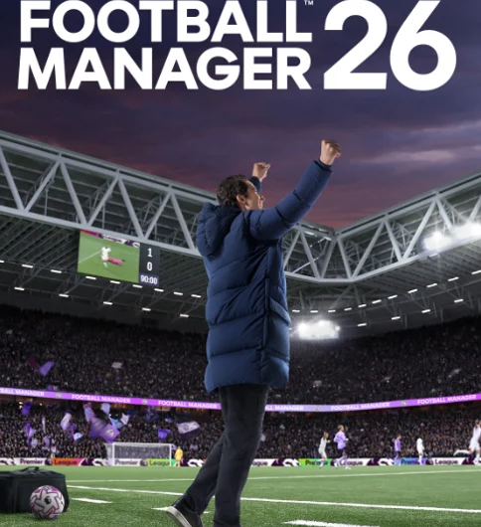
I use my football manager too play my games and select my formation etc.1.ATTACCKING FORMATION 2:BALANCE FORMATION-4-3-3 AND DEFENCE FORMATION-4-1-1 RECOMMEND THESE THREE TACTICAL TO HELP ME TO WIN CAME

outlook
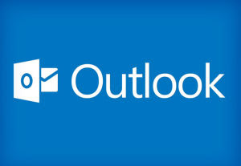
Looking my email, receive my emails and send email and organise

WhatsApp

I use my whatsapp too contact my family and friends. I can send receive videos/photos

Facebook

Facebook for me is a platform that helps me to connect and see the world in a different way, post my photos, comment on peoples pictures and enjoy Facebook

My Short Reflection
I use digital tools every day to communicate, share pictures and organise my life. I understand that digital tools are very important to my life and provide shortcuts for every day functioning

