

Title - Marketing Communication strategies of SHEIN


Student name: Meetkumar Jayeshbhai Patel
Student Number: 2210109
Module: Marketing Management(LCMB7001)
Lecturer: Tushara Balendran
Submission Date: 12th May, 2023

TABLE OF CONTENTS

1.0 Introduction 3
2.0 Company Overview 3
3.0 Define Communication and its Significance in Marketing 4
3.1 Shannon-Weaver Model of Communication 5
3.2 Integrated Market Communication 7
4.0 New Promotion Strategy can be used by SHEIN to improve its awareness 7
5.0 Define Branding and Brand Equity 8
6.0 Keller’s Brand Equity Model for SHEIN 9
6.1 Advantages and Disadvantages of this Model 10
7.0 Customer Journey and Customer Touchpoints in SHIEN 11
7.1 Per-purchase 11
7.2 Purchase 11
7.3 Post-purchase 12
7.4 Customer Journey Map 12
7.5 Strengths and Weakness of Customer Journey for SHIEN 13
8.0 Recommendation for New Customer Touchpoint in SHEIN 13
9.0 Conclusion 14
References 15

1.0 Introduction
Businesses are involved in selling products and services worldwide, and partnerships are the common strategy utilised by these organisations to form diverse cultural relationships as they develop. However, cultural differences between countries impose the greatest communication challenges on organisations. An organisation with adequate and proper marketing communication practices can maintain a good standard with the complexity of business deals. In contrast, inadequate communication practices lead to loss of business market and even tension in the business field. Thus, communication skills need to be integrated with etiquette and non-verbal communication for the effective development of the organisation. This report highlighted the significance of marketing communication considering SHEIN's marketing strategies to improve brand awareness and customer care practices.

2.0 Company Overview
SHEIN is one of the most powerful online Chinese fashion industries, founded by Nanjing in October 2008 and is considered the world’s largest online fashion retailer. Their mission is to be the leader in the modern fashion industry. To achieve this mission, they are heavily engaged in making fashion accessible and affordable to customers worldwide. SHEIN connects to their global customers by promoting its products through micro-influencer marketing (Shen, 2022). A strategy where they use the influence to spread awareness regarding their product on the online platform was one the unique strategy considering this company started in 2008. Their main promotional tools were KOL, live streaming and TikTok. This company is able to retain its customers as they provide cheap but good quality fashion products, and with that, they are aiming to double its annual revenue collection to £57 billion by 2025 with a profit target of £7 billion, as their current annual revenue collection is £19 billion, in 2022 (Sutrisno, 2023). Making it one of the most profitable online fashion industries; further, according to a market survey, it was observed that SHEIN’s second largest consumers are the United States, followed by Brazil.

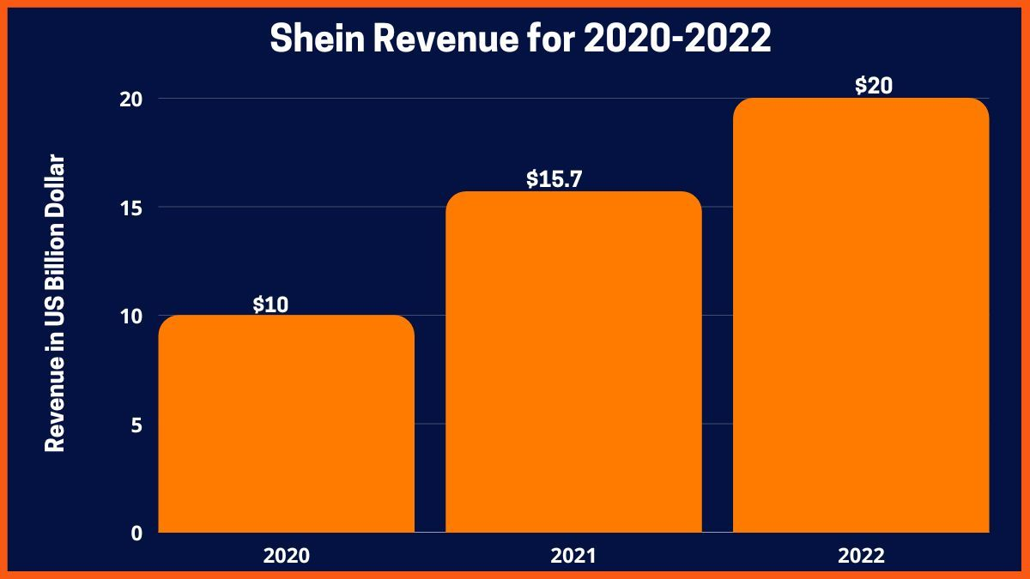
Figure 1: SHEIN Revenue collected from 2022 to 2022
Source: (Sutrisno, 2023)

3.0 Define Communication and its Significance in Marketing

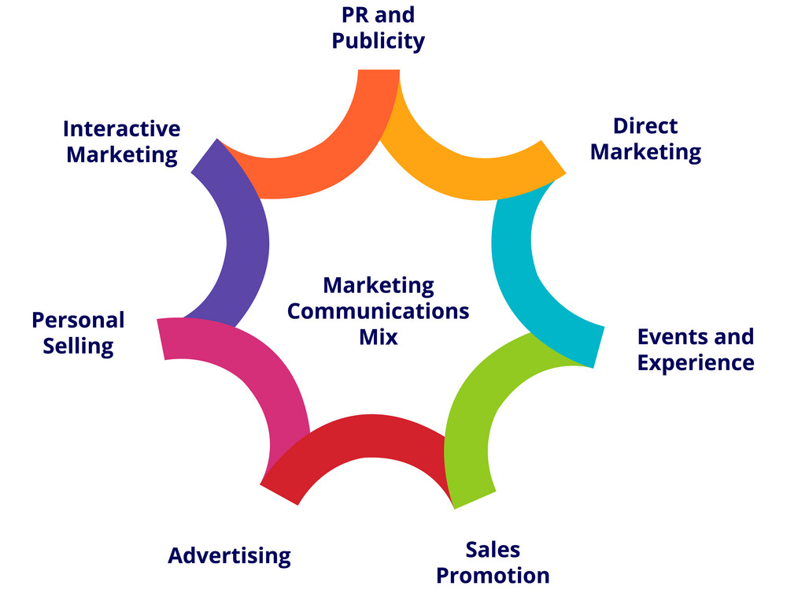
Figure 2: Marketing communication strategies utilised by the organisation.
Source:(Krizanova et al., 2019)

Marketing communication, which is also known as marcom, deals with different messages and media using strategies that a business organisation can use to communicate and form relationships with their target market segmentations. This strategy includes direct marketing, sales promotions, advertising on billboards and online platforms, and performing personal selling. The way effective communication is utilised within the business for sharing information and ideas to improve the efficacy of the workflow; in a similar way, marketing communication is utilised to enhance the internal organisation process (Krizanova et al., 2019). And for this effective market communication, an organisation use different media to exchange information regarding their new products and services with its target customers. This further improves their brand awareness. Proper marketing communication involves answering the mission of their service, the purpose of their products, the target market of their products, and where and when their products can be used.
SHEIN is engaged in marketing communication by providing omnichannel experiences with its website, mobile app, social media accounts such as Instagram, Twitter, and TikTok, and collaboration with fashion influencers to promote its products (Allison, 2022). This is mainly because their target customers are Generation Z, and these people rely more on social media, thus, SHEIN targets them through mobile advertising to discover new fashion trends.

3.1 Shannon-Weaver Model of Communication
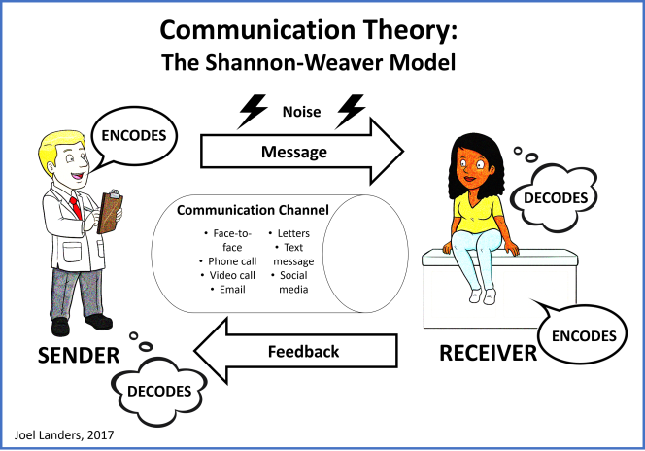
Figure 3: The Shannon-Weaver Model of Communication Theory.
Source: (Kuznar and Yager, 2020)

Weaver model | Definition | SHEIN
Sender | The person who has information regarding certain objects. This information source starts the process by identifying the receiver and channel through which they can share (Kuznar and Yager, 2020). | In the case of SHEIN, the sender shares information about new fashion products through their websites and social media to their target customers.
Encoder | They are the transmitter. They are responsible for sending information from the sender to the receiver. | SHEIN is involved in selling its products directly to its consumers by partnering with influencers and social media stars to promote its new launch. Thus they are transmitters of SHEIN (Wang, 2022).
Channel | This according to the model is the medium that gets information from the sender to transmit it to the receiver (De Giovanni, 2020). | SHEIN uses various mediums to spread awareness regarding their products globally, they are heavily engaged in using KOL, YouTube, and the website, SHEIN.COM (Holmes, 2022).
Noise | This according to the model deals with errors in information delivery. | SHEIN use advanced AI tools such as HTML5, jQuery & Google analytics to ensure their service (Ghosh, 2023).
Decoder | This step deals with converting signals into messages. | SHEIN creates product-specific ads and posters that depict their new launch or other fashion items to communicate when and where their products can be used (Liu, 2022).
Receiver | They are the endpoint of the model, as the person finally receives the information. | SHEIN’s end-point users are young women looking for affordable and trendy fashion products, thus they create their entire marketing strategy to communicate the significance of their product to attract these customers (SHEIN Group, 2022).

3.2 Integrated Market Communication
This deals with unifying the brand’s message to make it consistent across the communication media used by the organisation to reach its target customers. SHEIN operates through a vertically integrated business model, which enables them to undertake everything in-house and aid in monitoring the product processing from product planning to designing and manufacturing. This allows them the maintain consistency with their product quality and SHEIN uses this information regarding the good quality of the product during product promotion through multiple social media platforms (JungleWorks, 2022). Their main communication strategy lies in branding them as a body-positive brand and on-trend clothing influence in all of their online distribution channels, such as YouTube and TikTok, through fashion influencers.

4.0 New Promotion Strategy can be used by SHEIN to improve its awareness
SHEIN is already involved in performing extensive online marketing by promoting itself on various social media and is also consistent with its campaign agenda. However, considering its major competitors, such as ZARA and UNIQLO, who have strong social media-based customers, and a strong influence on the fashion industry, SHEIN needs to enhance their existing online marketing communication regarding its product delivery. This can be achieved by optimising their website, as this will lead to enhancing the search engine results page, which will aid in grabbing the attention of the target customers searching for similar products. Search engine optimization (SEO) deals with keywords, phrases and other advanced tools that are provided by Google and other types of search that the customers can use to search for their products. This will help SHEIN in increasing brand awareness to a wider range of customers globally (Das, 2021). SHEIN can also improve their existing content marketing strategies by frequently releasing unique campaigns of their new launch products or existing products with unique ways of using them, generating posts and short videos regarding their uniqueness and being trendy on social media (Poradova, 2020). However, while doing so, SHEIN needs to post new content regularly on social media to improve its performance in search results which will help them to be discovered by its users online faster.
Further, SHEIN can use paid email marketing but creating lists of their website and mobile app users and then use it to promote their fashion brand. According to market research, email marketing is the most common and trending brand marketing idea to be successful (Olson et al., 2021). This email marketing can be used to provide personalised coupons based on their purchasing behaviour and rewards for being loyal to their brand to their customers and also can be used to promote their new launch sales by sharing emails regarding the uniqueness of the product. This will further enhance the marketing communication of SHEIN and, in turn, will improve its brand awareness.

5.0 Define Branding and Brand Equity
In marketing, branding deals with making customers feel content with the support an organisation is providing and forming a good relationship with the customers. This process involves communicating the unique selling point of the product and services provided by the organisation, which aid them in differentiating its services from its competitor in the business market. These techniques often include the utilisation of logos, taglines, jingles, and mascots (Ebrahim, 2020). SHEIN is an international business-to-consumer clothing brand, as its branding strategy lies in product branding and is heavily engaged in internet-based sales. The logo of SHEIN reflects the reliability of customers to them and the professionalism they maintain in the company. Thus, with this logo, they reflect their value for quality performance and production and also aim to provide their customers with the latest trend in the fashion market. They also have their brand slogan, which states “ Shine In, Shine Out”, to promote their trendy fashion sense. Further, they brand themselves as a company that values body positivity, which aids them in gaming a huge customer base (Shein logo, 2023). Their brand is dedicated to plus-size clothes and promotes body positivity, something that is unique in the fashion market.

Brand equity stands for the value a brand has and is determined by the consumer’s perception of the product's quality and desirability. The four main dimensions of brand equity are brand loyalty, brand awareness, brand associations, and quality of perception. According to the survey by Harris Brand Platform in the first quarter and second quarters of 2022, SHEIN was the top apparel brand by brand equity growth. According to the survey, SHEIN holds the largest share, which is almost over 28% of the fast fashion market in the United States (Harris Poll, 2022). Further, they stated that SHEIN valuation is the third largest valuation for any private company following SpaceX and Byte-Dance.

6.0 Keller’s Brand Equity Model for SHEIN
Keller’s Brand Equity Model, a strategic framework to help organisations build a strong and sustainable brand, consists of four key components that include brand salience, brand performance, brand imagery and brand judgments/feelings/resonance.

Brand Salience is referred to such a degree where a brand is noticed or seen to be on top of mind in a given situation (Dharmawan and Hendrayati, 2019). SHEIN is expected to enhance its core brand salience with the creation of memorable and distinctive brand elements that include the likes of logo design, tagline and brand colours. Focusing on increasing brand awareness through the use of several marketing channels such as SEO, social media marketing and influential marketing might be useful for the brand to get a better response in the markets of the UK.

Brand Performance, a component referring to how well a brand can meet or exceed customer expectations, is key to defining organisational success (Foroudi, 2019). For SHEIN, providing trendy and affordable fashion products along with maintaining good quality and following consumer preferences could make SHEIN stand out in customer experience. Focusing on improving consumer service, delivery times and return policies would also make SHEIN better its brand performance.

Brand Imagery, an important component of the model, refers to the unique and appealing set of brand associations which a brand wants to convey (Jung, Kim and Kim, 2020). SHEIN should focus on building personality, values and lifestyle linked with its brand to present its image to the people as a fashion-loving organisation that follows up-to-date with modern trends. Using brand imagery and following uniqueness would help SHEIN differentiate itself from the competitors in creating and portraying a distinctive brand identity.

The component of Brand Judgments/Feelings/Resonance refers to the overall consumer attitude and loyalty to the brand (Goldstein and Carpenter, 2022). Building brand resonance will be important for SHEIN as creating a bond of emotional connection with the customers would help SHEIN operate better in market demand. Resonating with various brand-building activities such as promoting loyalty programs, brand events and personalised marketing would be beneficial for SHEIN to get people influenced more to come and purchase more SHEIN products.

6.1 Advantages and Disadvantages of this Model
The main advantages associated with Keller's Brand Equity Model would help SHEIN in providing a systematic approach in order to build a strong brand that would help the company identify areas to think of how the core of brand value should be improved (Vukasović, 2022). Creating a unique and appealing brand identity better resonates with the customers, therefore, the following model would prepare SHEIN to enhance brand loyalty and consumer retention by creating a strong brand identity (Vukasović, 2022). Moreover, the model would provide a way to measure brand equity in order to track the progress that SHEIN would make in the UK.

The model would provide the company with better opportunities and scope into identifying areas of improvement to work on bettering brand integrity. However, the main disadvantage of the model would be that it might be time-consuming and costly to implement. The model can be seen as a framework oversimplifying the complexity of building a brand, however, SHEIN cannot solely consider to depend on this model to influence its brand equity.

However, there is no doubt to admit that Keller's Brand Equity Model would make SHEIN better prepared to face challenges specific to the fast fashion industry such as sustainability concerns and ethical issues to work on its core infrastructure (Husain et al., 2020). That would help the fashion retailing brand understand what the customers expect SHEIN products to be and how the company can fulfil consumer desires.

7.0 Customer Journey and Customer Touchpoints in SHIEN

7.1 Per-purchase
SHEIN's customers have been identified as typically aware of the brand through various channels such as social media, search engines, TV commercials or influencer marketing. This gives the fashion retailing brand a huge boost at the pre-purchasing stage where most customers come to visit the website out of curiosity to see and purchase fashion products upon viewing positive reviews and referrals. According to Similar Web, the official website of SHEIN gets web traffic doubling up to 67.2 million monthly visits from 32.7 million visits in September 2020. The majority of traffic has been noted to come from big markets such as India, the United States and Brazil (Wang, 2022). The official website features a variety of products and showcases discounts and promotions in order to appeal to new customers. SHEIN is also active on Instagram platforms where the brand promises the customers to provide a seamless shopping experience along with letting the customers explore personalised recommendations based on their browsing and purchase history. Considering the pre-purchasing stage, consumers' interaction with the brand through several touch points of websites, social media and the mobile app makes a positive first impression of the brand that leads to purchasing.

7.2 Purchase
Following the pre-purchasing stage, the purchase stage is considered a critical point where customers have to make decisions if they want to buy a product from SHEIN or not. SHEIN offers a variety of payment options in online shopping such as PayPal, credit/debit cards and other e-wallet options. The net revenue of SHEIN is said to be around 8.8 billion euros in 2020 which was a notable growth from 2019's 5.1 billion euros (Allison, 2022). SHEIN also offers free shipping worldwide for orders over a specific amount which encourages customers to purchase more products from SHEIN. Customers usually interact with the brand through the official website or the mobile app to show the company if they are interested enough to buy products. The checkout process of the company is made in such a way that would looks simple and user-friendly that also provides customers hassle-free experience, letting customers desire more purchases or give recommendations to their friends and families.

7.3 Post-purchase
The post-purchase stage is the most essential stage where SHEIN has to track down the user experience to understand how people are responding after purchasing. In that way, the retail brand gets to know where the company is lacking and how to improve areas of improvement to better promote user experience and maintain a loyal base of customers. SHEIN sends post-purchase emails that provide customers with order confirmation, shipping updates and post-purchase recommendations. The company also asks the customers to rate and review in order to let the management know if the customers are satisfied. SHEIN has a good 4.2-star rating across web sources indicating a high level of customer satisfaction (Liu, 2022). The return policy of the company let the customers return products within 60 days of purchase without any chaotic product-return experience (Liu, 2022). The mobile app of SHEIN provides push notifications that enable customers to track their orders and receive updates on new products and promotions and the same goes for return policy also. The inclusion of various touch points through the mobile app, SHEIN’s website page and email create an emotional connection between the customers and the brand, uplifting customer loyalty and user experience.

7.4 Customer Journey Map

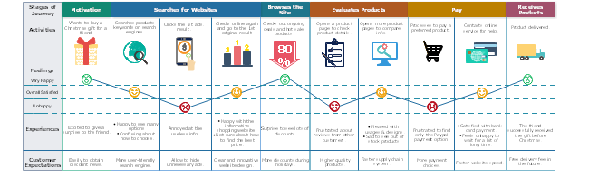
Figure 4 - A proposed framework of SHEIN’s Customer Journey Map
(Alvarez et al., 2020)

The Customer Journey Map of SHEIN, a visual representation of consumers' experience with the brand, includes the touchpoints like the search engine, SHEIN website, mobile app, checkout process, social media and post-purchase communications. Understanding the viewpoint of consumer interaction and tracking down the customer journey by comprehending from thinking of purchasing to purchasing and then using the product is important (Saleem et al., 2019). This helps SHEIN better integrate with the emotional connection of the customers.

7.5 Strengths and Weakness of Customer Journey for SHIEN
Following the consumer journey provides SHEIN with numerous opportunities of working on a user-friendly website, looking for easy-going payment options and having hassle-free return policies and post-purchase communications. Following the customer journey map gives the retail brand an overview of how things are going on and what people expect things to be (Pantano, Pedeliento and Christodoulides, 2022). This helps the brand reduce the gap between expectation and reality and upgrade user experience (Pantano, Pedeliento and Christodoulides, 2022). However, the main challenge associated with the customer journey can be a long time period on which the brand has to observe and come up with ideas. Lack of consistency can make things harder for SHEIN.

8.0 Recommendation for New Customer Touchpoint in SHEIN
- Introducing a virtual fitting room by allowing customers to try on clothes virtually would enhance the online shopping experience for the customers of SHEIN.
- Providing 24×7 AI Assistance assisting customers with their queries would improve customer support (Rathore, 2023).
- SHEIN should work on a loyalty program in the UK rewarding customers for their purchases and engagement with the brand by sending them notes or small rewards which would make the bond with customers better.
- Social media integration and understanding consumer feedback in the official SHEIN app and the website would help the management make better decisions in providing seamless experiences (Allison, 2022).
- Offering personalised product recommendations following customer preference and purchase history would create a more personalised shopping experience for individuals, making the customers happy and satisfied with the purchase.

9.0 Conclusion
In conclusion, the report highlights the significance of marketing communication that looks thoroughly into the marketing strategies of SHEIN in the context of the UK. The paper follows efficient communication practices and justifies how maintaining a good standard in communication strategy can result in bettering purchases and profits for SHEIN. The report ends with a series of realistic recommendations that SHEIN should consider to flourish their business.

References
Allison (2022) Shein's marketing strategy is conquering the West, Daxue Consulting - Market Research China. Available at: https://daxueconsulting.com/shein-market-strategy/ (Accessed: May 5, 2023).

Alvarez, J., Léger, P.M., Fredette, M., Chen, S.L., Maunier, B. and Senecal, S., 2020. An enriched customer journey map: how to construct and visualize a global portrait of both lived and perceived users’ experiences?. Designs, 4(3), p.29.

Das, S., 2021. Search engine optimization and marketing: A recipe for success in digital marketing. CRC press.

De Giovanni, P., 2020. Blockchain and smart contracts in supply chain management: A game theoretic model. International Journal of Production Economics, 228, p.107855.

Dharmawan, F. and Hendrayati, H., 2019. Customer-based brand equity in digital age: A conceptual approach. KnE Social Sciences, pp.986-1007.

Ebrahim, R.S., 2020. The role of trust in understanding the impact of social media marketing on brand equity and brand loyalty. Journal of Relationship Marketing, 19(4), pp.287-308.

Foroudi, P., 2019. Influence of brand signature, brand awareness, brand attitude, brand reputation on hotel industry’s brand performance. International journal of hospitality management, 76, pp.271-285.

Ghosh, P. (2023) Which is the best eCommerce platform for clothing brand in 2023?, BiztechCS. Available at: https://www.biztechcs.com/blog/best-ecommerce-platform-for-clothing-brand/ (Accessed: 2ND May 2023).

Goldstein, G.A. and Carpenter, G.S., 2022. Legitimately luxurious: Creating authentic luxury brands. Business Horizons, 65(5), pp.631-642.

Holmes, J., 2022. SHEIN: The Perfectionists of Manipulation and Exploitation. Critical Reflections: A Student Journal on Contemporary Sociological Issues.

Husain, T., Sani, A., Ardhiansyah, M. and Wiliani, N., 2020. Online Shop as an interactive media information society based on search engine optimization (SEO). International Journal of Computer Trends and Technology (IJCTT), 68(3), pp.53-57.

Jung, J., Kim, S.J. and Kim, K.H., 2020. Sustainable marketing activities of traditional fashion market and brand loyalty. Journal of Business Research, 120, pp.294-301.

Krizanova, A., Lăzăroiu, G., Gajanova, L., Kliestikova, J., Nadanyiova, M. and Moravcikova, D., 2019. The effectiveness of marketing communication and importance of its evaluation in an online environment. Sustainability, 11(24), p.7016.

Kuznar, L.A. and Yager, M., 2020. The Development of Communication Models, Quick Look. Joint Staff J39, Strategic Multi-layer Assessment Washington, DC United States.

Liu, J., 2022, December. Research on the Business Strategy and Deficiency of the Fast Fashion Industry to Enhance Development-a Case Study of Shein. In 2022 2nd International Conference on Economic Development and Business Culture (ICEDBC 2022) (pp. 1794-1801). Atlantis Press.

Olson, E.M., Olson, K.M., Czaplewski, A.J. and Key, T.M., 2021. Business strategy and the management of digital marketing. Business horizons, 64(2), pp.285-293.

Pantano, E., Pedeliento, G. and Christodoulides, G., 2022. A strategic framework for technological innovations in support of the customer experience: A focus on luxury retailers. Journal of Retailing and Consumer Services, 66, p.102959.

Poradova, M., 2020. Content marketing strategy and its impact on customers under the global market conditions. In SHS Web of Conferences (Vol. 74, p. 01027). EDP Sciences.

Rathore, B., 2023. Digital Transformation 4.0: Integration of Artificial Intelligence & Metaverse in Marketing. Eduzone: International Peer Reviewed/Refereed Multidisciplinary Journal, 12(1), pp.42-48.

Saleem, H., Uddin, M.K.S., Habib-ur-Rehman, S., Saleem, S. and Aslam, A.M., 2019. Strategic data-driven approach to improve conversion rates and sales performance of e-commerce websites. International Journal of Scientific & Engineering Research, 10(4), pp.588-593.

Shein logo (2023) 1000 Logos The Famous Brands and Company Logos in the World Shein logo Comments. Available at: https://1000logos.net/shein/ (Accessed: 2ND May 2023).

Shein: America's Number 1 fast fashion brand continues to rise (2022) Harris Poll. Available at: https://theharrispoll.com/briefs/shein-americas-number-1-fast-fashion-brand-continues-to-rise/ (Accessed: May 5, 2023).
Shein: The genius marketing strategy behind the billion dollar company (2022) JungleWorks. Available at: https://jungleworks.com/shein-the-genius-marketing-strategy-behind-the-billion-dollar-company/ (Accessed: 2ND May 2023).

Shen, J., 2022, April. Analyzing on the Going Global Marketing Strategy–Taking Shein as an Example. In 2022 International Conference on Creative Industry and Knowledge Economy (CIKE 2022) (pp. 225-229). Atlantis Press.

Sutrisno, G.B. (2023) Tech in Asia - connecting Asia's startup ecosystem. Available at: https://www.techinasia.com/shein-eyes-60b-revenue-2025-ipo-nears-report#:~:text=Specifically%2C%20Shein%20targets%20its%20annual,target%20of%20US%247.5%20billion. (Accessed: 2ND May 2023).

Vukasović, T., 2022. Customer-Based Brand Equity: Conceptual model. Management, 19, p.21.
Wang, Y., 2022, December. The survival of cross-border e-commerce under the pandemic-the example of Shein. In 2022 4th International Conference on Economic Management and Cultural Industry (ICEMCI 2022) (pp. 2116-2126). Atlantis Press.

Women's Wear Daily: Shein survey reveals how young consumers are reacting to&nbsp;inflation (2022) Women's Wear Daily: SHEIN Survey Reveals How Young Consumers Are Reacting to&nbsp;Inflation – SHEIN Group. Available at: https://sheingroup.com/corporate-news/womens-wear-daily-shein-survey-reveals-how-young-consumers-are-reacting-to-inflation/ (Accessed: 2ND May 2023).

