

Student name: Seli Tu Henriques Sequeira
Student ID:
Module name: Principles of Health and Social Care Practice
Module code: BMHP5016
Lecturer name: Dr Farah Wiita
Assessment:
Reflection on Person-Centred Care, Partnership Working and Ethics in Practice

Table of Contents
Introduction .................................................................... 3
TASK 1: Reflection on the Importance of Principles .............................. 3
Person-Centred Care .......................................................... 3
Partnership Working .......................................................... 3
Ethics in Health and Social Care ............................................. 4
Interconnections Between the Principles ...................................... 4
TASK 2: Practical Examples of Concepts in Practice .............................. 5
Case Study: Margaret’s Situation ............................................. 5
Application of Person-Centred Care ........................................... 6
Partnership Working in Practice .............................................. 6
Ethical Considerations ....................................................... 6
Critical Reflection on the Case .............................................. 7
TASK 3: Self-Reflection as a Professional ....................................... 7
Current Strengths ............................................................ 7
Areas for Development ........................................................ 7
Professional Development Plan ................................................ 8
Monitoring Progress and Future Practice ...................................... 8
Conclusion ...................................................................... 9
References ...................................................................... 10

Introduction
Reflective practice is an essential component of professional development in health and social care. This report critically examines three fundamental principles — person-centred care, partnership working, and ethics — within UK health and social care practice. It explores the theoretical and legislative foundations of these principles, their application in practice, and their influence on professional development.

The analysis draws upon key UK legislation, including the Care Act 2014 and the Health and Social Care Act 2012, alongside professional guidelines and relevant theoretical frameworks, particularly Vygotsky’s sociocultural theory, which emphasises learning through social interaction and collaboration (Vygotsky, 1978). These principles collectively underpin the delivery of high-quality, respectful, and effective care.

TASK 1: Reflection on the Importance of Principles

Person-Centred Care
Person-centred care places the individual at the centre of care planning and delivery. It moves beyond a purely medical model to recognise the person’s values, preferences, experiences, and aspirations (Skills for Health, 2024; Health Education England, 2023). This approach is rooted in humanistic psychology, particularly Carl Rogers’ person-centred therapy, which highlights empathy, unconditional positive regard, and congruence (Rogers, 1951). In UK practice, person-centred care is embedded in legislation through the Care Act 2014, which places a statutory duty on local authorities to promote individual wellbeing, dignity, and control over daily life (Department of Health and Social Care, 2014). McCormack and McCance’s Person-centred Nursing Framework further stresses the importance of contextual, attitudinal, and moral dimensions in maintaining the person at the heart of caring relationships (McCormack and McCance, 2021).

Partnership Working
Partnership working involves collaboration between professionals, service users, families, and organisations to achieve shared goals. It is particularly important when addressing complex needs that extend beyond a single discipline (Glasby, 2024). This principle is strongly supported by the Health and Social Care Act 2012 and the Health and Care Act 2022, which established Integrated Care Systems (ICSs) to promote joined-up working and reduce health inequalities (Department of Health, 2012; Department of Health and Social Care, 2022). From a theoretical perspective, partnership working aligns with Lev Vygotsky’s sociocultural theory, which emphasises that cognitive and social development occurs through interaction, shared knowledge construction, and collaborative processes within a social and cultural context (Vygotsky, 1978).
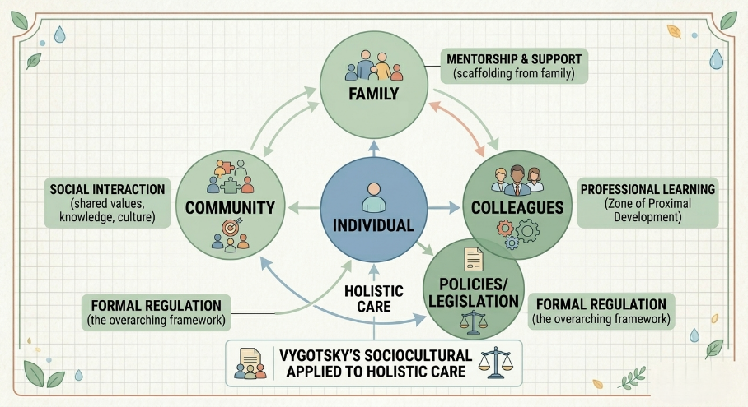
Vygotsky Sociocultural Theory Diagram

Ethics in Health and Social Care
Ethics provides the moral foundation for health and social care practice. The four core principles of biomedical ethics — autonomy, beneficence, non-maleficence, and justice — guide decision-making (Beauchamp and Childress, 2019). These are reflected in professional codes such as the Nursing and Midwifery Council (NMC) Code, which requires practitioners to treat people with respect and uphold dignity (Nursing and Midwifery Council, 2018). The Mental Capacity Act 2005 further supports autonomy by providing a legal framework for assessing capacity and making best-interest decisions (Department of Health, 2005).

Interconnections Between the Principles
These three principles are deeply interconnected. Person-centred care depends on effective partnership working, while both are underpinned by ethical practice. When applied together, they promote care that is respectful, coordinated, and rights-based rather than purely task-oriented. However, in practice, time pressures and resource constraints can sometimes undermine their full implementation, highlighting the need for ongoing commitment at both individual and organisational levels.
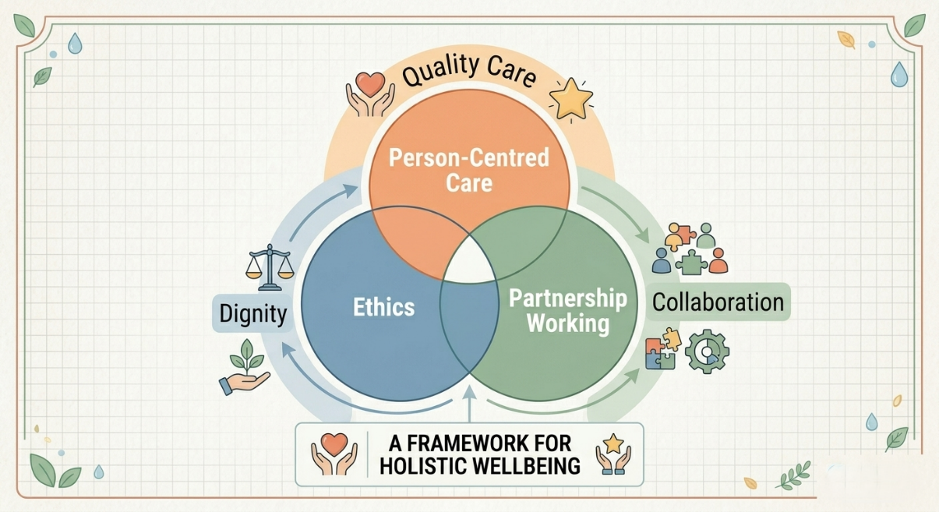
(Reflection on the Importance of Principles) to visually summarise how the three principles connect and support quality care

TASK 2: Practical Examples of Concepts in Practice

Case Study: Margaret’s Situation
A good example of how these principles can be applied to a specific case can be observed through the case of Margaret, who was an 82-year-old woman who was admitted to a health and social care environment after a fall at home. Margaret lives alone in her own home and has been living alone until the incident, which left her with a fractured hip, which necessitated surgery and rehabilitation. She was also diagnosed with early-stage dementia, and this complicated her discharge planning. Such a combination of physical injury, mental inability and social isolation implied that a holistic and well-coordinated approach was crucial to guarantee her safety, wellbeing and desired outcomes. The case has raised various issues, which include the desire of Margaret to go back home against the fact that she is vulnerable and the amount of assistance needed in the community.
Application of Person-Centred Care
The care team applied person-centred care by actively involving Margaret in decision-making. Nurses used clear, simple communication to explain options and confirm her understanding, thereby recognising her as an individual with preferences and rights rather than focusing solely on her medical condition (Skills for Health, 2024; Health Education England, 2023). This approach directly supports the wellbeing principle in the Care Act 2014, which requires care and support to be based on individual aspirations and to promote independence (Department of Health and Social Care, 2014).

Partnership Working in Practice
Partnership working was demonstrated through a multidisciplinary team (MDT) meeting involving the physiotherapist, occupational therapist, social worker, and Margaret’s daughter. Each professional contributed specialist expertise, including home adaptations, mobility assessments, and community support packages. This collaborative model reflects the integrated care approach promoted by the Health and Care Act 2022 and NICE guidance on older people’s integrated care (Department of Health and Social Care, 2022; National Institute for Health and Care Excellence, 2021).

Ethical Considerations
The process was ethically based. The team took into account the expressed desire of Margaret to go home against the will of her daughter to be placed in a care home. This ruling was a close call between the ethical doctrines of autonomy and non-maleficence and justified by the framework of the Mental Capacity Act 2005 on evaluating capacity and establishing best interests (Department of Health, 2005; Beauchamp and Childress, 2019).
The care team performed a detailed capacity evaluation and concluded that Margaret was able to make this particular decision. It was highly important to respect her autonomy, though accompanied by some risk. Meanwhile, the principle of non-maleficence was observed as a strong home care package was introduced and frequent monitoring was conducted to avoid any harm. The team also put into consideration beneficence by providing an overall well-being and quality of life to Margaret and justice by giving her the resources equally. This ethical practice shows how professionals need to negotiate the intricate family dynamics and conflicting priorities and adhere to the person-centred values and the requirements of the legislation.

Critical Reflection on the Case
While the outcome was positive, with Margaret returning home with a comprehensive care package, limitations were evident. Margaret appeared overwhelmed during the MDT meeting, suggesting that additional preparatory one-to-one discussions could have better supported her participation. This highlights a common challenge in multidisciplinary working, where time pressures and differing professional perspectives can sometimes reduce the depth of person-centred engagement (Glasby, 2024; Care Quality Commission, 2023).

Overall, this case demonstrates how the effective integration of person-centred care, partnership working, and ethical principles leads to improved outcomes, greater service user satisfaction, and more coordinated care.

TASK 3: Self-Reflection as a Professional

Current Strengths
As a final-year student approaching qualification, reflection on person-centred care, partnership working, and ethics has moved from theoretical understanding to practical application through placement experiences.

In terms of current strengths, empathy stands out as a key attribute that supports person-centred care. On placement, when a patient became agitated due to a discharge delay, taking time to listen to their concerns helped the individual feel heard and respected, aligning with the core values of person-centred practice (Skills for Health, 2024). Confidence in partnership working has also developed through active participation in handovers and MDT discussions, recognising the value of different professional contributions as promoted by the Health and Social Care Act 2012 (Department of Health, 2012).

Areas for Development
Areas requiring further development include confidence in formal and high-pressure situations, such as family meetings, where hesitation has occasionally limited contributions. Balancing empathy with professional boundaries remains another challenge, particularly in emotionally demanding end-of-life situations. The NHS Constitution highlights the importance of maintaining boundaries for sustainable practice (Department of Health and Social Care, 2021). In ethics, applying the Mental Capacity Act 2005 in complex cases involving capacity and consent still requires greater confidence (Department of Health, 2005).

Professional Development Plan
A clear development plan has been established. By the end of the module, active participation in placement discussions and seminars will be prioritised to build communication confidence. Over the next six months, targeted learning on safeguarding, ethics, and the Mental Capacity Act will be undertaken, utilising resources from the Social Care Institute for Excellence (SCIE, 2022). During the first year of qualified practice, regular supervision sessions will be sought to support reflective learning, consistent with Vygotsky’s emphasis on development through social interaction (Vygotsky, 1978).

Monitoring Progress and Future Practice
Progress will be monitored through a reflective journal and active seeking of feedback. Practice will be guided by the CQC’s “Right support, right care, right culture” framework (Care Quality Commission, 2022) and the NHS Long Term Plan (NHS England, 2019), ensuring continued commitment to person-centred, integrated, and ethically sound care.
This professional journey is viewed as an ongoing process of learning and refinement. Maintaining honest reflection and openness to development will be essential in becoming a competent, compassionate, and ethically grounded health and social care professional.

Conclusion

To sum up, effective, compassionate, and legally-compliant health and social care practice in the United Kingdom depends on person-centred care, partnership working and ethics. This report has shown that person-centred care provides people with dignity and active participation in their care decisions, which are highly encouraged by the Care Act 2014 and humanistic principles of Rogers. The coordinated, multidisciplinary response to the complex needs is achieved through partnership working, which is supported by the Health and Care Act 2022 and the sociocultural theory of Vygotsky. In the meantime, ethical practice under the four principles of Beauchamp and Childress and the Mental Capacity Act 2005 will help to keep the decisions ethically sound and right-based.

The example of Margaret is a clear indication of how a combination of these principles can provide safer and more personalised results and points out at the current issues of time constraints and communication problems. As a future professional, these are not just concepts that should be placed in theory but rather need to be used to provide quality services. With the ever-increasing needs in health and social care, a long-term dedication to these values, alongside an ongoing professional reflection and growth, will be essential. In the end, ensuring that all these principles are entrenched in practice will help to make the care system more humane, equitable, and effective which will actually make an individual the centre of it.

Reference
Beauchamp, T. L. and Childress, J. F. (2019) Principles of Biomedical Ethics. 8th edn. Oxford: Oxford University Press.
Care Quality Commission (CQC) (2022) Right support, right care, right culture. London: CQC.
Care Quality Commission (CQC) (2023) Fundamental standards. London: CQC.
Department of Health (2005) Mental Capacity Act 2005. London: HMSO.
Department of Health (2012) Health and Social Care Act 2012. London: HMSO.
Department of Health and Social Care (2014) Care Act 2014. London: HMSO.
Department of Health and Social Care (2021) The NHS Constitution for England. London: DHSC.
Department of Health and Social Care (2022) Health and Care Act 2022. London: HMSO.
Glasby, J. (2024) Partnership working in health and social care. 4th edn. Bristol: Policy Press.
Health Education England (2023) Person-centred care. Available at: https://www.hee.nhs.uk/our-work/person-centred-care
McCormack, B. and McCance, T. (2021) ‘The Person-centred Nursing Framework: a mid-range theory for nursing practice’, Journal of Research in Nursing, 26(1-2), pp. 47-60.
National Institute for Health and Care Excellence (NICE) (2021) Older people: integrated care. London: NICE.
NHS England (2019) The NHS Long Term Plan. London: NHS England.
Nursing and Midwifery Council (2018) The Code: Professional standards of practice and behaviour for nurses, midwives and nursing associates. London: NMC.
Rogers, C. R. (1951) Client-Centered Therapy: Its Current Practice, Implications, and Theory. Boston: Houghton Mifflin.
Skills for Health (2024) Person-Centred Care: Meaning and Implications. Available at: https://www.skillsforhealth.org.uk/article/person-centred-care-meaning-implications/
Social Care Institute for Excellence (SCIE) (2022) Safeguarding and good practice guidance. London: SCIE.
Vygotsky, L.S. (1978) Mind in Society: The Development of Higher Psychological Processes. Cambridge, MA: Harvard University Press.

