Problem Solving and Decision Making
University of Wales Trinity Saint David
Florina Bidea Student ID 1817440
Lecturer: Yajesh Kumar

Table of Contents
PPT 3
Speaker Notes 10
Complex Problem in a Workplace 10
Scope of Problem 10
Impact of Problem 10
Increased Workplace Conflict 11
Poor Company Morale 11
Reduced Organisational Productivity 11
Inequalities in an Organisation by HR Department 12
Policy-Based Inequality 13
Inequality in Decision Making 13
Inequalities Due to HR Enactment 14
Alternative Solutions 15
Solution for Policy-Based Inequality 15
Solution for Inequality in Decision Making 15
Solution for Inequalities Due to HR Enactment 16
Monitoring and Review Techniques 17
Baseline Assessment 17
Monitoring Implementation 17
References 18

PPT

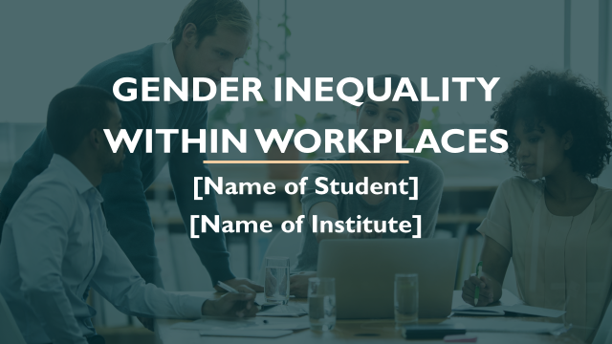



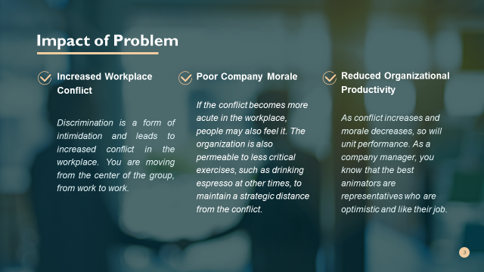

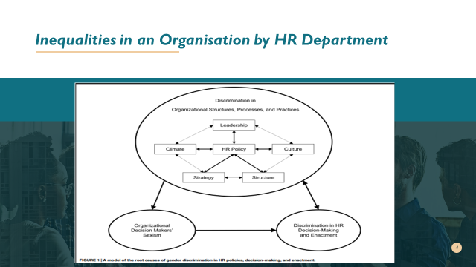
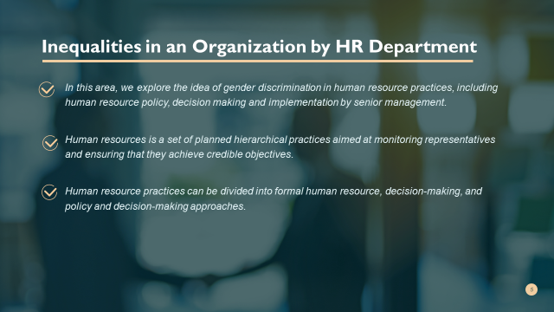
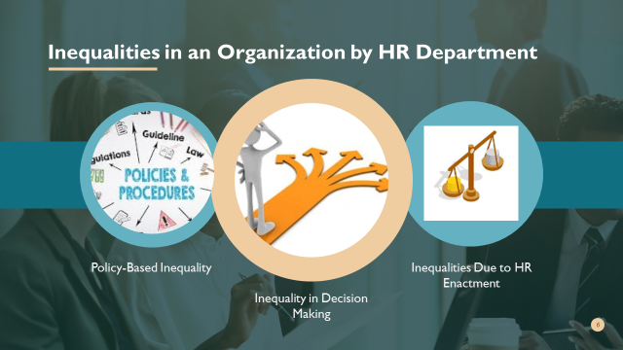
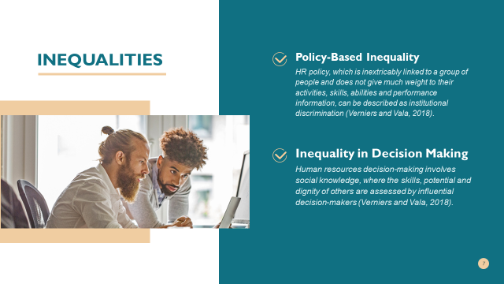
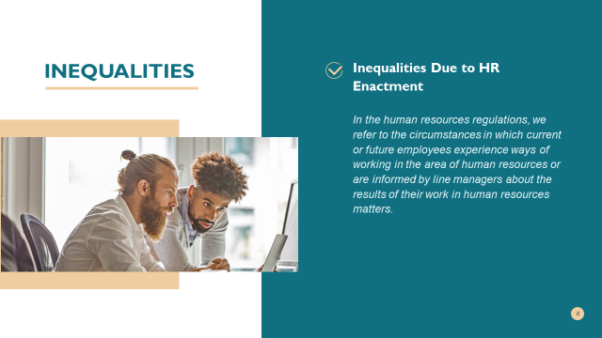
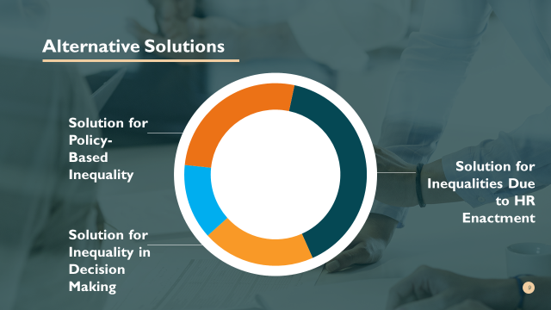

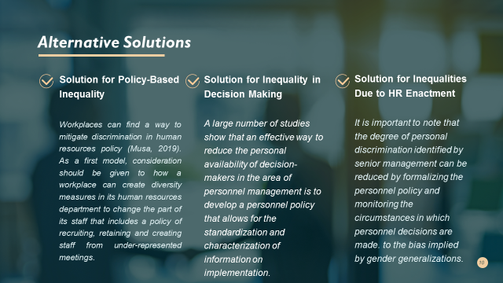
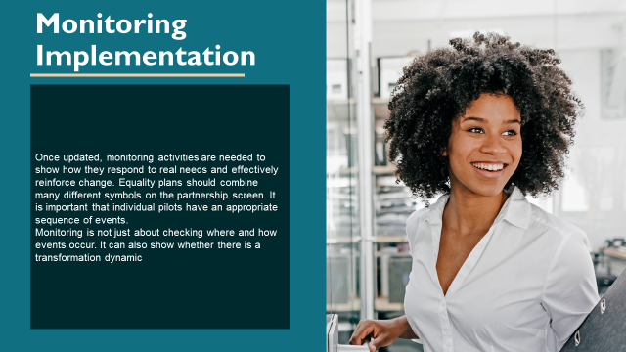
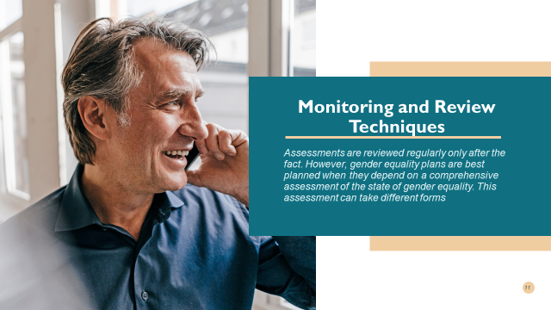
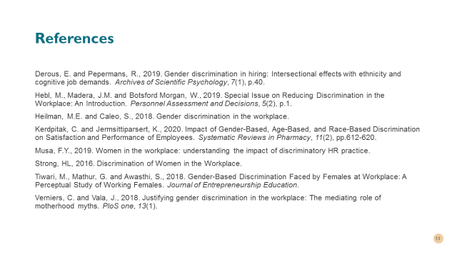

Speaker Notes

Complex Problem in a Workplace
In some cases, the work is described as inhospitable to women because of multiple gender inequalities (Derous and Pepermans, 2019). Some examples of how discrimination in the workplace affects women's income, and opportunities are the gender pay gap, the lack of a female driving force and the fact that women (as opposed to men) need more time to move up in the workplace. Discrimination in the workplace can reduce women's socio-economic status. This discrimination against women is largely due to personnel policies and decisions. In addition, personal discrimination can be seen as chauvinistic when employees are in contact with senior management when working with staff or when they are informed of the results of human resource decisions.

Scope of Problem
To the extent that equality between women and men is achieved in the workplace, managers can do much to improve equality between men and women in the workplace. The truth is that today's employers must see gender equality as more than a privilege for women. As a business leader, you must learn to understand, prevent and eliminate gender discrimination in order to maintain a strategic distance from destructive outcomes. The net impact of gender inequality on development is very uncertain; it can become an incredible obstacle to development or only increase it. It has a rapid impact on wages and can change general interest rates. These wage differences dominate the incentive framework that plans to invest in human capital and thus affect development (Hebl et al., 2019).

Impact of Problem
There are many negative effects of gender-based inequalities in an organisation. Some of the effects from literature has been identified mention below:

Increased Workplace Conflict
Discrimination is a form of intimidation and leads to increased conflict in the workplace. You are moving from the centre of the group, from work to work. You can divide the group by organising a meeting on behalf of the victim and giving a face to the alleged discriminator (Kerdpitak and Jermsittiparsert, 2020). This conflict is not useful in the workplace and can affect the work of the whole office or group.

Poor Company Morale
If the conflict becomes more acute in the workplace, people may also feel it. The organisation is also permeable to less critical exercises, such as drinking espresso at other times, to maintain a strategic distance from the conflict. The overall morale of the group decreases as individuals begin to distance themselves slightly from any escalation of the conflict. Low morale has a negative impact on corporate culture and is directly perceived by customers (Musa, 2019).

Reduced Organisational Productivity

As conflict increases and morale decreases, so will unit performance. As a company manager, you know that the best animators are representatives who are optimistic and like their job. When people try to stay away from negative behaviour, for example, by detecting or seeing gender discrimination, this can have a significant impact on the main business issue (Tiwari et al., 2018).

Inequalities in an Organisation by HR Department
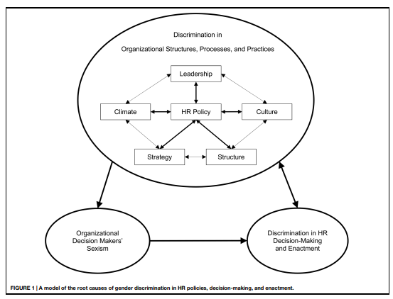
In this area, we explore the idea of gender discrimination in human resource practices, including human resource policy, decision making and implementation by senior management. Human resources is a set of planned hierarchical practices aimed at monitoring representatives and ensuring that they achieve credible objectives. Human resources include management identification, assessment, development and preparation (Tiwari et al., 2018). Depending on the size and history of the workplace, HR skills can range from highly organised and managed HR professionals in the office to irregular policies and technical mechanisms commissioned by directors and managers without formal training. Generally speaking, when deciding that new employees should be assessed for compensation and performance within the workplace, HR practices are important and can also influence how they are treated within the workplace (Strong, 2016).
Human resource practices can be divided into formal human resource, decision-making, and policy and decision-making approaches. The human resources approach organises practices in the area of human resources competence, implementation assessment, resource representation reporting and organisation. Human resources decision-making occurs when decision-makers with authority (i.e., human resources directors, managers or staff) use the human resources approach to decide how to apply it to a particular issue and person. The HR approach involves personal collaboration between key decision-makers and competitors or employees in the implementation of the HR policy. While the HR approach may reflect institutional discrimination, decision-making and the definition of HR may reflect personal discrimination by senior managers (Verniers and Vala, 2018).

Policy-Based Inequality
HR policy, which is inextricably linked to a group of people and does not give much weight to their activities, skills, abilities and performance information, can be described as institutional discrimination (Verniers and Vala, 2018). Institutional discrimination against women can manifest itself in any form of a personal approach, recruitment and selection of a person for a workplace, in relation to her professional tasks, training, salary, performance evaluation, rotation and termination of employment. For example, if women are under-represented in a particular educational program or type of work and such certification or initial training is required, women are often the victims, methodically but perhaps unconsciously. In another model, gender discrimination occurs when a test is used that offers more gender-specific contrasts than job evaluation. Therefore, institutional discrimination may be present in different parts of the human resource evaluation approach and may affect women's performance.

Inequality in Decision Making
Human resources decision-making involves social knowledge, where the skills, potential and dignity of others are assessed by influential decision-makers (Verniers and Vala, 2018). In this line, as in all other forms of social knowledge, human resource decisions are available according to personal preferences. Human resource decisions are, in principle, important because they determine women's pay and employment opportunities (e.g., promotion, preparation for work). Personal discrimination against women by senior managers can occur at any stage of human resources decision-making in relation to recruitment and selection, job allocation, training opportunities, remuneration, performance assessment, promotion and termination of employment.
Studies using different procedures show that women experience personal discrimination in the identification process. Meta-analyses show that when female candidates are considered for "male" work (i.e., professions that are regulated and accepted by men), they are even more exposed to mutual evaluation by survey participants and less often offer jobs, while male competitors play each other and coordinate their activities. For example, in a survey aimed at sending apparently authentic statements and changing the gender of the candidate, candidates are more hesitant than their male counterparts about whether they are satisfied or satisfied (Heilman and Caleo, 2018). A report on rotation, science, materials and science teachers, both men and women, evaluated the science subgroup as the director of the research centre. It found that the male candidate was very well equipped and recruited, offered a higher entry fee (approximately 5,000) and provided more professional advice than the candidate. In general, women suffer a clear loss when it comes to male occupations.

Inequalities Due to HR Enactment
In the human resources regulations, we refer to the circumstances in which current or future employees experience ways of working in the area of human resources or are informed by line managers about the results of their work in human resources matters. Personal gender discrimination may occur when employees receive sexist messages from line managers regarding the application of human resources. More specifically, this form of personal gender discrimination is called sexual harassment and includes a range of verbal and non-verbal practices that convey sexist, annoying or antagonistic attitudes towards women. Sexual harassment is the best-known form of gender discrimination (Strong, 2016).
While it may seem absurd for decision-makers to inform women about sexist provisions when they are informed about personnel decisions, there are striking examples of allegations of discrimination when it occurs. For example, in one of Walmart's attempts, women's experts found that, despite their dominant skills and management, they were making less progress than their husband. In general, the Regional Director was accused of arguing on behalf of certain women who were not taken into account when assessing progress, which was not the case for women in management positions.

Alternative Solutions

Solution for Policy-Based Inequality
Workplaces can find a way to mitigate discrimination in human resources policy (Musa, 2019). As a first model, consideration should be given to how a workplace can create diversity measures in its human resources department to change the part of its staff that includes a policy of recruiting, retaining and creating staff from under-represented meetings. Diversity action can serve as public policy for minorities in social programmes, such as workplaces that (a) monitor and evaluate the number of qualified people attending different meetings (e.g. women and men) in reserve, and (b) the number of qualified people attending each meeting that takes place or is at an advanced stage. If the number of participants in a meeting that is actually selected changes completely in relation to the size of the certified group, measures such as selective recruitment should be taken (Kerdpitak and Jermsittiparsert, 2020).
While welcoming the diversity of human resources and family-friendly policies, gender discrimination can be reduced, and other acceptable structures, procedures and practices can be reorganised, and gender equality within those structures and practices improved. In particular, if effective, these policies should increase the number of women in all departments and at all levels of the partnership. In addition, the fact that there are more women in leadership positions demonstrates that a reputable partnership is sensitive to diversity, which affects the atmosphere of diversity and ultimately, the culture of the partnership. In this sense, a specific human resources policy can reduce gender inequalities in all other State structures, procedures and practices (Tiwari et al., 2018).

Solution for Inequality in Decision Making
A large number of studies show that an effective way to reduce the personal availability of decision-makers in the area of personnel management is to develop a personnel policy that allows for the standardisation and characterisation of information on implementation. In order to reduce discrimination in human resources decisions (e.g., representative decisions on recruitment and promotion), professional surveys should be conducted to determine the relevant skills and information required for specific positions (Derous and Pepermans, 2019).
In this way, assumptions about the characteristics of the ideal representative for a given position will depend on accurate information about that position, not on gender-specific job profiles. In order to reduce discrimination in the assessment of implementation, human resources policy should include the use of reliable assessments that are consistent with expressed needs in the implementation and reliable application of this practice to all staff assessments. In cases where gender contrast is more pronounced in screening tests than in implementation assessments, the use of such unilateral screening tests should be reintroduced. In general, the establishment of a human resources policy that standardises and characterises the evaluation procedure for representatives/subcontractors and supervisors can reduce the personal propensity for human resources practices (Hebl et al., 2019).

Solution for Inequalities Due to HR Enactment
It is important to note that the degree of personal discrimination identified by senior management can be reduced by formalising the personnel policy and monitoring the circumstances in which personnel decisions are made. We have explained how human resource decisions are linked to social knowledge and are therefore susceptible to the bias implied by gender generalisations. This can happen by chance if people feel unbiased, but are affected by negative generalisations or scheduled work (Kerdpitak and Jermsittiparsert, 2020).
For example, if human resource policy is independent of objective models, and the evaluation context is uncertain, policymakers will use gender (and other) generalisations to fill gaps in the evaluation of candidates. It is important that the context can be developed to reduce these trends. For example, decision-makers will make fewer unilateral decisions if they have more time to evaluate others, are less subjective, have more data on applicants and are responsible for legitimising their evaluations and decisions. In this way, in the unlikely event that they have the capacity, inspiration and ability to make very well thought-out and gradually accurate decisions, discrimination in the assessment of implementation can be reduced.

Monitoring and Review Techniques

Baseline Assessment
Assessments are reviewed regularly only after the fact. However, gender equality plans are best planned when they depend on a comprehensive assessment of the state of gender equality. This assessment can take different forms. It can be carried out with the help of external, impartial experts. Internal information on gender issues and the organisation itself can also be activated. A variety of tools, including pilot studies, surveys, focus groups, interviews or ethnographic representations, can be used to examine gender inequalities, dispositions and characteristics at all levels (Heilman and Caleo, 2018).

Monitoring Implementation
Once updated, monitoring activities are needed to show how they respond to real needs and effectively reinforce change. Equality plans should combine many different symbols on the partnership screen. It is important that individual pilots have an appropriate sequence of events.
Monitoring is not just about checking where and how events occur. It can also show whether there is a transformation dynamic. Monitoring components can help to identify and address possible sources of protection against change. In short, the idealistic cycle can ensure that monitoring tools are part of a continuous updating process. Activities could then be systematically monitored through the development of appropriate markers and monitoring tools. Markers should be used in a structured way and adapted to the causes of the event. The measures envisaged to increase cooperation with women in management positions should be monitored not only through quantitative analysis (Heilman and Caleo, 2018).

References

Derous, E. and Pepermans, R., 2019. Gender discrimination in hiring: Intersectional effects with ethnicity and cognitive job demands. Archives of Scientific Psychology, 7(1), p.40.
Hebl, M., Madera, J.M. and Botsford Morgan, W., 2019. Special Issue on Reducing Discrimination in the Workplace: An Introduction. Personnel Assessment and Decisions, 5(2), p.1.
Heilman, M.E. and Caleo, S., 2018. Gender discrimination in the workplace.
Kerdpitak, C. and Jermsittiparsert, K., 2020. Impact of Gender-Based, Age-Based, and Race-Based Discrimination on Satisfaction and Performance of Employees. Systematic Reviews in Pharmacy, 11(2), pp.612-620.
Musa, F.Y., 2019. Women in the workplace: understanding the impact of discriminatory HR practice.
Strong, HL, 2016. Discrimination of Women in the Workplace.
Tiwari, M., Mathur, G. and Awasthi, S., 2018. Gender-Based Discrimination Faced by Females at Workplace: A Perceptual Study of Working Females. Journal of Entrepreneurship Education.
Verniers, C. and Vala, J., 2018. Justifying gender discrimination in the workplace: The mediating role of motherhood myths. PloS one, 13(1).

